Assignment 2 — Technical Analysis using R
Preliminary Stage | Student: Hamzeh Mourad | Course: BDA400
Repository: https://github.com/hamzeh-mourad-bda400/TechnicalAnalysis

1. Objective
Set up R/RStudio and a GitHub repository, retrieve stock prices using quantmod, calculate mean, numeric mode, median, standard deviation and a 20-day moving average, and display stock charts.

2. GitHub repository setup
Created a public TechnicalAnalysis repository and committed seven files. The instructor also requires an Assignment2 subfolder; the screenshots currently show files at repository root, so that organization remains to be completed.
Repository created
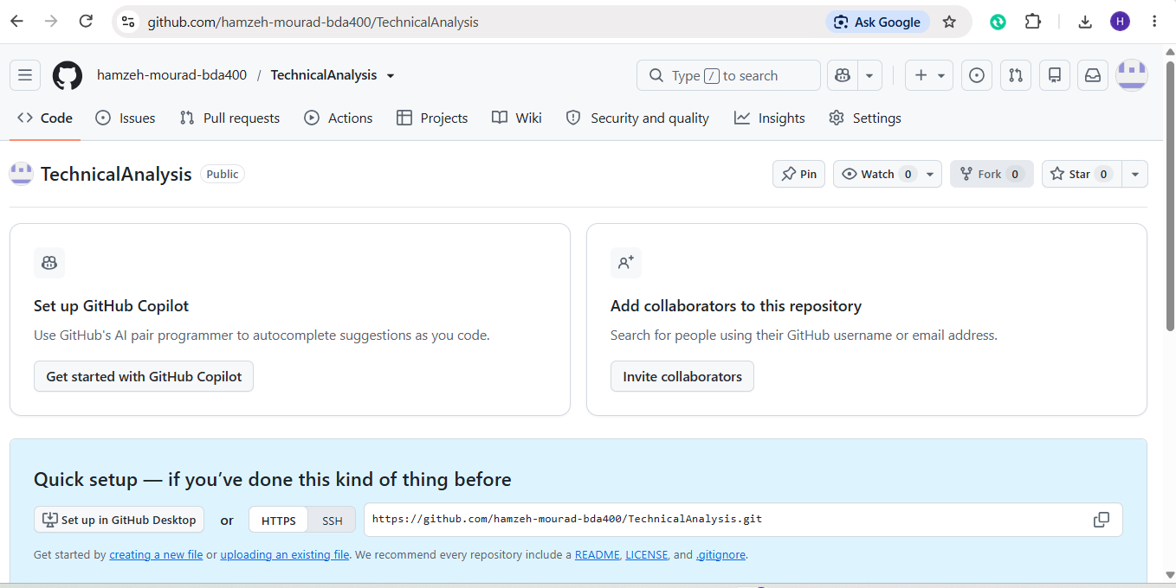
Files committed to repository
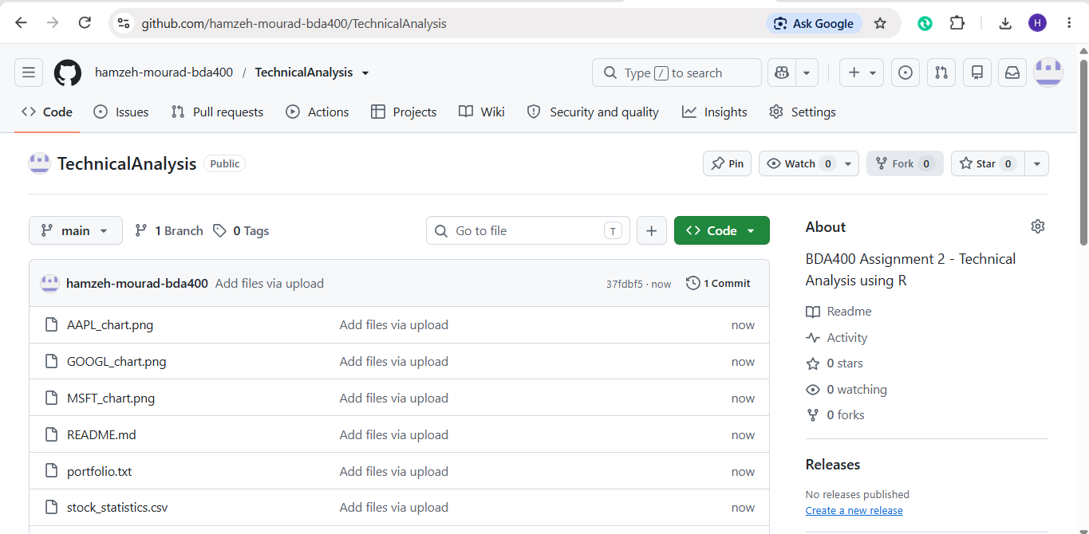

3. R and RStudio setup
RStudio was running with R 4.6.2 and the Assignment 2 working directory selected. Screenshots of the original installation wizard were not captured.
RStudio and working directory
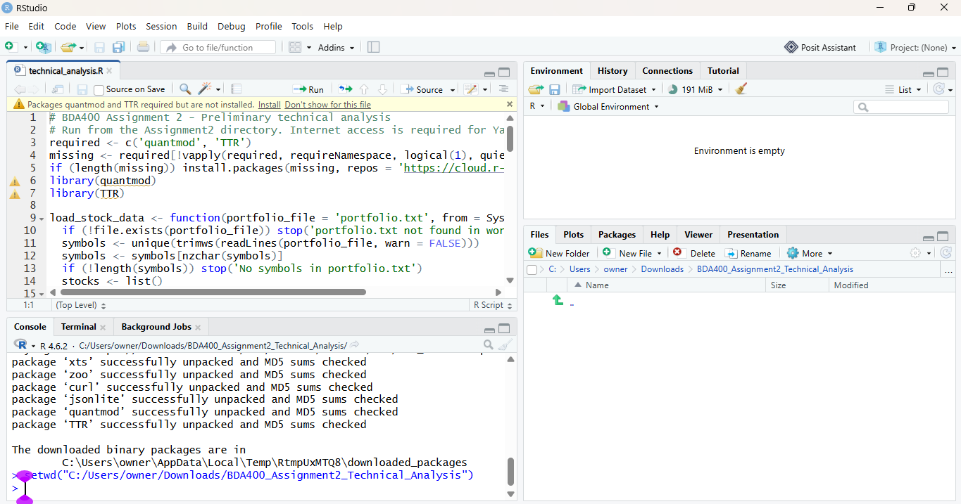

4. Package installation
RStudio console shows quantmod and TTR downloaded and unpacked successfully; the script ran to completion.
Successful execution and output
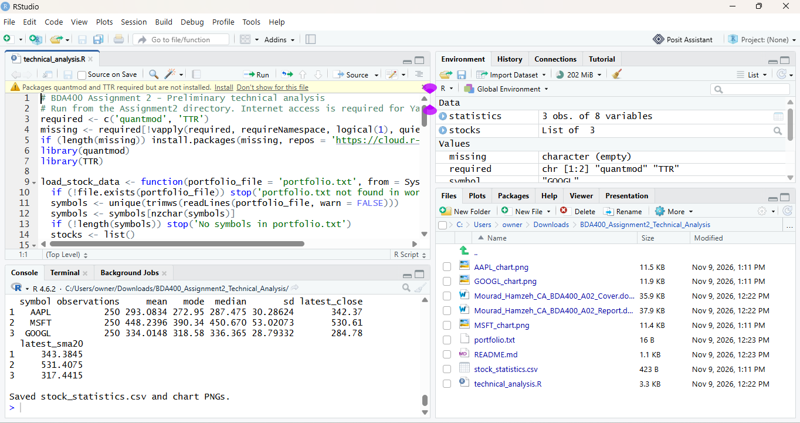

5. Portfolio configuration
The working folder contains portfolio.txt. The script processed AAPL, MSFT and GOOGL. The actual text-file contents should be verified directly if needed.
Assignment files in working directory
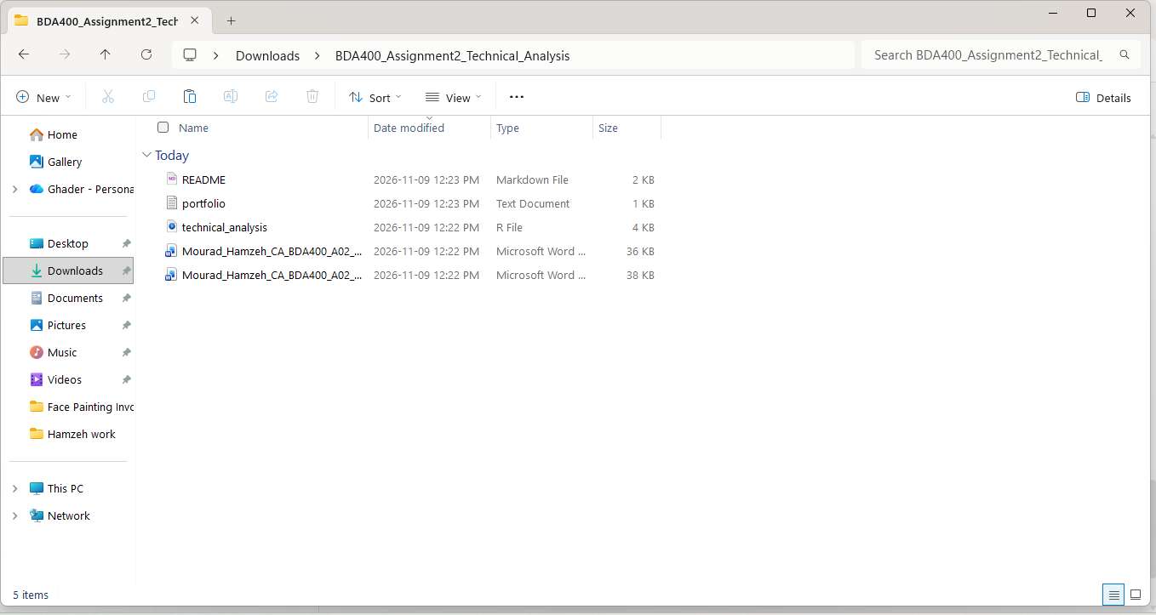

6. Stock import and statistics
The R script successfully produced stock statistics for three symbols. Console results: AAPL mean 293.0834, median 287.475, SD 30.28624, latest close 342.37, 20-day SMA 343.3845; MSFT mean 448.2396, median 450.670, SD 53.02073, latest close 530.61, SMA 531.4075; GOOGL mean 334.0148, median 336.365, SD 28.79332, latest close 284.78, SMA 317.4415. The console also shows mode values 272.95, 390.34, and 318.58 respectively. These are the recorded script outputs, not independently recalculated values.
RStudio statistics output

7. Charts and observations
Each chart plots daily closing prices (blue) and the 20-day simple moving average (red). Apple and Microsoft ended above their moving averages; Google ended below its moving average. The charts are visually legible and have dates, titles, and price axes.
Apple chart
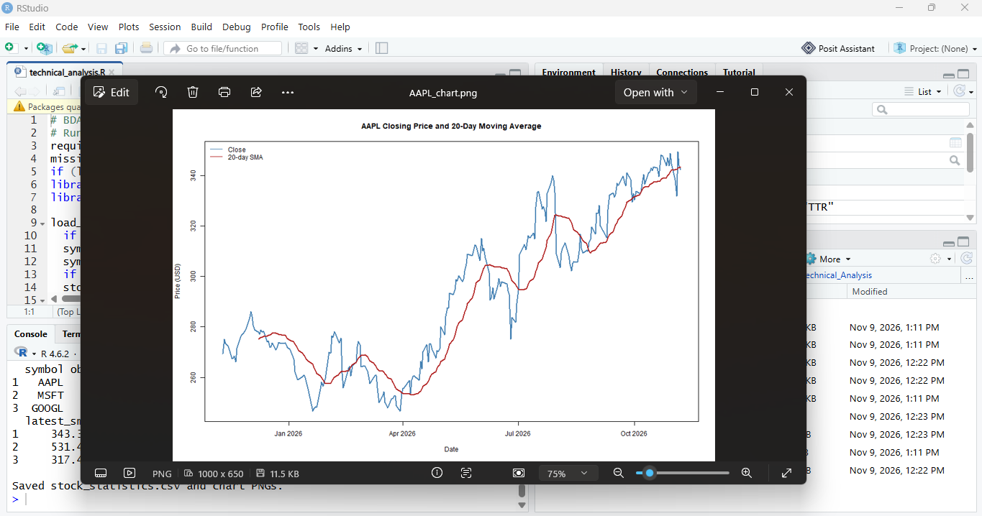
Microsoft chart
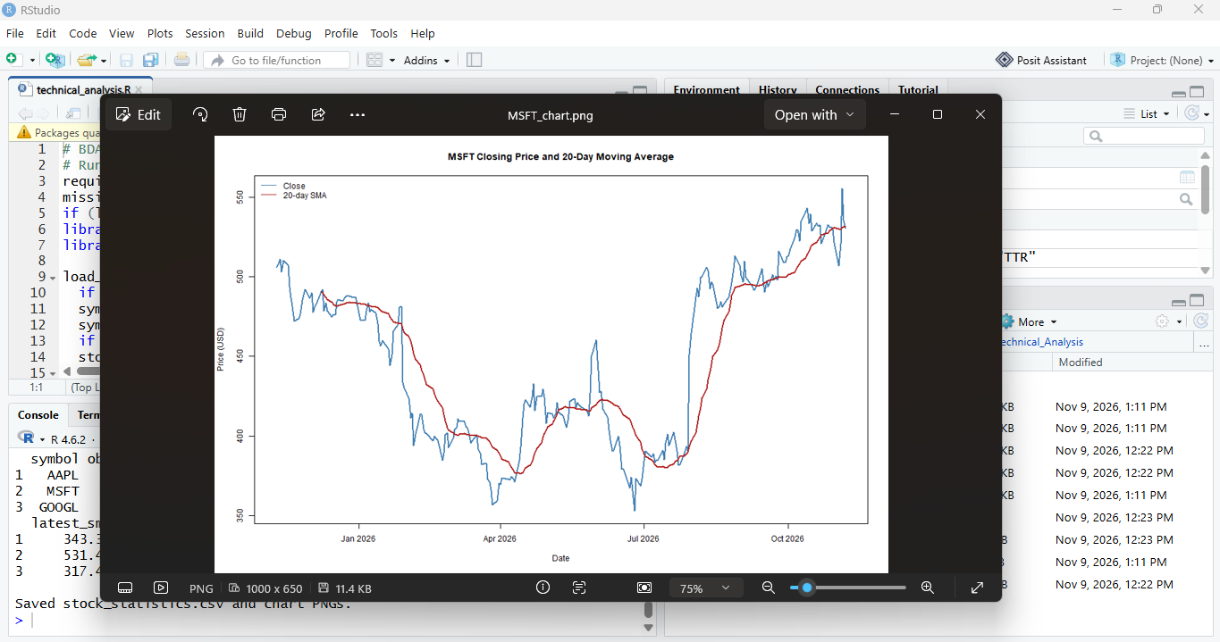
Google chart
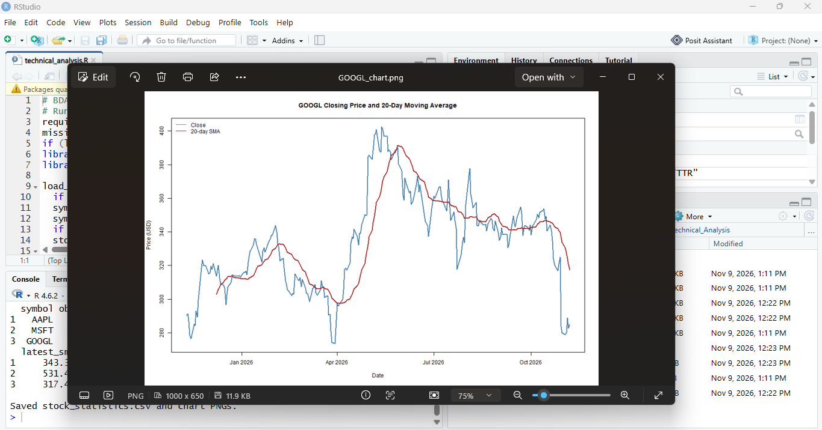

8. Verification and remaining tasks
- Execution observed on November 9, 2026. Symbols processed: AAPL, MSFT, GOOGL. The console reported saved stock_statistics.csv and chart PNGs.
- Before submission: create the Assignment2 subfolder in the repository and move/copy the assignment files into it.
- Upload this completed Word report and the Word cover page to the Assignment2 folder.
- If the instructor requires original installation-step screenshots, these are unavailable in the provided screenshots; do not present current RStudio screenshots as original installer captures.
- Independent recalculation of a statistic and package version numbers have not been verified from the provided evidence.

References
BDA400 Assignment 2 instructions; CRAN R Project; Posit RStudio; quantmod and TTR; Yahoo Finance.

