User manual

This application for take a question survey and save it and question divide into three types Slider,Smily,Stars and every type has attrubites

Now let’s look at application :

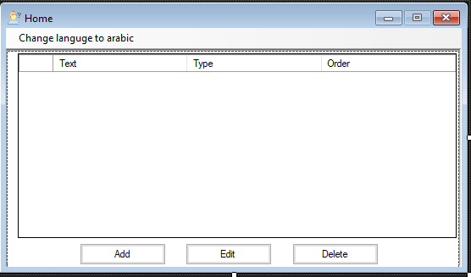

This Home page and contain a list has show the question will already add it , and have a button to change the language from Arabic to English and from English to Arabic , and have button for Add question and you should fill the fields and choose the type of question .

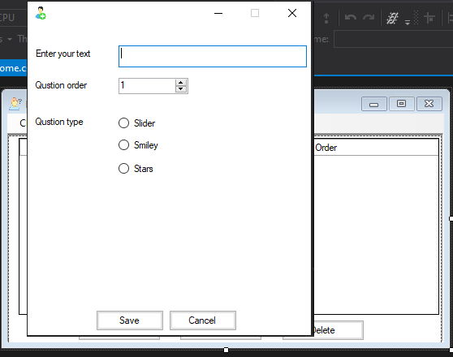

If I choose the question type Slider then the attributes will appear :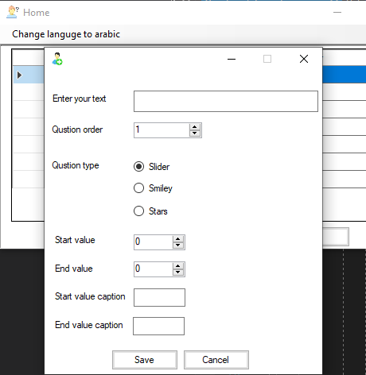

The text should be contain at least one character , order should be contain only numbers , start value should be contain only numbers and less than or equal 100 and less than end value , end value should be contain only numbers and less than 100 and greater than start value , start value caption should be at least one character and his length less than or equal 3 and end value caption should be at least one character and his length less than or equal 3 .

If I choose the type Smiley then attributes for Smiley will appear :

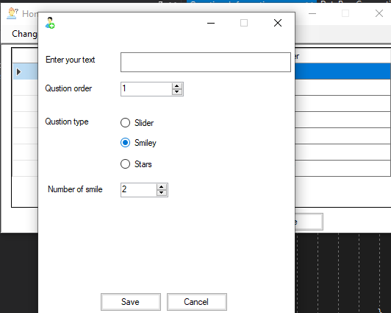

The text should be contain at least one character , order should be contain only numbers and the number of smile faces should only contain a numbers and greater than or equal 2 and less than or equal 5.

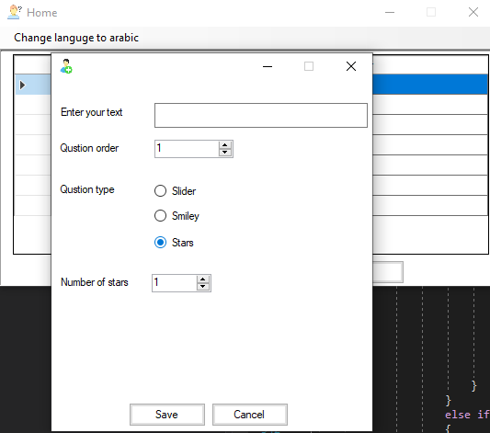

The text should be contain at least one character , order should be contain only numbers and the number of start should only contain a numbers and greater than or equals 1 and less than or equals 10.

Then the Edit Button you should select from list the question will edit it

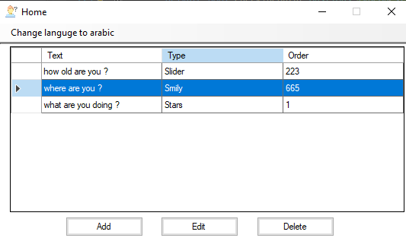

Then click edit button and page edit will appear :

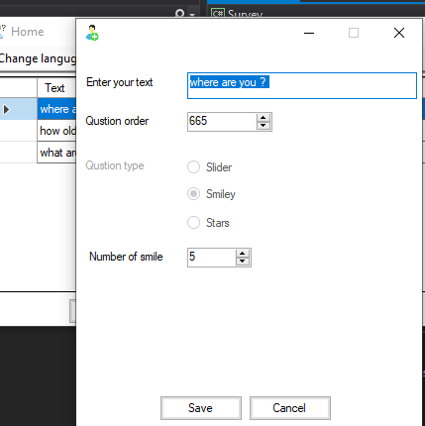

If I don’t choose will appear wrong message :

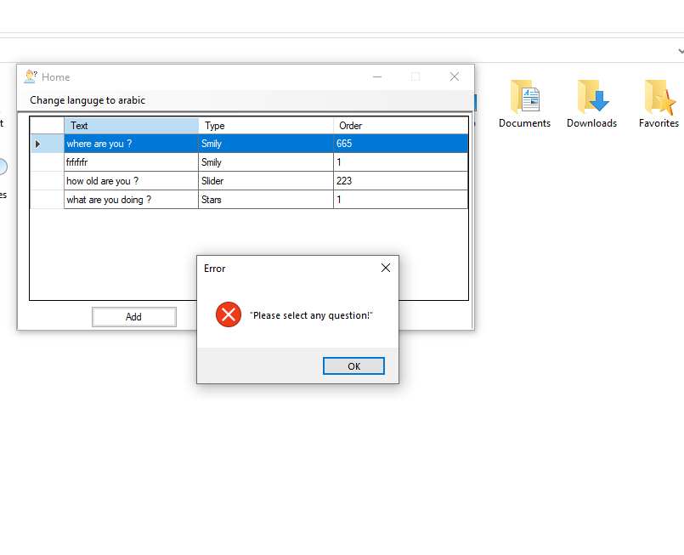

Then Choose one of question and click delete button then will appear message box ask you if you sure :

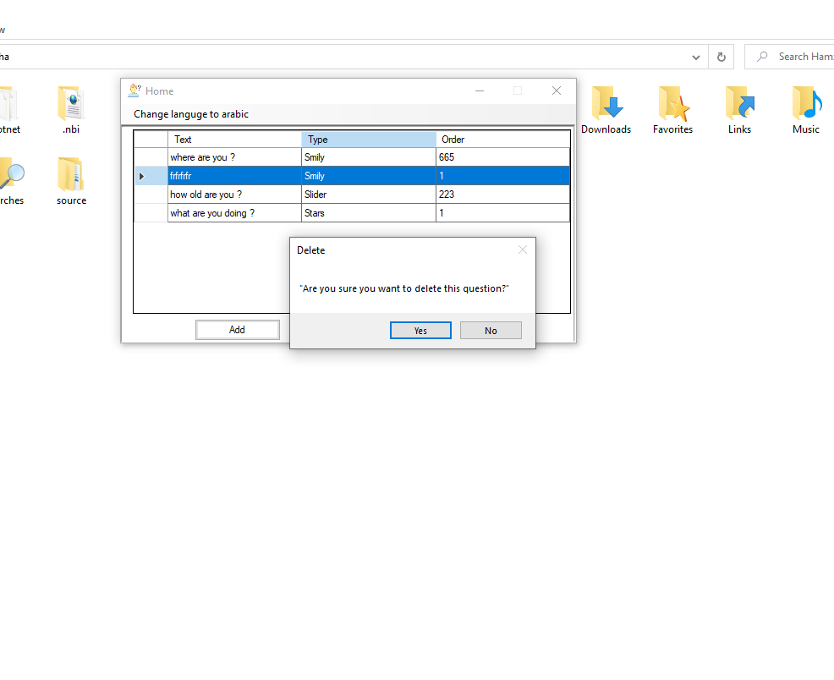

If I click I delete button and I don’t choose any question then will appear



Then if I click I button change language then :

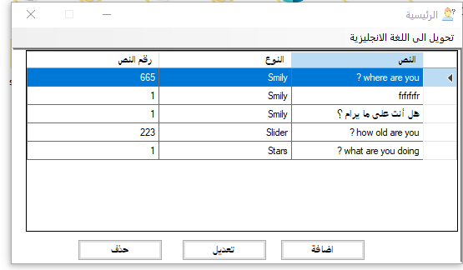

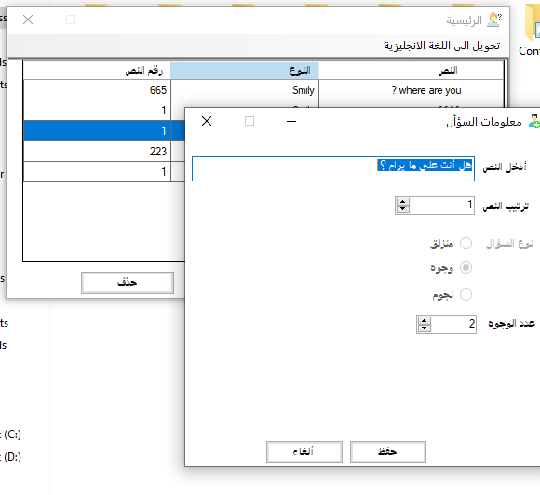

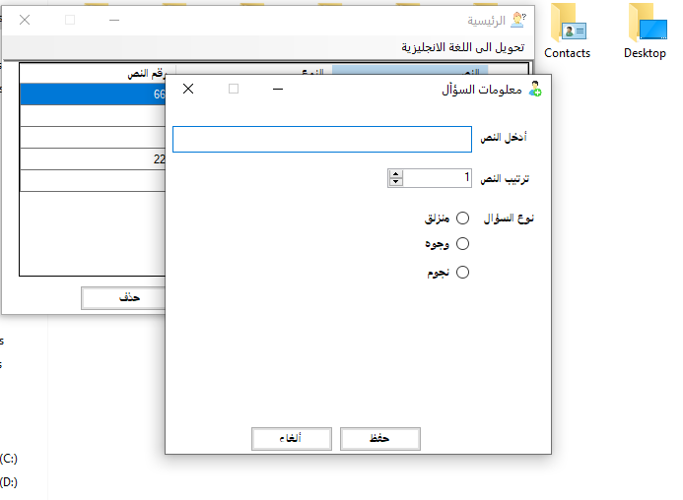

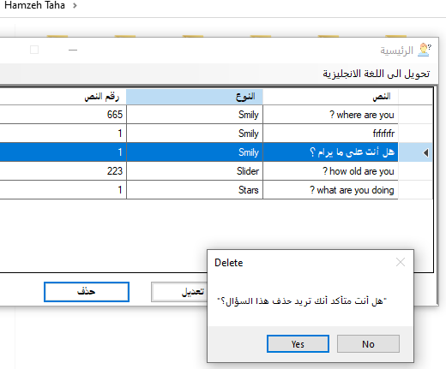

Developer manual

This application divide to layers :

1 – Data base layer :

The data base layer have function will connect to my database

AddSlider , AddSmile and AddStar this for add the question in data base

And function for AddQuestion from table question

And function to edit EditSlider,EditSmile and EditStar this for edit a question in data base

And function for EditQuestion from table Question

And function for delete question from data base DeleteSlider,DeleteSmile and DeleteStar

And function to delete question from table Question

And function for get data from database Is GetQuestionFromDatabase

And have some contant string for connectionstring and some operation in database.

2 – Operation manger layer :

This layer for mange between data base and my UI have Four Function AddQuestion and EditQuestion and DeleteQuestion and GetQuestion

And take the object from ui and go to the database before go to the database layer will work some condtions to know which type of question

3 – User interface layer :

That have the datagridview for show the question and the type of question and the order number and have button for language and three button for operation ADD ,EDIT,DELETE and have anthor form for ADD and EDIT and have some textbox and have numberic up down for numbers and radio buttons for types and tow button save and cancel in this form I can add a new question and after select the question I can edit the question in some validation in function that name CheckTheData() and the delete after select the question will appear YES or NO for delete

This for Repository design pattern

4- BaseLog layer this class for print the errors in the log file using function LOG()

5- Global layer this tow class the first class for static attributes and the second class for the constant attributes

6 – Question Layer this divide a four class the first class is abstract class is question and the second class this for Slider and have special attributes and inherited the Question Class and the Third class For Smile class and have special attributes and inherited the Question Class and fourth class for Star and have special attributes and inherited the Question Class.

This is Diagram for layers :

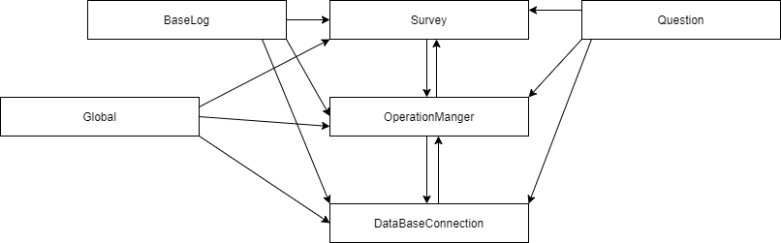

**Administrator**

To run the application you should trace steps step by step :

1. You should create the data base and create tables from file that name CreateDataBaseAndTables.sql .
2. You should change the connection string from App.cnfg , and add the server name , your database name , your user id and your password .
3. After these steps you can run the application from run file and you can run from bin -> debug -> Survey.exe