**Developer manual**

**Data base:**

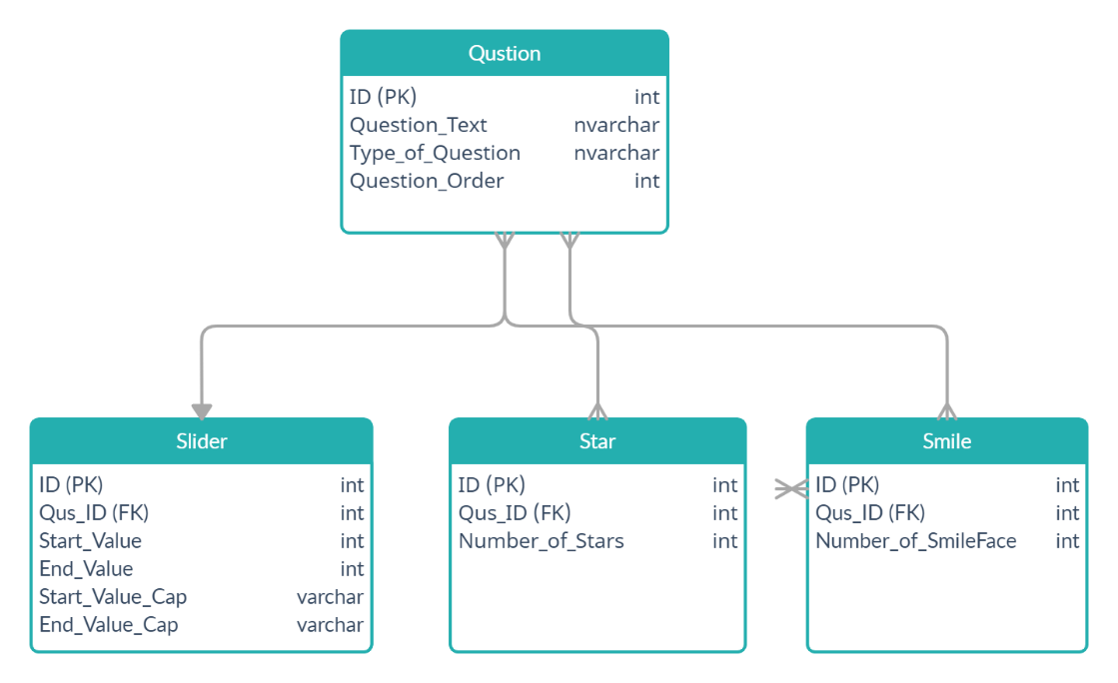

Database contain four tables

1. Table Question

* It will contain variables for all questions for all types

1. Table Slider

* It will contain foreign key from Question table and his attributes

1. Table Smile

* It will contain foreign key from Question table and his attributes

4-Table Stars

* It will contain foreign key from table question and have his attributes.

**Layers for application:**

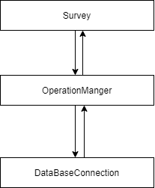

1. **Database layer:**

|  |  |  |  |  |
| --- | --- | --- | --- | --- |
| **The database layer contains several functions** | | | | |
|  | | | • **Add Question:** | |
|  | 1.AddSlider  2.AddSmile  3.AddStar  4.AddQuestion |
| This functions for add question in any type in database, every type of question has function for add and all types call AddQuestion then call their own function return number for succeed or fail to operation manger delete question. | | | | |
|  | | | • **Edit Question:** | |
|  | 1.EditSlider  2.EditSmile  3.EditStar  4.EditQuestion |
| This functions for edit question in any type from database every type of question has function for edit and all types call EditQuestion then call their own function and return number for succeed or fail to operation manger edit question. | | | | |
|  | | | • **Delete Question:** | |
|  | 1.DeleteSlider  2.DeleteSmile  3.DeleteStar  4.DeleteQuestion |
| This functions for delete question in any type from database every type of question has function for delete and all types call DeleteQuestion then call their own function and return number for succeed of fail to operation manger delete question. | | | | |
|  | | | • **GetQuestionFromDataBase:** | |
|  | This function for get question from database to the list and return list to operation manger. |
|  | 1. **Operation Manger layer:**   **This section connects the database and (UI) layer get data from database and send data to UI and get data from UI and send the data to database and have thread for refresh data in period of time and resend new data to UI.**   1. **User interface layer:**   **This section is for interacting with the user and contains several buttons and a display screen, and this section takes data from operation manager and here also check the conditions of each variables for each question.**   1. **BaseLog layer:** | | | |
|  | **This layer for print the errors for any layers in logfile using function Log().** | | |
|  | | | | |
|  | 5. Question layer:  **This layer divides the question into several types: slider, smiley, and star for each type have class and inherited question, each class have some variables.** | | | |
|  |  | | |
|  | | | | |

**This is Diagram for layers:**

