Semester Project Documentation (CS – 101 – Computing & AI)

Semester Project Title: Dungeon_Decisions (a simple combat game)
Student Details
 | Student Name | Student Reg # | Student Degree
Student-1 | Hamza Hasan Khan | 2025260 | BSAI

- Main Features
- Dynamic Combat System: A turn-based battle engine featuring 5 enemy types with scaling difficulty and critical hit mechanics.
- Recursive Magic Logic: An "Ancient Magic" ability that calculates damage using a recursive function, growing stronger as the player levels up.
- Secure Save System (Encryption): A file-handling system that saves player progress using XOR obfuscation and checksum validation to prevent tampering (cheating).
- Permadeath Mechanic: A "Hardcore" feature that permanently deletes the save file upon player death, enforcing high-stakes gameplay.
- Interactive Economy (Shop): A gold-based economy allowing players to purchase consumable potions and permanent weapon upgrades.
- Training & Progression: A training camp utilizing pointer manipulation to directly upgrade player stats (Attack and Max Health).
- Risk/Reward Resting: A campfire mechanic that heals the player at the cost of resetting the streak.

- Types of Users & Requirements
- The Player (Hero)
  - Will be able to start a new adventure or automatically load a previous save file with verified data integrity.
  - Will be able to engage in combat with randomized enemies that scale in difficulty based on the "Battles Won" counter.
  - Will be able to make strategic decisions: Attack, Use Potion, Flee, or cast Recursive Magic.
  - Will be able to visit a merchant to exchange earned gold for health potions or attack upgrades.
  - Will be able to train specific attributes (Health/Attack) by spending gold at the Training Camp.
  - Will be able to view real-time statistics, including current Health, Gold, Score, and Win Streak.
  - Will be able to securely save the game state to a text file for future sessions.

Requirements Breakdown
1. Combat & Enemy Logic:
  - Randomly select an enemy from the enemyNames array based on the player's progression level (e.g., Dragon only appears after 6 wins).
  - Utilize a while loop to manage turn-based actions until either the Player or Enemy HP reaches 0.
  - Implement recursiveMagic function to calculate damage based on the formula: Base + (Level * Scaling).
  - Use a pointer-based checkCritical function to determine if an attack deals double damage.
2. Economy & Shop System:
  - Pass gold and potions variables by Reference to the Shop function to allow transaction updates.
  - Validate user input to ensure sufficient funds before processing a purchase.
  - Update global player stats immediately upon successful purchase.
3. Save System & Data Integrity:
3.1. Create an ofstream object to write player stats (Health, Gold, etc.) to dungeon_save.txt.
3.2. Implement obfuscation by multiplying stats by secret key constants (e.g., HP * 30) before writing to the file.
3.3. Calculate a "Checksum" (sum of all stats * key) and save it to the file.
3.4. On loading (ifstream), decrypt the values and recalculate the Checksum; if they do not match, delete the file (Anti-Cheat).
4. Permadeath & High Score:
  - Detect if Player HP <= 0.
  - If dead, read the existing High Score from highscore.txt and update it if the current score is higher.
  - Execute the remove() function to permanently delete dungeon_save.txt.

- Features to Coding Matrix
Sr # | Feature Name | Programming Concept Used | No. of Files Used | No. of Arrays Created | No. Pointers / References Used | No. of Variables & Objects | Functions Created | Line of Code Written
1 | Combat Engine | Arrays, Loops, Recursion, Pointers | 1 (Read Highscore) | 2 (Names, Stats) | 2 (Pointers for Dmg/Crit) | 8 (Local vars) | startCombat, recursiveMagic, applyDamage, checkCritical | ~180
2 | Shop & Economy | Pass-by-Reference, Switch Case | 0 | 0 | 2 (References) | 3 | visitShop | ~65
3 | Training & Rest | Pointers, Input Validation | 0 | 0 | 7 (Pointers to stats) | 4 | trainPlayer, campRest | ~90
4 | Secure Save/Load | File Handling (fstream), Math Logic | 1 (Read/Write) | 0 | 0 | 15 (Temp vars) | saveGame, loadGame | ~110
5 | Main Menu/UX | Cross-platform compatibility (ifdef) | 0 | 0 | 0 | 2 | main, showMainMenu, wait | ~100

- Project Screenshots
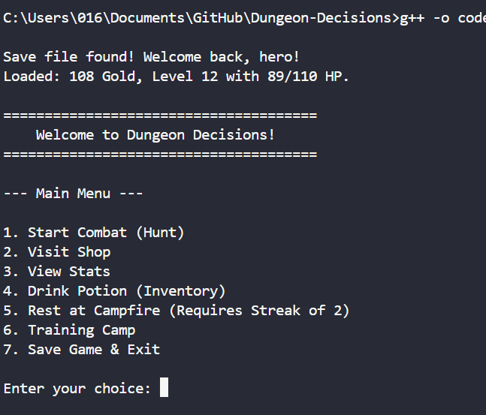
Main Menu showing loaded save file and game options.
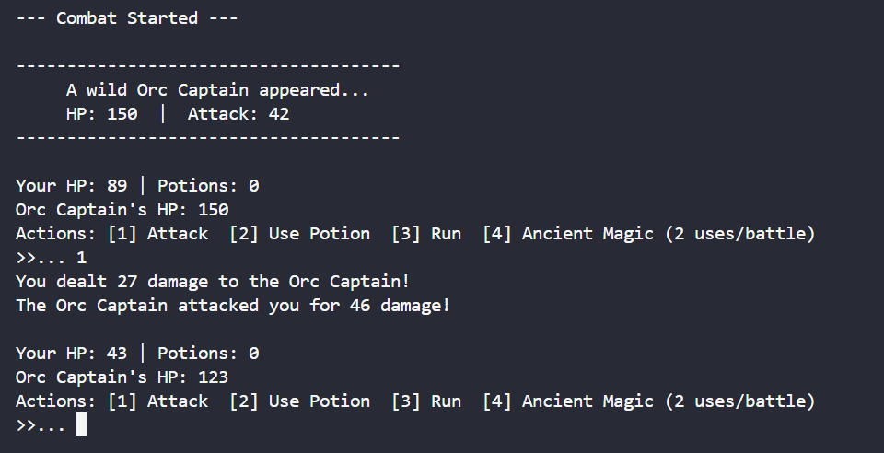
Combat Interface displaying Enemy Stats and Player Actions.
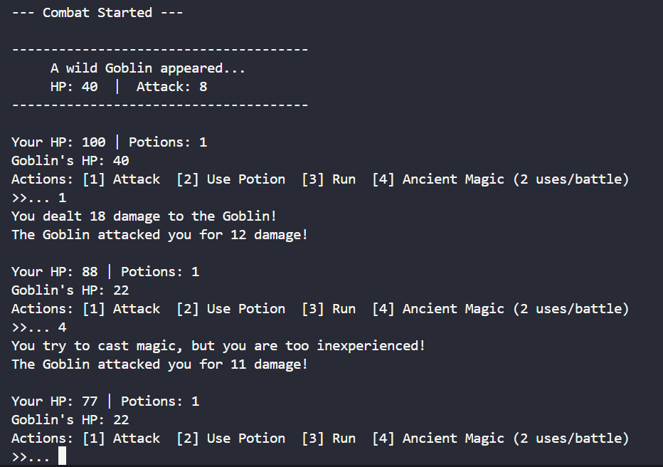
Combat Log showing logic flow and randomized outcomes.
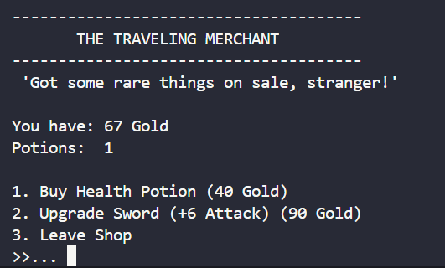
Shop Interface with validation logic for purchases.
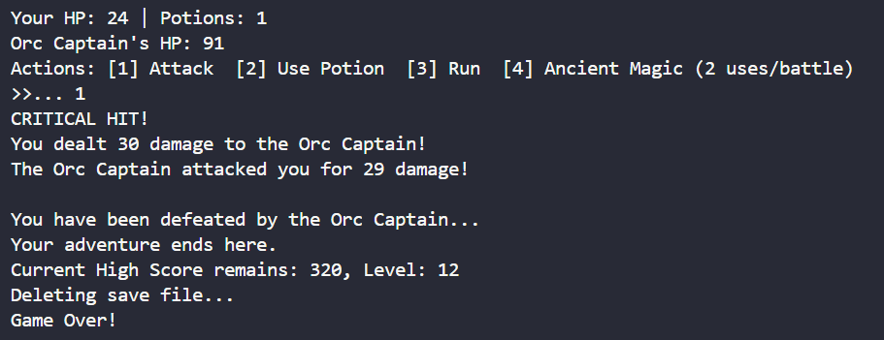
Game Over screen demonstrating the Permadeath (file deletion) feature.

