User Manual
IBM SkillsBuild Course Tracking Platform

Table of Contents
1. Introduction 3
2. Getting Started 3
2.1 Registering an Account 3
2.2 Logging In 3
3. Dashboard Overview 3
4. Navigation Overview 3
5. Course Interaction 3
5.1 Searching for Courses 3
5.2 Popular Courses 4
6. Course Progress Tracking 4
7. Completion and Reviews 4
8. XP and Badges 4
9. Goal Tracker 5
10. Leaderboards 5
11. Friends System 5
12. Summary 5

1. Introduction
This system is a gamified course tracking platform that integrates with IBM SkillsBuild. It allows users to track progress, earn rewards, and interact socially.

2. Getting Started

2.1 Registering an Account
- Open the application
- Enter your email address
- Enter a password
- Re-enter your password to confirm
- Click the 'Register' button
- Your account will be created

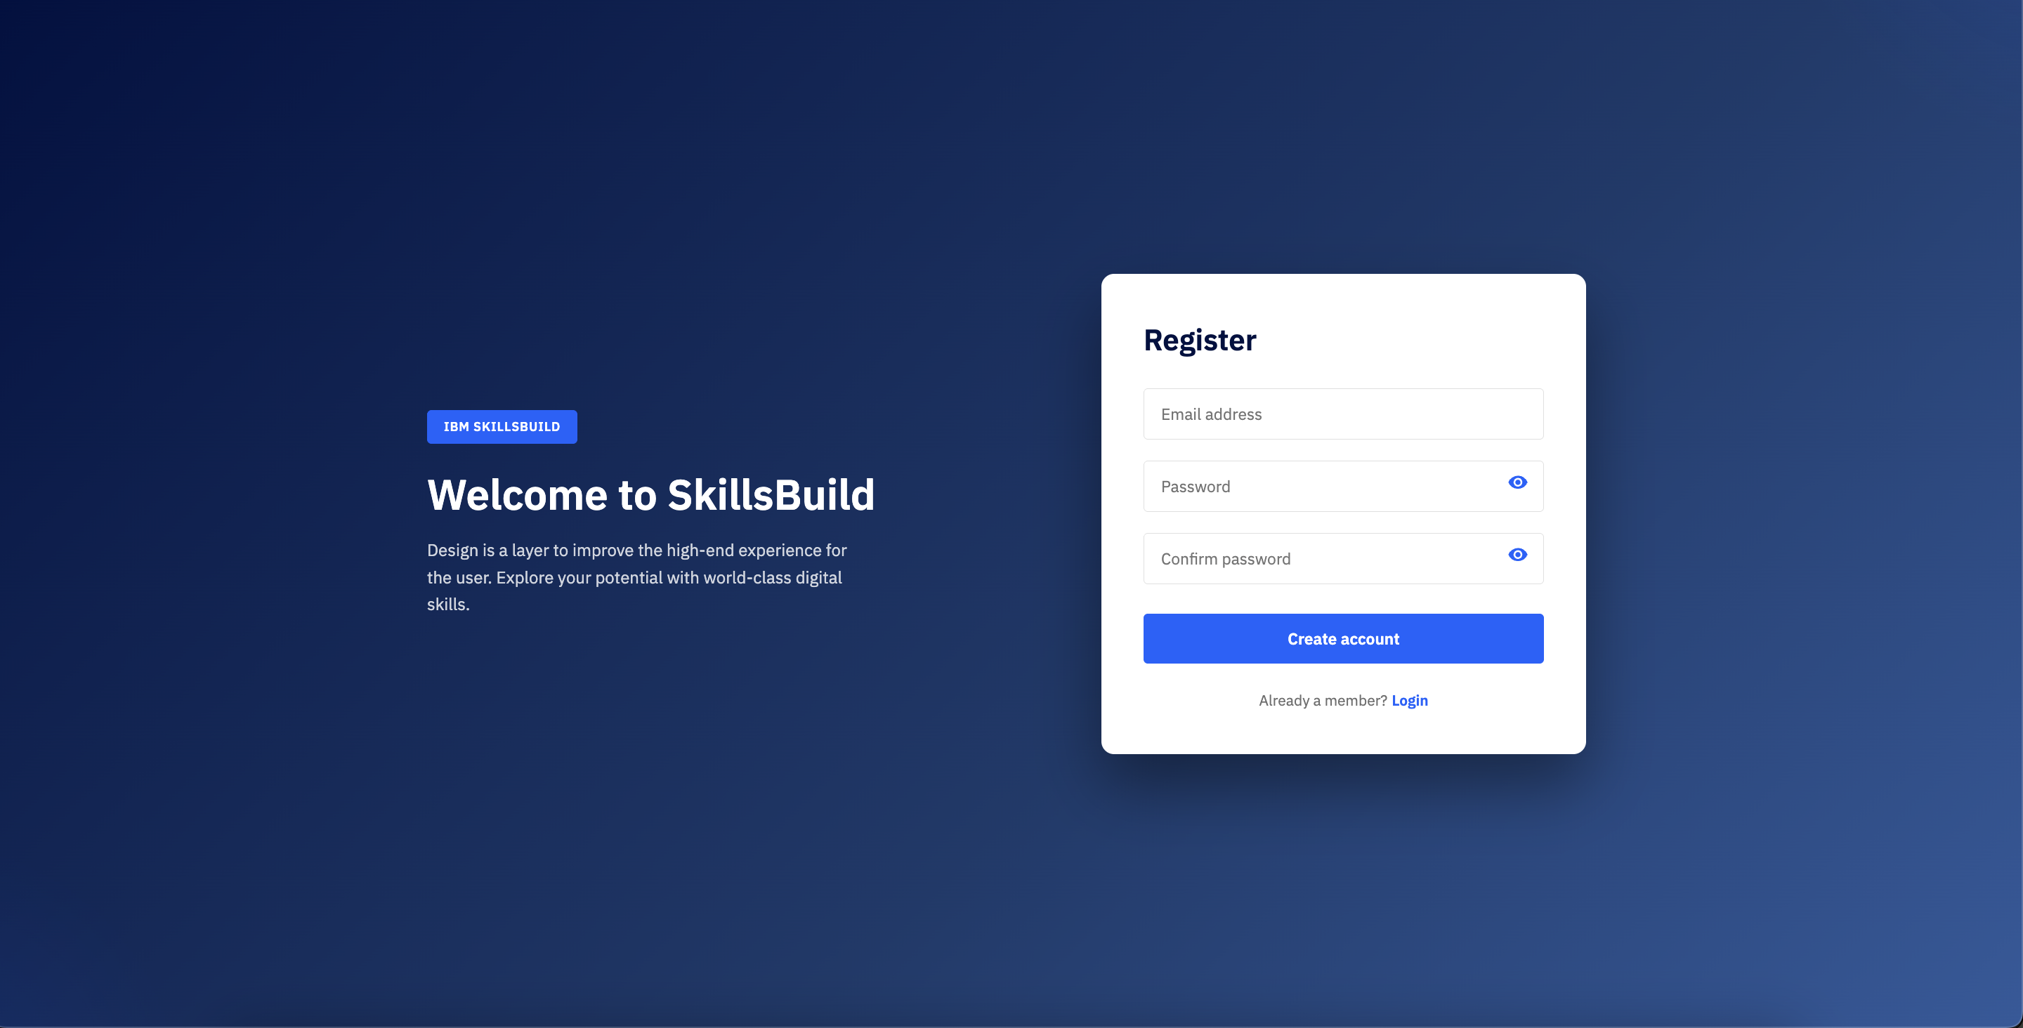
Figure 1: Registration Page

2.2 Logging In
- Enter your email and password
- Click the 'Login' button
- You will be redirected to the dashboard

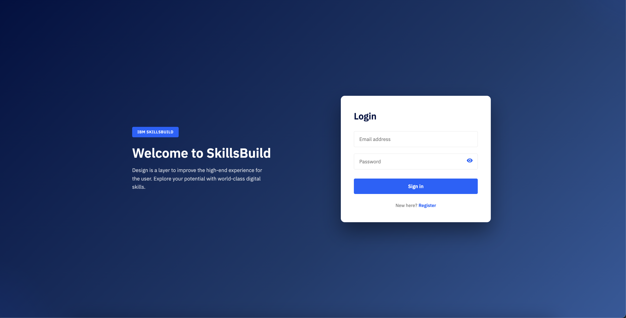
Figure 2: Login Page

3. Dashboard Overview
The dashboard is the central hub where users can view XP, badges, goals, reviews, and access all features.
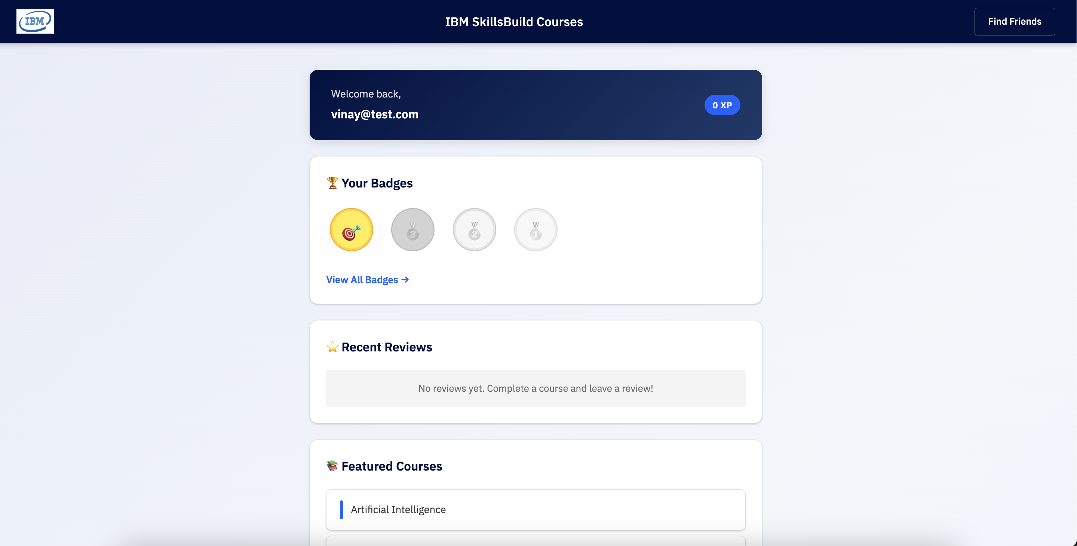
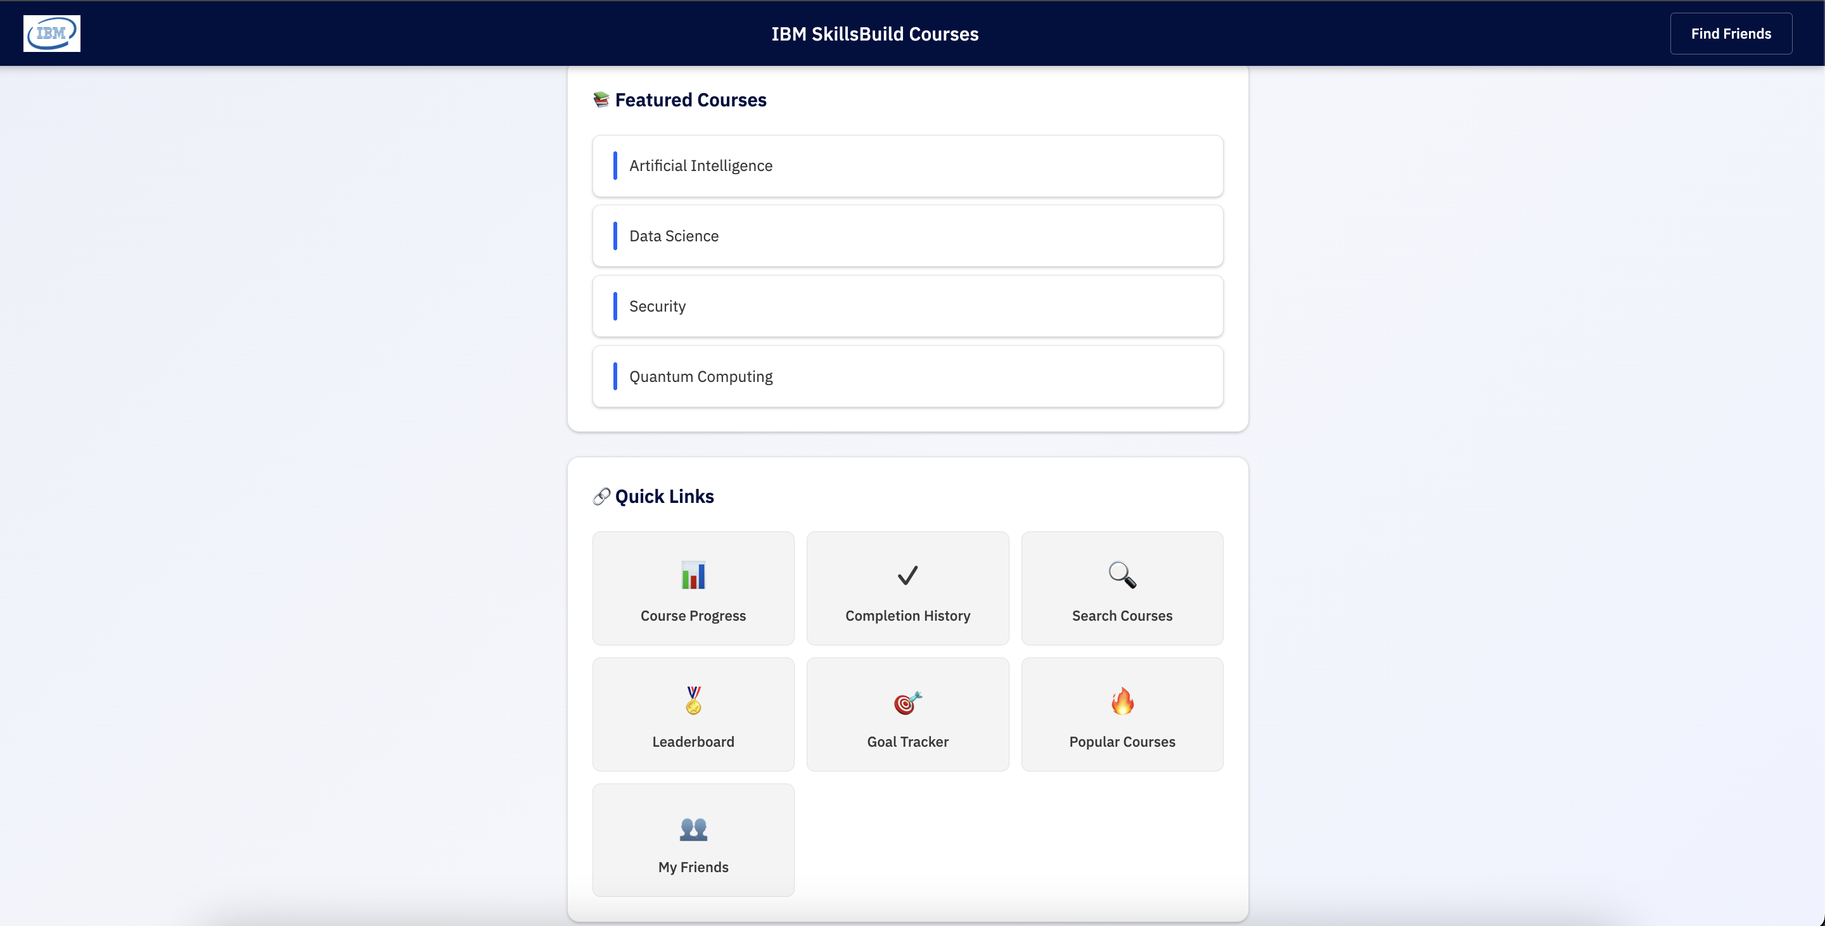
Figure 3: Dashboard Overview

4. Navigation Overview
All features are accessed from the dashboard via quick links including Course Progress, Search Courses, Leaderboards, Goals, and Friends.

5. Course Interaction

5.1 Searching for Courses
- Click 'Search Courses'
- Enter or select a course
- Click 'Search'
- Select a course
- You will be redirected to IBM SkillsBuild

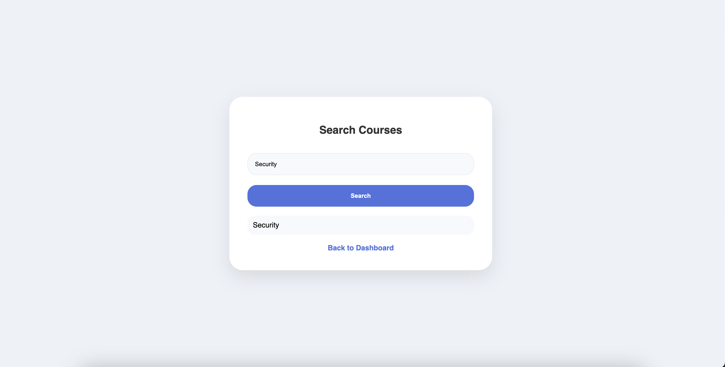
Figure 4: Search Courses

5.2 Popular Courses
- Click 'Popular Courses'
- Select a course
- You will be redirected to IBM SkillsBuild

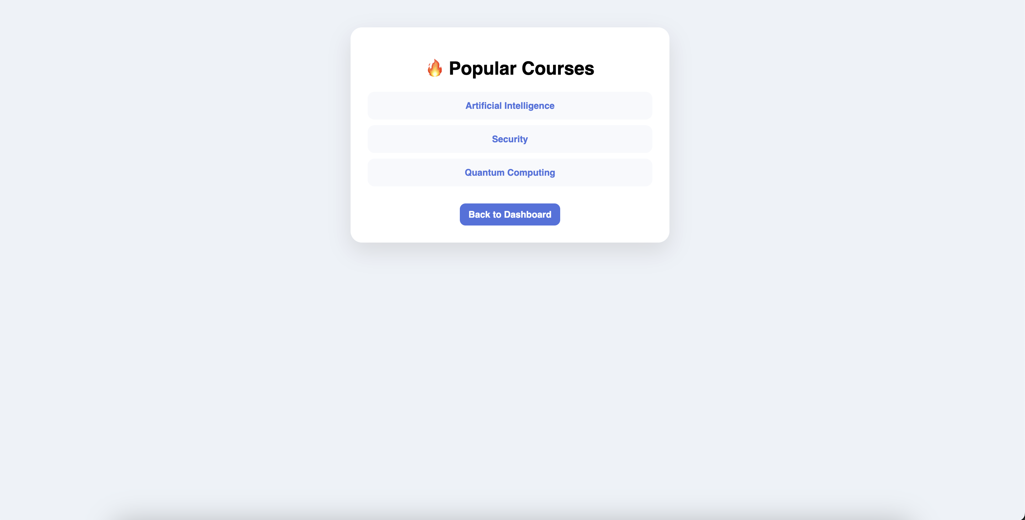
Figure 5: Popular Courses

6. Course Progress Tracking
- Return to the dashboard after completing a course
- Click 'Course Progress'
- The system will automatically begin tracking progress
- Click 'Pause' to stop the timer
- Click 'Resume' to continue
- Click 'Complete' when finished
- You will be redirected to the completion page
- Progress and time will update automatically

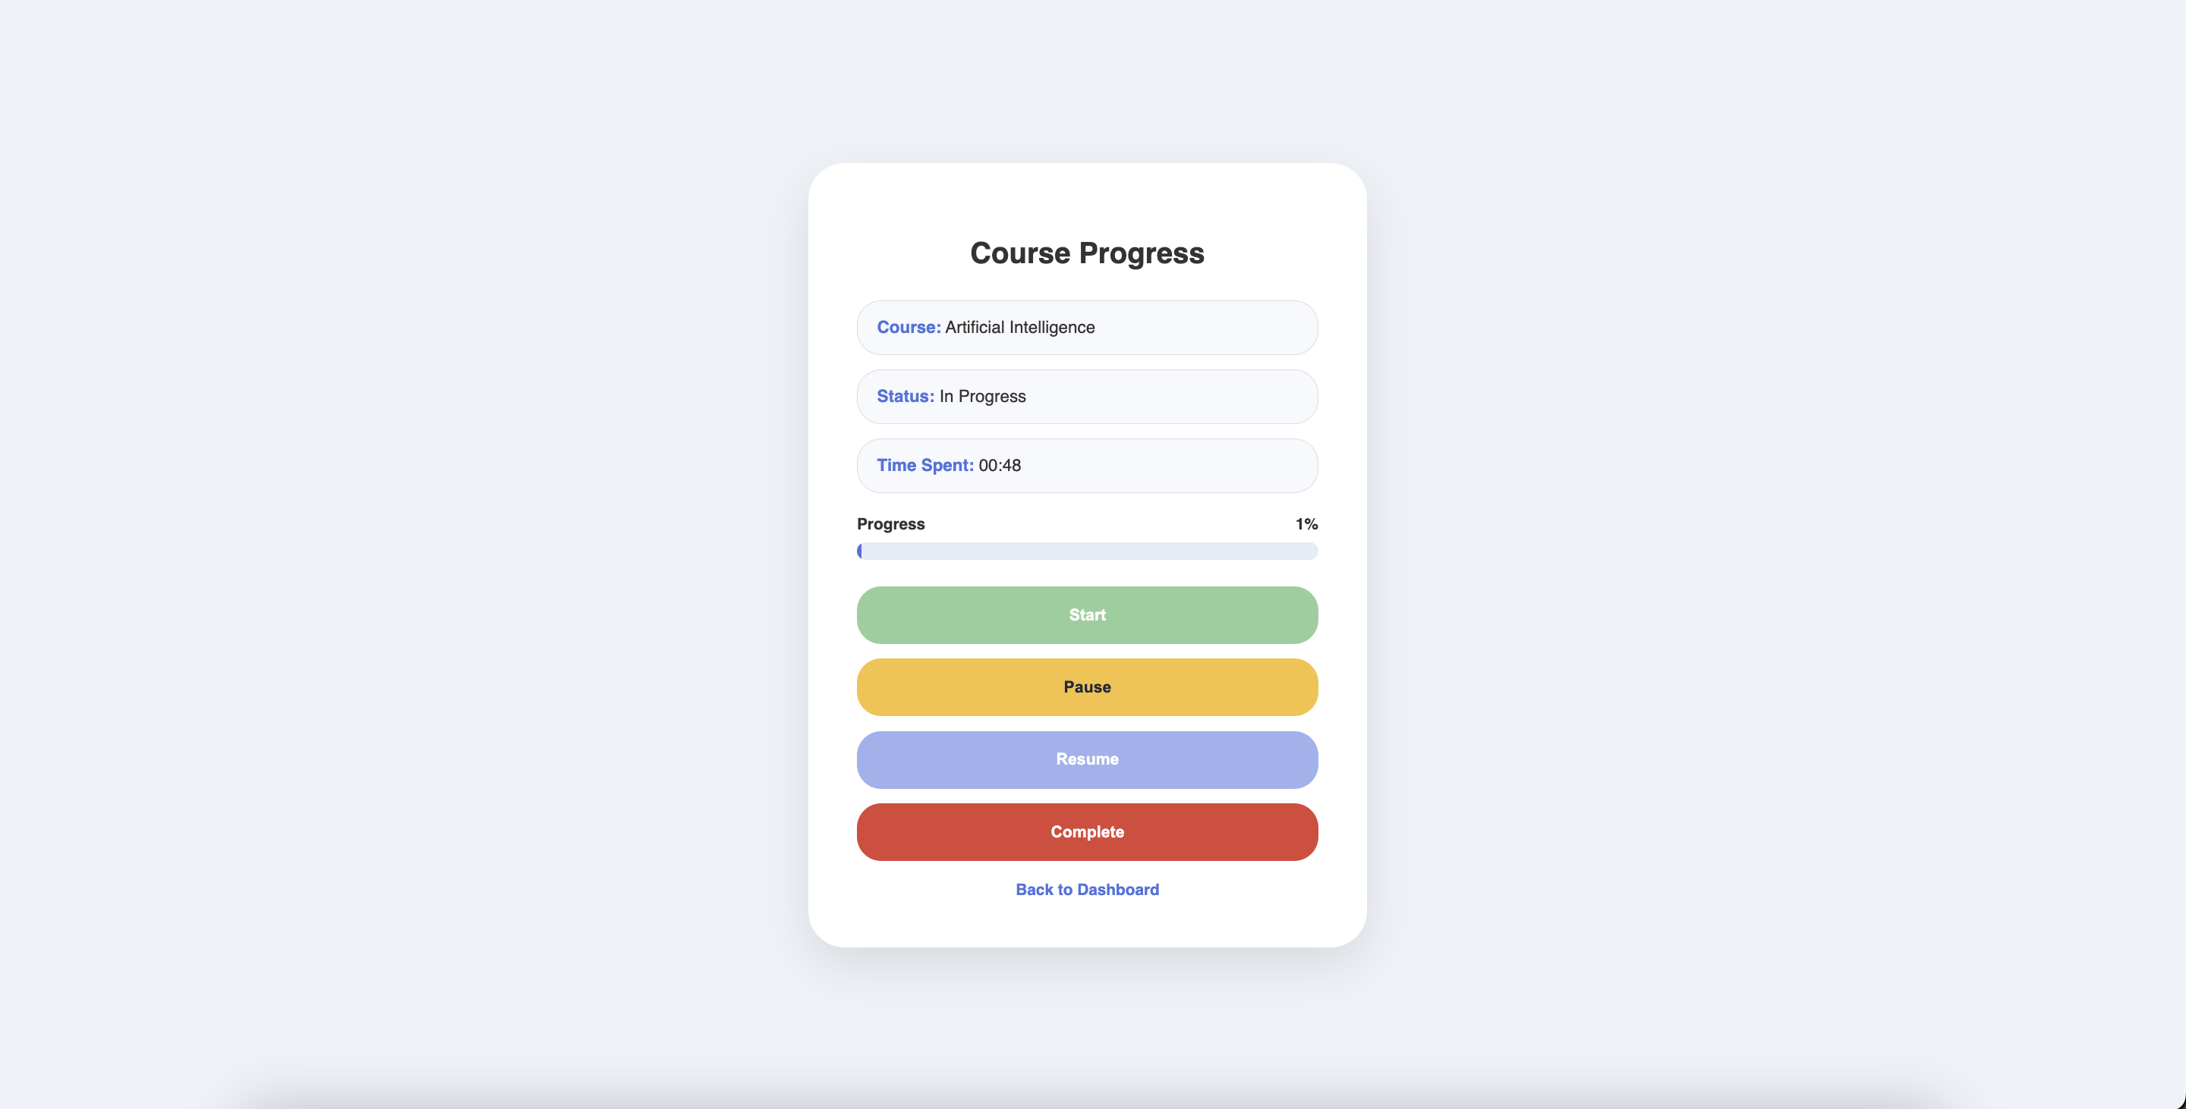
Figure 6: Course Progress

7. Completion and Reviews
- View completed courses
- Select a rating (1–5 stars)
- Enter a comment
- Click 'Submit Review'
- Your review appears on the dashboard

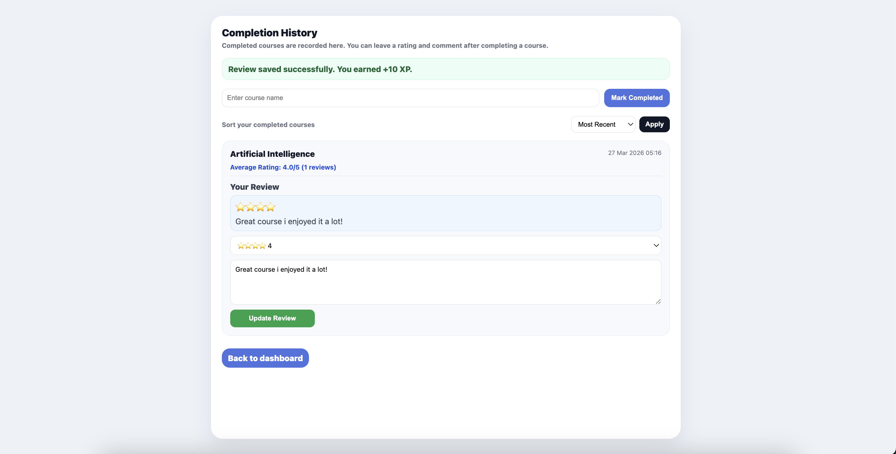

Figure 7: Review Page

8. XP and Badges
Users earn XP through:
- Completing a course (+100 XP)
- Writing a review (+10 XP)
- Completing a goal (+10 XP)
XP updates automatically and contributes to badge progression.
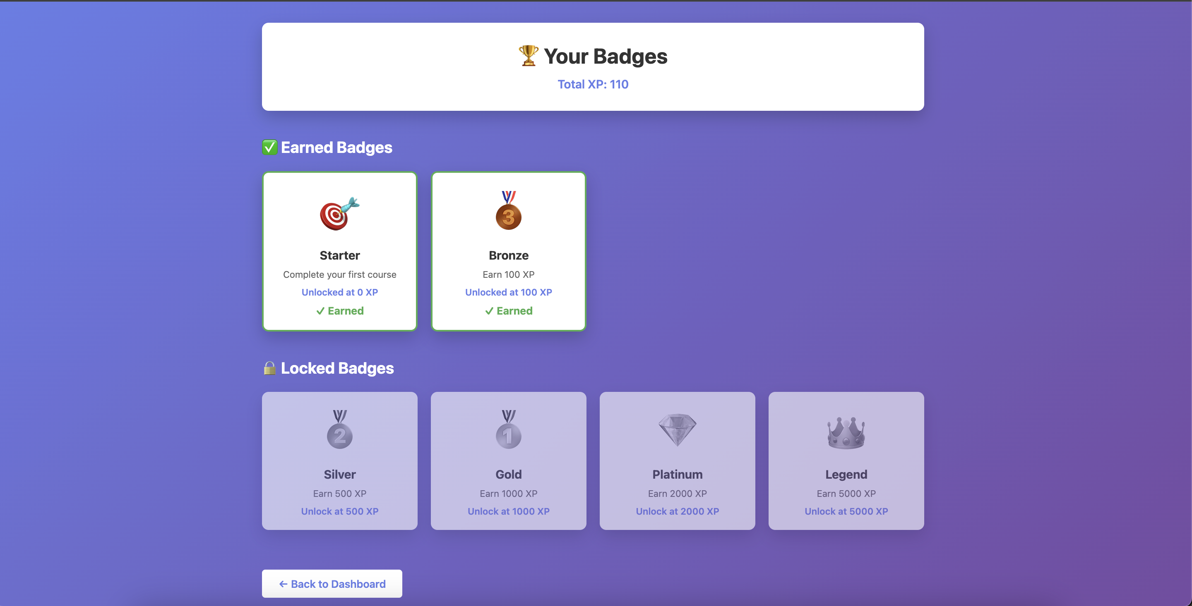
Figure 8: Badges Page

9. Goal Tracker
- Click 'Manage Goals'
- Enter number of courses (1–4)
- Select a deadline
- Click 'Set Goal'
- Complete courses to update progress
- Only new completions count toward the goal
- Completing the goal awards XP

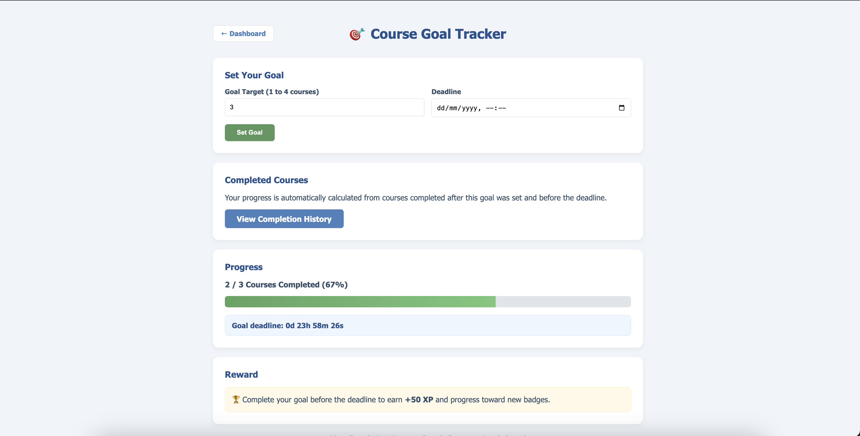
Figure 9: Goal Tracker

10. Leaderboards
- Click 'Leaderboard' to view global rankings
- Users are ranked by total XP
- Navigate to 'My Friends' to view friend leaderboard

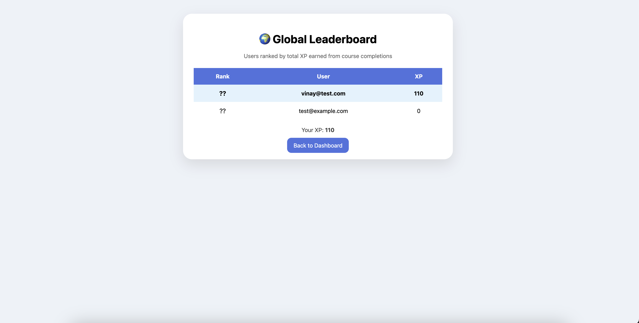
Figure 10: Leaderboard

11. Friends System
- Click 'Find Friends'
- Search for a user
- Click '+ Add'
- View friends in 'My Friends'
- Remove friends if needed

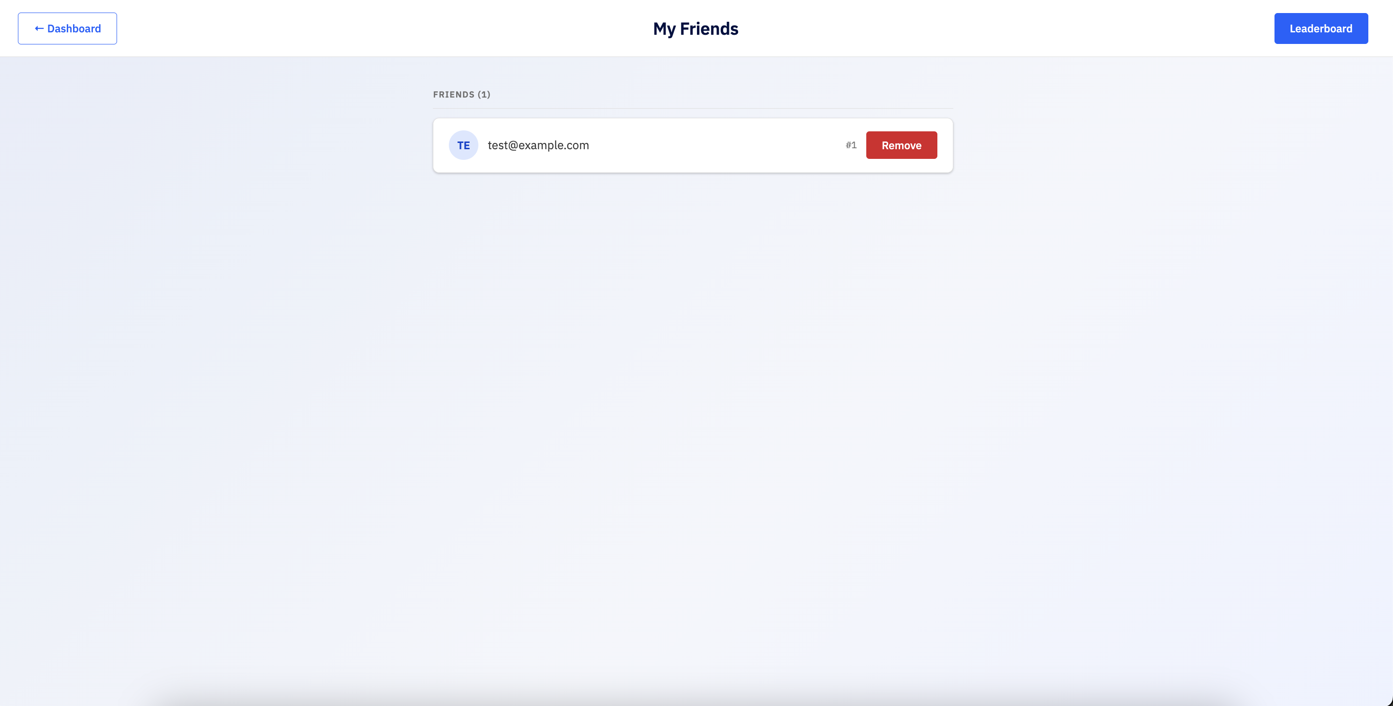
Figure 11: Friends Page

12. Summary
This platform enhances learning through gamification, goal setting, and social interaction.

