## 按钮组件-Layout

"view": {

            "type": "btn",

            "layout": "PL_M2_1",

            "btnNCB": [{

                "key": 0,

                "content": "是, 我现在还在烧",

            }, {

                "key": 1,

                "content": "不, 现在我不烧了"

            }]

        },

### BL_2_M1

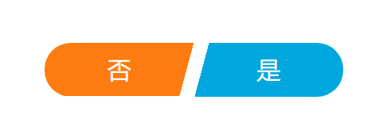

### BL_2_M2

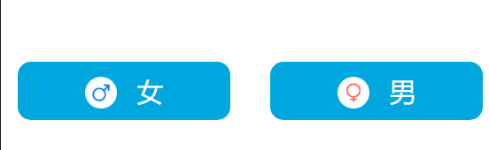

### PL_M1

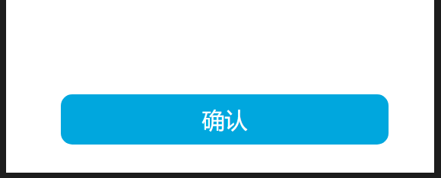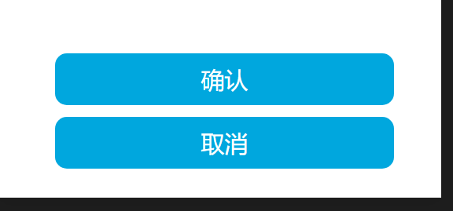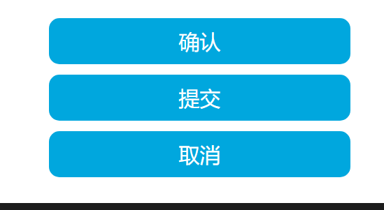

### PL_M2 按钮个数同上

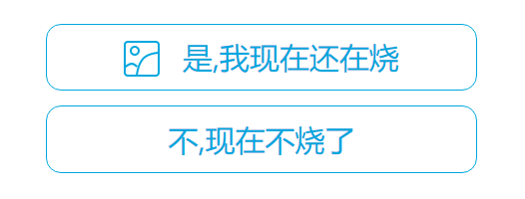

### PL_M1_1 PL_M2_1 一个按钮,位置随意调节

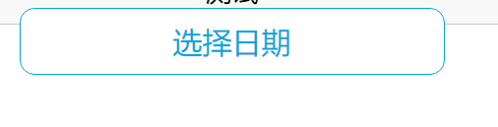

## 日期组件

"view": {

            "type": "date",

            "layout": "PL_M2",

            "btnNCB": [{

                "key": 0,

                "content": "选择日期",

                "icon": "../../package_public/images_doctor/190_1.png",

                "select": true

            }, {

                "key": 1,

                "content": "今天",

                "select": "today"

            }, {

                "key": 2,

                "content": "昨天",

                "select": "yesterday"

            }]

        },

### Layout: 同上

