HCMC UNIVERSITY OF TECHNOLOGY AND EDUCATION
FACULTY OF INFORMATION TECHNOLOGY
NEW TECHNOLOGIES IN SOFTWARE ENGINEERING
PROJECT REPORT
Building Career Simulation Platform for Students

Ho Chi Minh City, 2026

PART A: INTRODUCTION

1. Reasons for choosing the topic
Career orientation is an important decision-making process for secondary-school students, yet many students have limited opportunities to understand their own interests and strengths or to experience activities that resemble real professional work. Existing approaches commonly rely on interest inventories, informational websites, counselling sessions, or isolated career events. These approaches can provide useful information, but they do not necessarily give students a structured opportunity to test their expectations through practical activities.
This project proposes an experiential career exploration platform that combines a RIASEC-based assessment, task-oriented career simulations, objective evaluation, and AI-assisted feedback. The system is not intended to determine which career a student should pursue. Instead, it provides evidence from assessment results and simulated activities so that students can compare their interests, performance, and areas for improvement and make more informed decisions independently.
The initial implementation is intentionally limited to the Information Technology domain, covering representative career directions such as frontend development, backend development, data analysis, software testing, and cybersecurity. This restricted scope makes it possible to build a complete and demonstrable vertical slice within the eight-week course while leaving a clear path for future expansion.

2. Project objectives
The project aims to achieve the following objectives:
- Provide students with a structured workflow for exploring IT-related career directions.
- Use a RIASEC-based assessment to identify areas that students may wish to explore further without presenting the result as a deterministic career decision.
- Provide short, task-oriented career simulations that expose students to representative activities rather than only descriptive career information.
- Evaluate simulation performance using deterministic rules, answer keys, or test cases so that the core assessment remains reproducible.
- Use an LLM to interpret assessment and simulation evidence and generate personalized, understandable feedback and next-step exploration suggestions.
- Maintain graceful degradation by allowing the core assessment, simulation, and scoring workflow to operate when the AI service is unavailable.
- Provide a small but complete web application with a reproducible deployment environment that demonstrates frontend, backend, data, AI integration, and basic operational skills.

3. Target users

3.1. Students
Students are the primary users. They can complete the RIASEC-based assessment, select and perform career simulations, submit task answers, review objective results, and receive AI-assisted feedback. The system presents recommendations as exploration guidance rather than as final career decisions.

3.2. Enterprises and content providers
Enterprises represent a secondary user group responsible for providing or managing simulation content. Within the MVP, an enterprise user can create, edit, publish, and monitor career simulations and their associated tasks. Recruitment functionality is deliberately excluded so that the project remains focused on career exploration rather than employment matching.

4. Project scope and MVP boundary
The MVP includes:
- User authentication and student profiles.
- RIASEC-based assessment and deterministic scoring.
- IT-oriented career simulations with task-based activities.
- Objective simulation evaluation using predefined answers, rules, or test cases.
- AI-assisted reports, feedback, and basic career exploration guidance.
- Enterprise-side simulation management.
- Persistent data storage and a REST-based application backend.
- Containerized deployment on an Ubuntu Server virtual machine.
The following capabilities are outside the MVP:
- VR/AR and fully 3D career environments.
- Multiplayer simulations.
- Direct recruitment or job-matching workflows.
- A dedicated mobile application.
- Training a proprietary large language model.
- Full offline operation of the entire platform.

PART B: CONTENTS

CHAPTER 1: REQUIREMENT CAPTURING AND MODELING

1.1. Problem statement
The core problem is the gap between receiving career information and actually exploring whether a career direction is personally suitable. A student may obtain a high score in an interest test or read a description of a profession without understanding what the corresponding work feels like or which skills may require further development. Therefore, the proposed system focuses on a feedback loop: assess interests, experience representative tasks, evaluate performance, and reflect on the results.
The system is deliberately designed as a decision-support and exploration platform rather than a career prediction system. The final interpretation remains with the student. This distinction is important because an assessment score or an AI-generated explanation should not be treated as sufficient evidence for making a long-term educational or career decision.

1.2. Essential user stories
ID | User Story | Purpose
US-01 | As a student, I want to complete a RIASEC-based assessment and receive several IT career directions to explore further. | Establish an initial exploration direction.
US-02 | As a student, I want to complete a career simulation consisting of representative tasks so that I can experience the type of work before deciding whether to explore it further. | Provide experiential evidence.
US-03 | As a student, I want the system to analyze my assessment and simulation results and explain strengths, difficulties, and possible next steps without making the career decision for me. | Support reflection and informed exploration.

1.3. Complete vertical-slice scenario
The minimum demonstrable vertical slice is designed to be completed in less than two minutes and represents the complete student workflow from the user interface to persistent data, deterministic evaluation, and AI-assisted feedback.
- The student opens the “Backend Developer” simulation.
- The student completes three representative tasks: interpreting an API response, selecting an appropriate SQL query, and identifying a backend error.
- The frontend submits the answers to the Spring Boot REST API.
- The backend validates the request and retrieves the relevant simulation and task definitions from PostgreSQL.
- The evaluation engine calculates the result using predefined answers, rules, or test cases. AI is not responsible for determining the score.
- The backend persists the attempt and result and returns the objective score and task-level outcomes.
- The backend constructs a controlled AI context from the student's relevant RIASEC result, simulation result, task scores, and other permitted profile/history data.
- The AI service sends the controlled context to the selected LLM API and requests structured feedback covering strengths, difficulties, and possible next exploration steps.
- The backend validates the AI output before returning it to the frontend.
- If the AI service is unavailable, the system displays a rule-based feedback response generated from the objective results instead.
This scenario is intentionally narrow. It demonstrates the essential course requirement of a complete non-AI workflow first and then shows how AI adds value without becoming a single point of failure for the core application.

1.4. Functional responsibility of AI
AI is introduced only where probabilistic language generation can provide value beyond deterministic application logic. It is not used for authentication, database access, objective scoring, or other operations that require predictable and reproducible behavior.
System Function | AI Usage | Reason
RIASEC assessment | Optional AI-generated explanation after deterministic scoring. | The score itself must remain stable; natural-language interpretation can be personalized.
Simulation evaluation | No AI dependency for scoring. | Objective evaluation should be reproducible and auditable.
Post-simulation feedback | LLM generates an explanation of strengths and difficulties from controlled evidence. | LLMs are useful for converting structured results into understandable feedback.
Career exploration guidance | LLM proposes possible next exploration activities based on assessment and simulation evidence. | The model can synthesize multiple signals into readable suggestions without making a final decision.
AI unavailable | Rule-based feedback and predefined templates. | Preserves the essential user workflow without depending on the external model.

CHAPTER 2: SYSTEM DESIGN
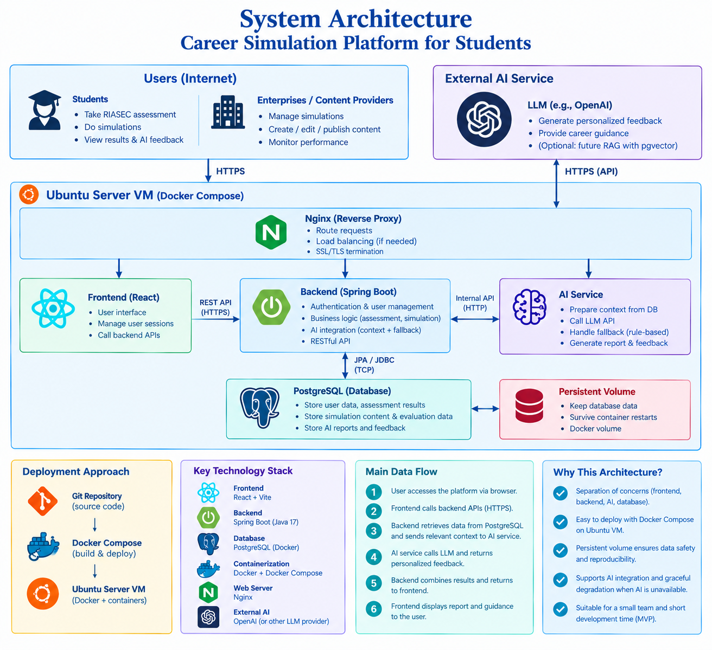
Figure 1. System architecture

2.1. Architectural approach
The proposed system adopts a layered monolithic architecture with clear internal modules. The frontend and backend are deployed as separate application components, while the backend contains the principal business modules and exposes REST APIs. The initial conceptual flow is:
React + Vite → Spring Boot REST API → Service Layer → Repository Layer → PostgreSQL
└→ AI Service → LLM API
The backend is organized into modules such as authentication, student profile, assessment, simulation, evaluation, recommendation, enterprise management, AI integration, and reporting. This organization keeps business responsibilities separated without introducing the operational complexity of multiple independently deployed services.

2.2. Modular monolith architecture
Architecture | Advantages | Limitations | Suitability for this MVP
Modular monolith | Simple deployment; clear separation of concerns; easy debugging; low operational overhead; suitable for a small team. | Scaling is less granular and modules share one runtime. | Selected. Best balance between engineering quality and eight-week delivery.
Microservices | Independent deployment and scaling; strong service isolation. | More services, networking, API contracts, monitoring, deployment, and failure modes. | Not selected. The MVP has neither the scale nor organizational need to justify the added complexity.
Serverless-first | Low infrastructure management and elastic execution. | Architecture becomes more dependent on platform-specific services and execution constraints. | Not selected as the primary architecture because the project aims to demonstrate a conventional backend and deployment stack as well as application logic.

The architectural decision follows the course principle of selecting technology according to problem constraints rather than choosing the most sophisticated architecture. Microservices may become reasonable if future growth produces independently scalable domains or requires separate operational ownership, but that condition does not exist in the initial MVP.

2.3. Frontend technologies
React with Vite is selected for the frontend because the application contains highly interactive workflows, including multi-step assessment, simulation tasks, result dashboards, and dynamic AI feedback. React provides a component-based structure for these stateful interfaces, while Vite provides a lightweight development and build workflow suitable for a small project.
Option | Advantages | Limitations | Decision
React + Vite | Strong component model; suitable for interactive state; lightweight build setup; large ecosystem. | Requires separate backend and explicit client-side routing/state decisions. | Selected for the MVP.
Next.js | SSR/SSG, routing, full-stack capabilities, strong production ecosystem. | Introduces capabilities that are not required for this MVP; SSR/SEO provide limited benefit for a logged-in application. | Not selected as the primary frontend path.
Plain HTML/CSS/JavaScript | Minimal dependencies and simple deployment. | Less convenient for a multi-screen, stateful application with reusable components. | Possible for a very small prototype, but less suitable for the final workflow.

2.4. Backend technologies
Java 17 with Spring Boot is selected as the backend platform. The application contains authentication, validation, business rules, persistent data management, simulation evaluation, and integration with an external AI service. Spring Boot provides a mature structure for separating controllers, services, and repositories and is therefore well aligned with the need for explicit application-layer responsibilities.
Option | Advantages | Limitations | Decision
Java 17 + Spring Boot | Strong structure for layered business applications; mature ecosystem; validation/security/data-access support; clear separation of concerns. | More configuration and boilerplate than lightweight frameworks. | Selected.
Node.js + Express | Fast development; simple JSON APIs; strong JavaScript ecosystem. | Less structurally opinionated; business-layer organization would require more conventions chosen by the team. | Not selected because AI integration is not the main reason to choose the backend runtime.
Python + FastAPI | Excellent developer productivity; strong AI/ML ecosystem; concise API development. | The project is primarily a transactional business application rather than an AI/ML system. | Not selected as the primary backend; AI remains an external service module.

2.5. Databases
PostgreSQL is selected because the core entities have clear relational relationships: students, assessment results, simulations, tasks, attempts, evaluation results, and enterprise-managed content. Referential integrity and transactional consistency are therefore more important than the schema flexibility of a document-oriented database.
For the initial environment, PostgreSQL can be provided through Supabase. This separates application deployment from database hosting and reduces database administration effort while retaining a relational data model.
Option | Advantages | Limitations | Decision
PostgreSQL | Relational integrity; transactions; expressive SQL; suitable for structured domain data. | Requires schema design and migrations. | Selected.
MySQL | Mature relational database; widely used; simple operational model. | Technically capable, but PostgreSQL provides the required relational features without a project-specific advantage being lost. | Viable alternative, but not selected.
MongoDB | Flexible document model; convenient for rapidly changing document structures. | Less natural fit for strongly related entities and transactional workflows in this MVP. | Not selected.
SQLite | Very simple local deployment and low operational overhead. | Less suitable for the intended multi-user server deployment and future growth path. | Not selected for the deployed MVP.

2.6. AI models and integration strategies
The initial AI integration uses a hosted Gemini API through a backend-only AI service. The exact model variant will be selected after the required course smoke test and model comparison rather than being fixed in the proposal using an unmeasured latency or quality assumption. This approach allows the team to evaluate actual response quality, structured-output reliability, latency, and operational constraints.
The frontend never calls the LLM provider directly and never contains model credentials. The backend collects the minimum relevant data, constructs the model context, calls the AI service, validates the returned structure, and exposes only the required result to the frontend.
This separation also provides a clean path for replacing the hosted model with another provider or a local inference service later. The application should therefore depend on an internal AI-service interface rather than scattering provider-specific calls throughout the business modules.

2.7. AI data Flow, reliability, and fallback
The proposed online flow is:
Frontend → Backend → PostgreSQL → AI Service → LLM → Backend → Frontend
The LLM does not directly query the database. Database access remains a backend responsibility so that the application can control authorization, select relevant context, minimize unnecessary data transfer, and prevent the model from obtaining unrestricted access to persistent data.
Importantly, AI is not required for the system to process its core data. The backend can authenticate users, retrieve records, calculate RIASEC scores, evaluate simulation answers, persist attempts, and generate deterministic feedback without an LLM. The AI component is therefore an enhancement layer for interpretation and personalization rather than a dependency for fundamental correctness.
Failure condition | System behavior | Result
LLM API unavailable | Return rule-based feedback using objective scores and predefined templates. | Core workflow remains usable.
LLM timeout | Stop waiting after the configured timeout and use deterministic fallback feedback. | Avoids blocking the user indefinitely.
Invalid or malformed LLM output | Validate the response schema; reject invalid output and use fallback logic. | Prevents malformed AI content from breaking the application.
Internet connection lost | The hosted LLM and Supabase database may both become unreachable. | Full offline operation is not guaranteed in the MVP; local caching/local DB is future scope.
Need for stronger privacy or offline operation in future | Introduce a local inference option such as Ollama behind the same AI-service interface and/or a local database/cache. | Possible future architecture, but not part of the initial eight-week MVP.

A local LLM is therefore treated as a future deployment option rather than the immediate fallback. Using a local model as the primary emergency path would require additional model packaging, hardware capacity, model selection, latency evaluation, and operational testing. For an eight-week MVP, a deterministic fallback provides a more reliable and explainable recovery mechanism.

2.8. Deployment strategy
The initial deployment target is an Ubuntu Server virtual machine hosted on the team's Windows environment. Docker Compose is used to package and run the application services, while Nginx acts as the reverse proxy. The resulting deployment path is conceptually:
Windows Host → Ubuntu Server VM → Nginx → React Container / Spring Boot Container
├→ Supabase PostgreSQL
└→ Gemini API
This deployment choice is intentional. A PaaS such as Render can reduce setup and operational work, but the course project also evaluates whether students understand deployment, containerization, networking, configuration, and service operation. Building the environment on an Ubuntu VM allows the team to demonstrate installation, package management, environment configuration, container startup and restart, logs, and basic failure recovery rather than only demonstrating that an application has been uploaded to a managed platform.
Deployment option | Advantages | Limitations | Initial decision
Ubuntu VM + Docker Compose + Nginx | High learning value; reproducible containers; visible networking and server operations; suitable for a small deployment. | More manual setup and maintenance; limited scalability. | Selected for the MVP.
PaaS (e.g., Render) | Fast deployment; less infrastructure management. | Less control and less evidence of low-level deployment operations. | Alternative if VM deployment becomes a blocker.
Kubernetes | Advanced orchestration, scaling, service discovery, and self-healing. | High operational complexity and unnecessary overhead for a small monolith. | Not justified for the eight-week MVP.

2.9. Scaling and future evolution
The initial architecture is designed for a small number of users and for demonstrating engineering capability within a constrained academic schedule. If adoption increases, the system should evolve incrementally rather than immediately replacing the monolith with a distributed architecture.
- Move the application from the development VM to a production cloud VM or managed container platform with appropriate monitoring and backup.
- Use a managed PostgreSQL deployment with stronger backup, connection management, and resource scaling.
- Introduce Redis or an equivalent cache only when profiling identifies repeated or expensive reads that justify caching.
- Scale backend instances horizontally behind a load balancer when concurrent demand requires it, while keeping the application stateless where practical.
- Separate resource-intensive or independently scalable components, such as AI processing, reporting, or background jobs, into dedicated services when operational evidence justifies the split.
- Adopt container orchestration such as Kubernetes only when the number of services, deployment frequency, availability requirements, or scaling needs make orchestration economically and technically justified.
This progression preserves the principle that architecture should respond to actual constraints. The monolith is therefore not considered a permanent limitation; it is the appropriate starting point for the current scale, team size, and course schedule.

CHAPTER 3: IMPLEMENTATION
The backlog is organized to follow the course's required development sequence: establish the problem and conventional application baseline first, integrate the LLM only after the non-AI workflow is functional, and reserve the final stage for stabilization and evidence.
Week | Main Work | Primary Owner(s) | Expected Deliverable
1 | Problem analysis, SRS, use cases, initial architecture, ERD, repository and development setup. | BA / Team Lead | Approved problem brief, repository, initial requirements and design artifacts.
2 | Authentication, student profile, database schema and migration setup. | Backend | Working authentication/profile baseline and persistent data.
3 | RIASEC assessment, scoring logic, frontend assessment workflow. | Backend + Frontend | Working assessment and deterministic scoring.
4 | Career simulation engine, task workflow, objective evaluation and non-AI vertical slice. | Backend + Frontend | Complete non-AI student workflow.
5 | Enterprise dashboard, simulation management, integration refinement and baseline testing. | Frontend + Backend | Frontend-backend-data baseline ready for AI integration.
6 | LLM experiment, model comparison, AI report/feedback, structured output and fallback. | AI + Backend | Baseline AI capability with evaluation cases and failure handling.
7 | AI integration hardening, testing, Dockerization, Ubuntu VM deployment and operational evidence. | Backend + DevOps | Deployed release candidate and deployment evidence.
8 | User testing, smoke test evidence, defect fixing, documentation, final architecture diagram and presentation. | Whole Team | Feature-frozen final release and complete evidence package.

CHAPTER 4: LLM SMOKE TEST AND EVALUATION PLAN
The instructor-provided LLM smoke-test script or notebook will be executed after the initial proposal has established the intended AI role. The proposal deliberately does not fabricate latency, response quality, or model-performance values. These values will be recorded from the actual experiment.

4.1. Proposed AI capability, expected benefit, failure risk, and non-AI fallback
Regarding the AI capability:
- The system integrates a Large Language Model, specifically the gemini-3.7-flash variant, acting as an automated career guidance assistant.
- The AI will receive the results of the user's RIASEC (Holland Codes) personality assessment and situational simulation test data.
- From this input, it will analyze and synthesize the information to provide in-depth evaluations, career orientation, and highly personalized advice that a static analysis system could not effectively deliver.
In terms of the expected benefit:
- The integration of AI personalizes the user experience by avoiding generic responses.
- The AI is capable of understanding the complex structure of a user's scoring profile to provide detailed explanations of why a specific career path is suitable or unsuitable for them.
- Furthermore, it enables natural interaction, allowing the application to deliver feedback in a friendly and easily comprehensible natural language format, creating an experience akin to conversing with a real career expert.
Addressing the failure risk, there are several potential issues:
- First, AI hallucinations represent a primary concern, where the model might provide inaccurate career guidance, suggest non-existent professions, or offer advice that is impractical for the current labor market.
- Second, system and connectivity errors, such as latency or timeouts, introduce the risk of delayed API responses, quota exceedances, or temporary connection failures due to reliance on a third-party service.
- Third, information security and prompt injection risks arise if users intentionally input information outside the scope of career guidance to manipulate the system's behavior.
To mitigate these risks, a non-AI fallback strategy has been designed to ensure high availability. The evaluation feature includes a deterministic fallback mechanism:
- In the event that the LLM API cannot be reached, the system will immediately disconnect from the AI using a timeout threshold and switch to internal data retrieval.
- Based on the user's highest-scoring RIASEC traits, the application will query the local database or predetermined backend to extract pre-compiled result templates, career lists, and standardized advice written by experts.
- On the user interface, the application will display a friendly message indicating that the advanced analysis system is under maintenance and then present basic orientations based on the RIASEC results.
- This mechanism guarantees that users will always receive their test results and independent counseling without having to wait for the AI feature to recover.

4.2. Smoke test evidence
Evidence Item | Planned Evidence
Prompt | Executed Smoke Test Prompt: "You are an AI assistant for a software engineering project. This is a smoke test. Reply with exactly: LLM_SMOKE_TEST_OK. Then add one short sentence explaining that the Gemini API request was successful."
Response | LLM_SMOKE_TEST_OK  The Gemini API request was received and processed successfully.
Model | gemini-3.7-flash
Latency | 1.2 seconds
Result | PASS based on the instructor's smoke-test requirements.
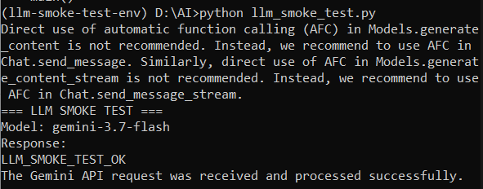
For the project feature itself, at least ten evaluation cases will be prepared. The evaluation set should include normal inputs, ambiguous or difficult inputs, and failure cases so that the team can determine whether AI provides useful value and where deterministic fallback is required.
- Normal inputs include clear simulation results and highly differentiated RIASEC scores that allow the AI to easily provide accurate orientation.
- Ambiguous or difficult inputs consist of cases where the RIASEC scores are relatively even across all groups without any prominent career inclination, evaluating the AI's ability to analyze more deeply or proactively suggest further assessment steps.
- Failure cases involve intentionally submitting empty inputs, malformed data, or requesting the AI to process queries outside the domain scope, testing the robustness of the guardrails and the system's ability to catch errors and smoothly redirect to the internal fallback system.

CHAPTER 5: DISCUSSION
The report is intended to produce verifiable implementation evidence rather than presentation-only screenshots.
- Repository URL and exact submitted commit.
- README with reproducible setup and execution instructions.
- Architecture diagram matching the implemented system.
- Runnable frontend and backend with persistent data.
- Evidence of the complete vertical-slice workflow.
- Tests or documented acceptance cases for normal and invalid behavior.
- AI evaluation cases, results, limitations, and failure analysis.
- AI assistance log and evidence of human review of generated code.
- Deployment or reproducible Ubuntu VM + Docker Compose setup.
- LLM smoke-test prompt, actual response, model, measured latency, and result.

CHAPTER 6: CONCLUSION
The proposed system addresses career exploration as an experiential and iterative process rather than as a one-time prediction task. Its MVP combines a RIASEC-based assessment, task-oriented IT career simulations, deterministic evaluation, and AI-assisted interpretation within a conventional web application architecture.
The technical design intentionally balances capability, explainability, and implementation risk. React + Vite is selected for the interactive frontend, Java 17 + Spring Boot provides the structured business backend, PostgreSQL supports the relational domain model, and Ubuntu VM + Docker Compose provides a practical deployment environment. The LLM is isolated behind the backend and is used only where language-based interpretation adds measurable value. Core application correctness does not depend on the LLM, allowing rule-based fallback when the AI service fails.
Future expansion can introduce local inference, stronger cloud infrastructure, caching, horizontal scaling, or selectively separated services when real usage and operational requirements justify those changes. The initial MVP therefore serves both as a functional career-exploration prototype and as a controlled demonstration of modern software engineering practices under an eight-week development constraint.

REFERENCES
Course materials, the instructor-provided LLM smoke-test specification, and any external references used to justify the final technology and AI-model decisions should be added to the final report after the relevant experiments and architecture decisions are completed.

