HCMC UNIVERSITY OF TECHNOLOGY AND ENGINEERING
FACULTY OF ADVANCED EDUCATION


FINAL PROJECT REPORT
COURSE: NEW TECHNOLOGIES IN SOFTWARE ENGINEERING

BUILDING A CAREER SIMULATION
PLATFORM FOR STUDENTS

LECTURER: MSc. Nguyen Duc Khoan
STUDENTS:
23110004 | Vo Nguyen Ngoc Bich
23110019 | Huynh Gia Han
23110065 | Mai Tran Thuy Trang

Ho Chi Minh City, October 2026
HCMC UNIVERSITY OF TECHNOLOGY AND ENGINEERING
FACULTY OF ADVANCED EDUCATION

FINAL PROJECT REPORT
COURSE: NEW TECHNOLOGIES IN SOFTWARE ENGINEERING

BUILDING A CAREER SIMULATION
PLATFORM FOR STUDENTS

LECTURER: MSc. Nguyen Duc Khoan
STUDENTS:
23110004 | Vo Nguyen Ngoc Bich
23110019 | Huynh Gia Han
23110065 | Mai Tran Thuy Trang

Ho Chi Minh City, October 2026

LECTURER’S COMMENTS

Ho Chi Minh City, April ..… 2026
Lecturer’s signature
(Sign and print name)

ACKNOWLEDGEMENT
We would like to express our sincere gratitude to MSc. Nguyen Duc Khoan, lecturer of the Project on Software Engineering course, for providing guidance, academic feedback, and methodological direction throughout the development of this project. The requirements-first perspective and emphasis on traceability helped the group organize the project from problem definition to system implementation and evaluation.
We also appreciate the support of our classmates and the academic environment of HCMC University of Technology and Engineering, which encouraged us to examine the career-orientation problem from both a software engineering and a user-centered perspective. Their feedback contributed to the refinement of the proposed student experience and the scope of the system.
Finally, we acknowledge the use of software development tools, documentation resources, and AI-assisted development techniques during the project. These tools were used under human review and within the project’s traceability and quality-control process. The final requirements, design decisions, implementation choices, and reported evidence remain the responsibility of the project team.
Members
Vo Nguyen Ngoc Bich
Huynh Gia Han
Mai Tran Thuy Trang

TABLE OF CONTENTS
LECTURER’S COMMENTS 3
ACKNOWLEDGEMENT 4
TABLE OF CONTENTS 5
LIST OF TABLES 8
LIST OF FIGURES 9
PART A: INTRODUCTION 1
1. Problem statement 1
2. Project objectives 1
3. Target users and scope 2
4. Methodologies 3
PART B: CONTENTS 1
CHAPTER 1: REQUIREMENT CAPTURING AND MODELING 1
1.1. Current status survey 1
1.2. Requirement list 2
1.2.1. Functional requirements specification 2
1.2.1.1. Student features 2
1.2.1.2. Enterprise features 4
1.2.1.3. Research and analytics features 4
1.2.2. Business rules 5
1.2.3. Non-functional requirements 6
1.3. Use case diagram 6
1.4. Use case specification 7
UC-01 Register account 8
UC-02 Log in 9
UC-03 View dashboard 9
UC-04 Manage profile 11
UC-05 Complete RIASEC assessment 12
UC-06 Browse simulations 13
UC-07 Complete simulation 14
UC-08 Consult career agent 16
UC-09 Manage scenario 18
UC-10 View analytics 20
UC-11 Send recruitment invitation 21
UC-12 Manage account 22
UC-13 Manage platform content 23
CHAPTER 2: SYSTEM DESIGN 26
2.1. Class diagram 26
2.2. Sequence diagrams 26
2.3. System architecture 27
CHAPTER 3: UI/UX DESIGN 28
3.1. Screen transition map 28
3.2. Interactive UI objects in screens 28
CHAPTER 4: IMPLEMENTATIONS 30
4.1. Development environment 30
4.1.1. Technologies used 30
4.1.2. Tools used 31
4.2. System structure 31
4.3. Experimental results 32
4.3.1. Experiment objectives 32
4.3.2. Results achieved 33
4.3.3. Overall evaluation 35
PART C: CONCLUSION 1
1. Achievements 1
1.1. Summary of results 1
1.2. Knowledge, skills and attitudes acquired 1
2. Advantages and limitations 2
2.1. Advantages 2
2.2. Limitations 2
3. Future work 3
REFERENCES 4
TEAM CONTRIBUTION 5

LIST OF TABLES
Table 1. Summary of Functional Requirements – Student Features ..... 7
Table 2. Summary of Functional Requirements – Enterprise Features ..... 10
Table 3. Summary of Functional Requirements – Research and Analytics ..... 11
Table 4. Business Rules ................................ 12
Table 5. Non-Functional Requirements ................... 13
Table 6. Core Use Case Catalogue ....................... 15
Table 7. Development Environment ....................... 37
Table 8. Technology Stack and Purpose .................. 37
Table 9. Implemented Module Structure .................. 39
Table 10. Prototype Test Evidence ...................... 40
Table 11. Functional Requirement Verification Summary ..... 41
Table 12. Non-Functional Requirement Evaluation Matrix ..... 41
Table 13. Load and Reliability Test Plan ............... 42
Table 14. User Evaluation Framework .................... 43
Table 15. Knowledge, Skills, and Attitudes Acquired ..... 44

LIST OF FIGURES
Figure 1. Overall Career Exploration Lifecycle ......... 3
Figure 2. System Use Case Diagram ...................... 15
Figure 3. Domain Class Diagram ......................... 33
Figure 4. Student Exploration Sequence ................. 33
Figure 5. Simulation Authoring Sequence ................ 33
Figure 6. AI Guidance and Fallback Sequence ............ 34
Figure 7. Logical System Architecture .................. 34
Figure 8. Screen Transition Map ........................ 35
Figure 9. Main Student Dashboard and Guidance Area ..... 36
Figure 10. Enterprise Simulation Authoring Interface ..... 36
Figure 11. Research Analytics Dashboard ................ 36
Figure 12. Deployed System Overview .................... 39

PART A: INTRODUCTION

1. Problem statement
Career exploration is difficult for students when they have limited opportunities to connect self-knowledge with actual experience. Interest or personality questionnaires can provide an initial signal, while career-information websites can explain occupations and required skills. However, these approaches may remain abstract: a learner can understand what a role is called without knowing whether the daily activities, problem types, decision-making patterns, or required working habits are personally engaging or comfortable.
Experiential platforms demonstrate another useful approach by allowing learners to perform simplified workplace activities. The project therefore treats career exploration as more than classification. The central problem is the lack of an integrated journey in which a learner can build a personal profile, receive several exploration directions, experience representative IT work through structured simulations, inspect objective evidence from those activities, reflect with AI assistance, and iteratively select what to explore next.
The proposed Career Simulation Platform for Students addresses this problem through five functional modules: Assessment & Profiling, Simulation Engine, AI Coaching & Feedback, Enterprise Portal, and Research & Analytics. The initial career domain is Information Technology because IT contains heterogeneous roles such as software engineering, backend development, frontend development, data analytics, quality assurance and testing, and cybersecurity. A single label such as “IT” is therefore insufficient for meaningful exploration; students need exposure to representative tasks.
The system is intentionally designed as an exploration and learning platform rather than as a deterministic career-prediction system. Assessment scores, simulation performance, and AI-generated recommendations are treated as evidence and suggestions. The learner remains responsible for deciding which direction to investigate further. This principle is carried into the requirements, business rules, AI safety controls, privacy model, and evaluation criteria.

2. Project objectives
The general objective of the project is to design and develop a web-based Career Simulation Platform that helps students explore IT career directions through a combination of structured self-assessment, representative work simulations, objective and rubric-based evaluation, AI-assisted reflection, and iterative exploration. The platform is intended to create a coherent evidence loop rather than a one-time recommendation.

More specifically, the project aims to:
• Provide students with a structured exploration profile containing RIASEC interests, a concise personality snapshot, self-assessed skills, goals, educational context, and previous project experience;
• Provide a scenario-based simulation engine in which each scenario defines context, role, dataset or resources, tasks, expected deliverables, evaluation criteria, recommended duration, and an extensible difficulty level;
• Use deterministic scoring for objectively evaluable tasks and structured rubrics for artifact-oriented evaluation, while keeping AI interpretation separate from the underlying score;
• Apply an AI career-exploration agent to interpret evidence, generate personalized debriefs, identify possible skill gaps, answer career questions, recommend learning resources, and propose a next exploration action without making a final career decision;
• Provide an enterprise portal for structured scenario authoring, task and rubric configuration, publication, participation monitoring, aggregate reporting, and controlled evidence sharing;
• Provide a research and analytics layer that logs exploration events, supports pre/post measurement, and enables analysis by learner group, IT area, simulation, and other study dimensions;
• Establish a maintainable modular-monolithic architecture with secure backend orchestration, persistent data storage, external AI integration through controlled interfaces, and a practical deployment model suitable for a small educational project; and
• Evaluate the resulting system through functional testing, non-functional evaluation, user testing, and documented deployment evidence without claiming unsupported predictive accuracy.

3. Target users and scope
The primary target users are students at the early stage of career exploration, especially high school students. First-year university students are treated as a secondary audience because they may also need to compare IT directions before selecting deeper study or internship paths. The system additionally contains enterprise users who contribute realistic scenario content and authorized research or administrative users who access aggregated analytics.
The project uses a layered scope model. The five modules define the target system concept, while implementation priority determines the MVP boundary. The current prototype provides strong evidence for the student assessment/simulation/guidance loop, the backend-centered AI orchestration model, security and fallback controls, and the deployment/testing setup. Enterprise recruitment invitation and research analytics are included in the requirements and design to make the overall domain complete, but they may remain at design or limited-prototype maturity within the current project timeline.
Figure 1. Overall Career Exploration Lifecycle — Insert an overview diagram showing Profile → Exploration Candidates → Simulation → Evidence → AI Reflection → Next Exploration → Research Evidence.
In scope are the five functional modules and the shared platform services required to support them. The project initially limits the career domain to IT and assumes a manageable simulation catalogue rather than a large-scale national career database. The initial content model can support approximately six representative IT areas, including Software Engineering, Backend Development, Frontend Development, Data Analytics, Quality Assurance and Testing, and Cybersecurity. Each simulation may contain approximately three to five tasks in the initial MVP.
Out of scope for the current MVP are full VR/AR experiences, complex 3D environments, hardware-dependent simulation, large-scale multiplayer experiences, automatic generation of complete simulations from scratch, a large proprietary language model trained from scratch, a full learning-management system, social-networking features, parent and mentor portals, enterprise payment workflows, and a full applicant-tracking or employment-management system. Recruitment invitations are bounded as an optional downstream capability rather than the primary purpose of the platform.

4. Methodologies
The project follows an integrated software engineering methodology combining Agile development, user-centered design, simulation-based career exploration, requirements-first modeling, and controlled AI-assisted development. Agile is used to support incremental delivery and refinement. Core functionality is prioritized first, while medium-priority and research-oriented features can be simplified without changing the central domain model.
User-centered design is applied because the target learners may have limited professional IT experience. Simulation instructions therefore need to explain context, task objectives, expected outputs, and evaluation criteria in accessible language. The simulation experience is intended to expose the nature of work rather than to assume professional-level expertise at entry.
Requirements engineering is treated as the foundation of later modeling. Functional requirements, business rules, and non-functional requirements are transformed into use cases, system interactions, classes, sequences, and implementation boundaries. The report therefore keeps a direct trace from the problem domain to design and testing.
AI-assisted development is governed by a human-in-the-loop workflow. The prototype establishes a traceability chain from Proposal/SRS to User Story, Acceptance Criteria, Feature Plan, Code, Tests, and Evidence. AI-generated assistance is reviewed by the development team and is not treated as an independent authority. This process is consistent with the prototype documentation and its emphasis on quality gates and evidence-based completion.
AI is also treated as a bounded system capability. Deterministic functions such as RIASEC scoring and objective simulation scoring remain inside controlled application logic. External LLM calls are optional and protected by consent, context minimization, validation, provenance recording, prompt-boundary checks, and fallback behavior. The prototype demonstrates this hybrid approach through standard guidance for deterministic quick actions and AI-assisted guidance for eligible free-text requests.

PART B: CONTENTS

CHAPTER 1: REQUIREMENT CAPTURING AND MODELING

1.1. Current status survey
=> viết gọn lại
Career guidance is commonly supported by interest or aptitude assessments, informational resources, counseling, and short experiential activities. RIASEC-based assessments are valuable because they provide a structured representation of vocational interests. The project adopts the RIASEC model as an initial signal rather than as a deterministic classifier. The current POSE report also uses the O*NET Interest Profiler as a methodological reference and identifies the six categories as Realistic, Investigative, Artistic, Social, Enterprising, and Conventional [2].
The Forage is the most relevant experiential reference for the simulation component. Its job simulations demonstrate the feasibility of self-paced activities that replicate aspects of real work without requiring an actual employment process. Virtual Internships represents a different model because it focuses on actual remote placements and projects with host organizations. The proposed platform deliberately targets the earlier stage of exploration, where a learner may benefit from trying representative activities before committing to a longer-term placement or training path [1], [3], [4].
The main gap identified by the project is therefore not the absence of career information. Instead, the gap lies in the separation of assessment, work-like experience, reflection, and evidence. A learner can receive an interest result without trying the suggested work, complete a task without understanding how it relates to a possible career, or receive feedback without a structured way to choose the next exploration activity.
A second gap concerns the internal diversity of IT. Software engineering, frontend development, backend development, quality assurance, data analytics, and cybersecurity require different task patterns and working contexts. The proposed simulation model makes those differences observable through scenarios and artifacts instead of presenting only job descriptions.
A third gap is the risk of overly prescriptive automated guidance. The system therefore distinguishes observable evidence from interpretation and suggestion. The learner can browse and select any simulation, even when it is not among the recommended options. Recommendations are intended to support exploration rather than remove learner agency.
A fourth gap concerns scalability of high-quality simulation content. A simulation is not only a list of questions; it requires context, datasets, task definitions, deliverable expectations, evaluation methods, rubrics, and content-management support. The enterprise authoring model is introduced to make future catalogue expansion feasible without changing the core learner workflow.
The final opportunity is an iterative exploration loop. A learner can begin with an optional profile or assessment, experience one simulation, review objective evidence and AI-assisted reflection, and then choose another simulation or learning resource. Each completed activity produces additional evidence for subsequent exploration.

1.2. Requirement list

1.2.1. Functional requirements specification
Category / ID | Required behavior | Related use case(s)
Student account (FR-S01–04) | Register/sign in, manage authorized profile and review owner-scoped dashboard; OAuth2 login, JWT-protected APIs and logout. | UC-01, UC-02, UC-03, UC-04
Assessments (FR-S05–07) | Admin publishes valid independent assessment types/versions; Student chooses optional assessments and reviews versioned attempts/results. | UC-05, UC-13
Simulation discovery (FR-S08–09) | Student searches, filters, sorts and pages published scenarios; locked model answers remain private. | UC-06
Simulation activity (FR-S10–14) | Enterprise publishes versioned ordered tasks; Student saves drafts, finalizes submissions, self-reviews model answers, and receives truthful completion/practiced skills. Quiz has a score but no pass threshold for completion. | UC-07, UC-09
Enterprise (FR-E01–09) | Enterprise manages scoped content and reads aggregate participation. Unauthorized personal/tenant evidence is withheld. | UC-09, UC-10
Platform administration (FR-A01–04) | Admin controls accounts, publication permissions and assessment/platform content. | UC-12, UC-13
KB Studio (FR-AI01–02) | Admin creates scoped KBs, uploads documents, ingests with versioned sources, tests retrieval separately from generated answers. | UC-14
Agent Builder (FR-AI03) | Admin sets model, prompt, policies, KB and tool grants, saves immutable config versions, previews, publishes and explicitly assigns Students. | UC-15
Student Agent (FR-AI04, AI09, AI12) | Authorized RAG with citations and insufficient-evidence response; LLM selects at least three real read-only domain tools; safe streaming and access restrictions. | UC-08
AI reports (FR-AI05) | Student expressly requests schema-validated InsightReport; only its owner accesses persisted content. | UC-08
Conversation (FR-AI06, AI10) | Owner-scoped ordered chat history, resume/delete and bounded summaries; external AI requires effective consent. | UC-08
Confirmed plans (FR-AI07) | AI-suggested plan has no official effect until Student explicitly confirms. | UC-08
Admin observability (FR-AI08, AI11) | Request counts, latency, cost/estimates, failures/refusals, called tools and token/prompt-version traceability. | UC-16

1.2.2. Business rules
ID | Approved rule
BR-01 | Assessment is optional; no assessment result or AI answer determines a unique career path.
BR-02 | Assessment type, published version, attempt and result remain distinguishable; limited evidence must be disclosed.
BR-03 | Only authorized Enterprise scenario versions are published; historical participation retains the content version used.
BR-04 | Quiz scores may be zero and do not prevent completion of a valid finalized task. Open/practical tasks do not require auto-grading.
BR-05 | Model answers are unavailable until the Student validly finalizes the corresponding task; Student acknowledges self-review before advancing.
BR-06 | Program completion follows required finalized task submissions, not scores. Final-task completion can precede final review acknowledgement where allowed.
BR-07 | Skills are recorded as practiced when linked tasks are completed, not awarded as verified proficiency.
BR-08 | Enterprise reports contain only authorized aggregate statistics; student personal evidence is not automatically shared.
BR-09 | Only Admin manages and publishes KBs/Agents and assigns a published Agent to the Student; saved versions are immutable.
BR-10 | Every model tool call is validated by backend capability grant and resource-level authorization; locked answers and cross-tenant data are never exposed.
BR-11 | InsightReport is produced on explicit Student request, validated before persistence and readable only by its Student owner.
BR-12 | ExplorationPlan remains a proposal until separate Student confirmation and valid backend authorization.
BR-13 | External LLM processing requires appropriate consent and minimized scope; provider failures cannot corrupt non-AI Core records.
BR-14 | Conversation is saved for authorized resume, can be deleted by Student, and must not reuse summary derived solely from deleted content.
BR-15 | The mandatory capabilities are A+B+C; deferred features are not silently elevated into acceptance criteria.

Rule IDs in this chapter are report presentation identifiers; the approved Requirements Baseline v1 and DR1–DR2 remain the canonical decision register. No historical BR IDs are silently redefined.

1.2.3. Non-functional requirements
Quality attribute | Expected outcome / verification
Security | OAuth2/OIDC identity, JWT-protected REST, validated APIs, CSRF protection where applicable, effective user/tenant/KB grants, no credentials in client/repository.
Privacy | Purpose-bound external processing consent, minimized model input, private Student data, appropriately limited Admin observability.
Data integrity | Durable attempts/results and immutable content versions; idempotent finalization; accurate model-answer unlock; consistent deletion and summary invalidation.
Availability and fallback | Container/deployed build demonstrable; non-AI workflows continue when external provider is unavailable.
Performance | Observe actual response times under stated prototype workload; label unmeasured latency/availability rather than inventing figures.
Usability / accessibility | Responsive desktop/mobile workflow, understandable progress/error messages and self-review; verify browser behavior.
AI grounding and safety | Authorized RAG citations, valid schema output, safeguards for injection/out-of-scope/failed AI and explicit insufficient evidence.
Auditability | Store model/prompt version, tools, token usage when available, latency and terminal outcome without exposing private prompts in aggregate Admin dashboard.
Maintainability | Java Spring Boot modular-monolith boundaries, PostgreSQL migrations and unit/integration checks backed by source evidence.
Reproducibility | Docker/deployed demo, documented configuration without secrets, traceability and AI evaluation before/after one improvement.

1.3. User stories
Ten selected User Stories describe the scope to be implemented and accepted under the course assignment. Each story specifies a user-oriented benefit, observable acceptance criteria, indicative story points and priority. The frozen Requirements Baseline v1 and its approved DR1–DR2 decisions remain separate source documents; report story IDs do not overwrite the baseline. Detailed API, source-file and test-case traceability will be completed after implementation.

1.3.1. US-01: Register account
Description
As a Student, I want to create my CareerSim account so that I can access a personal exploration workspace.
Acceptance criteria
Can I register using an eligible account or identity flow?
Can I see which required registration fields are missing or invalid?
Can I see a clear message when an account already exists?
Can I cancel registration without creating an account?
Story points: 3 Priority: High

1.3.2. US-02: Log in
Description
As a Student, Enterprise Representative, or Administrator, I want to sign in securely so that I can use the functions authorized for my role.
Acceptance criteria
Can I sign in through the configured Google OAuth2 login?
Can I access only pages and information allowed to my role and account?
Can I receive a clear message if login fails or my account is disabled?
Can I log out so that the current session can no longer access protected information?
Story points: 5 Priority: High

1.3.3. US-03: Complete career quiz
Description
As a Student, I want to complete an optional career quiz so that I can understand my interests and explore relevant career directions.
Acceptance criteria
Can I choose an available career assessment without being required to complete another assessment first?
Can I see instructions and answer the questions required by the published assessment?
Can I receive field-level guidance when I leave required answers incomplete?
Can I submit valid responses and view the resulting assessment summary?
Can I retain separate results when I take different assessments or versions?
Story points: 5 Priority: High

1.3.4. US-04: Explore simulations
Description
As a Student, I want to search and compare published simulations so that I can choose a career activity that interests me.
Acceptance criteria
Can I browse available simulations even if I have never completed a career quiz?
Can I search, filter, sort, and navigate paginated catalogue results?
Can I open a simulation to see its role, expected tasks, resources, and difficulty?
Can I receive a useful empty-state message when no simulation matches my search?
Can I browse without seeing locked model answers?
Story points: 3 Priority: High

1.3.5. US-05: Complete simulation
Description
As a Student, I want to complete the ordered tasks of a simulation so that I can experience representative work activities at my own pace.
Acceptance criteria
Can I start or resume an eligible published scenario?
Can I save a draft and return before making a final submission?
Can I finalize a valid task without a duplicate submission when retrying?
Can I view a task model answer only after my valid final submission?
Can I confirm self-review before progressing to the next task?
Can I complete a quiz task with a score of zero without being blocked by its score?
Story points: 8 Priority: High

1.3.6. US-06: View simulation results
Description
As a Student, I want to view my completed simulation and practiced skills so that I can reflect on what I experienced without confusing participation with certification.
Acceptance criteria
Can I view my completed tasks and their recorded submission status?
Can I see quiz scores only for tasks that support objective scoring?
Can I see practiced skills linked to completed tasks rather than assigned by score thresholds?
Can I access an eligible completion record or resume snippet that does not claim professional competence?
Can I view only my own private submissions and results?
Story points: 3 Priority: High

1.3.7. US-07: Consult career agent
Description
As a Student, I want to interact with a personalized career agent so that I can understand my exploration evidence, receive career guidance, and plan my next learning activities.
Acceptance criteria
Can I ask career-related questions even if I have not completed an assessment?
Can I receive guidance based on my available assessment results, simulation activities, and authorized knowledge sources?
Can I receive cited answers when the agent uses Knowledge Base information?
Can I continue previous conversations and delete my conversation history?
Can I request a structured career insight report and view the saved result?
Can I review, edit, and explicitly confirm an exploration plan before it is saved?
Can I receive a clear explanation when evidence is insufficient or the AI service is unavailable?
Can I be prevented from accessing locked model answers and other users' private information?
Story points: 8 Priority: High

1.3.8. US-08: Manage knowledge base
Description
As an Administrator, I want to upload, manage, and test authorized Knowledge Base content so that I can publish reliable sources for assigned Student Agents.
Acceptance criteria
Can I create and manage a Knowledge Base within its permitted scope?
Can I upload supported TXT, PDF, DOCX, MD, or XLSX documents and see ingestion status?
Can I review publication status and source provenance before allowing retrieval?
Can I test passage retrieval separately from an AI-generated answer?
Can I see a clear error when an upload is invalid or retrieval has no matching authorized source?
Can I keep existing published material available when a replacement ingestion fails?
Story points: 8 Priority: High

1.3.9. US-09: Create AI agent
Description
As an Administrator, I want to configure, test, publish, and assign a Student Agent so that I can manage a dependable assistant without changing application code.
Acceptance criteria
Can I create an Agent and configure its model, system prompt, policies, KB grants, and permitted tools?
Can I save a version without automatically publishing it to Students?
Can I preview the saved configuration without creating a Student conversation?
Can I publish an eligible immutable configuration version and explicitly assign the Agent to Students?
Can I verify that unassigned Students cannot use that Agent or access its private KBs?
Can I see validation feedback for missing required settings or conflicting updates?
Story points: 8 Priority: High

1.3.10. US-10: View AI usage dashboard
Description
As an Administrator, I want to view AI usage and service outcomes so that I can monitor AI reliability, latency, and operating cost.
Acceptance criteria
Can I view request counts for a selected reporting interval?
Can I see average latency and recorded or estimated cost without mistaking missing measurements for zero?
Can I distinguish failed and refused requests from successful ones?
Can I filter the report without viewing Students’ private chat content by default?
Can I see an appropriate message when usage data is unavailable?
Story points: 5 Priority: High

1.4. Use case diagram
The use case model groups the target functions into five business modules while showing shared authentication, consent, and persistence services. The AI agent is modeled as an internal system capability rather than as a human actor. External AI providers, when used, are dependencies invoked through an internal AI adapter and are not granted direct access to the database.
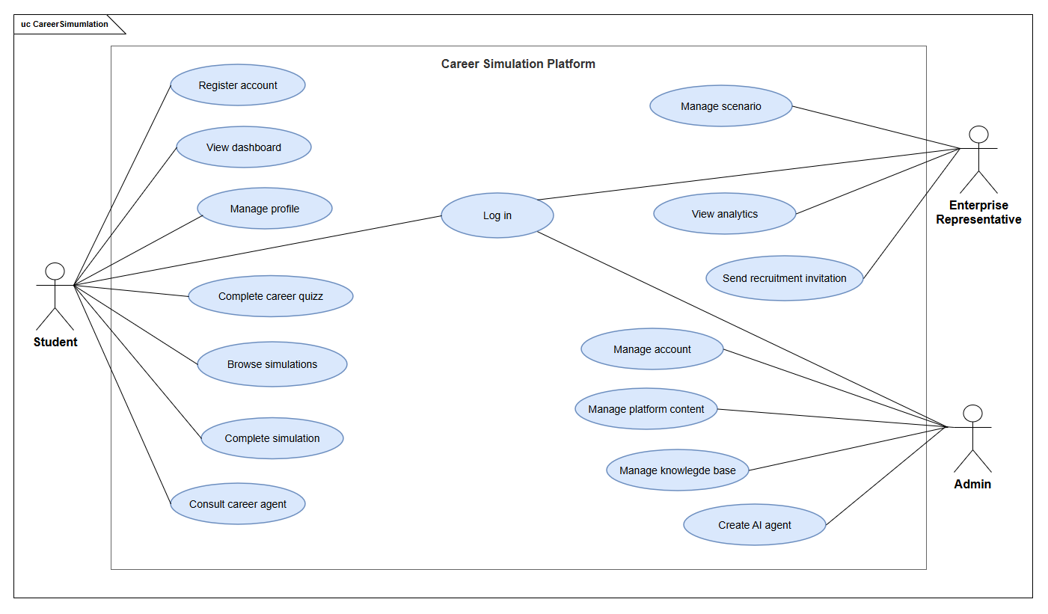
Figure 2. System Use case diagram

1.5. Use case specification
The following use cases are selected as the main behavioral specification for the proposed platform. Names follow a concise verb–noun pattern. Within each specification, “the actor” refers to the primary actor named in the table. Main, alternative, and exception flows use explicit step references so that invalid input and recovery behavior can be traced back to a specific location in the system.

Table 6. Core use case catalogue
ID | Use Case | Primary Actor
UC-01 | Register account | Student
UC-02 | Log in | Student / Enterprise Representative / Administrator
UC-03 | Complete career quiz | Student
UC-04 | Browse simulations | Student
UC-05 | Complete simulation | Student
UC-06 | Consult career agent | Student
UC-07 | Manage knowledge base | Administrator
UC-08 | Create AI agent | Administrator
UC-09 | View AI usage dashboard | Administrator
UC-10 | View dashboard | Student
UC-11 | Manage profile | Student
UC-12 | Manage scenario | Enterprise Representative
UC-13 | View analytics | Enterprise Representative
UC-14 | Send recruitment invitation | Enterprise Representative
UC-15 | Manage account | Administrator
UC-16 | Manage platform content | Administrator

1.5.1. UC-01 Register account
Field | Details
Use Case Name | UC-01 Register account
Primary Actor | Student
Trigger | The actor wishes to open a personal CareerSim account.
Description | Creates a personal account through the supported registration or identity flow.
Pre-Conditions | The actor is not authenticated and registration is available.
Post-Conditions | A valid personal account is created; cancellation creates no account.
Main Flow | 1. The actor opens account registration, supplies the required identity details, and requests account creation.  2. The system validates account eligibility and uniqueness, creates an authorized account, and displays the next sign-in or onboarding action.
Alternative Flow | 1a. The actor cancels registration on the registration page. The system discards any unsubmitted values, returns the actor to the landing page, and ends the use case.  1b. The actor omits optional profile fields. The system accepts the remaining valid information and continues at Main Flow Step 2.
Exception Flow | 2.1. If a required field is missing, the system highlights that field and displays the proposed message “Please complete the required fields.” The actor remains on the registration page and returns to Main Flow Step 1.  2.2. If the account already exists, the system displays the proposed message “An account with this email already exists. Please sign in.” No duplicate is created; the actor returns to Main Flow Step 1.  2.3. If the identity service is unavailable, the system displays the proposed message “Registration is temporarily unavailable. Please try again later.” No partial account is presented as complete.

1.5.2. UC-02 Log in
Field | Details
Use Case Name | UC-02 Log in
Primary Actor | Student / Enterprise Representative / Administrator
Trigger | The actor wants to access a protected CareerSim function.
Description | Authenticates a permitted account and applies role-appropriate access.
Pre-Conditions | The actor has an eligible identity; the authentication service is available.
Post-Conditions | The actor receives an authorized session or an explicit unsuccessful-login outcome.
Main Flow | 1. The actor selects the configured sign-in method and completes the identity-provider authentication.  2. The system verifies the identity, account state, and role, establishes protected API access, and opens the authorized landing page.
Alternative Flow | 1a. The actor cancels at the identity provider. The system creates no authenticated CareerSim session, displays the sign-in screen, and ends the use case.  2a. The actor uses a permitted sign-out action. The system invalidates the current access session and returns to the sign-in page.
Exception Flow | 2.1. If the identity token is missing, invalid, or expired, the system displays the proposed message “Your sign-in could not be verified. Please sign in again.” The actor remains unauthenticated and returns to Main Flow Step 1.  2.2. If the account is disabled or the role is not authorized, the system displays “You do not have permission to access this account.” The system denies access; the actor returns to Main Flow Step 1.  2.3. If the provider is unavailable, the system displays “Sign-in is temporarily unavailable. Please try again later.” No protected information is exposed.

1.5.3. UC-03 Complete career quizz
Field | Details
Use Case Name | UC-03 Complete career quiz
Primary Actor | Student
Trigger | The actor wants to explore vocational interests using an available career quiz.
Description | Supports optional, versioned career assessments, including RIASEC and other configured assessment types; not the quiz task within a simulation.
Pre-Conditions | The actor is authenticated and an eligible assessment version is published.
Post-Conditions | A valid attempt and assessment-specific result are saved; the actor may still browse simulations independently.
Main Flow | 1. The actor selects an available career quiz, reads its instructions, answers the required questions, and selects Submit.  2. The system validates the answers against the published assessment version, computes the configured result, and displays the stored summary.
Alternative Flow | 1a. The actor postpones the assessment. The system exits without creating an assessment result and returns the actor to assessment selection; simulation access remains available.  2a. The actor has previous results from other assessment types or versions. The system retains those records separately and displays the newly completed attempt.
Exception Flow | 2.1. If a required response is missing, the system highlights the unanswered question and displays “Please answer all required questions before submitting your career quiz.” The actor remains on the quiz page and resumes Main Flow Step 1.  2.2. If the published version is no longer available, the system displays “This career quiz is temporarily unavailable. Please select another quiz.” No unsupported result is created; the actor returns to assessment selection.  2.3. If saving fails, the system displays “Your career quiz result could not be saved. Please try again.” It does not falsely claim completion.

1.5.4. UC-04 Browse simulations
Field | Details
Use Case Name | UC-04 Browse simulations
Primary Actor | Student
Trigger | The actor wants to explore available career simulations before deciding whether to experience one.
Description | This use case allows the actor to browse, search, filter, inspect, and compare available simulations without starting a simulation.
Pre-Conditions | The actor is authenticated and published simulations are available.
Post-Conditions | The actor views the available simulation catalogue or the details of a selected simulation.
Main Flow | 1. The actor opens the simulation catalogue.  2. The system displays published simulations with information such as IT area, role, difficulty, duration, skills, and summary.  3. The actor searches, browses, filters, and selects a simulation.  4. The system displays the selected simulation details and available actions.
Alternative Flow | 2a. The actor has sufficient exploration evidence; the system highlights several recommended simulations while continuing to display other available simulations.  2b. The actor has limited exploration evidence; the system displays the general catalogue and marks recommendations as preliminary.  3a. The actor filters by IT area, role, level, difficulty, or another supported criterion; the system updates the displayed simulation set and returns to Main Flow Step 3.  3b. The actor enters a search term that matches no simulation; the system displays “No simulations match your search.” and allows the actor to modify or clear the search at Main Flow Step 3.  3c. The actor clears the search or filters; the system restores the default catalogue and returns to Main Flow Step 3.
Exception Flow | 2.1. Simulation catalogue data cannot be loaded; the system displays “Simulation catalogue could not be loaded. Please refresh the page or try again later.” and returns to Main Flow Step 1.  4.1. The selected simulation is no longer published or accessible; the system displays “This simulation is no longer available.” and returns to Main Flow Step 2.  4.2. Simulation details cannot be loaded; the system displays “Simulation details could not be loaded. Please try again later.” and returns to Main Flow Step 3.

1.5.5. UC-05 Complete simulation
Field | Details
Use Case Name | UC-05 Complete simulation
Primary Actor | Student
Trigger | The Actor selects Start or Resume on an eligible simulation.
Description | This use case allows the Actor to complete ordered simulation tasks, review model answers, and view completion results so that the Actor can experience representative workplace activities and reflect on practiced skills without implying professional competence.
Pre-Conditions | The Actor is authenticated. The selected simulation is published, valid, and accessible to the Actor.
Post-Conditions | Required task submissions and self-review confirmations are recorded, and the simulation is marked as completed. The Actor can view the completed tasks, applicable quiz scores, practiced skills, and eligible completion evidence.
Main Flow | 1. Actor selects Start or Resume for an eligible published simulation.  2. System displays the simulation information, saved progress, and the current available task with instructions, resources, and submission requirements.  Actor completes the current task and submits the required response.  System validates and records the final submission, marks the task as submitted, and reveals its model answer.  Actor compares the submitted work with the model answer and confirms the self-review.  System records the self-review confirmation and makes the next ordered task available.  Actor repeats Steps 3–5 for each remaining required task, with the System performing Step 6 whenever another task remains.  System marks the simulation as completed after all required tasks and self-reviews are completed.  System displays the simulation results, including completed tasks, recorded submission statuses, quiz scores where objective scoring applies, and practiced skills linked to completed tasks rather than score thresholds.  System provides eligible completion evidence or a resume snippet describing the simulated experience without claiming professional competence.  Actor reviews the results and available completion evidence.
Alternative Flow | 1a. The actor has an unfinished attempt; the system offers “Resume” or “Start a New Attempt” according to the scenario policy; the actor selects an option and continues at Main Flow Step 2.  2a. The actor chooses to review available resources before continuing a task; the system keeps the attempt open and returns to Main Flow Step 2.  3a. The actor saves progress instead of submitting; the system preserves the current attempt state and allows the actor to continue later.  4a. Required items are incomplete; the system identifies each incomplete task or deliverable, displays the corresponding message, and returns to Main Flow Step 3.  5a. A task requires asynchronous evaluation; the system marks that task as Pending, evaluates the tasks that can be completed immediately, and keeps the attempt in an appropriate evaluation state.  5b. Artifact evaluation is unavailable; the system stores the available objective evidence, marks the affected rubric component as “Unavailable”, and continues with the remaining evaluation.
Exception Flow | 1.1. The selected simulation is unavailable, invalid, or inaccessible; the system displays “This simulation cannot be started because the scenario is unavailable or you do not have permission to access it.” and returns to the simulation catalogue or previous valid entry point.  2.1. Required simulation resources cannot be loaded; the system displays “Required simulation resources could not be loaded. Please try again later.” and returns to the simulation details page.  4.1. Submission fails because of a network or persistence error; the system displays “Your submission could not be completed. Please check your connection and try again.”, keeps the attempt open, and returns to Main Flow Step 3.  5.1. The evaluation configuration is missing or invalid; the system preserves the submitted attempt, marks the evaluation status as Evaluation Error, and displays “This submission could not be fully evaluated because the scenario evaluation configuration is incomplete. Please contact the administrator.”  5.2. Evaluation cannot start after the submission has been stored; the system displays “Submission saved. Evaluation is temporarily pending.”, preserves the submission, and makes its status available through the dashboard or simulation history.

1.5.6. UC-06 Consult career agent
Field | Details
Use Case Name | UC-06 Consult career agent
Primary Actor | Student
Trigger | The actor opens an assigned career agent to request guidance or continue a previous conversation.
Description | The system provides personalized career guidance using authorized assessment information, simulation evidence, knowledge sources, and controlled AI tools. It also supports conversation history, structured insight reports, and exploration plans.
Pre-Conditions | The actor is authenticated and has access to a published, explicitly assigned career agent. External AI processing requires effective consent before protected information is transmitted.
Post-Conditions | The response and permitted conversation records are saved within the actor's scope. Requested insight reports are stored only after successful validation. Exploration plans are saved only after explicit confirmation. No unauthorized data access or write occurs.
Main Flow | 1. The actor opens an assigned career agent, enters a career-related question, and submits the request. An assessment result is not required to start a conversation.  2. The system verifies agent assignment, permissions, external AI consent, and available conversation context.  3. The system processes the request through the backend. The model may select authorized knowledge retrieval and application-data tools, including assessment results, published simulations, and the actor's simulation progress. The system validates tool arguments, permissions, and returned evidence before continuing generation.  4. The system validates the response, saves the permitted conversation records, and displays the answer with source references when applicable.  5. The actor reviews the response and may submit another question, returning to Main Flow Step 1.
Alternative Flow | 1a. Resume conversation: The actor selects a previous conversation. The system loads only authorized active messages and bounded context, then returns to Main Flow Step 1.  1b. Delete conversation: The actor requests deletion and confirms the action. The system removes the conversation from active history, invalidates derived context summaries, and returns to the conversation list.  3a. Insufficient assessment evidence: The actor has not completed an assessment. The system uses available assessment descriptions, published simulation information, or authorized knowledge without inventing personal assessment results, then continues to Main Flow Step 4.  3b. Generate insight report: The actor requests a career insight report. The system generates structured JSON using authorized evidence, validates the required schema, saves a valid report within the actor's scope, and displays it before returning to Main Flow Step 5.  4a. Confirm exploration plan: The system presents a proposed exploration plan as an unsaved draft. The actor may review and edit the proposal. Only explicit confirmation causes the system to validate and save the plan. Cancellation preserves any previously saved plan.  4b. Insufficient knowledge: No relevant authorized evidence supports the requested answer. The system explains the limitation and invites the actor to clarify the question, returning to Main Flow Step 1.
Exception Flow | 2.1. Agent unavailable: If the selected agent is unassigned, unpublished, or revoked, the system displays Proposed message: "This career agent is not available to your account." No restricted content is returned. The actor returns to agent selection.  2.2. Consent missing: If external processing consent is absent, the system displays Proposed message: "AI assistance requires your consent. Please review your privacy settings." No protected context is sent. The actor remains in the conversation interface and may retry after providing consent.  3.1. Unauthorized tool or source: If a requested tool or knowledge source is not permitted, the system rejects access and excludes its data from the response. It may provide guidance using other authorized evidence or explain the limitation.  3.2. Provider failure: If the provider times out or returns an invalid response, the system displays Proposed message: "AI assistance is temporarily unavailable. Please try again later." The submitted question remains available for retry, and non-AI functions remain accessible.  3.3. Invalid insight report: If structured output fails schema validation, the system does not save an invalid report. It displays Proposed message: "The insight report could not be generated. Please try again." The actor returns to the conversation.  4.1. Plan save failure: If validation or persistence fails after confirmation, the system displays Proposed message: "The exploration plan could not be saved." The previously saved plan remains unchanged, and the actor may review the draft and retry.

1.5.7. UC-07 Manage knowledge base
Field | Details
Use Case Name | UC-07 Manage knowledge base
Primary Actor | Administrator
Trigger | The actor opens knowledge base management to create, update, inspect, or test authorized knowledge sources.
Description | The system supports independent knowledge base management, document ingestion, versioned publication, source inspection, and testing of retrieval and grounded answers before knowledge is made available to authorized agents.
Pre-Conditions | The actor is authenticated with Administrator privileges and has permission to manage the selected knowledge base scope.
Post-Conditions | Valid documents are indexed with versioned source provenance and become available within the authorized scope. Failed ingestion or replacement does not expose incomplete data or remove the previous published version.
Main Flow | 1. The actor opens knowledge base management and creates or selects an authorized knowledge base.  2. The system validates the scope and displays the knowledge base, its documents, publication status, and available management actions.  3. The actor uploads supported TXT, PDF, DOCX, MD, or XLSX documents and initiates ingestion.  4. The system validates the files, extracts and normalizes text, creates source-linked chunks, generates embeddings, and records ingestion progress. Only a complete validated document version becomes active and retrievable.  5. The actor inspects the processing status, extracted text, chunks, and source metadata, then opens the independent knowledge base testing interface.  6. The actor enters a question and selects either passage retrieval or answer generation with sources. The system performs retrieval within the selected authorized knowledge base and displays ranked passages with source references. If answer generation is selected, the system separately generates and validates a grounded answer.
Alternative Flow | 1a. Create an empty knowledge base: The actor creates a knowledge base without uploading documents. The system saves its metadata with no searchable content and returns to Main Flow Step 2.  3a. Replace or reindex a document: The actor explicitly requests replacement or reindexing. The system processes a new version while preserving the previous active version until successful publication, then returns to Main Flow Step 5.  5a. Inspect a document: The actor selects a document or version. The system displays available extracted text, chunks, provenance, and processing warnings before returning to Main Flow Step 5.  6a. Retrieval-only test: The actor selects passage retrieval. The system returns ranked passages and source details without invoking answer generation. The actor may submit another question at Main Flow Step 6.  6b. No matching evidence: The search returns no useful authorized evidence. The system displays Proposed message: "No matching authorized evidence was found." No unsupported answer is generated. The actor remains in the testing interface and may revise the question.
Exception Flow | 3.1. Invalid document: If a file has an unsupported format, exceeds an allowed limit, or contains no processable content, the system displays Proposed message: "This document cannot be processed. Check the file format and content." The invalid file is not published. The actor remains on the document management page and may select another file.  4.1. Ingestion failure: If extraction, embedding, storage, or publication fails, the system records the failed stage and displays Proposed message: "Document ingestion failed. Previously published content remains available." The actor may inspect the failure and explicitly retry from Main Flow Step 3.  4.2. Version conflict: If the selected document changes during an update, the system rejects the conflicting publication and displays Proposed message: "This document has changed. Reload the latest version before continuing." Existing published content remains unchanged.  6.1. Answer generation failure: If the provider fails or the generated answer does not pass validation, the system displays Proposed message: "The AI answer could not be generated. Retrieved passages are still available." Valid retrieval results remain visible in the testing interface.  6.2. Source permission revoked: If a knowledge source is deleted or becomes unauthorized, the system prevents further retrieval and displays Proposed message: "This knowledge source is no longer available." The actor returns to the authorized knowledge base view.

1.5.8. UC-08 Create AI agent
Field | Details
Use Case Name | UC-08 Build AI agent
Primary Actor | Administrator
Trigger | The actor opens agent management to create, configure, test, publish, or assign a student career agent.
Description | The system supports configurable student agents with versioned model settings, instructions, policies, authorized knowledge bases, and tools. The actor can test saved configurations before publishing and explicitly assigning agents to eligible students.
Pre-Conditions | The actor is authenticated with Administrator privileges. Knowledge bases and tools selected for configuration must be available and permitted within the actor's administrative scope.
Post-Conditions | A valid configuration is stored as an immutable version. Publication and student assignment take effect only after their corresponding explicit actions. Previous saved or published versions remain unchanged by unsuccessful updates.
Main Flow | 1. The actor opens agent management and creates or selects an agent. The system displays the configuration editor and current saved version, if available.  2. The actor configures the agent's model, instructions, policies, conversation settings, authorized knowledge bases, and permitted tools.  3. The actor selects Save. The system validates the configuration and stores a new immutable version without automatically publishing it, assigning students, or invoking the AI provider.  4. The actor opens Preview and tests the saved configuration. The system executes the preview within the actor's authorized scope, applies the configured tools and knowledge permissions, and displays the response and safe execution details. Preview does not create a student conversation.  5. The actor reviews the configuration and explicitly requests publication. The system verifies publication readiness and publishes the selected valid version.  6. The actor selects eligible students and confirms assignment. The system validates the assignments and grants access only to the approved students.  7. The system displays the published version and assignment status.
Alternative Flow | 1a. Edit an existing agent: The actor selects an existing agent. The system loads its saved configuration and version information, then continues to Main Flow Step 2.  2a. Discard changes: The actor cancels unsaved edits. The system discards the draft changes and restores the last saved configuration.  3a. Save without publishing: The actor saves a valid configuration and leaves the editor. The system retains the immutable version as unpublished and creates no student assignments. The use case ends.  4a. Preview without publishing: The actor tests the saved configuration but chooses not to publish it. The system retains the saved version without changing publication or student access, then returns to Main Flow Step 2 or ends the use case.  5a. Revise after preview: The actor modifies the configuration after testing. The system requires a new Save, creating another immutable version before the revised configuration can be previewed or published. The flow returns to Main Flow Step 3.  6a. Publish without new assignments: The actor publishes a valid version but does not assign additional students. The system retains the published version without implicitly granting access.
Exception Flow | 3.1. Invalid configuration: If required model, policy, or configuration fields are missing or invalid, the system identifies the affected fields and displays Proposed message: "Complete the required agent settings before saving." No invalid version is stored. The actor returns to Main Flow Step 2.  3.2. Version conflict: If another update has changed the saved configuration, the system displays Proposed message: "This agent configuration has changed. Reload the latest version before saving." The actor's unsaved edits are preserved for review; the existing saved version remains unchanged.  3.3. Unauthorized knowledge base or tool: If the configuration includes a knowledge base or tool outside the authorized scope, the system rejects the grant and displays Proposed message: "This knowledge source or tool is not permitted for this agent." No implicit permission is created. The actor returns to Main Flow Step 2.  4.1. Preview failure: If the model is unavailable, a tool fails, or the generated output is invalid, the system displays Proposed message: "Agent preview could not be completed. Review the configuration or try again." The saved configuration remains unchanged, no student conversation is created, and the actor may retry Main Flow Step 4.  5.1. Publication failure: If the selected version fails readiness checks or cannot be published, the system displays Proposed message: "The agent could not be published. Review the configuration and try again." The previous published version remains effective, and the actor returns to Main Flow Step 2 or Step 5.  6.1. Assignment failure: If a selected student is ineligible or assignment validation fails, the system identifies the affected selection and displays Proposed message: "The selected student assignment could not be completed." No unauthorized assignment is created. The actor returns to Main Flow Step 6.

1.5.9. UC-09 View AI usage dashboard
Field | Details
Use Case Name | UC-09 View AI usage dashboard
Primary Actor | Administrator
Trigger | The actor wants to inspect AI workload and operational results.
Description | Reports request volume, latency, measured or estimated cost, and failed/refused outcomes without exposing Student message bodies.
Pre-Conditions | The actor is an authenticated Administrator.
Post-Conditions | The actor views the authorized AI usage summary for the selected interval.
Main Flow | 1. The actor opens AI usage dashboard and selects a supported time range or filter.  2. The system aggregates eligible AI execution records and displays request count, average latency, available cost and failed/refused counts.
Alternative Flow | 1a. The actor changes or clears a filter. The system recalculates the authorized summary and returns to Main Flow Step 2.  2a. No eligible requests exist. The system displays “No AI usage records are available for this period.” The actor may change the filter at Main Flow Step 1.
Exception Flow | 2.1. If an AI cost or token measurement is unavailable, the system displays “Not available” for that measure rather than a fabricated zero. The dashboard remains accessible.  2.2. If the usage query fails, the system displays “AI usage data could not be loaded. Please try again.” The actor remains on the dashboard and may retry Main Flow Step 2.

CHAPTER 2: SYSTEM DESIGN
The system design translates the requirement model into domain classes, interaction sequences, and a logical architecture. The design uses a modular monolith so that the project remains understandable and deployable as a single application while preserving clear module boundaries.

2.1. ERD diagram
The Entity–Relationship Diagram (ERD) illustrates the logical database structure of the Career Simulation Platform, covering user management, career assessments, simulations, and AI-assisted guidance. The model separates assessment and scenario definitions from student participation records, enabling content versioning and preserving historical results. The AI subsystem manages agent configurations, interactions, executions, and knowledge resources to support traceability of generated outputs. Primary and foreign keys define relationships among entities and establish the foundation for data integrity and consistency across the system.
Link to ERD diagram: ERD Diagram
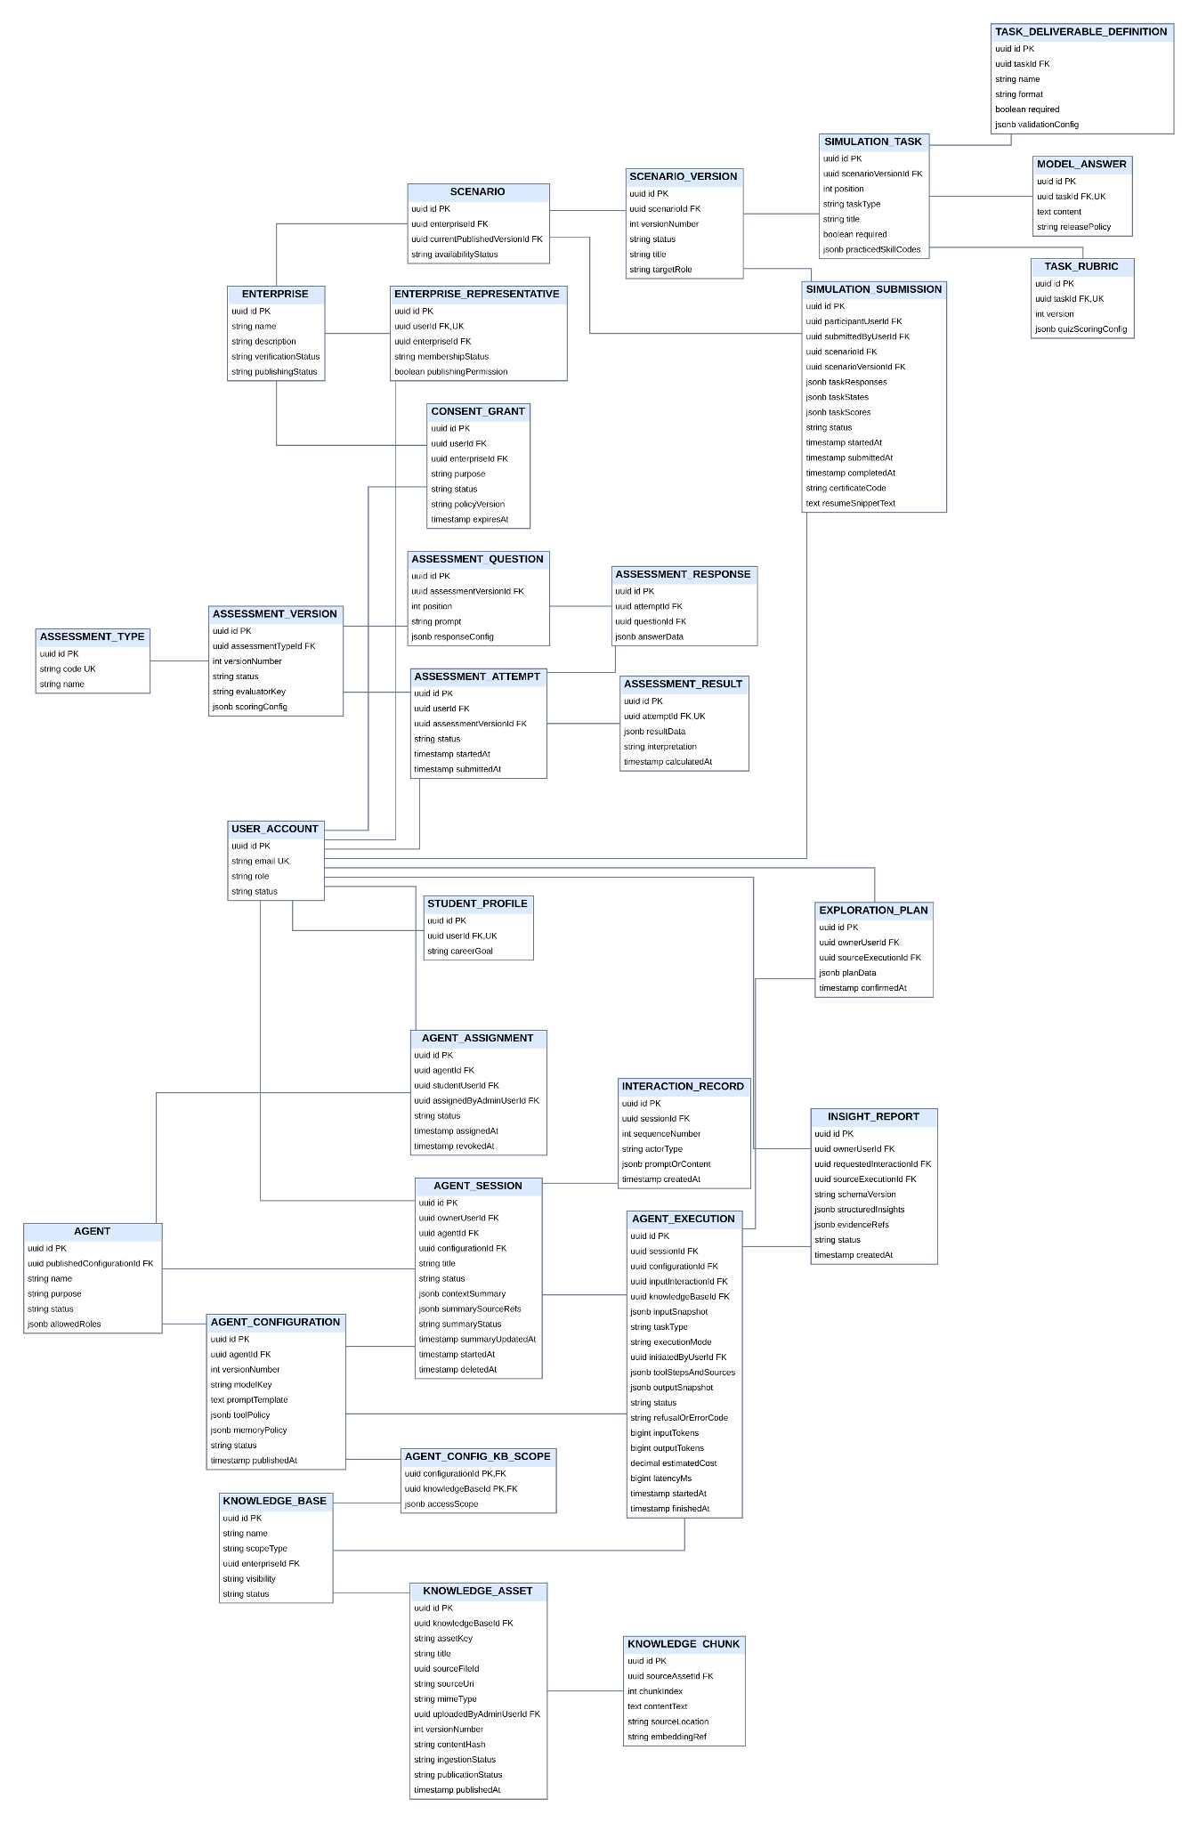
Figure 3. Target Logical ERD Diagram

2.2. Class diagram
The Class Diagrams illustrate the object-oriented domain structure of the Career Simulation Platform, divided into two complementary models: the Core Domain Model and the AI Agent Domain Model. The Core Domain Model defines the main classes related to user management, career assessments, simulation content, and student participation. The AI Agent Domain Model focuses on agent configurations, interactions, execution tracking, knowledge management, and AI-generated guidance. Together, these diagrams describe the key classes, their attributes, operations, and relationships, providing a structural foundation for the system's design and implementation.
Link to class diagram: AI Agent Class Diagram
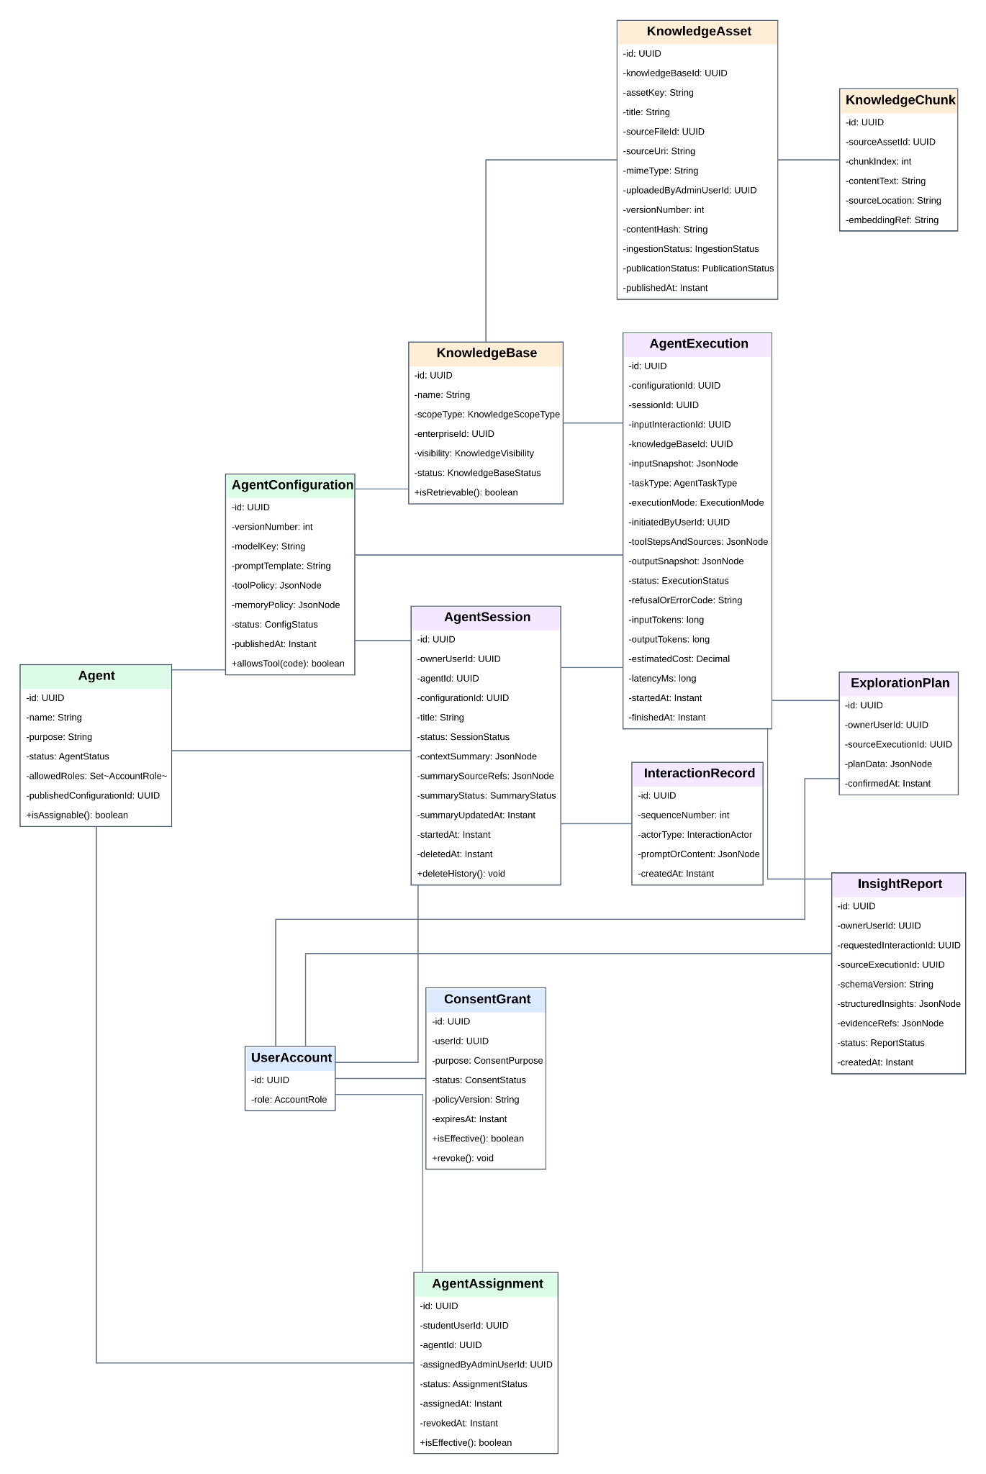
Figure 4. AI Agent Class Diagram Model - Data-first
Link to class diagram: Core Class Diagram
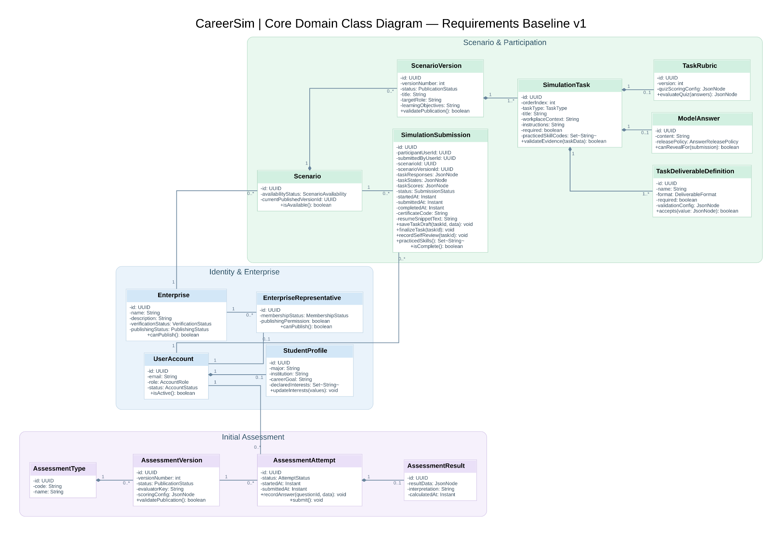
Figure 5. Core Domain Model - Revised

2.3. Sequence diagrams
The sequence design should cover the highest-value end-to-end behaviors rather than every CRUD operation. The recommended sequences are the student assessment-to-profile flow, simulation submission and evaluation flow, AI guidance with fallback, enterprise scenario authoring/publication, and research event/survey aggregation.
The current prototype provides a detailed implementation trace for the AI guidance path. It describes the request moving from the React browser through the Nginx edge gateway to Spring Boot, evidence retrieval from PostgreSQL, context minimization, external AI invocation, schema validation, audit recording, and final response rendering. The same architectural discipline can be reused for other sequences.
Link to sequence diagram: Sequence Diagrams

2.4. System architecture
The System Architecture Diagram illustrates the logical organization of the Career Simulation Platform, comprising the presentation, application, persistence, and external integration layers. The React-based frontend communicates with a Spring Boot modular monolithic backend through authenticated HTTP APIs. The backend manages identity and access control, career simulations, AI agent orchestration, knowledge retrieval, and reporting. PostgreSQL stores core application data, while a vector store supports Retrieval-Augmented Generation (RAG). External LLM providers are accessed exclusively through the backend, and Server-Sent Events (SSE) enable real-time AI response streaming. AI execution logs and metadata are persisted to support traceability and monitoring.
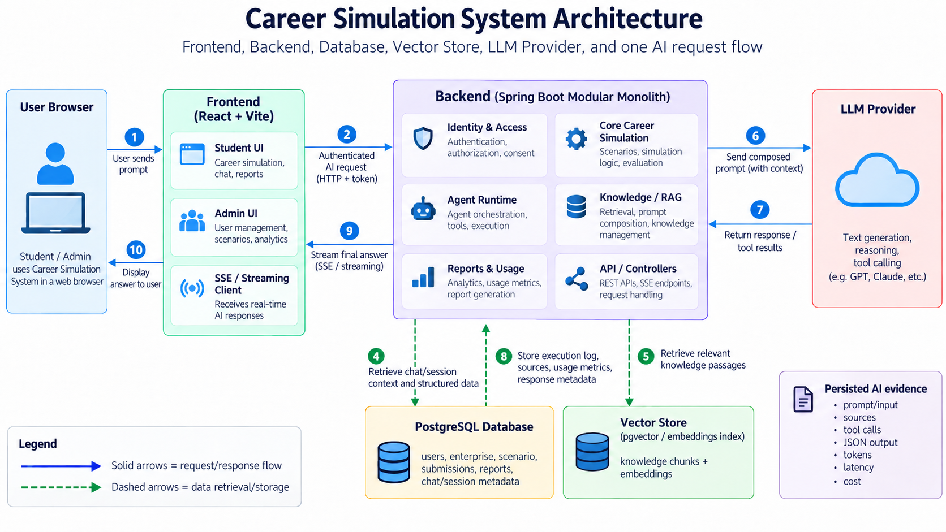
Figure 6. System Architecture of the Career Simulation Platform

CHAPTER 3: UI/UX DESIGN
The UI/UX design is based on the user-centered methodology described in Part A. Student interfaces prioritize clarity of purpose, visible progress, understandable feedback, and the ability to explore alternatives. Enterprise interfaces prioritize structured authoring and validation. Research interfaces prioritize aggregation, filtering, and privacy-aware presentation.

3.1. Screen transition map
The main Student journey is modeled as: Landing/Authentication → Onboarding/Profile → Assessment (optional) → Exploration Profile → Simulation Catalogue → Scenario Detail → Simulation Workspace → Result & Debrief → Exploration Agent → Next Simulation / Learning Resource → Exploration History. The Enterprise journey is: Enterprise Login → Scenario Library → Scenario Authoring → Task/Rubric Editor → Validation → Publish → Analytics → Authorized Participant Evidence → Optional Recruitment Invitation. The Research journey is: Research Access → Cohort → Pre-Survey → Exploration Activity → Post-Survey → Research Dashboard.
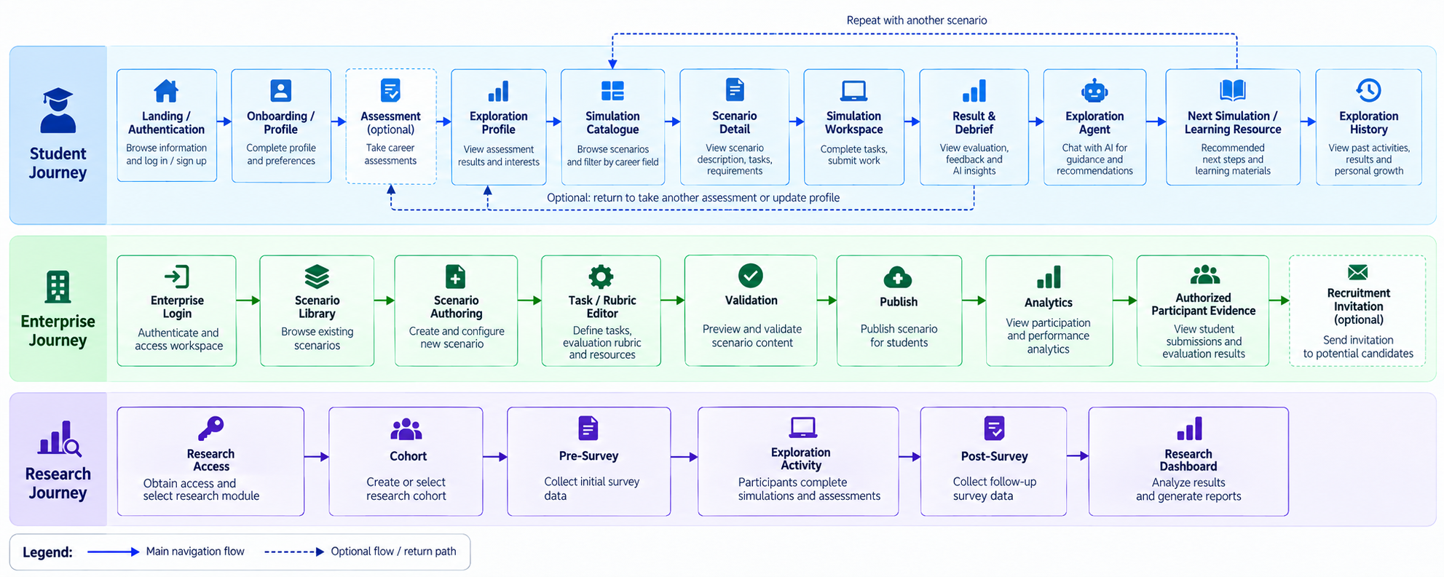
Figure 7. Screen Transition Map of the Career Simulation Platform

3.2. Interactive UI objects in screens
Table 3.2. Interactive UI objects in screens
Screen | Interactive objects | UX intent
Authentication | Text inputs, password field, validation messages, submit button, navigation links. | Clear field-level validation and session-state feedback.
Exploration Profile | Section tabs, select inputs, tag/chip controls, save button, completeness indicators. | The learner can distinguish required, optional, and inferred evidence.
RIASEC Assessment | Question card, progress indicator, response controls, navigation buttons, submit action. | The system prevents accidental incomplete submission and explains missing answers.
Simulation Catalogue | Search field, filters, recommendation cards, difficulty badges, duration labels. | Recommended options are suggestions; browsing remains unrestricted.
Simulation Workspace | Task navigator, resource viewer, editor/input area, autosave indicator, submit control. | The learner always knows the current task, expected deliverable, and remaining work.
Result & Debrief | Score summary, evidence cards, rubric feedback, source/provenance badge, next-action buttons. | Objective evidence is visually separated from AI interpretation.
Syn / AI Guidance | Chat input, quick actions, suggestion chips, plan draft card, source badge. | Quick actions can use deterministic guidance; external AI responses are labeled and fall back safely.
Enterprise Authoring | Multi-section form, task list, drag/reorder controls, rubric editor, validation checklist. | Publication is blocked when required content is incomplete.
Research Dashboard | Filters, summary cards, charts, cohort selector, date range, aggregate table. | Identity is hidden whenever the research question does not require individual-level information.
Figure 9. Main Student Dashboard and Guidance Area — Insert the main student dashboard wireframe or prototype screenshot.
Figure 10. Enterprise Simulation Authoring Interface — Insert the enterprise authoring screen mock-up.
Figure 11. Research Analytics Dashboard — Insert the research dashboard mock-up.

CHAPTER 4: IMPLEMENTATIONS

4.1. Development environment and technologies
The proposed web application follows a modular monolithic architecture. The technology stack supports secure data management, maintainable business functions, AI integration, and reproducible deployment without introducing unnecessary infrastructure complexity.
Table 4.1. Development environment and technology stack
Component | Technology or tool | Purpose
Frontend | React 19, Vite 8, TypeScript | Responsive user interfaces and integration with backend APIs.
Backend | Java 17, Spring Boot 3.5 | REST APIs, business rules, security, and AI orchestration.
Authentication | Spring Security, Google OAuth2/OIDC, JWT | User authentication and role-based access control.
Database | PostgreSQL 17, pgvector | Persistent application records, AI metadata, and vector retrieval.
Database migration | Flyway | Version-controlled database schema changes.
AI integration | Gemini API, backend provider adapters | Language generation, native tool calling, and structured output.
Real-time communication | Server-sent events (SSE) | Stream AI responses to the user interface.
Development tools | Java IDE, Visual Studio Code, Maven, Node.js, npm | Application development and build management.
Testing tools | JUnit 5, Testcontainers, Vitest | Business logic, database integration, and frontend testing.
Version control | Git, GitHub | Source history, reviews, and team collaboration.
Deployment | Docker, Docker Compose, Nginx | Containerized execution and reverse-proxy routing.
The backend is responsible for authorization, business operations, retrieval, and communication with external AI providers. API credentials remain on the server. The implementation scope includes account access, assessments, simulations, knowledge base management, and configurable student-facing AI assistance.

4.2. AI implementation and evaluation
The AI scope focuses on three capabilities required by the project assignment: retrieval-augmented generation (RAG), tool-using agents, and structured output. These capabilities support evidence-based guidance without replacing the application’s authoritative business rules.
Table 4.2. Selected AI capabilities
Capability | Implementation approach
A. Retrieval-augmented generation | Published documents are extracted, chunked, embedded, and retrieved through a scoped vector search. Knowledge-based answers cite available sources and acknowledge insufficient evidence.
B. Tool-using agent | The language model invokes authorized tools to retrieve assessment information, published simulations, and the current student’s permitted activity evidence. At least three real application-data tools must be demonstrated.
C. Structured output | The model produces schema-constrained JSON for career insight reports. The backend validates the result before storing it and making it available to its authorized owner.
Gemini is the initial planned language model provider because its APIs support function calling and structured generation. The final provider justification must be supported by measured response quality, speed, cost, and privacy considerations. Agent instructions, model selection, knowledge sources, and tool permissions are managed in versioned configurations. An administrator tests a configuration before publication and assignment to eligible students.
AI requests are subject to user authorization, the applicable external-processing consent, context minimization, and response validation. Safety controls address prompt injection, out-of-scope requests, and provider failures, including timeouts, invalid structured responses, and empty outputs. When the provider is unavailable, independent assessment and simulation functions remain accessible.
The evaluation will use at least 20 cases with expected outcomes, covering normal requests, ambiguous questions, missing evidence, refusal situations, and failure conditions. Results must be recorded before and after a documented improvement. Deterministic output-validation tests and live-model evaluation will be reported separately.
Table 4.3. AI evaluation summary
Measure | Result
Evaluation cases and categories | Pending execution and verification
Pass rates before and after improvement | Pending measurement
Prompt injection and out-of-scope handling | Pending demonstration
Provider failure and fallback | Pending demonstration
Average response time and cost per request | Pending measurement
Per-request records should capture prompt or configuration version, tools invoked, token usage, latency, and failure status when available. Final measurements will be derived from actual requests. The complete evaluation dataset and individual results will be retained as supporting project evidence rather than reproduced in this chapter.

4.3. Deployment and system quality
The planned demo environment uses Docker Compose to run the frontend, Spring Boot backend, and PostgreSQL, with Nginx acting as the reverse proxy. Persistent storage protects application records across container restarts. External AI requests are sent exclusively through the backend.
System-quality assessment will focus on deployment readiness and observable non-functional behavior, rather than treating automated test counts as the primary project outcome.
Table 4.4. System quality evaluation
Quality attribute | Evaluation focus | Result
Availability | Access to deployed core functions during the observation period. | Pending deployment verification
Reliability | Behavior under AI outages, interrupted requests, and retries. | Pending verification
Performance | Page response time, API latency, and AI response time. | Pending measurement
Data persistence | Preservation of valid records after service restart. | Pending verification
Security | OAuth2/JWT, authorization, API validation, and role isolation. | Pending verification
Privacy | Owner-scoped information, consent, and minimized provider inputs. | Pending verification
Usability | Responsive presentation and representative user workflows. | Pending user acceptance testing
The final report will replace pending entries with observed results, the test environment, and a concise explanation of limitations. Results that have not been verified will not be presented as measured system performance.

PART C: CONCLUSION

1. Achievements

1.1. Summary of results
The project established a complete domain model for a Career Simulation Platform that connects student profiling, experiential simulation, AI-assisted reflection, enterprise scenario provision, and research analytics. The report expands the original assessment-and-guidance concept into a five-module target system while maintaining the MVP principle that implementation must remain feasible and evidence-based.
From the provided prototype evidence, the implemented slice successfully demonstrates the student guidance workflow, modular-monolithic backend structure, React frontend, PostgreSQL persistence, Docker Compose deployment, Nginx edge gateway, external AI integration through a backend adapter, deterministic standard guidance, AI fallback, provenance recording, and automated quality gates. The prototype reports 47/47 backend tests and 9/9 frontend tests passing in the documented quality evidence.
The project also establishes traceability from requirements to user stories, acceptance criteria, implementation plans, source code, tests, and evidence. This provides a practical foundation for continuing the remaining modules without redesigning the overall system concept.

1.2. Knowledge, skills and attitudes acquired
Table 15. Knowledge, skills, and attitudes acquired
Area | Acquired Outcome
Requirements engineering | Ability to decompose an open-ended problem into actors, functional requirements, business rules, non-functional requirements, and explicit MVP boundaries.
Domain modeling | Ability to identify entities, relationships, lifecycles, and evidence flows across multiple business modules.
UML and software design | Ability to translate use cases into class and sequence models and connect them to modular backend responsibilities.
Backend engineering | Practical understanding of controller/service/persistence boundaries, authentication, authorization, data access, and REST-based application design.
Frontend engineering | Experience structuring React interfaces, state-driven guidance components, API adapters, and user-oriented navigation.
AI integration | Understanding of bounded LLM integration, context minimization, consent gates, schema validation, provenance, prompt-boundary controls, and deterministic fallback.
Testing and quality | Experience using automated tests, integration-oriented testing, build verification, configuration checks, and evidence-based quality gates.
Deployment | Practical understanding of containerized deployment, reverse proxying, Ubuntu server setup, PostgreSQL persistence, and deployment verification.
Research thinking | Understanding that system usefulness should be evaluated through defined measures rather than assumed from implementation alone.
Attitude | Greater emphasis on traceability, human review, privacy, evidence-based claims, maintainability, and responsible use of AI.

2. Advantages and limitations

2.1. Advantages
• The system connects assessment, experience, evidence, reflection, and next-step exploration into one coherent learner journey.
• The simulation data model is more expressive than a simple question bank because it supports scenario context, datasets/resources, deliverables, evaluation methods, and rubrics.
• The AI layer is explicitly bounded. Deterministic scoring remains separate from AI interpretation, and the prototype includes consent, context minimization, schema validation, provenance, prompt-boundary handling, and fallback.
• The modular-monolithic architecture is suitable for a small educational deployment while remaining structured enough to support future expansion.
• The enterprise side supports content scalability by making scenario authoring structured rather than requiring the engineering team to hard-code every scenario.
• The research module creates a path for the platform to be evaluated scientifically instead of relying only on anecdotal feedback.

2.2. Limitations
• The initial implementation does not fully cover every target-module capability described in the requirements; several enterprise recruitment and research functions remain design-level or partial.
• The simulation catalogue is intentionally small and initially focused on IT; broader career domains require additional content design and validation.
• Artifact-oriented AI evaluation remains more complex than deterministic scoring because rubric quality, input normalization, model variability, and evaluator agreement require further study.
• External AI provider availability introduces operational and cost dependencies, although deterministic fallback reduces functional disruption.
• Load-testing and human-user study results are not contained in the supplied prototype evidence and therefore require explicit execution before quantitative claims are added to the final report.
• Career exploration recommendations remain bounded by the quality and coverage of the scenario catalogue, profile data, mappings, and learning-resource metadata.

3. Future work

REFERENCES
[1] The Forage. “Free virtual job simulations and career prep.” Official platform. Accessed August 24, 2026. https://www.theforage.com
[2] National Center for O*NET Development. “O*NET Interest Profiler Manual.” 2021. https://www.onetcenter.org/reports/IP_Manual.html
[3] The Forage. “Forage Job Simulations.” Official simulation catalogue and platform description. Accessed August 24, 2026. https://www.theforage.com/simulations
[4] Virtual Internships. “How It Works – Host Companies.” Official platform information. Accessed August 24, 2026. https://www.virtualinternships.com/companies/how-it-works
[5] Virtual Internships. “Terms and Conditions – Interns.” Updated August 22, 2025. https://www.virtualinternships.com/policies/terms-and-conditions
[6] The Forage. “Career Explorer.” Official learning simulation page. Accessed August 24, 2026. https://www.theforage.com/simulations/learning/career-explorer-bgbk
[7] O*NET Resource Center. “Career Interest Types / Interests.” Official O*NET data documentation. Accessed August 24, 2026. https://www.onetcenter.org/dictionary
[8] CareerSim project prototype. “CareerSim — Interactive Technical Storyboard & Architecture Trace.” Project-provided HTML evidence, updated September 15, 2026.

TEAM CONTRIBUTION
Full name | Work performed
Huynh Gia Han | Problem analysis and requirement modeling; SRS/POSE refinement; domain and use-case design; backend-oriented architecture and AI orchestration analysis; deployment and testing coordination; report integration; prototype technical trace and evidence documentation.
Mai Tran Thuy Trang | Problem analysis and requirement refinement; student-facing UX and exploration-flow design; simulation and profile feature analysis; UI/prototype contribution; testing support; report review and documentation.
Vo Nguyen Ngoc Bích | Problem analysis and requirement refinement; student-facing UX and exploration-flow design; simulation and profile feature analysis; UI/prototype contribution; testing support; report review and documentation.
Shared responsibilities | Project planning, requirement review, modeling discussions, validation of scope, integration reviews, quality-gate verification, and final presentation preparation.

