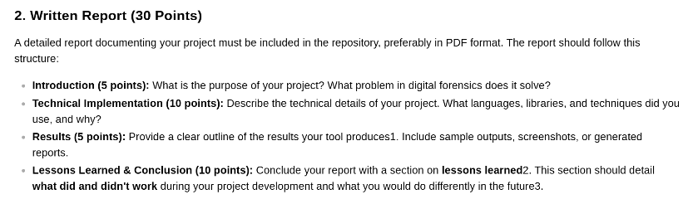
2. Written Report (30 Points)
A detailed report documenting your project must be included in the repository, preferably in PDF format. The report should follow this structure:
• Introduction (5 points): What is the purpose of your project? What problem in digital forensics does it solve? • Technical Implementation (10 points): Describe the technical details of your project. What languages, libraries, and techniques did you use, and why? • Results (5 points): Provide a clear outline of the results your tool producesl. Include sample outputs, screenshots, or generated reports. • Lessons Learned & Conclusion (10 points): Conclude your report with a section on lessons learned2. This section should detail what did and didn't work during your project development and what you would do differently in the future3.

Introduction (5 points)

Technical Implementation (10 points)

Results (5 points)

Lessons Learned & Conclusion (10 points)

