RelicBound
  - Database Design and Implementation Summary Guidance
Contents
List of students involved: 1
Entity Relationship Diagram 2
Data Dictionary 3
userTable 3
gameuserTable 4
gameTable 5
user_inventoryTable 6
inventoryTable 7
itemsTable 8
SQL 9

List of students involved:
- Ryan Alex (40450422​)
- Rehan Ananth (40415484​)
- Rose Carey-Small (40403099)
- Smaran Sudhindra Das (40439950​)
- Conor O’Carroll (40446516​)

Entity Relationship Diagram
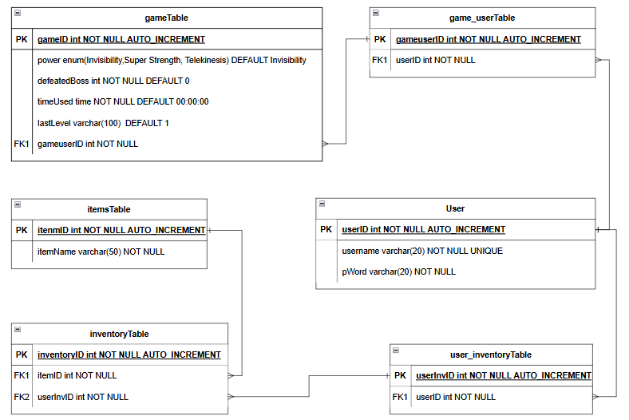

Data Dictionary
DB Name | Relicbound | Table Name | userTable | Key Field(s) | userID
General Table Description:
The userTable table allows the database user to sign in or create an account on the html side of the game and is linked to the user_inventoryTable.

Field Name | R | I | Data Type | Len | Validation Rule | Default Value | Description | Typical Data
userID | Y | U | INT |  | AUTO_INCREMENT |  | This is the primary key for the USER table that is auto incremented after a new user is created. | 2
username | Y | N | VARCHAR | 20 | NOT NULL UNIQUE |  | This is a unique field created by the user to link their game and log stats, allowing them to leave and return and progress to be kept. This adds security to the game. | Jsmith123
pWord | Y | N | VARCHAR | 20 | NOT NULL |  | The pWord which signifies password adds security to the game ensuring that only the user that created the account with the username will user the password they created then. | Pword2!

DB Name | Relicbound | Table Name | gameuserTable | Key Field(s) | gameuserID
Foreign Key Relationships
FK Table Name | FK Field | FK Table Name | FK Field
userTable | userID
General Table Description:
The gameuserTable table allows the database user to have a new game instance whenever a new user is made or when they replay the game.

Field Name | R | I | Data Type | Len | Validation Rule | Default Value | Description | Typical Data
gameuserID | Y | Y | int |  | AUTO_INCREMENT NOT NULL |  | This is the primary key for the gameuserTable that is auto incremented after a new instance is created. | 3
userID | Y | N | INT |  | NOT NULL |  | This is the foreign key from the userTable to help link when creating a new game instance. | 2

DB Name | Relicbound | Table Name | gameTable | Key Field(s) | gameID
General Table Description:
The gameTable table allows the database user to log back on their previous status on the html side of the game and is linked to the userTable table.

Field Name | R | I | Data Type | Len | Validation Rule | Default Value | Description | Typical Data
gameID | Y | U | INT |  | AUTO_INCREMENT |  | This is the primary key for the USER table that is auto incremented after a new user is created. | 2
power | Y | N | ENUM |  | NOT NULL | invisibility | This field allows only one power can be selected by the user, either Invisibility, Super Strength or Telekinesis. | telekinesis
defeatedBoss | Y | N | INT |  | NOT NULL | 0 | This field allows the user stats to be reset as well as the inventory after completing the game. | 1
timeUsed | Y | N | TIME |  | NOT NULL | 00:00:00 | This logs the time used by the user logs back in they can be returned to their previous point. | 00:03:48
lastLevel | Y | N | VARCHAR | 100 | NOT NULL | 1 | This field logs the level the user was last on so if they leave and return it can be used to return to the previous point and stay consistent. | 3

DB Name | Relicbound | Table Name | user_inventoryTable | Key Field(s) | userInvID
Foreign Key Relationships
FK Table Name | FK Field | FK Table Name | FK Field
userTable | userID

General Table Description:
The user_inventoryTable table allows the database user to access their personalized inventory from the html side of the game. This table is linked to the userTable table and the inventoryTable table.

Field Name | R | I | Data Type | Len | Validation Rule | Default Value | Description | Typical Data
userInvID | Y | U | INT |  | AUTO_INCREMENT |  | This is the primary key for the USER_INVENTORY table that is auto incremented after a new personal inventory instance is created. | 2
userID | Y | N | INT |  | NOT NULL |  | This foreign key allows a link for the user to see what items they have in their inventory. | 7

DB Name | Relicbound | Table Name | inventoryTable | Key Field(s) | inventoryID

Foreign Key Relationships
FK Table Name | FK Field | FK Table Name | FK Field
itemTable | itemID | user_inventoryTable | userInvID
General Table Description:
The inventoryTable table creates the link of the items the user has access to in the html side of the game.

Field Name | R | I | Data Type | Len | Validation Rule | Default Value | Description | Typical Data
inventoryID | Y | U | int |  | AUTO_INCREMENT |  | This is the primary key for the INVENTORY table that is auto incremented after a new inventory instance is created. | 2
itemID | Y | N | int |  | NOT NULL |  | This foreign key allows each item to be linked on for each user to have a personalized inventory. | 5
userInvID | Y | N | int |  | NOT NULL |  | This foreign key allows users to be linked on for each user to have a personalized inventory. | 3

DB Name | Relicbound | Table Name | itemsTable | Key Field(s) | itemID

General Table Description:
The itemsTable table gives the list of relics and weapons available throughout the html side of the game.

Field Name | R | I | Data Type | Len | Validation Rule | Default Value | Description | Typical Data
itemID | Y | U | int |  | AUTO_INCREMENT |  | This is the primary key for the ITEMS table that is auto incremented after a new item is created. | 2
itemName | Y | N | varchar | 50 | NOT NULL |  | This field holds the names of each relic, weapon, scroll etc. that can be held in the inventory. | The Celestial Core

Key: | R = Required | Y | Yes | N | No
 | I = Indexed | Y | Yes | U | Unique | N | No

SQL
SQL Comments | Pages Incorporated | Brief Description
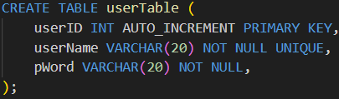 | userTable is implemented throughout all file pages. | This SQL code creates the userTable table allowing for new user instances to be creates and for people to log in with their details again.
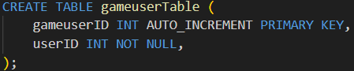 | gameuserTable is implemented throughout all file pages. | This SQL code creates the gameuserTable table allowing for new instances to be creates and a link between gameTable and userTable.
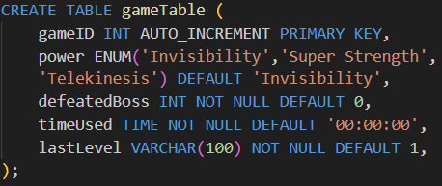 | gameTable is implemented throughout all file pages. | This SQL code creates the gameTable table allowing for new game instances to be creates and for users to return with the same details.
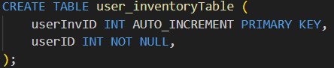 | user_inventoryTable is implemented throughout all file pages. | This SQL code creates the user_inventoryTable table allowing for the users to have access to their personalised inventory.
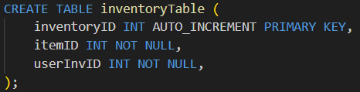 | inventoryTable is implemented throughout all file pages. | This SQL code creates the inventoryTable table allowing for the users to link and therefore have access to their personalised inventory.
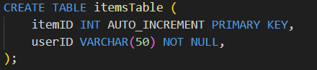 | itemsTable is implemented throughout all file pages. | This SQL code creates the itemsTable table allowing for the users to see the list of items they can gain access to in their inventory.
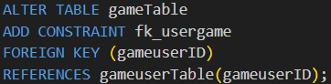 | This SQL is implemented throughout all file pages. | This code establishes the one-to-many relationship between gameuserTable and gameTable with gameuserID.
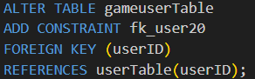 | This SQL is implemented throughout all file pages. | This code establishes the one-to-many relationship between gameuserTable and userTable with gameuserID.
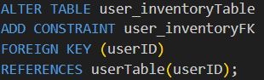 | This SQL is implemented throughout all file pages. | This code establishes the one-to-many relationship between user_inventoryTable and userTable with userID.
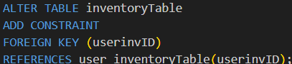 | This SQL is implemented throughout all file pages. | This code establishes the one-to-many relationship between inventoryTable and user_inventoryTable with userinvID.
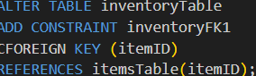 | This SQL is implemented throughout all file pages. | This code establishes the one-to-many relationship between inventoryTable and itemsTable with itemID.
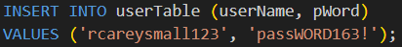 | Initialises the userTable table to be used throughout the pages | This SQL initialises the userTable table.
 | Initialises the gameTable table to be used throughout the pages | This SQL initialises the gameTable table.
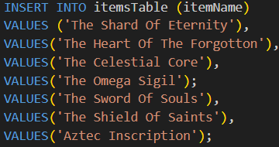 | Initialises the itemsTable table to be used throughout the pages | This SQL initialises the itemsTable table.
 | This is incorporated in the summary.html to help link end game stats. | This query gathers all data from gameTable when the gameID equals what is stored in the local storage.
 | This is incorporated in the summary.html to help link end game stats. | This query gathers all data in userinvID column from user_inventoryTable when the userID equals what is stored in the local storage.
 | This is incorporated in the summary.html to help link end game stats. | This query gathers all data in itemID column from inventoryTable when the userinvID equals what is stored in the local storage.
 | This is incorporated in the summary.html to help link end game stats. | This query gathers all data in itemName column from itemsTable when the itemID equals what is stored in the local storage.
 | This is incorporated in the summary.html to help link end game stats. | This query sets defeatedBoss to 1 in gameTable when the gameID equals what is stored in the local storage.
 | This is incorporated in the context1.html, context2.html and context3.html to help link end game stats. | This query sets lastLevel in gameTable to the pageUrl when the gameID equals what is stored in the local storage.
 | This is incorporated in the powers.html to help link end game stats. | This query sets power in gameTable to the local storage power when the gameID equals what is stored in the local storage and when the gameuserID equals what is stored in the local storage.
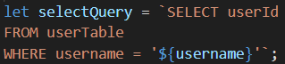 | This is incorporated in the LoginPageFinal.html to help link end game stats. | This query gathers the userId from userTable where username equals what is stored in the local storage.
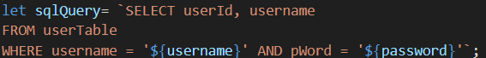 | This is incorporated in the LoginPageFinal.html to help link end game stats. | This query gathers the userId and username from userTable where username equals what is stored in the local storage and where password equals what is stored in the local storage.
 | This is incorporated in the StartPageFinal.html to help link end game stats. | This query sets a new gameuserID into gameTable with the data stored in local storage.
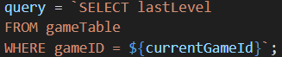 | This is incorporated in the StartPageFinal.html to help link end game stats. | This query gathers the lastLevel from gameTable where gameID equals what is stored in the local storage.
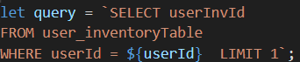 | This is incorporated in the obtainr1.html, relic3Success.html and relic3FillerSuccess.html to help link end game stats. | This query gathers the userInvId from user_inventoryTable where userID equals what is stored in the local storage.
 | This is incorporated in the obtainr1.html to help link end game stats. | This query sets a new userInvId and itemId as 1 into inventoryTable with the data stored in local storage.
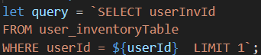 | This is incorporated in the relic2Success1.html, relic2Success2.html and relic2Success3.html to help link end game stats. | This query gathers the userInvId from user_inventoryTable where userID equals what is stored in the local storage.
 | This is incorporated in the relic2Success1.html, relic2Success2.html and relic2Success3.html to help link end game stats. | This query sets a new userInvId and itemId as 2 into inventoryTable with the data stored in local storage.
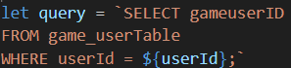 | This is incorporated in the relic3.html to help link end game stats. | This query gathers the gameId from game_userTable where userID equals what is stored in the local storage.
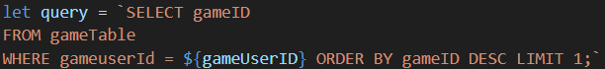 | This is incorporated in the relic3.html | This query gathers the gameId from gameTable where gameuserID equals what is stored in the local storage and puts it in descending order by gameID.
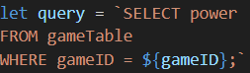 | This is incorporated in the relic3.html | This query gathers the power from gameTable where gameID equals what is stored in the local storage.
 | This is incorporated in the relic3FillerSuccess.html and relic3Success.html | This query sets a new userInvId and itemId as 3 into inventoryTable with the data stored in local storage.
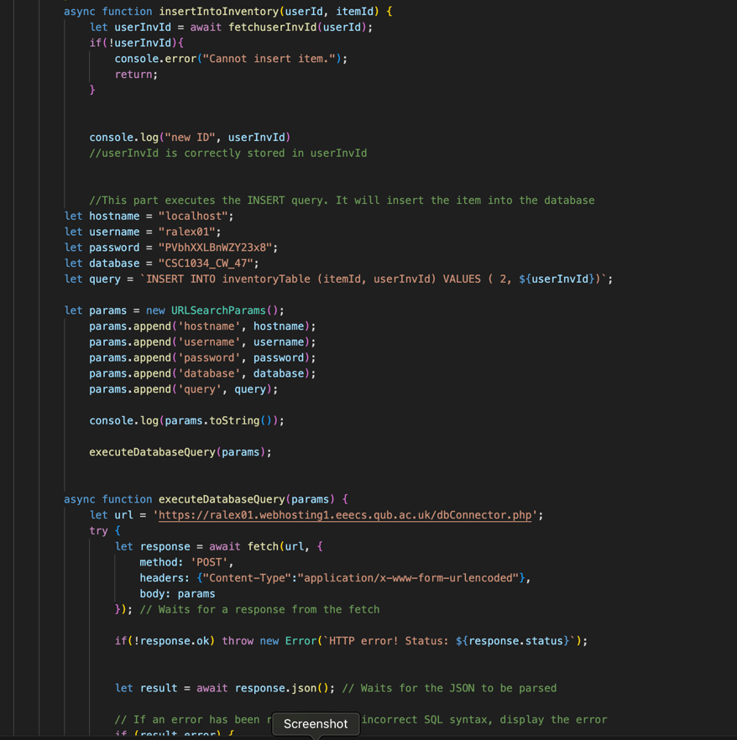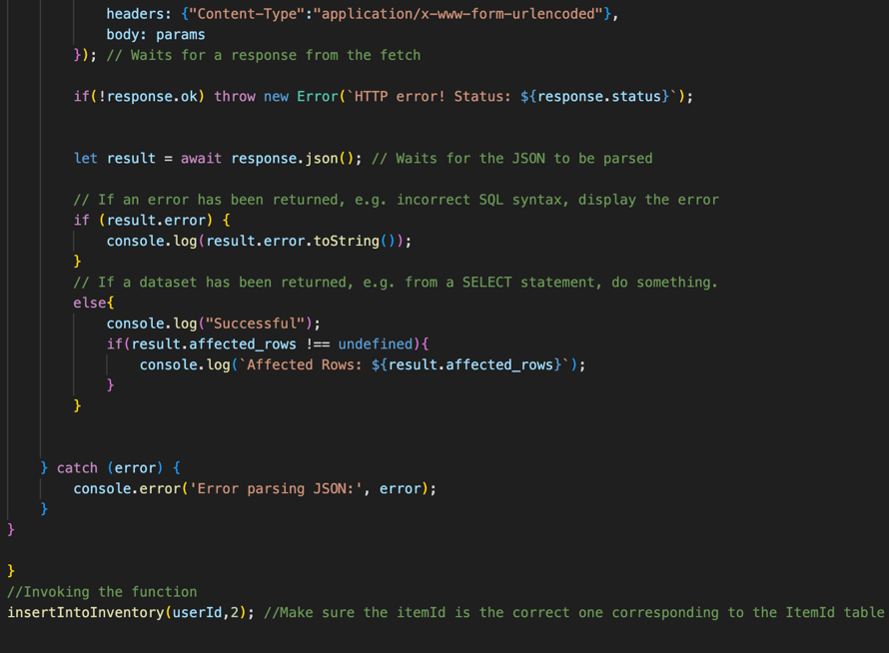 | The inventory code is implemented in every page where the user obtains an item, such as a relic, or a bonus item, | This code fetches userInvId, and then inserts the itemID tp the row with the specific userInvId, that’s given to the user.
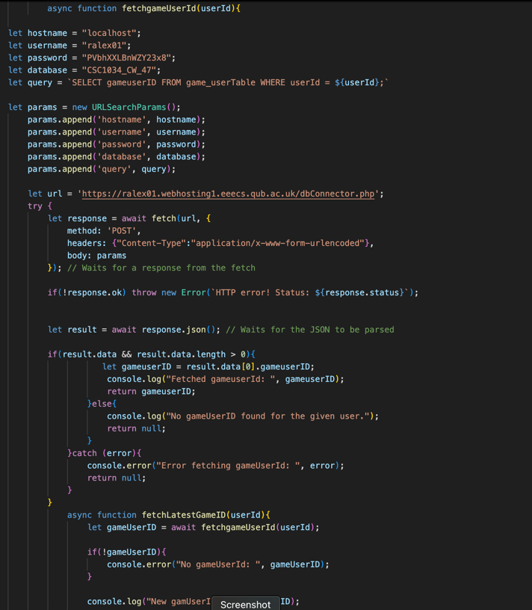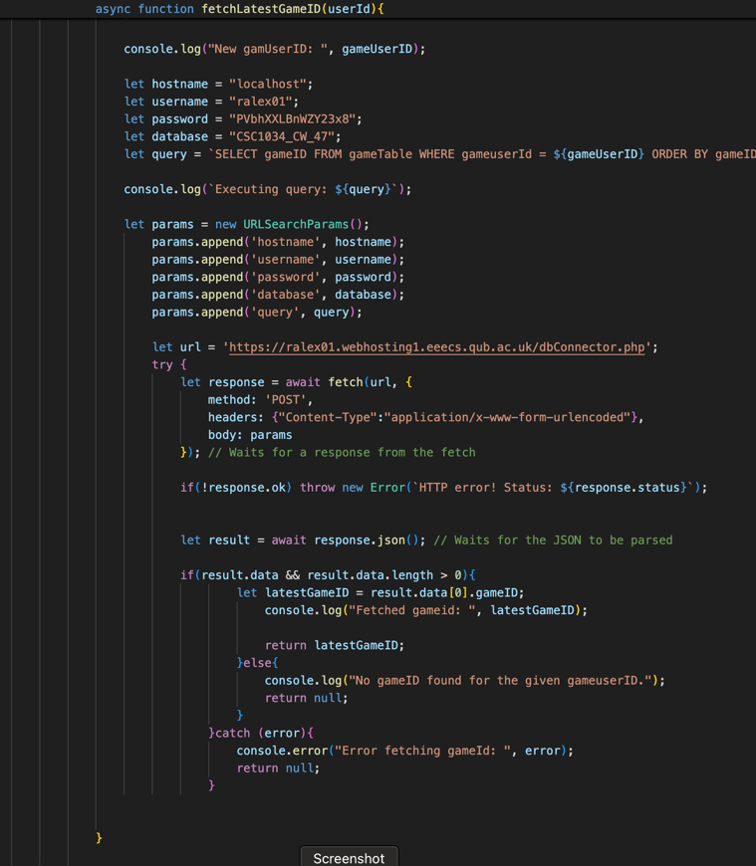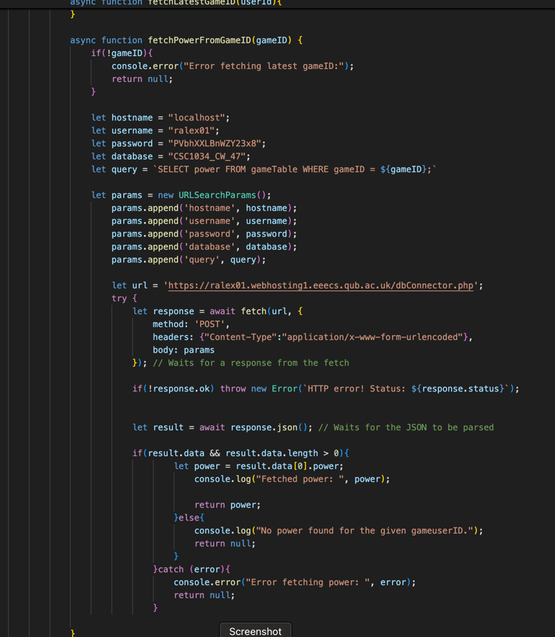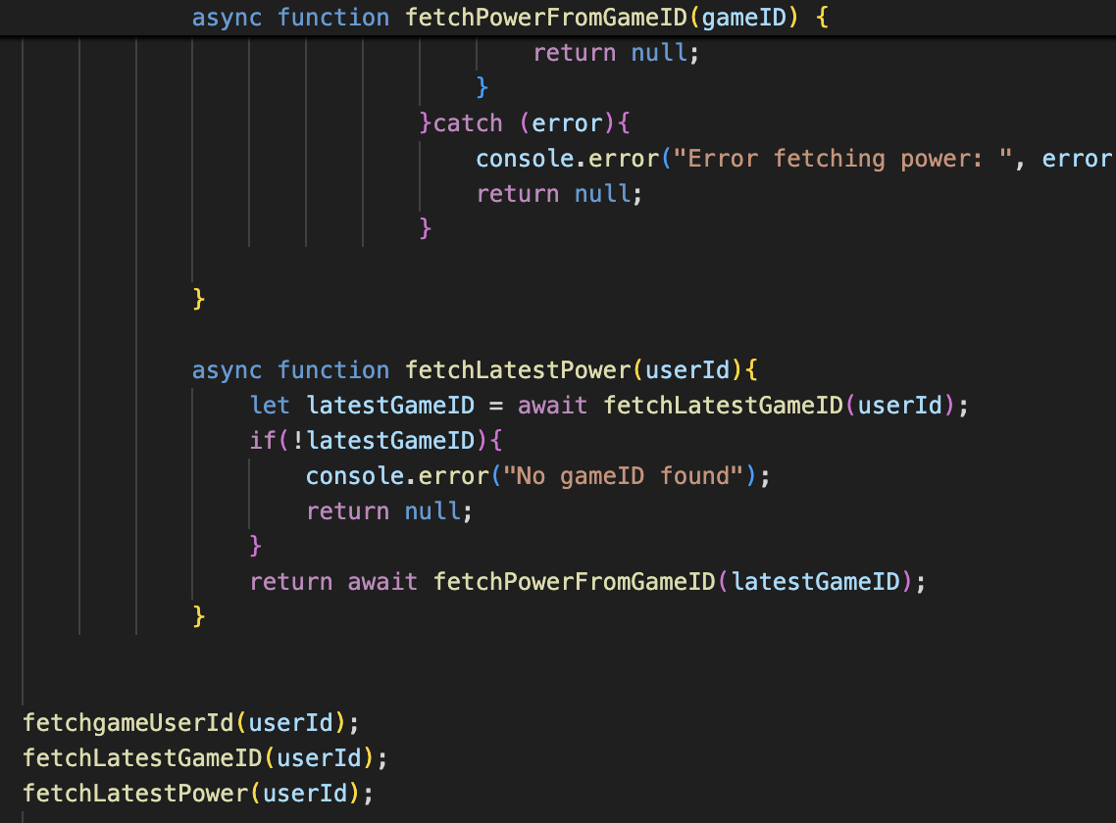 | This code is implemented in the relic 3 page. | Fetches, gameuserId, then the most recently added gameID, then fetches the power associated with that. It is used to validate the choices, ensuring the user is directed to the right page, depending on their choice, and power.
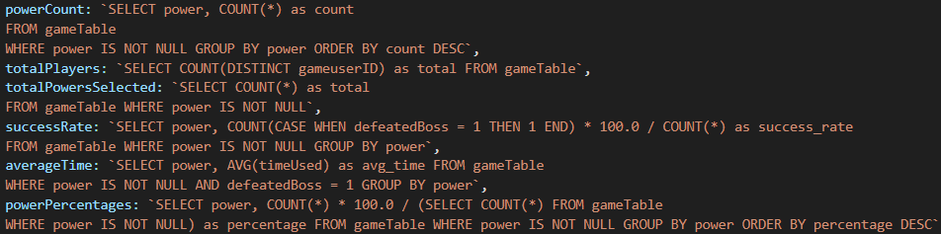 | This code is incorporated on globalStats.html | These queries return the data for the analytics for the end game leaderboard.

