**Part 1 진행 사항**

**각 노드 별 host 설정**

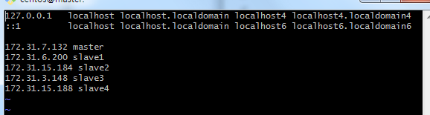



호스트 적용 후 reboot 실행.

**Java 설치**

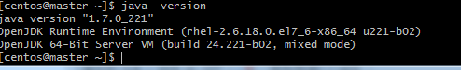

**MASTER 노드 CM SERVER 및 AGENT 설치 완료.**

$sudo yum install cloudera-manager-daemons cloudera-manager-server

$sudo yum install cloudera-manager-daemons cloudera-manager-agent

**나머지 SLAVE 노드 CM AGENT 설치 완료.**

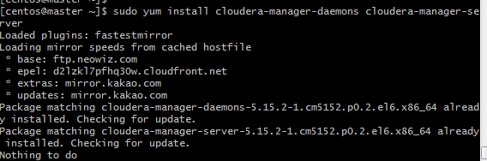

**MariaDB 설치 및 JDBC Driver 설치 완료.**

**Database 생성 완료**

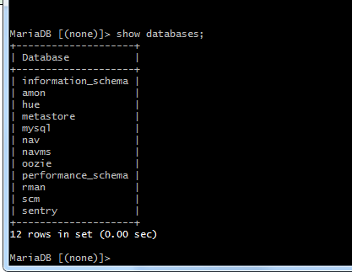

CREATE DATABASE scm DEFAULT CHARACTER SET DEFAULT COLLATE utf8_general_ci;

CREATE DATABASE amon DEFAULT CHARACTER SET DEFAULT COLLATE utf8_general_ci;

CREATE DATABASE rman DEFAULT CHARACTER SET DEFAULT COLLATE utf8_general_ci;

CREATE DATABASE hue DEFAULT CHARACTER SET DEFAULT COLLATE utf8_general_ci;

CREATE DATABASE metastore DEFAULT CHARACTER SET DEFAULT COLLATE utf8_general_ci;

CREATE DATABASE sentry DEFAULT CHARACTER SET DEFAULT COLLATE utf8_general_ci;

CREATE DATABASE nav DEFAULT CHARACTER SET DEFAULT COLLATE utf8_general_ci;

CREATE DATABASE navms DEFAULT CHARACTER SET DEFAULT COLLATE utf8_general_ci;

CREATE DATABASE oozie DEFAULT CHARACTER SET DEFAULT COLLATE utf8_general_ci;

GRANT ALL ON .* TO 'scm'@'%' IDENTIFIED BY 'scm';

GRANT ALL ON scm.* TO 'scm'@'%' IDENTIFIED BY 'scm';

GRANT ALL ON amon.* TO 'amon'@'%' IDENTIFIED BY 'amon';

GRANT ALL ON rman.* TO 'rman'@'%' IDENTIFIED BY 'rman';

GRANT ALL ON hue.* TO 'hue'@'%' IDENTIFIED BY 'hue';

GRANT ALL ON metastore.* TO 'hive'@'%' IDENTIFIED BY 'hive';

GRANT ALL ON sentry.* TO 'sentry'@'%' IDENTIFIED BY 'sentry';

GRANT ALL ON nav.* TO 'nav'@'%' IDENTIFIED BY 'nav';

GRANT ALL ON navms.* TO 'navms'@'%' IDENTIFIED BY 'navms';

GRANT ALL ON oozie.* TO 'oozie'@'%' IDENTIFIED BY 'oozie';

**SETUP CM DATABASE COMPLETE.**

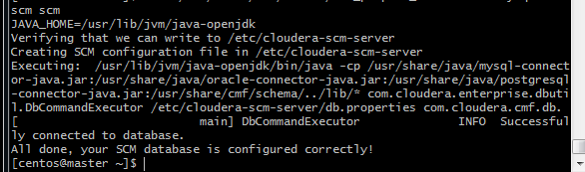

**SCM database까지 완료했으나, CM을 올리는데 실패하였습니다..**

**PART 2 – 1**

select a.id, b.type, a.status, a.amount, (a.amount - avg(b.amount)) as diff

from account a

inner join account b

on a.type = b.type

and a.status = 'Active'

group by a. id, b.type, a.status, a.amount

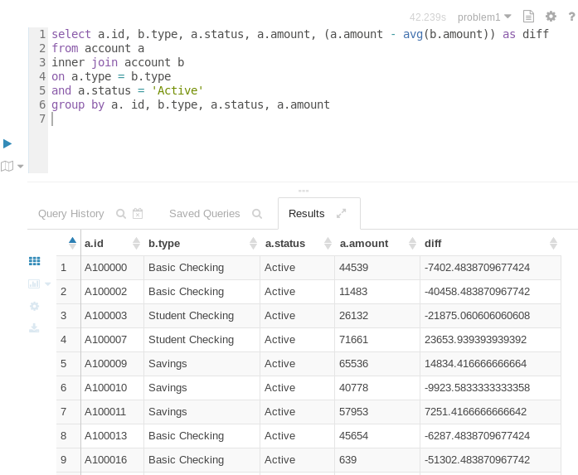

**PART 2-2**

create table employee

(id int,

fname string,

lname string,

address string,

city string,

state string,

zip string,

birthday string,

hireday string)

ROW FORMAT DELIMITED

FIELDS TERMINATED BY ','

LINES TERMINATED BY '\n'

STORED AS PARQUET

LOCATION '/user/training/problem2/data/employee/'

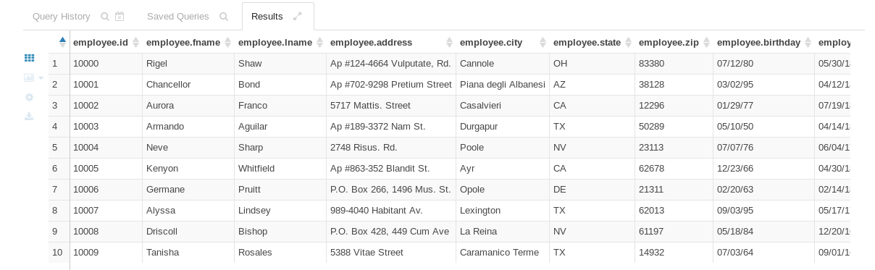

**PART 2-3**

select a.id, a.fname, a.lname, a.hphone

from customer a

inner join account b

on a.id = b.custid

where b.amount > 0;

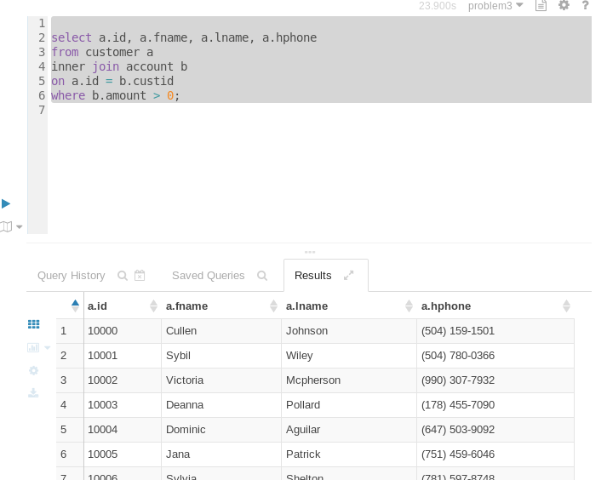

**PART 2-5**

select concat_ws('\t',fname, lname, city, state) as recode  from customer where city = 'Palo Alto' and state = 'CA'

union

select concat_ws('\t',fname, lname, city, state) as recode from  employee where city = 'Palo Alto' and state = 'CA';

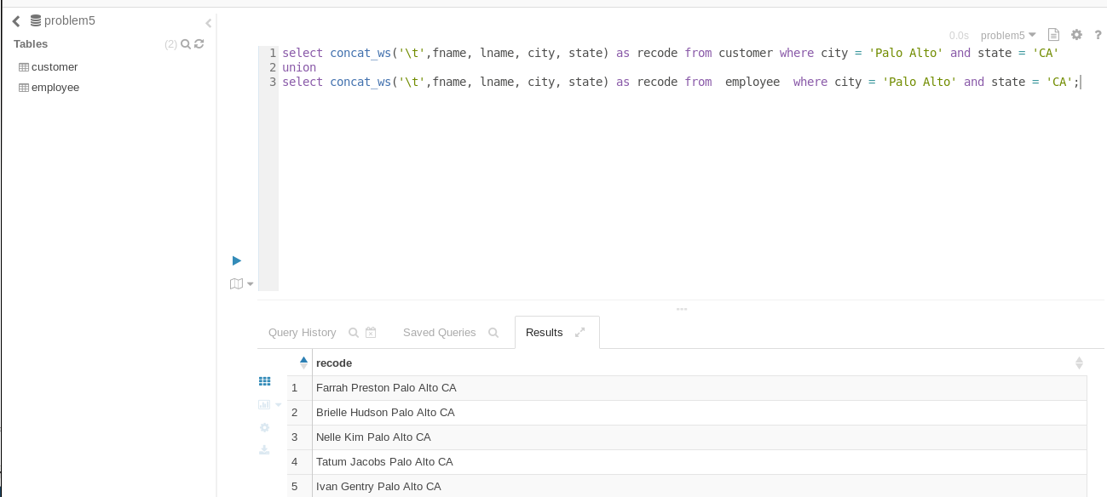

**2 – 10**

**1)TABLE 생성**

CREATE TABLE view (

  id string ,

 fname string ,

 lname string ,

 city string,

 state string,

 charge string,

 billdata string

 ) ;

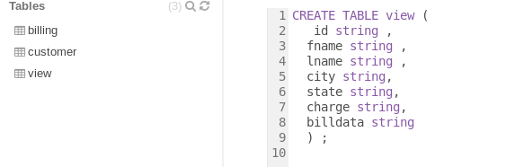

2) Insert Data

insert into view

select c.id, c.fname, c.lname, c.city, c.state, b.charge,

      to_date(b.tstamp)  as billdata

 from customer c , billing b where b.id = c.id ;

3) 결과 조회

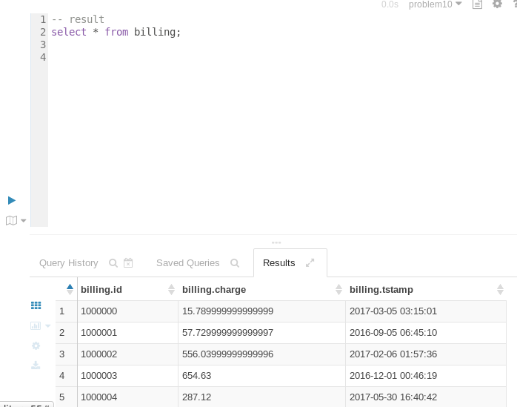

**PART 2-11**

-- top 3 Product

select p.name, p.prod_id,

       count(p.prod_id) as count

  from order_details od, products p

 where od.prod_id = p.prod_id

   and p.brand = 'Dualcore' group by p.prod_id, p.name

 order by count desc  LIMIT 3

-- solution 6

insert into solution (id, fname, lname,address, city, state, zip, birthday)

select id, fname, lname,address, city, state, zip, substr(birthday,1,5) as birthday

from employee ;

select * from solution;