Lab 5 Postman and APIs
Hassan Nasrallah | EECE435L | 8 October 2026
The Flask application manages users in SQLite through the five REST endpoints in the lab handout. The submission includes the Flask user app collection, an environment export, six saved response examples, source code, execution results and full-screen screenshots. All six collection requests and 22 assertions passed in Newman.

Endpoint results
Method | Endpoint | HTTP | Observed result
POST | /api/users/add | 201 | Created John Doe with a generated ID
GET | /api/users | 200 | Returned the list containing the new user
GET | /api/users/<user_id> | 200 | Returned the requested user
PUT | /api/users/update | 200 | Updated address, phone and country
DELETE | /api/users/delete/<user_id> | 200 | Confirmed successful deletion
GET | /api/users/<user_id> | 404 | Confirmed the deleted user was absent

Postman graded exercise
The collection is named Flask user app. Each request has a saved example containing an actual API response. The Flask local environment defines base_url as http://127.0.0.1:5000. Every request uses {{base_url}}; the add-user script captures user_id for the later requests. POST and PUT send raw JSON with Content-Type: application/json.
To reproduce the results, start app.py, import both JSON files from the postman folder, select Flask local, and run requests 01 through 06 in order. The collection can also be run with Newman. The exported examples remain available without running the server.

Implementation and verification
The users table contains user_id, name, email, phone, address and country. SQLite generates the ID. Queries bind parameters, connections close after use, and transactions commit or roll back. The API validates required fields and returns JSON errors for missing users or invalid input. The database and table are created automatically.
Five Python tests passed, covering CRUD persistence, invalid input, missing IDs, literal SQL-like text and JSON/CORS behavior. Newman passed all 6 requests and all 22 assertions with zero failures. Raw results are saved in verification. The screenshots show real GET responses in Postman before and after an update.

Git and GitHub
The database was committed on main. The Flask API and tests were added on codex/rest-api, then merged into main with a merge commit. Both branches were pushed. The final commit includes the collection, environment and submission evidence.
https://github.com/han33-dotcom/EECE435L-Lab5-Hassan-Nasrallah
References: supplied Lab5-Postman and APIs handout and Postman documentation on sending requests, variables and response examples. Links are provided in README.md.

Postman user list
Figure 1 GET /api/users returns HTTP 200 and the newly created John Doe record. The original full-screen image is included in screenshots.
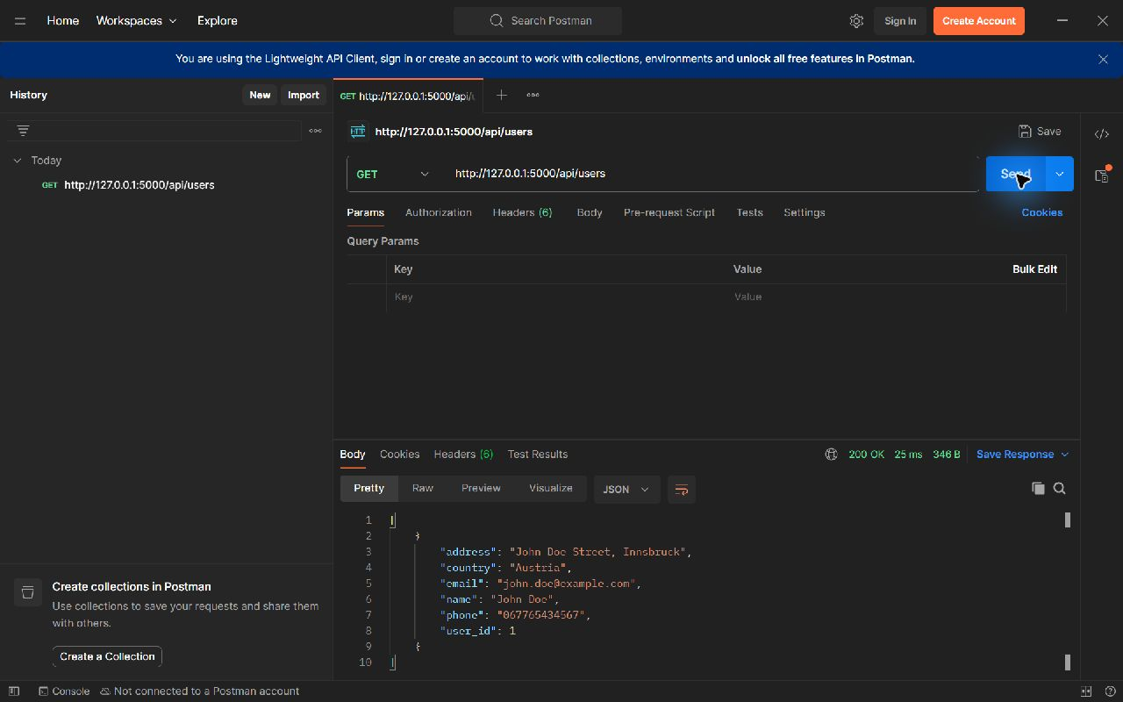

Postman updated user
Figure 2 A subsequent GET returns the updated address Beirut, country Lebanon and phone 031234567. The user ID remains 1. The original full-screen image is included in screenshots.
