控制点信息

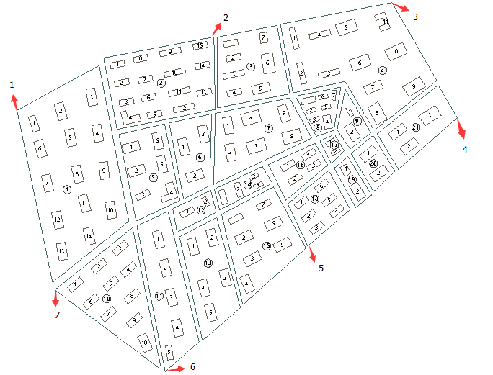

图 1 控制点示意图

表 1 控制点坐标信息

|  |  |  |
| --- | --- | --- |
| 编号 | X | Y |
| 1 | 681671.39119960752 | 3555381.230639332 |
| 2 | 682207.913802026 | 3555581.6669689133 |
| 3 | 682693.54286348424 | 3555675.3185969917 |
| 4 | 682871.335255673 | 3555361.0513728429 |
| 5 | 682463.66348274169 | 3555010.9560036324 |
| 6 | 682075.17644631537 | 3554668.1992113045 |
| 7 | 681774.47499724734 | 3554891.1622043704 |

EPSG：4548