Hana Khouli

CIS 241

Documentation

The home page is the starting page and a personal page where I introduce myself and say a few things about me.

Home page screenshot:

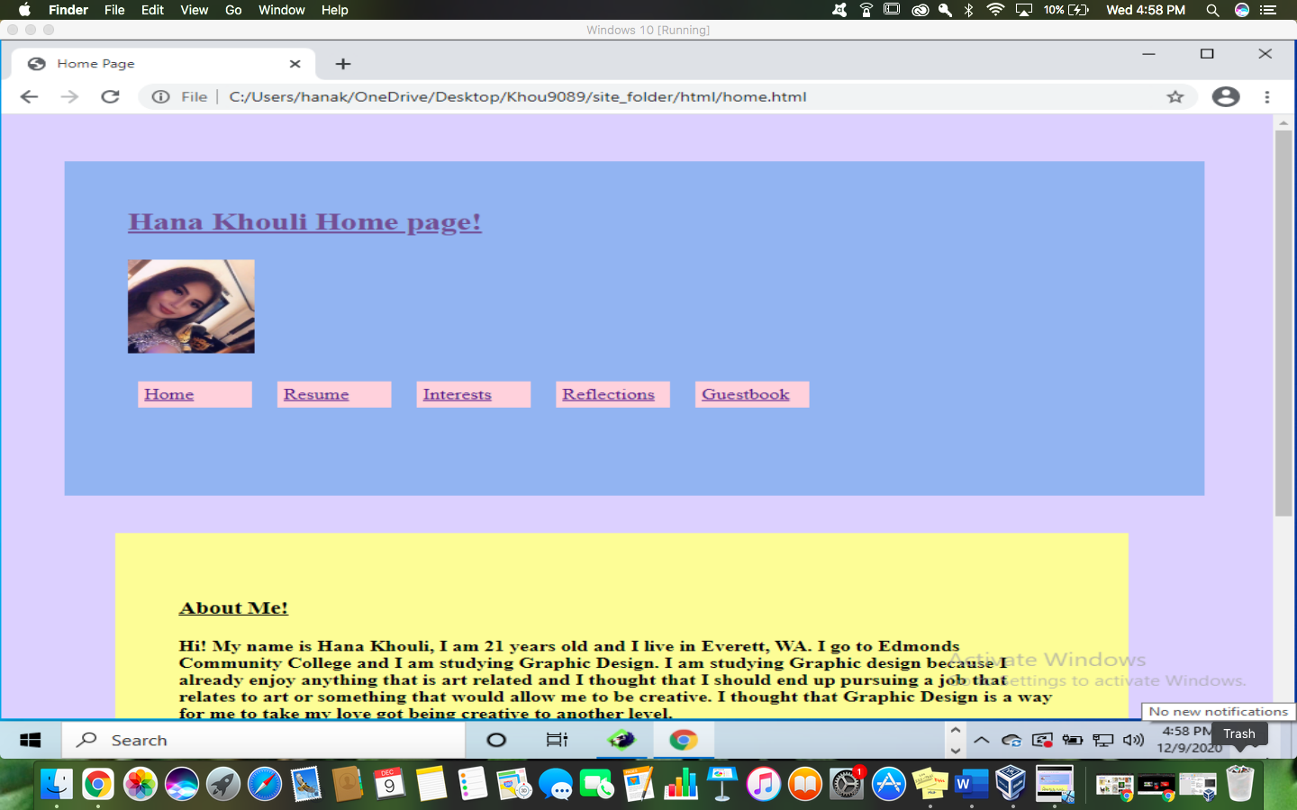

The resume page is a page that lists my desired job description, current skills, education, and my employment history.

Resume page screenshot:

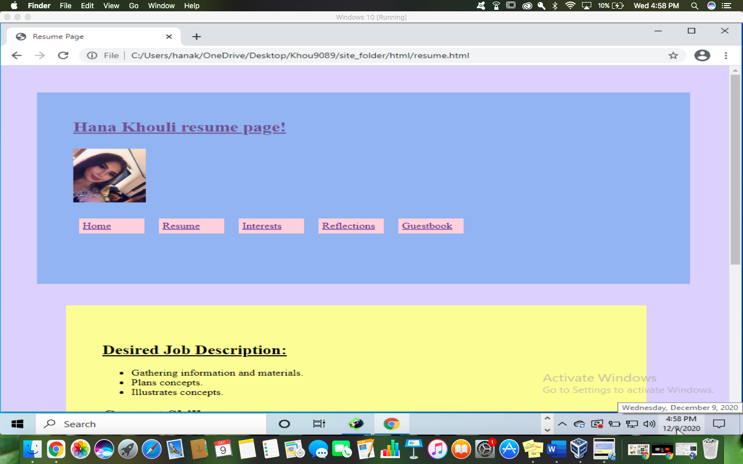

The Interests page consists of four links that take visitors to specific websites.

Interests page screenshot:

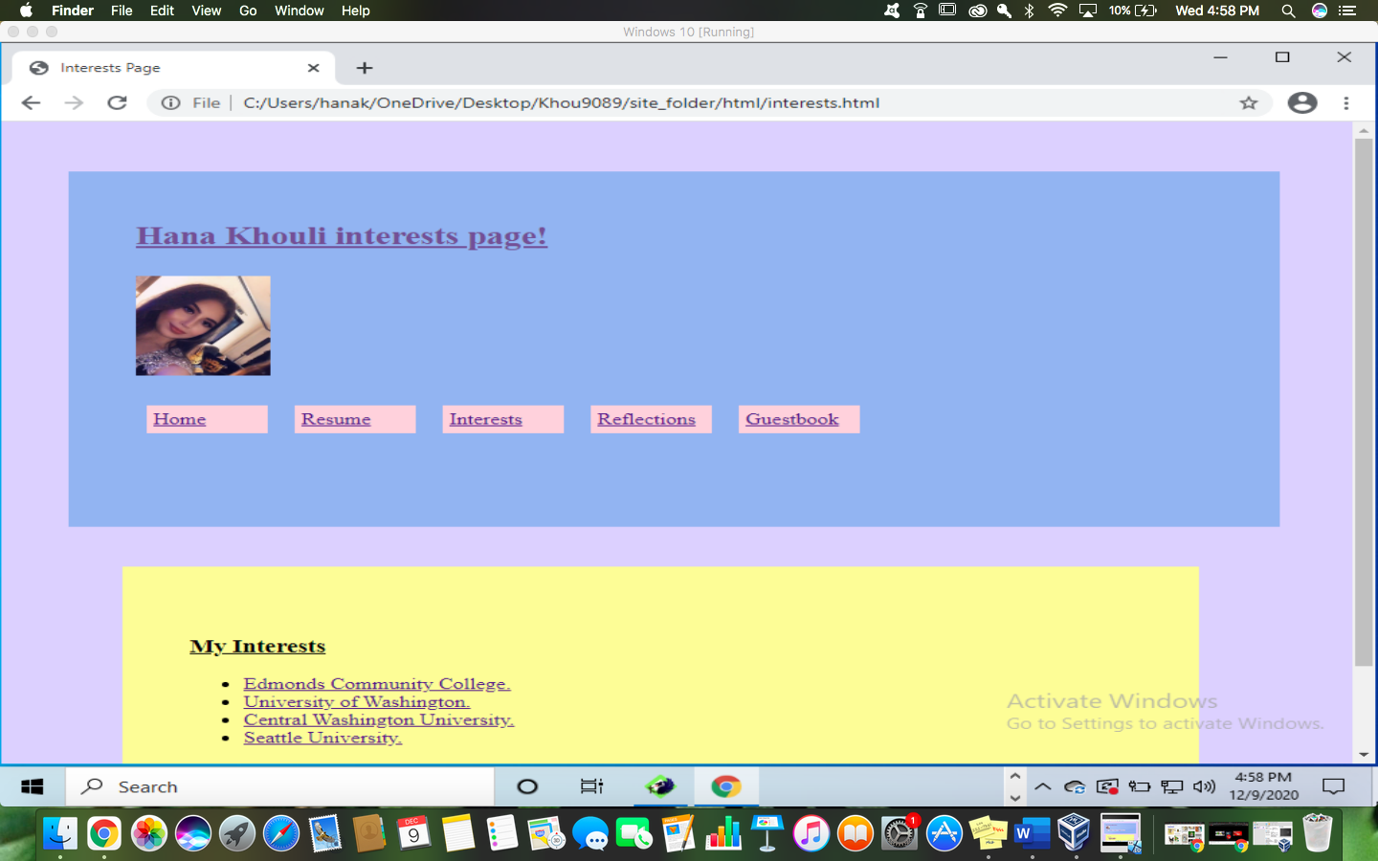

The reflection page is a page where I write about my experience with this course and about all the new skills I have learnt this quarter.

Reflection page screenshot:

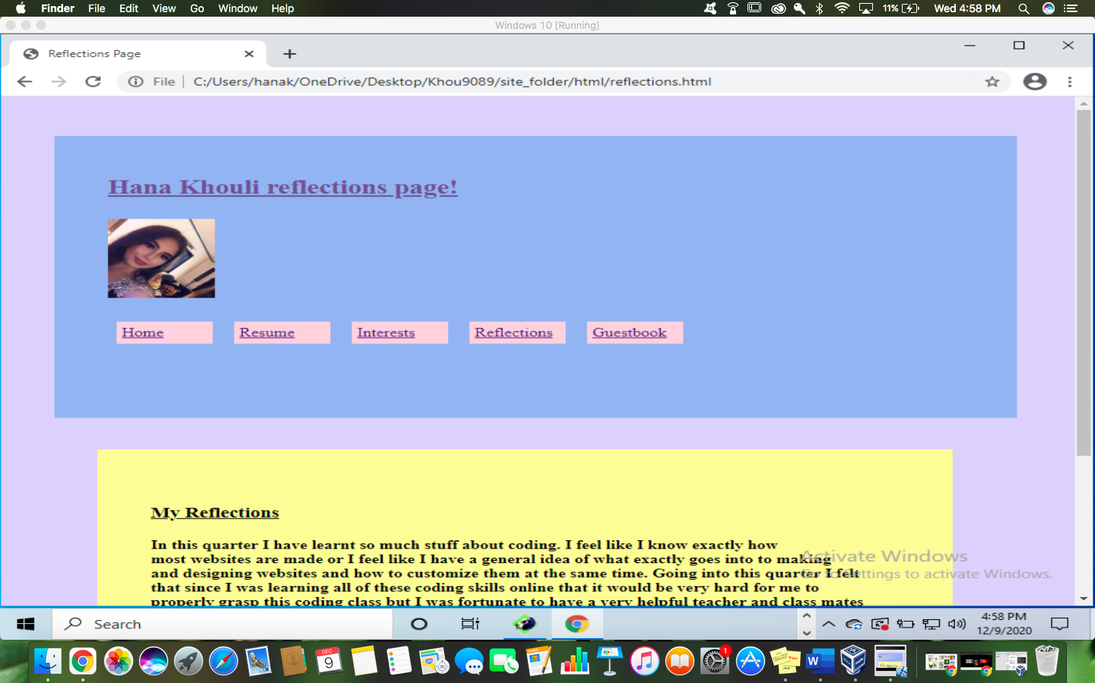

Lastly, the guestbook allows visitors who have found my website to give me some more information about them and to ask how they came across my website.

Screenshot:

