**Project 2**

Hana Magdy 5455

Maisoon Wahba 5919

Mayar Abuzeid 5773

Shimaa Ahmed 5556

Nadine Khaled 5444

**Methods Pseudocode**

**Method 1: Gauss Elimination**

1. Start

2. Input the equations from user and parse it to form augmented Matrix(A)

3. Apply Gauss Elimination on Matrix A:

For i = 1 to n-1

If Ai,i = 0

Print(“Divided by zero detected”)

Stop

End If

For j = i+1 to n

Ratio = Aj,i/Ai,i

For k = 1 to n+1

Aj,k = Aj,k - Ratio * Ai,k

Next k

Next j

Next i //End of Elimination

If A[n-1][n-1]==0 and A[n-1][n]==0

Print(“infinite number of solutions”)

Break

ElseIf A[n-1][n-1]==0 and A[n-1][n]!=0

Print(“No solutions”)

Break

4. Obtaining Solution by Back Substitution:

Xn-1= A[n-1][n]/A[n-1][n-1]

For i = n-2 to -1 (Step: -1)

X[i] = A[i][n]

For j = i+1 to n

X[i] = X[i] – A[i][j] * X[j]

Next j

X[i] = X[i]/A[i][[i]

Next i

5. Display Solution:

For i = 1 to n

Print X[i]

Next i

6. Stop

**Method 2: Gauss Jordan**

1. Start

2. Input the equations from user and parse it to form augmented Matrix(A)

3. Apply Gauss Elimination on Matrix A:

For i = 1 to n

If A[i][i] = 0

Print(“Divided by zero detected”)

Stop

End If

For j = i+1 to n

If i!=j and A[n-1][n-1]!=0

Ratio = A[j][i]/A[i][i]

For k = 1 to n+1

A[j][k] = A[j][k] - Ratio * A[i][k]

Next k

Next j

Next i //End of Elimination

If A[n-1][n-1]==0 and A[n-1][n]==0

Print(“infinite number of solutions”)

Break

ElseIf A[n-1][n-1]==0 and A[n-1][n]!=0

Print(“No solutions”)

Break

4. Obtaining Solution:

For i = 1 to n

Xi = A[i][n]/A[i][i]

Next i

5. Display Solution:

For i = 1 to n

Print Xi

Next i

6. Stop

**Method 3: Gauss Seidel**

1.Start

2. Input the equations from user and parse it to form augmented Matrix(A)

3. check if the input matrix is diagonally dominant matrix

For i=0 to n

Sum=0

For j=0 to n

Sum+=A[i][j]

Sum-=A[i][i]

If A[i][i]<Sum

Print(“the system of equations don't imply gauss seidel condition.(input matrix is not diagonal dominant”))

Break

4. copy input matrix in a temp and perform forward elimination to check that the system of equations has a unique solutions

For i = 1 to n

If temp[i][i] = 0

Print(“Divided by zero detected”)

Stop

End If

For j = i+1 to n

If i!=j and temp[n-1][n-1]!=0

Ratio = temp[j][i]/temp[i][i]

For k = 1 to n+1

temp[j][k] = temp[j][k] - Ratio * temp[i][k]

Next k

Next j

Next i //End of Elimination

If temp[n-1][n-1]==0 and temp[n-1][n]==0

Print(“infinite number of solutions”)

Break

ElseIf temp[n-1][n-1]==0 and temp[n-1][n]!=0

Print(“No solutions”)

Break

5. Perform Gauss seidel method:

For j= 0 to n

d=augmented matrix(b)[j]

For i =0 to n

If i!=j

Then d-=A[j][i]*x[i]

If A[j][j]==0

print(“Division by zero is detected”)

x[j]=d/A[j][j]

6. Stop If error is less than tolerance or the steps is greater than number of iterations given

7. Print value of x1, y1, z1 and so on

8. Stop

**Method 4: LU Decomposition**

1. Start

1. 2. Input the equations from user and parse it to form augmented Matrix(A)
2. 4. copy input matrix in a temp and perform forward elimination to check that the system of equations has a unique solutions

For i = 1 to n

If temp[i][i] = 0

Print(“Divided by zero detected”)

Stop

End If

For j = i+1 to n

If i!=j and temp[n-1][n-1]!=0

Ratio = temp[j][i]/temp[i][i]

For k = 1 to n+1

temp[j][k] = temp[j][k] - Ratio * temp[i][k]

Next k

Next j

Next i //End of Elimination

If temp[n-1][n-1]==0 and temp[n-1][n]==0

Print(“infinite number of solutions”)

Break

ElseIf temp[n-1][n-1]==0 and temp[n-1][n]!=0

Print(“No solutions”)

Break

1. Apply Lu decomposition on Matrix A:

1.Set the diagonal o Matrix L by 1

2. Apply forward elimination to obtain Matrix (U) and calculate the rest of the coefficient of (L) Matrix

3.

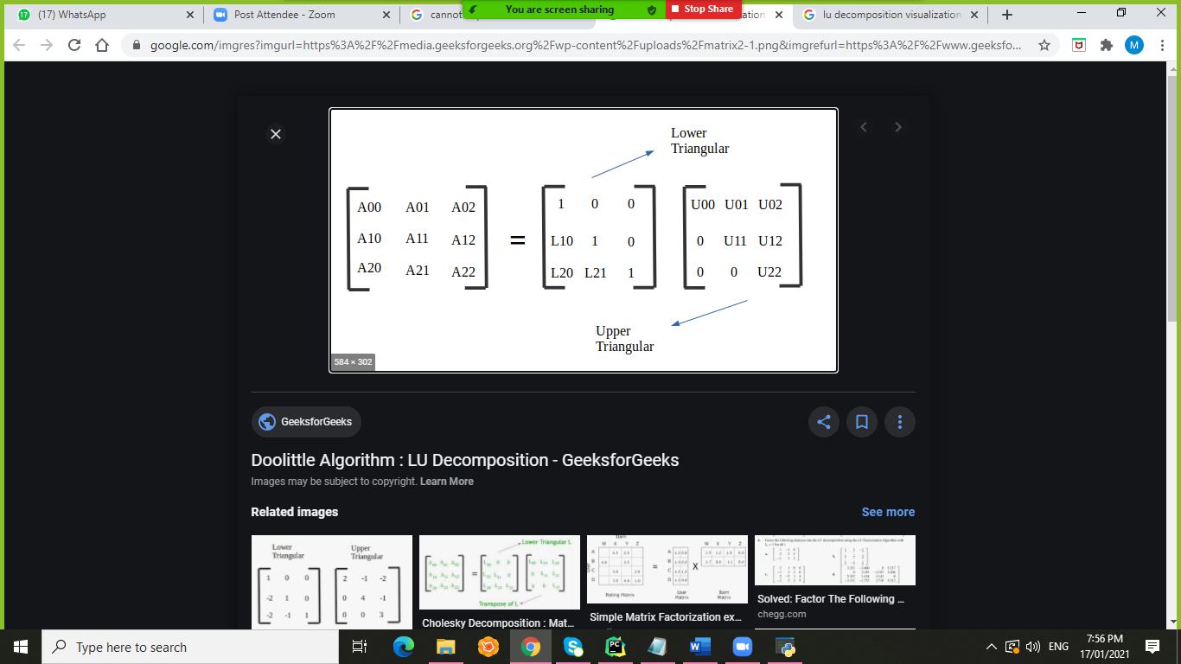

4.perform forward substitution Ly=b

For I =0 to n

Y[i]=b[i]

For k =0 to i

y[i]=y[i]-y[k]*L[i][k]

1. Perform backward substitution on Ux=y

For I =0 to n

X[i]=y[i]

For k =n-1 to i

j=k-1

x[i]=x[i]-x[j+1]*U[i][j+1]

x[i]=x[i]/U[i][i]

4. Obtaining Solution:

Return Array x

5.Stop

**Sample Runs**

**Sample Run 1:**

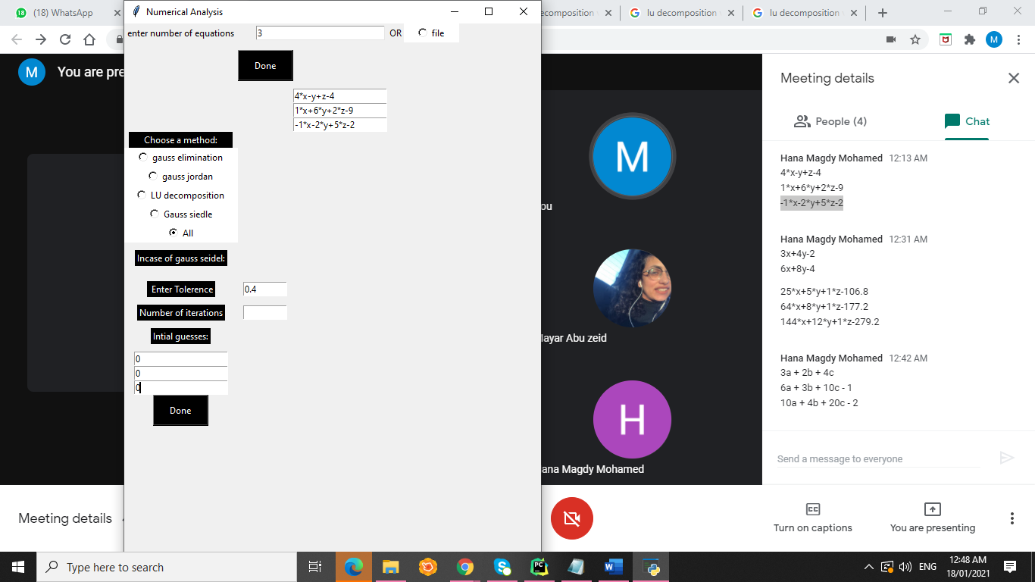

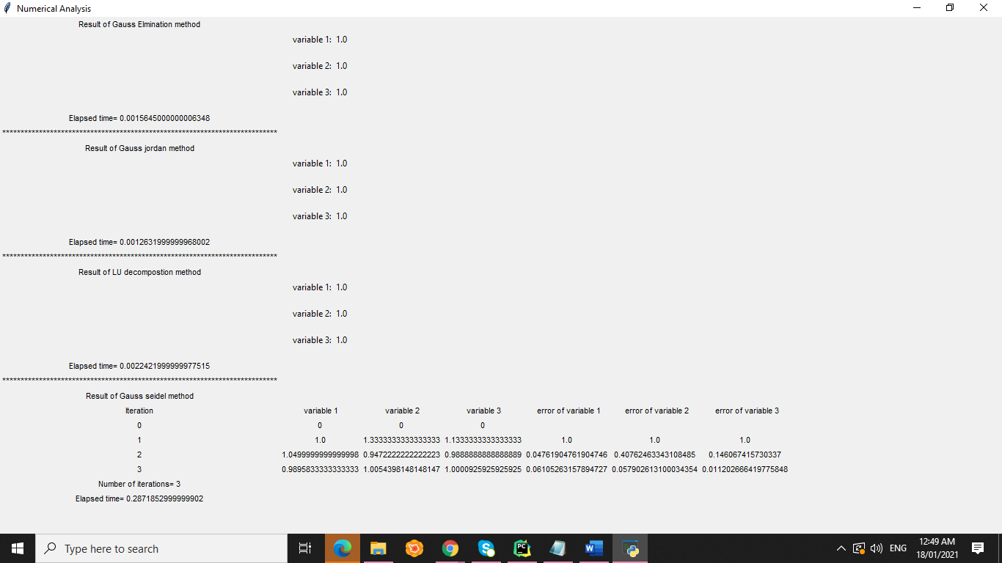

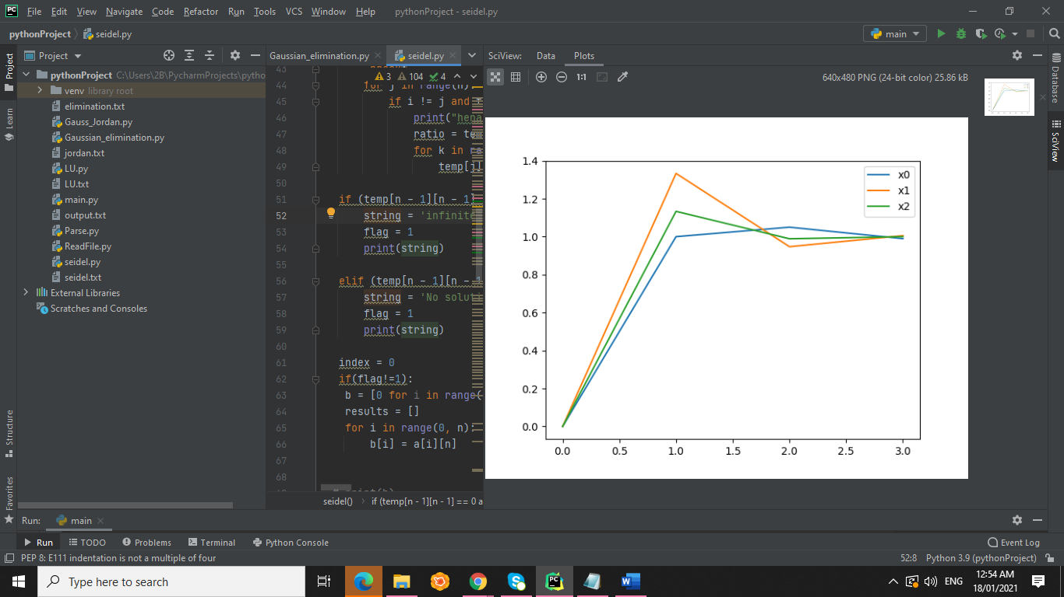

In which, x-axis is number of iterations

and y-axis is the output variables

System of equations has unique solutions. In non iterative methods: Gauss elimination, Gauss Jordan ,and Lu decomposition the result was the exact solution of the variables ,however Gauss seidel the error tolerance was satisfied after three iterations.

**Sample Run 2:**

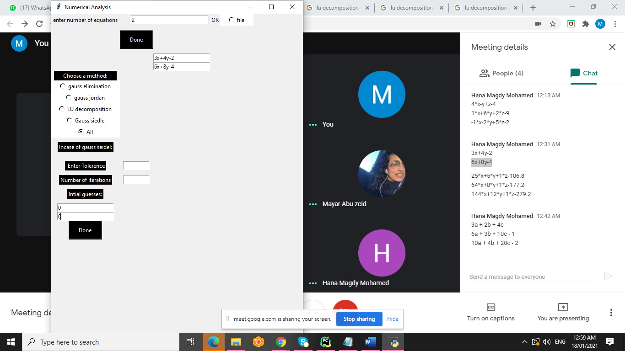

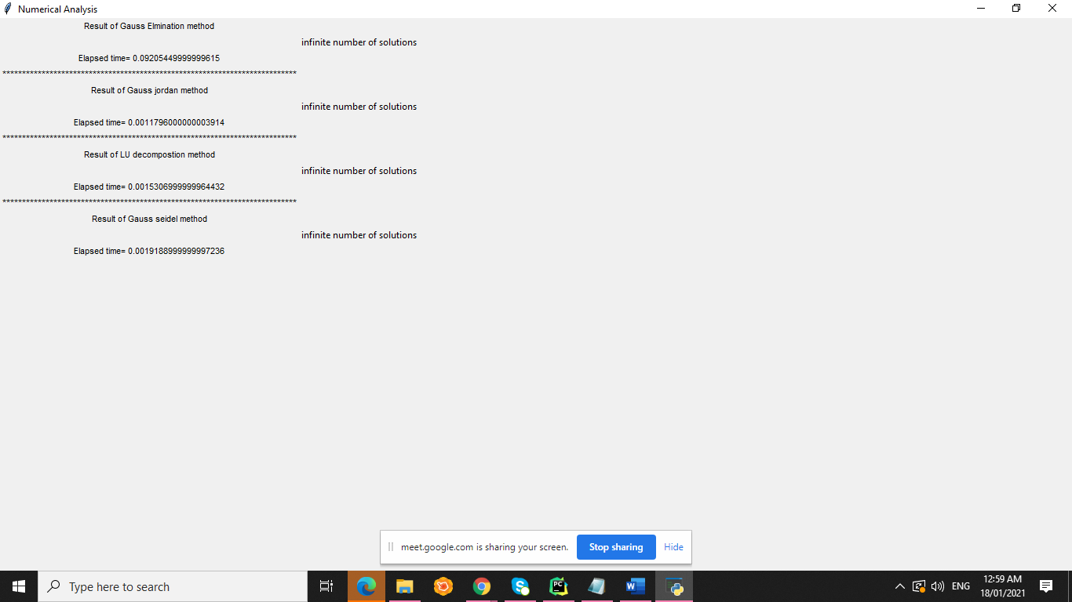

System of equations do not have unique solutions.

Sample Run 3:

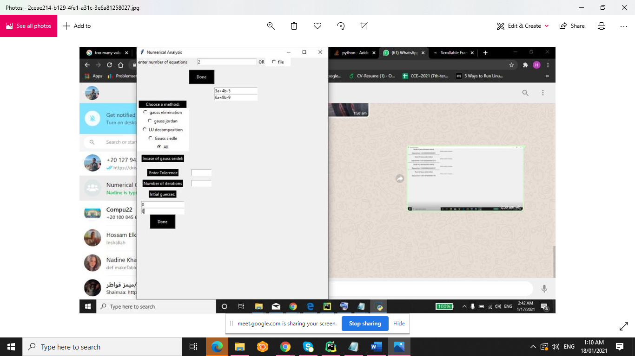



System of equations do not have solutions

Sample Run 4:

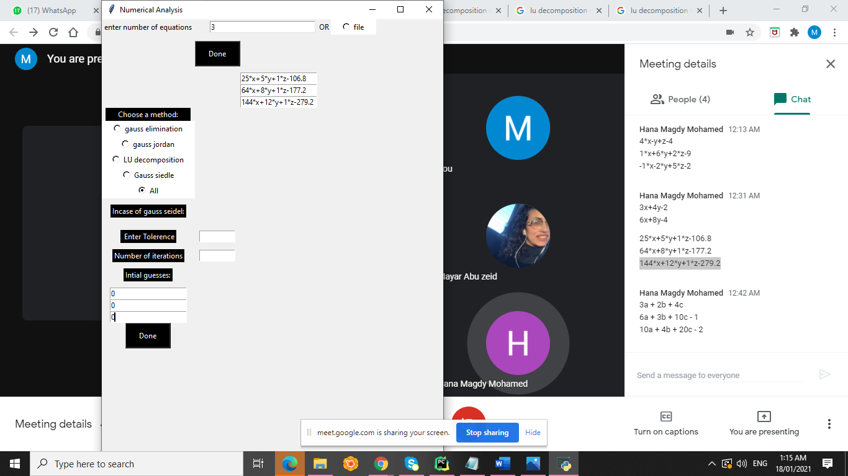

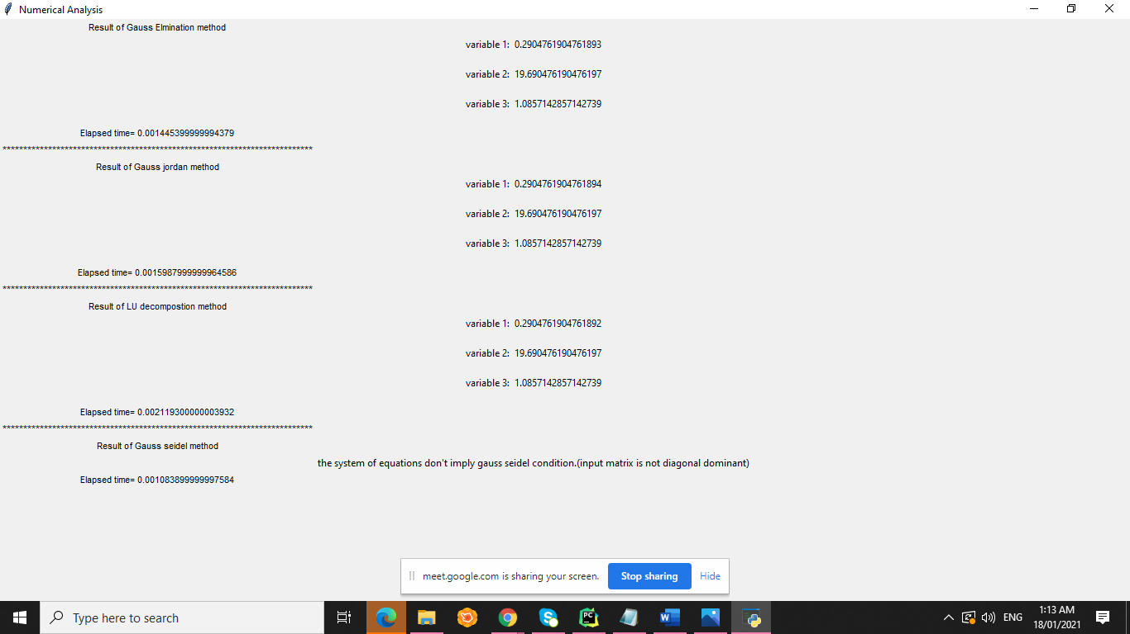

System of equations has unique solutions. In non iterative methods: Gauss elimination, Gauss Jordan ,and Lu decomposition the result was the exact solution of the variables , however in Gauss seidel the system of equation don’t satisfy gauss seidel condition in which the input matrix is not diagonally dominant.

A diagonally dominant matrix is a matrix where the diagonal elements are greater than the sum of all elements in the same row.