https://github.com/alexeygrigorev/mlbookcamp-code/tree/master

ML Zoomcamp 6.1 - Credit Risk Scoring Project

7

ML Zoomcamp 6.2 - Data Cleaning and Preparation
12

ML Zoomcamp 6.3 - Decision Trees
17

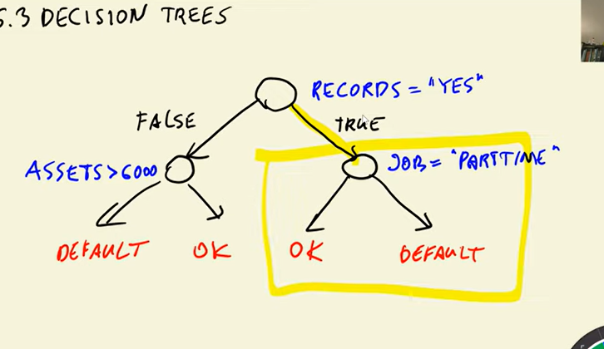

ML Zoomcamp 6.4 - Decision Tree Learning Algorithm
30

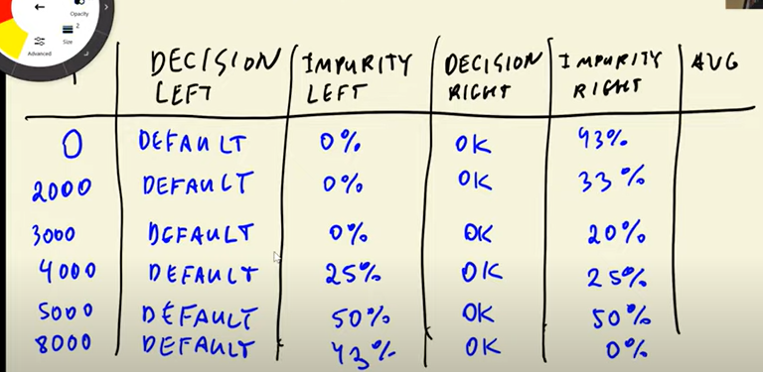

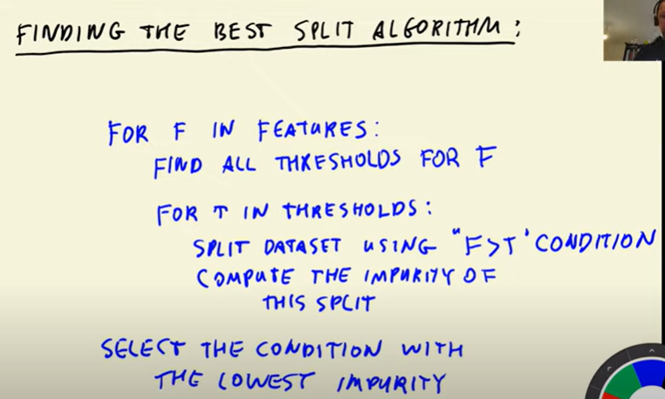

assets
[8000, 2000, 5000, 4000, 3000]
==============================================
 | assets | debt | status
0 | 8000 | 3000 | default
1 | 2000 | 1000 | default
2 | 0 | 1000 | default
3 | 5000 | 1000 | ok
4 | 4000 | 1000 | ok
6 | 3000 | 2000 | default
status
default 0.666667
ok 0.333333
Name: proportion, dtype: float64
 | assets | debt | status
5 | 9000 | 500 | ok
status
ok 1.0
Name: proportion, dtype: float64
 | assets | debt | status
1 | 2000 | 1000 | default
2 | 0 | 1000 | default
status
default 1.0
Name: proportion, dtype: float64
 | assets | debt | status
0 | 8000 | 3000 | default
3 | 5000 | 1000 | ok
4 | 4000 | 1000 | ok
5 | 9000 | 500 | ok
6 | 3000 | 2000 | default
status
ok 0.6
default 0.4
Name: proportion, dtype: float64
 | assets | debt | status
1 | 2000 | 1000 | default
2 | 0 | 1000 | default
3 | 5000 | 1000 | ok
4 | 4000 | 1000 | ok
6 | 3000 | 2000 | default
status
default 0.6
ok 0.4
Name: proportion, dtype: float64
 | assets | debt | status
0 | 8000 | 3000 | default
5 | 9000 | 500 | ok
status
default 0.5
ok 0.5
Name: proportion, dtype: float64
 | assets | debt | status
1 | 2000 | 1000 | default
2 | 0 | 1000 | default
4 | 4000 | 1000 | ok
6 | 3000 | 2000 | default
status
default 0.75
ok 0.25
Name: proportion, dtype: float64
 | assets | debt | status
0 | 8000 | 3000 | default
3 | 5000 | 1000 | ok
5 | 9000 | 500 | ok
status
ok 0.666667
default 0.333333
Name: proportion, dtype: float64
 | assets | debt | status
1 | 2000 | 1000 | default
2 | 0 | 1000 | default
6 | 3000 | 2000 | default
status
default 1.0
Name: proportion, dtype: float64
 | assets | debt | status
0 | 8000 | 3000 | default
3 | 5000 | 1000 | ok
4 | 4000 | 1000 | ok
5 | 9000 | 500 | ok
status
ok 0.75
default 0.25
Name: proportion, dtype: float64
ending the feature : assets

debt
[500, 1000, 2000]
==============================================
 | assets | debt | status
5 | 9000 | 500 | ok
status
ok 1.0
Name: proportion, dtype: float64
 | assets | debt | status
0 | 8000 | 3000 | default
1 | 2000 | 1000 | default
3 | 5000 | 1000 | ok
4 | 4000 | 1000 | ok
5 | 9000 | 500 | ok
6 | 3000 | 2000 | default
status
default 0.5
ok 0.5
Name: proportion, dtype: float64
 | assets | debt | status
1 | 2000 | 1000 | default
2 | 0 | 1000 | default
3 | 5000 | 1000 | ok
4 | 4000 | 1000 | ok
5 | 9000 | 500 | ok
status
ok 0.6
default 0.4
Name: proportion, dtype: float64
 | assets | debt | status
0 | 8000 | 3000 | default
1 | 2000 | 1000 | default
3 | 5000 | 1000 | ok
4 | 4000 | 1000 | ok
5 | 9000 | 500 | ok
6 | 3000 | 2000 | default
status
default 0.5
ok 0.5
Name: proportion, dtype: float64
 | assets | debt | status
1 | 2000 | 1000 | default
2 | 0 | 1000 | default
3 | 5000 | 1000 | ok
4 | 4000 | 1000 | ok
5 | 9000 | 500 | ok
6 | 3000 | 2000 | default
status
default 0.5
ok 0.5
Name: proportion, dtype: float64
 | assets | debt | status
0 | 8000 | 3000 | default
3 | 5000 | 1000 | ok
4 | 4000 | 1000 | ok
5 | 9000 | 500 | ok
6 | 3000 | 2000 | default
status
ok 0.6
default 0.4
Name: proportion, dtype: float64
ending the feature : debt



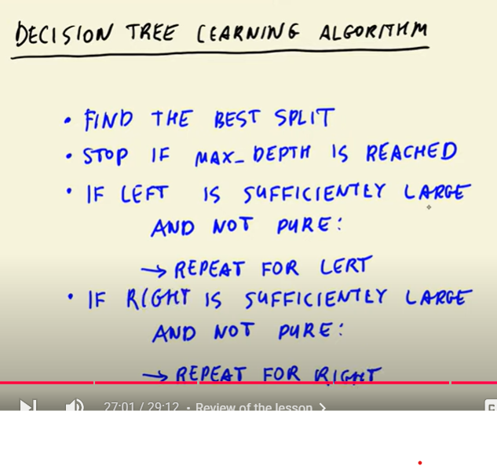

ML Zoomcamp 6.5 - Decision Trees Parameter Tuning
15

ML Zoomcamp 6.6 - Ensemble Learning and Random Forest

25
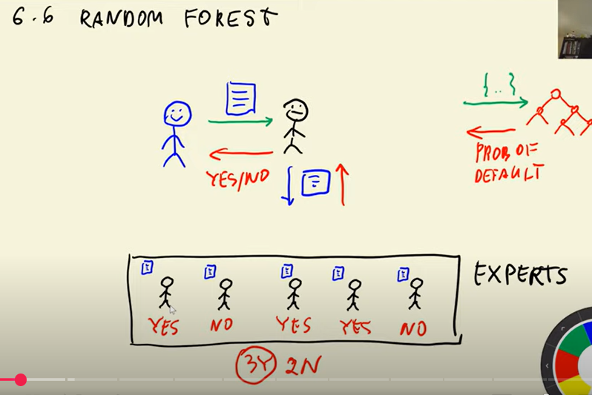

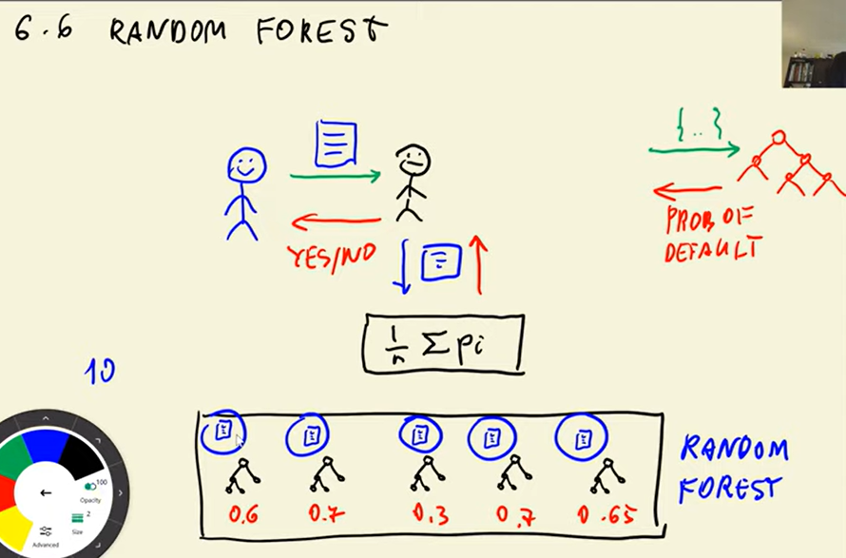

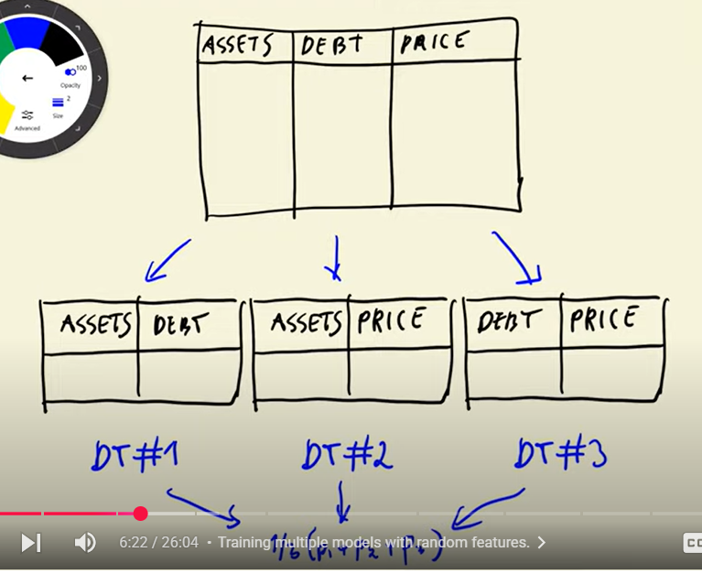

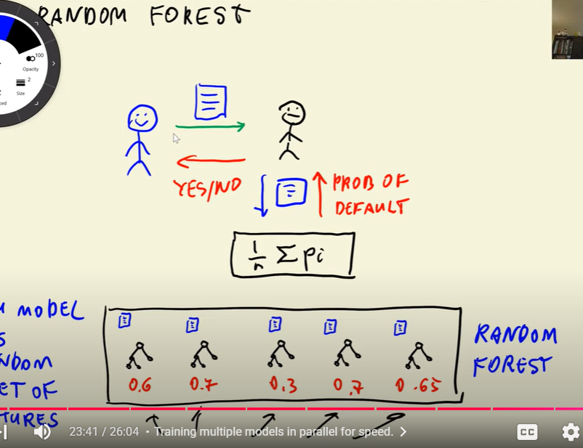

ML Zoomcamp 6.7 - Gradient Boosting and XGBoost

20

