workshop 2

https://github.com/DataTalksClub/data-engineering-zoomcamp/blob/main/cohorts/2024/workshops/rising-wave.md

https://github.com/risingwavelabs/risingwave-data-talks-workshop-2024-03-04/blob/main/workshop.md

Homework

Question 0:

What are the dropoff taxi zones at the latest dropoff times?

WITH latest_DO AS (SELECT max(profit_margin) max FROM sales)
SELECT product_name FROM products, max_profit
WHERE product_profit > max;

WITH latest_DO AS (SELECT max(tpep_dropoff_datetime) max FROM trip_data)
SELECT product_name FROM products, max_profit
WHERE product_profit > max;

WITH latest_DO AS (SELECT max(tpep_dropoff_datetime) FROM trip_data)
SELECT taxi_zone.Zone as pickup_zone, taxi_zone_1.Zone as dropoff_zone, tpep_pickup_datetime, tpep_dropoff_datetime
FROM trip_data
JOIN taxi_zone ON trip_data.PULocationID = taxi_zone.location_id
JOIN taxi_zone as taxi_zone_1 ON trip_data.DOLocationID = taxi_zone_1.location_id
WHERE tpep_dropoff_datetime =latest_DO ;

Question 1
Create a materialized view to compute the average, min and max trip time between each taxi zone.
Note that we consider the do not consider a->b and b->a as the same trip pair. So as an example, you would consider the following trip pairs as different pairs:

CREATE MATERIALIZED VIEW zones_trips_duration AS
SELECT taxi_zone.Zone as pickup_zone,
taxi_zone_1.Zone as dropoff_zone,
(tpep_dropoff_datetime-tpep_pickup_datetime) AS trip_duration
FROM trip_data
JOIN taxi_zone ON trip_data.PULocationID = taxi_zone.location_id
JOIN taxi_zone as taxi_zone_1 ON trip_data.DOLocationID = taxi_zone_1.location_id ;

CREATE MATERIALIZED VIEW zones_trips_duration_stats AS
SELECT
pickup_zone, dropoff_zone,
avg(trip_duration) AS avg_trip_duration,
min(trip_duration) AS min_trip_duration,
max(trip_duration) AS max_trip_duration
FROM
zones_trips_duration
GROUP BY pickup_zone, dropoff_zone;

dev=> describe zones_trips_duration_stats;
Name | Type | Is Hidden | Description
-------------------+----------------------------+-----------+-------------
pickup_zone | character varying | false |
dropoff_zone | character varying | false |
avg_trip_duration | interval | false |
min_trip_duration | interval | false |
max_trip_duration | interval | false |
primary key | pickup_zone, dropoff_zone | |
distribution key | pickup_zone, dropoff_zone | |
table description | zones_trips_duration_stats | |
(8 rows)

pickup_zone | dropoff_zone | avg_trip_duration | min_trip_duration | max_trip_duration
-------------------------------------+-------------------------------------+-------------------+-------------------+-------------------
Alphabet City | Astoria | 00:19:51 | 00:19:51 | 00:19:51
Alphabet City | Battery Park City | 00:10:29.333333 | 00:09:30 | 00:11:32
Alphabet City | Greenpoint | 00:18:45 | 00:18:45 | 00:18:45
Alphabet City | Midtown North | 00:19:23 | 00:19:23 | 00:19:23
Alphabet City | SoHo | 00:08:52 | 00:08:32 | 00:09:12
Alphabet City | Stuy Town/Peter Cooper Village | 00:06:31 | 00:06:05 | 00:06:57
Alphabet City | TriBeCa/Civic Center | 00:14:37 | 00:12:16 | 00:16:58
Astoria | Clinton East | 00:18:11 | 00:18:11 | 00:18:11
Astoria | Ridgewood | 00:44:12 | 00:44:12 | 00:44:12

select count(*) from zones_trips_duration_stats;
dev=> select count(*) from zones_trips_duration_stats;
count
-------
7397
(1 row)

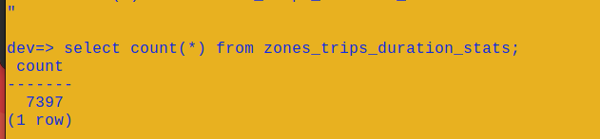
From this MV, find the pair of taxi zones with the highest average trip time. You may need to use the dynamic filter pattern for this.

select pickup_zone, dropoff_zone , avg_trip_duration from zones_trips_duration_stats order by avg_trip_duration desc ;

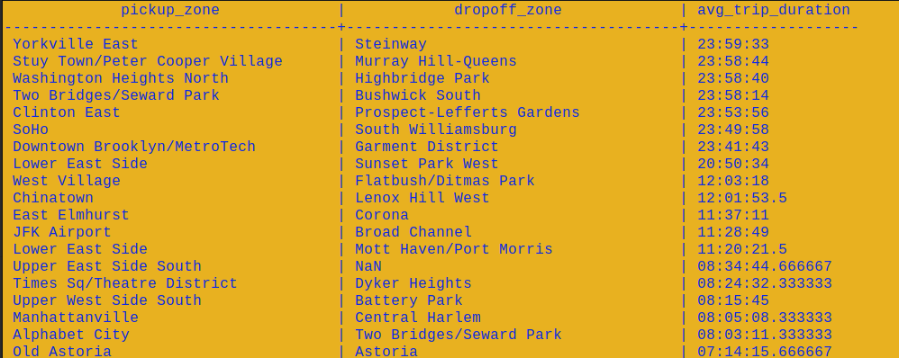

Options:
- Yorkville East, Steinway
- Murray Hill, Midwood
- East Flatbush/Farragut, East Harlem North
- Midtown Center, University Heights/Morris Heights

Question 2
Recreate the MV(s) in question 1, to also find the number of trips for the pair of taxi zones with the highest average trip time.
Options:
- 5
- 3
- 10
- 1

CREATE MATERIALIZED VIEW zones_trips_duration_count_stats_ AS
SELECT
pickup_zone, dropoff_zone,
avg(trip_duration) AS avg_trip_duration,
min(trip_duration) AS min_trip_duration,
max(trip_duration) AS max_trip_duration,
count() as cnt
FROM
zones_trips_duration
GROUP BY pickup_zone, dropoff_zone;

select pickup_zone, dropoff_zone , avg_trip_duration, cnt from zones_trips_duration_stats order by avg_trip_duration desc ;
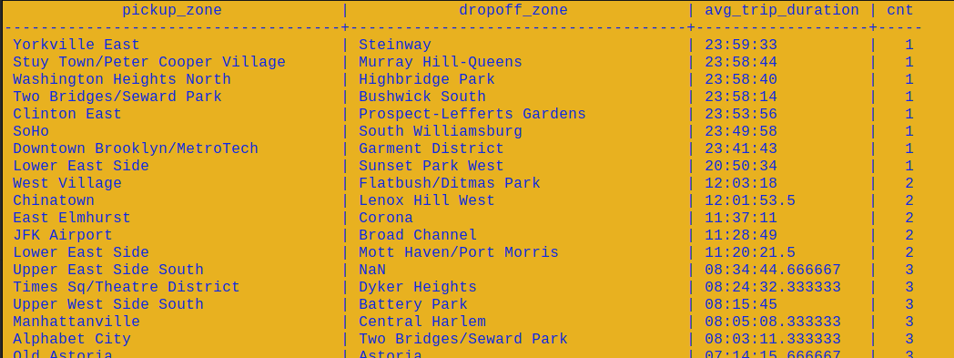

Question 3
From the latest pickup time to 17 hours before, what are the top 3 busiest zones in terms of number of pickups? For example if the latest pickup time is 2020-01-01 17:00:00, then the query should return the top 3 busiest zones from 2020-01-01 00:00:00 to 2020-01-01 17:00:00.
HINT: You can use dynamic filter pattern to create a filter condition based on the latest pickup time.
NOTE: For this question 17 hours was picked to ensure we have enough data to work with.
Options:
- Clinton East, Upper East Side North, Penn Station
- LaGuardia Airport, Lincoln Square East, JFK Airport
- Midtown Center, Upper East Side South, Upper East Side North
- LaGuardia Airport, Midtown Center, Upper East Side North

CREATE MATERIALIZED VIEW latest_pickup_time AS
WITH t AS (
SELECT MAX(tpep_pickup_datetime) AS latest_pickup_time
FROM trip_data
)
SELECT taxi_zone.Zone as taxi_zone, latest_pickup_time
FROM t, trip_data
JOIN taxi_zone
ON trip_data.pulocationid = taxi_zone.location_id
WHERE trip_data.tpep_pickup_datetime >= ( t.latest_pickup_time - INTERVAL '1' hour) ;

WHERE
'timestamp-column' > (NOW() - INTERVAL '1' MINUTE)

drop MATERIALIZED VIEW busiest_zones;
CREATE MATERIALIZED VIEW busiest_zones AS
WITH t AS (
SELECT MAX(tpep_pickup_datetime) AS latest_pickup_time
FROM trip_data
)
SELECT
taxi_zone.Zone AS pickup_zone,
count(*) AS last_pickup_cnt
FROM
t, trip_data
JOIN taxi_zone
ON trip_data.PULocationID = taxi_zone.location_id
WHERE
trip_data.tpep_pickup_datetime > (t.latest_pickup_time - INTERVAL '1020' MINUTE)
GROUP BY
taxi_zone.Zone;

ORDER BY last_pickup_cnt DESC ;

select * from busiest_zones order by last_pickup_cnt desc ;
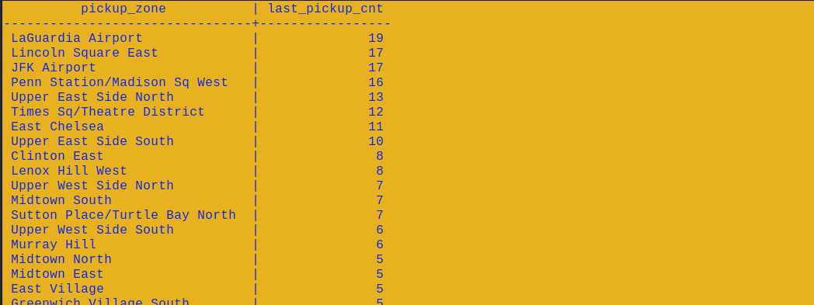
pickup_zone | last_pickup_cnt
--------------------------------+-----------------
LaGuardia Airport | 19
Lincoln Square East | 17
JFK Airport | 17
Penn Station/Madison Sq West | 16
Upper East Side North | 13
Times Sq/Theatre District | 12
East Chelsea | 11
Upper East Side South | 10

