

**DEBRE BIRHAN UNIVERSITY**

**COLLEGE OF COMPUTING**

**DEPARTMENT OF COMPUTER SCIENCE**

Course Title: Selected Topics in computer science

Course Code: CoSc4161

**Title of Project: -**property management system for DBU

GROUP_7

GROUP Members ID

1. Hanna Akalu……………………………………………………………………….1844/11

2. Tesfa Gebremedhin…………………………………………………………...1764/11

3. Bahiru Workineh………………………………………………………………..1632/11

4. Tadelech Bekele………………………………………………………………………1810/11

5. Samson Demeke…………………………………………………………………….3512/11

# 1. Introduction

property management system for DBU is giving an important service for the campus community. Property Management office is responsible for properly utilizing and maintaining all assets and equipment; Controls the loss, damage or misuse of property. All propertices are acquired from donation or supplier. These properties are distributed based on formal request forms. The current system gives vast service however it uses manual management system which leads the system to be inefficient. As part of the effort to bring efficient and modern property management system in DBU, a new system should be designed and implemented that enables properties to be controlled and managed properly. In this project a web based property management system is implemented in order to alleviate the problem of using manual system. This web based system helps to achieve fast, effective and high quality property management.

# 2. Objectives

The objective of our project is to develop web based Property management system for Debre Berhan University.

# 3. Existing System

## 3.1. Overview

➢The current system provides manual data processing mechanism.

➢The existing system is not providing an easy to use, fast and flexible way to manage property information properly.

➢This manual system is less efficient in managing properties information.

➢ Preparing and getting reports are time consuming and prone to error.

## 3.2. Users/Actors of the system

* Store Keeper
* Responsible for
* registering item
* view, update, delete item
* transfer item
* view approval
* register withdrawal item
* register returned item

# 4. Proposed System

## 4.1. Overview

The proposed system of property management system is developed in order to minimize the problem of the existing system. We will develop web based property management system for DBU, so the new system should be designed and implemented to know property’s information properly. Unlike the existing system the proposed system has main features like; registering new property, view property information, search property. The main aim of the proposed system is in order to improve the existing problem like reduce the redundancy of data, manage property in efficient manner, store data into the server so it can be easily retrieved, it has less chance in data loss and used at any time, provide highly security to data and decrease human labor that interacts with the system.

## 4.2. Functional Requirements

The new system expected to have the following functionalities: -

* Item information management.
* Recording item details.
* Managing item.
* Distribute items.
* Registering withdrawal item.
* Registering returned item.
* Viewing approval.

## 4.3. Use Case Model

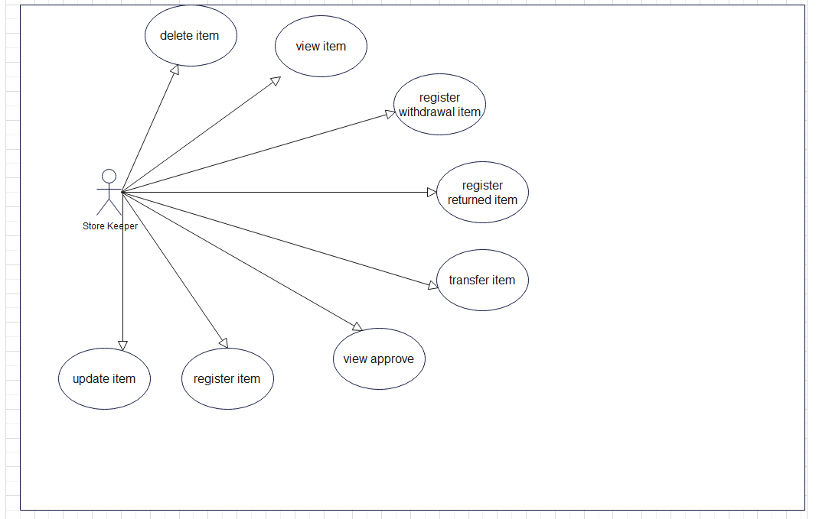

Figure 1:Use Case Diagram

# 4.4. Class Diagram

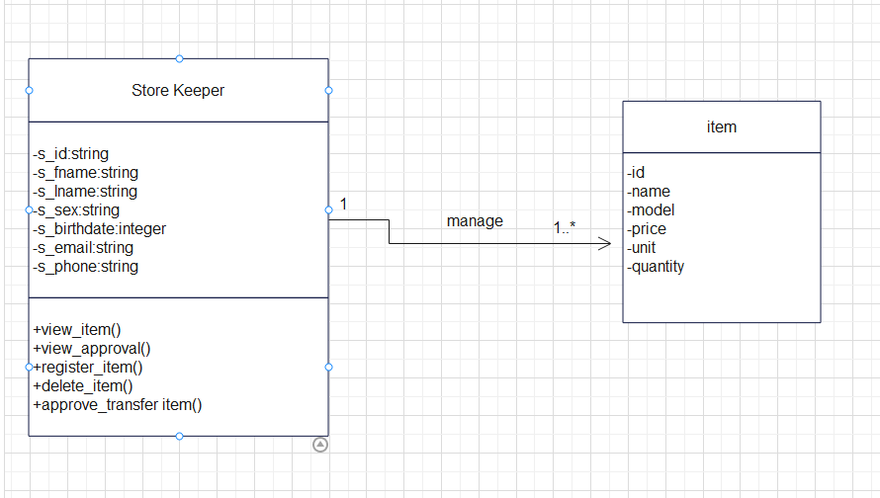

Figure 2 class diagram

## 4.5User Interface mock-up

User interface prototyping is an iterative analysis technique in which people participate actively in the creation of a system's user interface. It allows you to investigate the system's problem domain and solution space. It's all about modeling the system before putting it into practice. It allows user interface designers to compare the user's expected functionalities with the system model and obtain input from the user on whether the system model is appropriate.

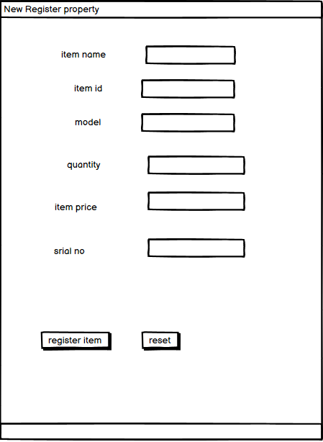

Figure 3 register item Interface

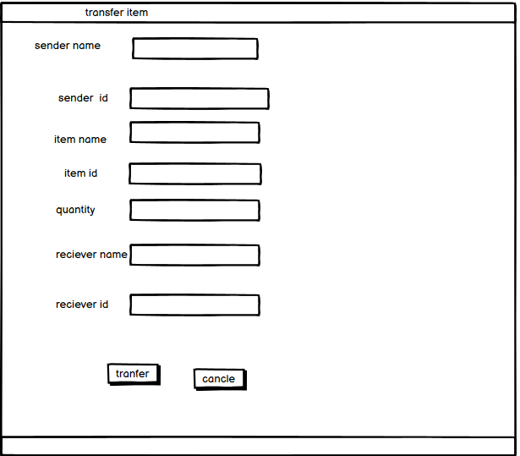

Figure 4 transfer item Interface

## 4.6 Database design

Physical database design translates the logical data model into a set of SQL statements that define the database. For relational database systems, it is relatively easy to translate from a logical data model into a physical database.

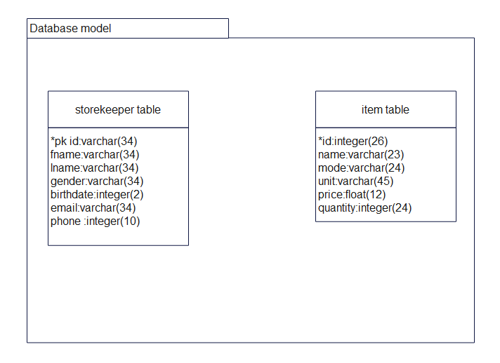

*Figure 4 Database design*