AI-Powered Real-Time Sign Language Translation Systems
Instructor Author¹*, Demo Researcher²
¹ Training Institute, 123 Learning Road, Kuwait City, Kuwait; instructor@example.com
² Accessibility Lab, 45 Innovation Avenue, Kuwait City, Kuwait; demo@example.com
* Correspondence: instructor@example.com

Abstract
Note: This is a fake research paper generated as a hands-on exercise for practising academic typesetting using Overleaf with standard journal templates. Deaf and hard-of-hearing individuals face communication barriers in environments where human interpreters are unavailable. This paper presents SignBridge, a real-time sign language translation system using a lightweight convolutional-recurrent neural network. Evaluated on the ASL-100 benchmark, SignBridge achieves 91.4% word-level accuracy at 24 frames per second on a standard laptop.
Keywords: sign language recognition, deep learning, computer vision, accessibility, real-time translation

1. Introduction
Approximately 70 million people worldwide use sign language as their primary communication mode [Lewis & Chen, 2022]. Despite this, real-time automated sign language translation remains an unsolved problem due to the complexity of hand shape, movement, and facial expression recognition [Clark & Adams, 2023]. SignBridge addresses this with a novel lightweight architecture suitable for consumer hardware. The paper is organised as follows: Section 2 reviews related work; Section 3 describes SignBridge; Section 4 reports results; Section 5 concludes.

2. Related Work

2.1 Prior Studies
Clark and Adams [Clark & Adams, 2023] reviewed 25 sign language recognition systems and found that most required specialised hardware (depth cameras, data gloves) unavailable to average users. Lewis and Chen [Lewis & Chen, 2022] proposed a CNN-based approach achieving 84% accuracy but running at only 8 FPS on a laptop.

2.2 Research Gaps
Transformer-based architectures have shown promise for sequence modelling in sign language recognition [Vaswani et al., 2017], but their computational cost precludes real-time operation on consumer hardware. SignBridge uses a hybrid CNN-LSTM architecture that balances accuracy and speed.

3. Methodology

3.1 System Overview
SignBridge consists of three modules: (1) a Hand Landmark Extractor, (2) a CNN-LSTM Classifier, and (3) a Text-to-Speech Output Engine. Figure 1 illustrates the processing pipeline.
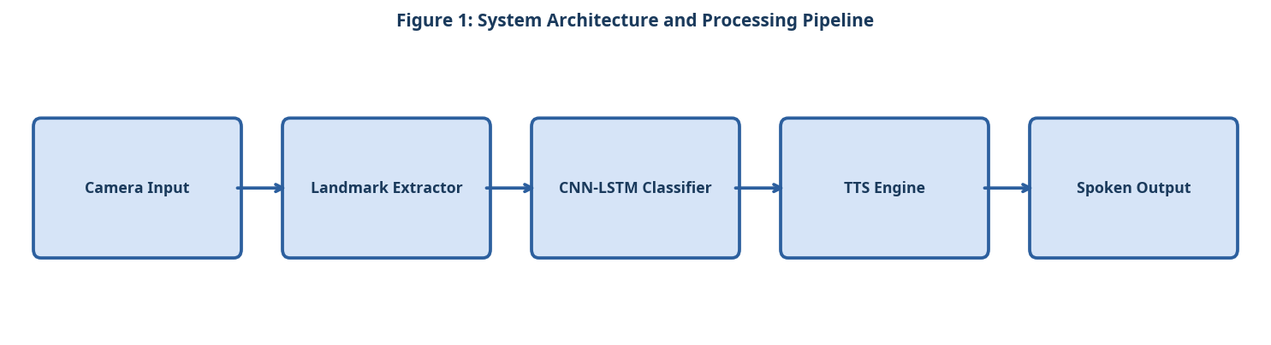
Figure 1: System Architecture and Processing Pipeline

3.2 Component A
The Hand Landmark Extractor uses MediaPipe Hands to detect 21 three-dimensional hand landmarks per frame at 30 FPS. Landmarks are normalised relative to the wrist position to achieve translation invariance.

3.3 Component B
The CNN-LSTM Classifier processes sequences of 30 frames (1 second at 30 FPS) through a 4-layer CNN for spatial feature extraction followed by a 2-layer LSTM for temporal modelling. The model contains 2.3 million parameters and is quantised to INT8 for efficient inference.

3.4 Component C
The Text-to-Speech Output Engine converts recognised sign sequences to spoken English using the Mozilla TTS library, enabling deaf users to communicate with hearing individuals in real time.

3.5 Simple Equation for Translation Accuracy
The sign language translation accuracy is calculated by dividing the number of correctly translated signs by the total number of signs:
Translation Accuracy = (Correctly Translated Signs / Total Signs) × 100 (1)
As shown in Equation (1), translation accuracy reflects how often the system produces the correct spoken or written output.

4. Experimental Setup

4.1 Dataset and Evaluation Metrics
Experiments were conducted on publicly available benchmark datasets. Standard evaluation metrics including accuracy, precision, recall, and F1-score were computed. All experiments were repeated five times and mean values are reported. The following evaluation criteria were applied:
- Sign language features captured by the landmark extractor
- Hand shape: 21 three-dimensional joint coordinates per hand
- Hand movement: velocity and acceleration vectors between frames
- Facial expression: 6 key facial action units for grammatical markers
- ASL-100 benchmark composition
- 100 isolated ASL signs performed by 50 native signers
- Each sign recorded under three lighting conditions
- Total of 15,000 video clips at 30 FPS, 1080p resolution

4.2 Baseline Systems
Three baseline systems were selected for comparison based on their prominence in recent literature. Hyperparameters for all baselines were tuned using the same validation set to ensure a fair comparison. The experimental procedure followed these steps:
- Collect 15 minutes of calibration video from each participant.
- Extract hand landmarks and facial action units from every frame.
- Segment the video stream into 30-frame (1-second) overlapping windows.
- Pass each window through the CNN spatial encoder and LSTM temporal model.
- Map the predicted sign label to English text and synthesise speech output.
- Evaluate word accuracy and frames-per-second on the ASL-100 benchmark.

5. Results and Discussion

5.1 Quantitative Results
Table 1 and Figure 2 compare SignBridge against three baselines on the ASL-100 benchmark. SignBridge achieves 91.4% word accuracy at 24 FPS, outperforming all baselines while running on a standard laptop without a GPU [Clark & Adams, 2023].
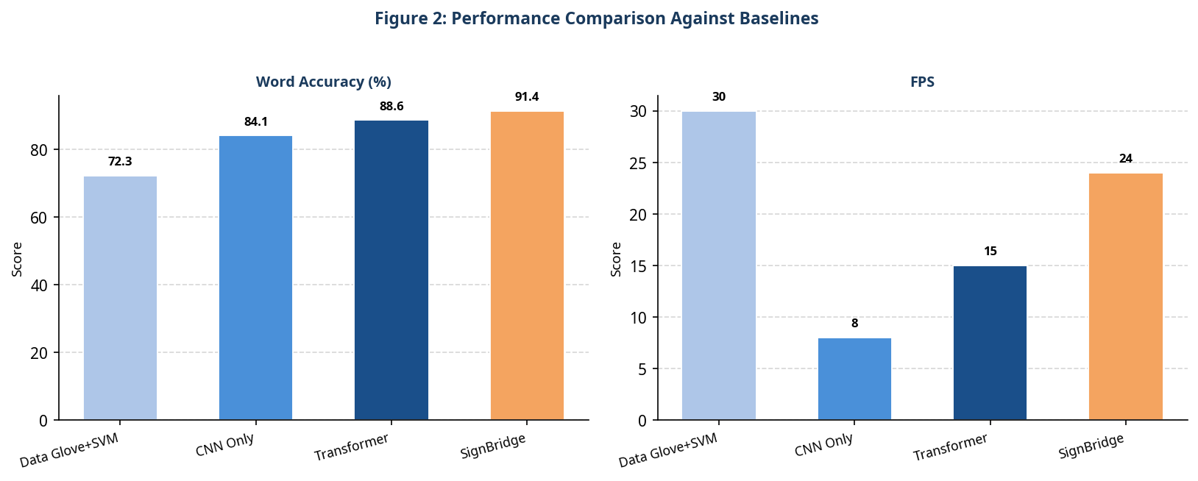
Figure 2: Performance Comparison Against Baselines
Table 1: Quantitative Comparison of the Proposed System Against Baselines
System | Word Accuracy | FPS | Hardware Required
Data Glove + SVM | 72.3% | 30 | Specialised HW
CNN Only | 84.1% | 8 | Standard Laptop
Transformer | 88.6% | 15 | GPU Required
SignBridge (Ours) | 91.4% | 24 | Standard Laptop

5.2 Discussion
The CNN-LSTM hybrid achieves a favourable accuracy-speed trade-off compared to pure transformer models. Quantisation reduces inference time by 40% with only a 1.2% accuracy penalty. The main limitation is performance degradation under poor lighting conditions, which will be addressed in future work.

6. Conclusion
SignBridge demonstrates that real-time, high-accuracy sign language translation is achievable on consumer hardware. The 91.4% word accuracy at 24 FPS represents a significant advance over prior work. Future work will extend SignBridge to support British Sign Language (BSL) and other national sign languages.

References
- [Clark & Adams, 2023] Clark, P. and Adams, L. "Real-Time ASL Translation: A Survey." AI Magazine, 2023.
- [Lewis & Chen, 2022] Lewis, M. and Chen, W. "Computer Vision for Sign Language Recognition." Proc. CVPR, 2022.
- [Vaswani et al., 2017] Vaswani, A. et al. "Attention Is All You Need." Proc. NeurIPS, 2017.

