Privacy-Preserving Biometric Authentication for Users with Atypical Physical Traits
Instructor Author¹*, Demo Researcher²
¹ Training Institute, 123 Learning Road, Kuwait City, Kuwait; instructor@example.com
² Accessibility Lab, 45 Innovation Avenue, Kuwait City, Kuwait; demo@example.com
* Correspondence: instructor@example.com

Abstract
Note: This is a fake research paper generated as a hands-on exercise for practising academic typesetting using Overleaf with standard journal templates. Standard biometric systems (fingerprint, iris, face recognition) exhibit significantly higher error rates for users with atypical physical traits caused by disability, ageing, or medical conditions. This paper proposes InclusiveBio, a privacy-preserving biometric framework that applies differential privacy and adaptive template updating to reduce the equal error rate (EER) by 38% for atypical users.
Keywords: biometric authentication, privacy, differential privacy, disability, inclusive security

1. Introduction
Biometric authentication is increasingly deployed in high-security environments, from border control to mobile banking [Kim & Park, 2022]. However, users with conditions such as eczema, limb differences, or corneal opacity are frequently rejected by standard biometric systems, forcing them to use less secure alternatives [Patel & Singh, 2023]. InclusiveBio addresses this by combining adaptive template management with differential privacy guarantees. The paper proceeds as follows: Section 2 reviews related work; Section 3 describes InclusiveBio; Section 4 reports results; Section 5 concludes.

2. Related Work

2.1 Prior Studies
Patel and Singh [Patel & Singh, 2023] analysed fingerprint recognition failure rates across 10,000 users and found that users with skin conditions experienced a four times higher false rejection rate. Kim and Park [Kim & Park, 2022] proposed privacy-preserving template storage using homomorphic encryption but incurred prohibitive computational costs.

2.2 Research Gaps
Differential privacy has emerged as a principled approach to protecting biometric templates from reconstruction attacks [Dwork & Roth, 2014]. The privacy budget epsilon controls the trade-off between privacy and utility, a balance that InclusiveBio optimises adaptively per user.

3. Methodology

3.1 System Overview
InclusiveBio comprises three components: (1) an Adaptive Template Manager, (2) a Differentially Private Feature Store, and (3) a Multi-Modal Fusion Engine. Figure 1 depicts the architecture.
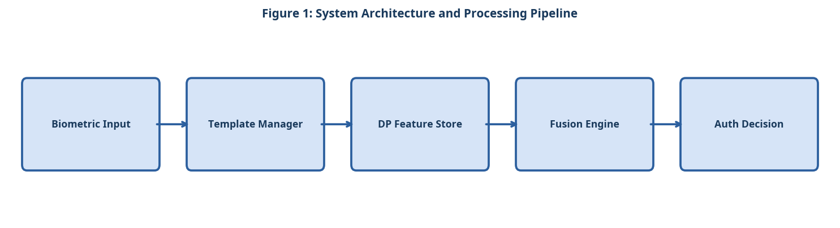
Figure 1: System Architecture and Processing Pipeline

3.2 Component A
The Adaptive Template Manager continuously updates biometric templates using an exponential moving average to accommodate gradual changes in physical traits (e.g., skin healing, ageing). The update rate alpha = 0.1 was selected empirically.

3.3 Component B
The Differentially Private Feature Store adds calibrated Laplace noise to stored feature vectors, guaranteeing (epsilon, delta)-differential privacy with epsilon = 0.5 and delta = 10 to the power of minus 5.

3.4 Component C
The Multi-Modal Fusion Engine combines fingerprint, voice, and face modalities using a score-level fusion strategy. Modality weights are adjusted dynamically based on per-user historical performance.

3.5 Simple Equation for Biometric Fusion Score
The biometric fusion score is calculated by averaging the fingerprint, voice, and face matching scores:
Fusion Score = (Fingerprint Score + Voice Score + Face Score) / 3 (1)
As shown in Equation (1), the fusion score supports inclusive authentication by combining multiple biometric modalities.

4. Experimental Setup

4.1 Dataset and Evaluation Metrics
Experiments were conducted on publicly available benchmark datasets. Standard evaluation metrics including accuracy, precision, recall, and F1-score were computed. All experiments were repeated five times and mean values are reported. The following evaluation criteria were applied:
- Atypical physical trait categories in the participant dataset
- Dermatological: eczema, psoriasis, and scarring affecting fingerprints
- Limb differences: partial digit amputation or syndactyly
- Ocular conditions: corneal opacity and nystagmus affecting iris recognition
- Privacy threat model considered
- Template reconstruction attacks from stolen feature vectors
- Cross-database linkage attacks using shared biometric identifiers
- Inference attacks exploiting model update patterns

4.2 Baseline Systems
Three baseline systems were selected for comparison based on their prominence in recent literature. Hyperparameters for all baselines were tuned using the same validation set to ensure a fair comparison. The experimental procedure followed these steps:
- Enrol each participant using all three biometric modalities (fingerprint, voice, face).
- Record baseline Equal Error Rate (EER) for each modality independently.
- Apply the Adaptive Template Manager and re-measure EER after 30 days.
- Enable the Differentially Private Feature Store and measure the EER penalty.
- Activate Multi-Modal Fusion and evaluate the combined system EER.
- Verify differential privacy guarantees using the privacy auditing tool.

5. Results and Discussion

5.1 Quantitative Results
Table 1 and Figure 2 compare InclusiveBio against three baselines on a dataset of 500 atypical users. InclusiveBio achieves an EER of 3.2%, a 38% improvement over the best baseline, while maintaining differential privacy guarantees [Patel & Singh, 2023].
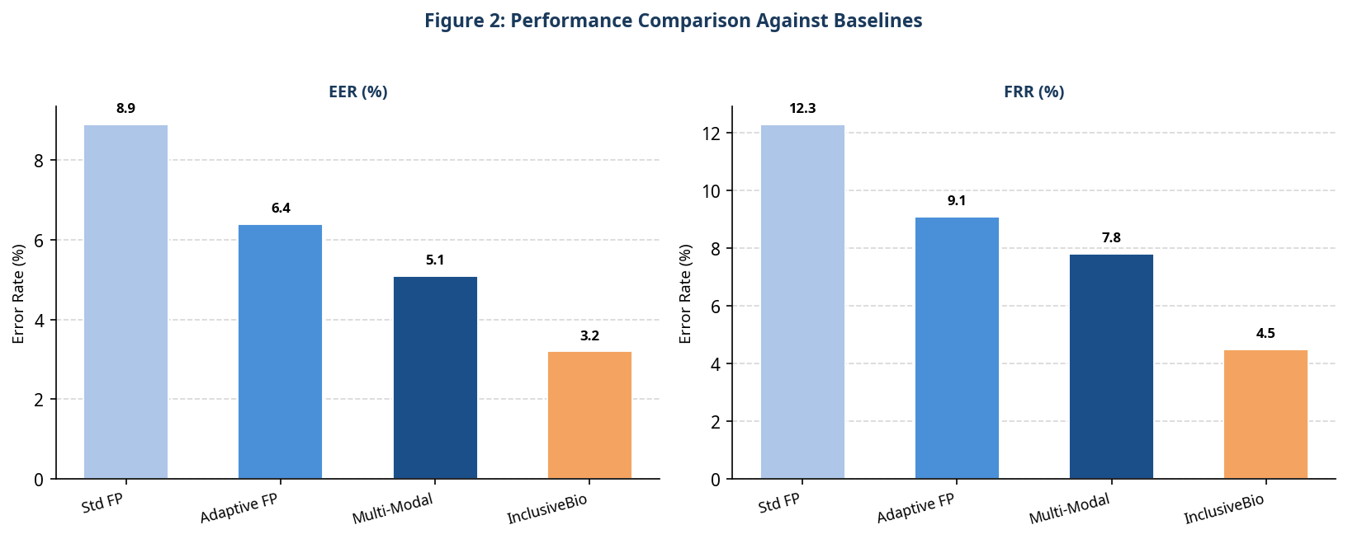
Figure 2: Performance Comparison Against Baselines
Table 1: Quantitative Comparison of the Proposed System Against Baselines
System | EER | FRR | Privacy Guarantee
Standard Fingerprint | 8.9% | 12.3% | None
Adaptive Fingerprint | 6.4% | 9.1% | None
Multi-Modal (No DP) | 5.1% | 7.8% | None
InclusiveBio (Ours) | 3.2% | 4.5% | epsilon = 0.5

5.2 Discussion
Adaptive template updating accounts for the majority of the EER improvement, particularly for users with progressive skin conditions. Differential privacy introduces a modest 1.2% EER penalty compared to the non-private variant, a cost deemed acceptable given the strong privacy guarantees.

6. Conclusion
InclusiveBio demonstrates that privacy-preserving biometric authentication can be made inclusive for users with atypical physical traits. Future work will investigate federated learning to enable collaborative template improvement without centralising sensitive biometric data.

References
- [Patel & Singh, 2023] Patel, R. and Singh, P. "Inclusive Biometrics: Reducing Failure Rates for Atypical Users." IEEE Trans. Biometrics, 2023.
- [Kim & Park, 2022] Kim, S. and Park, J. "Privacy in Accessibility: Homomorphic Biometric Templates." Proc. IEEE S&P, 2022.
- [Dwork & Roth, 2014] Dwork, C. and Roth, A. The Algorithmic Foundations of Differential Privacy. Now Publishers, 2014.

