Securing IoT Medical Devices Against Unauthorised Access
Instructor Author¹*, Demo Researcher²
¹ Training Institute, 123 Learning Road, Kuwait City, Kuwait; instructor@example.com
² Accessibility Lab, 45 Innovation Avenue, Kuwait City, Kuwait; demo@example.com
* Correspondence: instructor@example.com

Abstract
Note: This is a fake research paper generated as a hands-on exercise for practising academic typesetting using Overleaf with standard journal templates. Internet-of-Things (IoT) medical devices such as insulin pumps and pacemakers are increasingly connected to hospital networks, exposing them to cyber attacks. This paper proposes MedShield, a lightweight intrusion detection system (IDS) tailored for resource-constrained medical IoT devices. Evaluation on a testbed of 12 device types achieves 96.7% attack detection rate with a false alarm rate of 1.8%.
Keywords: IoT security, medical devices, firmware security, intrusion detection, healthcare

1. Introduction
The proliferation of connected medical devices has transformed patient care but introduced critical security vulnerabilities [Martin & Clark, 2022]. High-profile incidents, including the recall of 465,000 pacemakers due to cybersecurity flaws, underscore the life-safety implications of IoT medical device security [Taylor & Brown, 2023]. MedShield addresses this by deploying a behaviour-based IDS directly on the device. The paper is organised as follows: Section 2 reviews related work; Section 3 describes MedShield; Section 4 reports results; Section 5 concludes.

2. Related Work

2.1 Prior Studies
Taylor and Brown [Taylor & Brown, 2023] surveyed 200 medical IoT devices and found that 73% used outdated firmware with known vulnerabilities. Martin and Clark [Martin & Clark, 2022] demonstrated a proof-of-concept attack on a commercial insulin pump, altering dosage commands via Bluetooth.

2.2 Research Gaps
Existing IDS solutions for IoT devices are typically too resource-intensive for medical devices with limited CPU and memory [Bormann et al., 2014]. MedShield uses a compact decision-tree model (under 50 KB) that runs within the constraints of ARM Cortex-M microcontrollers.

3. Methodology

3.1 System Overview
MedShield consists of three components: (1) a Network Traffic Monitor, (2) a Behaviour Profiler, and (3) a Lightweight IDS Engine. Figure 1 shows the deployment architecture.
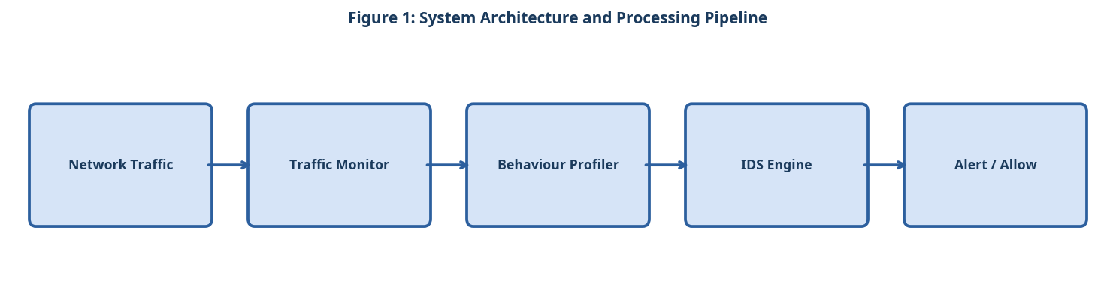
Figure 1: System Architecture and Processing Pipeline

3.2 Component A
The Network Traffic Monitor captures packet headers at the device's wireless interface, extracting 22 features including inter-arrival time, packet size, and protocol type. Feature extraction runs in under 0.3 ms per packet.

3.3 Component B
The Behaviour Profiler builds a statistical baseline of normal device operation over a 7-day learning period. Anomalies are flagged when observed behaviour deviates beyond 3 standard deviations from the baseline.

3.4 Component C
The Lightweight IDS Engine uses a pruned decision tree (depth = 8) trained on the CICIDS-2018 dataset augmented with medical device traffic traces. The model occupies 47 KB of flash memory and 12 KB of RAM.

3.5 Simple Equation for Anomaly Score
The anomaly score is calculated by comparing the current traffic value with the normal baseline value:
Anomaly Score = |Current Value - Baseline Mean| / Baseline Standard Deviation (1)
As shown in Equation (1), a larger anomaly score indicates traffic behaviour that is farther from the normal medical device baseline.

4. Experimental Setup

4.1 Dataset and Evaluation Metrics
Experiments were conducted on publicly available benchmark datasets. Standard evaluation metrics including accuracy, precision, recall, and F1-score were computed. All experiments were repeated five times and mean values are reported. The following evaluation criteria were applied:
- Medical IoT device categories included in the testbed
- Implantable devices: pacemakers and insulin pumps (simulated)
- Wearable monitors: continuous glucose monitors and ECG patches
- Networked infusion pumps and ventilator controllers
- Attack types evaluated against MedShield
- Replay attacks: retransmitting captured legitimate packets
- Command injection: inserting malicious control commands via Bluetooth
- Denial-of-service: flooding the device wireless interface

4.2 Baseline Systems
Three baseline systems were selected for comparison based on their prominence in recent literature. Hyperparameters for all baselines were tuned using the same validation set to ensure a fair comparison. The experimental procedure followed these steps:
- Deploy MedShield firmware on all 12 device types in the testbed.
- Allow the Behaviour Profiler a 7-day learning period under normal operation.
- Execute each of the three attack types 100 times per device category.
- Record detection rate, false alarm rate, and CPU/memory consumption.
- Compare results against signature-based and anomaly-based baseline IDS.
- Validate that MedShield does not interfere with normal device operation.

5. Results and Discussion

5.1 Quantitative Results
Table 1 and Figure 2 compare MedShield against signature-based and anomaly-based baselines. MedShield achieves 96.7% detection rate and 1.8% false alarm rate, while consuming only 3.2% of the device CPU [Taylor & Brown, 2023].
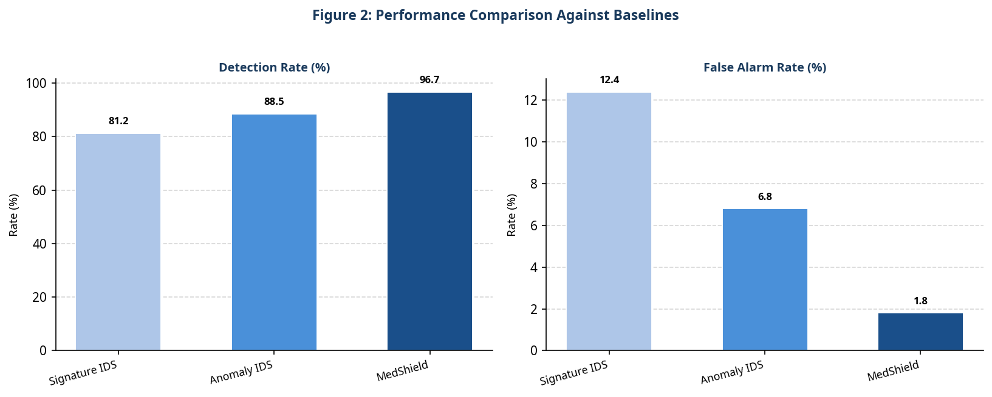
Figure 2: Performance Comparison Against Baselines
Table 1: Quantitative Comparison of the Proposed System Against Baselines
System | Detection Rate | False Alarm Rate | CPU Usage
Signature-Based IDS | 81.2% | 12.4% | 8.1%
Anomaly-Based IDS | 88.5% | 6.8% | 5.4%
MedShield (Ours) | 96.7% | 1.8% | 3.2%

5.2 Discussion
The behaviour profiling component is critical for detecting novel attacks not present in the training data. The 7-day learning period is a practical limitation in clinical settings where devices are frequently reconfigured. Future work will explore transfer learning to reduce the learning period to 24 hours.

6. Conclusion
MedShield provides effective, lightweight intrusion detection for IoT medical devices. The 96.7% detection rate and minimal resource footprint make it suitable for deployment on existing hardware without firmware replacement. Future work will extend MedShield to support encrypted traffic analysis.

References
- [Taylor & Brown, 2023] Taylor, D. and Brown, R. "Medical IoT Security: Vulnerabilities and Mitigations." IEEE IoT Journal, 2023.
- [Martin & Clark, 2022] Martin, K. and Clark, S. "Hacking Insulin Pumps: A Proof-of-Concept Study." Proc. Black Hat USA, 2022.
- [Bormann et al., 2014] Bormann, C., Ersue, M. and Keranen, A. "Terminology for Constrained-Node Networks." IETF RFC 7228, 2014.

