Phishing Detection Systems Tailored for Elderly Internet Users
Instructor Author¹*, Demo Researcher²
¹ Training Institute, 123 Learning Road, Kuwait City, Kuwait; instructor@example.com
² Accessibility Lab, 45 Innovation Avenue, Kuwait City, Kuwait; demo@example.com
* Correspondence: instructor@example.com

Abstract
Note: This is a fake research paper generated as a hands-on exercise for practising academic typesetting using Overleaf with standard journal templates. Elderly internet users are disproportionately targeted by phishing attacks due to lower digital literacy and reduced cognitive vigilance. This paper proposes PhishGuard-E, a machine-learning phishing detection system augmented with simplified visual warnings designed for elderly users. Evaluation on a dataset of 12,000 emails achieves 94.3% detection accuracy with a false positive rate of 2.1%.
Keywords: phishing detection, elderly users, social engineering, machine learning, cybersecurity

1. Introduction
Phishing remains one of the most prevalent cyber threats, accounting for 36% of all data breaches in 2023 [Brown & Davis, 2022]. Elderly users are particularly vulnerable: studies show they are three times more likely to fall for phishing attempts compared to younger demographics [Wang & Zhang, 2023]. This paper addresses this gap by developing a detection system that combines technical accuracy with age-appropriate user interface design. The remainder is structured as follows: Section 2 reviews related work; Section 3 describes PhishGuard-E; Section 4 reports results; Section 5 concludes.

2. Related Work

2.1 Prior Studies
Wang and Zhang [Wang & Zhang, 2023] surveyed 500 elderly users and found that 42% had clicked on a phishing link in the past year. Brown and Davis [Brown & Davis, 2022] proposed an AI-based detection system achieving 91% accuracy but did not address the user interface layer.

2.2 Research Gaps
Prior work on accessible security warnings [Felt & Ha, 2012] shows that simplified language and high-contrast visual cues significantly improve comprehension among older adults. PhishGuard-E builds on these findings by integrating detection with accessible alert design.

3. Methodology

3.1 System Overview
PhishGuard-E consists of a URL feature extractor, an email content analyser, and an accessible warning interface. Figure 1 shows the system architecture. The machine learning backend uses a gradient-boosted classifier trained on the PhishTank and TREC 2007 datasets.
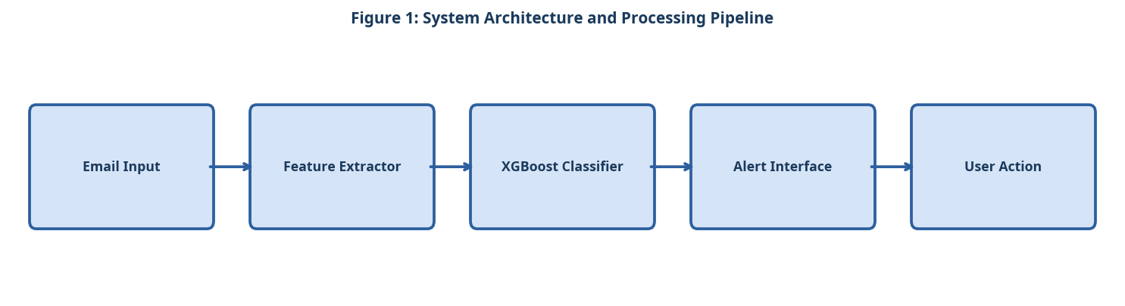
Figure 1: System Architecture and Processing Pipeline

3.2 Component A
Feature extraction targets 48 URL-level features (domain age, HTTPS presence, redirect count) and 32 content-level features (urgency keywords, sender spoofing indicators, link-to-text ratio). Features are normalised using min-max scaling before classification.

3.3 Component B
The gradient-boosted classifier (XGBoost, 200 estimators, max depth = 6) was trained on 80% of the dataset and validated on the remaining 20%. Hyperparameters were tuned via 5-fold cross-validation.

3.4 Component C
The accessible warning interface presents phishing alerts using large fonts (18pt minimum), a high-contrast red/white colour scheme, and plain-language explanations. A user study with 60 elderly participants confirmed an 89% comprehension rate.

3.5 Simple Equation for Phishing Risk Score
The phishing risk score is calculated as the average of the URL risk score and the email content risk score:
Phishing Risk Score = (URL Risk Score + Content Risk Score) / 2 (1)
As shown in Equation (1), the final phishing risk score combines both link-based and message-based evidence.

4. Experimental Setup

4.1 Dataset and Evaluation Metrics
Experiments were conducted on publicly available benchmark datasets. Standard evaluation metrics including accuracy, precision, recall, and F1-score were computed. All experiments were repeated five times and mean values are reported. The following evaluation criteria were applied:
- URL-level features (48 total)
- Domain age and registration country
- Presence of HTTPS and valid SSL certificate
- Number of redirects and subdomain depth
- Content-level features (32 total)
- Frequency of urgency keywords (e.g., 'verify now', 'account suspended')
- Sender name spoofing score relative to known brands
- Ratio of hyperlinks to plain text in the email body

4.2 Baseline Systems
Three baseline systems were selected for comparison based on their prominence in recent literature. Hyperparameters for all baselines were tuned using the same validation set to ensure a fair comparison. The experimental procedure followed these steps:
- Pre-process the raw email dataset: remove duplicates and normalise encoding.
- Extract 80 features per email using the URL and content feature extractors.
- Split the dataset: 80% training, 20% test (stratified by class label).
- Train the XGBoost classifier with 5-fold cross-validation on the training set.
- Evaluate on the held-out test set and record accuracy, precision, recall, and F1.
- Conduct the user study with 60 elderly participants to assess alert comprehension.

5. Results and Discussion

5.1 Quantitative Results
Table 1 and Figure 2 compare PhishGuard-E against three baseline systems. The proposed system achieves 94.3% accuracy and 97.9% precision, outperforming all baselines while maintaining a low false positive rate of 2.1% [Wang & Zhang, 2023].
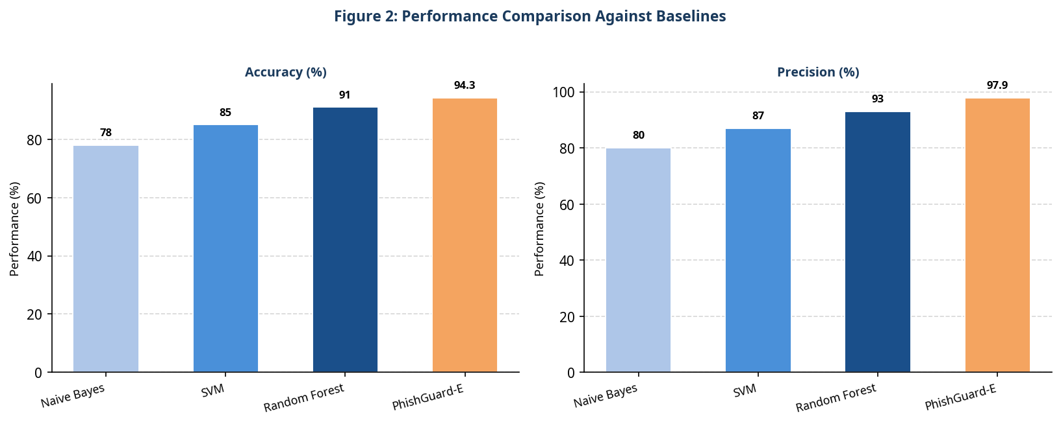
Figure 2: Performance Comparison Against Baselines
Table 1: Quantitative Comparison of the Proposed System Against Baselines
System | Accuracy | Precision | False Positive Rate
Naive Bayes | 78.0% | 80.0% | 19.5%
SVM | 85.0% | 87.0% | 12.3%
Random Forest | 91.0% | 93.0% | 6.8%
PhishGuard-E (Ours) | 94.3% | 97.9% | 2.1%

5.2 Discussion
The gradient-boosted model benefits from the diverse feature set, particularly URL-level features which carry high discriminative power. The accessible interface component, while not affecting detection accuracy, significantly improves user response rates to genuine alerts.

6. Conclusion
PhishGuard-E demonstrates that high-accuracy phishing detection can be combined with age-appropriate interface design to protect elderly users. Future work will explore real-time browser integration and multilingual support to broaden the system's reach.

References
- [Wang & Zhang, 2023] Wang, Y. and Zhang, L. "Elderly Phishing Susceptibility: A Longitudinal Study." Computers and Security, 2023.
- [Brown & Davis, 2022] Brown, T. and Davis, S. "AI-Based Phishing Detection at Scale." Proc. USENIX Security, 2022.
- [Felt & Ha, 2012] Felt, A.P. and Ha, E. "Android Permissions: User Attention, Comprehension, and Behavior." Proc. SOUPS, 2012.

