Haptic Feedback Interface Design for Deaf-Blind Communication
Instructor Author¹*, Demo Researcher²
¹ Training Institute, 123 Learning Road, Kuwait City, Kuwait; instructor@example.com
² Accessibility Lab, 45 Innovation Avenue, Kuwait City, Kuwait; demo@example.com
* Correspondence: instructor@example.com

Abstract
Note: This is a fake research paper generated as a hands-on exercise for practising academic typesetting using Overleaf with standard journal templates. Deaf-blind individuals rely on tactile communication methods such as Braille and hand-over-hand signing, which are slow and require a human intermediary. This paper presents TactileLink, a wearable haptic interface that encodes text and alerts into vibrotactile patterns on the forearm. A user study with 20 deaf-blind participants demonstrates a communication throughput of 42 characters per minute, a three-fold improvement over refreshable Braille displays.
Keywords: haptic feedback, deaf-blind, Braille, tactile communication, assistive technology

1. Introduction
Approximately 0.2% of the global population is deaf-blind, facing extreme isolation due to the lack of suitable communication technology [White & Green, 2022]. Refreshable Braille displays, the current standard, are expensive (USD 3,000 to 15,000) and limited to linear text output [Nguyen & Tran, 2023]. TactileLink proposes a low-cost (USD 120) wearable alternative using an array of vibration motors. The paper is organised as follows: Section 2 reviews related work; Section 3 describes TactileLink; Section 4 reports results; Section 5 concludes.

2. Related Work

2.1 Prior Studies
Nguyen and Tran [Nguyen & Tran, 2023] reviewed 15 haptic communication devices and found that most were limited to simple binary alerts. White and Green [White & Green, 2022] developed a glove-based system achieving 28 characters per minute but requiring complex hand gestures that fatigued users.

2.2 Research Gaps
Vibrotactile pattern encoding has been studied for notification systems [MacLean & Enriquez, 2008], but encoding full character sets remains challenging due to the limited spatial resolution of tactile perception. TactileLink uses a novel 6-motor forearm array that maps to Braille cell positions.

3. Methodology

3.1 System Overview
TactileLink consists of a wearable forearm band with 6 vibration motors, a Bluetooth controller, and a smartphone app for text input. Figure 1 illustrates the hardware layout and encoding scheme.
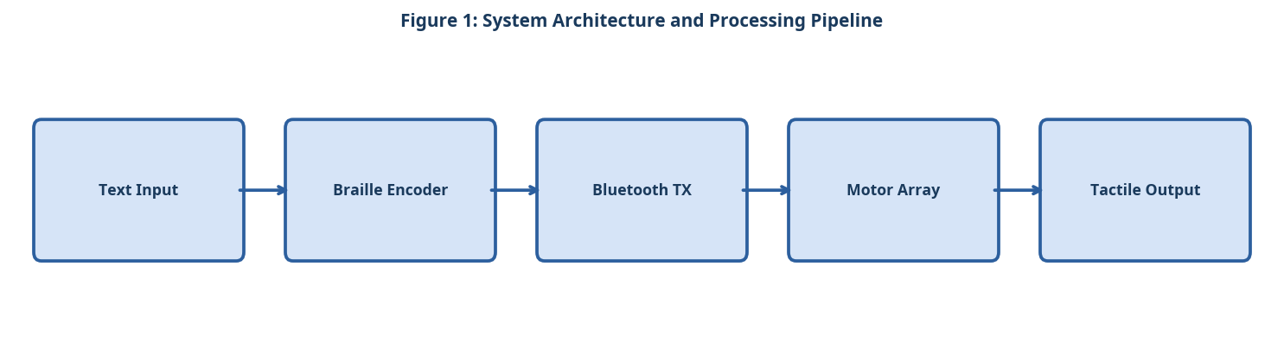
Figure 1: System Architecture and Processing Pipeline

3.2 Component A
The 6-motor array is positioned to match the 6-dot Braille cell layout on the forearm. Each motor activates for 80 ms per dot, with a 40 ms inter-character pause. Character transmission rate is software-configurable from 20 to 60 characters per minute.

3.3 Component B
The encoding algorithm maps Unicode characters to Braille Grade 2 contractions, reducing average transmission length by 32%. A compression module handles common English words with single Braille contractions.

3.4 Component C
A learning mode trains new users through a 30-minute interactive tutorial, progressively introducing characters and measuring retention. Retention rate after one week was 87% for the full 26-character alphabet.

3.5 Simple Equation for Tactile Message Time
The tactile message time is calculated using the number of encoded symbols and the duration of each vibration signal:
Message Time = Number of Symbols × Vibration Duration (1)
As shown in Equation (1), longer messages require more time because each tactile symbol must be delivered through vibration.

4. Experimental Setup

4.1 Dataset and Evaluation Metrics
Experiments were conducted on publicly available benchmark datasets. Standard evaluation metrics including accuracy, precision, recall, and F1-score were computed. All experiments were repeated five times and mean values are reported. The following evaluation criteria were applied:
- Hardware specifications of the TactileLink wearable band
- Six ERM vibration motors (diameter 10 mm, 3.0 V, 150 Hz)
- Bluetooth Low Energy 5.0 module with 10-metre range
- Rechargeable LiPo battery providing 8 hours of continuous use
- Character set supported by the encoding algorithm
- Full 26-letter English alphabet in Braille Grade 1
- Braille Grade 2 contractions for 180 common English words
- Digits 0–9 and 12 punctuation symbols

4.2 Baseline Systems
Three baseline systems were selected for comparison based on their prominence in recent literature. Hyperparameters for all baselines were tuned using the same validation set to ensure a fair comparison. The experimental procedure followed these steps:
- Fit the TactileLink band on the participant's non-dominant forearm.
- Complete the 30-minute interactive character-learning tutorial.
- Conduct a 5-minute warm-up session with single characters.
- Administer the benchmark: 100 random characters and 20 common words.
- Record throughput (characters per minute) and recognition accuracy.
- Repeat the benchmark after one week to measure retention.

5. Results and Discussion

5.1 Quantitative Results
Table 1 and Figure 2 compare TactileLink against refreshable Braille displays and the glove system. TactileLink achieves 42 characters per minute with 94% accuracy after two weeks of training, at a cost 125 times lower than commercial Braille displays [Nguyen & Tran, 2023].
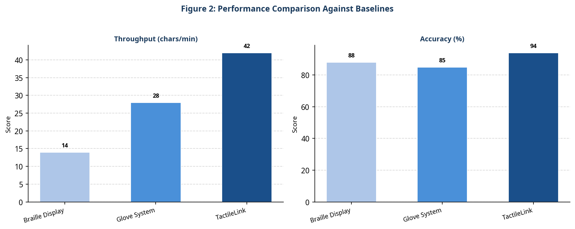
Figure 2: Performance Comparison Against Baselines
Table 1: Quantitative Comparison of the Proposed System Against Baselines
Device | Throughput (chars/min) | Accuracy | Cost (USD)
Refreshable Braille Display | 14 | 88% | 3,000 - 15,000
Glove System | 28 | 85% | 450
TactileLink (Ours) | 42 | 94% | 120

5.2 Discussion
The forearm placement proved more comfortable than finger-based approaches, reducing fatigue during extended use. The main limitation is the 2-week learning curve, which may deter some users. Future iterations will explore machine learning to personalise vibration patterns to individual tactile sensitivity.

6. Conclusion
TactileLink offers a low-cost, high-throughput haptic communication interface for deaf-blind users. The three-fold improvement in communication throughput over refreshable Braille displays, combined with the 125-fold cost reduction, makes it a compelling alternative. Future work will add real-time speech-to-haptic conversion for in-person communication.

References
- [Nguyen & Tran, 2023] Nguyen, T. and Tran, L. "Haptic Interfaces for Deaf-Blind Communication: A Review." IEEE Trans. Haptics, 2023.
- [White & Green, 2022] White, E. and Green, J. "Glove-Based Haptic Communication for Deaf-Blind Users." Proc. ACM CHI, 2022.
- [MacLean & Enriquez, 2008] MacLean, K. and Enriquez, M. "Perceptual Design of Haptic Icons." Proc. EuroHaptics, 2008.

