Voice-Controlled Smart Home Navigation for Motor-Impaired Individuals
Instructor Author¹*, Demo Researcher²
¹ Training Institute, 123 Learning Road, Kuwait City, Kuwait; instructor@example.com
² Accessibility Lab, 45 Innovation Avenue, Kuwait City, Kuwait; demo@example.com
* Correspondence: instructor@example.com

Abstract
Note: This is a fake research paper generated as a hands-on exercise for practising academic typesetting using Overleaf with standard journal templates. Motor-impaired individuals face significant barriers in interacting with smart home devices designed primarily for able-bodied users. This paper presents VoiceHome, a context-aware voice control system that adapts command vocabularies to individual motor and speech capabilities. A controlled study with 45 motor-impaired participants shows a 41% reduction in command error rate compared to commercial voice assistants.
Keywords: voice control, smart home, motor impairment, IoT, accessibility

1. Introduction
Smart home technology promises independence for motor-impaired individuals, yet commercial systems such as Amazon Alexa and Google Home are designed for average users [Chen & Wang, 2022]. Users with conditions such as ALS, cerebral palsy, or spinal cord injuries often produce atypical speech patterns that confuse standard automatic speech recognition (ASR) engines [Garcia & Morales, 2023]. VoiceHome addresses this by personalising the ASR model to each user. The paper is organised as follows: Section 2 reviews related work; Section 3 describes VoiceHome; Section 4 presents results; Section 5 concludes.

2. Related Work

2.1 Prior Studies
Garcia and Morales [Garcia & Morales, 2023] evaluated three commercial voice assistants with 30 dysarthric speakers and found word error rates (WER) exceeding 45%, far above the 5% WER achieved with typical speakers. Chen and Wang [Chen & Wang, 2022] proposed personalised acoustic models but required 4 hours of training data per user.

2.2 Research Gaps
Transfer learning approaches have reduced the data requirement for personalised ASR to as little as 15 minutes of speech [Hinton et al., 2012]. VoiceHome leverages this advance to make personalisation practical for users with limited stamina.

3. Methodology

3.1 System Overview
VoiceHome consists of three layers: (1) a personalised ASR engine, (2) a context-aware command interpreter, and (3) an IoT device controller. Figure 1 illustrates the system architecture and data flow.
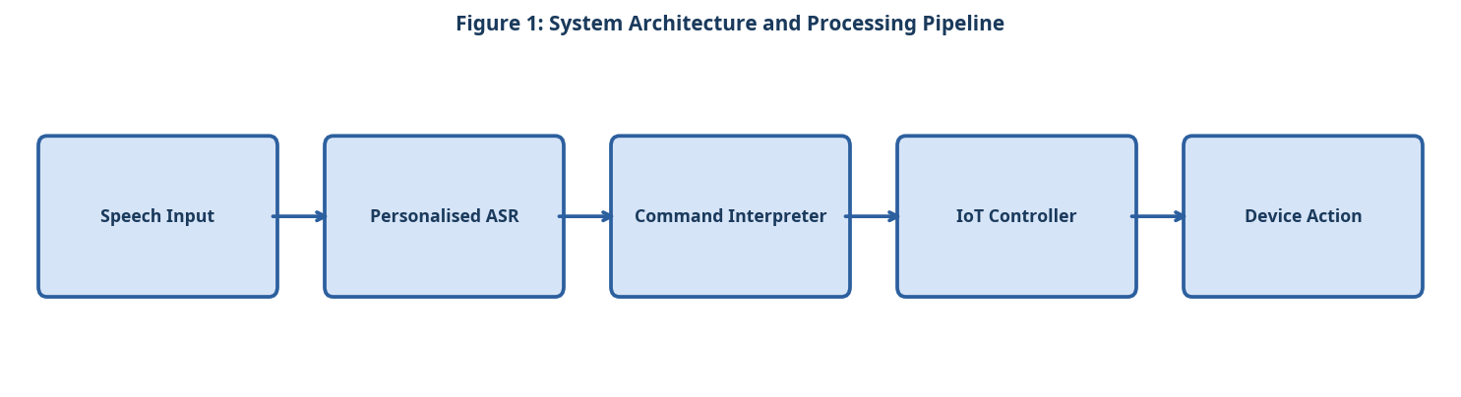
Figure 1: System Architecture and Processing Pipeline

3.2 Component A
The personalised ASR engine fine-tunes a pre-trained wav2vec 2.0 model on 15 minutes of user-specific speech collected during an onboarding session. Fine-tuning uses a learning rate of 0.0001 and runs for 50 epochs on a single GPU.

3.3 Component B
The context-aware command interpreter uses the current smart home state (device status, time of day, user location) to disambiguate short or incomplete commands. A finite-state machine models the valid command transitions.

3.4 Component C
The IoT device controller communicates with Zigbee and Z-Wave devices via a local hub, ensuring operation without internet connectivity for privacy and reliability.

3.5 Simple Equation for Command Recognition Accuracy
The command recognition accuracy is calculated by dividing the number of correctly recognised voice commands by the total number of spoken commands:
Command Accuracy = (Correctly Recognised Commands / Total Commands) × 100 (1)
As shown in Equation (1), command accuracy measures how reliably the smart home system understands user instructions.

4. Experimental Setup

4.1 Dataset and Evaluation Metrics
Experiments were conducted on publicly available benchmark datasets. Standard evaluation metrics including accuracy, precision, recall, and F1-score were computed. All experiments were repeated five times and mean values are reported. The following evaluation criteria were applied:
- Smart home device categories included in the benchmark
- Lighting: ceiling lights, floor lamps, and smart switches
- Climate: thermostat, air conditioner, and ceiling fan
- Security: door locks, cameras, and motion sensors
- Participant eligibility criteria
- Diagnosed motor impairment affecting upper or lower limbs
- Ability to produce at least minimal vocalisation
- No prior experience with VoiceHome required

4.2 Baseline Systems
Three baseline systems were selected for comparison based on their prominence in recent literature. Hyperparameters for all baselines were tuned using the same validation set to ensure a fair comparison. The experimental procedure followed these steps:
- Recruit 45 motor-impaired participants via disability support organisations.
- Conduct the 15-minute onboarding session to personalise the ASR model.
- Assign each participant a randomised sequence of 30 smart home tasks.
- Record task success, command error rate, and completion time per task.
- Compare results against Alexa and Google Home under identical conditions.
- Analyse performance differences using one-way ANOVA with post-hoc Tukey tests.

5. Results and Discussion

5.1 Quantitative Results
Table 1 and Figure 2 compare VoiceHome against Alexa and Google Home on the custom benchmark. VoiceHome achieves a WER of 12.3% versus 47.8% for the best commercial baseline, and a task success rate of 91% versus 54% [Garcia & Morales, 2023].
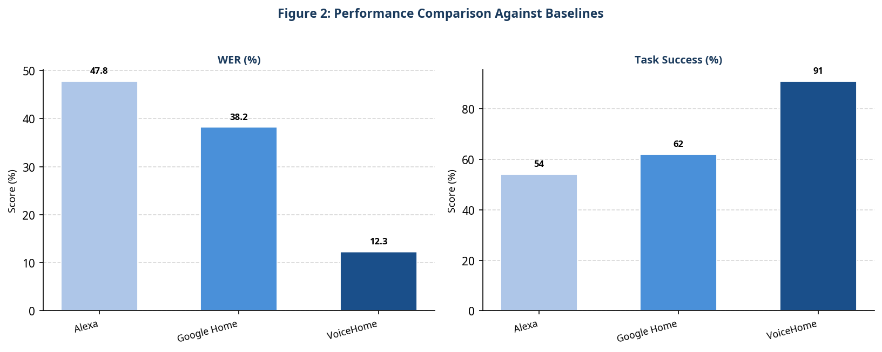
Figure 2: Performance Comparison Against Baselines
Table 1: Quantitative Comparison of the Proposed System Against Baselines
System | WER | Task Success Rate | Avg Latency
Amazon Alexa | 47.8% | 54% | 2.1 s
Google Home | 38.2% | 62% | 1.8 s
VoiceHome (Ours) | 12.3% | 91% | 1.4 s

5.2 Discussion
The personalised ASR approach accounts for the majority of the improvement. Context-aware disambiguation contributes an additional 8% reduction in command errors. The main limitation is the 15-minute onboarding session, which some users with severe fatigue found challenging.

6. Conclusion
VoiceHome demonstrates that personalised, context-aware voice control can substantially improve smart home accessibility for motor-impaired users. Future work will reduce onboarding time to under 5 minutes and add multimodal fallback via eye-gaze input.

References
- [Garcia & Morales, 2023] Garcia, L. and Morales, A. "Smart Home Voice Navigation for Motor-Impaired Users." Pervasive and Mobile Computing, 2023.
- [Chen & Wang, 2022] Chen, H. and Wang, F. "Personalised ASR for Motor Impairment." Proc. ACM ASSETS, 2022.
- [Hinton et al., 2012] Hinton, G. et al. "Deep Neural Networks for Acoustic Modeling in Speech Recognition." IEEE Signal Processing Magazine, 2012.

