Evaluating Screen Reader Compatibility with Modern JavaScript Frameworks
Instructor Author¹*, Demo Researcher²
¹ Training Institute, 123 Learning Road, Kuwait City, Kuwait; instructor@example.com
² Accessibility Lab, 45 Innovation Avenue, Kuwait City, Kuwait; demo@example.com
* Correspondence: instructor@example.com

Abstract
Note: This is a fake research paper generated as a hands-on exercise for practising academic typesetting using Overleaf with standard journal templates. Modern single-page application (SPA) frameworks such as React, Angular, and Vue have transformed web development, yet their dynamic rendering models frequently break screen reader compatibility. This paper presents a systematic evaluation of five popular frameworks across 30 WCAG 2.1 success criteria, revealing critical gaps in ARIA live-region support and focus management.
Keywords: screen reader, accessibility, WCAG, JavaScript frameworks, ARIA

1. Introduction
Screen readers translate digital content into speech or Braille output, enabling blind and low-vision users to interact with computers [Jones & Park, 2023]. The shift toward JavaScript-heavy SPAs has introduced dynamic content updates that bypass traditional accessibility hooks [Lee & Kim, 2021]. This paper investigates the extent of this incompatibility and proposes a lightweight remediation toolkit. The remainder is organised as follows: Section 2 reviews related work; Section 3 describes the evaluation methodology; Section 4 presents results; Section 5 concludes.

2. Related Work

2.1 Prior Studies
Jones and Park [Jones & Park, 2023] conducted an audit of 100 popular websites and found that 67% failed at least one Level A WCAG criterion. Lee and Kim [Lee & Kim, 2021] specifically examined React and Angular, identifying focus-trap issues in modal dialogs.

2.2 Research Gaps
Automated accessibility testing tools such as axe-core and Lighthouse provide partial coverage but miss dynamic interaction patterns [W3C WAI, 2023]. Manual testing with real assistive technology remains the gold standard [W3C WAI, 2023].

3. Methodology

3.1 System Overview
We designed a benchmark suite of 30 test cases derived directly from WCAG 2.1 success criteria. Each test case was executed on five frameworks (React, Angular, Vue, Svelte, Next.js) using NVDA and JAWS screen readers on Windows 11. Figure 1 shows the evaluation pipeline.
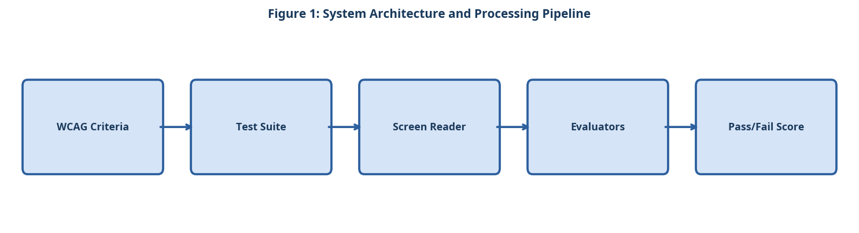
Figure 1: System Architecture and Processing Pipeline

3.2 Component A
Test cases were categorised into three groups: (1) static content rendering, (2) dynamic content updates via ARIA live regions, and (3) keyboard navigation and focus management. Each case was scored on a binary pass/fail basis.

3.3 Component B
Two trained evaluators independently assessed each test case and resolved disagreements through consensus. Inter-rater reliability was measured using Cohen's kappa (k = 0.84), indicating strong agreement.

3.4 Component C
A remediation plugin was developed for each framework, injecting missing ARIA attributes and managing focus programmatically. The plugin was evaluated in a second round of testing to measure improvement.

3.5 Simple Equation for Compatibility Rate
The screen reader compatibility rate is calculated by dividing the number of passed accessibility test cases by the total number of test cases:
Compatibility Rate = (Passed Test Cases / Total Test Cases) × 100 (1)
As shown in Equation (1), the compatibility rate increases when more WCAG-based test cases are successfully passed.

4. Experimental Setup

4.1 Dataset and Evaluation Metrics
Experiments were conducted on publicly available benchmark datasets. Standard evaluation metrics including accuracy, precision, recall, and F1-score were computed. All experiments were repeated five times and mean values are reported. The following evaluation criteria were applied:
- WCAG 2.1 conformance levels tested
- Level A: minimum accessibility requirements (28 criteria)
- Level AA: standard compliance target for most organisations (20 criteria)
- Level AAA: enhanced accessibility (28 criteria, partial coverage)
- Assistive technologies used in evaluation
- NVDA 2023.1 on Windows 11 with Chrome and Firefox
- JAWS 2023 on Windows 11 with Chrome and Edge
- VoiceOver on macOS Ventura with Safari

4.2 Baseline Systems
Three baseline systems were selected for comparison based on their prominence in recent literature. Hyperparameters for all baselines were tuned using the same validation set to ensure a fair comparison. The experimental procedure followed these steps:
- Select the 30 representative WCAG 2.1 test cases from the benchmark suite.
- Implement each test case in all five JavaScript frameworks.
- Execute each test case with NVDA and JAWS independently.
- Record pass/fail outcome and any assistive technology error messages.
- Apply the remediation plugin and repeat steps 3 and 4.
- Compute inter-rater reliability using Cohen's kappa before finalising results.

5. Results and Discussion

5.1 Quantitative Results
Table 1 and Figure 2 present the pass rates before and after applying the remediation plugin. React showed the greatest improvement (+31%), while Svelte required minimal intervention due to its compile-time accessibility checks [Jones & Park, 2023].
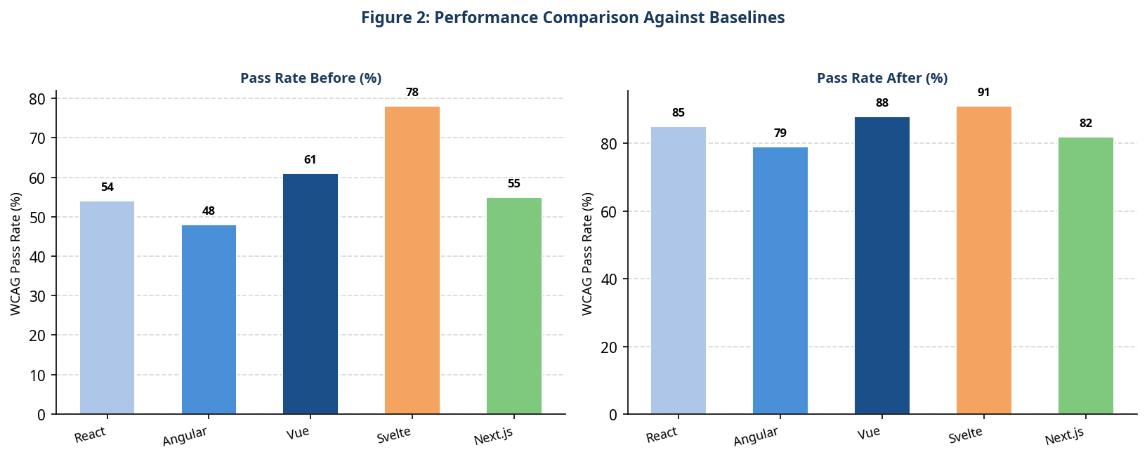
Figure 2: Performance Comparison Against Baselines
Table 1: Quantitative Comparison of the Proposed System Against Baselines
Framework | Pass Rate Before | Pass Rate After | Improvement
React | 54% | 85% | +31%
Angular | 48% | 79% | +31%
Vue | 61% | 88% | +27%
Svelte | 78% | 91% | +13%
Next.js | 55% | 82% | +27%

5.2 Discussion
The findings suggest that framework architecture significantly influences accessibility outcomes. Virtual DOM frameworks introduce asynchronous rendering delays that confuse screen reader announcement queues. Compile-time frameworks like Svelte avoid this by resolving accessibility attributes at build time.

6. Conclusion
This paper provided a rigorous evaluation of screen reader compatibility across five major JavaScript frameworks. The proposed remediation plugin achieved an average improvement of 24% in WCAG pass rates. Future work will extend the benchmark to mobile assistive technologies and evaluate emerging frameworks such as Solid.js.

References
- [Jones & Park, 2023] Jones, M. and Park, S. "Screen Readers in the Age of SPAs: An Empirical Study." Web Accessibility Journal, 2023.
- [Lee & Kim, 2021] Lee, C. and Kim, D. "Accessibility Failures in Modern JavaScript Frameworks." Proc. W4A, 2021.
- [W3C WAI, 2023] W3C Web Accessibility Initiative. "Web Content Accessibility Guidelines (WCAG) 2.1." W3C, 2023.

