**Introduction**

The app does basic calculation such as addition , Subtraction, Multiplication, Division , reminder and changing of sign. The decimal (.) functionality in the UI is not implemented. There are Unit and UI tests added to the project. The project is done using Swift language for iOS platform(for iOS device or simulator with iOS 13.0 or later)

The application also shows the latest 10 calculation in a table view above the calculator , I placed the table view above the calculator because I think it looks better. I am using Coredata for persistent storage.

**How to Run It**

To run the application

1. Open the Xcode project file with Xcode 11 or later
2. Connect a device or simulator with iOS 13 later
3. Press the run button on Xcode.

**Demo Of Application UI**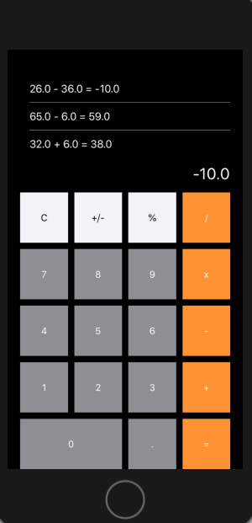

You can see from the UI the application has

1. Digits 0 - 9
2. A button (C) to reset the calculator
3. A Button (+/-) to change sign
4. Buttons (%, /, x, -, + ) to perform remainder, division , multiplication, subtraction and addition respectively
5. A Button(=) to actually do the operations
6. The Button(.) is **Not implemented**
7. At the top there is a table view to show the 10 most recent calculations