CSIS1275-01 JAVA Assignment 3 (15%) Winter 2015
Due date: April 9th/2015
You can do this assignment with one partner, in which case, hand in one piece of work with both your names on it.

Create a Java Applet using Java Swing components and layout managers, call it ChannelSubcribe.java, that will allow customers to select a channel to subscribe. It should have the following functionality and layout :

Main Screen
The initial main screen is as shown on the next page.

Layout

Ensure that the layout of the main screen remains the same, whatever the size of the applet (i.e. use layout managers)

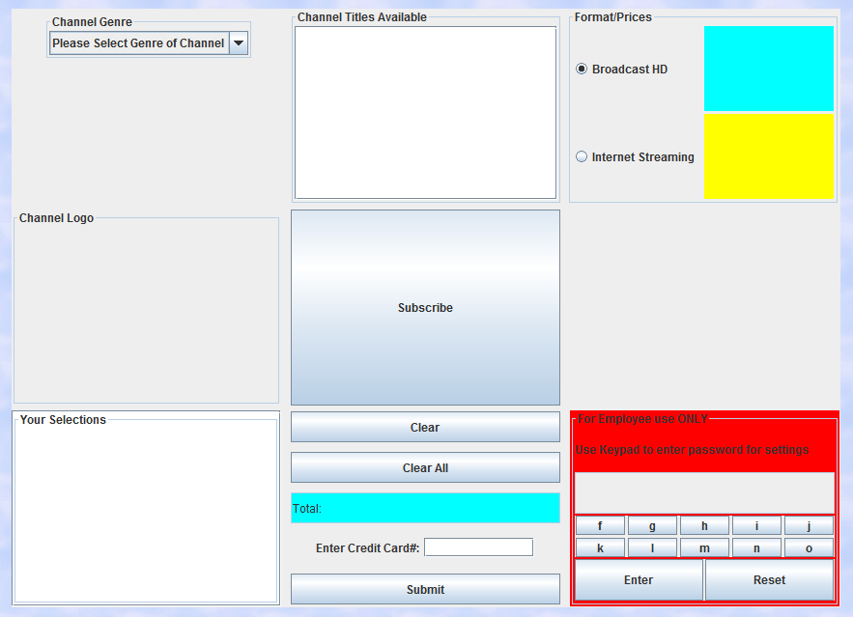

NOTE: The default for Format/Prices is 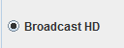.

Functionality
The user will first click 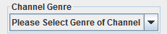 combo box, to display the available channel genres. The selections are: 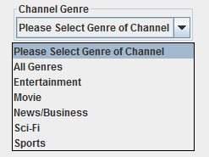. If user selects “All Genres” , then the Channel Titles Available JList box will display all the channels available, i.e. 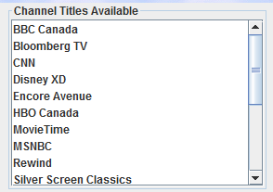. (please see last page to see where the data is from).

If the user had selected “Movie” as the genre, then only the movie channels will be displayed, i.e.:
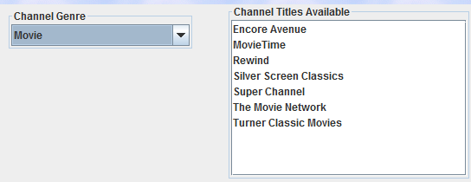

2. Assuming the user has selected the Movie channels genre. When he/she clicks on 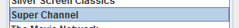, then that channel’s prices for Broadcast HD and Internet Streaming should appear in their respective JLabels. Also a picture of the channel’s logo appears in the Channel Logo JLabel.
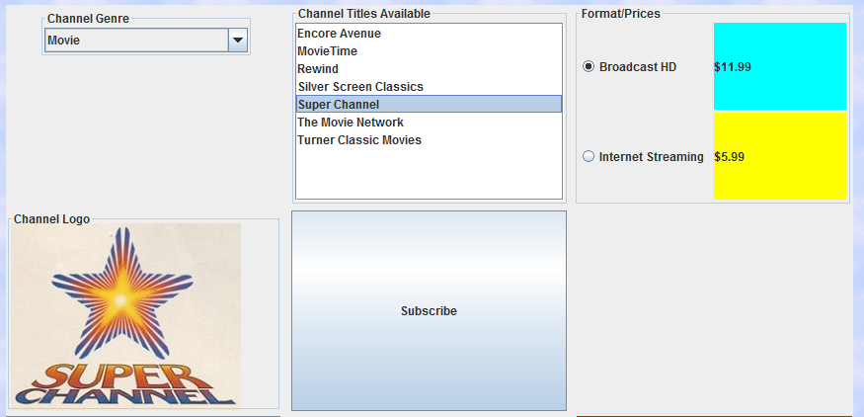
When the user selects another channel, then that channel’s logo and prices will appear in their respective areas. Note, the channel logo and prices are different for each channel.

Note:

If the user selected another genre like “Entertainment”, then your applet should clear the boxes as shown, as well as displaying the Entertainment channels:

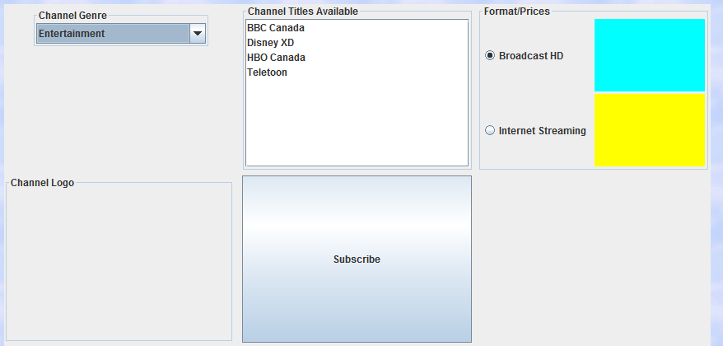

3. The user can select how to receive the channel by Broadcast HD or Internet streaming, by selecting their respective JRadioButtons, i.e. 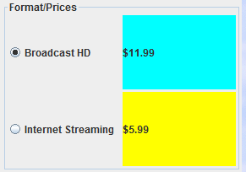.
If the user now clicks the 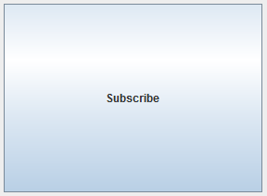 button, then that channel and the Format price will appear in the Your Selections JList box and Total JTextField (It should also have a cyan background and is READ ONLY. ) respectively.

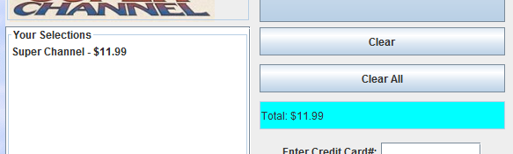

Note, the Total JTextField should keep a running total, i.e. as soon as the “Subscribe” button is clicked, the new total should be displayed.

If the user selects another channel, like “Rewind” for Internet streaming, then it will appear in the Your Selections JList box and a new total is displayed in the Total JTextField.

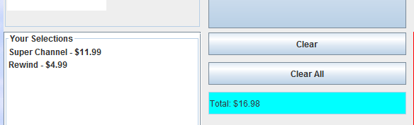

If the user selects a channel/format to subscribe, but has already been selected, then an error box should be displayed. For example, if the user selected “Super Channel” with “Broadcast HD”, then the following error box appears.

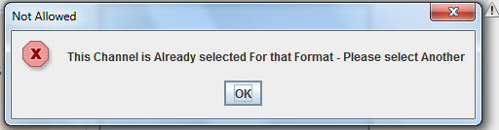

HOWEVER, if he/she selects “Super Channel but for “Internet Streaming” then that is FINE.
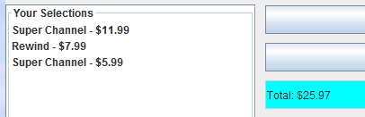 (of course if the user selects that same combination again, then the aforementioned error box appears.

- If the user is ready to pay for those channels, he/she will enter the credit card number (NOT an actual one of course) and click the submit button, i.e.: 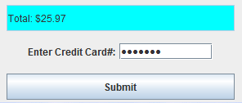 (Note the credit card field must be a JPasswordField)

A warning box appears, i.e.: 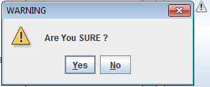 If the user clicks “Yes” then 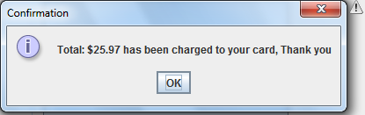 appears. Clicking on “Ok” will clear the Your Selections JList box and the , Total JTextField. If the No button or close button is clicked, then NO action is taken (assuming the customer wants to purchase more).

If user clicks “Submit” and there are Channels selected for subscribing but did NOT enter a credit number, then after the usual “ Are You Sure Yes/No” dialog box, it should display 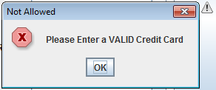.

If there are NO Channels selected for subcribing, but the customer still clicks on the “Submit” button (after entering a credit card number), then after the usual “ Are You Sure Yes/No”dialog box, it should display 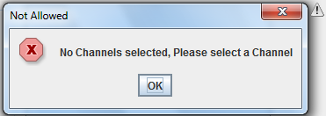.

Clear and Clear All Button

The Channel Selected JList Box is single-selectable, i.e. 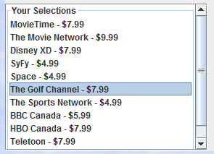. Here the user can remove any of his/her selections before actually subscribing to those Channels. Once the Channel to remove is selected, the user can click the  button, in which case the selection will be deleted from the JList box with the Total JTextField updated i.e. the amount should be reduced from. 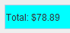 to 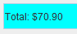, i.e. it should keep a running total. NOTE, if the user continues to clear every selection in the Channel Selected JList box, then the total eventually should be 0.00.

If the Clear button was clicked BUT NO Channel selected, then the following error box should appear.
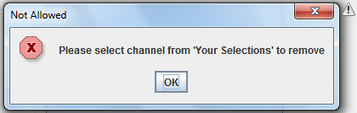.

If the  button is clicked then a warning box such as is displayed. If user clicks on Yes button, then ALL the Channels will be deleted from the Your Selection JList Box, with $0.00 displayed in the Total JTextField.

If the No button or close button is clicked, then NO action is taken.

Update

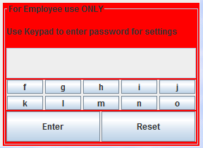
This is a an alphabetic keypad, where employees can enter alphabetic password by clicking on the keypad 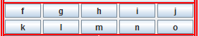 (i.e. NOT entering on the keyboard). If the button is clicked and the correct password was entered, then it will go into the Cahnnel Update window (please see next page for details).

When clicking the password, make sure that it is masked out i.e.. The password can be any number of characters, which I leave up to you. You can “hardcode” the passcode into the program. If user enters the wrong password, then the following error box should appear: 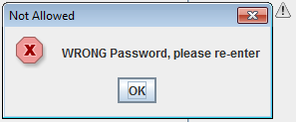 .

The  merely clears the password field (just in case you entered the wrong password and want to restart).

Upon entering the correct password it should reset and clear the boxes as shown below, i.e.:
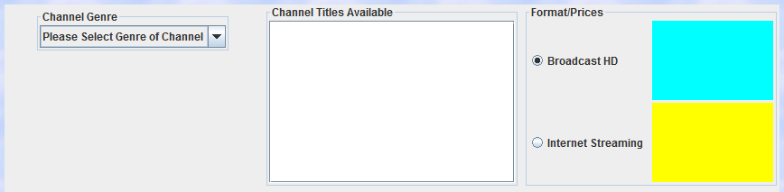

then the following Channel Update window appears.

Channel Update Window (Save this part as UpdateFrame.java)
Upon entering the correct password, this will generate a window with the following layout and components.
Note, this window is resizable BUT the layout should remain the SAME, whatever the size of the window, i.e. use Layout Managers.

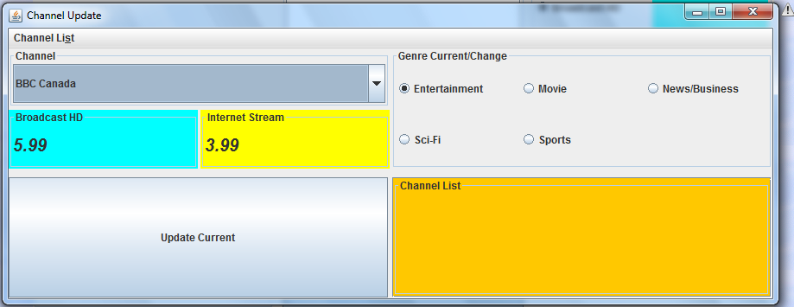

Channel JTextArea, with scrollbar

Functionality
Here the user can change the Channel properties i.e. it’s prices and genrel

Price/Genre
Here the user can change the Channel’s prices and genre. The user selects the channel pull down box, i.e. 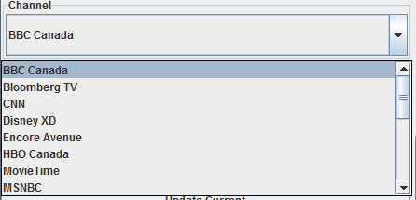. The box should display all the channels available irrespective of genres. Note initially, the first entry (in this case BBC Canada) would be selected. The current Channel details i.e. it’s price and genre, will be displayed in their respective components, i.e. 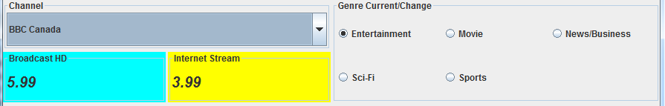
JTextField

The user can make changes to the prices and genre, i.e.:
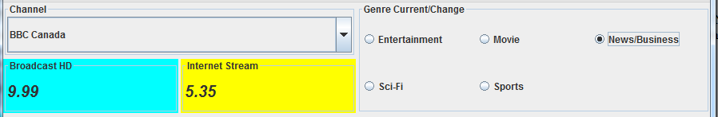

Once you are satisfied with all changes FOR this Channel, then the 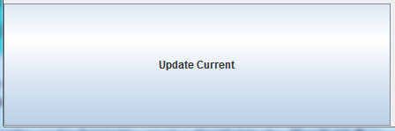 button MUST be clicked. The following confirmation dialog box should appear 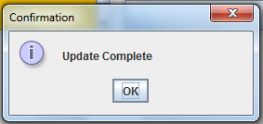. Note, the changes made here, MUST then be reflected in the JApplet (see page 16).

Channel List Menu
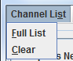
This should have the above selections and corresponding mnemonics.
- If the user selects Full List , then it should display in the Channel JTextArea, a full list of all the Channels and their current properties i.e. 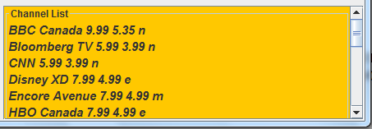 (Note, the font is Helvetica, bolded, italics at 14pt) AND HAVE a scrollbar available). (Note, if user continues to click Full List, make sure to clear the Channel JTextArea before displaying another full list. Also the letter at the end is for the channel’s genre, ii.e. “n” stands for news, “m” for movie etc)
- If the user selects Clear , then it simply clears Channel JTextArea.

Exiting Channel Update
- Ensure also the following buttons  do work with this window.

Note: It is important that when the user exits from this Channel Update screen and returns back to the main JApplet, the following are blank.

Now, if the user looks at News/Information genre, you should find “BBC Canada” there and the prices should have changed as well, i.e.:
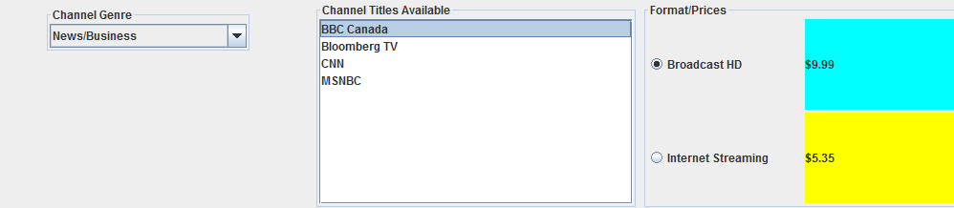

Finally, create an HTML file ( call it ChannelBuy.html) to hold this applet. The background should be a sky background utilising the sky.gif file.

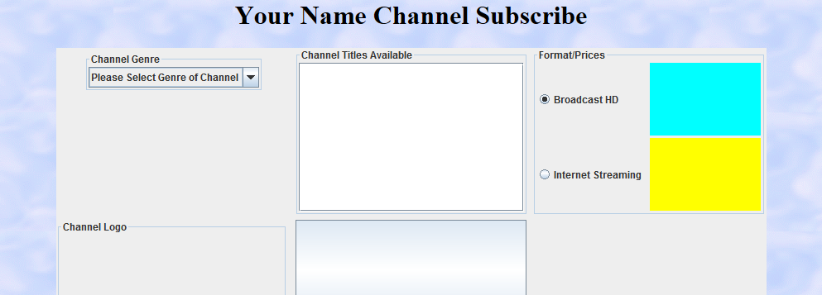
Note the top part  is from the HTML file. Please replace  with you actual name.

Classes
You must create at least 2 classes to start off with. These classes are in “ChannelInfo.java” which will be given to you.

What to Hand in
- Front cover page with your name, course, assignment number, instructor’s name and due date
- Hardcopy of the program listing
- Zip up and Save as csis1275Assign3W2015YourName.zip and either File Submission (myDouglas) or burn to CD for the .java source files, any picture files and the HTML file.
4. The password for the Channel Update window.

MARKS WILL BE LOST IF ANY OF THE ABOVE IS NOT MET OR IF THIS IS NOT YOUR OWN WORK OR IF THE DISK IS NOT READABLE OR PROGRAM NOT COMPLIABLE.

