Data Grouping and Risk Differentiation

Initial Grouping Strategy
We implemented two categorical variables for our GLM analysis:
1. NumberOfPersons (NoPGroup) - 6 groups based on company size 2. ActivityCode (ActivityGroup) - 3 groups based on business sector

Analysis of Initial Groups

NumberOfPersons Groups
The aggregated statistics reveal the following distribution:
Group | Duration (years) | Claims | Frequency | Avg Cost (€) | Yearly Cost (€/year)
01. <2 | 18,802 | 44 | 0.0023 | 6,484 | 15
02. 2-4 | 27,356 | 62 | 0.0023 | 9,241 | 21
03. 5-14 | 14,704 | 71 | 0.0048 | 19,481 | 94
04. 15-49 | 7,201 | 75 | 0.0104 | 16,241 | 169
05. 50-99 | 2,068 | 38 | 0.0184 | 24,186 | 444
06. >=100 | 3,377 | 219 | 0.0648 | 12,494 | 810
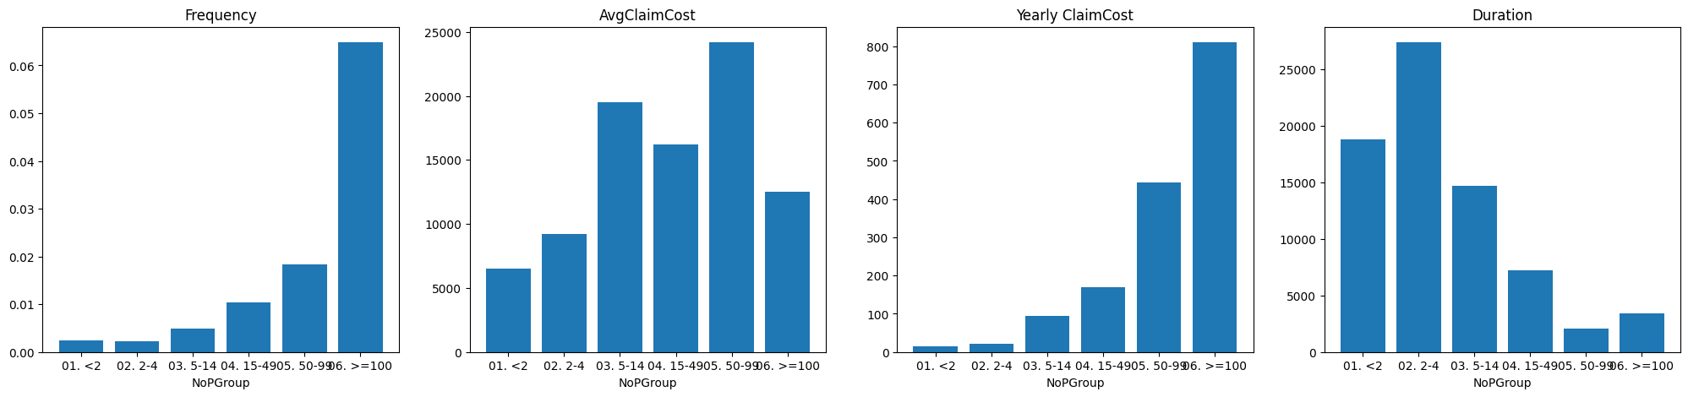
Key Observations:
- Clear Risk Progression: The frequency increases monotonically from small companies (0.0023) to large companies (0.0648), demonstrating a 28-fold difference in claim frequency between the smallest and largest groups.
- All Groups Have Claims: Each group contains at least 38 claims, satisfying the requirement for stable GLM estimation.
- Sufficient Exposure: The smallest group (05. 50-99) has 2,068 years of exposure, which is acceptable for our analysis.
Identified Issue:
Groups 01 (<2 persons) and 02 (2-4 persons) exhibit identical claim frequencies (0.0023 claims per year). This suggests these two groups are risk homogeneous and should potentially be merged. The GLM will assign them nearly identical risk factors, making the distinction unnecessary and reducing model efficiency.

ActivityCode Groups
The sector-based grouping shows:
Group | Duration (years) | Claims | Frequency | Avg Cost (€) | Yearly Cost (€/year)
Industry | 475 | 3 | 0.0063 | 22,179 | 140
Other | 60,767 | 413 | 0.0068 | 13,695 | 93
Service | 12,266 | 93 | 0.0076 | 14,979 | 113
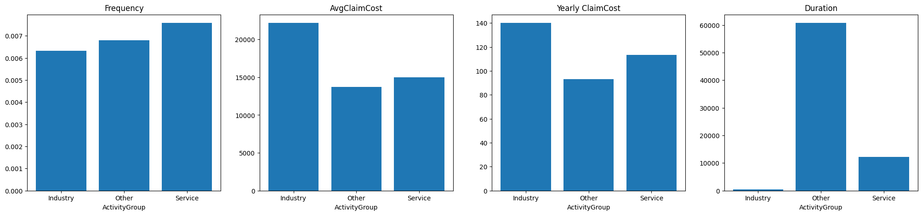

Key Observations:
- Similar Frequencies: All three sectors show frequencies in the narrow range of 0.0063-0.0076, suggesting limited risk differentiation by activity sector alone.
- Highly Unbalanced Data: The "Industry" group has only 475 years of exposure and 3 claims, while "Other" has 60,767 years. This imbalance raises concerns about the stability of estimates for the Industry group.
- Severity Variation: Despite similar frequencies, average claim costs vary (Industry: €22,179 vs Other: €13,695), indicating that sector affects claim severity more than frequency.
Identified Issues:
- The "Industry" group has very limited data (only 3 claims total). When combined with NumberOfPersons groups in the aggregated tariff cells, this could result in empty or unstable cells.
- The three sectors show minimal frequency differentiation, questioning whether this variable significantly improves the model.

Proposed Modifications
Based on this analysis, we recommend the following modifications:
1. Merge NumberOfPersons Groups 01 and 02
Proposed grouping:
- 01. 1-4 persons (merged from 01+02)
- 02. 5-14 persons
- 03. 15-49 persons
- 04. 50-99 persons
- 05. >=100 persons
Justification: Identical risk profiles warrant consolidation to improve model parsimony and avoid redundant parameters.
2. Consider Merging or Excluding ActivityGroup
We will test whether ActivityGroup significantly improves model fit using a Likelihood Ratio Test. If the p-value exceeds 0.05, we may:
- Option A: Exclude this variable entirely and use a simpler model
- Option B: Merge Industry with Other to create a binary classification (Service vs Non-Service)
3. Add Additional Risk Variables
To improve risk differentiation, we should consider incorporating:
- FinancialRating: Company credit rating likely affects cancellation risk
- TravellingArea: Geographic scope of coverage (Sweden vs World) significantly impacts exposure
These modifications will be validated through model comparison using AIC, BIC, and Likelihood Ratio Tests in the subsequent analysis.
======================================================================
MISSING AND PROBLEMATIC DATA ANALYSIS
======================================================================

1. TECHNICAL MISSING VALUES (NaN):
AvgClaimCost 149142
dtype: int64

2. STRANGE/INCOMPLETE DATA:

ActivityCode:
- 'X' (Missing code): 1581 rows (1.06%)
→ Strategy: Group 'X' with 'Other'

FinancialRating:
- 'IR' (Insufficient Reporting): 2378 rows
- 'AN' (New Company, no history): 10490 rows
- Total incomplete ratings: 12868 (8.61%)
→ Strategy: Create separate 'Missing' group

Extreme/Zero Values:
- Duration = 0: 0 rows
- NumberOfPersons = 0: 0 rows
- Very short policies (Duration < 0.1): 17077 rows
Analysis after modifications:

Nb Person :
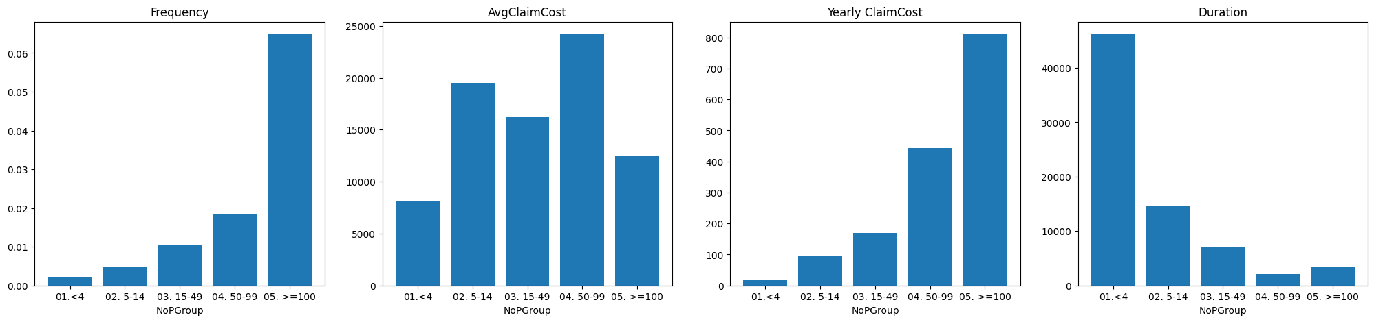

ActivityCode:
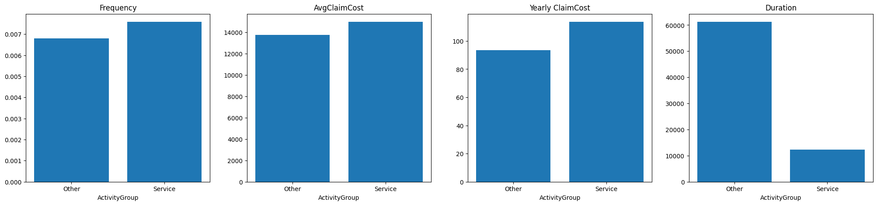

Financial Rating groups:
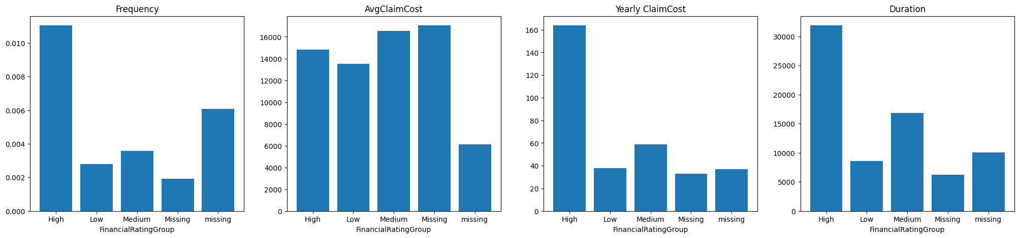
Traveling Area:
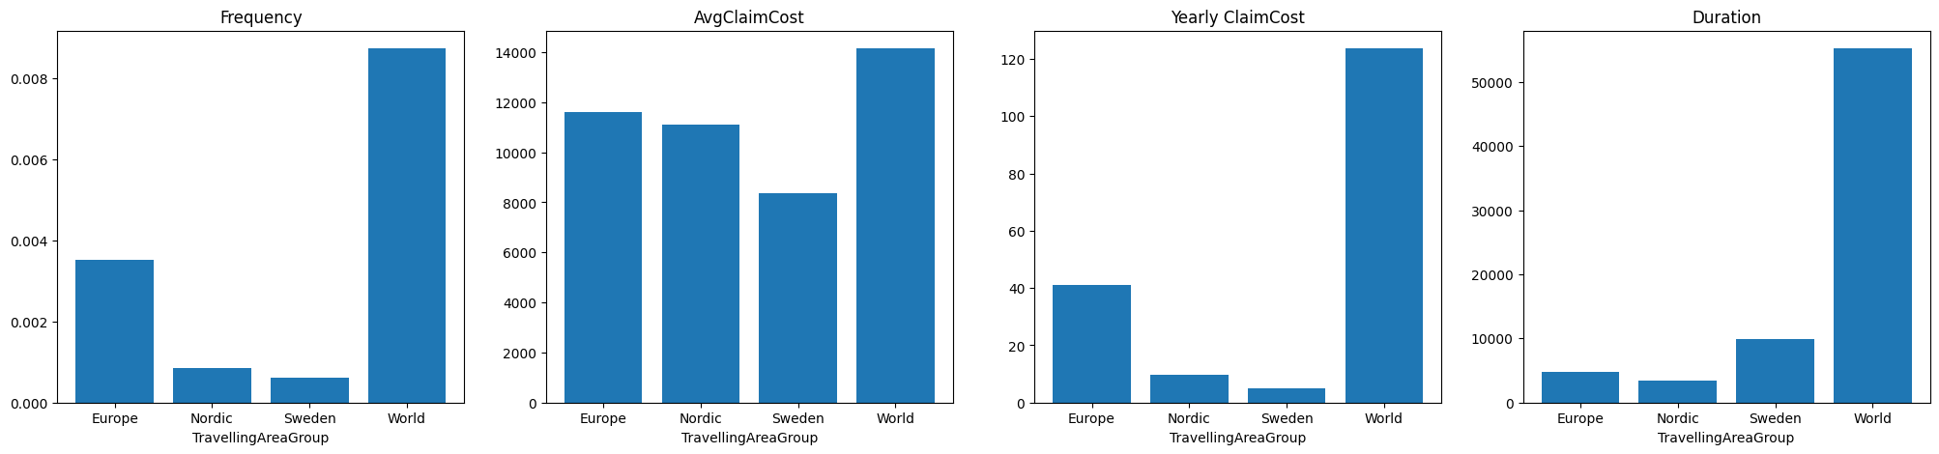

GROUPING STRATEGIES TESTED IN THE NOTEBOOK

1. VARIABLES ANALYZED

Four variables with multiple grouping strategies each:
- NumberOfPersons (NoPGroup)
- ActivityCode (ActivityGroup)
- FinancialRating (FinancialRatingGroup)
- TravellingArea (TravellingAreaGroup)
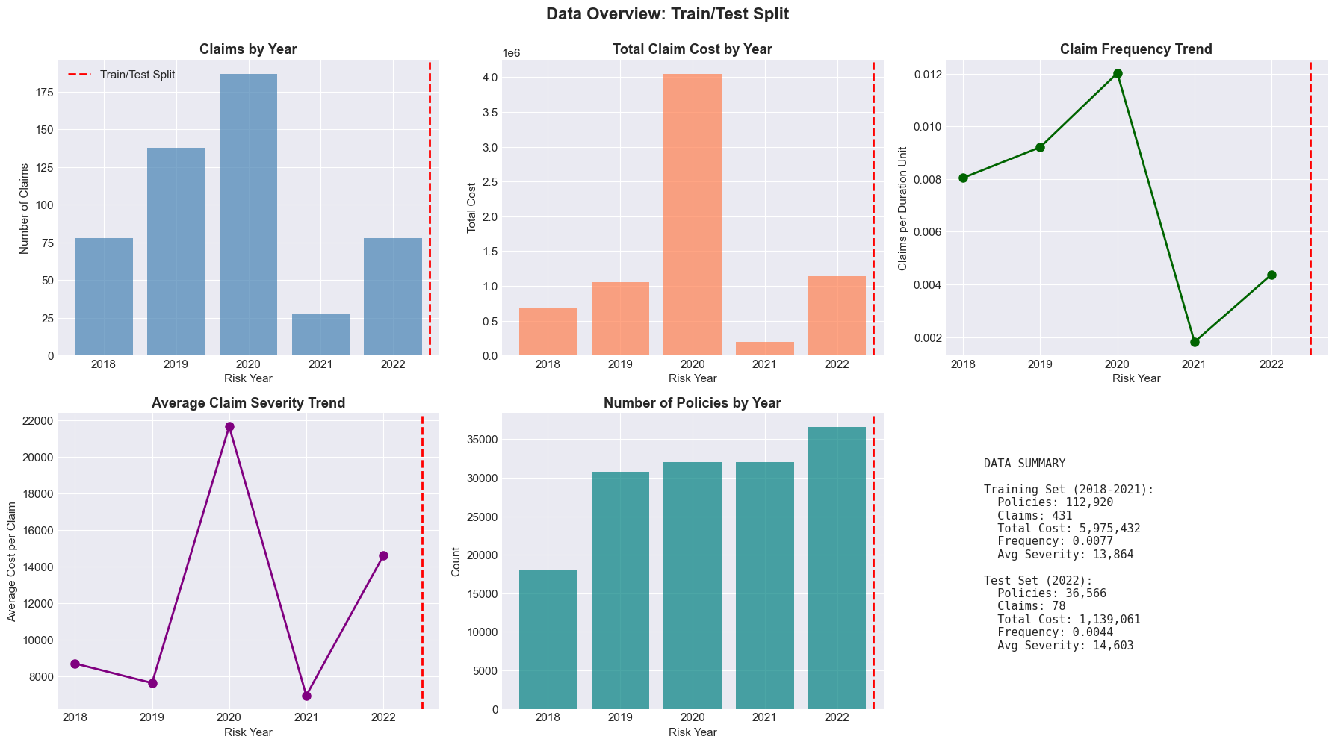

2. TESTED STRATEGIES BY VARIABLE
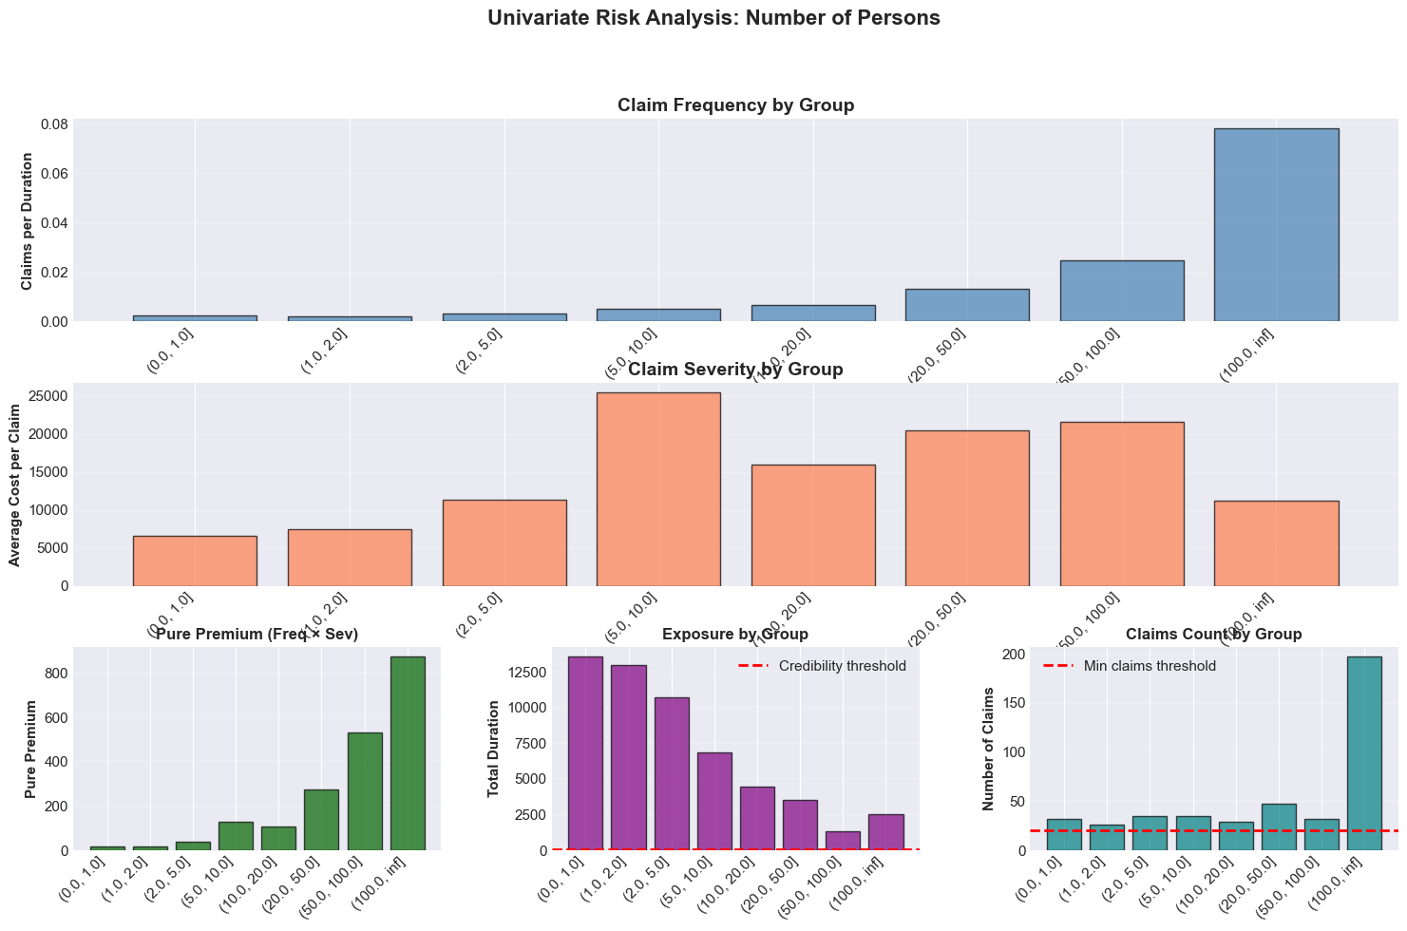
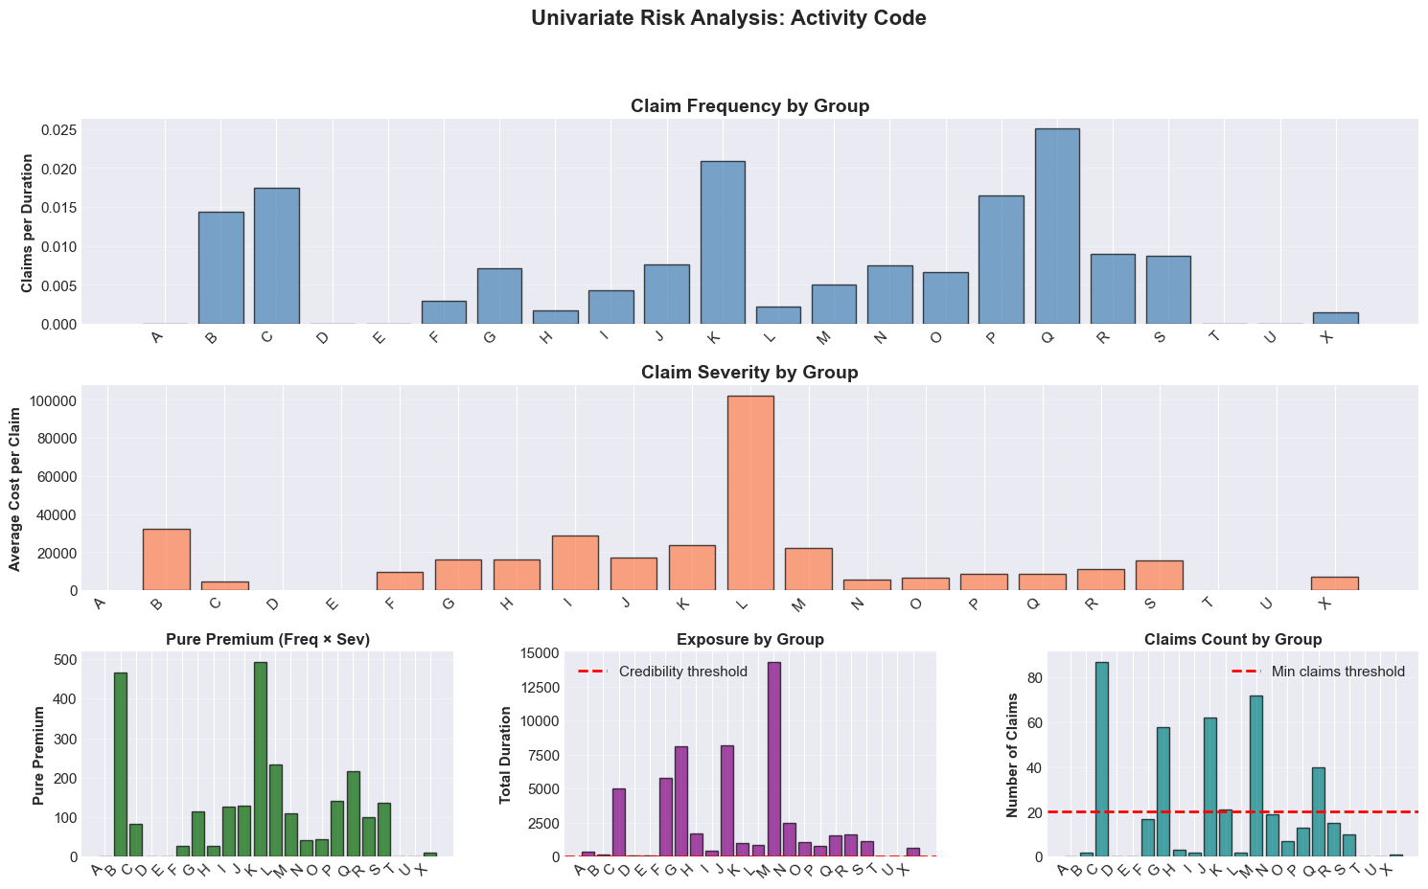
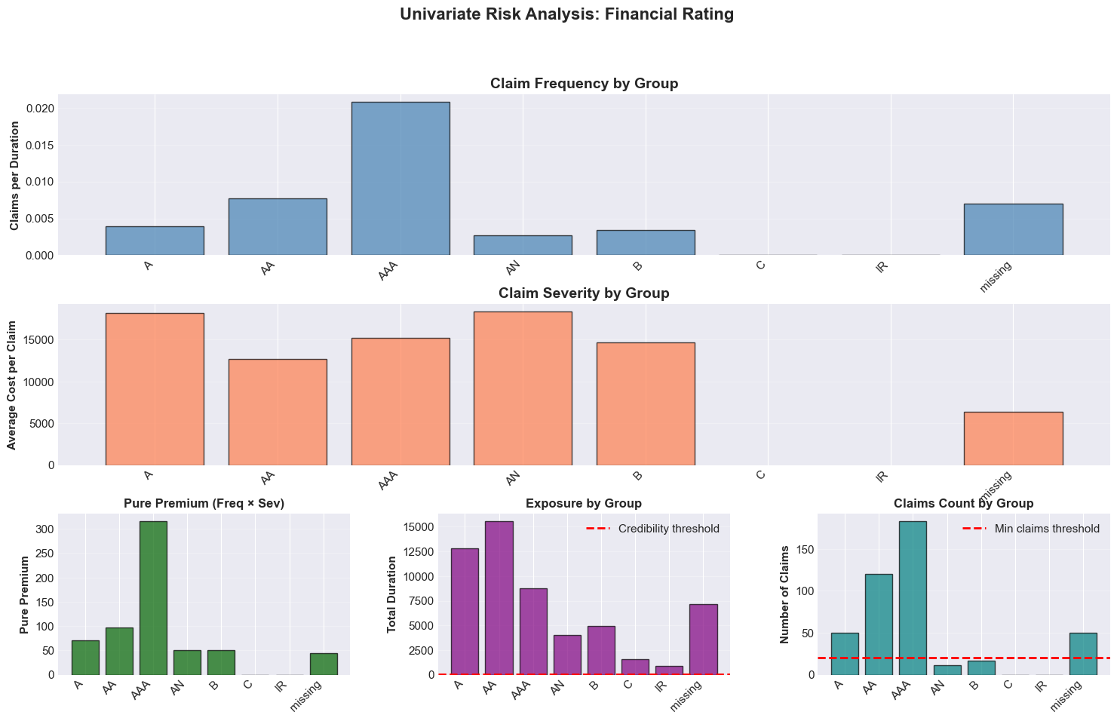
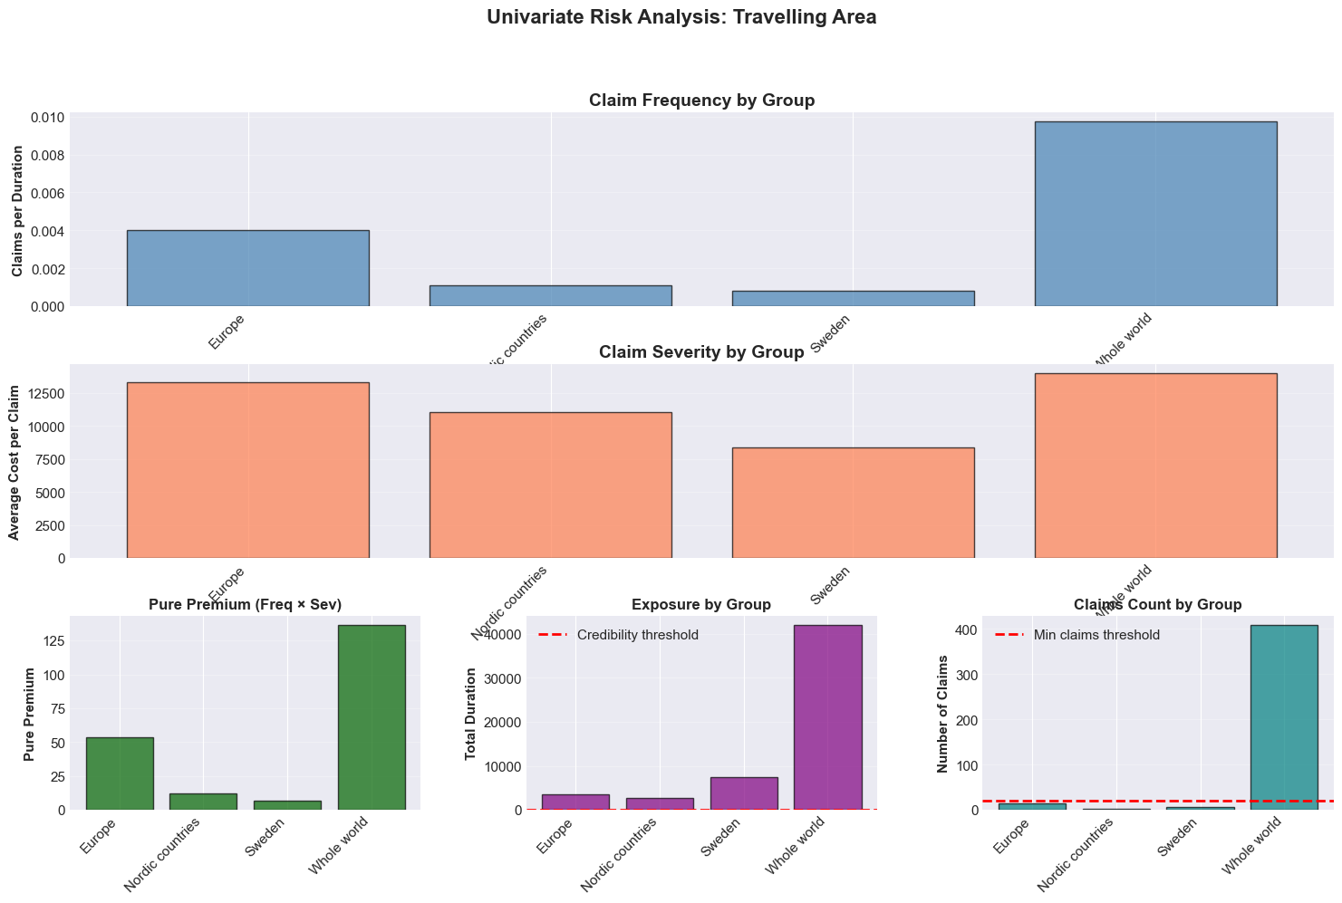

2.1 NumberOfPersons - 4 Strategies

v1_simple (3 groups)
- 1-5 persons: Very small companies
- 6-30 persons: Small and medium enterprises
- >30 persons: Large enterprises
Rationale: Basic segmentation distinguishing micro-enterprises, SMEs, and large companies.

v2_medium (6 groups)
- 1-2 persons: Micro-enterprises
- 3-5 persons: Very small businesses
- 6-15 persons: Small SMEs
- 16-50 persons: Medium SMEs
- 51-100 persons: Large SMEs
- >100 persons: Large enterprises
Rationale: Intermediate segmentation following standard company size thresholds.

v3_detailed (8 groups)
- 1 person: Exactly 1 person
- 2 persons: Exactly 2 persons
- 3-5 persons: 3 to 5 persons
- 6-10 persons: 6 to 10 persons
- 11-20 persons: 11 to 20 persons
- 21-50 persons: 21 to 50 persons
- 51-100 persons: 51 to 100 persons
- >100 persons: More than 100 persons
Rationale: Fine-grained segmentation to capture maximum risk differences.

v4_fine (9 groups)
- 1 person: Exactly 1 person
- 2-3 persons: 2 to 3 persons
- 4-7 persons: 4 to 7 persons
- 8-12 persons: 8 to 12 persons
- 13-25 persons: 13 to 25 persons
- 26-50 persons: 26 to 50 persons
- 51-100 persons: 51 to 100 persons
- 101-200 persons: 101 to 200 persons
- >200 persons: More than 200 persons
Rationale: Very fine segmentation for large enterprises.

2.2 ActivityCode - 4 Strategies

v1_simple (4 groups)
- Industry: Manufacturing and construction (codes C, F, B, D, E)
- Services: Commercial services (codes G, K, M, L, N, J)
- Public: Public sector (codes O, P, Q)
- Other: Other activities
Rationale: Grouping by major economic sectors.

v2_medium (6 groups)
- Manufacturing: Manufacturing sector (codes C, D, E)
- Construction: Construction sector (codes F, B)
- Finance/Consulting: Finance and consulting (codes K, M, J)
- Trade: Commerce (code G)
- Public/Care: Public and care services (codes O, P, Q)
- Other: Other activities
Rationale: Intermediate segmentation separating sectors with different risk profiles.

v3_detailed (10 groups)
- Manufacturing: Manufacturing (code C)
- Construction: Construction (code F)
- Trade: Commerce (code G)
- Transport: Transport (code H)
- Consulting: Consulting (code J)
- Finance: Finance (code K)
- Professional: Professional services (code M)
- Public: Public administration (code O)
- Care: Health and care (code Q)
- Other: Other activities
Rationale: Detailed segmentation by specific activity type.

v4_minimal (2 groups)
- High_Risk: High risk activities (codes F, H, I, B - Construction, Transport, Accommodation)
- Low_Risk: Standard risk (all others)
Rationale: Binary segmentation based solely on risk level.

2.3 FinancialRating - 4 Strategies

v1_simple (3 groups)
- High: High rating (AAA, AA, A)
- Medium: Medium rating (B, BB, BBB)
- Low: Low rating (C and below)
Rationale: Grouping by major financial strength categories.

v2_medium (4 groups)
- AAA_AA: Excellent rating (AAA, AA)
- A: Good rating (A)
- B_group: Medium rating (B, BB, BBB)
- Low: Low rating (C and below)
Rationale: Separation of best ratings.

v3_detailed (6 groups)
- AAA: Excellent (AAA)
- AA: Very good (AA)
- A: Good (A)
- B: Medium (B, BB, BBB)
- C: Weak (C)
- Low: Very weak (below C)
Rationale: Fine segmentation following standard ratings.

v4_binary (2 groups)
- Good: Good ratings (AAA, AA, A)
- Other: Other ratings
Rationale: Binary segmentation simplifying pricing.

2.4 TravellingArea - 3 Strategies

v1_simple (2 groups)
- Sweden: Sweden only
- International: Outside Sweden
Rationale: Basic national vs international distinction.

v2_medium (4 groups)
- Sweden: Sweden only
- Nordic: Nordic countries/Scandinavia
- Europe: Europe (excluding Nordic)
- World: Worldwide
Rationale: Segmentation by expanding geographical zones.

v3_detailed (original values)
- Keeps original values without grouping
Rationale: Maximum detail by specific zone.

3. OPTIMIZATION METHODOLOGY

3.1 Selection Algorithm

The optimize_groupings() function works as follows:

1. For each variable (NoPGroup, ActivityGroup, FinancialRatingGroup, TravellingAreaGroup):
- Tests all available strategies (v1, v2, v3, v4)
- Builds a GLM model for each strategy
- Calculates AIC, BIC, deviance, log-likelihood

2. Best strategy selection:
- Main criterion: Lowest AIC
- The strategy with best AIC is selected for this variable

3. Separate models:
- Frequency model: Optimized separately
- Severity model: Optimized separately

3.2 Selection Criteria

AIC (Akaike Information Criterion)
AIC = -2 × Log-Likelihood + 2 × k
- k = number of parameters
- Lower is better
- Penalizes complexity less than BIC

BIC (Bayesian Information Criterion)
BIC = -2 × Log-Likelihood + k × log(n)
- n = number of observations
- Lower is better
- Penalizes complexity more heavily

Deviance
- Measure of fit to data
- Lower = better fit

4. VISUALIZATION OF SELECTION
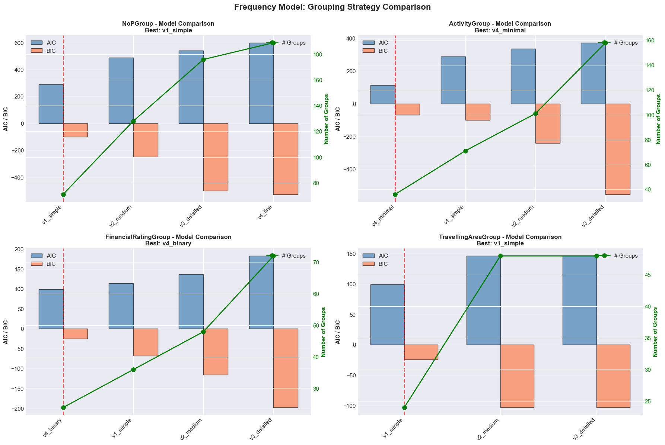
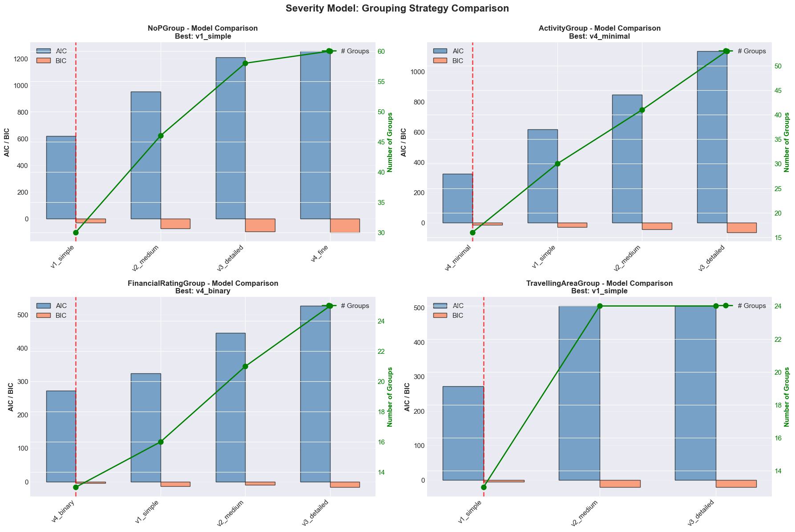
4.1 Comparison Charts

For each variable, the notebook generates a chart showing:

Bars:
- Blue bars = AIC for each strategy
- Orange bars = BIC for each strategy

Green line:
- Number of groups for each strategy

Red vertical line:
- Indicates selected strategy (best AIC)

Example reading:
NumberOfPersons:
v1_simple: AIC=450, BIC=430, 3 groups
v2_medium: AIC=440, BIC=410, 6 groups (SELECTED - lowest AIC)
v3_detailed: AIC=460, BIC=420, 8 groups
v4_fine: AIC=480, BIC=430, 9 groups

4.2 Chart Title

Each subplot displays:
[Variable name] - Model Comparison
Best: [selected strategy]

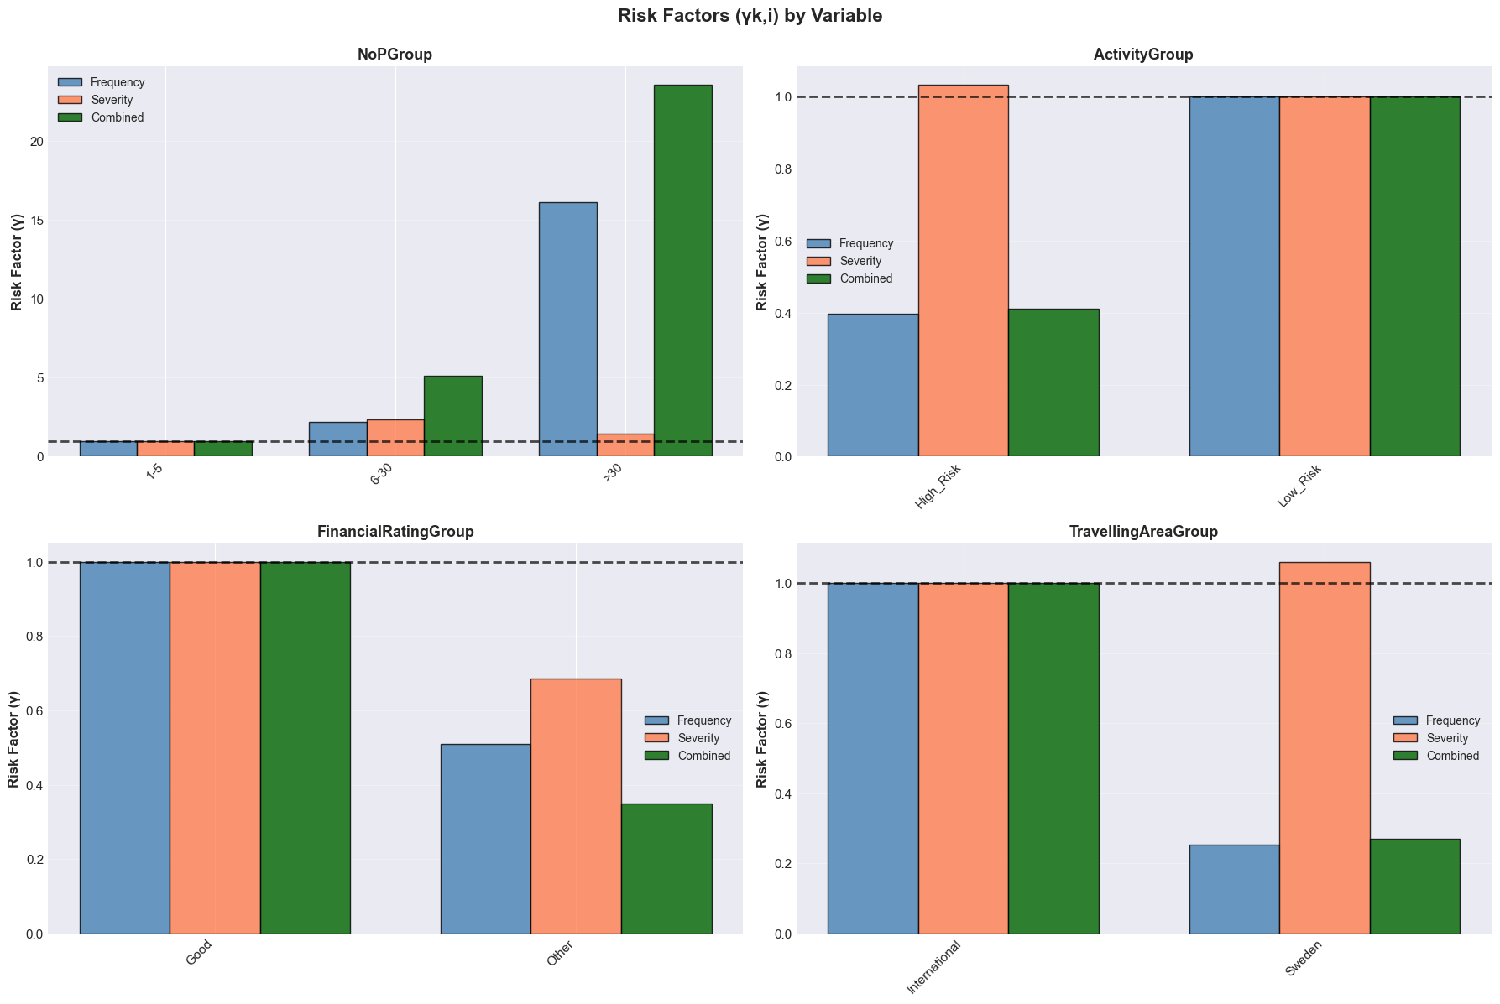
5. LIKELIHOOD RATIO TESTS
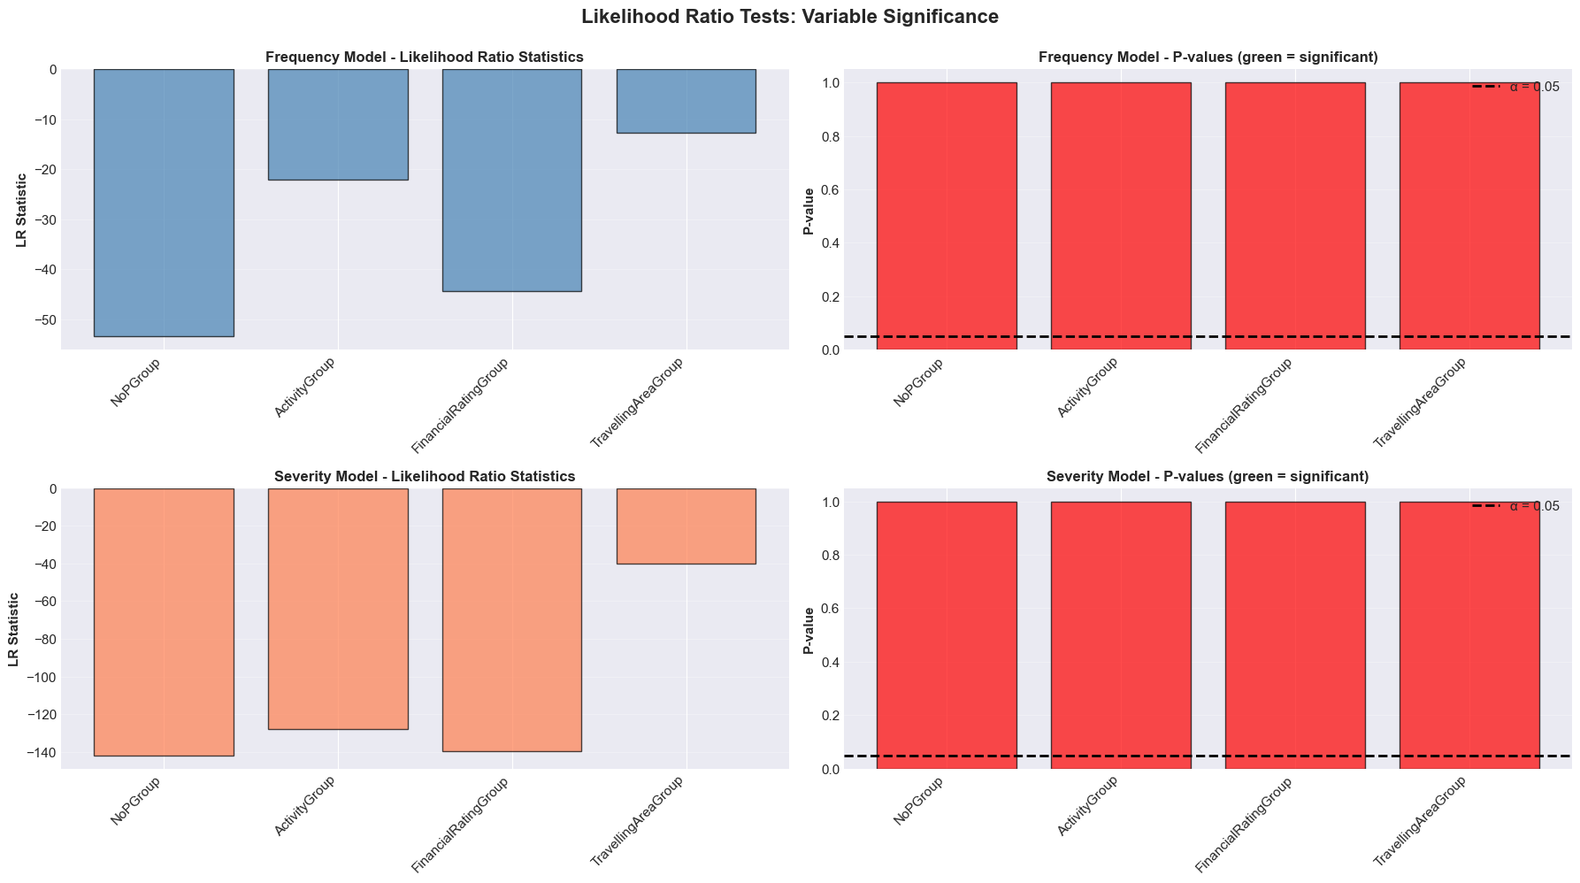

After selection, the notebook performs LR tests to validate that each variable is significant:

Test performed:
For each variable:
FULL model: with all variables
REDUCED model: without this variable

LR_statistic = 2 × (LL_full - LL_reduced)
p-value = Chi-squared(LR_statistic, df)

Interpretation:
- p < 0.05: Variable SIGNIFICANT (green bar)
- p >= 0.05: Variable NOT significant (red bar)

LR Test Chart:
- Chart 1: LR statistics (height = importance)
- Chart 2: P-values (green if < 0.05)

6. VALIDATION ON TEST DATA

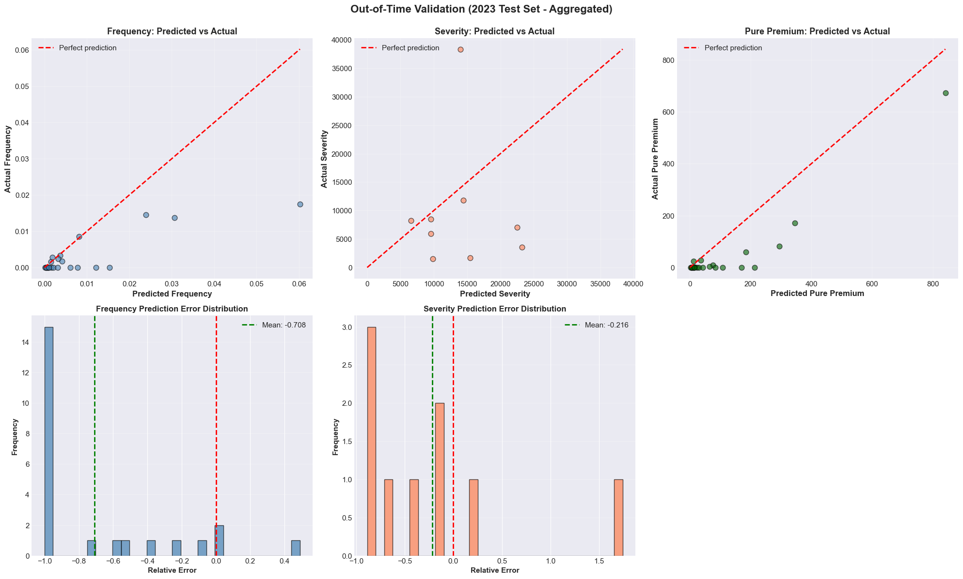
6.1 Application of Groupings

Best configurations are applied to test data:
df_test_freq = apply_grouping_config(df_test, best_config_freq)
df_test_sev = apply_grouping_config(df_test, best_config_sev)

6.2 Performance Metrics

For frequency:
- Chart: Predicted Frequency vs Actual Frequency
- Points aligned on red line = good predictions

For severity:
- Chart: Predicted Severity vs Actual Severity
- Verification of prediction quality

Calculated metrics:
- Test Claims Ratio = Actual claims / Predicted claims
- Test Cost Ratio = Actual cost / Predicted cost

7. FINAL CALIBRATION (LEVELING)
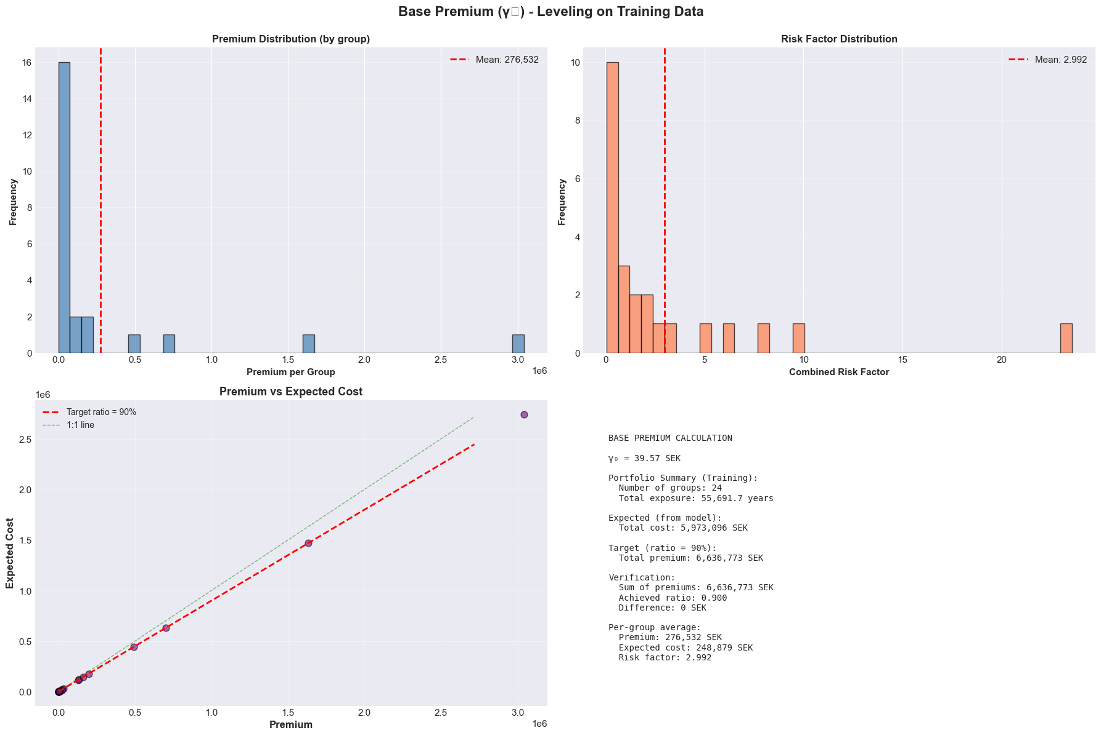

7.1 Calculation of gamma_0 (Base Premium)

The gamma_0 factor is calculated so that:
Sum of Premiums collected = Target × Sum of Expected costs

Formula:
gamma_0 = (Target × Sum of Actual costs) / Sum of Predicted costs

Typical Target: 0.90 (90%)
- 90% goes to claims
- 10% for expenses and profit

7.2 Leveling Charts

Chart 1: Premium Distribution
- Histogram of premiums by group
- Shows premium distribution

Chart 2: Risk Factor Distribution
- Distribution of combined risk factors

Chart 3: Premium vs Expected Cost (MOST IMPORTANT)
- Scatter plot: Premium vs Expected cost
- Red line: Target ratio (e.g., 0.90)
- Green line: 1:1 ratio
- Verification of pricing balance

8. FINAL SUMMARY AND EXPORT
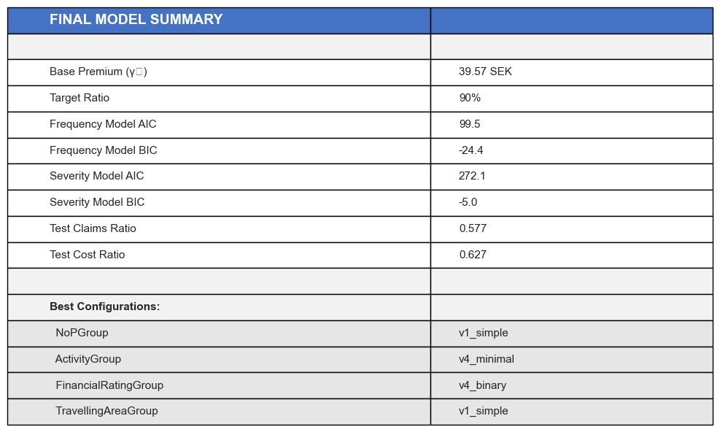

8.1 Summary Table

The notebook generates a table with:

Model metrics:
- Base Premium (gamma_0)
- Target Ratio
- AIC/BIC of frequency models
- AIC/BIC of severity models
- Test Claims Ratio
- Test Cost Ratio

Best configurations:
NoPGroup: [selected strategy]
ActivityGroup: [selected strategy]
FinancialRatingGroup: [selected strategy]
TravellingAreaGroup: [selected strategy]

8.2 Final Risk Factors

For each variable and each category, the notebook displays:

Frequency Factor (gamma_freq)
Severity Factor (gamma_sev)
Combined Factor (gamma_combined = gamma_freq × gamma_sev)

Example for NumberOfPersons (if v1_simple selected):
Group Freq Sev Combined
1-5 persons 1.0 1.0 1.0 (reference)
6-30 persons 1.8 1.2 2.16 (2.16x riskier)
>30 persons 4.5 2.0 9.0 (9x riskier)

Ce qu’il reste a faire:
- Injecter le meilleur grouping dans le notebook principal (GLM-1)
- Faire le leveraging (déja fait dans notebook vizualisation mais le faire dans notebook principal donné par le prof: GLM-1 en suivant sa méthode donnée dans le sujet)
- Selon les resultats de severity et frequence adapter avec méthodes …
- Aussi j’ai considéré que 4 variables mais il y en avait d’autres dans le data set donc peut-être essayé de voir si ça améliore resultat ..

