This output was before sorting the appointments ascendingly according to time.

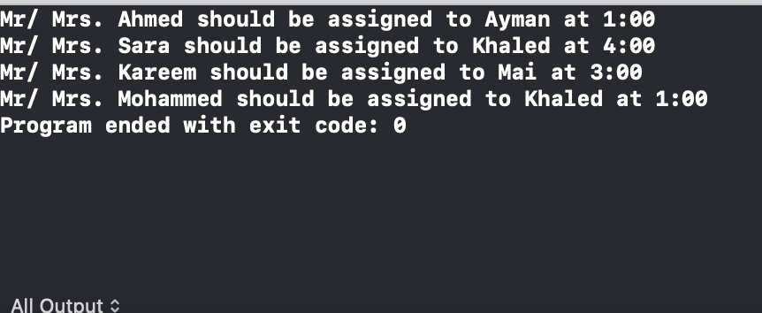

This output was after sorting the appointments ascendingly according to time

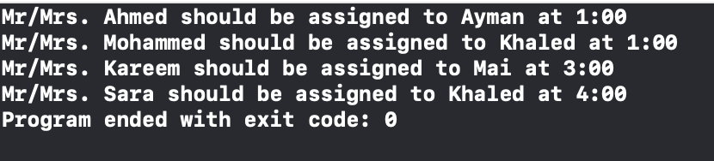

I added another customer named Hana having same appointment as another customer to test out and check if this message would be outputed