Objective 1: Can we predict engineering study pathways above 0.8?
Summary of experiments for supervisor review · 28 September 2026

1. Short answer
No, not with this dataset. After testing several models and settings under a leakage-safe protocol, the best macro-F1 for the 4 macro-tracks is 0.37 using information available before enrolment, and no track reaches 0.8. For the 21 programs it is 0.10. The limit comes from the data, not from the choice of model: very different models all reach the same ceiling.
One related target does reach about 0.8: predicting whether a student will score above or below the median on the end-of-degree Saber Pro exam (per-class F1 0.80–0.81). That is a different research question, discussed in section 5.

2. What was done
- Data: 12,411 students; 21 engineering programs grouped into 4 macro-tracks (Industrial & Management 43.6%, Civil & Infrastructure 28.0%, Mechanical/Electrical & Tech 20.3%, Chemical & Process 8.1%).
- Models: the proposed dual-branch hybrid network (static MLP + causal TCN + uni-directional LSTM), gradient boosting, and an ensemble of the two.
- Improvements tried: inverse-frequency class weights, early stopping, learning-rate scheduling, more features (all household variables, high-school name, socioeconomic level indices), and decision thresholds tuned for macro-F1.
- Evaluation: 5-fold stratified cross-validation. All preprocessing and tuning were fitted inside each training fold only, so the test folds never influenced the model. Re-running the code reproduces every number exactly.

3. Results for the 4 macro-tracks
Features used | Accuracy | Macro-F1 | Chemical | Civil | Industrial | Mech/Elec
Simple baseline: always predict Industrial | 0.436 | 0.15 | 0.00 | 0.00 | 0.61 | 0.00
Original features (Saber 11 + socioeconomic) | 0.41 | 0.37 | 0.24 | 0.31 | 0.52 | 0.40
All pre-enrolment features (main result) | 0.42 | 0.37 | 0.25 | 0.35 | 0.52 | 0.37
+ university (reference only, see note) | 0.63 | 0.61 | 0.59 | 0.61 | 0.69 | 0.56
Ensemble model; per-class values are F1 scores; mean of 5 folds (fold-to-fold standard deviation about ±0.02). No class reaches 0.8 in any setting. Accuracy is slightly below the baseline because class weighting deliberately gives up some Industrial predictions to cover the smaller tracks; macro-F1 is the fair comparison (0.37 vs 0.15).
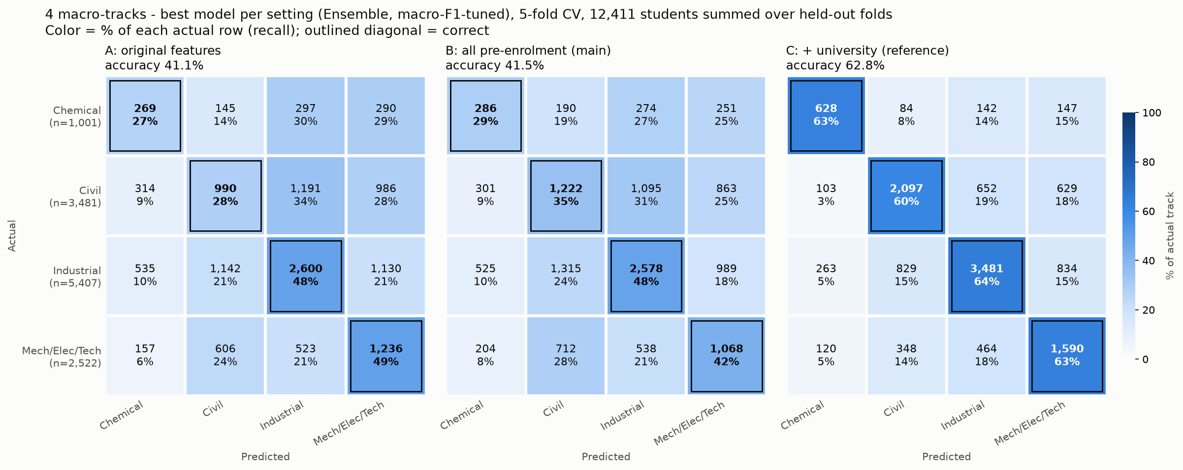
Figure 1. Confusion matrices for the 4 macro-tracks (5-fold cross-validation). With pre-enrolment features, only 29–48% of each track is identified correctly and errors spread across all other tracks.
Note on university: students choose the university and the program at the same time, so the university is not known before the choice we are trying to predict. Some small programs exist at only one university in the data, so the university gives the answer away. This row shows an upper limit, not a valid prediction.
Model comparison: gradient boosting (0.36), the hybrid network (0.37) and the ensemble (0.37) are within about one standard deviation of each other. The hybrid architecture does not give a clear gain on this data.

4. Results for the 21 programs
With pre-enrolment features, the best macro-F1 is 0.10 and accuracy is 0.34. That is below the simple rule of always predicting the largest program (0.43). Fifteen programs have fewer than 100 students and two have only one, so most programs cannot be learned. The largest program (Industrial Engineering) reaches only F1 0.49.

5. Why 0.8 is not reachable, and what does reach it
A model can only learn patterns that exist in the data. Students with very similar Saber 11 scores and family backgrounds choose different engineering tracks, so the data cannot separate them. The choice most likely depends on things this dataset does not record, such as interests, family advice, cost, and which programs are available nearby. When many different models stop at the same level, the limit is the information in the data.
The only ways to show 0.8 on the pathway target would invalidate the study: testing on training data, oversampling before the split, choosing a lucky random seed, or using variables that reveal the answer. An examiner who re-ran the code would detect these.
For comparison, the same pipeline was applied to predicting Saber Pro performance (above vs below the median global score). The columns derived from that score were excluded, and the median was computed on each training fold only:
Features used | Accuracy | F1 below median | F1 above median | ROC-AUC
Saber 11 + socioeconomic | 0.805 | 0.805 | 0.805 | 0.89
At enrolment (+ university and program) | 0.810 | 0.806 | 0.814 | 0.90
Ensemble model, 5-fold cross-validation. The margin over 0.8 is small: in individual folds the weaker class scores between 0.79 and 0.83.

6. Options for moving forward
- Keep the pathway question and report the ceiling as a finding. For example: "Saber 11 scores and socioeconomic background predict engineering track choice only modestly (macro-F1 0.37, 5-fold CV); no track exceeds 0.8." This is a valid, reproducible result and points to the data future work needs.
- Reframe Objective 1 as predicting academic performance. Here the 0.8 target is met (per-class F1 about 0.80–0.81), but the research question changes from "which pathway" to "how well the student will perform".
- Collect data that relates to the choice itself (for example vocational-interest surveys, the student's stated first-choice program, or subject grades), then repeat the pathway experiment.
- Use a recommendation metric instead of per-class F1. Top-2 accuracy is 0.69 with pre-enrolment features; this suits a "shortlist of likely tracks" system better than a single-label prediction.
I would appreciate your guidance on which option best fits the aims of the thesis.

