Nama:Hanafiyatussamhah

Kelas: R1/210511012

Tugas11_PBO2

1.Tampilan Pyathlon

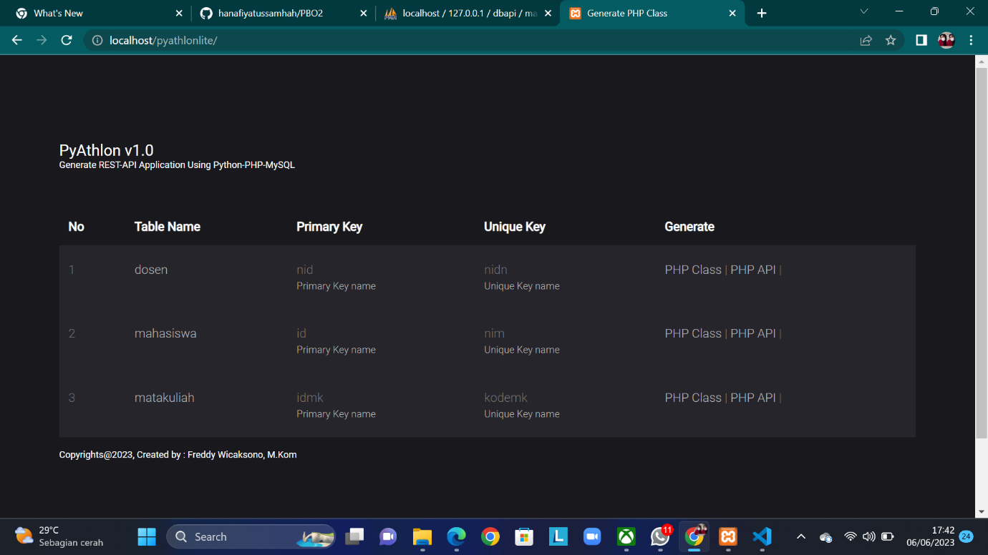

2.entry

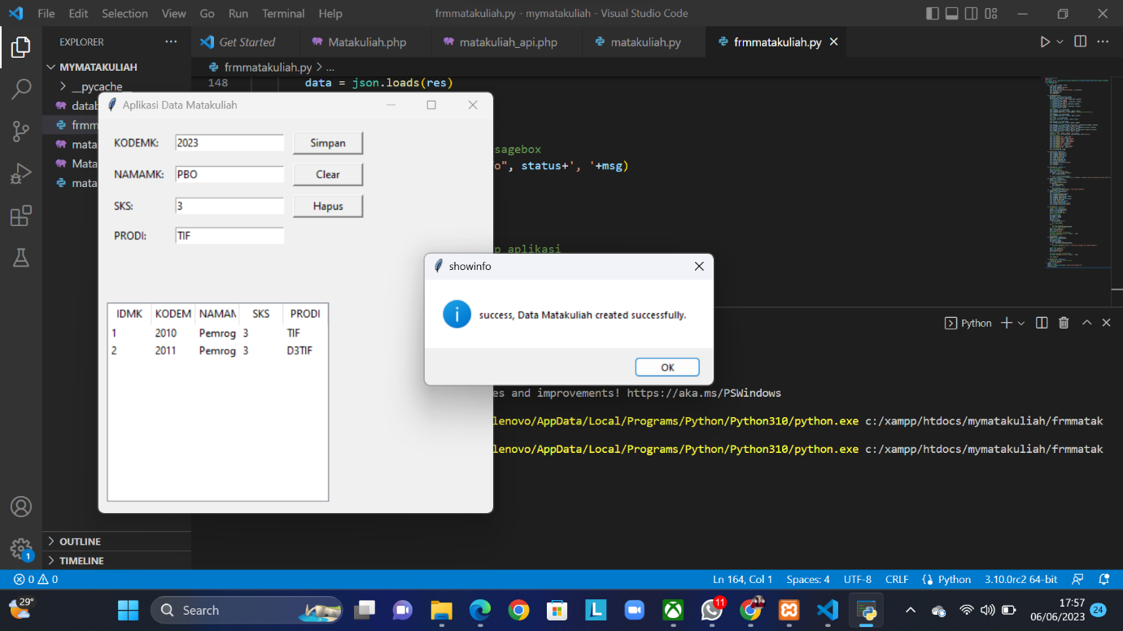

3.Delete

