

METEODYN UNIVERSE
MICROSCALE ADVANCED NOTES
2023

Table of contents
Units and abbreviations ......................................................................................................................4 Units 4
Abbreviations ..............................................................................................................................4
Technical notes ...........................................................................................................................5
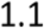 The wind flow equations......................................................................................................5 1.1.1 Reynolds-Averaged Navier-Stokes equations ...............................................................5 1.1.2 Turbulence modelling ..................................................................................................5 1.1.3 Turbulence modelling for strong stability – 3-Layer Model ...........................................6
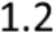 Mesoscale/Microscale coupling ...........................................................................................7
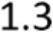 CFD advanced settings .........................................................................................................8 1.3.1 Mesh parameters.........................................................................................................8 1.3.2 Solver Parameters ........................................................................................................9 1.3.3 Drag coefficient parameters .........................................................................................9
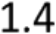 Auto-convergence ...............................................................................................................9
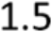 Mesh generation ............................................................................................................... 11 1.5.1 Surface grid generation .............................................................................................. 11 1.5.2 Volume grid generation ............................................................................................. 11 1.5.3 Boundary smoothing .................................................................................................. 12
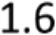 Boundary conditions .......................................................................................................... 13 1.6.1 Inlet boundary conditions - Thermal stability classes 0 to 6 ........................................ 13 1.6.2 Inlet boundary conditions - Thermal stability classes 7 to 9 ........................................ 15 1.6.3 Ground boundary conditions ..................................................................................... 16 1.6.4 Lateral boundary conditions....................................................................................... 16 1.6.5 Top boundary condition ............................................................................................. 17 1.6.6 Outlet boundary condition ......................................................................................... 17
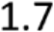 The forest model ............................................................................................................... 17 1.7.1 Canopy height vs roughness length ............................................................................ 17 1.7.2 The surface cells ........................................................................................................ 17 1.7.3 The volume mesh....................................................................................................... 17
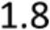 The Lidar correction........................................................................................................... 18 1.8.1 Zx Lidar ...................................................................................................................... 18 1.8.2 Windcube Lidar .......................................................................................................... 18 1.8.3 Molas Lidar ................................................................................................................ 18 1.8.4 Correcting measurements .......................................................................................... 19
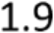 Meteodyn WT domains ..................................................................................................... 20

 Thermal stability classes .................................................................................................... 21
1.10.1 Obtaining Meteodyn WT classes from site measurements ......................................... 21
1.10.2 Implementation in Meteodyn WT .............................................................................. 22
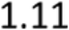 Compute air density from Time series................................................................................ 22
1.11.1 Density available at another height ............................................................................ 23
1.11.2 Temperature and Pressure available at the same height ............................................ 23
1.11.3 Temperature and Pressure available at different height ............................................. 23
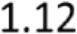 Power Curve correction ..................................................................................................... 24
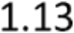 Wake effect computation .................................................................................................. 25
1.13.1 The modified PARK model .......................................................................................... 25
1.13.2 The Eddy Viscosity Model .......................................................................................... 26
1.13.3 Added turbulence models: The Frandsen model (2007) ............................................. 28
1.13.4 Added turbulence models: The simplified Frandsen model (2003) ............................. 28
1.13.5 Added turbulence models: The Quarton model .......................................................... 28
1.13.6 Wake effect combination ........................................................................................... 29
1.13.7 Added turbulence coverage models ........................................................................... 29
1.13.8 Wake model comparisons .......................................................................................... 30
1.13.9 Large park wake model .............................................................................................. 32
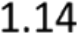 Weibull fitting of the wind speed distribution .................................................................... 34
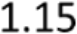 Turbulence intensity and turbulence correction................................................................. 34
1.15.1 Turbulence intensities ................................................................................................ 34
1.15.2 Turbulence corrections .............................................................................................. 34
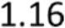 Extreme wind speed computations .................................................................................... 35
1.16.1 Speed-up factor and gust coefficient .......................................................................... 36
1.16.2 Computation based on the regional extreme wind ..................................................... 36
1.16.3 Computations based on the extreme wind at the measurement point ....................... 37
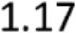 Site calibration .................................................................................................................. 38
1.17.1 Roughness calibration ................................................................................................ 38
1.17.2 Stability calibration .................................................................................................... 39
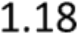 Definitions ......................................................................................................................... 41
1.18.1 Directional results ...................................................................................................... 41
1.18.2 Synthesis results ........................................................................................................ 41
1.18.3 IEC results – IEC 61400-1 Edition 4 – Design parameters ............................................ 44
1.18.4 IEC results – IEC 61400-1 Edition 3 – Design parameters ............................................ 51
1.18.5 IEC results – IEC 61400-1 Edition 2 ............................................................................. 56
1.18.6 Losses evaluation ....................................................................................................... 57
1.18.7 Uncertainties evaluation ............................................................................................ 59
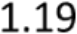 Formats ............................................................................................................................. 60

1.19.1 Topographical data (orography + roughness) ............................................................. 60
1.19.2 Orographical data ...................................................................................................... 62
1.19.3 Roughness data ......................................................................................................... 63
1.19.4 Element data ............................................................................................................. 67
1.19.5 Climatology data ........................................................................................................ 68
1.19.6 Wind turbine data ...................................................................................................... 70
1.19.7 Lidar correction data .................................................................................................. 71
1.19.8 WRG/RSF exports....................................................................................................... 72
References ................................................................................................................................ 75

UNITS AND ABBREVIATIONS
Units
Throughout the software the units most used for the different quantities are
• Meters (m) for distance.
• Seconds (s) for time.
• Kilograms (kg) for mass.
• Meters per second (m/s) for speed.
• Kilograms per cubic meter (kg/m3) for density.
• Kilowatt (kW) and Megawatt (MW) for power.
• Megawatt hour (MWh) and Gigawatt hour (GWh) for energy.
• Decimal degrees (o) for angles.
• Byte (B) for memory data.
• Pascal (Pa) for pressure.
• Degrees centigrade (oC) for temperature.
Abbreviations
The term “WT” throughout the software and the user manual means wind turbine(s).

TECHNICAL NOTES
The wind flow equations
1.1.1 Reynolds-Averaged Navier-Stokes equations
Due to the turbulent and random nature of the wind, the flow is characterized through statistical
parameters as the averaged wind velocity components (generally over a period of 10-min) or the
standard deviation of turbulent fluctuations.
Following Reynolds’ method, quantities are expressed as the sum of a mean and a fluctuating part. For
instance, the instantaneous velocity 𝑢𝑖 in the direction 𝑖 is the sum of the mean velocity 𝑢𝑖̅ and the
fluctuating part 𝑢𝑖′ :
𝑢𝑖= 𝑢𝑖̅ + 𝑢𝑖′
By averaging the instantaneous momentum and mass equation, we obtain the Reynolds Averaged
Navier-Stokes equations (RANS equations):
𝜕𝑢𝑗
𝜕𝑥𝑗= 0
𝜕𝑢𝑖𝜕𝑝̅𝜕𝜕𝑢𝑖 𝜕𝑢𝑗
−𝜌𝑢𝑗𝜕𝑥𝑗−𝜕𝑥𝑖+𝜕𝑥𝑗[𝜇(𝜕𝑥𝑗+𝜕𝑥𝑖) −𝜌𝑢𝑖′𝑢𝑗′̅̅̅̅̅̅] + 𝜌𝑓𝑖= 0
From left to right, the different terms of the equations have the following meanings:
➢ The convective transport of the mean wind speed
➢ The pressure gradient
➢ The laminar viscosity stress: in the atmospheric flows, the laminar viscosity stress can be
neglected against the Reynolds-stress terms.
➢ The quantities −𝜌𝑢𝑖′𝑢𝑗′̅̅̅̅̅̅, appearing in the process of averaging, are referred to as turbulent
fluxes or also Reynolds-stress terms, denoted 𝜏𝑖𝑗. These terms are new unknown variables
which must be modelized in order to close the equations system (turbulence modelling).
➢ The other body forces fi
Where 𝑝 is the pressure, 𝜌 is the density, 𝜇 is the dynamic viscosity, 𝑥𝑖 and 𝑥𝑗 are the space
variables in the directions 𝑖 and 𝑗.
1.1.2 Turbulence modelling
Eddy viscosity models are based on the hypothesis that the Reynolds-stress terms are proportional to
the wind speed gradients, by considering the concept of eddy viscosity (or turbulent viscosity):
𝜏𝑖𝑗= −𝜌𝑢𝑖′𝑢𝑗′̅̅̅̅̅ = 𝜇𝑇(𝜕𝑢𝑖
𝜕𝑥𝑗+
𝜕𝑢𝑗
𝜕𝑥𝑖)
Then, additional transport equations are required to solve the problem. Prandtl postulated the one
equation model, in which eddy viscosity considers the effect by flow history and depends on the
turbulent kinetic energy 𝑘. So, the eddy viscosity 𝜇𝑇 is given by:
𝑘2
𝜇𝑇= 𝜌𝑘1 2⁄ 𝐿𝑇= 𝐶𝐷 𝜖

Where 𝑘= 2 𝑢𝑖′𝑢𝑖′̅̅̅̅̅ = 2 (𝑢′𝑢′̅̅̅̅̅ + 𝑣′𝑣′̅̅̅̅̅ + 𝑤′𝑤′̅̅̅̅̅̅) = 2 (𝜎𝑢2 + 𝜎𝑣2 + 𝜎𝑤2)
1
The turbulent kinetic energy 𝑘 is calculated from the conservation equation:
𝜕𝑘 𝜕𝑢̅𝑖 𝜕 𝜇𝑇 𝜕𝑘
−𝜌𝑢𝑗𝜕𝑥𝑗+ 𝜏𝑖𝑗𝜕𝑥𝑗−𝜌𝜀+𝜕𝑥𝑗[(𝜎𝑘)𝜕𝑥𝑗] = 0
Where 𝜎𝑘 is fixed at 1 and the turbulent dissipation rate 𝜀 is:
𝑘3 2
𝜀= 𝐶𝐷𝐿𝑇
The turbulence length scale 𝐿𝑇 and the parameter 𝐶𝐷 depend on the thermal stability, defined
through a mixing length 𝑙 (model of (Yamada, 1983) and (Arritt, 1987)).
We have:
𝐿𝑇= √2𝑆𝑚𝑙 with 1/𝑙= 1/κz + 1/𝑙0
Where κ is the Karman constant, z is the height above the ground and Sm is calculated based on the
Richardson flux number 𝑅𝑖𝑓, modified from (Yamada, 1983). 𝑙0 is a constant equal to 100 m in order
to fix the mixing length far from the ground (Louis, 1979).
If Rif > 0.16 Sm = 0.085
(0.1912−𝑅𝑖𝑓)(0.2341−𝑅𝑖𝑓)
If Rif < 0.16 𝑆𝑚= 1.96 (1−𝑅𝑖𝑓)(0.2231−𝑅𝑖𝑓)
The Richardson flux number 𝑅𝑖𝑓 is computed according to the Monin-Obukhov length L. Each stability
class defined in the software corresponds to a different Monin-Obukhov length.
𝑅𝑖𝑓= 1 −[(𝑅𝑖𝑡2 + 1)1/2 −𝑅𝑖𝑡] 2 with Rit = 7/L if L <0 and 𝑅𝑖𝑡= 1+50/𝐿 if L>0
7/𝐿
Rit is positive for stable stratification, negative for unstable stratification and zero for neutral
stratification.
The coefficient CD is given by 𝐶𝐷= 𝐶𝑜𝐷𝑆𝑚/16.6, where CoD is a coefficient depending on the thermal
stability (Table below).
WT thermal stability classes | 0 | 1 | 2 | 3 | 4 | 5 | 6
CoD coefficient | 0.52 | 0.50 | 0.63 | 0.80 | 1.00 | 1.25 | 1.51
1.1.3 Turbulence modelling for strong stability – 3-Layer Model
The strong thermal stability detailed statistical analysis requires an advanced turbulence modelling. In
the transport equation of the turbulent kinetic energy (TKE), the Obukhov length 𝐿 is used to
determine the dissipation terms obtained by the Meteodyn three layers model. The layers are the
following:
- the Monin-Obukhov Similarity Theory (MOST) layer, where the Gradient Richardson number
is lower than about 0.1 (Grachev, 2013). (Yamada, 1983) and (Arritt, 1987) model is used with
a modification in the mixing length formulation to consider a limiting buoyancy length scale.
In the classical MOST layer, a constant Monin-Obukhov length 𝐿 only depends on the stability.

- the local MOST layer, where a local MOST theory is applied. 𝐿 depends not only on the stability
but also on the height. Therefore, the fluxes decrease with height up to a critical Richardson
number.
- The outer layer, where the turbulent fluxes depend on large scale turbulence generated at the
mesoscale-scale level (Zilitinkevich, 2010).
The turbulence length 𝐿𝑇 in the Meteodyn three layers model is calculated in the same way as in the
Meteodyn one-layer model:
𝐿𝑇= √2𝑆𝑚𝑙 with 1/𝑙= 1/κz + 1/𝑙0
Where κ is the Karman constant, z is the height above the ground and Sm is calculated based on the
Richardson flux number 𝑅𝑖𝑓 modified from (Yamada, 1983). 𝑙0 is a constant equal to 100 m in order to
fix the mixing length far from the ground (Louis, 1979).
- In the MOST layer (𝑧< 𝑧𝑠), Sm is calculated based on Richardson flux number
If Rif > 0.16 Sm = 0.085

If Rif < 0.16 𝑆𝑚= 1.96

(0.1912−𝑅𝑖𝑓)(0.2341−𝑅𝑖𝑓)
(1−𝑅𝑖𝑓)(0.2231−𝑅𝑖𝑓)

𝑅𝑖𝑓 depends on 𝐿. Each stability class is assigned a different Monin-Obukhov length.
𝑅𝑖𝑓= 1 −[(𝑅𝑖𝑡2 + 1)1/2 −𝑅𝑖𝑡] 2 where 𝑅𝑖𝑡= 7/𝐿 if 𝐿< 0 and 𝑅𝑖𝑡= 1+50/𝐿 if 𝐿> 0
7/𝐿
Where 𝑧𝑠 is the surface layer height and 𝑧ℎ is local MOST layer height.
- In the local MOST layer (𝑧𝑠< 𝑧≤𝑧ℎ), 𝐿𝑇 depends not only on the stability, but also on the
height. Thus, 𝑆𝑚_𝑧ℎ varies with height:
𝑆𝑚_𝑧ℎ= 𝑆𝑚+ (𝑆𝑚_𝑜𝑢𝑡−𝑆𝑚)(𝑧−𝑧s)
(𝑧h −𝑧s)
- Above the local MOST layer (𝑧ℎ< 𝑧), we take 𝑆𝑚_𝑜𝑢𝑡 as:
WT thermal stability classes | 7 | 8 | 9
𝑆𝑚_𝑜𝑢𝑡 | 0.18 | 0.15 | 0.15
Mesoscale/Microscale coupling
The process of the statistical downscaling and mesoscale/microscale coupling is the following:
- WRF outputs are classified by wind direction and stability categories (based on the Monin-
Obukhov length) to obtain ensemble-averaged inlet and top boundary conditions for
MeteodynWT RANS K − l model. Three classes of atmospheric stability (unstable, neutral and
stable) are simulated via the turbulence kinetic energy and the turbulence length scale.

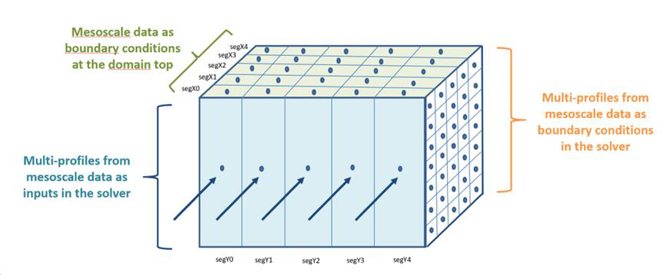
Figure 1 Mesoscale inlet and boundary conditions
- A force term is added to relax the microscale flow to the mesoscale wind profiles in the meso
zone that starts 500 m above ground level, vertical profiles of mesoscale model output being
assimilated into the CFD model as a body force. Below this level, no relaxation is applied
because of the high topography resolution in the microscale CFD model.
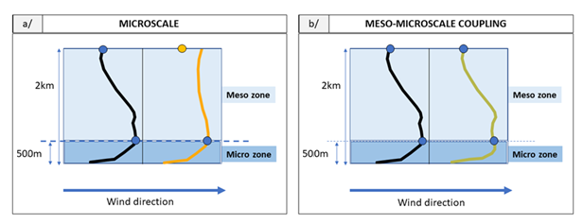
Figure 2 Conservation of mesoscale data
CFD advanced settings
1.3.1 Mesh parameters
• nfirst The nfirst first cells in the vertical direction (from ground to upper levels)
have a constant vertical size equal to the “minimum vertical
refinement”. Above this cells the cells vertical dimensions are

stretched according to the
= 10

“vertical expansion coefficient” ; default value

• ratiomax it defines the maximum aspect ratio between the length and the height of a
cell. It avoids creating very thin cell leading to divergence; default value = 100
• coefzdomain the height of the computational domain is defined as:
Max ( 2800 m ; Zmax + coefzdomain * (Zmax - Zmin) )
where Zmin and Zmax are respectively the maximum and
minimum altitudes inside the domain; default value = 5

1.3.2 Solver Parameters
• nbrelax relaxation number of post-prolongation in the multi-grid cycle.
• relin linear relaxation coefficient (hydrodynamic solver).
• falsdt false time step relaxation (hydrodynamic solver)
• falsdtk false time step relaxation (kinetic energy solver).
• relink linear relaxation coefficient (kinetic energy solver).
• rlat latitude value (deg) (used for the Ekman layer and the surface layer evaluation).
1.3.3 Drag coefficient parameters
• forestlow Drag coefficient value for 'low' forest density.
• forestnor Drag coefficient value for 'normal' forest density.
• foresthigh Drag coefficient value for 'high' forest density.
Auto-convergence
When the auto-convergence option is activated, the diverged calculations (i.e. when the convergence
rate lies under the minimum convergence threshold) are launched successively with new CFD
parameters, from level 1 to level 4, by using CFD parameters more and more favorable to convergence.
If a calculation still has not converged at level 4, it is shown as diverged.
The minimum convergence threshold is defined by the user, as a percentage. The accepted values are
between 0 and 100. The default value is 95%.
The parameters which are modified in the auto-convergence process in order to improve convergence
are:
• falsdt: false time step relaxation (hydrodynamic solver).
• falsdtk: false time step relaxation (kinetic energy solver).
• Maximum iteration number.
• Minimum vertical resolution.
• Minimum horizontal resolution.
Furthermore, in the forest model, the verticality is set at 0.5 and the relin and relink parameters are
set at 0.3 for all the auto-convergence steps. Please refer to Mesoscale/Microscale coupling section.
Mesoscale/Microscale coupling
The process of the statistical downscaling and mesoscale/microscale coupling is the following:
WRF outputs are classified by wind direction and stability categories (based on the Monin-Obukhov
length) to obtain ensemble-averaged inlet and top boundary conditions for MeteodynWT RANS K − l
model. Three classes of atmospheric stability (unstable, neutral and stable) are simulated via the
turbulence kinetic energy and the turbulence length scale.


Figure 1 Mesoscale inlet and boundary conditions
A force term is added to relax the microscale flow to the mesoscale wind profiles in the meso zone that starts 500 m above ground level, vertical profiles of mesoscale model output being assimilated into the CFD model as a body force. Below this level, no relaxation is applied because of the high topography resolution in the microscale CFD model.

Figure 2 Conservation of mesoscale data
CFD advanced settings to have a description of the CFD parameters.
The auto-convergence has been tested on 50 complex sites for 8 directions each time. The line "Test cases reaching convergence" indicates how many of these 400 directional computations reached a 95% convergence rate.
The parameters used for each level of auto-convergence are described in the following table.

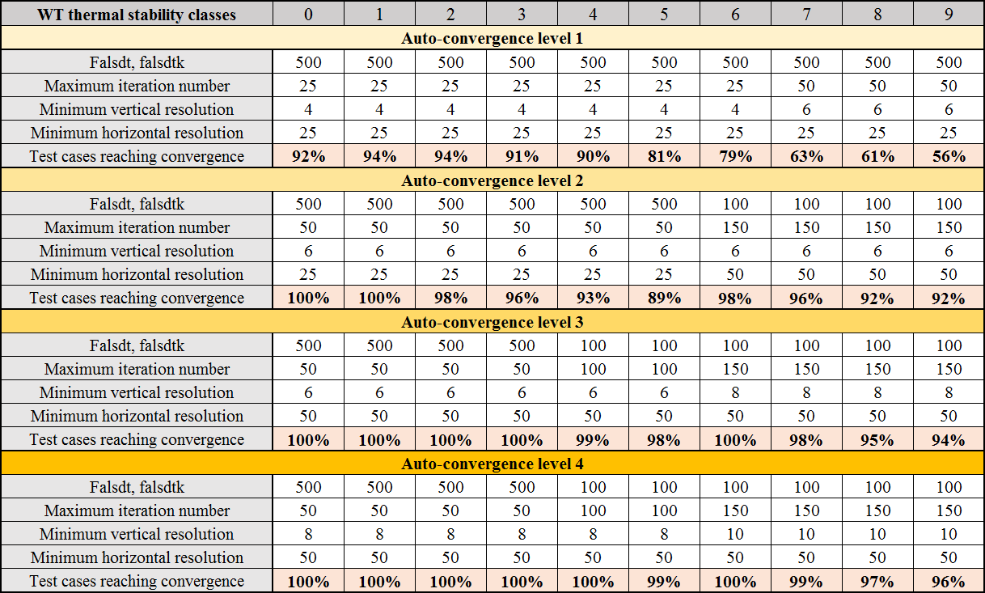
It is impossible to launch a directional computation with a minimum vertical resolution higher than the height of the points or the height of the mapping.
However, the auto-convergence modifies the minimum vertical resolution of the calculation up to a vertical resolution of 10 m to increase convergence. So, in rare cases it would be possible that a directional computation is launched with a minimum vertical resolution slightly higher than the height of the points or the height of the mapping. This would make the results for this point/these points wrong.
If you input points at an altitude lower than 10 meters, we request that you verify the auto-convergence level reached and the corresponding vertical resolution.
Mesh generation
1.5.1 Surface grid generation
A cartesian grid with refinement at the vicinity of the "result points" is generated. The expansion of cell dimensions as well as aspect ratios are controlled in order to avoid convergence instabilities.
It is possible to improve the resolution of the mesh at special locations, by adding result points there.
The mapping area will impose the minimal resolution of the grid on the whole mapping surface.
1.5.2 Volume grid generation
A method of front propagation (starting from the surface grid) is used in order to build the volume mesh. The altitude of the top boundary condition is computed according to:
Ztop = Zmax + max( 2800 m ; Coefzdomain*(Zmax - Zmin) )

With:
• Ztop: Altitude for the top boundary condition
• Zmax: Maximal altitude of the terrain inside the computational domain
• Zmin: Minimal altitude of the terrain inside the computational domain
The result points have no influence on the vertical meshing.
The 3-D mesh orthogonality is controlled in order to avoid generating skew cells. The orthogonality to the ground can be controlled by the Verticality parameter.
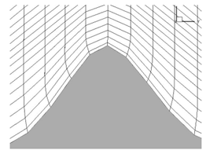
Figure 3 Mesh orthogonality
1.5.3 Boundary smoothing
In case of convergence issues due to sharp hilly areas in the border of the domain, it is recommended to activate the mesh boundary smoothing. Then, the elevation data at the vicinity of the domain boundaries will be smoothed according to the following scheme:
1) The elevation is smoothed at the four boundary lines of the computational domain.
2) The smoothing is propagated towards the inside of the domain until the radius R is reached. The width of the smoothed zone is equal to 20% of the domain radius value.
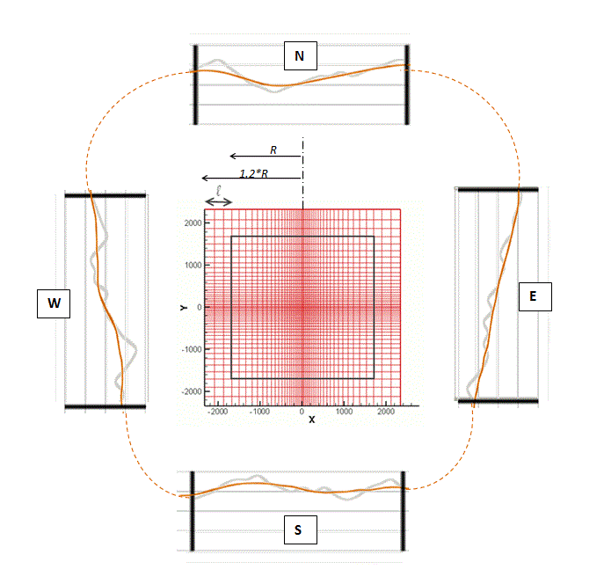
Figure 4 Boundary smoothing

Boundary conditions
1.6.1 Inlet boundary conditions - Thermal stability classes 0 to 6
Surface layer depth
Following (Tennekes, 1982), the Atmospheric Boundary Layer depth can be expressed as 𝑧ℎ= 𝑐𝑢∗/𝑓
where 𝑢∗ is the friction velocity, c an empirical constant depending on the stability (from 0.60 for
instability to 0.16 for very stable (Garratt, 1994) and 𝑓 the Coriolis parameter. 𝑓= 2𝛺sin 𝜙 where 𝛺
is the angular velocity of earth, and 𝜙 the latitude.
The surface layer depth 𝑧𝑠, is about 10% of the ABL depth, based on observation (Kaimal, 1994).
Inlet wind profiles
The wind profiles for horizontally homogenous terrain in the Surface Layer are based on the Monin-
Obukhov similarity theory (MOST) and the (Dyer, 1974) parameters. We have:
𝜅𝑢̅/𝑢∗= ln (𝑧/𝑧0) −𝛹(𝑧/𝐿)
Where κ is the von Karman constant (equal to 0.41), z is the height above the ground, 𝑧0 is the
roughness length and 𝐿 the Monin-Obukhov length, all characteristic of the thermal stability.
The Monin-Obukhov function 𝛹(𝑧/𝐿) is given by:
|𝐿| > 1500 m 𝛹(𝑧/𝐿) = 0
1+𝑥 1+𝑥2
-1500 m < 𝐿 < 0 m 𝛹(𝑧/𝐿) = 2 ln [ 2 ] + ln [ 2 ] −2tan−1𝑥+ π/2
where 𝑥= (1 −16 𝑧/𝐿)0.25
0 m < 𝐿 < 1500 m 𝛹(𝑧/𝐿) = −5(𝑧/𝐿)
Above the surface layer, the wind velocity is found to approach gradually the geostrophic wind 𝑢𝑔
according to:
𝑢̅ = 𝑢𝑔−(𝑢𝑔−𝑢𝑧𝑠)ln (𝑧ℎ/𝑧)/ln (𝑧ℎ/𝑧𝑠)

And where 𝑢𝑔 is given by:

(𝑢𝑔κ/𝑢∗)² = (ln(𝑧ℎ/𝑧0) −A2)2 + B2 2

Where 𝑢𝑧𝑠 is the wind speed at the top of the surface layer, A2 and B2 are affected by the stability 𝜇,
expressed by 𝜇= 𝑧ℎ/𝐿.
The functions for 𝐴2 and 𝐵2 are given by (Garratt, 1994):
• Unstable – Neutral (𝜇< 0): A2 = 5 −4(1 −0.0084 𝜇)−1/3 B2 = 4.5(1 −3.3 𝜇)−1/3
• Slightly stable (0 < 𝜇< 35): A2 = 1 −0.38 𝜇 𝐵2 = 4.5 + 0.3 𝜇
• Strongly stable (𝜇> 35): A2 = −3.17(𝜇−20)1/2 B2 = 3.17(𝜇−12.5)1/2
The diagram shows different inlet wind profiles according to the thermal stratification for a given
roughness length and different stability classes (S00-S06).

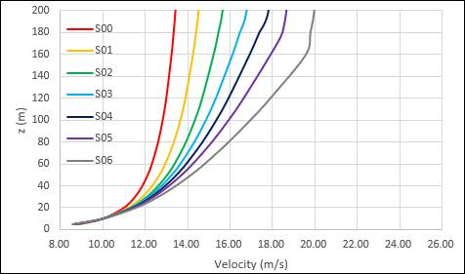
Turbulence kinetic energy profiles
The turbulence kinetic energy 𝑘 is given by:
𝑘= 1 2 (𝑢′2̅̅̅̅ + 𝑣′2̅̅̅̅ + 𝑤′2̅̅̅̅̅)
Where 𝑢′, 𝑣′and 𝑤′are the velocity fluctuation components.
Based on observations in neutral conditions, (Panofsky H.A., 1984) propose:
𝑘= 0.9(𝑢∗/κ)²
Where κ is the Karman constant, equal to 0.41.
The diagram shows different inlet TKE profiles according to the thermal stratification for a given
roughness length
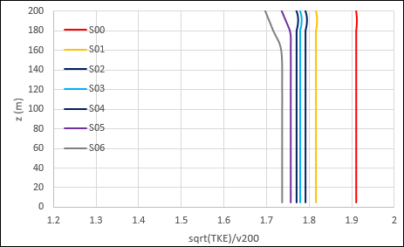
Implementation in Meteodyn WT
In Meteodyn WT, the simulation is driven by the mass flux at the inlet by specifying an inlet vertical
profile. Here, the friction velocity is calculated from 𝑢𝑔, from the following the relationship:
(
𝑢𝑔
)
2
= (ln (𝑧ℎ) −𝐴2)
2
+ 𝐵2²
𝑢∗ 𝑧0
We assigned the geostrophic wind 𝑢𝑔 from the reference wind velocity 𝑣𝑟𝑒𝑓, as the value at 10 m high
above a flat terrain, with a 5 cm roughness. By default, 𝑣𝑟𝑒𝑓is fixed at 10 m/s, which depends on the
latitude (45° by default). Table 1 gives the calculated values of 𝑢𝑔 as a function of Meteodyn WT
stability classes, with 𝑣𝑟𝑒𝑓 = 10 m/s.
Stability class | 0 | 1 | 2 | 3 | 4 | 5 | 6
𝑢𝑔 (m/s) | 20 | 19.4 | 20.5 | 21 | 22 | 22.5 | 23.5

Then the inlet wind velocities and TKE used in Meteodyn WT, for stability classes 0 to 6, are given by:
z< zs : u̅ = (u∗/κ)[ln(𝑧/z0) −Ψ(z/L)] 𝑘= 0.9(u∗/κ)2
𝑧𝑡𝑜𝑝−𝑧
zs <z< zh : u̅ = ug −(ug −uzs)ln (zh/z)/ln (zh/zs) 𝑘= (𝑧𝑡𝑜𝑝−𝑧𝑠0.99 + 0.01)(u∗/κ)2
𝑧𝑡𝑜𝑝−𝑧
z > zh : u̅ = ug 𝑘= (𝑧𝑡𝑜𝑝−𝑧𝑠0.99 + 0.01 )(u∗/κ)2
Where 𝑧𝑡𝑜𝑝 is the altitude of the top computational domain.
1.6.2 Inlet boundary conditions - Thermal stability classes 7 to 9
Considering strongly stable thermal stability conditions, a new thermal stability model is required.
Namely the Meteodyn three-layers models (3L model). In the model, we involve the stability classes 7,
8 and 9.
The atmospheric boundary layer (ABL) is divided into three layers as shown in the following diagram.
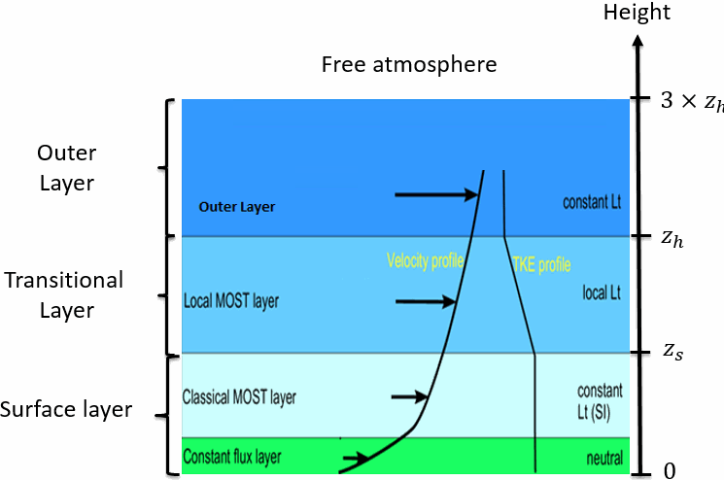
3 Layer model scheme
We initialize the average wind profile and the TKE profile for the stability classes 7 to 9:
• In the surface layer where 𝑧< 𝑧s:
𝑧𝑧
u̅ = 𝑢∗𝜅(𝑙𝑛(𝑧0) + 5𝐿) √𝑘0 = 0.95𝑐𝑘𝑢∗
where 𝐿 is the Monin-Obukhov length and the turbulence coefficient 𝑐𝑘 is equal to 1.0 and
𝑘0 𝑖𝑠 the value for 𝑘 at the constant flux layer.
• In the local MOST layer where 𝑧s < 𝑧≤𝑧h:
u̅ = 𝑢∗𝜅(𝑙𝑛(𝑧0) + 5
𝑧𝑧𝑠
𝐿+ 5
(𝑧−𝑧𝑠)
𝐿𝑡𝑟𝑎𝑛𝑠) √𝑘= √𝑘0 +
(√𝑘200−√𝑘)∗(𝑧−𝑧𝑠)
200−𝑧𝑠
, 𝑧≤200
where 𝐿𝑡𝑟𝑎𝑛𝑠 is the slope coefficient in the local MOST layer.
• In the outer layer where 𝑧h < 𝑧≤3𝑧h:
u̅ = 𝑢∗𝜅(𝑙𝑛(𝑧0) + 5
𝑧𝑧𝑠
𝐿+ 5
(𝑧ℎ−𝑧𝑠)
𝐿𝑡𝑟𝑎𝑛𝑠+ 5
(𝑧−𝑧ℎ)
𝐿𝑜𝑢𝑡) √𝑘= √𝑘0 +
(√𝑘200−√𝑘)∗(𝑧ℎ−𝑧𝑠)
200−𝑧𝑠

where 𝐿𝑜𝑢𝑡 is the slope coefficient in the outer layer and 𝑘200 is the turbulence intensity at
200 m.
• Outside of the outer layer where 3𝑧h < z:
u̅ = 𝑢∗/𝜅(𝑙𝑛(𝑧0) + 5
𝑧 𝑧𝑠
𝐿+ 5
(𝑧ℎ−𝑧𝑠)
𝐿𝑡𝑟𝑎𝑛𝑠+ 5𝐿𝑜𝑢𝑡)
2𝑧ℎ
√𝑘= √𝑘0 +
(√𝑘200−√𝑘)∗(𝑧ℎ−𝑧𝑠)
200−𝑧𝑠
The table shows five stability parameters in the Meteodyn three-layers model.
Stability class | 7 | 8 | 9
𝐿 | 200 | 130 | 70
𝑧h | 180 | 105 | 90
𝑧𝑠 | 150 | 65 | 55
𝐿𝑡𝑟𝑎𝑛𝑠 | 10000 | 210 | 210
𝐿𝑜𝑢𝑡 | 10000 | 300 | 300
The inlet wind profile and the inlet TKE profile for stability class 7 to 9 in Meteodyn WT are described
in the following figures.

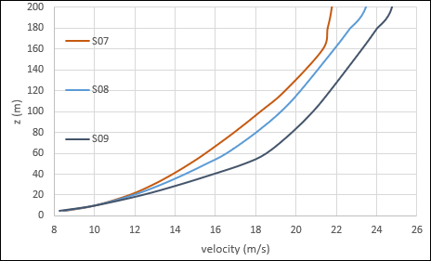
For more information, please refer to:

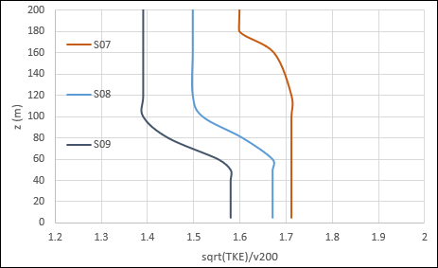

Ru L., Zeming S., Bin F. and Delaunay D. "A new Turbulence Model for the Stable Boundary Layer with Application to CFD in Wind Resource Assessment".
C. Albrecht, D. Delaunay, A. Grözner, M. Kohiert et L. Pauscher, “Atmospheric stability: general classification and simulation in Meteodyn WT”
1.6.3 Ground boundary conditions
The boundary condition is given through the logarithmic profile. The momentum flux condition at the ground is equal to 𝑢∗2. The TKE flux is also calculated from the logarithmic wall law. Moreover, a surface sink term 𝐹𝑆 is introduced in the momentum equations for all the cells laying on the ground.
𝐹𝑆= −𝜌𝐶𝑆𝑈𝑡|𝑈|
Where:
• 𝑈𝑡 is the wind speed tangential to the lower surface.
• 𝐶𝑠 is a calibrated drag and friction coefficient computed as a function of the local roughness of the cell and of the thermal stability class.
In the case where 20 times the roughness length is greater than the height of the first cell, the forest model is automatically activated (refer to The forest model on section 2.6).
1.6.4 Lateral boundary conditions
Symmetrical boundary conditions are applied on the lateral boundaries of the computational domain.

1.6.5 Top boundary condition
A pressure outflow boundary condition is applied on the top boundary of the computational domain.
1.6.6 Outlet boundary condition
A pressure outflow boundary condition is applied on the outlet boundary of the computational domain.
The forest model
Principles
The forest model includes a drag term which is added in the momentum conservation equation and
the dissipation term is modified in the TKE equation through the alteration of the turbulent length
scales.
1.7.1 Canopy height vs roughness length
The ratio between the canopy height 𝐻𝑐 and the roughness length 𝑧0 can be defined at “User settings >
CFD”:
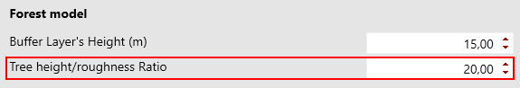
The default value of 20 for this parameter has been chosen by calibrating the computed profiles for
high roughness lengths with standard profiles given by the (Eurocode 1 (EC1), part 1-4: Wind Actions
(EN 1991-1-4:2005E)., 2005)
1.7.2 The surface cells
In the cells bordering the ground, the surface sink term 𝐹𝑆 is applied in the momentum equation:
𝐹𝑆= −𝜌𝐶𝑆𝑈|𝑈|
Where 𝐶𝑆 is a calibrated drag and friction coefficient which depends on the cell roughness.
1.7.3 The volume mesh
If the canopy height reaches at least the bottom of the second cell (vertically), then the forest model
is activated, and a volume sink term is applied. The corresponding equation is:
𝐹𝑉= −𝜌𝐶𝐷𝑈|𝑈|
Where 𝐶𝐷
• depends on the forest density, which can be modified in the “site” tab of Meteodyn WT,
• the percentage of forest in the cell
• and is constant up to a height of 3𝐻𝑐/4 and decreases linearly to 0 between 3𝐻𝑐/4 and 𝐻𝑐.
In the forest, the turbulent mixing length is equal to 2 m. Just above the canopy, the turbulent mixing
length is modified over a depth of 15 m.

The Lidar correction
1.8.1 Zx Lidar

In the LIDAR data treatment, the assumption is made that the flow over the measurement cone is homogeneous, i.e. it is admitted that 𝜑𝑈= 𝜑𝐷 and 𝑉𝐶= (𝑉𝑈+𝑉𝐷)/2. This assumption breaks down when the flow is non-uniform.
In complex terrain, a CFD correction is needed.
1.8.2 Windcube Lidar

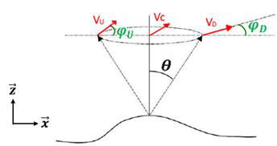

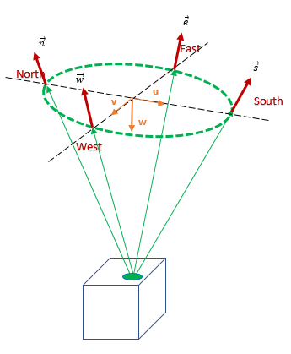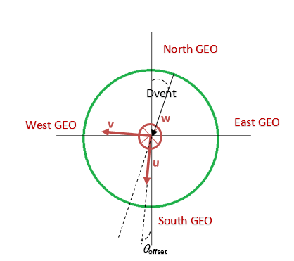
In case of Windcube lidar, the correction factor is computed from Meteodyn CFD results such as speed up factor and inflow angle along 4 beams: North, West, south and east.
1.8.3 Molas Lidar

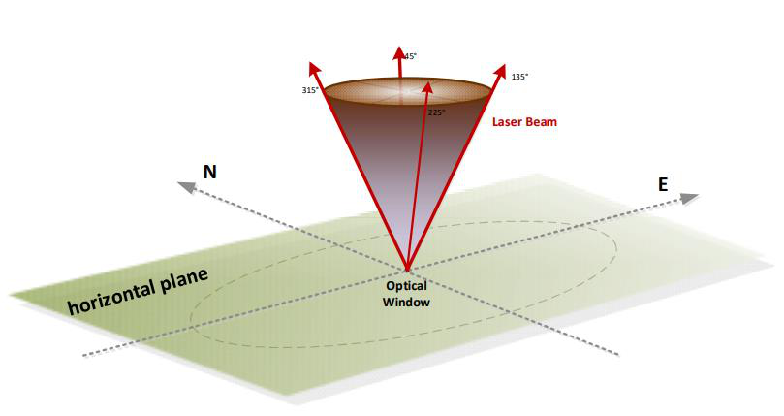

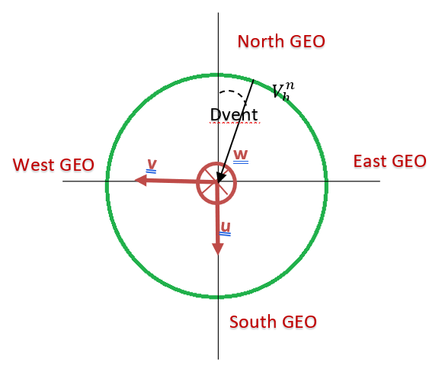

As output of the Movelaser Molas B300, we have 𝑉𝑙𝑖𝑑𝑎𝑟 the horizontal component of the wind at the center of the lidar and 𝐷𝑤𝑖𝑛𝑑, the direction of the wind at lidar. The wind direction is assumed as homogeneous in the sighting cone of the Molas on the same horizontal plane.

The correction factor is computed from Meteodyn CFD results such as speed up factor and inflow angle along 4 beams with aiming point 𝜃𝑖= 45° + 𝑖∗90°.
1.8.4 Correcting measurements
Using the calculated inflow angles, Meteodyn Universe delivers a ZCR format correction file which can be opened through notepad.
It contains the X and Y coordinates of the Lidar on the 1st line (green), the direction sectors in degrees on the 2nd line (red), the measurement height in meters (blue) and the correction factors (black) on the remaining lines.
Lidar location (m), Direction (deg), Heights (m)
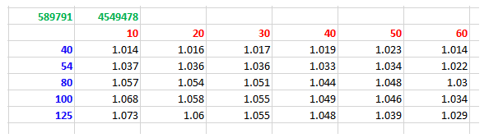
To correct the Lidar file using this ZCR file, the wind speeds in each direction is multiplied by the correction factor for this direction. In the example below, the Lidar data at the height 80 m and in the sector 20 deg must be increased by 5.4%.
An interpolation of the correction factors is made for the in between directions
For more information, see: Post conversion of Lidar data on complex terrains – S. SANQUER, A. WOODWARD.

Meteodyn WT domains
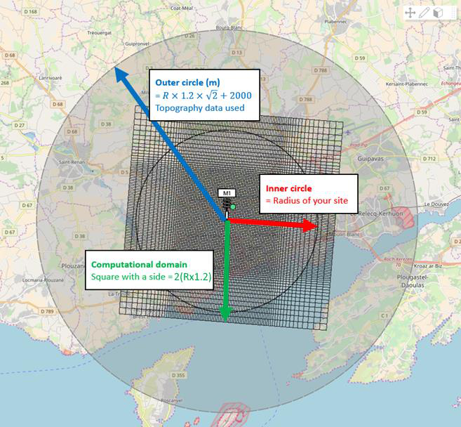
We consider 3 domains with the following use:
The Inner circle has a radius equal to the domain radius 𝑹, defined through the interface or automatically computed from the position of interest points. It is only inside the inner circle that you can place elements and obtain CFD results.
The computational domain is a square which its side length is equal to (𝟏.𝟐× 𝑹) × 𝟐. The alignment of the square depends on the inlet wind direction (the mesh is always aligned with the inlet wind direction). The mesh is created inside the computational domain. Therefore, only inside this square can CFD results be obtained for the direction in question.
The Outer circle has a radius equal to 𝟏.𝟐× √𝟐× 𝑹+ 𝟐𝟎𝟎𝟎 𝐦 in order to get a minimal fetch for estimating upwind orography and roughness:
• Regarding orography, it is required to have data for the whole circle, otherwise it is impossible to launch the CFD computations.
• For roughness however, you can have less data and Meteodyn WT will complete the missing
areas using the default roughness value. However, this could decrease the quality of the CFD
results.

Thermal stability classes
Principles
The effects of the thermal stability in CFD computations are considered by means of 10 thermal stability classes from very instable (class 0) to very stable (class 9)
These classes are defined through the Obukhov length 𝐿 which gives the relative importance of mechanical turbulence production due to thermal effects. The table below shows the Obukhov length values associated to the designated stability classes:

Class | 0 | 1 | 2
Condition | Very  unstable | Unstable | Neutral
𝐿 𝑟𝑎𝑛𝑔𝑒 (𝑚) | >-1000 | -5000<L<-1000 | |L|>5000

3 | 4 | 5 | 6 | 7 | 8
Near neutral | Slightly stable | Stable | Stable | Very stable | Very  stable
2600<L<5000 | 1700<L<2600 | 950<L<1700 | 550<L<950 | 200<L<550 | 70<L<200

The effect of choosing one of these classes for computations has some effects on three parameters: • Inlet profiles
• Turbulence length scale
• Turbulent viscosity
The model is described in section 1.6
1.10.1 Obtaining Meteodyn WT classes from site measurements
In stable situations, the surface layer height can be considered of the same magnitude as the Obukhov length, and the MOST theory applies only inside the surface layer.
Obtaining the Obukhov length from measurements is not simple given that the turbulent fluxes must be measured. Therefore, the gradient Richardson number 𝑅𝑖 is generally determined from measurements and then the Obukhov length is calculated from 𝑅𝑖 using the Monin Obukhov theory.
The gradient of potential temperature is determined from the air temperature gradient by removing the adiabatic lapse rate from air (0.0098 K/m in dry air; 0.0065 K/m in cloudy atmosphere):
𝜙𝐻 and 𝜙𝑀 are the Monin Obukhov functions of the similarity theory. According to the theory, 𝑅𝑖 cannot be greater than 0.2 corresponding to 𝐿= 0 which means that the mechanical turbulence has been totally suppressed by the thermal effects.
In the case of 𝐿 > 10 m, we can estimate 𝐿 from the Richardson number evaluated at a reference height of 10 m.
In case we obtain 𝑅𝑖 > 0.2, it means we are in the case of a very strong stability with 𝐿 < 10 m. This case is not treated in Meteodyn WT. However, the stability class 9 is applied, which means that 𝐿 = 60 m in the Meteodyn WT equations.
In a complex terrain, and particularly at the summit of a hill or a mountain, it is not possible to consider the mean speed vertical gradient 𝑑𝑉/𝑑𝑧 calculated from measurements, because if there is a speed-

up effect, this gradient is local, and is not representative of the gradient in a large area, which is the
one which determines the stability.
Then the procedure in Meteodyn WT is to determine, thanks to the computed speed-up factor the
undisturbed wind gradient, considering flat terrain and the average roughness over the site. The
procedure is iterative as the speed-up coefficients depend on the thermal stability.
1.10.2 Implementation in Meteodyn WT
The effects of thermal stability in Meteodyn WT are considered via the Obukhov length. The Richardson number used in the (Arritt, 1987) model is the Richardson number at 10 m height directly derived from the Obukhov length. The MOST theory can be applied at 10 m height since the surface layer height is greater. Consequently, the 10 Meteodyn WT stability classes are defined by fixing 10 values to the Obukhov length.
4 classes (classes 3 to 6) are in the range of slight or moderate stable cases. This is because in the current use of Meteodyn WT, we generally consider one "average stability" so that this average is generally inside this range. Also, even if classes 3 to 6 represent the same stability case, changes in the values of the Obukhov length lead to significant changes in the vertical mean wind speed profiles, therefore we need this detailed classification for a better fitting to the measured mean profiles.
Strongly stable stability classes (from classes 7 to 9) are handled through a new stability model (3-L turbulence model) described in section 1.6
Compute air density from Time series
In the Time series, the air density at a given height could be computed within Meteodyn Universe Microscale in order to:
• Evaluate the mean power density, as a function of the air density and local wind speed • Correct the data of power curves according to the air density at the hub height
All these results are gathered in the Time series export of the synthesis. The results from the whole export is computed from the statistical data, therefore the density used for these computations are the one defined in the synthesis configuration as following:
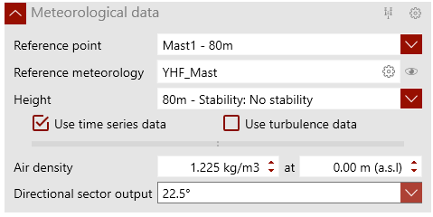
In the time series, three cases could appear when computing density at a given height:

• A density value is available at another height
• A Temperature and a Pressure values are available at the same height • A Temperature and a Pressure values are available at different heights
1.11.1 Density available at another height
In this case, the air density is computed according to the elevation above sea level of the point of
interest:
𝜌𝑃= 𝜌𝑟𝑒𝑓−(1.194 10−4)(𝑧𝑃−𝑧𝑟𝑒𝑓)
This approximates the US Standard atmospheric profile for air density and gives a good long-term average value of air density in temperate zones (around 285 K).
1.11.2 Temperature and Pressure available at the same height
In this case, the air density is computed according to the following relation:
𝜌= 𝑃0𝑅𝑇
Where:
P0= Air pressure (Pa)
R = Specific gas constant for air (287 m2/s2/K)
T = Temperature (Kelvin)
1.11.3 Temperature and Pressure available at different height
In this case, the aim is to compute the pressure at the height where the Temperature is known. For this we use the barometric leveling formula:
5.255
𝑃(𝑧) = 1013,25 (1 −0.0065 ∗𝑧288,15 )
The application looks for the highest-pressure sensor (PZ1) to compute a Reference Pressure Pref using the barometric level formula.
Then the application looks for the highest-temperature sensor (TZ2) to compute an Expected Pressure Pexp using the barometric level formula.
Then:
PZ2= PZ1 + (Pexp- Pref)
The equivalent density at the height Z2 is computed using:
𝜌= 𝑃0𝑅𝑇
And then, the following equation is used to recompute density at other heights:

𝜌𝑃= 𝜌𝑟𝑒𝑓−(1.194 10−4)(𝑧𝑃−𝑧𝑟𝑒𝑓)
Power Curve correction
How is the power curve corrected according to the air density?
In Meteodyn WT, the air density at a local point is computed in order to:
• Evaluate the energy density, as a function of the air density and local wind speed • Correct the data of power curves according to the air density at the hub height
The air density can be computed according to the elevation above sea level of the point of interest:
𝜌𝑃= 𝜌𝑟𝑒𝑓−(1.194 10−4)(𝑧𝑃−𝑧𝑟𝑒𝑓)
This approximates the US Standard atmospheric profile for air density and gives a good long-term average value of air density in temperate zones (around 285 K).
The next table displays the values of air density obtained from the formula used in Meteodyn WT and the values obtained using a local temperature sensor:
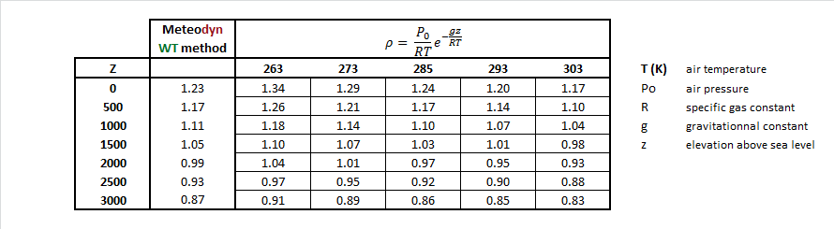
If the site is in a temperate zone or if the site altitude is near the reference altitude, the default value of air density can be used. Otherwise, we recommend using a value of air density that corresponds to the site mean value, calculated from on-site temperature measurements or from a regional weather station. This value may be specified in the software.
This method enables to compute a specific value of air density at each wind turbine.
The IEC 61400 - 12 standard provides information about the power performance measurements of electricity produced by wind turbines, it gives guidance in the measurement analysis and reporting of power performance testing for wind turbines.
A correction is applied if the local air density is different from the one provided for the power curve. The correction method depends on the wind turbine control system:
For a stall regulated wind turbine, the corrected Power, 𝑃𝑐𝑜𝑟𝑟𝑒𝑐𝑡𝑒𝑑 is calculated as follows:
𝑃𝑐𝑜𝑟𝑟𝑒𝑐𝑡𝑒𝑑(𝑉) = 𝑃𝑖𝑛𝑖𝑡𝑖𝑎𝑙(𝑉) 𝜌
𝜌0
Where:

𝜌 is the air density computed at each wind turbine
𝜌0 is the reference air density (the default value is 1.225 kg/m3) and
𝑃𝑖𝑛𝑖𝑡𝑖𝑎𝑙 is the power provided by the turbine manufacturer at the reference air density
For a pitch regulated turbine, the correction is applied in two steps:
1) Scaling the wind speed to obtain a new power curve (𝑉𝑛, 𝑃𝑖𝑛𝑖𝑡𝑖𝑎𝑙) :
𝑉𝑛= 𝑉0(𝜌0/𝜌)1/3
Where:
𝑉0 is the wind speed used in the original power curve and
𝑉𝑛 is the new wind speed to be used with the initial power curve data
2) Interpolating the new corrected power values at the initial wind speed i.e. (𝑉0, 𝑃𝑎𝑑𝑗𝑢𝑠𝑡𝑒𝑑) from (𝑉𝑛, 𝑃𝑖𝑛𝑖𝑡𝑖𝑎𝑙). The interpolation is performed every 0.1 m/s.
To check the IEC recommendations, you must provide:
• The power control method (pitch or stall regulated) in a .txt format.
• A reference value for air density and its associated altitude in order to compute the local air density at each wind turbine hub.
Note that by default, the power curve is given for an air density of 1.225 kg/m3 at 0 m elevation.
Wake effect computation
To compute the wake effects, the speed-up factor (WT coefficient) is multiplied by a wake coefficient defined as follows:
Cwake = Udownwind/Uupwind
1.13.1 The modified PARK model
The model considers an axisymmetric flow behind the wind turbine, as shown on the next figure.
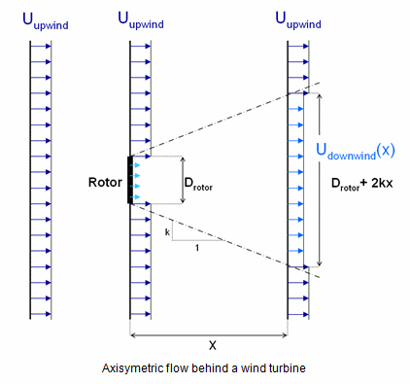
The wake coefficient downwind to the wind turbine is

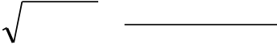
2
C wake =
U downwind
U upwind
( x )
= 1−( 1− 1−C t )⎛
⎜⎜
⎝D rotor
D rotor
+ 2 kx
⎞
⎟⎟
⎠
Where 𝑘 is the wake decay constant obtained from the turbulence intensity 𝐼𝑟𝑜𝑡, at the hub height of
the wind turbine generating the wake, therefore
𝑘= 𝐼𝑟𝑜𝑡/2,
𝐶𝑡 is the thrust coefficient, which depends on the upwind wind speed,
𝑥 is The distance from the wind turbine to the point of interest in the wind direction,
𝐷𝑟𝑜𝑡𝑜𝑟 is the diameter of the wind turbine rotor.
If the rotor is only partially located in the wake cone generated by another wind turbine, the wake
coefficient is scaled according to the overlapping area as follows:
2
𝐶𝑤𝑎𝑘𝑒=
𝑈𝑑𝑜𝑤𝑛𝑤𝑖𝑛𝑑(𝑋𝑊𝑇2)
𝑈𝑢𝑝𝑤𝑖𝑛𝑑
= 1 −(1 −√1 −𝐶𝑡) (𝐷𝑟𝑜𝑡𝑜𝑟+2𝑘𝑋𝑊𝑇2)
𝐷𝑟𝑜𝑡𝑜𝑟(𝐴𝑂𝑉𝐸𝑅𝐿𝐴𝑃
𝐴𝑊𝑇2
)
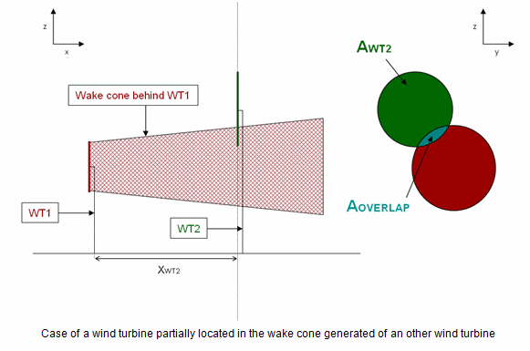
1.13.2 The Eddy Viscosity Model
The Ainslie Eddy Viscosity Model (Ainslie, 1988) describes the wake behind a wind turbine as follows:
𝑈𝜕𝑈𝜕𝑥+ 𝑉𝜕𝑉𝜕𝑟= 𝜀𝑟 (𝜕𝑈𝜕𝑟+ 𝑟𝜕2𝑈𝜕𝑟2 ) [1]
Where:
𝜕𝑈 1 𝜕𝑉
𝜕𝑥= −𝑟(𝑟𝜕𝑟+ 𝑉) [2] 𝐸𝑞𝑢𝑎𝑡𝑖𝑜𝑛 𝑜𝑓 𝑐𝑜𝑛𝑡𝑖𝑛𝑢𝑖𝑡𝑦
𝑈 Upstream windspeed
𝑉 windspeed in the radial direction
𝑥 downstream distance from the rotor
𝑟 radial distance from the rotor axis
𝜀 turbulent viscosity
The turbulent viscosity is computed as follows:
𝜀= 𝐹 (𝐾1𝑏(𝑈0 −𝑈𝐶) + 𝜅2𝐼0)
Where:

𝑥−4.5 1/3
𝐹= 0.65 + [ 23.32] if 𝑥< 5.5 and 𝐹= 1 if 𝑥≥5.5
Where:
𝐾1 = 0.015
𝜅= 0.41
𝐼0 turbulent intensity
𝑈𝐶 central line velocity
𝑈0 free stream velocity
𝑏 wake width
All distances are normalized by the rotor diameter. (Ainslie, 1988) concludes from the experiment
that the initial profile is Gaussian as follows:
1 −𝑈
𝑈0
= 𝐷𝑀exp (−3.56 𝑟2𝑏2
) [5]
Where 𝐷𝑀 is the centerline wake deficit, and:
3.56 𝐶𝑡
𝑏= √8𝐷𝑀(1 −0.5𝐷𝑀) [6]
From (Ainslie, 1988), the initial wake deficit is related to the thrust coefficient and the turbulent
intensity as follows:
𝐷𝑀𝑖= 𝐶𝑡−0.05 −(16𝐶𝑡−0.5) ∗𝐼0/ 1000 [7]
Where 𝐼0 is the ambient turbulence intensity.
Due to gaussian properties, 𝑏 is equal to 1 .89, the half-width of the gaussian distribution.
From these equations, it is possible to obtain the velocity behind the rotor of a wind turbine through
a numerical scheme such as the Crank–Nicolson method (Crank & Nicolson, 1947) . However, due to
the constraints of convergence, this method is highly restrictive given the computational resources
available.
To avoid this difficulty, a simplified model has been proposed. The previous equations show that the
Gaussian shape of the wake is preserved and only its width and depth vary. Since the width of the cone
is connected to the wake speed deficit by the equation of time, it is enough to calculate the wake along
the line passing through the center of the rotor.
From equation [5] we have:
𝑈= 𝑈0 [1 −𝐷𝑀exp (−3.56𝑟2𝑏2
)]
Integrating this equation in [2] and [1], we obtain:
𝜕𝑈𝑐𝜕𝑥= 16𝜀(𝑈𝑐3 −𝑈𝑐2 −𝑈𝑐+ 1)𝑈𝑐𝐶𝑡
With 𝑈𝑐= 𝑈0(1 −𝐷𝑀)
At the initial iteration 𝐷𝑀= 𝐷𝑀𝑖 as described in equation [7], then the initial width of the wake is given
by equation [6].

This is a first order equation which may be solved by a simple numerical method.
1.13.3 Added turbulence models: The Frandsen model (2007)
The added turbulence intensity due to wake effects is given by the (Frandsen S. T., 2007) model:
1
∆𝐼= 1.5+0.8𝑑/√𝐶𝑇 with 𝑑= 𝑥/𝐷
Where 𝑥 is the distance downwind (distance to the wind turbine plan), 𝐷 the rotor diameter and 𝐶𝑇
the thrust coefficient.
1.13.4 Added turbulence models: The simplified Frandsen model (2003)
The added turbulence intensity due to wake effects is given by the (Frandsen S. M., 2003) model:
√0.9
∆𝐼= 1.5+0.3𝑑√𝑉ℎ𝑢𝑏 with 𝑑= 𝑥/𝐷
𝑉ℎ𝑢𝑏 is the mean upwind wind speed at the hub height of the upstream wind turbine.
This cautious approach of the added turbulence by (Frandsen S. M., 2003) was obtained by a
conservative general thrust curve modelled as 𝐶𝑇= 7/𝑉ℎ𝑢𝑏 (in m/s).
1.13.5 Added turbulence models: The Quarton model
The added turbulence Quarton model (D.C. Quarton, 1990) is employed. The parameters in the
following equation have been re-calibrated by (D.C. Quarton, 1990) and the TNO Laboratory (European
Wind Turbine Standards II, 1998):
𝛼3
𝐼𝑎𝑑𝑑𝑒𝑑= 𝐾1𝐶𝑡𝛼1𝐼𝑎𝑚𝑏𝛼2 [ 𝑋]
𝑋𝑛
and
𝑋 is the distance to the upwind wind turbine,
𝑋𝑛 is the length of the near wake and
𝐼𝑎𝑚𝑏 is the ambient turbulent intensity (without considering wake effects).
The following table provides the constants used in the Quarton model (D.C. Quarton, 1990):
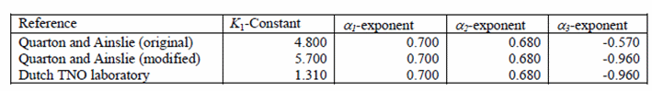
𝑋𝑛 is determined by the Vermeulen method (Vermeulen PEJ., 1982) . The near wake is divided into
several parts, the first 𝑥ℎ is calculated as follows:
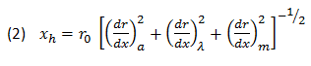
Where 𝑟0 is the effective radius defined by:
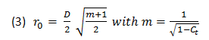
The length of the near wake is defined by the contribution of the ambient turbulence of the turbulence
generated by the rotor and by shearing. Where

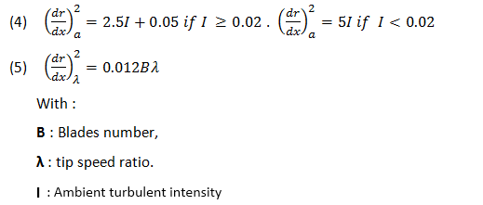
These values must be provided by the user.
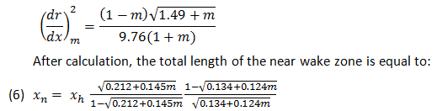
1.13.6 Wake effect combination
If a wind turbine is in the wake of more than one wind turbine the following rule is applied:
• The overall wake coefficient is the minimum value of all individual wake coefficients. • The added turbulent intensity is the maximum value of all individual added turbulent intensities.
1.13.7 Added turbulence coverage models
In the synthesis configuration page, two different models are available:
• Overlap model
If the rotor is only partially located in the wake cone generated by another wind turbine, the added turbulence is scaled according to the overlapping area described previously:
𝐼𝑎𝑑𝑑_𝑐𝑜𝑣𝑒𝑟𝑎𝑔𝑒= 𝐼𝑎𝑑𝑑(𝐴𝑂𝑉𝐸𝑅𝐿𝐴𝑃) 𝐴𝑊𝑇2• Frandsen added turbulence model
In Frandsen added turbulence model description (Frandsen S. T., 2007), the wake profile of turbulent fluctuations can be considered as an axis-symmetric superposition of the wake turbulence generated by the rotor and the vertical ambient turbulence profile. However, this symmetric assumption only stands when the mean wind direction is parallel to the axis of the turbines (θ = 0). For other wind directions, the two-dimensional wake exposes the downwind unit to a non-symmetric and inhomogeneous field of turbulent wind speed fluctuations. The degree of in-homogeneity varies with turbine separation.

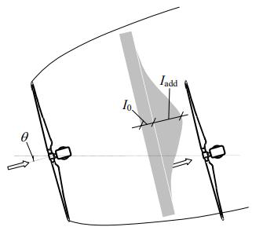

Frandsen S. T., 2007

The total turbulence intensity in the center of the wake affected rotor can be expressed as
2
𝐼𝑇= 𝐼0(1 + 𝛼∗exp (−[ 𝜃] ))
𝜃𝑤
where 𝐼0 is the ambient turbulence, 𝜃 is the angle between the connection line of the two wind turbine
units and the wind direction and 𝜃𝑤 is a characteristic view-angle of the wake-generating unit, seen
from the wake-effected unit. 𝜃𝑤 is deduced from the wake-width which uses linearly expanding wake
from Jensen (1983) and is defined as
𝜃𝑤= 1 2 (180𝜋. tan−1 (1𝑠) + 10°)
where 𝑠= 𝑥/𝐷 is the non-dimensional downwind distance.
1.13.8 Wake model comparisons
This section presents analyses and compares the Wake models with that of other software.
In WAsP for example, the wake decay 𝑘 is constant, equal to 0.075 by default. In Meteodyn WT, 𝑘 is
computed according to the turbulence intensity.
Regarding the interpolation method for the computation of AEP (annual energy production), the
climatology data may be interpolated. There are several types of interpolation. Hereafter we present
two methods which are employed on Meteodyn WT and Openwind. The difference generated by the
interpolation method explains the difference in the final production.
In the figure below, the darker red means a greater frequency in an initial climatology:
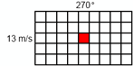
The initial climatology is a *.tab file, with one bin of wind speed (13 m/s) and one-degree direction
(synoptic direction = 270o). A bin of 13 m/s means that the wind speed is between [12.1; 13].
When 100% of the wind speed comes from 270o with a wind speed of 13m/s, the interpolation for the
direction is uniform in Openwind between 255o and 285o. On the contrary, in Meteodyn WT, it is not
uniform.

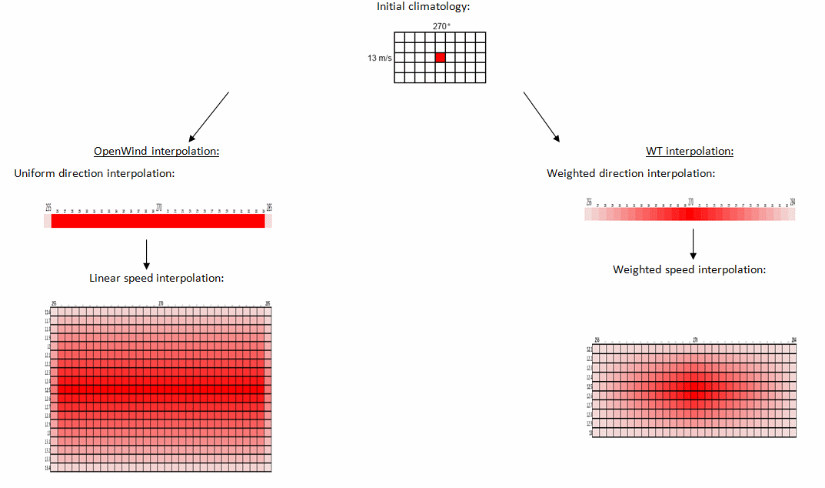
We can observe that during the directional interpolation at 12.5 m/s for the 270° synoptic direction the frequency is most important in Meteodyn WT whereas in Openwind, for example, the frequency is the same for the 12.5 m/s bin regardless of the direction between 255o and 285o.
References:
European Wind Energy Association Conference and Exhibition, October 1986, Italy - "A Simple Model for Cluster Efficiency", I. Katic, J. Højstrup and N.O. Jensen:
Risø-R-1188 Report, 2007 - "Turbulence and turbulence generated fatigue in wind turbines clusters", S.
Frandsen

1.13.9 Large park wake model
The large park model aims at simulating the wake effects in regularly arranged large wind farms where
the inter-turbine distance is lower than 15 rotor diameters. Single wake models do not consider the
change of the atmospheric boundary layer caused by a roughness increase associated with the
presence of wind turbines. More wind turbines are far from the windward side of the farm, where the
wind velocity deficit increases causing the wind speed to slow down over the farm. Therefore, the
boundary layer profile is a function of the equivalent roughness 𝑧′0 and the wind position relative to
the upstream turbine.
Note: The large park model developed for Meteodyn Universe Platform is designed for quasi-regular
parks with cluster shape. The large park model has been validated at Horns Rev and Nysted offshore
wind farms [1].
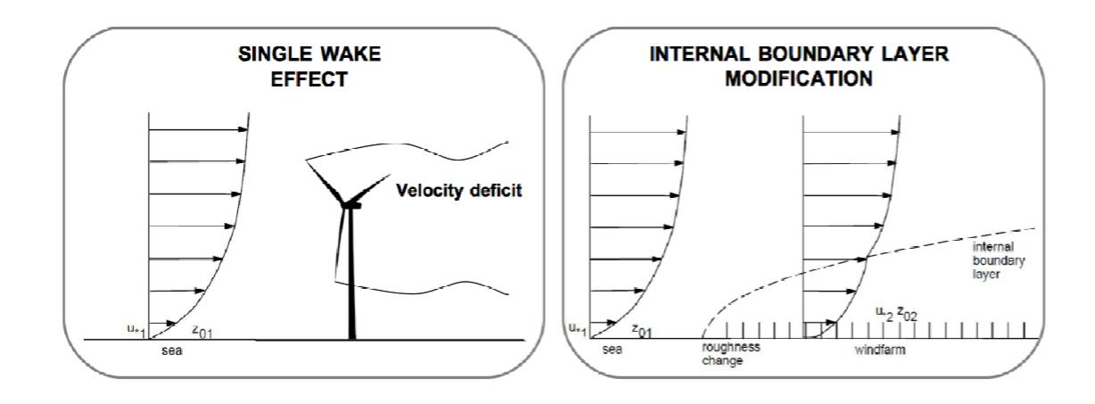
Figure X: Sketch of large wind farm effect
The large park model is described below.
1) The equivalent roughness z'0 is calculated with formula (1) using the Frandsen method [2][3]:
𝐾
𝑧′0 = ℎ𝐻 𝑒𝑥𝑝 −
2
(1)
(
√𝐶𝑡+(𝐾⁄ln (ℎ𝐻𝑧0 )
)
)
Where:
𝜋
𝐶𝜏= 𝐶𝑇
8𝑆𝑑𝑆𝑐
CT is the representative thrust coefficient. Sd and Sc represent the spacing between two rows of wind
turbines along the wind direction (Sd) and the crosswind direction (Sc).
Where:
K is the Karman constant,
Z0 is the mesoscale roughness and
hH is the mean hub height.

2) For each wind turbine located in the large park area, the height of the internal boundary layer h is
computed from (2) using z'0 and the distance between the wind turbine and the limit of the large
park area along the wind direction noted XBL :
ℎ ℎ𝑋𝐵𝐿
𝑧0′ (ln𝑧0′ −1) = 0.9 𝑧0
′ (2)
The velocity deficit CBL is calculated as follows:
𝑢(𝑧′)
𝐶𝐵𝐿=𝑢1(𝑧′) = (3)
1 𝑓𝑜𝑟 𝑧′ ≥𝑖𝑏𝑙2 ℎ′
ln (𝑧′
1
𝑧0)
[
ln (ℎ′
ln (ℎ′
𝑧0)
𝑧0
′)
ln (𝑖𝑏𝑙1 ℎ′
𝑧0
′ )(1 −
ln (
ln (𝑖𝑏𝑙2
𝑖𝑏𝑙1 ℎ′)
𝑖𝑏𝑙1)
𝑧′
) + ln (𝑖𝑏𝑙2 ℎ′
𝑧0
)
ln (
ln (𝑖𝑏𝑙2
𝑖𝑏𝑙1 ℎ′)
𝑖𝑏𝑙1)
𝑧′
] 𝑓𝑜𝑟 𝑖𝑏𝑙1 ℎ′ ≤𝑧′ ≤𝑖𝑏𝑙2 ℎ′
{
[ln (ℎ′
𝑧0
) × ln (𝑧′
𝑧0′ )]⁄[ln (ℎ′
𝑧0
′) × ln (𝑧′𝑧0
)] 𝑓𝑜𝑟 𝑧′ ≤𝑖𝑏𝑙1 ℎ′
Where:
Hstart is the reference height for model activation
h is the height of the internal boundary layer
Z is the hub height
z’=z−Hstart
h’=h− Hstart
ibl1 is the relative height of the first internal boundary layer induced by wind turbines
ibl2 is the relative height of the second internal boundary layer corresponding to the transitory zone
3) An additional standard wake model (park or Fast EVM) is used to describe the inter-turbine wake
deficits. For each speed bin value, the two wake models are compared. The global wake deficit is
the minimum value between the large park velocity deficit and the standard velocity deficit.
References
[1] E Tromeur, S Puygrenier and S Sanquer, METEODYN, Investigation and validation of wake model
combinations for large wind farm modelling in neutral atmospheric boundary layers, Journal of Physics:
Conference Series, Volume 749, Number 1.
[2] Frandsen, S., Barthelmie, R., Pryor, S., Rathmann, O., Larsen, S., Højstrup, J., and M. Thøgersen,
Analytical modelling of wind speed deficit in large offshore wind farms. Wind Energy, 9, 2006
[3] Frandsen ST. “Turbulence and Turbulence-Generated Structural Loading in Wind Turbine Clusters”.
Technical report from the Risø National Laboratory (Risø-R-1188), Roskilde, Denmark, 2007; p130.

Weibull fitting of the wind speed distribution
Three methods of Weibull fitting can be used in Meteodyn WT:
• The maximum likelihood method (used by default for result points)
• The energy fitting method (used by default for mapping areas)
• The least squares method
At one meteorological mast of a demo site, a test was carried out to compare the (A and k) parameters
of the Weibull distribution. A comparison with WindPRO was also made.
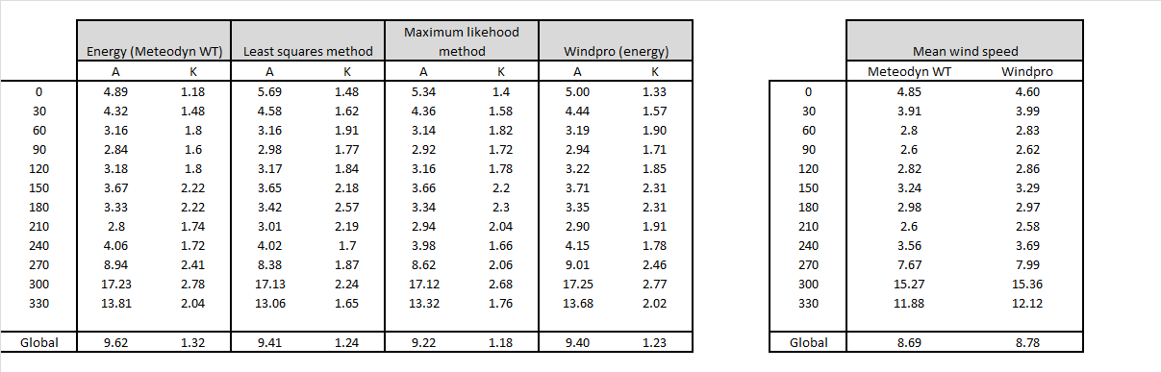
The directional values of (A, k) can be quite different according to the methods used to fit the Weibull
distribution.
When using a WRG/RSF file in another software like WindPRO, you can note some differences in the
mean value of wind speed:
• WindPRO does not use the same number of decimals when reading the (A, k) parameters
• At wind turbine locations, an approximation is realized in WindPRO, the production is
computed according to the 4 nearest mapping points around the turbines.
Turbulence intensity and turbulence correction
1.15.1 Turbulence intensities
The turbulence intensities computed by Meteodyn WT are the following:
• Ambient turbulence intensity, i.e. the turbulence results from the CFD computations. If
turbulence measurements are available, this turbulence will be corrected as described in
the Turbulence correction.
• Added turbulence intensity due to wake effects. For more information about the added
turbulence please refer to sections 1.13.3, 1.13.4 and 1.13.5.
• Total turbulence intensity which combines both ambient and added turbulence. Therefore,
𝐼𝑡𝑜𝑡𝑎𝑙= √𝐼𝑎𝑚𝑏
2
+ 𝐼𝑎𝑑𝑑
2 where 𝐼𝑎𝑚𝑏 and 𝐼𝑎𝑑𝑑 are respectively the ambient and the added
turbulence intensity.
1.15.2 Turbulence corrections
1.15.2.1 Directional turbulence correction
The corrected directional turbulence at the result point Icorp(dir) is computed according to:
Icorp(dir) = Icalcp(dir) + Delta_I(dir)

where:
Delta_I(dir) = Imes (dir) – Icalcm(dir)
Imes(dir) is the measured directional turbulent intensity at the reference point. Icalcm(dir) is the computed directional turbulent intensity at the reference point.
Icalcp(dir) is the computed directional turbulent intensity at the result point.
1.15.2.2 Turbulence matrix correction
The corrected matrix of turbulence at the result point Icorp(bin,dir) is computed according to:
Icorp(bin,dir) = Icalcp(dir) * P(v) + Delta_I(bin,dir)
where:
Delta_I(bin,dir) = Imes (bin,dir) – Icalcm(dir) * P(v)
Turbulence intensity values are extrapolated for every bin of wind speed using the P(v) function from
IEC 61400-1:
P(v) = 0.75 + (3.8 / v)
Imes(bin,dir) is the measured turbulent intensity matrix at the reference point. Icalcm(dir) is the computed directional turbulent intensity at the reference point.
Icalcp(dir) is the computed directional turbulent intensity at the result point.
If the turbulence matrix correction is activated on the software, the directional turbulence corresponds to the strong wind turbulence, obtained from all the high wind speeds (i.e. greater than 10 m/s). Up till now no quantile is applied.
1.15.2.3 How is the ambient turbulence matrix computed if there is no file for correction?
Even if a turbulence intensity correction (directional or matrix one) is not used, Meteodyn WT provides the ambient turbulence matrices as an output of the synthesis process.
• For each directional computation, the turbulence intensity is computed and corresponds to strong wind speeds (obtained from the directional computations). For high wind speeds, the ambient turbulence intensity is constant.
• Thanks to the turbulence equation obtained from the different intensity curves from the IEC 61400-1 standard, the value of turbulence intensity is extrapolated for every lower bin of wind speed.
This is done for each direction in order to create a matrix of ambient turbulence intensity. The same method is used for a directional correction. In this case, the turbulence intensity previously calculated from directional computations for high wind speeds is directly read from the directional correction file.
Extreme wind speed computations
After giving definitions of speed-up factors and gust coefficients, this section explains how the extreme wind speeds are computed given the provided inputs. The computed parameters are the 50-year (50-yr) 10-minute (10-min) mean wind speed and the 3-second (3-sec) wind gust at all result points of the site.

For the assessment of extreme wind speeds, the thermal stratification of the atmosphere can be considered neutral because the winds are strong enough to neglect the thermal effects.
1.16.1 Speed-up factor and gust coefficient
At any location, Meteodyn WT computes a directional speed-up factor as the ratio of the computed wind speed V and the reference wind speed Vref corresponding to reference conditions (10 m high, flat terrain, open rural terrain with a homogeneous roughness length of 5 cm).
We call Ci the speed up factor at one location, for a reference wind direction in sector i. In addition, we define the 3-sec gust coefficient G in any given point of the site as the average value of the ratio of the maximum instantaneous wind speed during a period of 10 minutes, divided by the corresponding 10-min mean wind speed.
The 3-sec gust coefficient G can be computed as a function of the turbulence intensity I with the relationship G = 1+2.84I, where I is the turbulent intensity computed for each direction.
1.16.2 Computation based on the regional extreme wind
1.16.2.1 Regional reference 50-year wind speed
The regional extreme wind speed at any location can generally be found in standards and codes for the design of structures considering the actions of the wind (Europe: Eurocode 1, USA: ISO4354, etc.). These values have been evaluated from reliable statistically based studies and we recommend using them.
These standards provide the "50-year extreme wind speed" at 10 m height over a reference site as defined above (flat terrain, homogeneous roughness length of 5 cm).
The user enters the value of the regional 50-yr reference wind speed and specifies whether this value is a 10-min mean wind speed or a 3-sec gust.
In the case of the 3-sec gust option, the 50-yr reference mean wind speed is calculated from the 50-yr reference gust speed by using the value of the gust coefficient at a reference site (10 m height, flat, homogeneous roughness length of 5 cm) as follows:
V50ref = V50gustref / 1.55
1.16.2.2 Evaluation of 50-yr wind speeds
At any result point, the 50-yr mean wind speed is given by the product of the regional 50-yr mean wind speed and the maximum value Cmax of directional speed-up coefficients.
The 50-yr gust speed is given by the product of the regional 50-yr mean wind speed and the maximum value of the product CiGi over all the directions.
Therefore:
V50mean = CmaxV50ref
V50gust = (CG)maxV50ref

1.16.3 Computations based on the extreme wind at the measurement point
If the regional value of the extreme wind is not available, the extreme wind speed at any given point of a wind farm can also be calculated from the measured data of the site.
In this case, an extreme wind analysis at the measurement point (including a Measure-Correlate-Predict (MCP) analysis) must be performed by the user in order to get the extreme wind speed over a 50-year period at the measurement point.
The extreme wind analysis at the measurement point is relevant only if this point is surrounded by an unobstructed area in all the directions. C0 and G0 are the directional speed-up factor and gust coefficient at the measurement point respectively. In the extreme wind analysis, the direction of the extreme wind speed is not known. Therefore, it is safer to consider that the extreme wind speed can occur from any direction.
If in some directions, C0 is very low, therefore the calculated extreme wind speed can be overestimated because the direction for which C/C0 is maximal may be a direction where strong winds are rare. Consequently, the area must be unobstructed. The directions which have a low speed-up coefficient may be ignored only if it is assumed that the extreme wind speed cannot come from this direction.
1.16.3.1 Graphical User Interface
If the the extreme wind speed at the meteorological mast location is known, the 50-yr value of either the 10-min mean wind speed, or the 3-sec gust speed can be provided to the software. The computation provides the 50-yr 10-min mean wind speed and the 50-yr 3-sec gust speed at the result points.
1.16.3.2 Computation based on the 10-min mean wind speed
If the user specified the 50-yr value of the 10-min mean wind speed at the measurement point. At any result point, the software provides the 50-yr 10-min mean wind speed and 3-sec gust speed by performing the following calculations:
V50mean = (C/C0)maxV50meanmes
V50gust = (GC/C0)maxV50meanmes
1.16.3.3 Computation based on the 3-sec mean wind gust
If the user specified the maximum value of the 10-min mean wind speed at the measurement point. At any result point, the software provides the 50-yr 10-min mean wind speed and the 50-yr 3s gust by performing the following calculations:
V50mean = (C/(C0 G0))maxV50gustmes
V50gust = (GC/(C0 G0))maxV50gustmes

Site calibration
Meteodyn WT is calibrated with default values relevant for most of the sites. However, some of them require special attention due to their variability depending on the location, the period of the year or the time of day. Two main elements require calibration to obtain a more reliable model:
• Forest model/roughness value
• Thermal stability
The site calibration is based on the wind speed profile measurement from a meteorological mast or a Lidar. The goal is to choose the parameters so that the wind profile simulated by the software is as close as possible to real conditions.
1.17.1 Roughness calibration
The first element to calibrate is the roughness value. This value must be calibrated because the roughness value is only an indicator over the terrain. Unlike the orography, the roughness value does not describe exactly how the land cover is. Consequently, two similar land covers can have the same value of roughness and not the same effect on the wind flow depending on the classification used or the type of forest.
As mentioned above, the software will change the effect of the roughness by modifying parameters in order to fit the measured wind speed profile. However, the thermal stability will also affect the profile and is not yet calibrated. It is thus necessary to ensure we are not reliant on stability in the case.
In order to consider neutral stability condition, the roughness calibration should be done on a 1-year period.
Then, launch CFD computation for neutral stability (Meteodyn thermal stability class 2) with the default parameters for roughness. Once the computation has ended, launch the synthesis process:
The wind speed shear from measurement (𝛼𝑚) and the wind speed shear at the met mast from the CFD (𝛼𝑐) are compared. If the fit is not satisfactory, some parameters may be adjusted:
- 𝑧0 : roughness length of your input files or “the tree height roughness ratio”
- 𝐶𝑑 : Drag coefficient depending on the forest density
If 𝛼𝑐> 𝛼𝑚 : Reduce 𝑧0 or 𝐶𝑑 (by changing the forest density)
If 𝛼𝑐< 𝛼𝑚 : Increase 𝑧0 or 𝐶𝑑 (by changing the forest density)
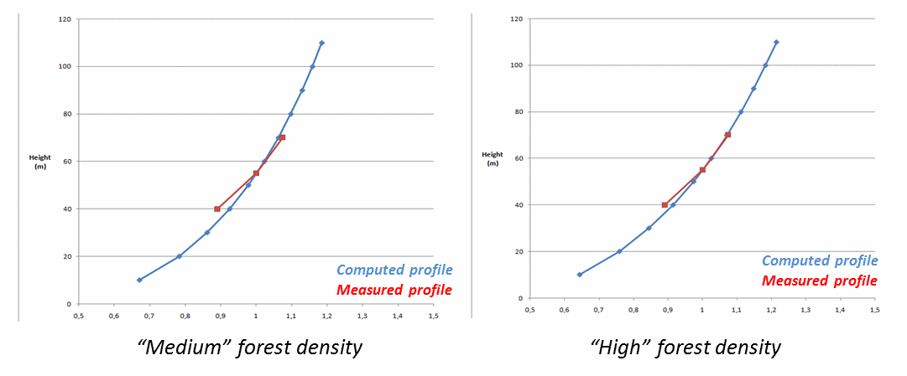
Depending on the complexity and the inhomogeneity of the site, the calibration may be performed on the mean wind speed profile or direction by direction.

You should always consider the shape of the wind speed profile. If you only compare the shear coefficients, make sure you computed them the same way from measurement and from Meteodyn WT results.
Steps:
1. Considering neutral thermal stability conditions for the measurements. 2. Launch CFD computation for neutral stability and default parameters. 3. Run synthesis and compare wind speed profiles.
4. Change input parameters and relaunch computation.
1.17.2 Stability calibration
When the thermal stability conditions have been determined on a site, Meteodyn WT can consider the influence of the thermal stability in the Navier-Stockes equations to improve the accuracy of production estimation. For thermal stability determination, four methods can be used in Meteodyn
WT, which can be selected based on the complexity of the site and the availability of data . The different atmospheric stratification determination methods have been validated on both simple and complex sites. For more information, please refer to: For more information, please refer to:
Li R., Leonard E., Tromeur E. Comparison of three methods in atmospheric stratification determination. Windeurope 2022.
Li R., Leonard E., Tromeur E. Atmospheric Stratification Determinations at Complex Wooded Site. Windeurope 2023.
• Method 1 based on wind profile calibration using CFD results
• Method 2 using two temperature sources and wind speed data • Method 3 using wind shear and turbulence data
• Method 4 using wind shear data (only for flat terrain or offshore site)
Methods 2, 3 and 4 are automatic methods available in the meteorological data module.
1.17.2.1 Method 1 based on wind profile calibration using CFD results
Since the wind profile is not only determined by stability, but also by terrain and roughness, the Meteodyn WT software is used to simulate the wind flow around the tower location.
-The first step is to launch CFD results for all stability classes. In order to save computation time, only 4 or 5 thermal stability classes corresponding to the main thermal stability categories can be used (for example: class 0 for unstable, class 2 for neutral, class 4 for near stable, class 6 for stable and class 8 for very stable).
-Then, at each time step, the measured wind speed profile is compared to the simulated wind profile from CFD to determine the best fitand finally deduce theappropriate thermal stability class. An automatic wind shear analysis by filtering the data based on month, direction and time of day can be performed to simplify this step.
There are several ways of calibrating the stability:
- Calibration of the global stability: one stability represents entire time period and directions.

- Calibration per direction: one stability represents entire time period for each direction.
- Calibration per month: one stability represents monthly time period for each direction.
- Calibration per direction, and on a monthly and hourly time period
Since the thermal stability does not vary over 10-min, it is not necessary to carry out the
calibration for every time step. The measured time series can be averaged over an hour or more and
then the stability classes may be applied to every 10-min step within that time frame.
The calibration can be automated by comparing shear coefficient for each time step. The time series
of stability class determined may then be used during the synthesis.
1.17.2.2 Method 2 using temperature and speed data
The second method is based on the Monin-Obukhov similarity theory (MOST). The atmospheric
stratification is generally estimated with the Monin-Obukhov length or the Richardson numbers which
depend on the heat flows but can also be obtained by the temperature profile. Using the temperature
profile (T1 and T2) and the wind speed, Meteodyn WT calculates the Monin-Obukhov length iteratively
from a guessed Monin-Obukhov length for each time step. The algorithm searches iteratively the
better approximation of the Monin-Obukhov length and a thermal stability class is finally deduced for
each time step using an automatic process.
𝐿= −1
𝛽
(∆𝑉)2[ln(𝑧2
∆𝜃[ln(𝑧2𝑉𝑧1
𝑇𝑧1
𝑉) −𝛹𝑚(𝑧2
𝑇) −𝛹ℎ(𝑧2
𝑉,𝐿) + 𝛹𝑚(𝑧1
𝑇, 𝐿) + 𝛹ℎ(𝑧1
𝑉, 𝐿)]
𝑇, 𝐿)]
1.17.2.3 Method 3 using wind shear and turbulence data
This method proposes an automatic process to classify thermal stability at each time step by
quantifying the deviations of shear and turbulence from their neutral levels in the wind direction over
each 10-minute interval. The method has four processing steps to quantify stability in each 10-minute
interval described below.
Step 1 – Estimate neutral levels of shear and TI versus direction.
Step 2 – Estimate normalized deviations of shear and TI.
Step 3 – Apply smoothing kernel to enhance stability signal.
Step 4 – Make diagnostic plot and estimate Monin-Obukhov lengths.
Reference
A novel method to quantify atmospheric stability, Lasse Svenningsen, Global Wind summit 2018.
1.17.2.4 Method 4 using wind shear for flat terrain or offshore sites
This method proposes an automatic process to classify thermal stability at each time step by
quantifying the deviations of shear and turbulence from their neutral levels in the wind direction over

each 10-minute interval. The method has four processing steps to quantify stability in each 10-minute interval described below.
Step 1 – Estimate neutral levels of shear versus direction.
Step 2 – Estimate normalized deviations of shear.
Step 3 – Apply smoothing kernel to enhance stability signal.
Step 4 – Make diagnostic plot and estimate Monin-Obukhov lengths.
Definitions
1.18.1 Directional results
1.18.1.1 Speed-up factors 𝑉ℎ
Horizontal speed-up factor, calculated from the reference wind speed (10 m high, flat open terrain): 𝑉ℎ= √𝑉𝑋2 + 𝑉𝑌2
𝑉𝑟𝑒𝑓
1.18.1.2 Wind direction
Calculated wind direction at the result point location (in degrees).
1.18.1.3 Deviation angle
Calculated difference (in degrees) between the wind direction at the result point and the wind direction at a reference site (10 m high, flat open terrain). This reference wind direction is also the inlet wind flow direction.
Negative values are used for anti-clockwise rotation. Positive values are used for clockwise rotation.
1.18.1.4 Inflow angle
Vertical inclination of the flow at the result point location (in degrees, upwards is positive).
1.18.1.5 Turbulence intensity
The turbulence intensity is calculated from the turbulent kinetic energy 𝑘 and the local wind speed at the result point location, according to the relationship 𝐼𝑢= 1.03√𝑘 /𝑈, where U is the longitudinal component of the mean wind velocity vector. This relationship is calculated from the (Panofsky H.A., 1984) relationships between longitudinal, lateral and vertical standard deviations of the turbulent fluctuations.
1.18.2 Synthesis results
1.18.2.1 Wind speed
Interpolated mean wind speed (in m/s).

1.18.2.2 Turbulence
If the directional turbulence correction is activated, this turbulence intensity considers the turbulence corrections.
If the matrix turbulence correction is activated, this turbulence intensity is evaluated from high wind events (only contemplating wind speeds greater than 10 m/s).
See: Turbulence intensity and turbulence correction.
1.18.2.3 Inflow angle
Averaged vertical inclination of the flow (degrees).
If the Inflow angle result is calculated for all wind directions, the averaging is made on absolute values of the directional Inflow angle result.
If it is calculated for a wind sector, the directional Inflow angle result is directly averaged.
1.18.2.4 Power density
Power density indicates the average power of the wind per surface unit. Power density is expressed in W/m².
The power density calculation considers local air density, turbulent intensity and wind speed results: 𝑃𝑜𝑡= 1 2 𝜌(1 + 3𝐼2)𝑉3
1.18.2.5 Production
Expected production per year (in MWh/year), contemplating the specified power curve for the given result points and the local climatology. The calculation is based on 365.25 days a year.
1.18.2.6 Capacity factor
The capacity factor is the production that a turbine or a wind farm generates in one year divided by the total amount it could generate if it ran at full capacity, i.e. the nominal power given by the power curve file. The capacity factor is specified for all the result points.
1.18.2.7 Weibull parameters
A is the scale parameter of the Weibull distribution (m/s).
k is the shape parameter of the Weibull distribution.
1.18.2.8 Extreme mean wind speed
Extrapolated 10-minute mean wind speed in m/s. Refer to: Extreme wind speed computations.
1.18.2.9 Extreme gust wind speed
Extrapolated 3-second gust wind speed in m/s. Refer to: Extreme wind speed computations.
1.18.2.10 Wind shear exponent
The wind shear exponent at the hub height is commonly known as the power law exponent. For turbines and other result points (e.g. a meteorological mast), the wind shear exponent is computed as

follows:
• If a thrust curve is available: the wind shear is given at the hub height (or at the point's height in case of result points) and calculated between the lowest and highest points reached by the end of the wind turbine blades. The turbine rotor diameter is specified in the thrust curve file.
• If there is no thrust curve available: the wind shear is given at hub height (or at the point's height in case of result points) for a default radius of 50 m.
α = ln(V2/V1)/ln(z2/z1)

1.18.3 IEC results – IEC 61400-1 Edition 4 – Design parameters
1.18.3.1 Wind turbine IEC Classes
According to the IEC 61400-1 ed. 4 (2019) standard, wind turbines classes are defined in terms of wind
speed and turbulence intensity.
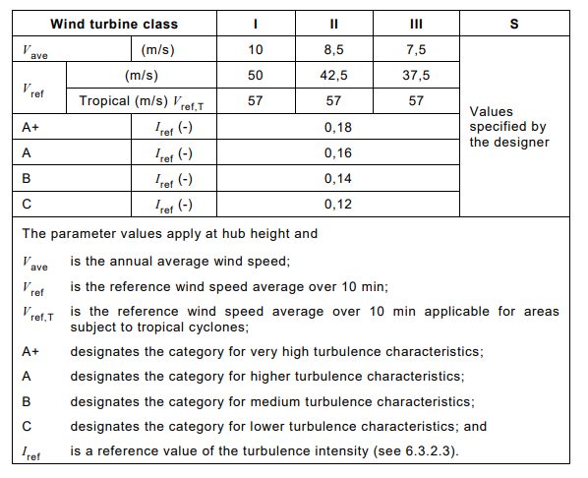
The design lifetime for wind turbines classes I to III shall be at least 20 years.
The design value for the wind turbines class S shall be chosen by the designer and specified in the
design documentation.
Class T assumes all wind model parameters to be the same and allows the combination of Vref,T with
all turbulence categories.
1.18.3.2 Probability density of the wind speed distribution
The wind speed distribution is significant for wind turbine design as it determines the frequency of
occurrence of individual load conditions for normal design situations.
The IEC design limit assumes that the wind speed distribution follows a Weibull distribution with a
shape factor of 2 (𝑘= 2) and a mean wind speed of 0.2*Vref, with Vref depending on the turbine
classes I, II or III. The probability distribution function (pdf) of the wind speed is:
𝑘−1 𝑘
𝑝𝑑𝑓(𝑉ℎ𝑢𝑏) = 𝑘𝐴(𝑉ℎ𝑢𝑏𝐴)𝑒−(𝑉ℎ𝑢𝑏)

1.18.3.3 Effective turbulence intensity
The effective turbulence intensity represents the fatigue loads during normal operation. It is computed
as a function of wind speed, weighting the directional turbulence over all sectors by means of the
weighted probability of occurrence. The material fatigue is considered with the Wöhler exponent.
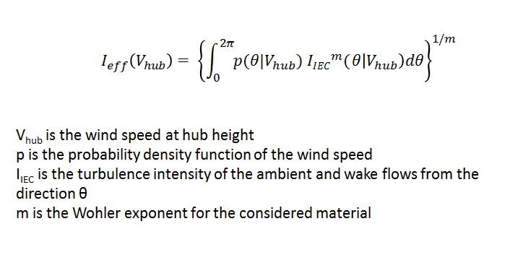
The "total IEC" turbulence, IIEC, considered in the effective turbulence computation is defined as:
2
𝐼𝐼𝐸𝐶= √[𝐼𝑎𝑚𝑏+
1.28𝜎𝜎
𝑉ℎ𝑢𝑏] + 𝐼𝑎𝑑𝑑
2
where Iamb and Iadd are respectively the ambient and the added turbulence intensity.
In this case, the 90th quantile of the ambient turbulence standard deviation is considered.
1.18.3.4 Normal turbulence model (NTM)
For the normal turbulence model, the representative value of the turbulence standard deviation, 𝜎1,
shall be given by the 90% quantile for the given hub height wind speed.
For the standard classes, this value shall be given by:
Iref depending on the turbine classes A, B or C.
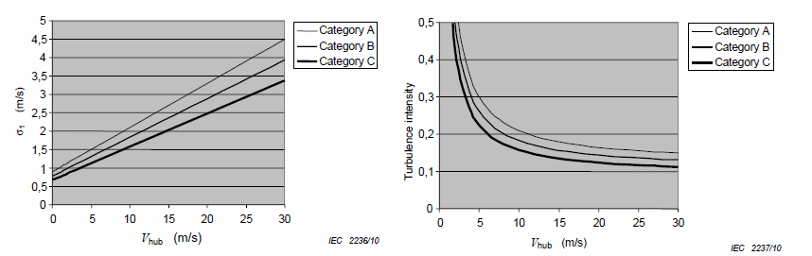
1.18.3.5 Extreme turbulence model (ETM)
The extreme turbulence model uses a longitudinal component standard deviation:
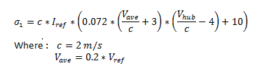

1.18.3.6 Wöhler exponent
The Wöhler exponent is specific to the component under consideration. The most commonly used
value is 10, which represents reinforced fiberglass. This approach is the most conservative.
The Wöhler exponent is a key parameter in the effective turbulence computation, accounting for
material fatigue.
1.18.3.7 Reference meteorological mast
The reference mast is the mast used as reference for the turbulence verification. The standard
deviation of the turbulence will be computed from random 10-min measurements of turbulence at the
reference mast.
If measurements of turbulence are not available, a value of 20% of the turbulence is assumed for the
standard deviation of turbulence.
1.18.3.8 Extreme mean wind speed (50 years)
The 50-year extreme wind speed is the wind speed which on average is exceeded once every 50 years
by the 10-minute average wind speed (in m/s). Refer to Extreme wind speed computations.
1.18.3.9 Weibull parameters
A (or C in the IEC standard) gives the scale parameter of the Weibull distribution (m/s).
k gives the shape parameter of the Weibull distribution. Refer to Weibull fitting.
1.18.3.10 Coefficient of variation of the annual maximum wind speed
The coefficient of variation of the annual maximum wind speed (COV) can approximately be obtained
assuming a Gumbel distribution and assuming that for example 50-year and 100-year return values of
the wind speed, V50 and V100, are available.
𝐶𝑂𝑉= 𝜎𝜇= 𝜋√6𝛽
1
𝛼+ 0,5772
With 𝛼=𝑃100−𝑃50
𝑉100−𝑉50
𝛽= 𝑉50 −𝛼 𝑃50
1 1
𝑃100 = −ln (−𝑙𝑛(1 −100)) 𝑎𝑛𝑑 𝑃50 = −ln (−𝑙𝑛(1 −50))
If COV is larger than 15 %, they can be increased linearly by a factor η from 1,0 at COV = 15 % to 1,15
at COV = 30 %. If η > 1,0 an adjusted value of the extreme 10 min average wind speed of
V50 = √η 𝑉50 can be used in the assessment of the structural integrity.

1.18.3.11 Validation rules for fatigue load
Wind distribution analysis
The site value of the wind speed probability density function at hub height pdf(Vhub) shall be less than
or equal to the design probability density function at all values of Vhub between the wind speeds Vave
and 2Vave.
Weibull k
If the shape parameter k of the site-specific Weibull wind speed distribution is greater than or equal
to 1,4, then, k shall fulfill the following equation:
6.5 ⋅𝑉𝑎𝑣𝑒,𝑠𝑖𝑡𝑒 −4.5 ≤𝑘≤−6.0 ⋅𝑉𝑎𝑣𝑒,𝑠𝑖𝑡𝑒 + 8.0
𝑉𝑎𝑣𝑒,𝑑𝑒𝑠𝑖𝑔𝑛 𝑉𝑎𝑣𝑒,𝑑𝑒𝑠𝑖𝑔𝑛
Turbulence analysis
The standard deviation of the Normal turbulence model should be greater or equal to the 90% quantile
of the turbulence standard deviation including both ambient and wake turbulence, for a range of wind
speeds going from Vave and 2Vave:
σ1 > CCT ∗σ̂eff (= IeffVhub)
Where Ieff is computed following the effective turbulence. In case of complex terrain, the estimated
90 % quantile of the wind speed standard deviation is increased in order to account for the distortion
of the turbulent flow. This can be done by additional multiplication with a turbulence structure
correction parameter CCT (See assessment of the topographical complexity of a site for CCT computation).
Flow inclination
The site flow inclination, taken as the wind energy weighted mean from all directions, shall be between
–8° and +8°.
Global wind shear exponent
The average wind shear is computed as the weighted average of the sector-wise shear exponents:
• If a thrust curve is available, the average wind shear exponent is given across the rotor of the
turbine.
• If there is no thrust curve available, a default radius equal to 50 meters is considered.
The energy weighted average over all wind directions and wind speeds during power production of the
vertical site wind shear exponent α shall be in the range of 0,05 to 0,25.
Air density
The air density (in kg/m3) is computed at the hub height for wind turbines and at the result point's
height for the rest of points. It is calculated as a function of altitude for a standard atmosphere.
The average site air density shall be less than the IEC design limit of 1.225 kg/m3
For an air density greater than 1.225 kg/m3, it shall be demonstrated that the following condition
applies:
2 2
𝜌𝑑𝑒𝑠𝑖𝑔𝑛 × 𝑉𝑎𝑣𝑒,𝑑𝑒𝑠𝑖𝑔𝑛 ≥𝜌𝑠𝑖𝑡𝑒 × 𝑉𝑎𝑣𝑒,𝑠𝑖𝑡𝑒

1.18.3.12 Validation rules for ultimate load
Extreme wind speed
The site estimate of the extreme 10-min average wind speed V50 at hub height with a return period of
50 years shall be less than or equal to Vref. Alternatively, the wind turbine site central estimate of
extreme 3s average wind speed at hub height with a return period of 50 years shall be less than Ve50.
V50 shall be modified when the coefficient of variation of the annual maximum wind speed (COV) is
larger than 15 %. If the average site air density is different from 1.225 kg/m3, it shall be demonstrated
that the following condition applies:
2 2
𝜌𝑑𝑒𝑠𝑖𝑔𝑛 × 𝑉𝑟𝑒𝑓 ≥𝜌𝑠𝑖𝑡𝑒 × 𝑉50,ℎ𝑢𝑏
Turbulence analysis for ultimate load
The design value of the wind speed standard deviation shall be greater than or equal to the site value
of the estimated 90 % quantile of the wind speed standard deviation at all values of Vhub between the
wind speeds 0.6 × Vr and 1.6 × 𝑉𝑟 (𝑉𝑟 is the rated speed ).
𝜎1 > Cct ∗(𝜎̂ + 1.28 𝜎̂𝜎)
In case of complex terrain, the estimated 90 % quantile of the wind speed standard deviation shall be
increased in order to account for the distortion of the turbulent flow. This may be done by additional
multiplication with a turbulence structure correction parameter CCT (See assessment of the
topographical complexity of a site for CCT computation).
Extreme turbulence intensity
The extreme ambient wind speed standard deviation 𝜎̂1,𝐸𝑇𝑀 is estimated by the following equation
and it should not be exceeding the ETM model.

𝜎̂1,𝐸𝑇𝑀= 𝜎̂ + 𝑘𝑝𝜎̂𝜎;𝑘𝑝= 0.01(𝑉𝑎𝑣𝑒,𝑠𝑖𝑡𝑒 𝑚/𝑠
Maximum center wake wind speed standard deviation

−21)(𝑉ℎ𝑢𝑏𝑚/𝑠−5) + 5

In case of wake situations, it shall be demonstrated that the maximum center-wake wind speed standard deviation in the most severe direction does not exceed the ETM model.

Assessment of the topographical complexity of a site (IEC 61400-1 edition 4)
The complexity of the site is characterised by the slope of the terrain and variations of the terrain topography from a plane.
To obtain the slope of the terrain, planes are defined that fit the terrain within specific distances and sector amplitudes for all wind direction sectors around the wind turbine, see Figure below. The fitted planes do not need to pass through the tower base.
The slope denotes the angle between a horizontal line and the different mean lines of sectors projected. Accordingly, the terrain variation from the fitted plane denotes the distance, along a vertical line, between the fitted plane and the terrain at the surface points. The resolution of surface grid and its original source map used for terrain complexity assessment doesn’t exceed 50 m. The circle sectors are 30°.
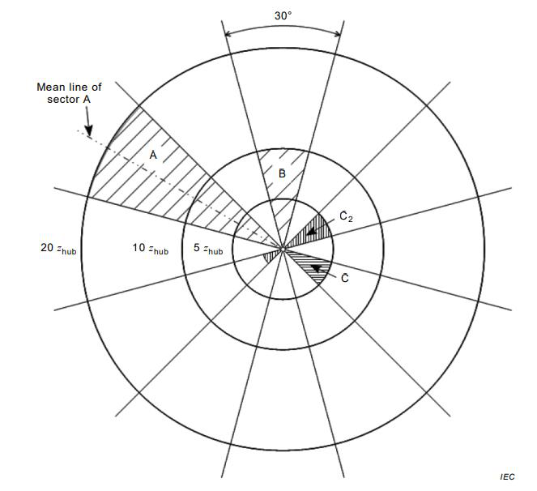
Representation of 30° sectors for fitting the terrain data
Using thus defined slope and terrain variation, terrain slope indices (TSI) and terrain variation indices (TVI) for each circle area are given by the following equations:
12
𝑇𝑆𝐼30 = ∑𝑓𝑒𝑛𝑒𝑟𝑔𝑦(𝑖). |𝜃(𝑖)|
𝑖=1
12
|𝐷𝑇𝑉(𝑖)|
𝑇𝑉𝐼30 = ∑𝑓𝑒𝑛𝑒𝑟𝑔𝑦(𝑖). 𝑅
𝑖=1
𝑇𝑆𝐼360 = 𝑘1. 𝜃360
𝑇𝑉𝐼360 = 𝐷𝑇𝑉(𝑖)𝑘2. 𝑅
Where:
𝑓𝑒𝑛𝑒𝑟𝑔𝑦(𝑖) is the percentage of the wind energy coming through ith 30° sector
𝜃(𝑖) is the slope of fitted plane for ith 30° sector
𝜃360 is the slope of the fitted 360° circle plane
𝐷𝑇𝑉(𝑖) is the standard deviation of terrain variation in ith 30° sector
𝐷𝑇𝑉360 is the standard deviation of terrain variation of the 360° circle area
R is the radius of the circle area; k1 is the empirical adjustment factor for TSI360, k1 = 5/3; k2 is the empirical adjustment factor for TVI360, k2 = 3.

Terrain is assessed for terrain complexity by means of two indices TSI and TVI for the different circle areas (5 zhub, 10 zhub, and 20 zhub). For both indices, three complexity categories low (L), medium (M) and high (H) are defined (see Table below). If the TSI30 and TVI30 values as well as the TSI360 and TVI360 values for all three circle areas are below the threshold value for category L, the site is assessed as not complex. If not, the site is assessed as complex and assigned one of the three complexity categories, L, M or H, depending on the highest category TSI or TVI for any of the circle areas.
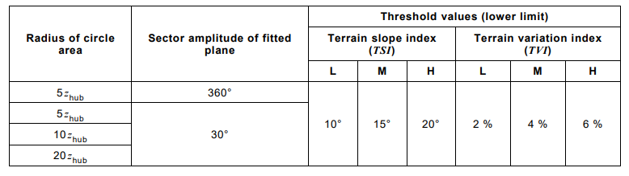
Threshold values of the terrain complexity categories where Zhub is the hub height
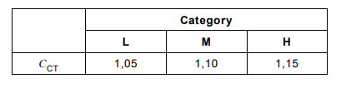
Values of turbulence structure correction parameter depending on terrain complexity category

1.18.4 IEC results – IEC 61400-1 Edition 3 – Design parameters
1.18.4.1 Wind turbine IEC Classes
According to the IEC 61400-1 ed. 3 (2010) standard, wind turbines classes are defined in terms of wind
speed and turbulence intensity.
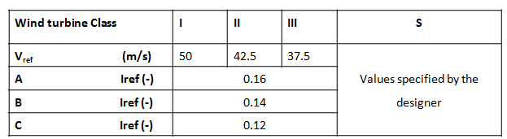
The design lifetime for wind turbines classes I to III shall be at least 20 years.
The design value for the wind turbines class S shall be chosen by the designer and specified in the
design documentation.
• Vref is the reference wind speed, the extreme wind speed with a 50-year recurrence.
• A designates the category for high turbulence.
• B designates the category for medium turbulence.
• C designates the category for low turbulence.
• Iref is the expected value of turbulence intensity at 15m/s. Iref is defined here as the mean value.
1.18.4.2 Probability density of the wind speed distribution
The wind speed distribution is significant for wind turbine design as it determines the frequency of
occurrence of individual load conditions for normal design situations.
The IEC design limit assumes that the wind speed distribution follows a Weibull distribution with a
shape factor of 2 (𝑘= 2) and a mean wind speed of 0.2*Vref, with Vref depending on the turbine
classes I, II or III. The probability distribution function (pdf) of the wind speed is:
𝑘−1 𝑘
𝑝𝑑𝑓(𝑉ℎ𝑢𝑏) = 𝑘𝐴(𝑉ℎ𝑢𝑏𝐴)𝑒−(𝑉ℎ𝑢𝑏)

1.18.4.3 Normal turbulence model (NTM)
For the normal turbulence model, the representative value of the turbulence standard deviation, 𝜎1, shall be given by the 90% quantile for the given hub height wind speed.
For the standard classes, this value shall be given by:
Iref depending on the turbine classes A, B or C.

1.18.4.4 Extreme turbulence model (ETM)
The extreme turbulence model uses a longitudinal component standard deviation:

1.18.4.5 Wöhler exponent
The Wöhler exponent is specific to the component under consideration. The most commonly used value is 10, which represents reinforced fiberglass. This approach is the most conservative.
The Wöhler exponent is a key parameter in the effective turbulence computation, accounting for material fatigue.
1.18.4.6 Reference meteorological mast
The reference mast is the mast used as reference for the turbulence verification. The standard deviation of the turbulence will be computed from random 10-min measurements of turbulence at the reference mast.
If measurements of turbulence are not available, a value of 20% of the turbulence is assumed for the standard deviation of turbulence.
1.18.4.7 Extreme mean wind speed (50 years)
The 50-year extreme wind speed is the wind speed which on average is exceeded once every 50 years by the 10-minute average wind speed (in m/s). Refer to Extreme wind speed computations.

1.18.4.8 Weibull parameters
A (or C in the IEC standard) gives the scale parameter of the Weibull distribution (m/s).
k gives the shape parameter of the Weibull distribution. Refer to Weibull fitting.
1.18.4.9 Wind distribution analysis
The IEC limit for the wind distribution verification is described in the Design wind distribution section
of the norm. The site value of the probability density function of Vhub shall be less than the design
function at all values of Vhub between 0.2Vref and 0.4 Vref, where Vref depends on the turbine class I, II
or III. The Weibull distribution of wind speed is given by:
𝑘−1 𝑘
𝑝𝑑𝑓(𝑉ℎ𝑢𝑏) = 𝑘𝐴(𝑉ℎ𝑢𝑏𝐴)𝑒−(𝑉ℎ𝑢𝑏)
1.18.4.10 Effective turbulence intensity
The effective turbulence intensity represents the fatigue loads during normal operation. It is computed
as a function of wind speed, weighting the directional turbulence over all sectors by means of the
weighted probability of occurrence. The material fatigue is considered with the Wöhler exponent.

The value of the turbulence intensity in this equation depends on the edition of the IEC standard:
In the Edition 3.0, the "total IEC" turbulence, IIEC, considered in the effective turbulence computation
is defined as:
2 2
𝐼𝐼𝐸𝐶= √𝐼𝑎𝑚𝑏+ 𝐼𝑎𝑑𝑑
where Iamb and Iadd are respectively the ambient and the wake turbulence intensity.
Iadd should be computed using the simplified Frandsen model (2003).
In the Edition 3.0 Amendment-1, the "total IEC" turbulence, IIEC , considered in the effective turbulence
computation is defined as:
2
𝐼𝐼𝐸𝐶= √[𝐼𝑎𝑚𝑏+
1.28𝜎𝜎
𝑉ℎ𝑢𝑏] + 𝐼𝑎𝑑𝑑
2
where Iamb and Iadd are respectively the ambient and the added turbulence intensity.
In this case, the 90th quantile of the ambient turbulence standard deviation is considered.

1.18.4.11 Turbulence analysis
The turbulence verification depends on the edition of the standard:
Edition 3.0
The standard deviation of the Normal turbulence model should be greater or equal to the 90% quantile of the turbulence standard deviation including both ambient and wake turbulence, for a range of wind speeds going from 0.6Vr to Vout, and from 0.2Vref to 0.4Vref if the turbine properties are not known,
i.e.:
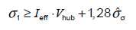
Where Ieff is computed following the effective turbulence Edition 3.0 equations.
Edition 3.0 Amendment-1
The standard deviation of the Normal turbulence model should be greater or equal to the 90% quantile of the turbulence standard deviation including both ambient and wake turbulence, for a range of wind speeds going from 0.6Vr to Vout, and from 0.2Vref to 0.4Vref if the turbine properties are not known
i.e.:
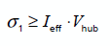
Where Ieff is computed following the effective turbulence Edition 3.0 Amendment 1 equations.
1.18.4.12 Absolute inflow angle
The absolute inflow angle is the maximum inflow angle for all directions (in degrees). This value should be less than the IEC design level, set to 8° (in absolute value).
1.18.4.13 Global wind shear exponent
The average wind shear is computed as the weighted average of the sector-wise shear exponents: • If a thrust curve is available, the average wind shear exponent is given across the rotor of the turbine.
• If there is no thrust curve available, a default radius equal to 50 meters is considered.
This value of wind shear should be above 0 and less than 0.2, the IEC design limits.
1.18.4.14 Air density
The air density (in kg/m3) is computed at the hub height for wind turbines and at the result point's height for the rest of points. It is calculated as a function of altitude for a standard atmosphere.
The air density value should be lower than the IEC design limit of 1.225 kg/m3
1.18.4.15 Site specific extreme turbulence analysis (Edition 3.0 Amendment 1)
The site-specific extreme turbulence including wake effects shall not exceed the design IEC extreme turbulence model (ETM).
The site-specific extreme turbulence is represented by the maximum center wake turbulence in the most severe direction.

1.18.4.16 Assessment of the topographical complexity of a site
Terrain complexity
The determination of the topographical complexity of a site follows the IEC 61400-1 edition 3.1 amendment 1 standard.
The complexity of the site is characterised by the slope of the terrain and variations of the terrain topography from a plane. To obtain the slope of the terrain, planes are defined that fit the terrain within specific distances (5 Zhub, 10 Zhub and 20 Zhub) (where Zhub is the hub height) and sector amplitudes for all wind direction sectors around the wind turbine and pass through the tower base. The slope, used in Table (1), denotes the slopes of the different mean lines of sectors passing through the tower bases and contained in the fitted planes. Accordingly, the terrain variation from the fitted plane denotes the distance, along a vertical line, between the fitted plane and the terrain at the surface points.
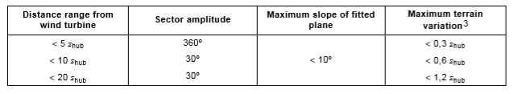
Table 1 Terrain complexity indicators where Zhub is the hub height
The resolution of surface grids used for terrain complexity assessment must not exceed 50 m
The site is considered complex, if 15 % of the energy in the wind comes from sectors that fail to conform to the criteria in Table (1). A complexity index ic is defined, such that ic = 0 when less than 5 % of the energy comes from complex sectors, and ic = 1 when more than 15 % of the energy comes from complex sectors. In between, ic varies linearly.
Turbulence analysis
The effect of complex terrain may be included by additional multiplication with a turbulence structure correction parameter CCT:
σ1 > CCT ∗σ̂eff (= IeffVhub)
Where
𝐶𝐶𝑇= 1 + 0.15 ∗𝑖𝐶
and ic is the complexity index.
The altitude values to compute the terrain complexity coefficients will not be available if the site has been imported from a PWX file to a lower version than the version 1.3 of Meteodyn Universe. You will have to export and import again the site into Meteodyn Universe 1.3 in order to automatically generate the missing altitude values.

1.18.5 IEC results – IEC 61400-1 Edition 2
1.18.5.1 Mean characteristic turbulence intensity at 15 m/s
It is the average of the sector-wise characteristic turbulence intensity for a wind speed equal to 15 m/s. IEC61400-1 edition 2 defines the characteristic turbulence intensity as the mean ambient turbulence intensity + standard deviation of random ten-min measurements of turbulence.
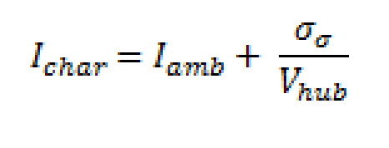
If measurements of turbulence are not available, a value of 20% is assumed for the standard deviation of turbulence.
1.18.5.2 Mean characteristic turbulence intensity for strong winds
It is the average of the sector-wise characteristic turbulence intensity for strong wind speeds, wind speeds over 10m/s.
IEC61400-1 edition 2 defines the characteristic turbulence intensity as the mean ambient turbulence intensity + standard deviation of random ten-min measurements of turbulence.


1.18.6 Losses evaluation
This section provides you with information about the distinctive categories and sub-categories of losses and uncertainties available in the software. These categories have been defined according to several publications listed in the references part.
When doing a wind resource assessment, meteorological data must be used. Long term reference data is usually coupled with on-site measurements. This process is affected by errors and inaccuracies that should be evaluated in order to obtain the probability of exceedance of production at the end of the analysis.
What is the probability of exceedance of production?
The P50 is the central value of the AEP (annual energy production), and as it is admitted that the AEP fits a normal distribution, the P50 means that:
> There is a 50% probability of exceeding the estimate production > There is a 50% probability of being below the estimate production
The aim of this part is to evaluate the net energy production (defined as the gross energy production computed with a synthesis of Meteodyn WT minus total losses).
The losses total can be computed using either an additive or multiplicative method.
The additive method considers each loss item as a percentage of the estimated annual energy production, without taking into consideration the other possible losses. It simply adds the percentage of each loss item to compute the total percentage losses.
The multiplicative method, on the other hand, estimates each loss as a percentage of the real production, calculated after considering any other losses. It multiplies all the differences between 1 and the percentage of each loss item together with the gross production.
For example, if loss A = 5% and loss B = 3%, the net production will be equal to (1 - 0.05) * (1 - 0.03) * gross production.
Here is the list of all the items available for the loss’s evaluation:
• Losses due to wake effects:
> Wake effect for all wind turbines: this is the global loss due to the internal wake effect (i.e. the effect that the wind turbines produce on the other turbines within the farm).
> Future wake effect: this is the effect that a neighboring wind farm has on the considered one.
• Losses due to availability: the three sub-categories named hereafter emphasize the fact that the availability is not 100% the whole time.
> Wind turbines: for example, this can include regular maintenance or component failures when the turbine is not available to produce electricity. This value can be calculated thanks to experience of maintenance in the region. In a region where this kind of information is not available, a common value can be of 95%. 98% can be used in a region where wind energy sector is well established.
> Balance of plants: this corresponds to the downtime of the balance of plants.
> Grid: this corresponds to the downtime of the balance of grids.

• Losses due to turbine performance:
> Power curve: the power curve provided by the manufacturer is achieved in flat terrain, according the IEC standards (61400 - 12). However, under specific conditions, this power curve needs to be adjusted.
> High wind hysteresis: when the wind speed is above a certain limit, the wind turbine is shut down. Therefore, in order to avoid repeated start-up and shut-down of the turbines, when the wind is close to the upper limit, hysteresis is used. In order to evaluate this point, you can compute the production of the farm using a reduced cut-out wind speed.
> Wind flow: this can be losses due to high turbulence, inclined flow, etc. resulting in a difference with the power curve tested and the power curve on-site.
• Electrical losses:
> Electrical losses: this factor depends on the resistance of the conductors and the electrical current and defines the electrical losses, expressed as a reduction in the energy measured by an export meter at the point of connection.
> Facility assumption: this sub-category can include consumption by electrical equipment within the turbine and substation. Most of the time, this sub-category is omitted.
• Environmental losses:
> Performance degradation due to icing: losses due to ice accumulation on blades resulting in a change in the aerodynamic in the blade that reduces the production.
> Performance degradation not due to icing: losses due to blade degradation (physical degradation of the blade surface, accumulation of dirt, etc.)
> Shutdown due to icing, lighting, hail, ...
> High and low temperature: wind turbines are designed to operate under specific thermal range. If the on-site temperature is out of this range, the turbine is shut down.
> Site access and other overwhelming force events: losses due to difficult access to the wind farm for example.
> Tree growth or tree fall: if the farm is located near forested areas, the impact of how the trees may change and so therefore, the wind flow, will affect the production.
• Losses due to curtailment:
> Wind sector management: when turbines are close to other ones, it may be necessary to shut down some turbines in certain conditions.
> Grid curtailment and ramp rate: it defines the losses due to limitation on the external grid. > Power purchase agreement curtailment: losses due to the power purchaser electing to not take power generated by the facility.
> Environmental noise: in certain jurisdictions, there may be a requirement to shut down the turbines during specific meteorological conditions.
> Shadow flicker: in certain jurisdictions, there may be a requirement to shut down the turbines during specific meteorological conditions.
> Birds, bats: in certain jurisdictions, there may be a requirement to shut down the turbines during specific conditions.
• Other losses

1.18.7 Uncertainties evaluation
In the current version of the software, the evaluation of the uncertainties must be performed by the user.
The uncertainties evaluation is based on annual averages except for the wind variability where the expected lifetime of the wind farm influences the uncertainty value.
• Wind data: this category is one of the most important ones in the uncertainties evaluation and depends on the type of wind data that can be provided. In fact, in the case of using a local meteorological mast on-site, the position of the mast and the instrument calibration can be a source of uncertainty. If long term data generated by the MCP process is used, you can compare the results obtained thanks to several input data sources.
> Wind measurements / wind data
> Long term correction
> Year to year variability
> Future variability
> Other wind related uncertainties
• Wind model: this part can be computed by analyzing the vertical extrapolation (at meteorological mast with several measurement heights) and the horizontal extrapolation (available if at least two met masts are located on-site)
> Vertical extrapolation
> Horizontal extrapolation
> Other wind model related uncertainties
• Power conversion: this information can be found in the reports from power curve measurements.
> Power curve uncertainties
> Other AEP related uncertainties
• Losses: this part defines the bias that can exist in the losses listed in the previous section
• Other: any other uncertainties you would like to consider.
Uncertainties are added as independent errors on a root-sum square basis in order to give the total uncertainty. The P50 is the central value of the AEP, and it is admitted that the AEP fits a normal distribution function. Therefore, from the P50 and the total value of uncertainties, it is possible to deduce the whole distribution function.
References
Jones S., "Standard of loss definitions for wind resource / Energy assessment" AWEA 2008
Hughes H., "A common approach to loss and uncertainty categories in energy assessment" UK Renewables 2011
AWEA 2011: Workshop of wind resource assessment (December 2011)

Formats
For all kinds of topographical data, the point "." must be the decimal separator.
1.19.1 Topographical data (orography + roughness)
1.19.1.1 MAP format
The data is stored in an ASCII (text) file with a default file name extension "map".
The general format of the file is shown below. Numbers in the same line of the file must be separated by a blank space (or spaces) or a comma.
All the parameters used in the software are highlighted and detailed below. The other parameters not mentioned are not used for data processing.

Line Contents

Comments

1

Text string identifying the terrain map.

This line is not used in the data process.

2

not_used / not_used / offsetX / offsetY

offsetX and offsetY affect the data processing.
In most of the cases (no data transformation to be applied), offsetX and offsetY are equal to 0.

3

not_used / not_used / offsetMax / not_used

offsetMax affects the data processing.
In most of the cases (no data transformation is to be applied), offsetMax is equal to 1.

4

not_used / not_used

This line is not used in the data process.

5A

Elevation / N (number of points defining the contour)

Elevation contour

5B

Zoleft / Zoright / N (number of points defining the contour)

Roughness contour

5C

Zoleft / Zoright / Elevation / N (number of points defining the contour)

Elevation and roughness contour

6

X1 Y1 [...] XN YN

Cartesian coordinates of line described in 5A, 5B, or
5C.
These coordinates are scaled according to:
C=offsetMax-offsetX
Xi=C*Xi+offsetX
Yi=C*Yi+offsetY
The pattern given in line 5 and 6 is repeated as many times as there are height contours in
 the file.
Each line in the map must be described by a minimum of two points.

Two MAP file samples are displayed below.
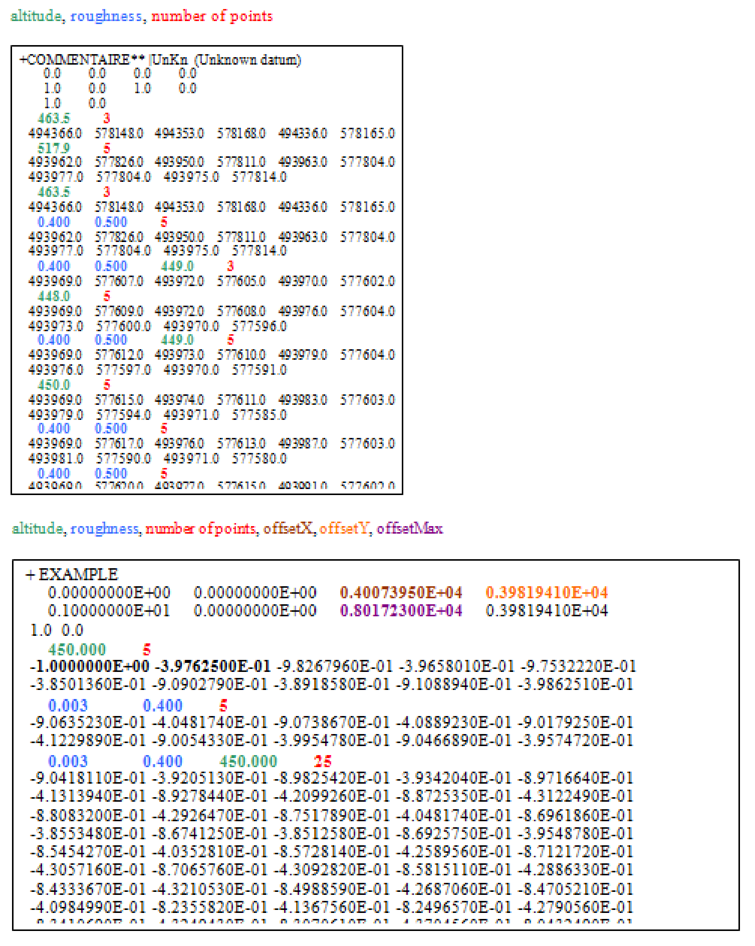

1.19.2 Orographical data
1.19.2.1 XYZ format
Data is stored in an ASCII (text) file with a default file name extension "xyz".

The points do not have to be ordered and structured.
One XYZ file sample is displayed:
The line "Coordinate X - Coordinate Y - Altitude"
is not required in the file, it is written here as an indication. 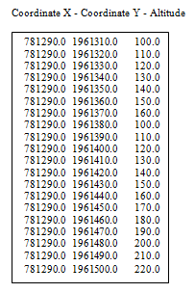
The file should contain a row of altitude points.
Each altitude point should be written on a single line, and contain:
- The X location (in meters) of the point.
- The Y location (in meters) of the point.
- The Z elevation (in meters) of the point.
1.19.2.2 DXF format
DXF, or Drawing Exchange Format, is an open source CAD (Computer Aided Design) data file format.
It enables data interoperability of 2D and 3D drawings between AutoCAD and other programs.
A DXF file is generally composed of several sections - in the following order:
> Header (contains general information about the drawing).
> Classes (contains application-defined information).
> Tables (contains item definitions).
> Blocks (contains descriptions of entities).
> Entities (contains drawing entities).
> Items (contains data of non-graphical objects).
> Thumb-Nail-Image (contains a preview of the image).
> Each section has a code that is associated with its value.
The code begins with a 0 followed by a string and ends with a 0 followed by ENDSEC.
Almost all CAD drawings can be represented by a DXF file and several software can create slightly
different types of DXF files.
As a result, Meteodyn WT can sometimes not read properly these files leading to errors in your
Topographical files.
In this case, do not hesitate to contact us by e-mail at
Some difficulties may appear with the DXF converter included in Meteodyn WT if the DXF file is too
big. In this case, you must split your file.

1.19.2.3 SHP format
A .shp file is a vector data format describing geometries like points, polylines or polygons which
contain different types of information. The file consists of a single fixed length header followed by
one or more variable length records. Each of the variable length records includes a record header
component and a record contents component.
In the case of orography data, the attribute's name must be "ELEVATION" or "ALTITUDE".
The attribute's name can also be defined by the user. For more information, please refer to User
manual - The <Data> tab.
There are some mandatory files related to this format:
-SHP: shape format; the feature geometry itself.
-SHX: shape index format; a positional index of the feature geometry to allow seeking forwards
and backwards quickly.
-DBF: attribute format; columnar attributes for each shape, in dBase IV format.
When using a shp file it is necessary to have the .DBF and .SHX files associated with your
 shape file in the same folder.
1.19.2.4 TIFF format
Both file extensions .tif and .tiff may be used in Meteodyn WT.
TIFF (Tagged Image File Format) is a file format where a pixel has a value of an elevation (No RGB
values).
1.19.3 Roughness data
If the data do not have a roughness file, a default roughness value of 5 cm is applied. This default value
may be changed by the user. A normal forest density is used.
The highest authorized value is equal to 2m (this may be changed by the user).
1.19.3.1 XYZ format
Data is stored in an ASCII (text) file with a default file name extension "xyz".
The file must contain a row of roughness points.
Each roughness point must be written on a single line, and contain:


The roughness points do not have to be ordered
and structured.
One XYZ file sample is displayed: 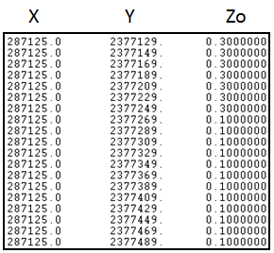
- The X location (in meters) of the point.
- The Y location (in meters) of the point.
- The Z0 roughness length (in meters) of the point.

1.19.3.2 CHM format
Data is stored in an ASCII (text) file with the default file name extension "chm". The file must contain a row of canopy height points.
Each canopy height point must be written on a single line, and contain: - The X location (in meters) of the point.
- The Y location (in meters) of the point.
- The H0 canopy height (in meters) of the point.
The canopy height points do not
 have to be ordered and structured.
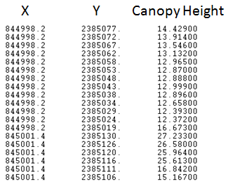
One CHM file sample is displayed:
During the Verification process, the software automatically converts canopy height data to roughness length data, dividing the canopy height data by 20 in order to be consistent with
 Moreover, a specific process is done as soon as the canopy height data is lower than 4.0 the forest model.
meters. For those low canopy height data, the software automatically applies a 0.05-meter roughness length.

1.19.3.3 SHP format
Refer to section 1.19.2.3
In the case of roughness data, the following standard databases are automatically managed by
Meteodyn WT:
- CLC database (Corine Land Cover, CLC2006, 20 m resolution) which provides consistent information on land cover changes during the past decade across Europe.
- LULC database (Land Use/Land Cover) is a digital database of urban areas that represents morphological characteristic of the land with a resolution of 5 × 5 m. Land use/land cover map is available for the following countries: Croatia, Bosnia and Herzegovina, Macedonia and Serbia.
- NLCD database (National Land Cover Database) is a 16-class land cover classification scheme that has been applied consistently across all 50 United States and Puerto Rico at a spatial resolution of
30 meters.
When using a shp file, it is necessary to have the .DBF and .SHX files associated with your
 shape file in the same folder.
- A row giving a "Reference number"
- A row giving the associated roughness length
- Columns must be separated by tabulation or space key.
No point or comas are allowed.
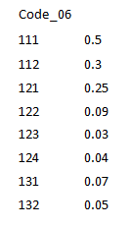
In the case you want to use your own database
The database (txt file) must have the following format:
- Header
The header must correspond to the code describing the roughness in the associated shape
file: the .DBF (which gives the attribute format).

This file can be opened with Excel, in the following figures, we can observe that the
roughness code is associated to the parameter "CODEAREA".
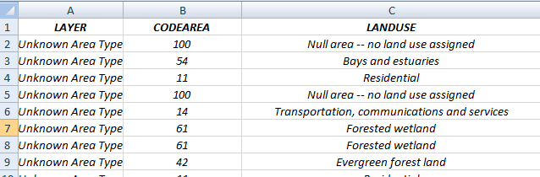

1.19.3.4 TIFF format
Both file extensions .tif and .tiff may be used in Meteodyn WT.
TIFF (Tagged Image File Format) is an adaptable file format for handling images and data within a single file, by including the header tags (size, definition, image-data arrangement, applied image compression) defining the image's geometry.
Each color path in the TIFF file will be associated to a roughness length. In the case of roughness data, the following standard databases are automatically considered by Meteodyn WT:
- CLC database (Corine Land Cover, CLC2006, 20 m resolution) which provides consistent information on land cover changes during the past decade across Europe.
- UCL database (Catholic University of Louvain) - Global Land Cover Map project from ESA and UCL is a 37-class land cover classification scheme across the world (300 m resolution)
- NLCD database (National Land Cover Database) is a 16-class land cover classification scheme that has been applied consistently across all 50 United States and Puerto Rico at a spatial resolution of
30 meters.
In the case you want to use your own database:

The database (txt file) must have the following
format:
- Text file
- No heading
- Columns must be separated by tabulation or space key. No point or comas are allowed.

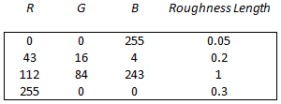

If your TIFF file contains projection and datum information (GEOTIFF file), they won't be
considered. If you want your projection details to be considered, you must define them in
the site information area.

1.19.4 Element data
1.19.4.1 XYH (or TXT) format
Data is stored in an ASCII (text) file with a default file name extension "xyh" (or "txt"). The file should contain a row of elements.
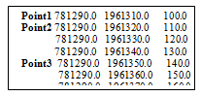
Each element should contain:
- The X location (in meters) of the element.
- The Y location (in meters) of the element.
- The H height (in meters) of the element.
1.19.4.2 PFH (or TXT) format
Is used for a vertical wind profile. Data is stored in an ASCII (text) file with a default file name extension "pfh" (or "txt"). The file should contain a row of elements without a headline.
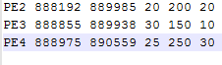
Each result point must be written on a single line, and must contain: - The Label of the vertical wind profile.
- The X location (in meters) of the vertical wind profile.
- The Y location (in meters) of the vertical wind profile.
- The Minimum height in meters (Hmin) of the vertical wind profile.
- The Maximum height in meters (Hmax) of the vertical wind profile.
- The Step (in meters) of the vertical wind profile. This value must be an INTEGER.

1.19.5 Climatology data
1.19.5.1 TAB file
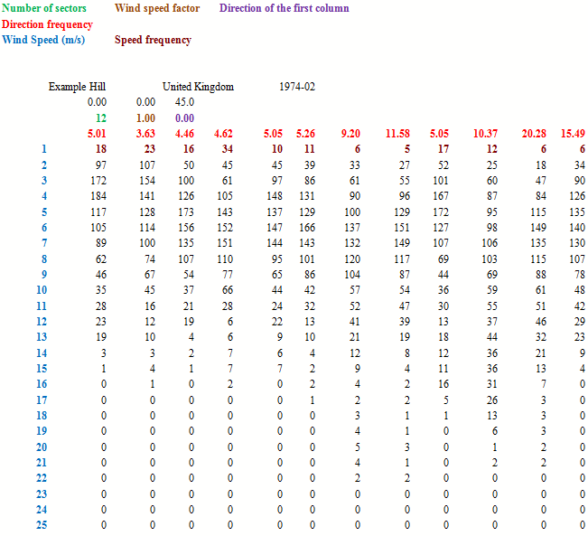
This format is the WAsP format.
• The two first lines are mandatory, but they are not read by Meteodyn WT.
• The "wind speed factor" is the value by which each wind speed bin must be multiplied to have
the real wind speed.
• The "direction of the first column" is the value (in degrees) of the wind direction in the first
column.
The direction frequency must be expressed in per cent (%). The wind speed should correspond to
the upper limit of the measured wind speed. The speed frequency must be expressed in per thousand.

1.19.5.2 Time series
The time series are imported using the new wizard. Please consult the manual Meteorological data
module for more information.
1.19.5.3 Turbulence correction matrix
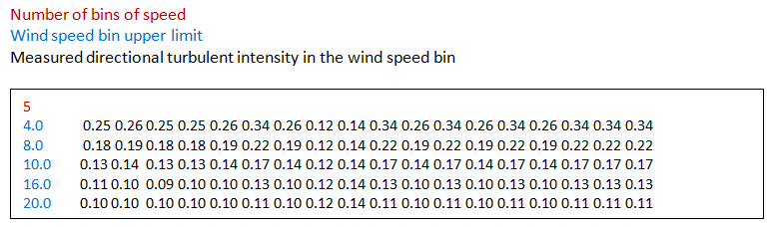
• The wind speed bins must be integers.
• North direction (0°) should be first.
• The measured turbulence is constant in each wind speed bin.
 It is a requirement to have the same number of values for each line of the matrix.
1.19.5.4 Turbulence table
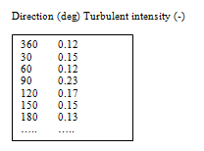
• North direction (0°) should be first.
• The mean directional value of turbulence intensity should fit the measured turbulence
intensity for 15 m/s.
1.19.5.5 Relative standard deviation of turbulence
The format is the same as the turbulence correction matrix (refer to section 1.19.5.3)
1.19.5.6 Association file for multi-meso
X center ; Y center ; Height ; X length ; Y length ; filename (tab or tim)
442135;5752140;80;500;500;x442135y5752140h110.tab 442635;5752140;80;100;100;x442635y5752140h110.tab 440635;5753640;80;500;500;x440635y5753640h110.tab 441135;5753640;80;500;500;x441135y5753640h110.tab 440635;5754140;80;500;500;x440635y5754140h110.tab
The coordinates unit can be in metrics (m) or in latitude/longitude (decimal degree)

1.19.6 Wind turbine data
1.19.6.1 Power curve data
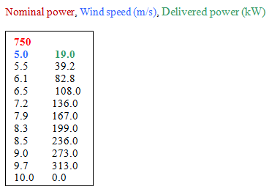
 It is not a requirement to specify the cut-out wind speed. Meteodyn WT automatically considers the last wind speed as the cut-out wind speed (power output equals zero for all the wind speeds greater than this cut-out wind speed).
1.19.6.2 Thrust curve data
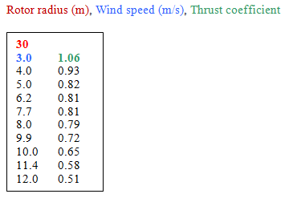
1.19.6.3 WTG data
The WTG format is the format used in the WAsP turbine editor. Refer to their online manual for more information on this type of file.
 It is not possible to import multiple power/thrust curves for the same air density.

1.19.7 Lidar correction data
Lidar location (m), Direction (deg), Heights (m)



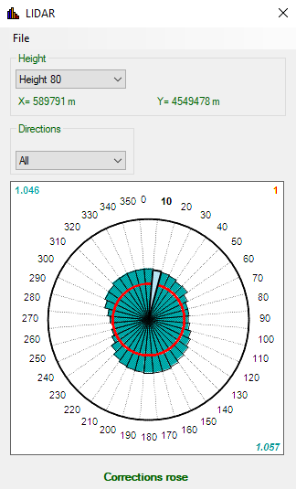

1.19.8 WRG/RSF exports
WRG export
The exported files for Power density in W/m2 are:
- sitename_map_Snumber_Hheight_powerdensity.wrg
- sitename_metmast_Snumber_elementname_powerdensity.wrg
The exported files for Production in Wh/year are:
- sitename_map_Snumber_Hheight_production.wrg
- sitename_metmast_Snumber_elementname_production.wrg
Where:
- map refers to the whole mapping.
- S refers to the Synthesis.
- H refers to the mapping height.
- metmast refers to the point of the meteorological mast.
- elementName refers to the label of the element.
For mappings
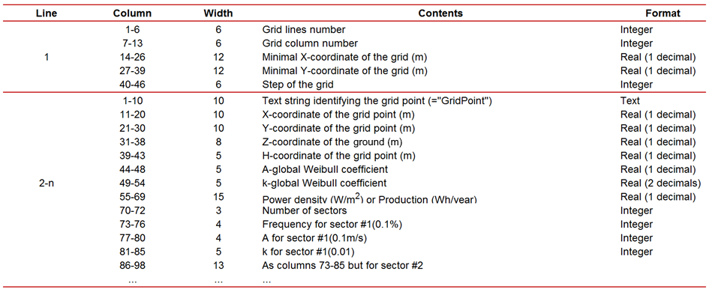
For met masts
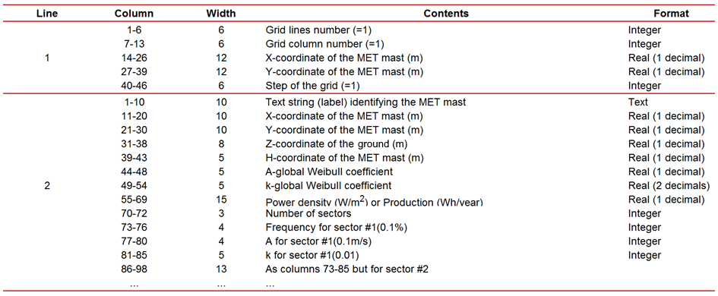

RSF export
The exported files for Power density in W/m2 are:
- sitename_map_Snumber_Hheight_powerdensity.rsf
- sitename_metmast_Snumber_elementname_powerdensity.rsf
- sitename_all_Snumber_potential.rsf
The exported files for Production in Wh/year are:
- sitename_map_Snumber_Hheight_production.rsf
- sitename_metmast_Snumber_elementname_production.rsf
- sitename_all_Snumber_production.rsf
Where:
- map refers to the whole mapping.
- S refers to the Synthesis.
- H refers to the mapping height.
- metmast refers to the point of the meteorological mast.
- all means for all the elements except the met masts and the mappings.
- elementName refers to the label of the element.
For mappings
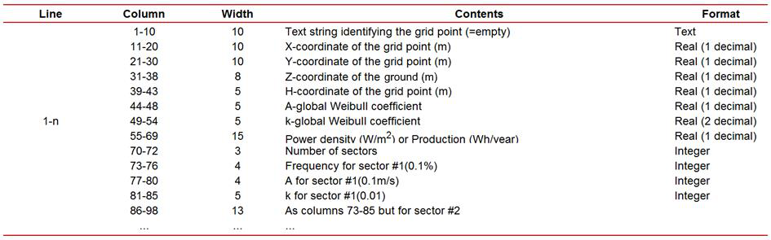
For met masts
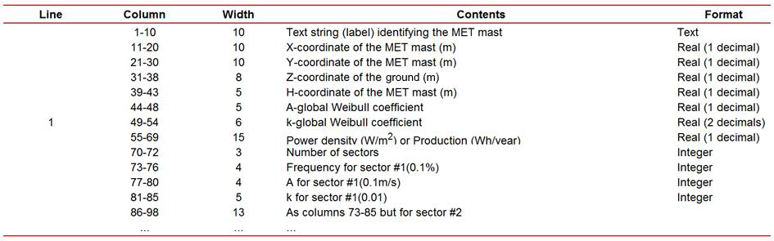

For all other elements
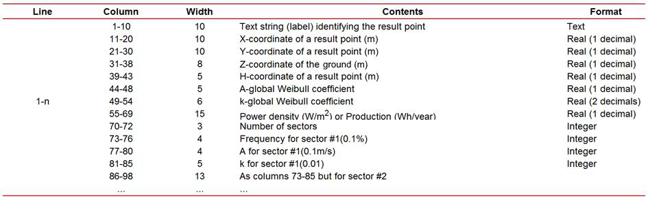

REFERENCES
Ainslie, J. (1988). Calculating the velocity field in the wake of wind turbines. Journal of Wind Engineering and Industrial Aerodynamics, 27, 213–224.
Arritt, R. W. (1987). The Effect of Water Surface Boundary Layers. Boundary-Layer Meteorology Vol. 40, 101–125.
Crank, J., & Nicolson, P. (1947). A practical method for numerical evaluation of solutions of partial differential equations of the heat conduction type. Proc. Camb. Phil. Soc. 43, 50-67.
D.C. Quarton, J. A. (1990). Turbulence in Wind Turbine Wakes. Wind Engineering Vol 14 No 1, 15-23. Dyer, A. J. (1974). A review of flux-profile relationships. Boundary-Layer Meteorology Volume 7, Issue 3,, 363–372.
(2005). Eurocode 1 (EC1), part 1-4: Wind Actions (EN 1991-1-4:2005E). European standard EN 1991-1- 4.
(1998). European Wind Turbine Standards II. ECN-C--98-096.
Frandsen, S. M. (2003). Spatially average of turbulence intensity inside large wind turbine arrays.
European Seminar on Offshore Wind Energy in the Mediterranean and Other European Seas (OWEMES 2003). Naples.
Frandsen, S. T. (2007). Turbulence and turbulence generated structural loading in wind turbine clusters. Roskilde: Risø National Laboratory.
Garratt, J. R. (1994). The atmospheric boundary layer. Cambridge University Press.
Grachev, A. A. (2013). The Critical Richardson Number and Limits of Applicability of Local Similarity Theory in the Stable Boundary Layer. Boundary-Layer Meteorology, Vol. 147, Issue 1, 51-82. Kaimal, J. F. (1994). Atmospheric boundary layer flows – their structure and measurement. New York: Oxford University Press.
Louis, J. (1979). A parametric model of vertical eddy fluxes in the atmosphere. Boundary-Layer Meteorology Volume 17, Issue 2, 187–202.
Panofsky H.A., D. J. (1984). Atmospheric turbulence - Models and Methods for Engineering Applications. Wiley Interscience Ed.
Tennekes, H. (1982). Similarity Relations, Scaling Laws and Spectral Dynamics. Atmospheric Turbulence and Air Pollution Modelling: A course held in the Hague, 21-25 September,1981. (p. 37). The Hague: D. Reidel Publishing Co.
Vermeulen PEJ., B. P. (1982). Turbulence measurements in simulated wind turbine clusters. Report 82- 03003. TNO Division of Technology for Society.
Yamada, T. (1983). Simulations of nocturnal drainage flows by a q2l turbulence closure model. Journal of Atmospheric Sciences, vol. 40, Issue 1, 91-106.
Zilitinkevich, S. S. (2010). Turbulence closure for stably stratified flows: local and non-local formulations. 8th European Conference on Applied Climatology. Zürich, Switzerland: EMS2010. Li R., Leonard E., Tromeur E. Comparison of three methods in atmospheric stratification determination. Windeurope 2022.
Li R., Leonard E., Tromeur E. Atmospheric Stratification Determinations at Complex Wooded Site. Windeurope 2023.

