**Candidate : Hana Helweh**

**Assignment: choose 4 from 5 methods.**

1- Using (HTML4 Table System) (Not Responsive)

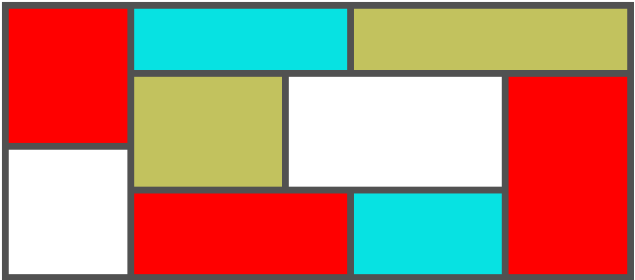

**HTML4.html**

<style>

  table, tr, td{

    border: 7px solid rgb(81, 81, 81);

    border-collapse: collapse;

  }

</style>

<table style="width: 650px;">

<tr>

  <td rowspan="2" style="background-color: red; height: 145px; width: 120px;"></td>

  <td colspan="2" style="background-color: rgb(7, 226, 226); height: 70px; width: 150px;"></td>

  <td colspan="2" style="background-color: rgb(194, 194, 94); height: 70px; width: 150px;"></td>

</tr>

<tr>

  <td rowspan="2" style="background-color: rgb(194, 194, 94); width: 150px; height: 120px;"></td>

  <td colspan=2" rowspan="2" style="background-color: white; width: 150px; height: 120px;"></td>

  <td rowspan="3" style="background-color: red; width: 120px; height: 120px;"></td>

</tr>

<tr>

  <td rowspan="2" style="background-color: white; width: 120px; height: 120px;"></td>

</tr>

<tr>

  <td colspan="2" style="background-color: red; height: 90px; width: 150px;"></td>

  <td style="background-color: rgb(7, 226, 226); height: 90px; width: 150px;"></td>

</tr>

</table>

3- Without Using Grids

**grid.html**

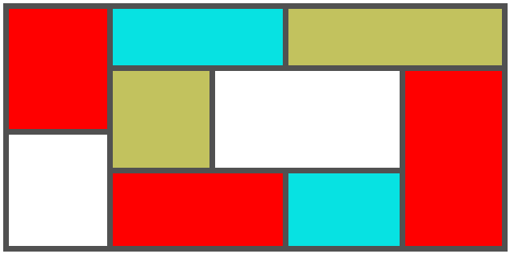

<!DOCTYPE html>

<html lang="en">

<head>

  <meta charset="UTF-8">

  <meta name="viewport" content="width=device-width, initial-scale=1.0">

  <title>Document</title>

  <style>

    .container{

      height: 294px;

      width: 40%;

      background-color: rgb(81, 81, 81);

      border: 7px solid rgb(81, 81, 81);

    }

    .column1{

      width: 20%;

      float: left;

      height: 100%;

      margin-right: 7px;

    }

    .red{

      background-color: red;

      height: 149px;

    }

    .white{

      background-color: white;

      height: 138px;

      margin-top: 7px;

    }

    .bigcolumn2{

      width: calc(80% - 7px);

      float: left;

    }

    .top{

      height: 70px;

      width: 100%;

      margin-bottom: 7px;

    }

    .blue{

      width: calc(45% - 7px);

      height: 100%;

      background-color: rgb(7, 226, 226);

      float: left;

      margin-right: 7px;

    }

    .beige{

      width: 55%;

      height: 100%;

      background-color: rgb(194, 194, 94);

      float: left;

    }

    .left{

      width: 75%;

      float: left;

    }

    .leftTop{

      width: 100%;

      height: 120px;

    }

    .leftBottom{

      width: 100%;

      height: 90px;

      margin-top: 7px;

    }

    .beige2{

      width: calc(35% - 7px);

      height: 100%;

      background-color: rgb(194, 194, 94);

      float: left;

      margin-right: 7px;

    }

    .white2{

      width: calc(65% - 7px);

      height: 100%;

      background-color: white;

      float: left;

      margin-right: 7px;

    }

    .red2{

      width: calc(60% - 7px);

      height: 100%;

      background-color: red;

      float: left;

      margin-right: 7px;

    }

    .blue2{

      width: calc(40% - 7px);

      height: 100%;

      background-color: rgb(7, 226, 226);

      float: left;

    }

    .bottom{

      height: 100%;

    }

    .right{

      background-color: red;

      width: 25%;

      height: 217px;

      float: left;

    }

  </style>

</head>

<body>

  <div class="container">

    <div class="column1">

      <div class="red"></div>

      <div class="white"></div>

    </div>

    <div class="bigcolumn2">

      <div class="top">

        <div class="blue"></div>

        <div class="beige"></div>

      </div>

      <div class="bottom">

        <div class="left">

          <div class="leftTop">

            <div class="beige2"></div>

            <div class="white2"></div>

          </div>

          <div class="leftBottom">

            <div class="red2"></div>

            <div class="blue2"></div>

          </div>

        </div>

        <div class="right"></div>

      </div>

    </div>

  </div>

</body>

</html>

4- Using Flex (Responsive)

**flex.html**

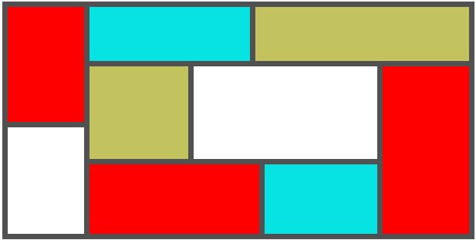

<!DOCTYPE html>

<html lang="en">

<head>

  <meta charset="UTF-8">

  <meta name="viewport" content="width=device-width, initial-scale=1.0">

  <title>Document</title>

  <style>

    .flex{

      display: flex;

      gap: 7px;

    }

    .container{

      height: fit-content;

      width: 40%;

      background-color: rgb(81, 81, 81);

      border: 7px solid rgb(81, 81, 81);

      box-sizing: border-box;

    }

    .column1{

      flex: 0.2;

      flex-direction: column;

    }

    .red{

      background-color: red;

      height: 149px;

    }

    .white{

      background-color: white;

      height: 138px;

    }

    .bigcolumn2{

      flex: 1;

      flex-direction: column;

    }

    .top{

      height: 70px;

    }

    .blue{

      flex: 1.5;

      background-color: rgb(7, 226, 226);

    }

    .beige{

      flex: 2;

      background-color: rgb(194, 194, 94);

    }

    .left{

      flex: 1;

      flex-direction: column;

    }

    .leftTop{

      height: 120px;

    }

    .leftBottom{

      height: 90px;

    }

    .beige2{

      flex: 3.5;

      background-color: rgb(194, 194, 94);

    }

    .white2{

      flex: 6.5;

      background-color: white;

    }

    .red2{

      flex: 6;

      background-color: red;

    }

    .blue2{

      flex: 4;

      background-color: rgb(7, 226, 226);

    }

    .right{

      background-color: red;

      flex: 0.3;

    }

  </style>

</head>

<body>

  <div class="container flex">

    <div class="column1 flex">

      <div class="red"></div>

      <div class="white"></div>

    </div>

    <div class="bigcolumn2 flex">

      <div class="top flex">

        <div class="blue"></div>

        <div class="beige"></div>

      </div>

      <div class="bottom flex">

        <div class="left flex">

          <div class="leftTop flex">

            <div class="beige2"></div>

            <div class="white2"></div>

          </div>

          <div class="leftBottom flex">

            <div class="red2"></div>

            <div class="blue2"></div>

          </div>

        </div>

        <div class="right"></div>

      </div>

    </div>

  </div>

</body>

</html>

5- Using Mobius library

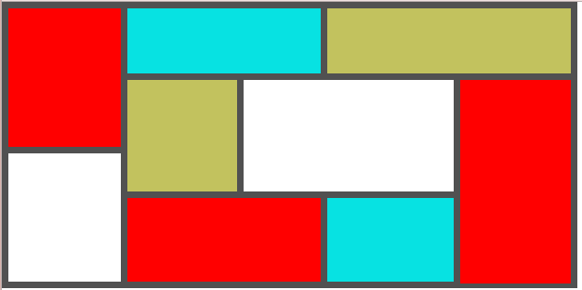

**Index.html**

<!DOCTYPE html>

<html lang="en">

  <head>

    <title>My First Project</title>

    <meta charset="UTF-8" />

    <meta

      name="viewport"

      content="width=device-width, initial-scale=1.0, minimum-scale=1.0"

    />

    <meta name="language" content="En" />

    <meta rel="publisher" content="LumenJS https://www.lumenjs.com/" />

    <meta rel="author" content="LumenJS https://www.lumenjs.com/" />

    <meta name="title" content="My First Project Official Site" />

    <meta name="description" content="My First Project Official Site." />

    <meta name="Keywords" content="" />

    <meta name="theme-color" content="#FFA302" />

    <link href="/css/bea.css" rel="stylesheet" type="text/css" />

    <link href="/css/styles.css" rel="stylesheet" type="text/css" />

    <link rel="icon" type="image/x-icon" href="/favicon.ico" />

*<!-- <link rel="icon" type="image/png" href="/favicon.png" /> -->*

    <link rel="preconnect" href="https://www.beaapis.com/" />

    <link rel="dns-prefetch" href="http://www.beacdn.com/" />

    <meta property="og:url" content="https://www.lumenjs.com/" />

    <meta property="og:title" content="My First Project Official Site" />

    <meta property="og:type" content="business.business" />

    <meta property="og:site_name" content="My First Project" />

    <meta property="fb:admins" content="592515154" />

    <meta property="fb:app_id" content="138025696270006" />

    <meta property="og:description" content="My First Project Official Site." />

    <meta property="og:image" content="/images/lumenjs.svg" />

    <meta

      property="business:contact_data:street_address"

      content="Street Address."

    />

    <meta property="business:contact_data:locality" content="Tripoli" />

    <meta property="business:contact_data:postal_code" content="1300" />

    <meta property="business:contact_data:country_name" content="Lebanon" />

    <meta property="business:contact_data:email" content="info@lumenjs.com" />

    <meta

      property="business:contact_data:phone_number"

      content="+96171299411"

    />

    <meta property="business:contact_data:fax_number" content="" />

    <meta

      property="business:contact_data:website"

      content="https://www.lumenjs.com/"

    />

  </head>

  <body>

    <div class="container1">

      <div class="column1 w20 left h100">

        <div class="red"></div>

        <div class="white bgw"></div>

      </div>

      <div class="bigcolumn2 left">

        <div class="top w100">

          <div class="blue h100 left"></div>

          <div class="beige left h100"></div>

        </div>

        <div class="bottom h100">

          <div class="left w75">

            <div class="leftTop w100">

              <div class="beige2 h100 left"></div>

              <div class="white2 h100 bgw left"></div>

            </div>

            <div class="leftBottom w100">

              <div class="red2 h100 left"></div>

              <div class="blue2 h100 left"></div>

            </div>

          </div>

          <div class="right w25 left"></div>

        </div>

      </div>

    </div>

  </body>

</html>

**Style.css**

.container1{

  height: 308px;

  width: 40%;

  border: 7px solid rgb(81, 81, 81);

  background-color: rgb(81, 81, 81);

}

.column1{

  margin-right: 7px;

}

.red{

  background-color: red;

  height: 149px;

}

.white{

  height: 138px;

  margin-top: 7px;

}

.bigcolumn2{

  width: calc(80% - 7px);

}

.top{

  height: 70px;

  margin-bottom: 7px;

}

.blue{

  width: calc(45% - 7px);

  background-color: rgb(7, 226, 226);

  margin-right: 7px;

}

.beige{

  width: 55%;

  background-color: rgb(194, 194, 94);

}

.leftTop{

  height: 120px;

}

.leftBottom{

  height: 90px;

  margin-top: 7px;

}

.beige2{

  width: calc(35% - 7px);

  background-color: rgb(194, 194, 94);

  margin-right: 7px;

}

.white2{

  width: calc(65% - 7px);

  margin-right: 7px;

}

.red2{

  width: calc(60% - 7px);

  background-color: red;

  margin-right: 7px;

}

.blue2{

  width: calc(40% - 7px);

  background-color: rgb(7, 226, 226);

}

.right{

  background-color: red;

  height: 219px;

}