**Computer Vision 236873 - HW1**

*Aram Gasparian, 310410865, aram89g@gmail.com   
Hana Matatov, 203608302, hanama888@gmail.com*

Your code should be well documented and clear. The code should run from **any** computer and include all path definitions (You should take care of this in the code). Please divide the code by questions.

כדאי לוודא שהדרך שבה אתה מגדיר את התמונות של העלים למשל (מתוך התיקיות שהגדרת) לא פוגעת בהנחיה פה

**Q2 Photometry:**

1. The following surface 3D in Matlab:





Explanation:

We defined X and Y axes as -4 to 4 with intervals of 0.2. We choose symmetric axes because the surface Z is not flat in the center of the grid.   
We choose intervals of 0.2 in order to have a smoother surface.

1. 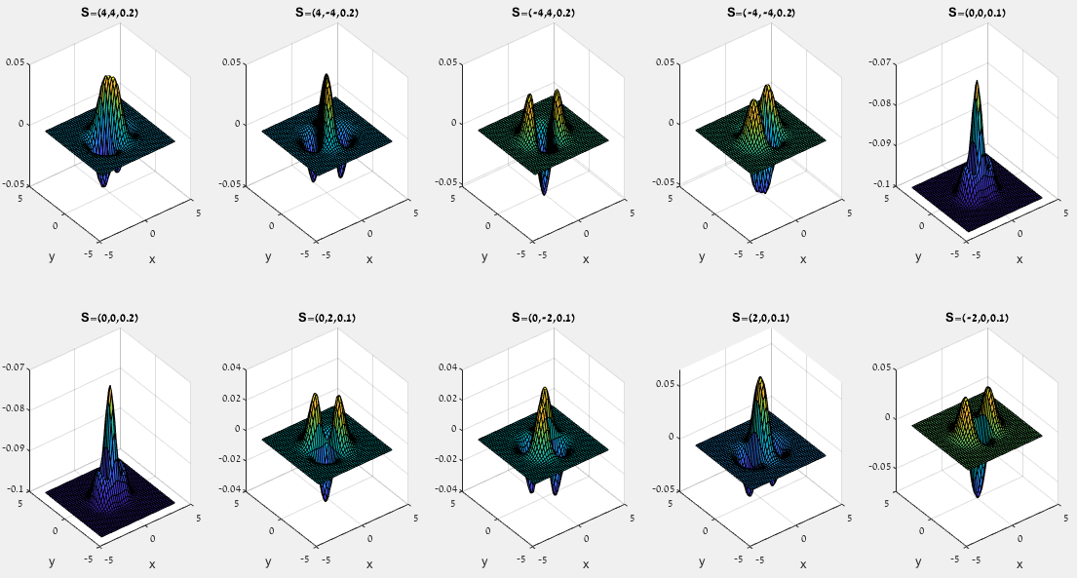The irradiance I for 10 different illumination vectors :

Explanation:

We defined 10 different coordinates for s, each is trying to capture a different direction point:

|  |  |  |
| --- | --- | --- |
| **X** | **Y** | **Z** |
| 4 | 4 | 0.2 |
| 4 | -4 | 0.2 |
| -4 | 4 | 0.2 |
| -4 | -4 | 0.2 |
| 0 | 0 | 0.1 |
| 0 | 0 | 0.2 |
| 0 | 2 | 0.1 |
| 0 | -2 | 0.1 |
| 2 | 0 | 0.1 |
| -2 | 0 | 0.1 |

Then, we normalized the size of each source s to be 1 (a unit vector ).

Finally, we calculated the formula for irradiance of Lambertian surface as:



When  as defined, is the normal of each pixel on the surface and from before.

We printed the 10 different surfaces, each represent the surface  as a function of X and Y, differ according to the s coordinates.

1. SVD factorization of each of the images for finding their effective dimension:

Explanation:

We calculated the SVD factorization of each of the images by using SVD factorization for each of the matrixes I (irradiance when using different source vectors s).

Then, we looked only on the middle-returned matrix which is the singular values matrix – the diagonal matrix.

The values on the diagonal of this matrix are the singular values of I.

The number of the non-zero singular values is the rank of the matrix I.

Also, the non-zero singular values are square roots of the non-zero eigenvalues of  and of  .

Therefore, we calculated the sum of squares of K non-zero singular values to get those eigenvalues.

Then, we calculated the result for every K divided by the value for all N:



This is a value between 0 (when i=0) to 1 (when the numerator and denominator are equal).

We saw that this value gets to 1 when K<5, therefore we plot the graphs for .

Results:

When S=(4,4,0.2) the effective dimension is 3.

When S=(4,-4,0.2) the effective dimension is 3.

When S=(0,0,0.2) the effective dimension is 1.

When S=(0,2,0.1) the effective dimension is 2.

And so on.

**Q3:**

1. A schematic diagram showing the ball, the camera and the light source:

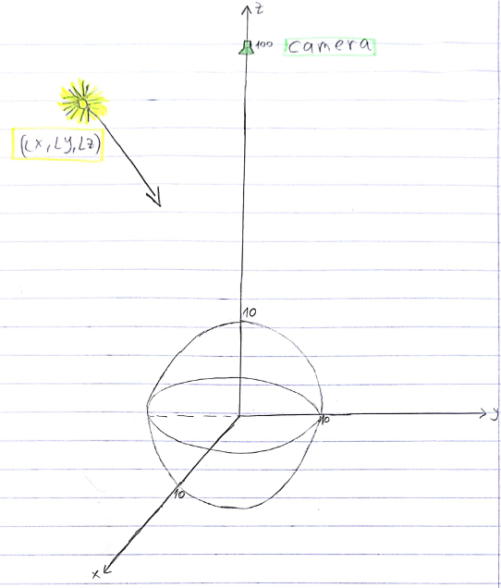

Explanation:

The ball is of radius 10, centered at the origin.

The ideal camera located at (0,0,100), above the ball - marked in green in the schematic diagram.

A point illumination source is located in some unknown place (Lx,Ly,Lz>0), far from the ball – assume it is in the point marked in yellow in the schematic diagram.

1. A schematic description of the image taken by the camera:

לא חושב שהציור טוב, צריך להראות ציור שבו יש הארה חזקה במקום מסויים.

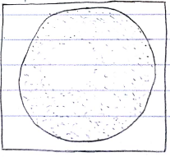

Explanation:

Since the illumination source is far from the ball, and it is Lambertian ball, we can assume that the direction of the illumination source is equal for every point on the ball, and that the illumination is approximately uniform on all points on the ball.

But, since the camera and the illumination source are both above the ball, in the image only the upper side of the ball will be seen, and it will look as a circle.

Because of the direction of light, the part of the upper-ball where the normal is in the same direction as the illumination source direction, will have more illumination (*this area looks brighter in the schematic description*).

1. An algorithm for finding the illumination source direction:
2. Count the radius of the ball in the image (pixels units).
3. Calculate the ratio between the radius of the ball in the world (centimeters units), to the radius of the ball in the image (pixels units) from step 1. It is possible since we know that the radius of the ball in the world is 10.

צריך לפרט איך מחשבים את זה לדעתך? לא

1. Find the coordinates  of the brightest pixel of the image by:



Where  is the value of brightness on each point on the image.

We are using thatfor Lambertian ball and the approximation for far illumination sources. The brightest point is where  and directions are the same (the vectors are parallel).

1. Find in world’s coordinates system by using the results of steps 2 and 3.

We are using the distance between the center of the circle in the image to , as proportional to the distance between the center of the ball in the world to the projection of  on XY surface (Z=0).

It relies on the fact that the camera’s center is directly above ball’s center.

1. Find  in world’s coordinates system by using the result of step 4 and the ball’s formula.
2. Find the normal to the ball surface at the point .
3. Define the direction of the normal from step 6 as the direction of the illumination source.

אם אני לא טועה הכיוון מנוגד באחד הצירים ולא ממש זהה? לא רואה איזה כיוון מנוגד.

**Q5 – Camera Calibration**

1. The camera matrix P we got using the DLT method is:

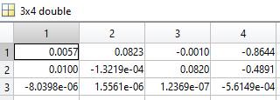

1. The re-projected points are the red circles:

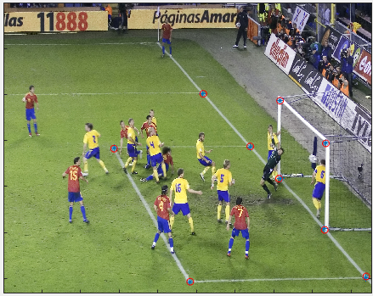

As we can see they correspond with the image points given so we can be sure that the camera matrix P we got is good.

The error measure we define is:

, it measures the mean distance between the image points to the re-projected points we calculated in pixels.

1. The goal of the rq() function is to deconstruct P to KR where K is an upper triangle matrix and R is a unitary matrix.

The difference with the matlab qr() function is that the qr() deconstructs to QR where Q is unitary matrix and R is an upper triangle, and this is the reason we didn't use qr().

[Q,R] = qr(flipud(M)');

% QR decomposition of a flipped up down M'

R = flipud(R');

R = fliplr(R);

Q = Q';

Q = flipud(Q);

% force the diagonal to be positive

T = diag(sign(diag(R)));

R = R * T;

Q = T * Q;

Any full rank matrix can be decomposed into the product of an upper triangular matrix and an orthogonal matrix by using RQ-decomposition, but matlab doesn't have this function in its libraries so we need to implement it.

The first part implements an RQ-decomposition but it's not unique, so we force the diagonal to be positive.

1. The K matrix we got needs to be normalized because the solution of the optimization problem is correct until multiplication by a factor.

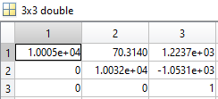

The skew is 70.

The px and py are positive and negative respectively, we expected it to be the opposite. The reason it is like this is because the x-axis of the image and the camera are opposing each other, the same about the y-axis.

The focal lengths fx and fy are fairly the same but we expected the to be negated from the same reason.

* A link that explains the reasons for the results and what happened.

<http://ksimek.github.io/2012/08/14/decompose/?fbclid=IwAR26woRzfsramAlJpHlhS1AS7SNlkyBA96i15LLIpB6otD-h7DnuLcLRVZo>

1. The orientation of the camera that we get from rq() isn't good (also the determinate is -1) it makes the camera face the other direction, the reason for this is the enforcement of the positive diagonal made in rq(). If we negate the R we got from rq() we get the camera orientation we expected, x-axis of the image is the same as x-axis of the camera, the same for y-axis and the camera faces the positive z coordinate.
2. The camera location c is:

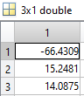

The location is reasonable because we expect it to be left of the goal frame (negative x and positive y), and above the ground (positive z).

1. The 3d location of the camera is represented by the red x:

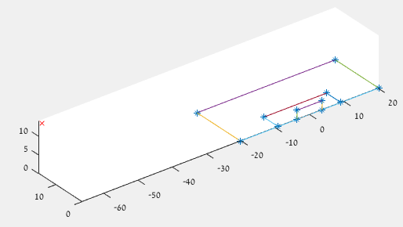

And we can see now the result from the previous section is reasonable.

1. 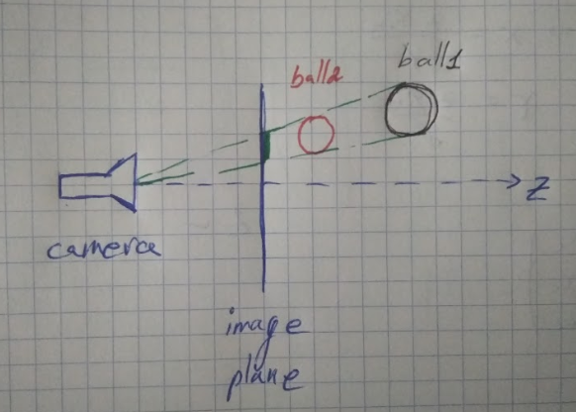We cannot determine the depth of the ball because we don't know it's real world size, this is the missing piece we need to be able to calculate.

As depicted in the image ball1 and ball2 have different distance from the camera and are in different sizes but the size on the image plane is the same so we cannot determine the ball distance from camera using only information from the image.