Java Programming for Use Case: Submit Paper

* Login Choice:

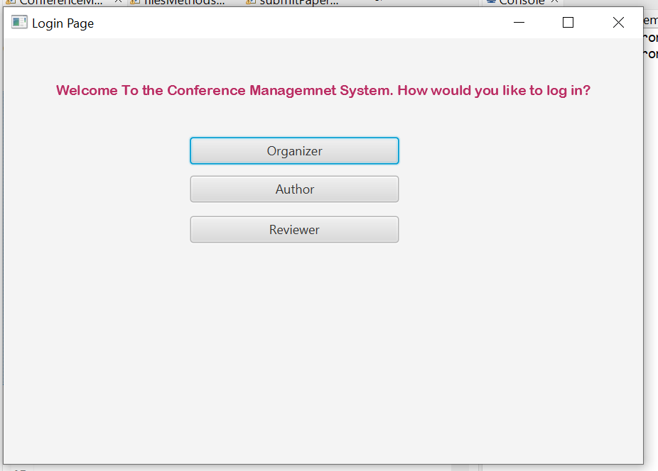

* Selecting Author:

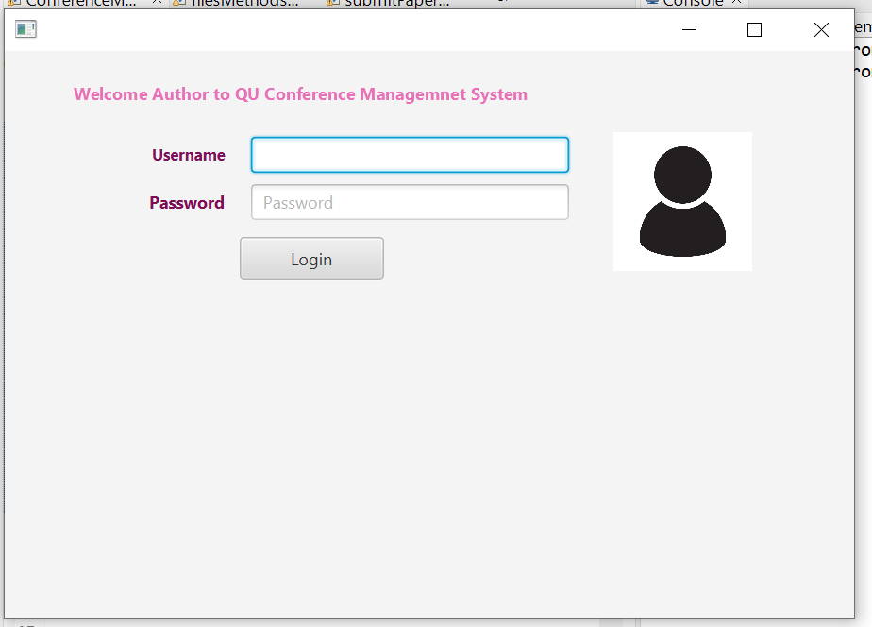

Logging in without entering username/password:

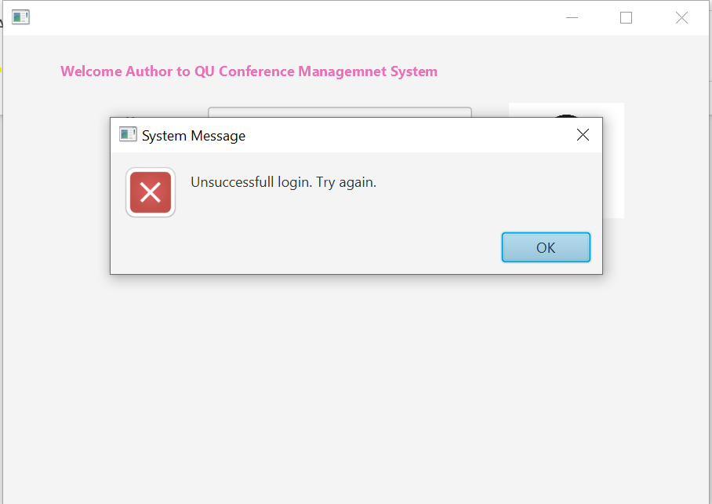

After Ok Directly goes to Another Login Page with Sign Up option:

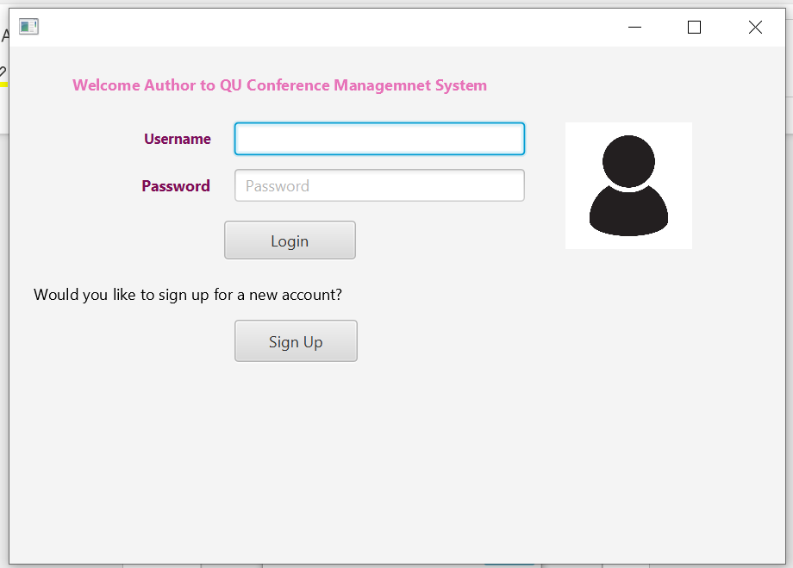

If Author is Available:

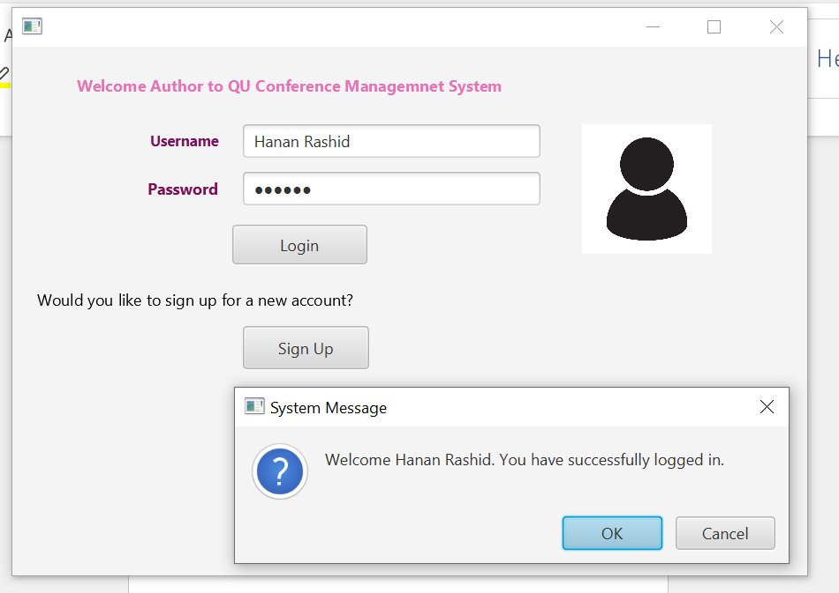

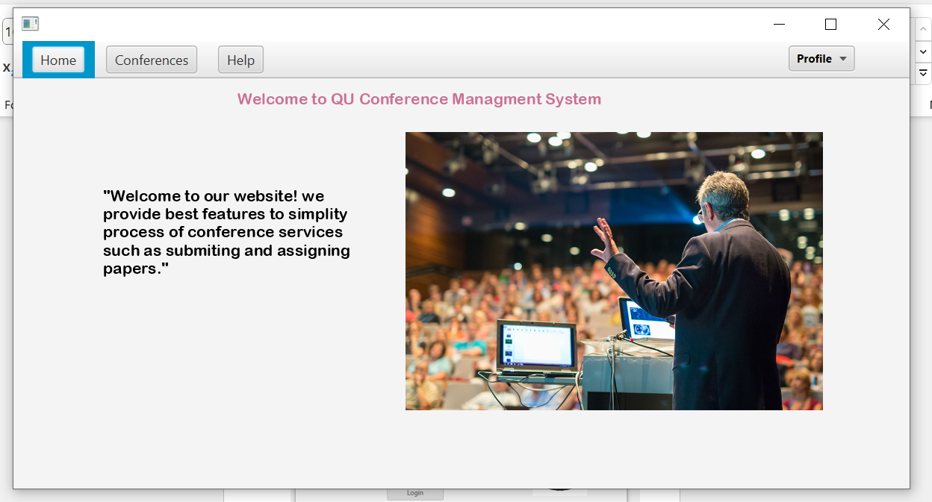

If Author Not Available:

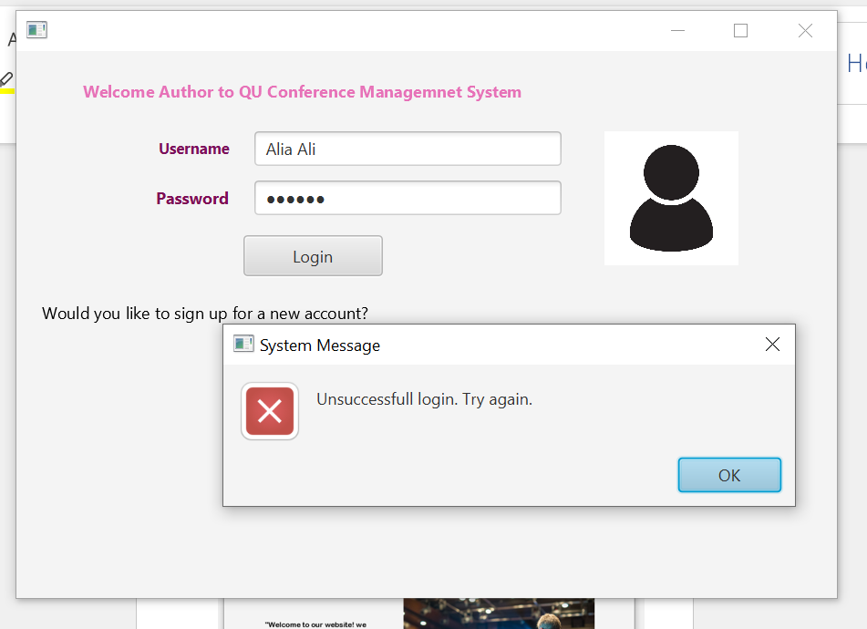

User Chooses Sign Up:

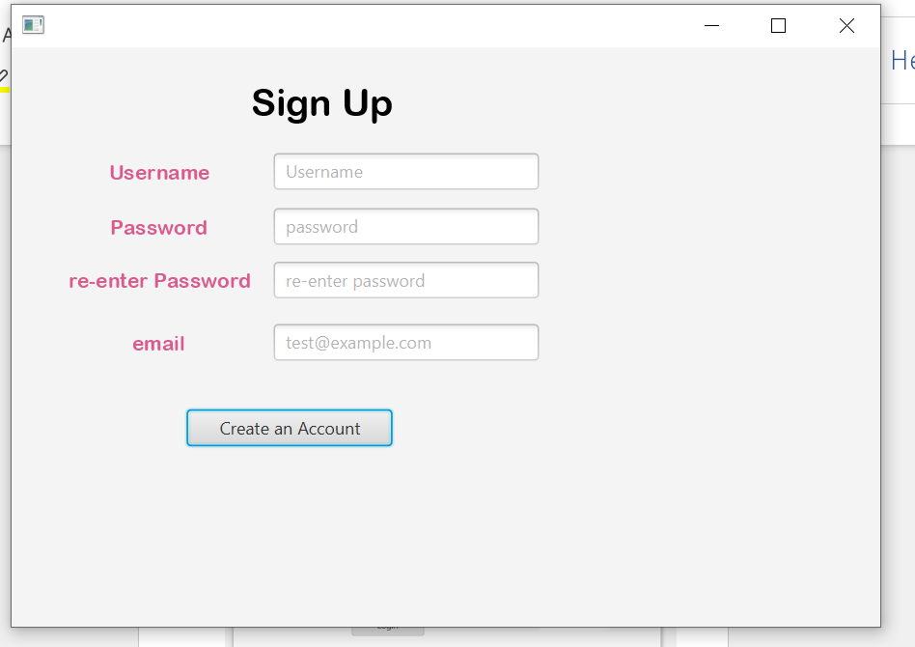

If blanks not filled:

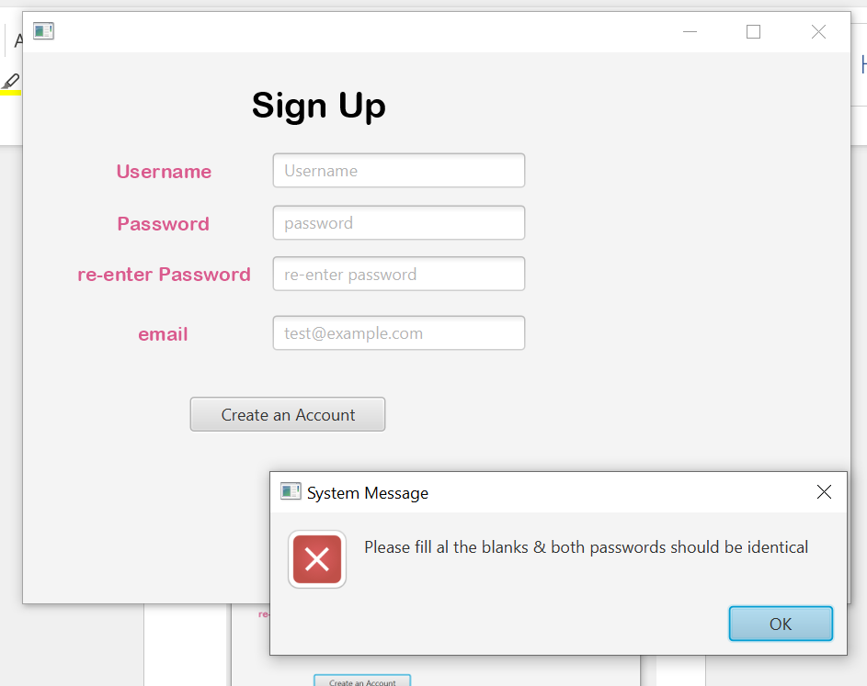

If password not above 6 & not identical:

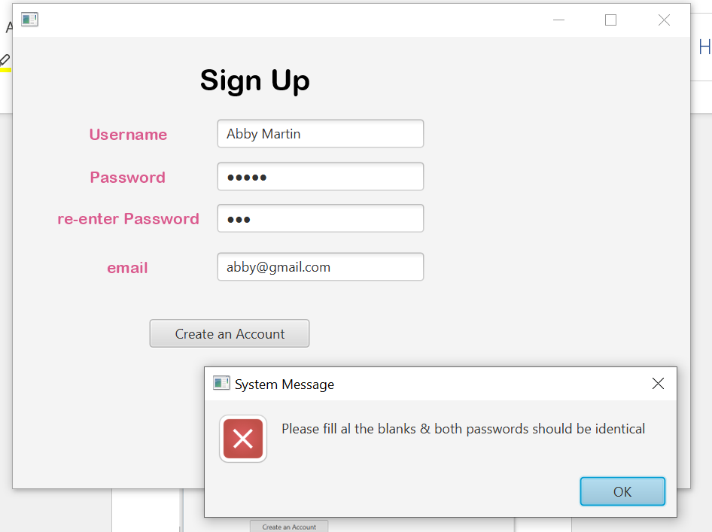

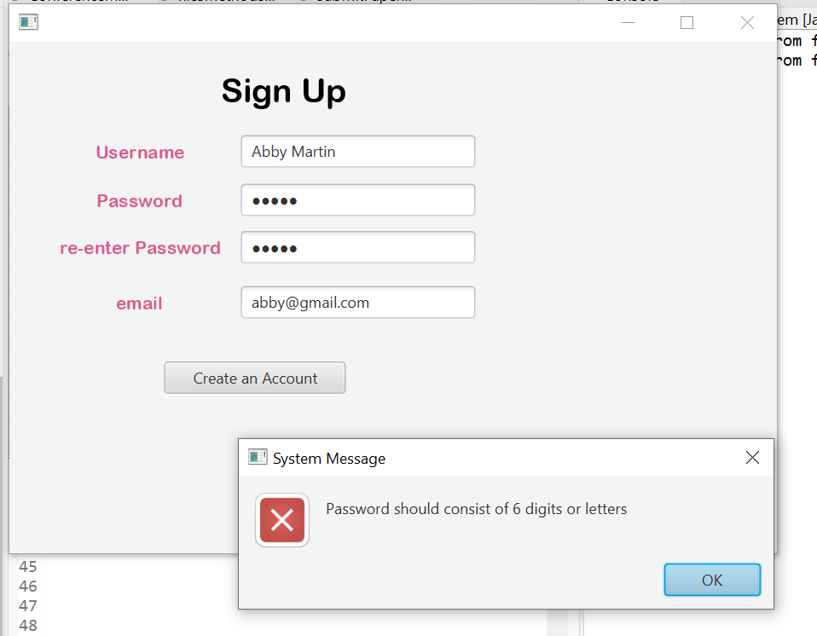

Email Validation:

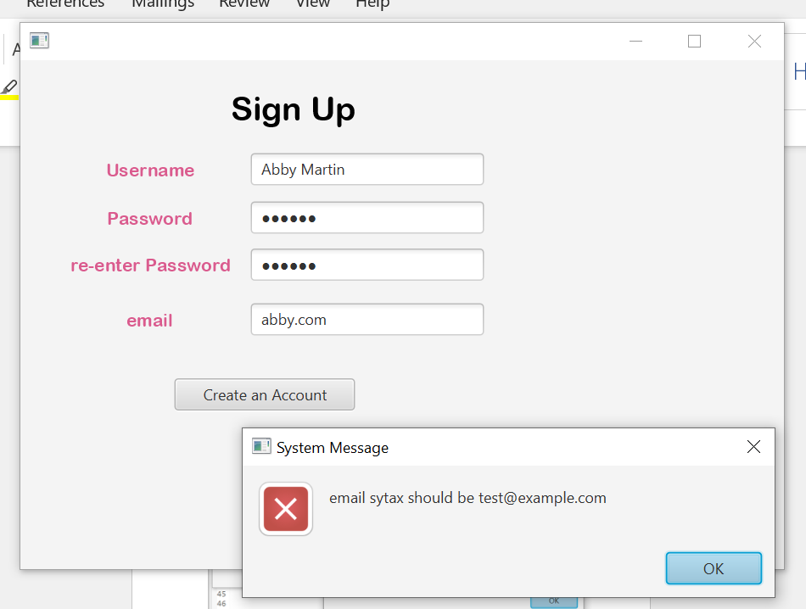

Entered data is valid:

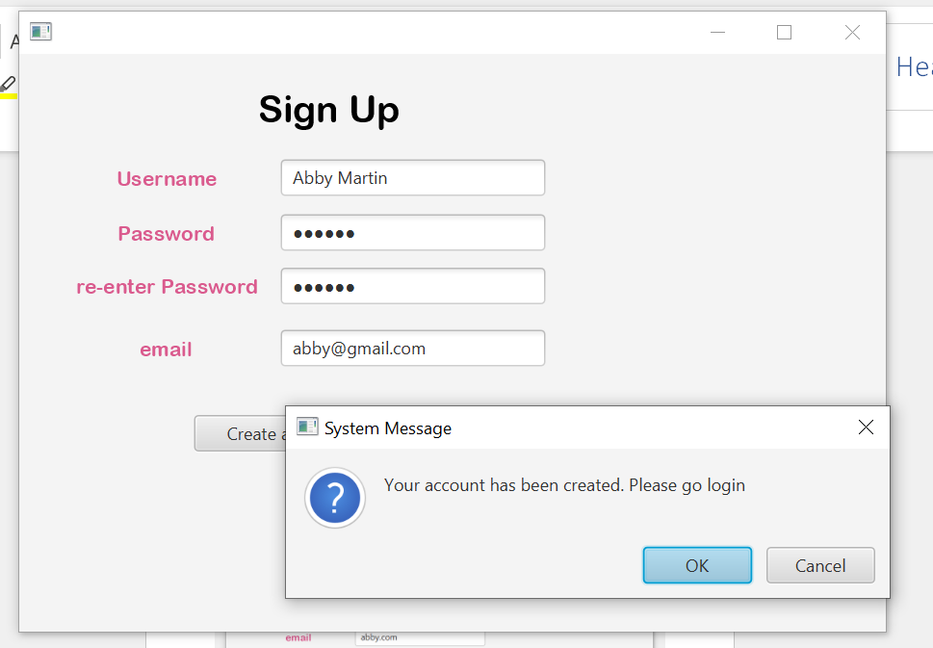

Goes to Login Pages:

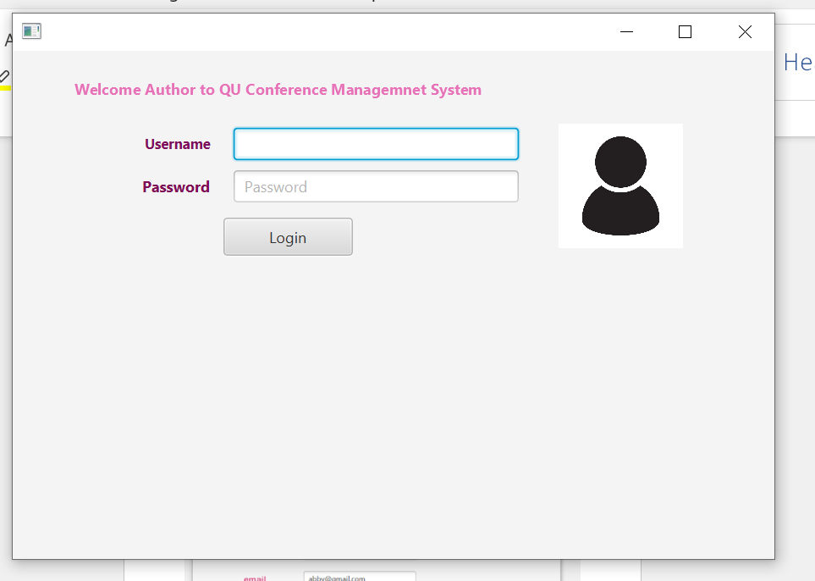

Add The New Account Data:

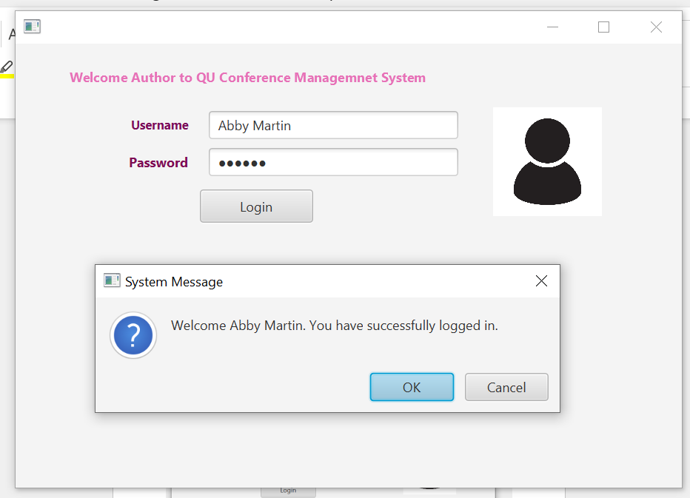

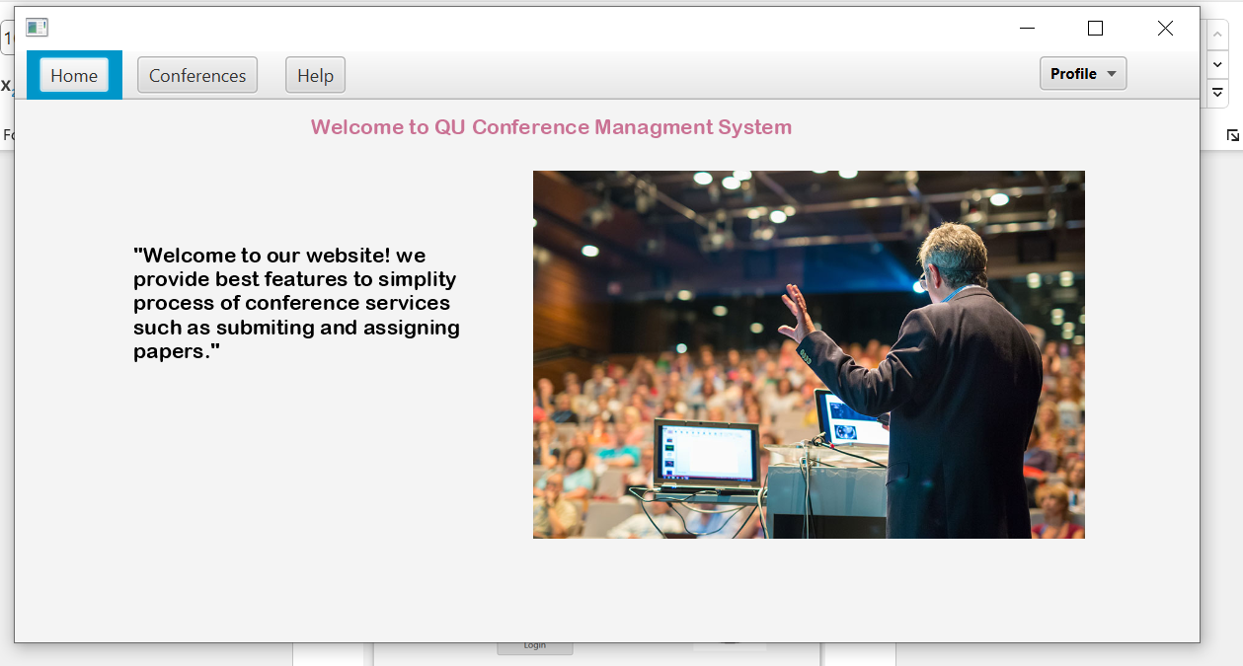

Press Profile: (she is newly Registered Account and has no Papers Submitted);

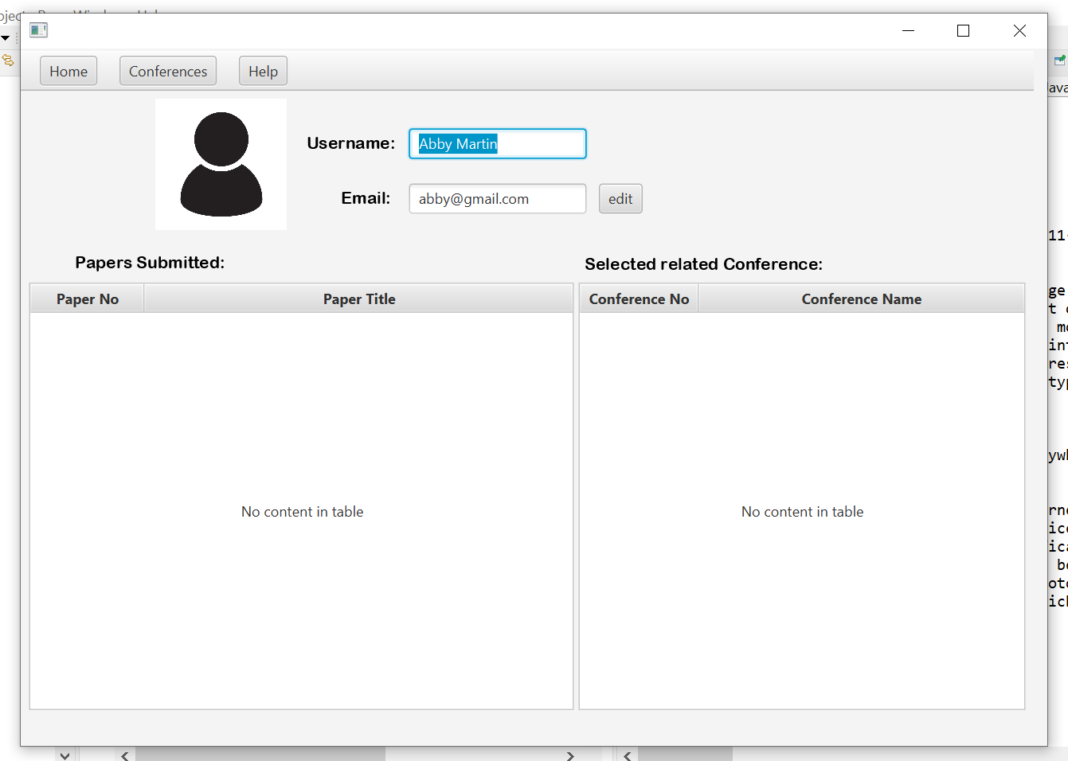

Press Conference:



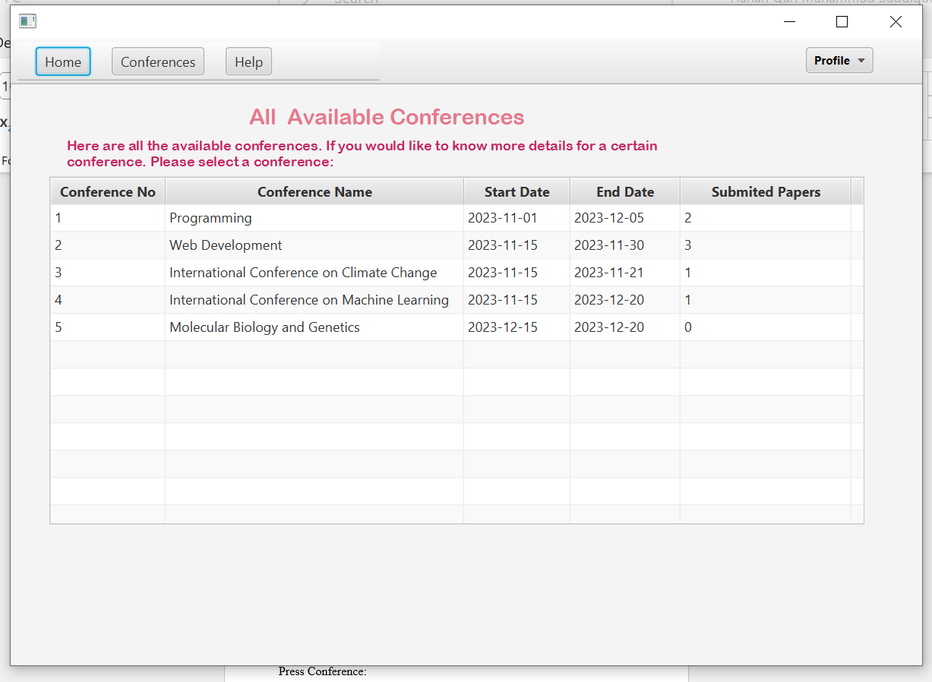

After the user Selects a Conference (1st one):

User Cannot Change the Conference Information except for adding a new Paper.

Shows detailed Information of the conference with different venues available. Displays the reviewers for tis conference. Also list of Papers Submitted Already.

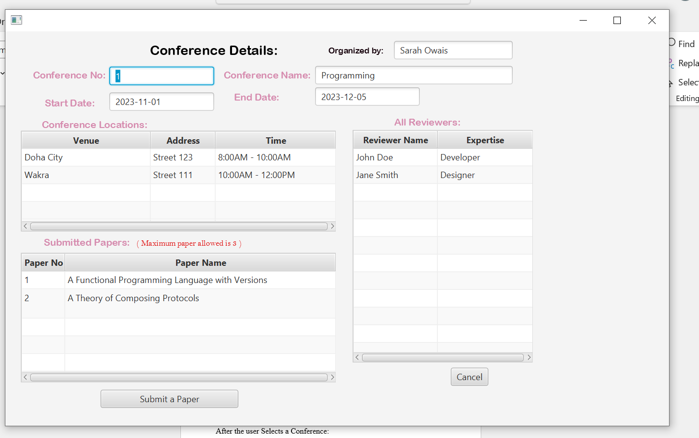

Press One of the Papers Submitted:

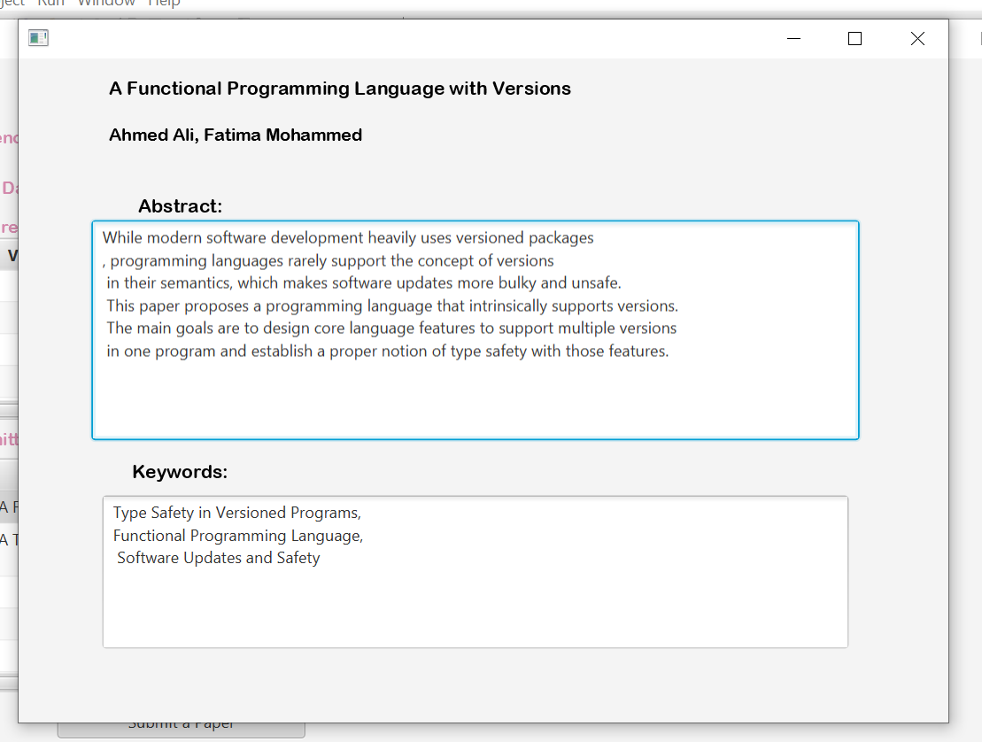

Press Submit Paper:

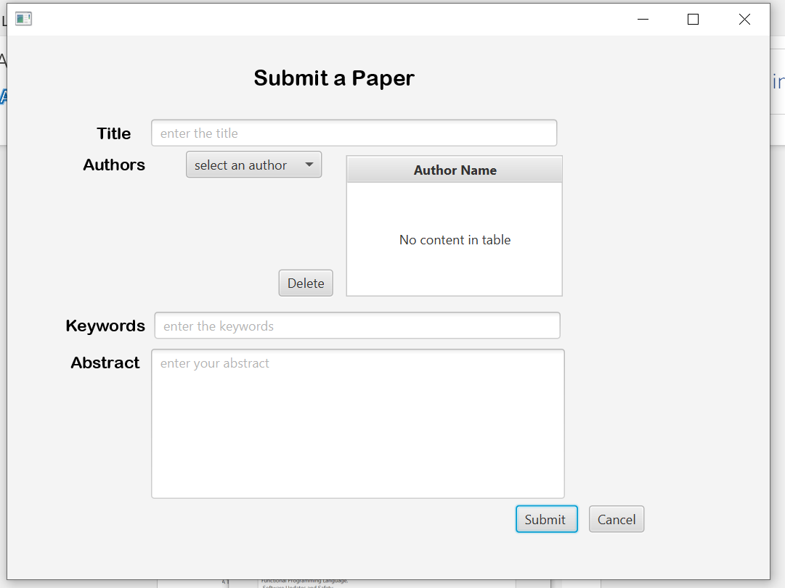

If not filled

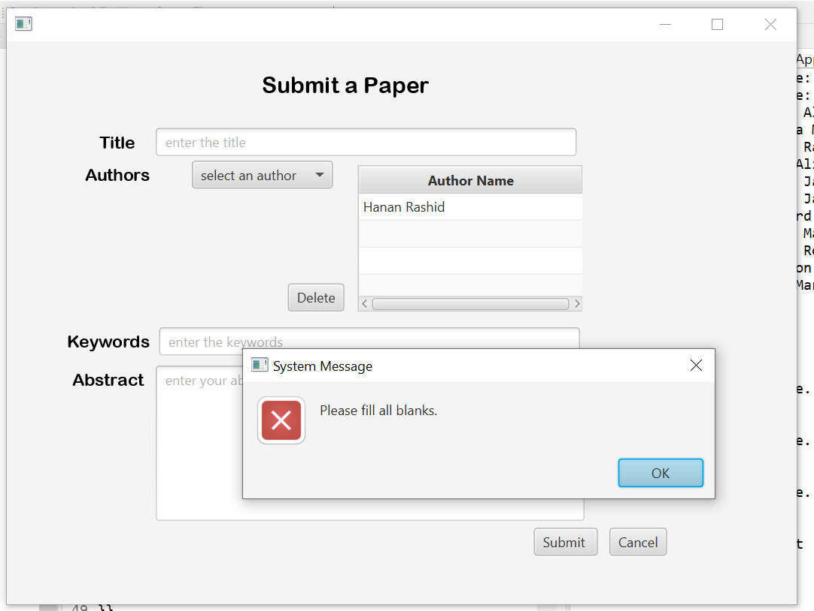

Deleted an author from choosen list

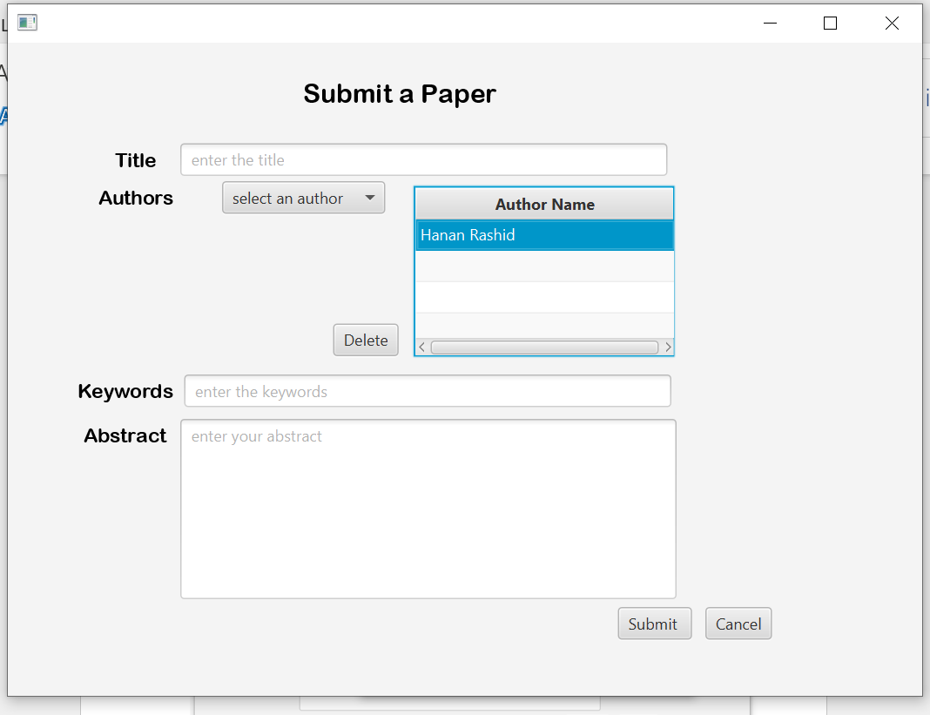

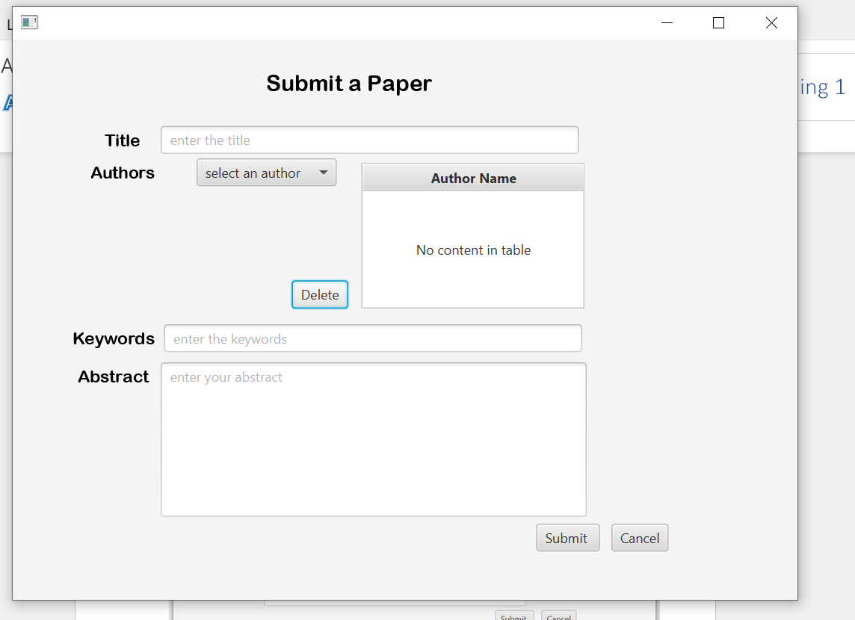

If Author not selected

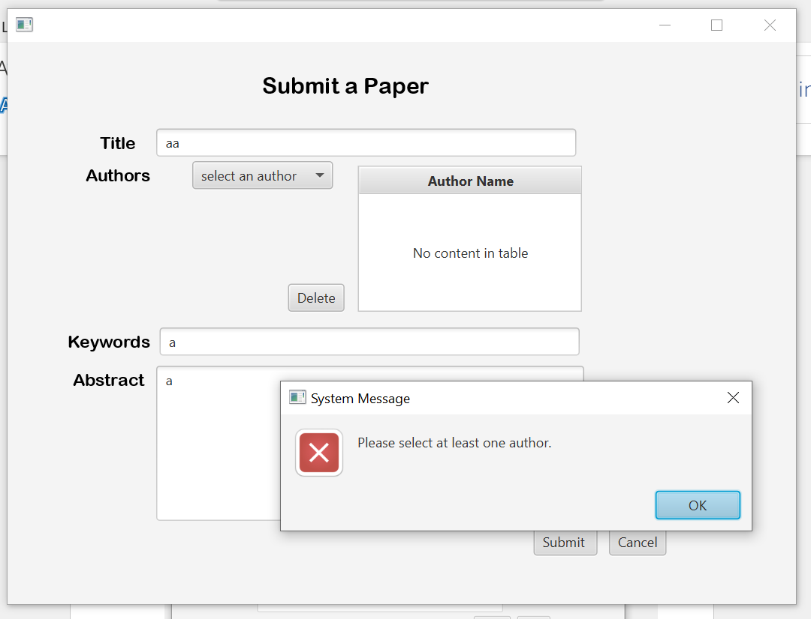

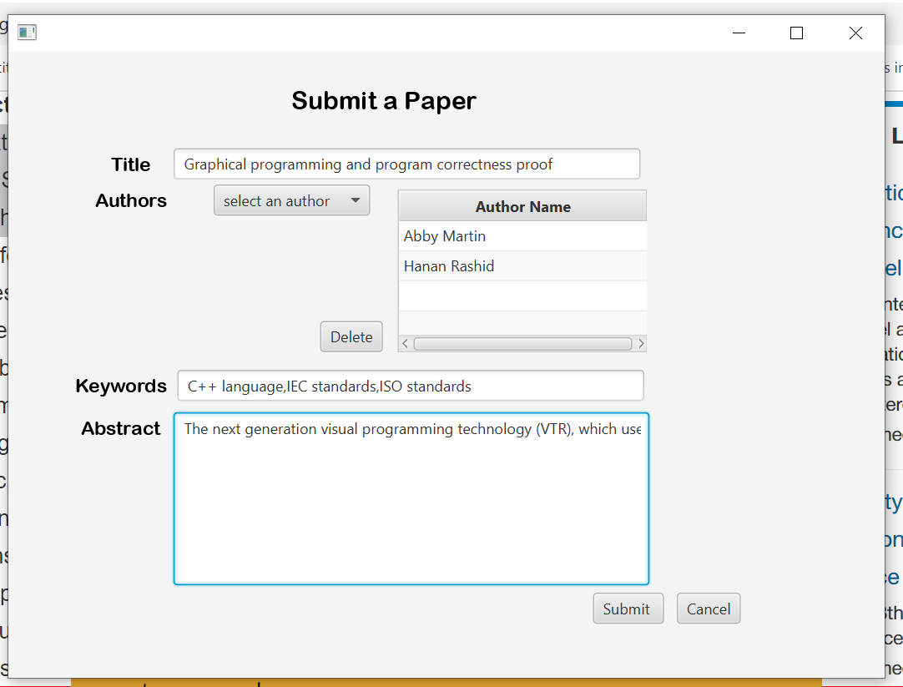

As Shown Before That total papers in all conference were 7 and adding this new Paper, system Assigned a Unique Paper no.

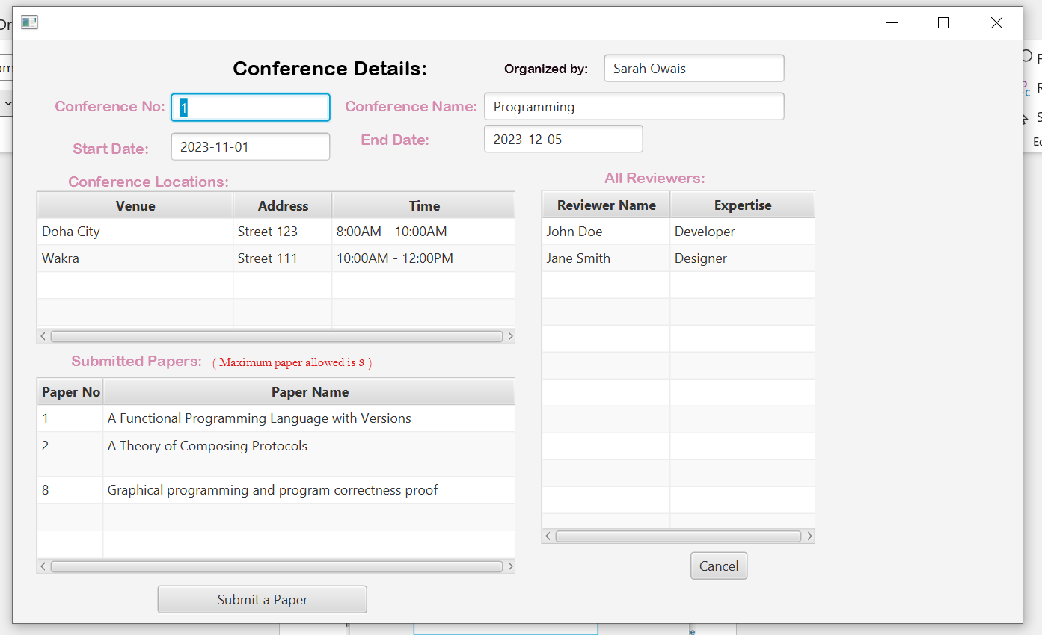

Cancel:

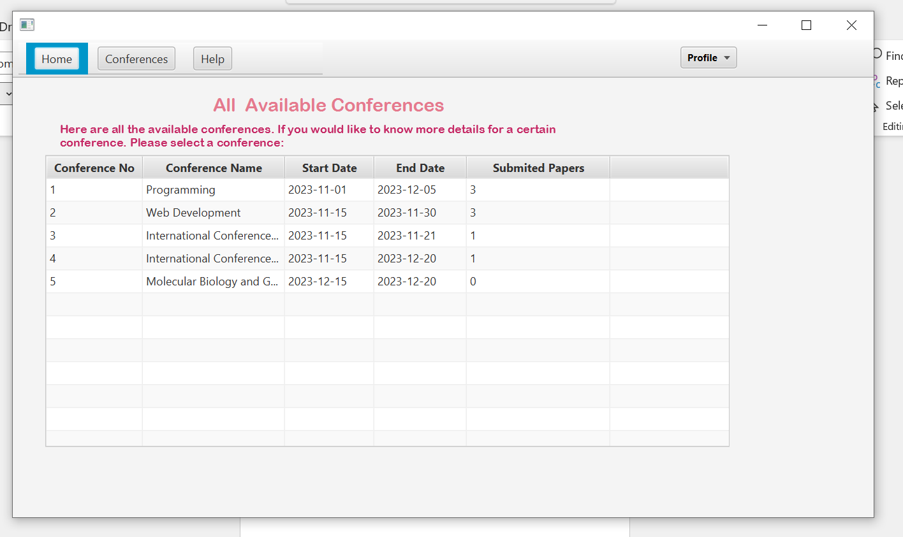

Check Profile: Added New Paper is Updated under the Author.

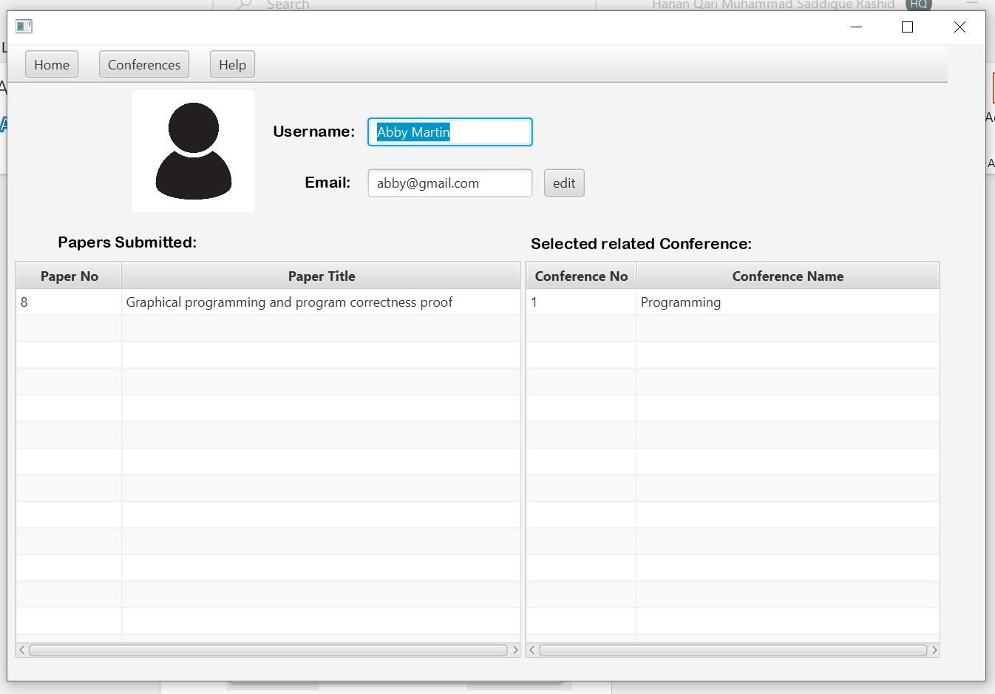

Conference: and Help

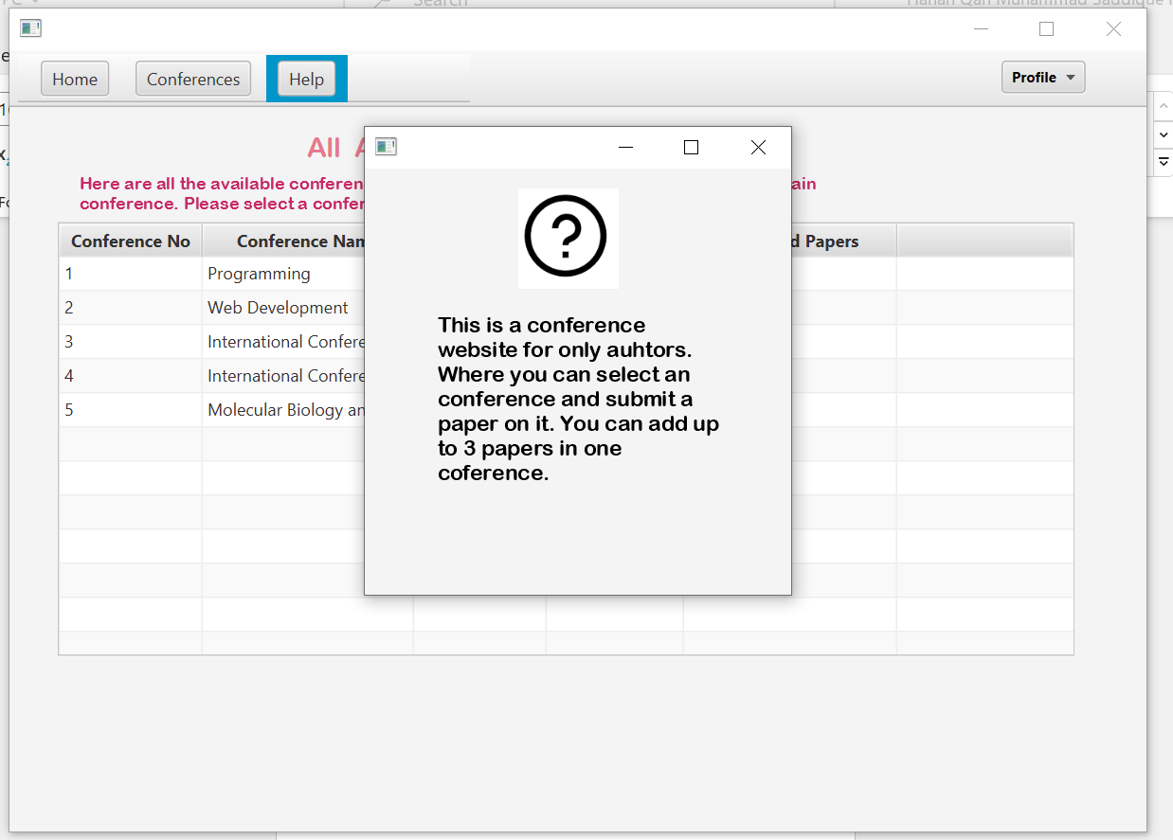

Also after submitting no of Submitted Paper is changed from 2 to 3.



Press Again First Conference And try adding a paper:

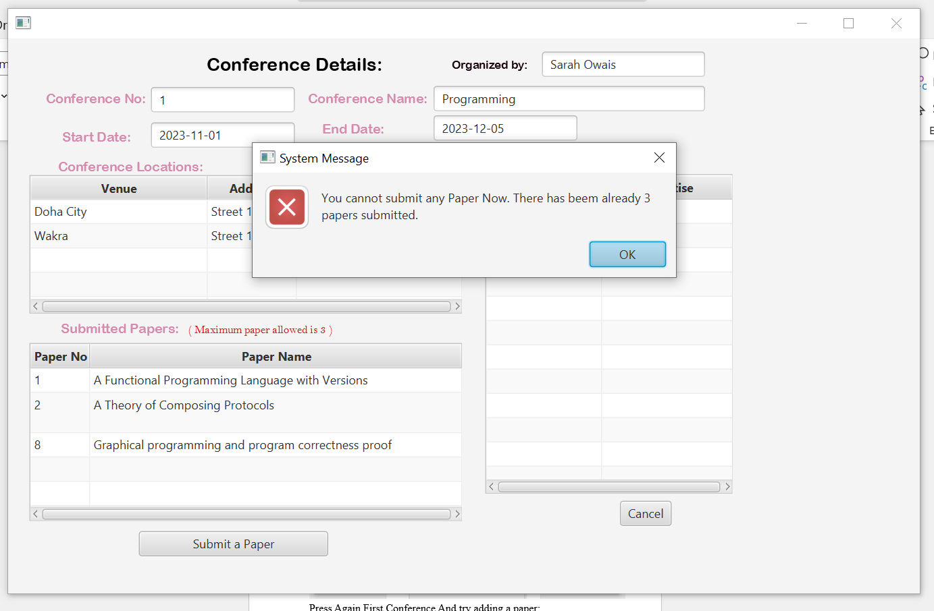

Choose Conference Where Due date is over and try submitting:

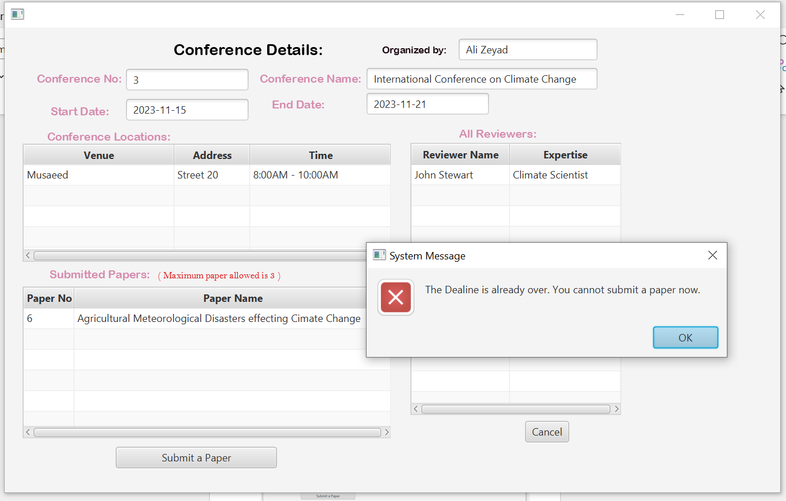

Choose Conference where Start date has not started yet:

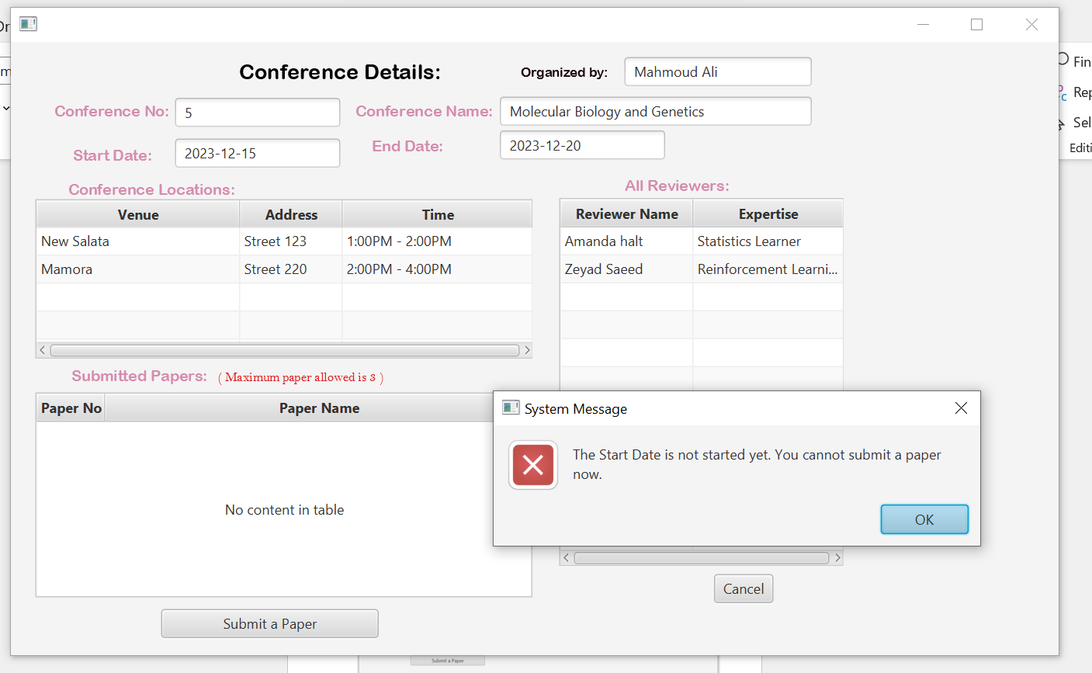

Home:



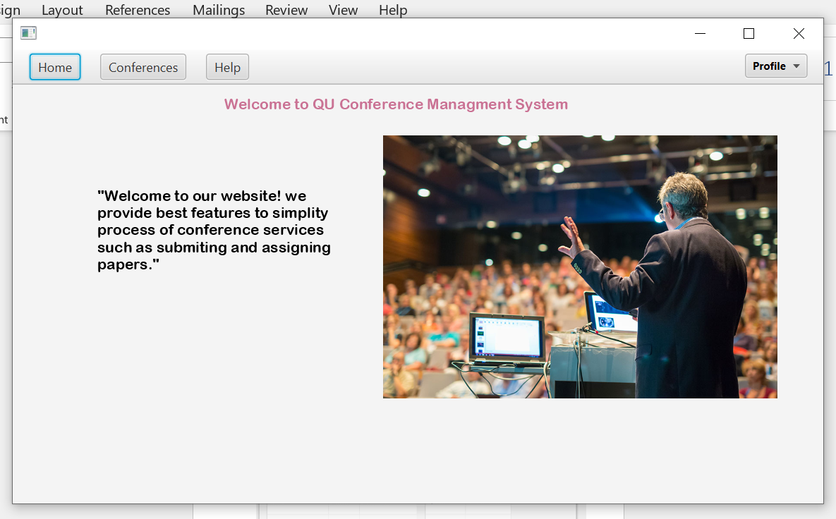

Logout:

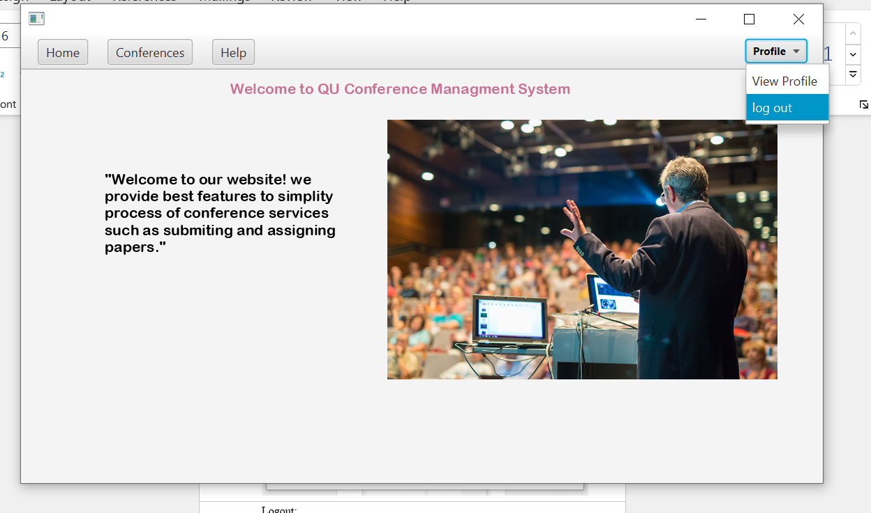

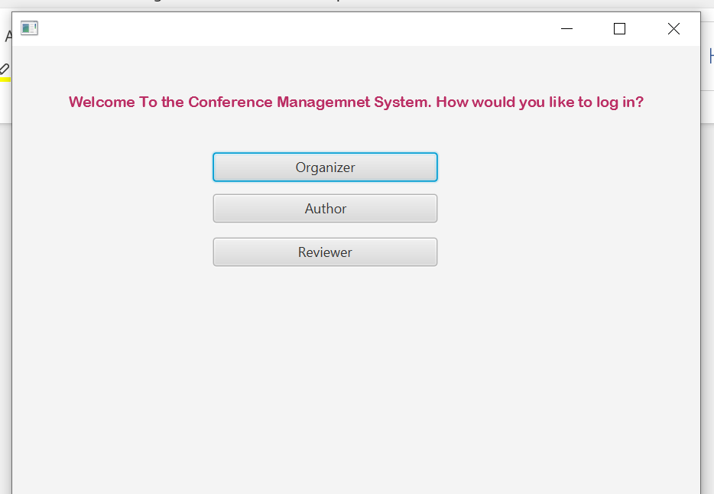

Enter as Hanan Rashid As Abby Martin Submitted Paper under herself and Hanan Rashid: Paper NO 8 is added and updated under her. And Shows the corresponding Conference to it.

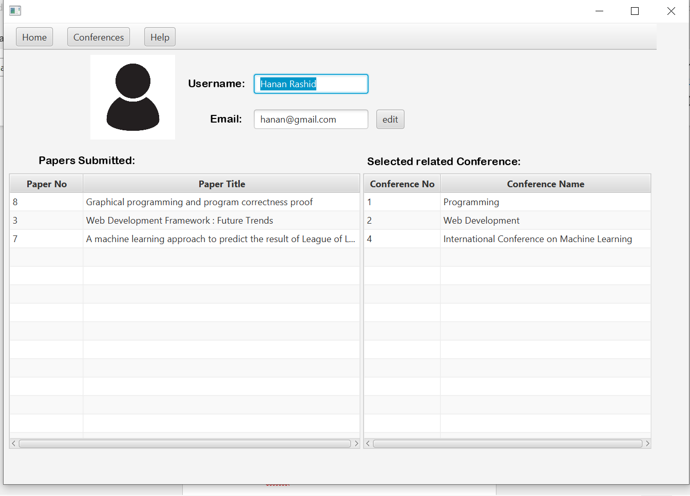

Select One of Papers:

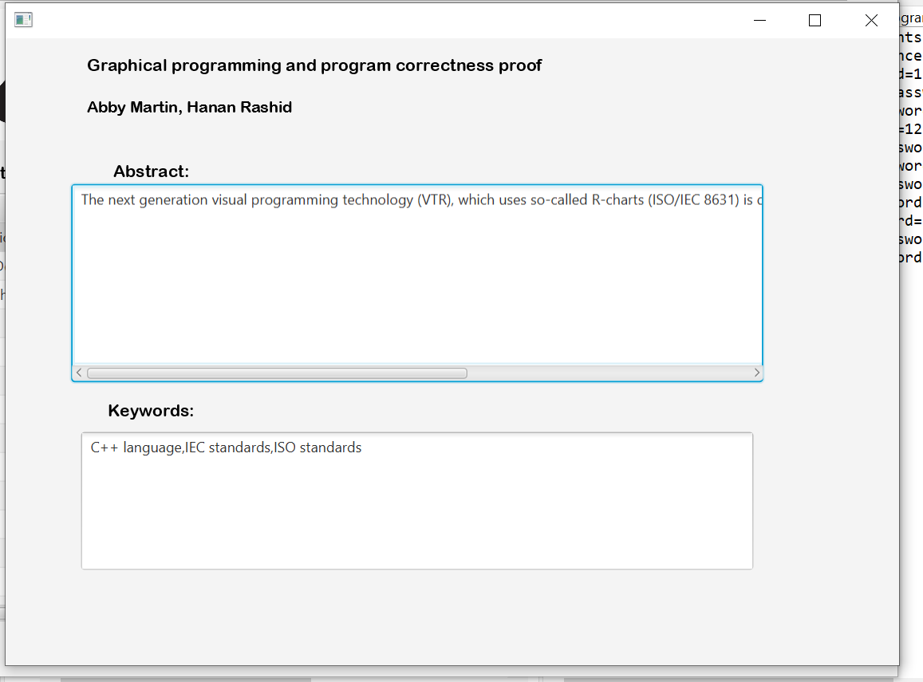

Select one of conference:

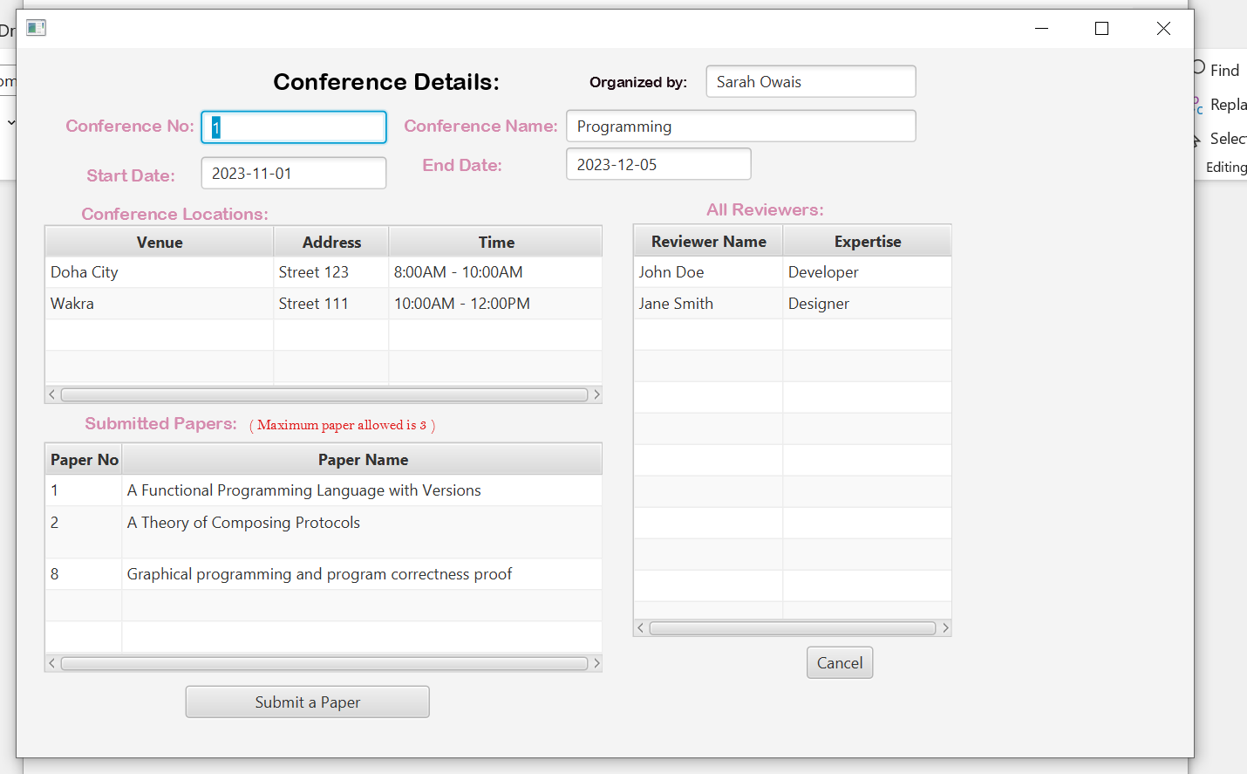

After Closing The whole CMS system and Running it Again.

Check if the author and the papers it submitted were saved.

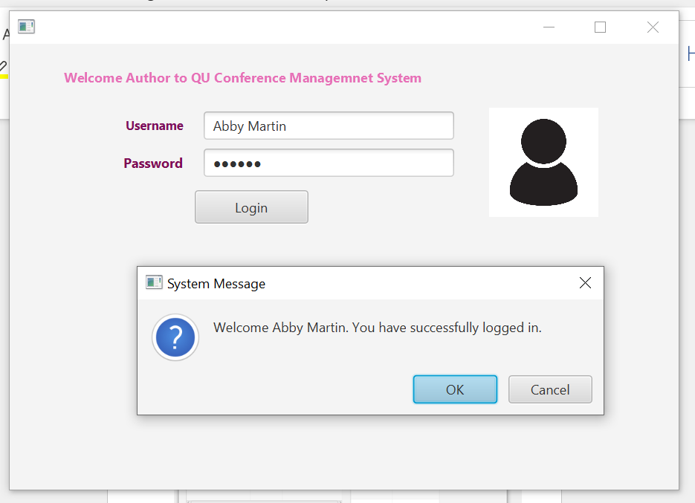

Check the Paper It Submitted Prior:

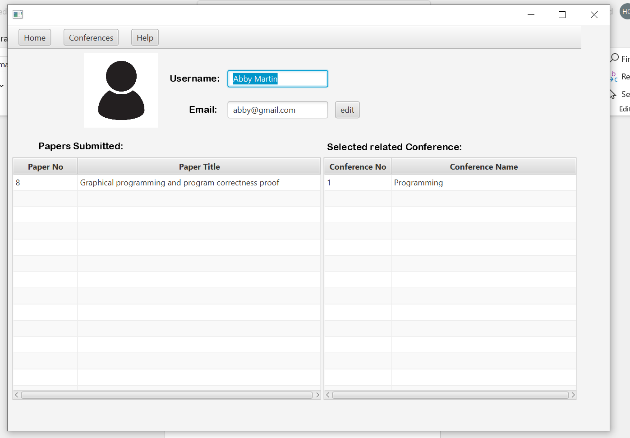

* Part 4: Testing

