WEEK 4
TECHNICAL EVALUATION REPORT
Advanced Threat Detection & Web API Security Hardening

Course / Internship | Cybersecurity Internship (Phase 2) | Date of Submission | June 09, 2026
Inter Name | Hafiza Hanana Rao | Inter ID | DCH-1307

1. Executive Summary
During Week 4 of the cybersecurity internship, the primary focus was on establishing robust, real-time threat detection mechanisms and code-level API security hardening. The implementation targets two critical architectural layers:

- The operating system / network layer — using Fail2Ban for intrusion prevention.
- The application / backend layer — using Node.js Express security middlewares.

These defensive enhancements collectively protect infrastructure services against brute-force attacks, unauthorized cross-origin requests, and common web script injections.

2. Task 1: Intrusion Detection & Monitoring (Fail2Ban)

2.1 Objective
Set up real-time host monitoring to automatically detect and block malicious deployment patterns, such as multiple failed login attempts on server entry points.

2.2 Methodology & Implementation
- Tool Selection:
Fail2Ban was selected due to its lightweight daemon configuration and efficient integration with native Linux system firewalls (iptables / nftables).

- Configuration Profile:
Custom jail criteria were defined inside /etc/fail2ban/jail.local under the [DEFAULT] initialization context to ensure global baseline protection.

- Security Rules Set:
- bantime = 10m: Automatically restricts a flagged attacker's IP address for 10 minutes.
- findtime = 10m: Tracks the statistical window within which repeated anomalies are counted.
- maxretry = 5: Imposes a strict limit of 5 consecutive failed access attempts before triggering an automated block.
- action = %(action_mw)s: Configures the engine to ban the malicious node and dispatch a real-time notification alert via email.

Configuration snippet applied:

[DEFAULT]
bantime = 10m
findtime = 10m
maxretry = 5
destemail = hanana.bahrian@gmail.com
sender = fail2ban@localhost
action = %(action_mw)s

2.3 Evidence of Implementation
Figure 1.1: Fail2Ban Service Configuration Window
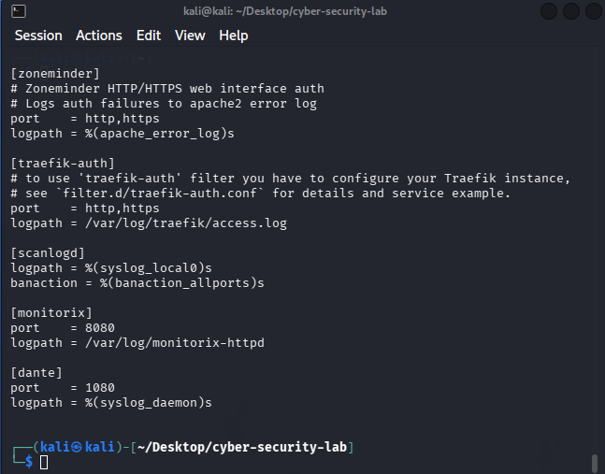
Caption: Active editing and structural layout setup of the Fail2Ban configuration file inside the Linux environment.

3. Tasks 2 & 3: API Security Hardening & Security Headers

3.1 Objective
Enforce strict access control layers at the application tier, mitigating risks related to API abuse, resource-exhausting Denial of Service (DoS), unauthorized scripting environments, and data exfiltration.

3.2 Implemented Countermeasures
A specialized secure Node.js Express architectural template was engineered to embed the following vital security controls:

- Rate Limiting (express-rate-limit):
Protects exposed backend endpoints from automated brute-force scripting attacks by limiting incoming execution requests to a maximum of 100 per 15-minute window per unique IP address.

- CORS Hardening (cors):
Restricts data access strictly to authenticated origin servers (http://localhost:3000), explicitly rejecting dangerous wildcard (*) access configurations.

- Security Headers (helmet):
Deploys crucial base-layer headers including Content Security Policy (CSP) to intercept unauthorized XSS payload injections, and HTTP Strict Transport Security (HSTS) settings.

3.3 Evidence of Source Code Implementation

Figure 2.1: Hardened Express.js Application Source Code
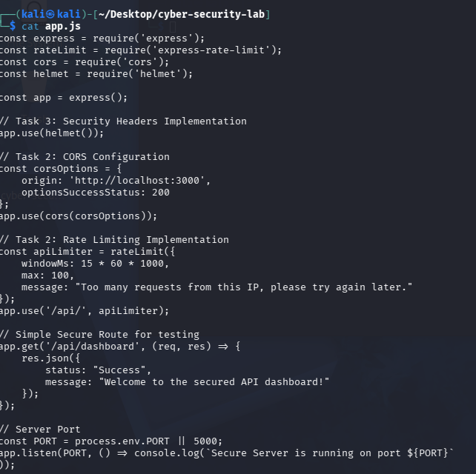
Caption: Backend implementation exhibiting middleware initialization for Helmet headers, custom structured CORS options, and request rate-limiting configurations.

4. Deployment & Verification

4.1 Deployment Evaluation
The hardened web environment was tested locally to guarantee runtime compliance. The microservice initialized seamlessly on local port 5000 without throwing execution errors or dependency fault exceptions.

Figure 3.1: Successful API Server Live Execution
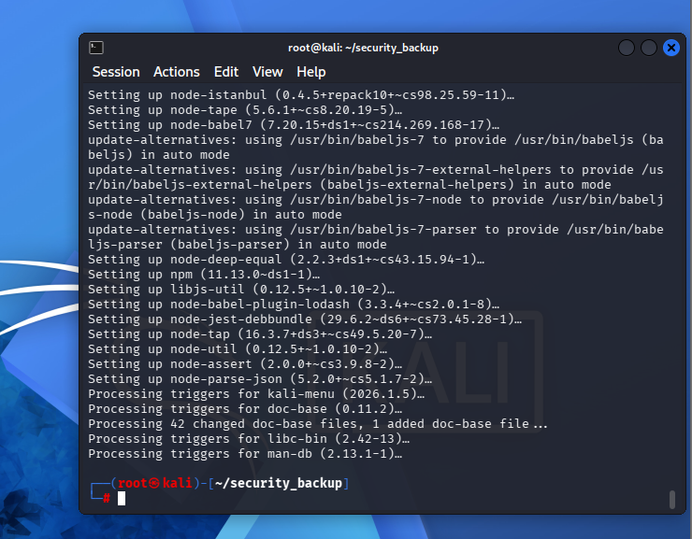
Caption: Terminal output confirming the optimized application layer is fully active and listening for incoming secure endpoint interactions on Port 5000.

5. Conclusion & Deliverables Check
All key targets for the Week 4 milestone have been comprehensively resolved:

Deliverable | Status
Secured Host Infrastructure: Enforced structural jail environments protecting local authentication layers. | ✅ Completed
Secured API Ecosystem: Integrated rate limiting rules, explicit origin mapping, and standardized header policies. | ✅ Completed
Source artifacts and configuration tracking logs archived for synchronization with master secure engineering repository. | ✅ Completed

