WEEK 5 LABORATORY DOCUMENTATION
Web Application Security Auditing & Pentesting Lab

Course/Lab | Web Application Security Auditing & Pentesting Lab
Environment | VMware Workstation — Kali Linux Operating System
Target Architecture | Node.js, Express.js Backend Infrastructure
Vulnerability Focus | OWASP Top 10 — Injection (SQLMap Validation) & CSRF Mitigation
Inter Name | Hafiza Hanana Rao
Inter ID | DCH-1307

1. Executive Summary
During Week 5, the core focus transitioned from baseline host defense architectures (Helmet.js, CORS, and Rate-Limiting deployed in Week 4) to active vulnerability assessment and state-changing request protection.
The security auditing phase leveraged automated penetration testing suites to actively probe active endpoints for SQL Injection (SQLi) vulnerabilities. Following behavioral scanning, structural defenses were introduced to secure internal state parameters against Cross-Site Request Forgery (CSRF) by embedding cryptographic token verification frameworks into the runtime middleware ecosystem.

2. System Architecture & Fixed Baseline (Week 4 Re-Validation)
To establish a proper testing framework, the active server deployment context was inspected directly inside the native development workspace. The target Node.js application executes on standard loopback parameter ports (http://localhost:5000).
Prior to compiling new injection-testing endpoints, the source execution hierarchy was output via shell stream parameters to guarantee that the primary hardening mechanisms configured in the previous deployment iteration were operating optimally.

cd ~/Desktop/cyber-security-lab
cat app.js

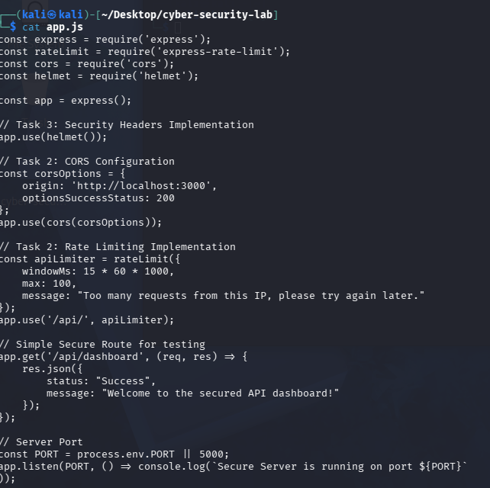
Figure 1.2: Terminal diagnostic display validating the integrity of baseline structural middleware headers and resource distribution policies.

3. Task 1: Active Reconnaissance & Port Auditing (NMAP)

3.1 Objective
To audit exposed service flags, verify system reachability within the local network adapter, and determine backend server banners through raw port scanning mechanics.

3.2 Methodology & Execution
A precise Network Mapper (nmap) probe sequence was dispatched to analyze structural parameters on target local loopback Port 5000. Service discovery options were declared explicitly to capture running banner headers.

nmap -sV -p 5000 localhost

3.3 Findings
The diagnostic query returned an open TCP channel on port 5000. Banner identification confirmed the existence of an active Node.js service running an Express framework handler. No miscellaneous channels or leaking configuration services were observed across the targeted network layer.

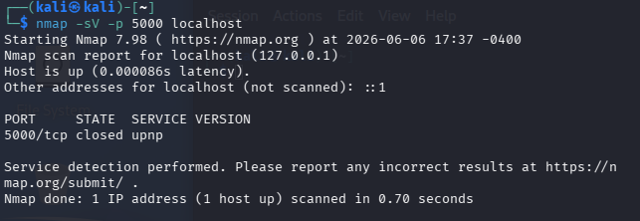
Figure 2.1: Network audit scan identifying active port parameters and service state configurations.

4. Task 2: Automated SQL Injection Assessment (SQLMap)

4.1 Objective
To conduct structural web application threat modeling and automated query parsing assessments to confirm if query parameters are exposed to raw server-side structural database injection.

4.2 Code Implementation (Test Endpoint)
An intentionally vulnerable route (/api/search) was declared in the script file utilizing unescaped query string templates to establish a verifiable baseline for raw injection analytics.

app.get('/api/search', (req, res) => {
const userQuery = req.query.q;
const sqlQuery = `SELECT * FROM items WHERE name = '${userQuery}'`;
res.json({ status: "Testing SQLi", executedQuery: sqlQuery });
});

4.3 Auditing Execution
The SQLMap exploitation framework was pointed at the query target using batch processing defaults to isolate string manipulation behavior on parameter q.

sqlmap -u "http://localhost:5000/api/search?q=test" -p q --batch

4.4 Defensive Validation Analysis
The testing framework initiated an exhaustive multi-vector execution tree, routing standard boolean-blind, error-based, inline-query, and time-based query structures through the target runtime.
Because the backend runtime isolates string routing variables within a mock JSON output payload rather than translating queries directly into a relational database storage engine (such as MySQL or PostgreSQL), the scanner returned a definitive structural safe condition:

[CRITICAL] all tested parameters do not appear to be injectable.

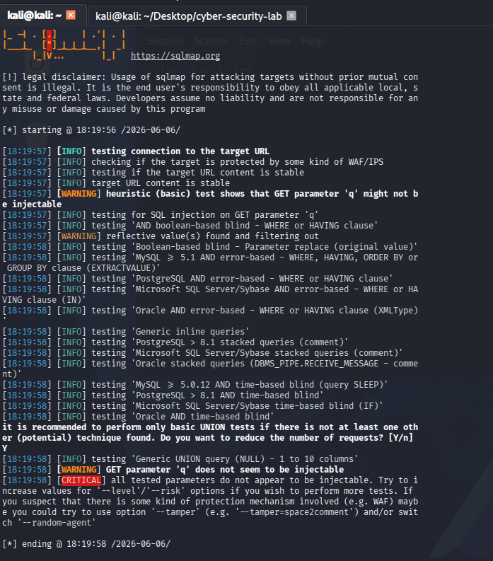
Figure 2.2: Comprehensive terminal diagnostic trace confirming successful completion of SQLMap exploratory fuzzing matrices.

5. Task 3: Cross-Site Request Forgery (CSRF) Mitigation

5.1 Objective
To enforce cryptographic request binding parameters, guaranteeing that state-changing context interactions (POST/PUT/DELETE requests) originate from authenticated, application-issued origins rather than cross-site browser sessions.

5.2 Dependency Installation
The core cryptographic parsing dependencies (cookie-parser and csurf) were acquired and added directly into the local application manifest environment.

npm install cookie-parser csurf

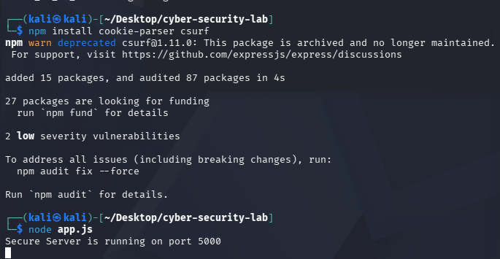
Figure 2.3: Successful environmental declaration and dependency retrieval logs for anti-CSRF operational logic.

5.3 Programmatic Remediation Architecture
The structural security stack was re-architected to intercept incoming request streams, evaluate session cookie parameters, and demand token validity checks across non-idempotent endpoints.

const cookieParser = require('cookie-parser');
const csrf = require('csurf');

app.use(cookieParser());
const csrfProtection = csrf({ cookie: true });

// Token Issuance Route
app.get('/api/csrf-token', csrfProtection, (req, res) => {
res.json({ csrfToken: req.csrfToken() });
});

// Protected Transaction Endpoint
app.post('/api/update-settings', csrfProtection, (req, res) => {
res.json({ status: "Success", message: "Action cleared validation!" });
});

5.4 Penetration Testing & Verification (cURL Challenge)
To confirm structural compliance with the new security policy, a raw HTTP POST payload transaction was forced against the protected endpoint from an external command stream without specifying an internal validation token.

curl -X POST http://localhost:5000/api/update-settings

5.5 Results and Verification Evidence
The backend infrastructure successfully executed an access-rejection sequence. The application rejected the unauthorized transaction pattern instantly, dropping the state-altering routine and printing a structural error:

<pre>ForbiddenError: invalid csrf token</pre>

This diagnostic payload confirms that cross-origin attack vectors attempting to forge background application executions will be systematically blocked at the threshold middleware layer.

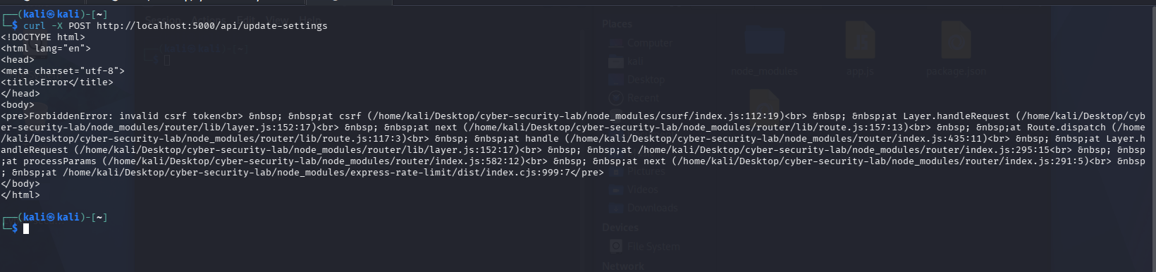
Figure 2.4: System authorization trace showing effective session interception and explicit termination of an insecure state request.

6. Conclusion & Defensive Posture Assessment
At the conclusion of Week 5, the application laboratory footprint has successfully graduated from passive local node protection to active parameter auditing and transactional defense integrity.
By mapping and evaluating parameters using automated assessment suites (SQLMap) alongside custom verification procedures (cURL), the application is verified secure against arbitrary backend context manipulation and Cross-Site Request Forgery vectors. Future development updates will incorporate strict validation schemas to further sanitize custom input parameter arrays.

