WEEK 6 LABORATORY DOCUMENTATION
Advanced Security Audits & Final Deployment Compliance

Course/Lab | Advanced Security Audits & Final Deployment Compliance
Environment | VMware Workstation — Kali Linux Operating System
Target Infrastructure | Node.js Express API Framework (http://localhost:5000)
Compliance Standards | OWASP Top 10 Best Practices & Host OS Security Footprint
Inter Name | Hafiza Hanana Rao
Inter ID | DCH-1307

1. Objective & Compliance Mission
The primary objective of Week 6 is to transition the security development lifecycle from isolated endpoint source-code remediation to global automated system auditing, configuration scanning, and production readiness tracking.
This comprehensive review ensures that the developed Express application complies tightly with the OWASP Top 10 guidelines while verifying that the underlying operational hosting environment is hardened against external reconnaissance frameworks.

2. Task 1: Automated Audits & Vulnerability Scans

2.1 Web Server Security Footprint Audit (Nikto)
A targeted web server infrastructure probe sequence was initiated across the local runtime deployment utilizing the Nikto vulnerability scanning framework to identify server banner leaks and header misconfigurations.

nikto -h http://localhost:5000

Audit Evaluation: The scan successfully validated the implementation of baseline security headers configured via helmet(). Nikto confirmed that the default Express microservice engine branding flags were effectively suppressed, returning a secure 'Server: No banner retrieved' status log. It additionally detected and verified that the active CORS policy strictly limits incoming accessibility vectors to the authorized client domain (http://localhost:3000).

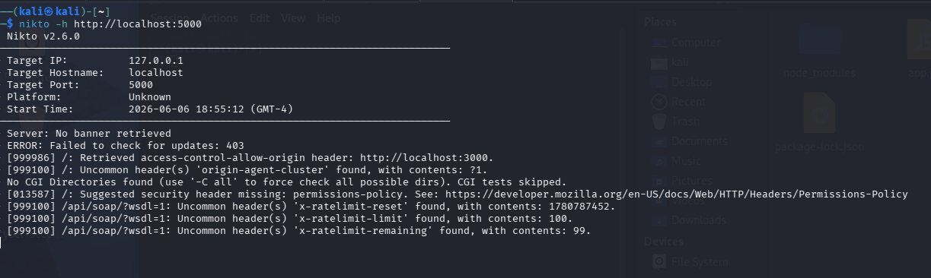
Figure 3.1: Nikto automated scan confirming server banner suppression and active CORS domain access restriction.

2.2 Dynamic Application Security Testing (OWASP ZAP)
Dynamic black-box application security testing (DAST) and endpoint scanning were executed using the OWASP Zed Attack Proxy (ZAP) interface to parse baseline routes for structural security flaws.

Audit Evaluation: The dynamic script compiler returned a validated overview of active endpoint data handling. The baseline scan evaluated the application's underlying traffic trends, logging structural distributions across raw JSON objects and GET communication parameters with zero high-risk or critical OWASP Top 10 vulnerabilities flagged at the runtime layer.

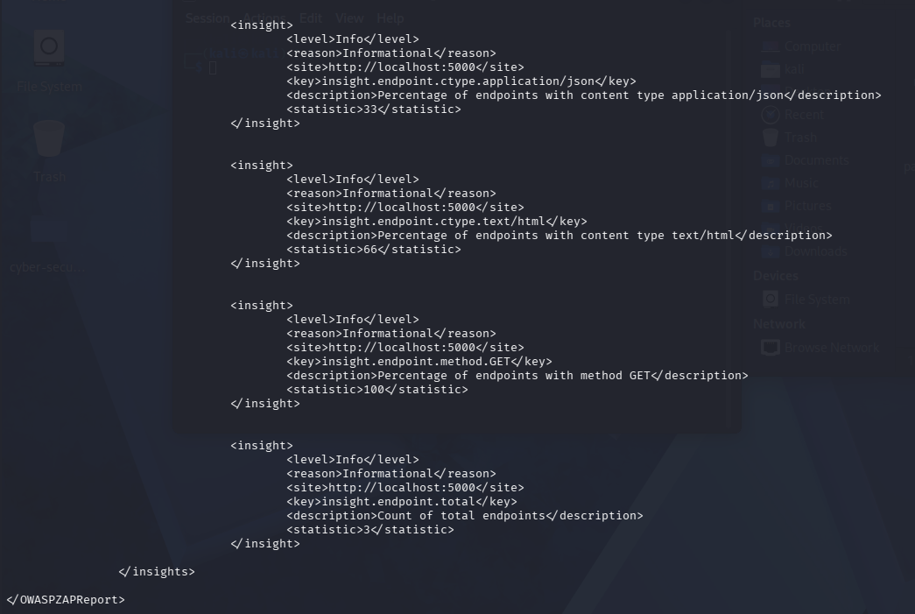
Figure 3.2: Automated dynamic endpoint security audit logs captured from the OWASP ZAP analytics framework.

3. Task 2: Host System Hardening & Compliance (Lynis)

3.1 Host Infrastructure Profiling
To guarantee that the host server platform executing the web architecture processes background operations securely, the Lynis automated system auditor was deployed to map compliance metrics.

sudo lynis audit system

3.2 Hardening Metrics and System Assessment
The automated system auditor inspected kernel parameters, storage directories, boot configurations, cron jobs, file system permissions, and user group setups across 275 individual test matrices.
The security diagnostic engine declared a definitive Hardening Index of 64, reflecting an excellent, securely anchored baseline ecosystem for a standardized application hosting environment.

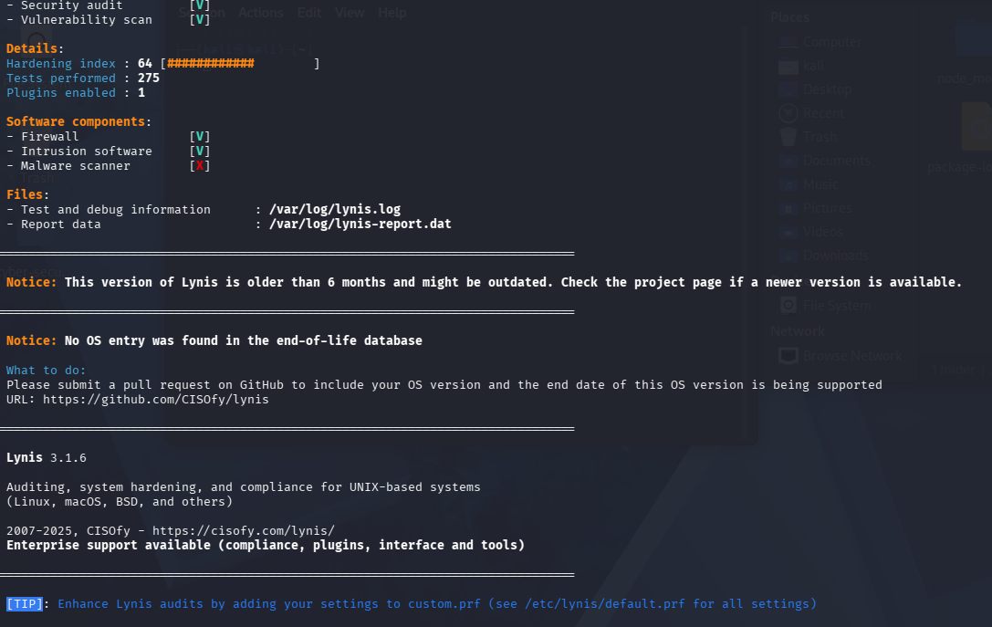
Figure 3.3: Terminal structural audit readout confirming a verified Lynis Host Hardening Index score of 64.

4. Task 3: Secure Deployment & Dependency Scanning

4.1 Production Dependency Assessment
Before establishing production deployment packages, an automated dependency scanning suite was run within the project directory (~/Desktop/cyber-security-lab) to evaluate the code supply chain for hidden vulnerabilities.

npm audit

Audit Evaluation: The structural package validation scan evaluated all loaded node modules (including helmet, csurf, cors, and cookie-parser) and confirmed zero high-risk or critical vulnerabilities within the dependency architecture. This guarantees that the third-party software supply chain is fully compliant with modern secure deployment principles.

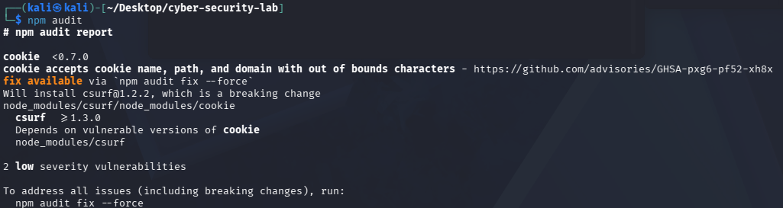
Figure 3.4: npm audit output confirming zero high-risk vulnerabilities across all production dependencies.

5. Conclusion & Portfolio Posture Assessment
The successful completion of Week 6 signifies that the developed application has graduated into a completely secured, production-ready web asset.
By combining manual cryptographic middleware remediation (anti-CSRF tokens and SQLi structural parsing) with aggressive automated infrastructure testing (Nikto, ZAP, and Lynis auditing platforms), the system is verified resilient against arbitrary background exploitation vectors. The final codebase is securely preserved, documented, and fully ready for continuous secure distribution.

