

**Cairo University**

**Faculty of Engineering**

|  |  |
| --- | --- |
| ***Team Members:***  ***Name:* Ghadir Momen**  ***Name:* Hanna Nabil**  ***Name:* Mohamed Zidan** | ***Supervisor :***  **Dr. Tamer Basha**  ***Technical advisor:*** |



**1. Abstract**

**Problem description:**

Hearing impairment is one of the commonest birth defects. Its impact on the individual and society is too significant to neglect. Development of hearing loss leads to severe handicap that affects the sufferer’s job, home and life with subsequent social and economic burden on the society. In children the problem is compounded since normal hearing is the primary source for acquisition of language, speech and cognitive skills.

Since this type of impairment is very impactful and quite common in our country, it called for our responsiveness to this noteworthy problem.

### **Proposed solution and impact:**

An adjustble digital hearing aid that allows the dynamic change of its amplification by the user. It will be less costly than an analogue prefixed hearing aid that requires repeated hardware changes to adapt with the patient’s varying state.

Thus, providing a long term solution which does not need continuous calibration or many doctor visits, because the patient can adjust it anytime anywhere.

**Our product consists of two separate products:**

First product: a mobile app that helps hearing impaired persons to amplify the frequencies they don’t hear well by the help of a smart phone and a neat Bluetooth headset.

Second product: a complete standalone headset (hardware) that works as a digital hearing aid, which is adjustable by the mobile app via Bluetooth.

With the help of our academic supervisor and technical advisors, we now have a working prototype of the proposed system.

1. **Table of Contents**

1 Cover Page 1

2 Abstract 2

3 Abreviations and Terms _

4 Table of Contents 3

5 Introduction 4

6 Background Research and Realted Work 6

2.1 History and State-of-the-Art 6

2.2 Industry and Market Analysis 6

2.3 Proposal Objectives 6

2.4 Marketing Strategy 6

7 Novelty 6

8 Methodology 7

4.1 The Starting Point: [Select Idea/Proof-of-Concept/Prototype] 7

4.2 Technical Methods/Approaches 7

4.3 Work Packages and Reporting Scheme 7

9 High Level architecture of the system 7

10 Resources 8

11 Test and Results 8

12 Product Features 8

13 Practical Deployment 5

14 Value 5

15 Conclusion 5

16 References 5

1. **Introduction**

The most basic function of a hearing aid is to amplify sound. Digital hearing aids do this in a rather sophisticated way. As sound enters the device, it is broken into multiple frequency bands. Each band is then amplified by the amount necessary to return the wearer's hearing to normal levels at that band.

With digital technology, devices can now break sound into as many as 24 different bands. Given that every person has a unique pattern of hearing loss, the sound quality provided by a modern hearing aid is far better the previous analogue technologies that were restricted to two bands - base (low frequencies) and treble (high frequencies).

**Problem description:**

Hearing impairment is one of the commonest birth defects. It is the third leading chronic disability affecting nearly 250 million people in the world, and 75% of sufferers live in developing countries.

The impact of hearing impairment on the individual and society is significant. Development of hearing loss leads to severe handicap that affects the sufferer’s job, home and life with subsequent social and economic burden on the society. In children the problem is compounded since normal hearing is the primary source for acquisition of language, speech and cognitive skills.

In a national household survey conducted to estimate the prevalence of hearing impairment in Egypt, it was found to be high in those aged 0-4 years (22.4%).

**Why hasn't it been solved before?**

The oldest defect in the analog solution which is the only available in our country is that it’s not adaptive as it increase the gain of the whole sound signal not the weak frequencies only as our product do , so that the hearing-impaired person can’t sense the amplification

**Key components of our approach and results?**

Connectivity to mobile devices and entertainment systems

Wearers are increasingly looking for solutions to improve their ability to use their hearing aids more effectively in partnership with their mobile phones, digital radio, plasma televisions, and personal stereos (i.e. iPods and MP3 players).

In response, manufacturers have developed streamers that connect wireless devices to the user's hearing aid.   
The benefit is that this delivers improved performance in terms of speech intelligibility and sound quality as signals from the external devices are streamed directly into the hearing aid, without background noise and the need for the hearing aid to first process a sound signal.

Multiple and automatic programming

Different listening environments often call for different settings within hearing aids in order to maximize their effectiveness.

For example, when listening to music, the user would prefer to turn off features that may misinterpret elements of the music as noise.

When in a quiet room, a wearer will not need the benefit directional microphones and noise reduction to the same extent they would in a crowd at the football.

Advanced hearing aids allow the user to change the settings by pressing a small button on the device. The most advanced hearing aids will even listen to the environment and change the hearing aids settings automatically, without the wearer needing to touch or think about their hearing aids.

**Academic Supervisor:** Dr. Tamer Basha ,Postdoctoral Research Fellow at Harvard Medical School , Project Manager at Crescentech Inc , Assistant Professor at Cairo University

The team has worked together on multiple projects providing us with the experience needed to handle significant work load and function as a unit.

Our technical members have worked on many related projects and have successfully delivered satisfying results.

We have an industrial partner: ServoMed, E-mail: servomed@servomed-co.com

Servomed is a premier surgical and medical equipment distributor that provides top quality & high-tech medical equipment of leading multinational suppliers to the medical professionals in Egypt and the Middle East region. It is operating in the Egyptian Market for more than 34 years with a very long and successful track record. Its office in Cairo has a State–Of–The–Art Service Center, advanced ERP System, well-geared Sales, Marketing and Post-Sale-Service Departments that proves it is the Partner-Of-Choice not only to us but also to the clients.

1. **Background Research and Related Work**

Latest Digital hearing aids are programmed to re-balance a wearers hearing.  As sound enters the hearing aid, it is broken into multiple frequency bands. Each band is then amplified by the amount necessary to return the wearer’s hearing to normal levels at that band.

We Have has three competitors:

* Hansaton:

Hansaton carries a full range of hearing solutions. They produce digital hearing aids with award-winning designs, with features such as feedback blocking, speech direction adjustment, and high fidelity sound listening capability.

* Phonak:

Phonak has a complete portfolio of hearing solutions for every age - infants to adults. Their product line begins with an affordable basic model that has key features such as feedback blocking and the ability to block background noise.

* Siemens:

Siemens has to stand-out series of hearing aids, the binax series, and the Aquaris hearing aid. The binax series of hearing aids has technology that two studies have shown enables the wearer to hear speech better in difficult background noise than a person with normal hearing is able to hear.

Similar products:

1. <https://www.starkey.com/hearing-aids>
2. <https://www.hearingtracker.com/hearing-aids/oticon-opn-bte13-pp-1>
3. <https://eargo.com/products-hearing-aids>

**Uniqueness**

Uniqueness of our main product lies in the fact that we will make Digital Hearing Aid available in Egypt, therefore enabling our people to use this technology at an affordable price.

1. **Methodology**

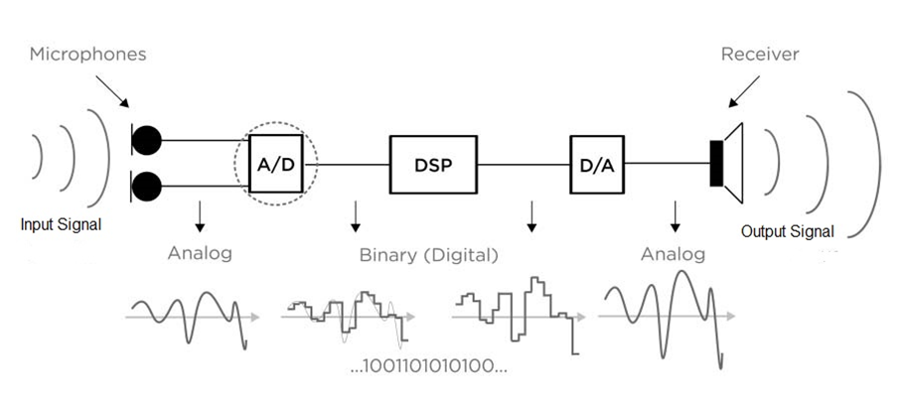

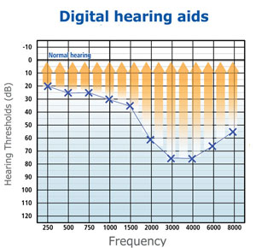The idea in its simplest form, we take an analog signal by a small condenser electret (or high capture) microphone

then pass this signal to our ADC (analog to digital converter )

then to our micro-processor in which the DSP (digital signal processing will take place ) in this stage we configure our signal to match the desired output , so we do that by amplifying some frequencies which are barely heard by the person and suppress some frequencies ,

after that the signal goes to be digitalize again through DAC (Digital to analog converter)

finally the output audio signal will be hopefully on the Bluetooth headset device like an ordinary any Bluetooth headset , except that we’ll have our Bluetooth headset will be optimized for our specific purpose

***Execution Plan***

First Product :

* Android Studio (Java and C++ libraries dependancies)
* Tested or resulted app on Injoo and Samsung core

Second Product:

* Used dsPic33FJ64GP802 as a Processor Unit for the DSP
* Used Electret Microphone for Capturing the Voice Signal
* Sound Signal Enter the dsPic through ADC Peripheral
* The signal then Sampled and Digitalized and here comes the role of DSP
* After DSP Takes place the Signal is then output on DAC Peripheral of the dsPic
* This Process is controlled over a standalone mobile app that control the dsPic through Bluetooth

Production Phase :

All we need is to combine all the components including:

1. High quality amplifiers
2. Microphones
3. Capacitors and resistors
4. Long-life Battery

Once we collect them all in a well-organized block diagram, we will send it to our contributors in China to start manufacturing our product with a user friendly design.

We will have another contributor to help us delivering our product in Egypt or any place in Africa.

Your fund will decide our start-up quantity from the product.

Proof of Concept:

We already have done our proof of concept as a Digital Hearing aid

[https://goo.gl/16J9Ba](https://goo.gl/16J9Ba%20) ==> This a video where we are demonstrating our proof of concept on a Raspberry-pi

Protyotype:

We have our own working protoype, and we are continuously working on improving its features and usability.

First product (mobile App): <https://goo.gl/yq1Fcj>

Second product (standalone system): <https://goo.gl/pwHGMf>

1. **High Level Architecture of the system**

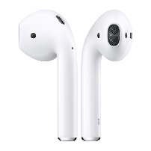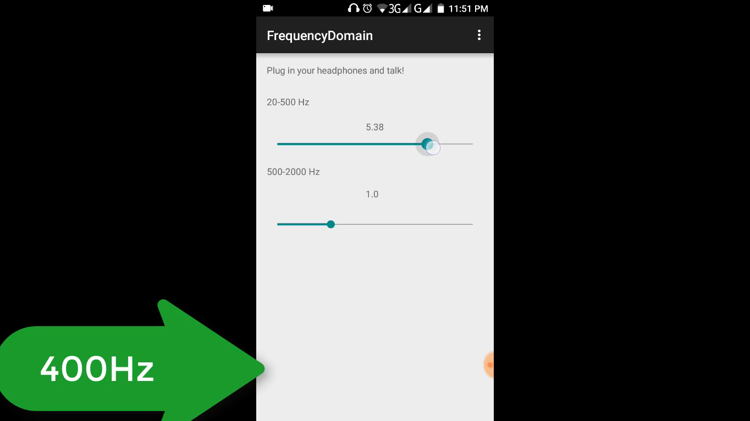**1-First Product**

Output signal via Bluetooth to

Mobile Phone Microphone

**2-Second Product**

Mobile DSP Processor

1. 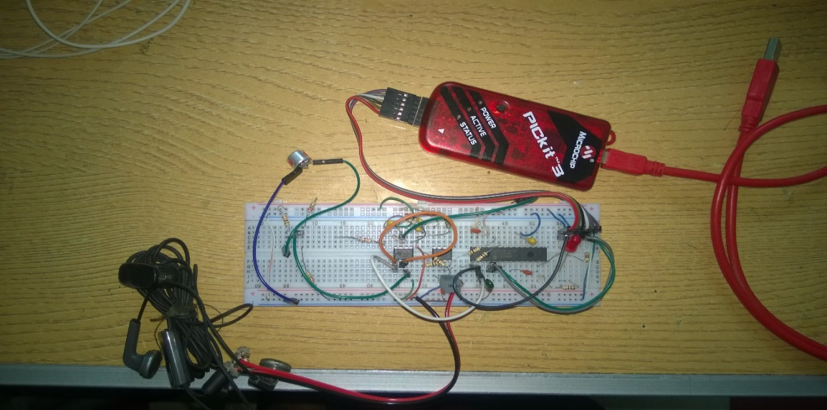**Resources**

Detailed description of features of the equipment that will be used in the project and justification for needing them may be given in this section. Distribution of these resources over the milestones may also be given. This section may be combined with other sections if the applicant sees it is better to do so.

The equipment will be:

First Product (Mobile App):

1. Any android Mobile
2. Wireless Bluetooth earphone

Second Product (standalone hearing Aid):

1. Electret Microphone: to get the voice from the surrounding environment (Micro strong Condenser)
2. DsPIC33F: where Digital Signal Processing happen
3. Capacitors and resistors
4. Wireless Bluetooth earphone
5. Long life battery

Once we collect them all in a well-organized block diagram, we will send it to our contributors in China to start manufacturing our product with a user friendly design.

We will have another contributor to help us delivering our product in Egypt or any place in Africa.

Your fund will decide our start-up quantity from the product.

1. **Test and Results**

Proof of concept on Raspberry-Pi: [https://goo.gl/16J9Ba](https://goo.gl/16J9Ba%20)

We have our own working prototype, and we are continuously working on improving its features.

First Product (Mobile App): <https://goo.gl/yq1Fcj>

Second Product (Standalone system): <https://goo.gl/pwHGMf>

1. **Product Features:**

|  |  |
| --- | --- |
| * Adaptable to user’s needs. * Affordable. * Ability to filter any surrounding noise.  1. **Practical Deployment** | * Maximization of the sound signals. * User friendly. * Portable small size. |

**Business canvas:**

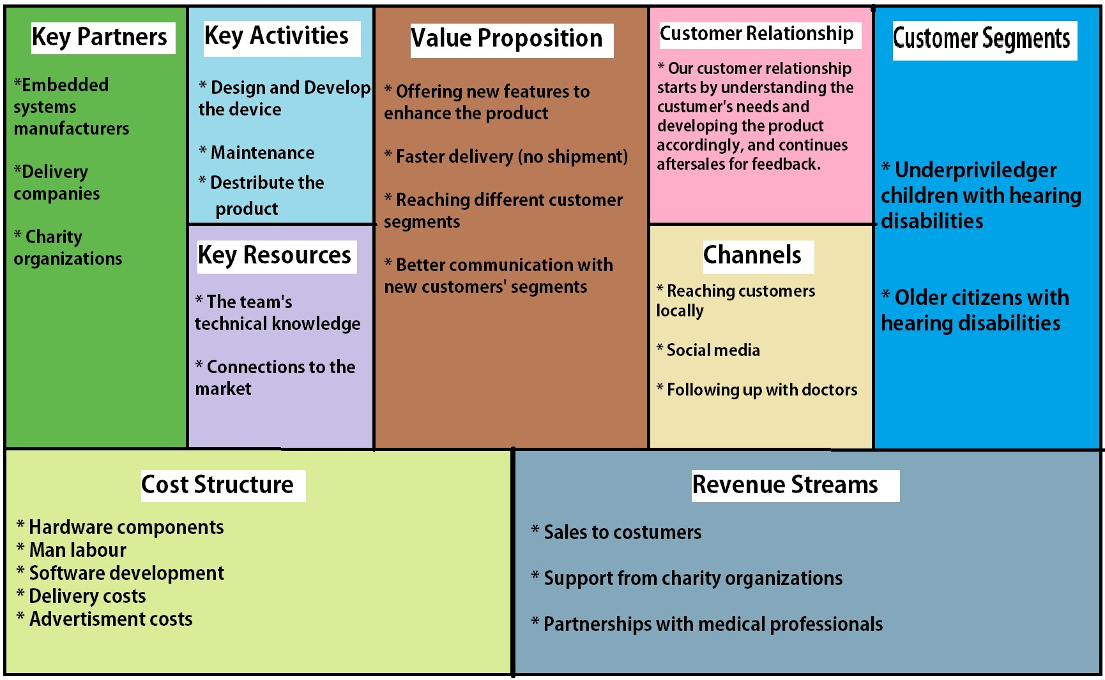

1: Business canvas

1. **Value**

***Our competitive advantage:***

1. *We provide a long term device which does not need continuous calibration or doctor visits, because the patient can adjust it anytime anywhere.*
2. *We offer the product at a much lower price. At 15 USD per piece the price is unmatched given that it does not need to be replaced to adjust for change in patient’s status.*
3. *We have no competitors within the Egyptian market, which would make us pioneers in this field in Egypt.*

**Marketing Strategy**

The outcomes will be unlimited as it will include:

1. Help people with hearing disabilities to have a cheap, high quality and save hearing aid
2. Enrich the Egyptian market with our unique product
3. As an impact in our society, our company will help in employing lots of young people and training them to gain more experience in that field
4. For researchers, we will be the pioneers in hearing aid in Egypt and that will open the space for more researchers to look for a better scientific solutions

Marketing plan:

We plan to reach our target market in two ways:

A – Using social networks, as many people use it these days it can reach anyone either directly or indirectly, i.e. people can recommend us to a customer or vice versa.

B – Via partnerships with charity organizations such as Resala, Misr El-Khair, … etc. Because they already have the manpower to scan many areas to reach potential customers

Quality matrix:

• Acceptable look and comfortable wear.

• Signal to noise ratio.

• Real time processing.

**Market Trends**

There will be a 2-4% yearly unit growth driven by demographic development. According to many researches, there is +10% of population in Egypt suffer from hearing disabilities (more than 3 million people), 35-40% of population aged +65 are hearing –impaired, and Just above 20% of the hearing impaired use a hearing aid.

The drivers for increased penetration are:

* Increasing age and gross domestic product (GDP).
* Next 65+ generation is wealthier.
* Developing markets are significantly underpenetrated.
* Ability to access to great distribution.

**Target market**

Our target market will be the people who are aged +30 as they represent more than 2 million people in Egypt.

1. **Conclusion:**

As you can see, we propose to provide a solution to a significant health problem affecting a large demographic of our society. Thus, achieving both profit and delivering a value to people’s lives as well as to society over all.

Why choose us? Because we are qualified engineers working on a product in our field, and we have the knowledge and passion to pursue this opportunity from start as far as it takes us.

We will be happy to receive your emails: [hananabilabd@gmail.com](mailto:hananabilabd@gmail.com)