**Palestine Technical University - Khadoorie**

**Faculty of Engineering and Technology**

**Department of Computer Systems Engineering**



**"Introduction to Graduation Project" Thesis**

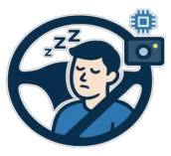

**DriveSafe: AI-Based Driver Drowsiness Detection System**

**Prepared by:**

Aseel Jayousi

Hanan Abuzainab

**Supervised by:**

Anas Melhm, Ph.D.

Tulkarm – Palestine

June 2025

**Table of contents**

**LIST OF FIGURES** 3

**LIST OF TABLES** 3

ABSTRACT 4

ملخص 5

CHAPTER 1 – INTRODUCTION 6

1.1 Motivation 7

1.2 Problems 8

1.3 Objectives 8

CHAPTER 2 – LITERATURE REVIEW 9

2.1 Traditional Drowsiness Detection Methods 10

2.1.1 Physiological Signal-Based Approaches (EEG, EOG, ECG) 10

2.1.2 Vehicle Behavior-Based Approaches 11

2.2 Vision-Based Drowsiness Detection (Without AI) 11

2.3 Deep Learning Techniques for Detecting Drowsiness 12

2.3.1 Single Model Approaches 12

2.3.2 Hybrid Model Approaches 12

2.4 Comparison between Single Model and Hybrid Model 13

2.5 Conclusion 13

CHAPTER 3 - PROPOSED SOLUTION 14

3.1 Proposed Model 15

3.2 Proposed Scenario 16

3.3 Diagrams 17

3.3.1 Activity Diagram 17

3.3.1 Sequence Diagram 18

3.4 Project Timeline: 19

Reference list 20

**LIST OF FIGURES**

Figure 1:Driving Drowsiness Monitoring using EGG signal 10

Figure 2:Eye landmark points used for EAR calculation 11

Figure 3:llustrates the drowsiness detection pipeline using a hybrid CNN-LSTM model. 16

Figure 4:Activity diagram 17

Figure 5:Sequence diagram 18

Figure 6:Project life cycle 19

**LIST OF TABLES**

Table 1:The difference between Single Model and Hybrid Model 13

Table 2:Project Timeline 19

# ABSTRACT

Driver drowsiness is a major cause of road accidents, especially during long or late-night trips. This project introduces a real-time drowsiness detection system that monitors the driver’s full facial features using a front-facing camera. It detects signs of fatigue like eye closure and head movement, then alerts the driver before it becomes dangerous. While similar systems are usually only available in modern high-end vehicles car, Through intelligent monitoring, the solution contributes to safer roads and more attentive driving.

# ملخص

تُعدّ حالة النعاس أثناء القيادة من الأسباب الرئيسية لحوادث الطرق، خاصةً خلال الرحلات الطويلة أو أثناء القيادة ليلاً. يقدّم هذا المشروع نظامًا للكشف عن النعاس يعمل في الوقت الحقيقي، حيث يقوم بمراقبة ملامح وجه السائق بالكامل باستخدام كاميرا أمامية. يكتشف النظام علامات التعب مثل إغلاق العينين وحركة الرأس، ثم يُصدر تنبيهًا للسائق قبل أن تتطور الحالة إلى وضع خطير. وعلى الرغم من أن أنظمة مشابهة تتوفر عادةً فقط في السيارات الحديثة والفاخرة، فإن هذا النظام يهدف من خلال المراقبة الذكية إلى المساهمة في تعزيز السلامة على الطرق ودعم التركيز والانتباه أثناء القيادة.

## 

# CHAPTER 1 – INTRODUCTION

This chapter introduces the project and highlights its main idea.

Traffic accidents are a major problem that causes material and moral losses and is one of the main causes of injury, disability, and death around the world [1][2] with the increasing number of vehicles on the roads. There are many causes of accidents, including excessive speed and the use of mobile phones while driving, among others [1] especially in low-income countries, the causes of accidents are increasing [3]. One of the serious and slowly developing causes is drowsiness [4], a real problem in which the driver loses concentration and is less able to notice sudden changes in the road, making incorrect decisions, and having difficulty staying on the right lane. Factors that cause drowsiness include driving long distances or during night driving, or it may occur due to the driver's lack of sleep, which causes poor concentration. There are early signs of drowsiness, such as frequent yawning, frequent blinking, and heavy eyelids, but these signs are often ignored by drivers, leading to accidents that affect not only the driver but also passengers and other road users. Therefore, there is a need for systems that detect driver drowsiness in its early stages to reduce traffic accidents and their significant effects. Many cars still don't have drowsiness detection systems, like older or low-cost cars, leaving a segment of drivers unprotected from drowsiness and its consequences. Therefore, it has become necessary to find a smart, practical, and low-cost solution that suits all categories to monitor drivers and keep them alert. This project aims to develop a system to detect driver drowsiness, monitor their behavior in real time, and detect potential signs of drowsiness. If signs appear, the system alerts the driver. This system can reduce traffic accidents resulting from drowsiness, save lives, and make driving safer.

## 1.1 Motivation

The idea of a driver drowsiness detection system is motivated by the following key points:

1. **Providing safety for all drivers**: Every driver deserves to reach their destination safely and to use drowsiness detection systems that are easy to use, affordable, and effective. Drowsy driving is a major risk, especially in developing countries and low-cost vehicles that lack such systems.
2. **Save lives**: By preventing accidents that could be avoided by drowsiness detection, we aim to reduce the resulting harm and protect the lives of drivers, passengers, and other road users.
3. **Lack of driver awareness**: Drowsiness is a danger while driving. Many drivers ignore drowsiness and continue driving without considering it a risk, leading to accidents.

### 

## 1.2 Problems

The following problems highlight the need for the proposed drowsiness detection system:

1. **Drowsiness increases the risk of accidents**: When drivers are tired, their focus and reaction time go down—especially during long trips or late at night. Some drivers even experience “microsleep,” where they briefly fall asleep without realizing it, which can lead to serious accidents.
2. **Such systems are not widely available**: Most cars don’t have tools that can detect signs of drowsiness. And the systems that do exist are usually expensive and found only in luxury vehicles, not in regular or public transport cars [5].
3. **Drivers often don’t realize how tired they are**: Many people think they’re fine to drive, even when they’re actually very tired. This makes it hard to judge their own alertness, which increases the risk without them noticing.

## 1.3 Objectives

The focus of this project is to design and implement an intelligent system that monitors driver alertness in real time. The main objectives are to:

1. **Enhance road safety** by providing a real-time alert system that helps prevent accidents caused by driver drowsiness.
2. **Design a cost-effective and adaptable solution** that can be installed in various types of vehicles, including personal cars, buses, and trucks, making it accessible to a wide range of users.
3. **Raise awareness about drowsy driving** by using the system to highlight the risks of driver fatigue and promote the use of intelligent safety technologies.
4. **Present the system as a proof of concept** to demonstrate how AI can contribute to road safety and inspire future development beyond the student level.

# CHAPTER 2 – LITERATURE REVIEW

This chapter presents a review of existing studies and related work relevant to the project.

## 2.1 Traditional Drowsiness Detection Methods

### 2.1.1 Physiological Signal-Based Approaches (EEG, EOG, ECG)

Some of the earliest methods for detecting drowsiness focused on physiological signals, in other words, measuring how the body responds internally when someone starts to feel tired. These approaches rely on specialized sensors that monitor brain activity, eye movement, and heart rate to detect signs of fatigue.

* **EEG (Electroencephalogram):** This measures electrical activity in the brain. Studies have shown that as a person gets drowsy, high-frequency brain waves like beta waves start to decrease, while slower waves such as theta and delta increase. These shifts are considered early indicators of sleepiness.
* **EOG (Electrooculogram):** This tracks how the eyes move and blink. When someone is tired, their blinks slow down, and the eyes tend to remain closed for longer periods — both of which are strong signs of drowsiness.
* **ECG (Electrocardiogram):** This monitors heart rate and rhythm. A decrease in heart rate or irregular heartbeat patterns can also point to the onset of fatigue.

One study [6] used EEG signals to estimate PERCLOS — the percentage of eyelid closure over time — and achieved a very low error rate (RMSE = 0.117), which shows high accuracy in predicting drowsiness.

Also in [7], the authors proposed a hybrid drowsiness detection system based on EEG and ECG signals. They tested the approach on 22 subjects in a simulated driving environment and achieved an accuracy of 80% using only two electrodes—one for EEG and one for ECG.

Even though these methods are accurate, they’re not very practical for real-world use. Most of them require physical contact with the skin or scalp through electrodes, which can be uncomfortable and not ideal for daily driving situations. That’s why their use is mostly limited.

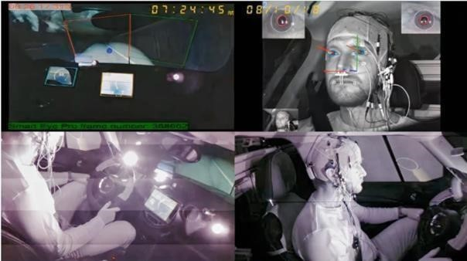

Figure :Driving Drowsiness Monitoring using EGG signal

### 2.1.2 Vehicle Behavior-Based Approaches

Another way to detect driver drowsiness is by observing how the driver controls the vehicle - like steering wheel movements, lane drifting, or braking patterns. These systems don’t require physical contact with the driver and often use sensors already built into modern vehicles.

In [8], the authors proposed a non-intrusive driver drowsiness detection model using steering wheel data. They applied an adaptive neuro-fuzzy feature selection method with a support vector machine classifier, achieving 98.12% accuracy in detecting whether the driver was drowsy or alert.

However, these methods usually detect drowsiness only after the driver’s behavior has already changed. They can also produce false alarms due to external factors like road curves, wind, or bumps. In addition, not all vehicles have the required sensors, and installing them can be expensive or impractical.

## 2.2 Vision-Based Drowsiness Detection (Without AI)

Before the use of artificial intelligence, vision-based drowsiness detection systems relied on handcrafted geometric features extracted from facial landmarks. A key metric used in these systems is the **Eye Aspect Ratio (EAR)**, which measures eye openness and is defined as:

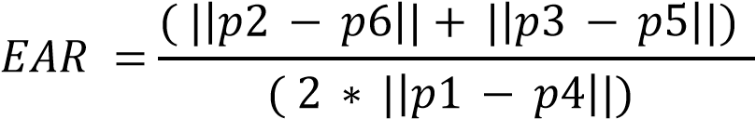

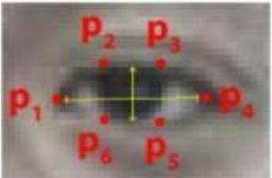

Figure :Eye landmark points used for EAR calculation

In [9], Soukupova and Cech proposed a real-time eye blink detection method based solely on EAR values and facial landmarks. Their system, which used Dlib for facial point detection, did not involve any machine learning techniques. Instead, it applied threshold-based classification to detect blinks in real time.

The method worked well in normal conditions but was less accurate with low light or head movement.

## 2.3 Deep Learning Techniques for Detecting Drowsiness

With the development of deep learning, there has been a shift in understanding and processing data. It solves problems in a way similar to how humans think and matches the neural networks in the human brain, including convolutional neural networks (CNNs) and recurrent neural networks (RNNs).

**CNN**: A neural network designed to extract features from datasets, useful for visual data such as images or videos. It consists of multiple convolutional layers for spatial

**RNN :** is designed for sequential data like time series and language. It uses loops to retain past information but struggles with long sequences due to the vanishing gradient problem. **LSTM (Long Short-Term Memory)** is a type of RNN developed to solve this issue and can handle long-term dependencies more effectively.

### 2.3.1 Single Model Approaches

This approach is based on a single model and is simpler than hybrid models in terms of structure and number of layers, but it is not suitable in cases that require analysis of temporal and spatial patterns together.

In [10] a system for driver drowsiness detection was proposed using computer vision and deep learning techniques. Two models were studied and compared: a custom-designed CNN model and a pre-trained VGG16 model. A dataset containing diverse images was used, and the accuracy of the CNN model was 97%, while the custom VGG16 model achieved 74%.

Also, in this study [11], a drowsiness detection system was developed using convolutional neural networks and computer vision. This system uses real-time video processing using OpenCV to extract and analyze facial features and eye ratios. The results achieved an accuracy of 97.2%. However, this system detects drowsiness automatically, meaning it processes images individually without taking into account the temporal sequence of facial movements.

### 2.3.2 Hybrid Model Approaches

This approach relies on more than one model and is used when combining temporal and spatial analysis is needed. It requires powerful hardware to operate.

In [12] a system is proposed to detect driver drowsiness from video while driving. A dataset containing video clips was used, divided into frames. The system combines two deep learning models, CNN and LSTM, and was then tested and compared with a set of other models. After comparison, the best accuracy results were achieved using the CNN + LSTM model, The precision attained reached 98.3% for training and 97.31% for testing.

## 2.4 Comparison between Single Model and Hybrid Model

Table 1:The difference between Single Model and Hybrid Model

|  |  |  |
| --- | --- | --- |
| **Aspect** | **Single Model (CNN)** | **Hybrid Model (CNN +LSTM)** |
| Framework operation | Uses CNN layers to extract features from Static image | Uses CNN for feature extraction and LSTM for temporal and sequence analysis. |
| Temporal Analysis | Cannot handle temporal analysis. | Strong temporal modeling — can detect trends over time |
| Hardware  Requirements | Suitable for low-power devices (Raspberry Pi) | Requires more computational resources (PC with GPU) |
| Key Strengths | Excellent for Classifying single images. | Excellent for sequential and time related data. |
| Processing Speed | Faster- only CNN layers | slower due to extra LSTM  processing layer |
| Accuracy | High accuracy per frame, but may miss behavioral trends | high for temporal analysis. |
| Complexity | Simple | More complex (combined CNN + RNN/LSTM) |
| Performance Metrics | - Custom CNN model: 97% accuracy [10] | CNN + LSTM model: 97.31% test accuracy, 98.3% training precision [12] |

## 2.5 Conclusion

#### After evaluating both the CNN and the CNN + LSTM models, we found that the hybrid model (CNN + LSTM) offers higher accuracy in detecting driver drowsiness. This is because it doesn’t just analyze individual frames, but also considers how the driver’s facial features change over a sequence of images. This temporal analysis helps the system recognize early signs of fatigue more effectively. For this reason, we decided to adopt the CNN + LSTM model in our system to ensure more accurate and reliable drowsiness detection.

# CHAPTER 3 - PROPOSED SOLUTION

This chapter presents the proposed system, and how it works

In this chapter, we present a proposed driver drowsiness detection system that initiates detection immediately using video inputs and determines the driver's state using a proposed hybrid model. It uses indicators to determine the system's state. If drowsiness is detected, the system activates an alert to warn the driver.

## Proposed Model

The proposed model consists of three main stages: Input, Processing, and Decision Making. These stages work together to enable real-time drowsiness detection, as illustrated in Figure 3.

**1. Input Stage**

The system uses real-time video captured from a front-facing **camera** mounted on the dashboard of the vehicle.

During the development phase, we use the **NTHU Drowsy Driver Detection (NTHU-DDD) dataset**[13], a dataset designed specifically for drowsiness detection. It contains annotated video sequences of drivers in various states such as awake, blinking, yawning, drowsy, and asleep, recorded under different lighting conditions (daylight, night, infrared). The dataset is split into training, validation, and testing subsets. Each video is segmented into individual frames before further processing.

**2. Processing Stage**

* **Face Detection:** Each video frame is passed through a face detection algorithm to locate the driver’s face. Only the facial region is extracted and forwarded for further processing.
* **Preprocessing:** The extracted face is converted to grayscale to reduce computational complexity, resized to a fixed input size (128×128 pixels), and normalized to ensure consistent input across all frames.
* **Feature Extraction(CNN):** The preprocessed face image is fed into a Convolutional Neural Network, which extracts key spatial features from each frame. These features represent facial characteristics such as eye openness, mouth shape, and head orientation.
* **Frame Sequencing:** A sequence of consecutive frames (20 frames) is grouped together to preserve the temporal flow of facial expressions. This sequence forms the input for the LSTM.
* **Temporal Analysis(LSTM):** The CNN features are sent to an LSTM network, which looks at how the face changes over time across a group of frames. It learns to recognize signs of drowsiness, like eyes staying closed for several frames, frequent blinking, or yawning that lasts over time.

**3. Decision Making stage**

* **State Classification:**  
  After analyzing the input sequence, the model classifies the driver’s condition into one of three states:
* **Awake**
* **Drowsy**
* **Asleep**
* **System Response:**   
  Based on the detected state, the system responds in real time using a buzzer to alert the driver:
* **Alert:** No action is taken, and the system continues monitoring.
* **Drowsy:** A medium-speed buzzer is triggered to gently alert the driver.
* **Asleep:** A high-speed, urgent buzzer is activated to strongly warn the driver.
* 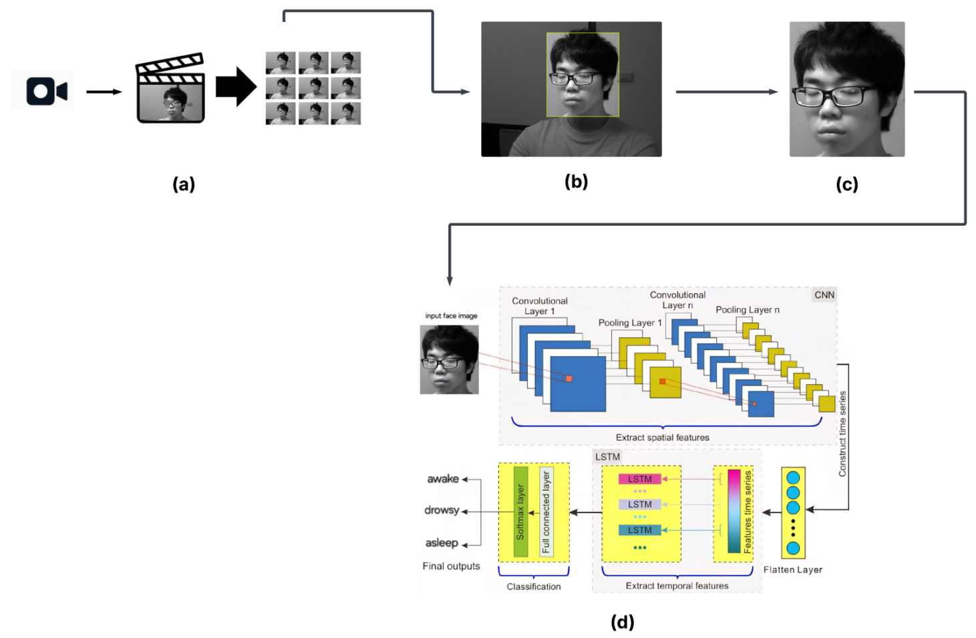**continuous monitoring:**   
  The system continuously updates its prediction as new frames are captured, ensuring that any change in the driver’s condition is quickly detected and handled.

Figure :llustrates the drowsiness detection pipeline using a hybrid CNN-LSTM model.

(a)A video stream is captured in real-time using a front-facing camera. (b) From each frame, the driver’s face is detected and localized using a face detection algorithm. (c) The detected face region is then cropped to isolate the relevant features. (d) The cropped face images are passed to a CNN to extract spatial features related to eye and facial conditions. These features are then fed into an LSTM network to analyze temporal changes over time. The final output is a classification of the driver’s state into awake, drowsy, or asleep.

## 3.2 Proposed Scenario

In a driver drowsiness detection system, the model is trained on a dataset of facial images. A night-vision camera is used to capture real-time video of the driver's face to extract, analyze, and classify frames. An LED indicator is used to alert the driver whether the system is operating or not, and an alert device (buzzer) warns the driver.

The system relies on two LED indicators, red and green, to indicate the system status to the driver and provide visual notification of the system status, helping the driver identify the system's operation or make adjustments if an error occurs.

* **Red LED**: The red LED turns on when there is a specific error or problem.
* case 1: The driver's face cannot be seen due to the camera not being directed toward them, their head tilted, or their wearing sunglasses that obstruct their vision.
* case 2: A hardware error, such as a camera connection failure.

* **Green LED**: The green LED turns on when the system is operating properly. This results in the following three cases:
* case 1: The driver's face is visible while awake.

The system continues without activating an alert or issuing any signal.

* Case 2: The driver's face is visible while drowsy.

The system activates a medium-speed buzzer to alert the driver.

* Case 3: The driver's face is visible while asleep.

The system activates a high-speed buzzer to wake the driver.

## 3.3 Diagrams

This section includes two diagrams that illustrate the internal behavior of the drowsiness detection system.

### 3.3.1 Activity Diagram

The following diagram illustrates the core workflow of the proposed drowsiness detection system.

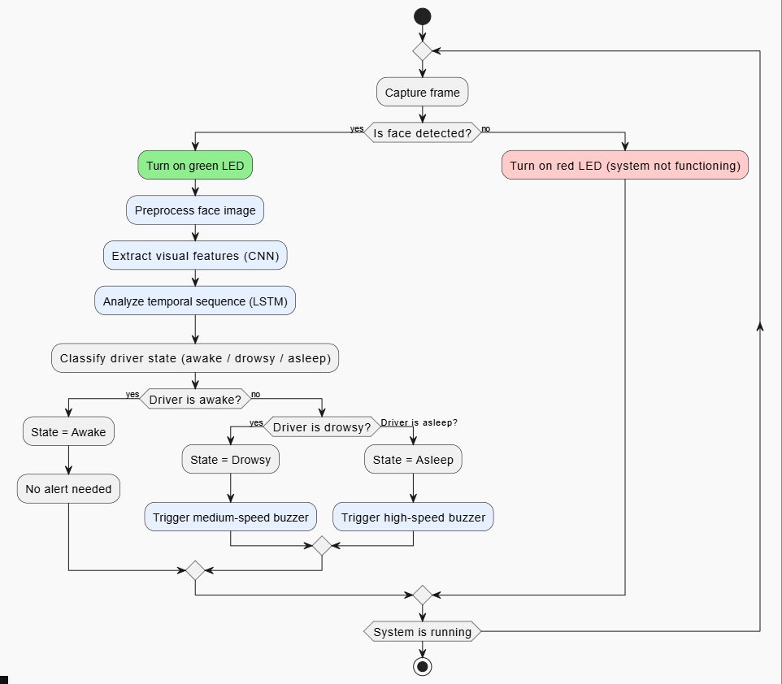

Figure :Activity diagram

### 3.3.1 Sequence Diagram

The following diagram illustrates a sequence diagram of the interactions between the proposed drowsiness detection system and the remaining components.

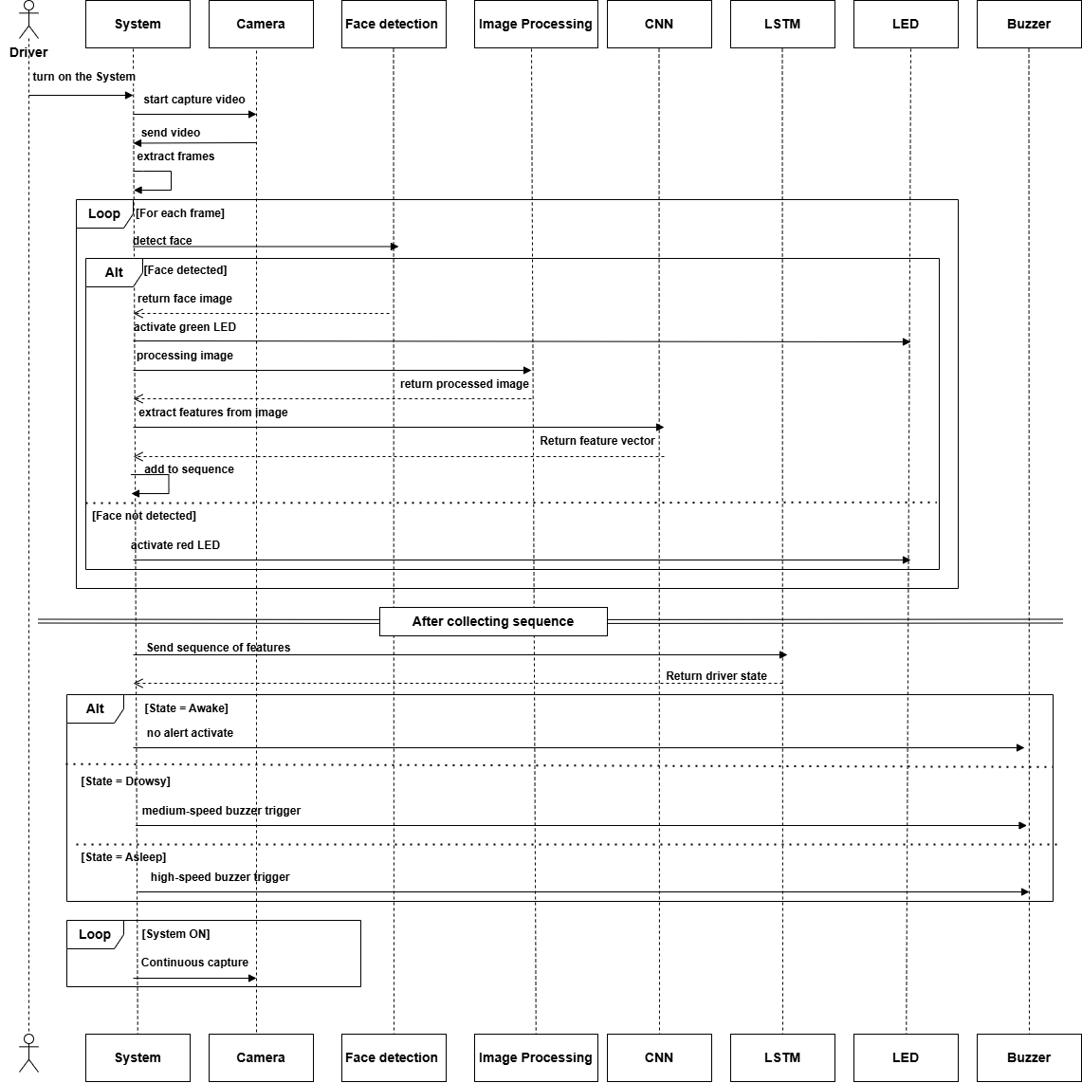

Figure :Sequence diagram

## 3.4 Project Timeline:

The following chart shows a suggested calendar to show when the project starts and ends. The tasks are divided into weeks for each month to help organize the work.

Table :Project Timeline



The circular life cycle diagram in Figure 6 shows how we followed the Agile methodology. This approach is based on working in short phases, with continuous updates and improvements. In each phase, we focused on specific tasks like data preparation, model training. This helped us stay flexible and make changes whenever we faced any issues or needed to improve something.

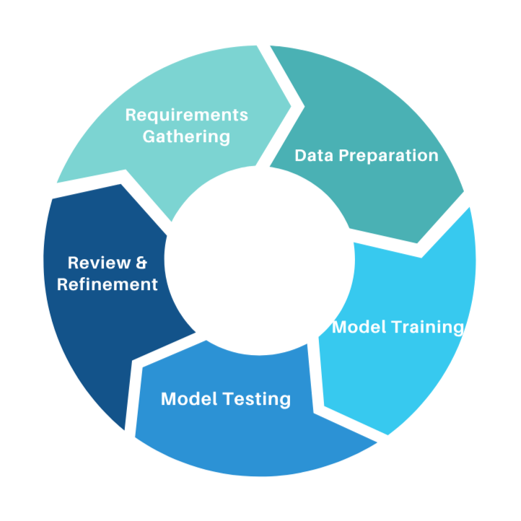

Figure :Project life cycle

# Reference list

[1] World Health Organization. (2023, December). Road traffic injuries. World Health Organization. <https://www.who.int/news-room/fact-sheets/detail/road-traffic-injuries>

[2] Palestinian Central Bureau of Statistics. (2023, September 4). Casualties in road traffic accidents in Palestine by governorate and type of injury, 2022. <https://www.pcbs.gov.ps/statisticsIndicatorsTables.aspx?lang=en&table_id=2037>

[3] Amoadu, M., Ansah, E. W., & Sarfo, J. O. (2023). Psychosocial work factors, road traffic accidents and risky driving behaviours in low-and middle-income countries: a scoping review. IATSS research, 47(2), 240-250. <https://doi.org/10.1016/j.iatssr.2023.03.005>

[4] AAA Foundation for Traffic Safety. (2024, March). Drowsy driving in fatal crashes, United States, 2017–2021. [https://aaafoundation.org/drowsy-driving-in-fatal-crashes-united-states-2017-2021 /](https://aaafoundation.org/drowsy-driving-in-fatal-crashes-united-states-2017-2021%20/)

[5] Fundación MAPFRE, "Fatigue detection system," Fundación MAPFRE, 2023. [Online]. Available: <https://www.fundacionmapfre.org/en/education-outreach/road-safety/adas-systems/types/fatigue-detection-system>

[6] M. Arefnezhad, M. K. Daneshvar, and R. Boostani, “PERCLOS estimation from EEG signals using dynamic regression models,” *Scientific Reports*, vol. 12, no. 1, 2022. [Online]. Available: <https://www.nature.com/articles/s41598-022-05810-x>

[7] M. Awais, N. Badruddin, and M. Drieberg, “Driver drowsiness detection using physiological signals: A review,” *Sensors*, vol. 17, no. 3, p. 495, Mar. 2017. [Online]. Available: https://[www.mdpi.com/1424-](http://www.mdpi.com/1424-) 8220/17/9/1991

[8] M. Arefnezhad, B. Sadeghi, and A. A. Pouyan, “Driver drowsiness detection based on steering behavior,” *Journal of Medical Signals and Sensors*, vol. 9, no. 1, pp. 45–52, 2019. [Online]. Available: <https://doi.org/10.3390/s17030495>

[9] T. Soukupova and J. Cech, “Real-time eye blink detection using facial landmarks,” in *Proc. 21st Computer Vision Winter Workshop*, Rimske Toplice, Slovenia, 2016. [Online]. Available:

<https://vision.fe.uni-lj.si/cvww2016/proceedings/papers/05.pdf>

[10] Ahmed, M. I. B., Alabdulkarem, H., Alomair, F., Aldossary, D., Alahmari, M., Alhumaidan, M., ... & Zaman, G. (2023). A deep-learning approach to driver drowsiness detection. *Safety*, *9*(3), 65. https://[www.mdpi.com/2313-576X/9/3/65](http://www.mdpi.com/2313-576X/9/3/65)

[11] Madane, A., Singh, A., Fargade, S., & Dongare, A. (2025). *Real-time driver drowsiness detection using deep learning and computer vision techniques*. International Journal of Scientific Research in Science,Engineering and Technology, 12(3), 222–229. <https://doi.org/10.32628/IJSRSET2512335>

[12] Gomaa, M., Mahmoud, R., & Sarhan, A. (2022, August). A CNN-LSTM-based deep learning approach for driver drowsiness prediction. Journal of Engineering Research, 6. :

<https://digitalcommons.aaru.edu.jo/cgi/viewcontent.cgi?article=1209&context=erjeng>

[13] C.-H. Chou, "NTHU Drowsy Driver Detection Dataset (NTHU-DDD)," National Tsing Hua University, [Online]. Available: <http://cv.cs.nthu.edu.tw/php/callforpaper/datasets/DDD/>