**Palestine Technical University - Khadoorie**

**Faculty of Engineering and Technology**

**Department of Computer Systems Engineering**



**"Introduction to Graduation Project" Thesis**

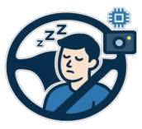

**DriveSafe: AI-Based Driver Drowsiness Detection System**

**Prepared by:**

Aseel Jayousi

Hanan Abuzainab

**Supervised by:**

Anas Melhm, Ph.D.

Tulkarm – Palestine

June 2025

Table of contents

**ABSTRACT** **3**

**4** ................................................................................................................................................ **ملخص**

**CHAPTER 1 – INTRODUCTION** **5**

**1.1 Motivation** **7**

**1.2 Problems** **8**

**1.3 Objectives** **9**

## ABSTRACT

Driver drowsiness is one of the leading causes of road accidents, particularly during long-distance or nighttime driving. This project proposes a real-time drowsiness detection system that monitors the driver’s eye behavior using a simple front-facing camera. By identifying early signs of fatigue—such as frequent eye closure—the system aims to alert the driver and prevent potential accidents. Unlike existing solutions that are often costly or limited to high-end vehicles, the proposed system is designed to be efficient, affordable, and accessible for all drivers. Through intelligent monitoring, the solution contributes to safer roads and more attentive driving.

# ملخص

يعُد نعاس السائق من أبرز أسباب حوادث الطرق، خاصة أثناء القيادة لمسافات طويلة أو في فترات الليل. يقترح هذا المشروع نظامًا ذكياً يعمل في الوقت الحقيقي لاكتشاف النعاس، وذلك من خلال مراقبة سلوك العين باستخدام كاميرا

أمامية بسيطة. يعتمد النظام على التعرف المبكر على علامات التعب، مثل تكرار إغلاق العينين، بهدف تنبيه السائق قبل وقوع أي حادث محتمل. وعلى عكس الأنظمة الحالية التي غالباً ما تكون باهظة الثمن أو محصورة في المركبات

الفاخرة، فإن النظام المقترح يتميز بكفاءته وتكلفته المنخفضة وإمكانية استخدامه

من قِبل جميع السائقين. ومن خلال المتابعة الذكية، يساهم هذا الحل في تعزيز السلامة على الطرق وتشجيع القيادة الواعية

## CHAPTER 1 – INTRODUCTION

This chapter introduces the project and highlights its main idea.

Road safety has always been one of the most important aspects of public health and transportation planning. With the increasing number of vehicles on roads, driver safety has become a major concern around the world. Driving requires full attention and focuses on all times, because even a short moment of distraction can lead to serious consequences. One of the most critical issues that affect driving performance is drowsiness, a condition where the driver starts to lose alertness and may fall asleep without even realizing it. Unlike other distractions, drowsiness usually develops slowly and silently, which makes it hard for drivers to notice the danger in time. Drowsy driving increases the chance of accidents because it slows down the driver’s reaction time, affects their ability to make good decisions, and makes it harder to stay in the correct lane or notice sudden changes on the road. This problem becomes even more serious during long-distance trips, nighttime driving, or when driving on quiet and boring roads. In these situations, the lack of stimulation can make the driver feel tired faster. The danger does not only affect the driver but also puts passengers, other road users, and pedestrians at risk. Many drivers experience signs of fatigue—like heavy eyelids, frequent yawning, or difficulty keeping their head up without paying much attention to them. These signs are often ignored or go unnoticed, especially when the person is in a hurry or feels confident in their driving skills. Unfortunately, most vehicles do not include built-in systems to detect these signs, especially older or low-cost cars. This leaves many drivers unprotected against the dangers of drowsiness. Because of this growing concern, there is a real need to create a smart and practical solution that can help keep drivers alert and safe. This project aims to develop an intelligent system that monitors the driver’s behavior in real time and detects early signs of drowsiness based on physical cues such as eye movement. When the system notices these signs, it can alert the driver before the situation becomes dangerous. By warning the driver at the right moment, this solution can help prevent accidents, save lives, and make driving safer for everyone. It is a step toward building a safer road environment using simple but effective technology that can be used in a wide range of vehicles.

### 1.1 Motivation

The idea of a driver drowsiness detection system is motivated by the following key points:

1. **Promoting Equal Safety for All Drivers:** Every driver deserves to reach their destination safely and have access to an effective, affordable, and easy-to-use drowsiness detection tool. Drowsy driving is a silent and dangerous threat that can turn a normal trip into a serious accident, especially since most low-cost vehicles lack such protective systems.

1. **Saving Lives by Preventing Avoidable Accidents:** This project is driven by a strong desire to reduce the number of road accidents caused by a common but dangerous condition (falling asleep while driving). Our goal is to protect lives by detecting drowsiness early.

1. **Noticing the Lack of Driver Awareness About Drowsiness:** Many drivers underestimate the danger of drowsiness and fail to recognize its early signs, treating it as a minor issue rather than a serious risk.

### 1.2 Problems

The following problems highlight the need for the proposed drowsiness detection system:

1. **Increased Accident Risk Due to Drowsiness and Microsleep**

**Episodes**

Fatigue severely affects a driver’s concentration and reaction time, especially during late-night hours or long-distance trips. Professional drivers, such as truck and bus operators, are particularly vulnerable to Microsleep—brief, uncontrollable episodes of unconsciousness—which can lead to serious or even fatal accidents.

1. **Lack of widely available and affordable drowsiness detection technologies:**

Most vehicles are not equipped with intelligent systems capable of monitoring physiological signs such as eye movement or facial expressions. Furthermore, existing commercial solutions are often expensive and limited to high-end vehicles, making them inaccessible to the average driver or public transport operators.

1. **Drivers’ inability to assess their own level of fatigue while driving:**

Many drivers are unaware of how tired they actually are and tend to overestimate their alertness. This makes self-assessment unreliable, especially during long, repetitive, or nighttime drives, increasing the chances of falling asleep without warning.

### 1.3 Objectives

The focus of this project is to design and implement an intelligent system that monitors driver alertness in real time. The main objectives are to:

1. **Enhance road safety** by providing a real-time alert system that helps prevent accidents caused by driver drowsiness.

1. **Design a cost-effective and adaptable solution** that can be installed in various types of vehicles, including personal cars, buses, and trucks, making it accessible to a wide range of users.

1. **Present the system as a proof of concept** to demonstrate how AI can contribute to road safety and inspire future development beyond the student level.

1. **Raise awareness about drowsy driving** by using the system to highlight the risks of driver fatigue and promote the use of intelligent safety technologies.

**Table of Contents**

**CHAPTER 2 – LITERATURE REVIEW**

#### 2.1 Traditional Drowsiness Detection Methods

2.1.1 Physiological Signal-Based Approaches (EEG, EOG, ECG) 2.1.2 Vehicle Behavior-Based Approaches

#### 2.2 Vision-Based Drowsiness Detection (Without AI) 2.3 Deep Learning Techniques for Detecting Drowsiness

2.3.1 Single Model Approaches

2.3.2 Hybrid Model Approaches

#### 2.4 Comparison between Single Model and Hybrid Model 2.5 Conclusion

**CHAPTER 2 – LITERATURE REVIEW**

This chapter presents a review of existing studies and related work relevant to the project.

#### 2.1 Traditional Drowsiness Detection Methods

**2.1.1 Physiological Signal-Based Approaches (EEG, EOG, ECG)**

Some of the earliest methods for detecting drowsiness focused on physiological signals, in other words, measuring how the body responds internally when someone starts to feel tired. These approaches rely on specialized sensors that monitor brain activity, eye movement, and heart rate to detect signs of fatigue.

* **EEG (Electroencephalogram):** This measures electrical activity in the brain. Studies have shown that as a person gets drowsy, high-frequency brain waves like beta waves start to decrease, while slower waves such as theta and delta increase. These shifts are considered early indicators of sleepiness.
* **EOG (Electrooculogram):** This tracks how the eyes move and blink. When someone is tired, their blinks slow down, and the eyes tend to remain closed for longer periods — both of which are strong signs of drowsiness.
* **ECG (Electrocardiogram):** This monitors heart rate and rhythm. A decrease in heart rate or irregular heartbeat patterns can also point to the onset of fatigue.

One study [1] used EEG signals to estimate PERCLOS — the percentage of eyelid closure over time — and achieved a very low error rate (RMSE = 0.117), which shows high accuracy in predicting drowsiness.

Also in [2], the authors proposed a hybrid drowsiness detection system based on EEG and ECG signals. They tested the approach on 22 subjects in a simulated driving environment and achieved an accuracy of 80% using only two electrodes—one for EEG and one for ECG.

Even though these methods are accurate, they’re not very practical for real-world use. Most of them require physical contact with the skin or scalp through electrodes, which can be uncomfortable and not ideal for daily driving situations. That’s why their use is mostly limited.

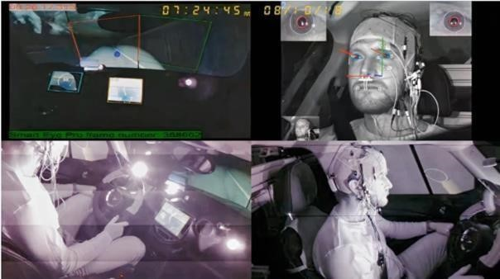

**2.1.2 Vehicle Behavior-Based Approaches**

Another way to detect driver drowsiness is by observing how the driver controls the vehicle - like steering wheel movements, lane drifting, or braking patterns. These systems don’t require physical contact with the driver and often use sensors already built into modern vehicles.

In [3], the authors proposed a non-intrusive driver drowsiness detection model using steering wheel data. They applied an adaptive neuro-fuzzy feature selection method with a support vector machine classifier, achieving 98.12% accuracy in detecting whether the driver was drowsy or alert.

However, these methods usually detect drowsiness only after the driver’s behavior has already changed. They can also produce false alarms due to external factors like road curves, wind, or bumps. In addition, not all vehicles have the required sensors, and installing them can be expensive or impractical.

#### 2.2 Vision-Based Drowsiness Detection (Without AI)

Before the use of artificial intelligence, vision-based drowsiness detection systems relied on handcrafted geometric features extracted from facial landmarks. A key metric used in these systems is the **Eye Aspect Ratio (EAR)**, which measures eye openness and is defined as:

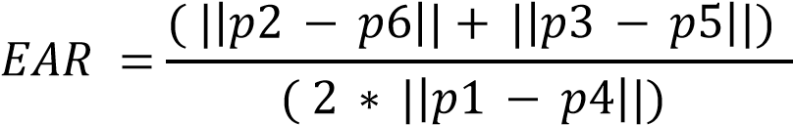

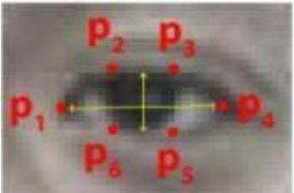

In [4], Soukupova and Cech proposed a real-time eye blink detection method based solely on EAR values and facial landmarks. Their system, which used Dlib for facial point detection, did not involve any machine learning techniques. Instead, it applied threshold-based classification to detect blinks in real time.

The method worked well in normal conditions but was less accurate with low light or head movement.

#### 2.3 Deep Learning Techniques for Detecting Drowsiness

With the development of deep learning, there has been a shift in understanding and processing data. It solves problems in a way similar to how humans think and matches the neural networks in the human brain, including convolutional neural networks (CNNs) and recurrent neural networks (RNNs).

* **CNN**: A neural network designed to extract features from datasets, useful for visual data such as images or videos. It consists of multiple convolutional layers for spatial
* **RNN :** is designed for sequential data like time series and language. It uses loops to retain past information but struggles with long sequences due to the vanishing gradient problem. **LSTM (Long Short-Term Memory)** is a type of RNN developed to solve this issue and can handle long-term dependencies more effectively.

##### 2.3.1 Single Model Approaches

This approach is based on a single model and is simpler than hybrid models in terms of structure and number of layers, but it is not suitable in cases that require analysis of temporal and spatial patterns together.

In [5] a system for driver drowsiness detection was proposed using computer vision and deep learning techniques. Two models were studied and compared: a custom-designed CNN model and a pre-trained VGG16 model. A dataset containing diverse images was used, and the accuracy of the CNN model was 97%, while the custom VGG16 model achieved 74%.

Also, in this study [6], a drowsiness detection system was developed using convolutional neural networks and computer vision. This system uses real-time video processing using OpenCV to extract and analyze facial features and eye ratios. The results achieved an accuracy of 97.2%. However, this system detects drowsiness automatically, meaning it processes images individually without taking into account the temporal sequence of facial movements.

**2.3.2 Hybrid Model Approaches**

This approach relies on more than one model and is used when combining temporal and spatial analysis is needed. It requires powerful hardware to operate.

In [7] a system is proposed to detect driver drowsiness from video while driving. A dataset containing video clips was used, divided into frames. The system combines two deep learning models, CNN and LSTM, and was then tested and compared with a set of other models. After comparison, the best accuracy results were achieved using the CNN + LSTM model, The precision attained reached 98.3% for training and 97.31% for testing.

2.4 Comparison between Single Model and Hybrid Model

|  |  |  |
| --- | --- | --- |
| **Aspect** | **Single Model (CNN)** | **Hybrid Model (CNN +LSTM)** |
| **Framework operation** | Uses CNN layers to extract features from Static image | Uses CNN for feature extraction and LSTM for temporal and sequence analysis. |
| **Temporal Analysis** | Cannot handle temporal analysis. | Strong temporal modeling — can detect trends in eye closure over time |
| **Hardware**  **Requirements** | Suitable for low-power devices (Raspberry Pi) | Requires more computational resources (PC with GPU) |
| **Key Strengths** | Excellent for Classifying single images. | Excellent for sequential and timerelated data. |
| **Processing Speed** | Faster- only CNN layers | slower due to extra LSTM  processing layer |
| **Accuracy** | High accuracy per frame, but may miss behavioral trends | high for temporal analysis. |
| **Complexity** | Simple | More complex (combined CNN + RNN/LSTM) |
| **Performance Metrics** | - Custom CNN model: 97% accuracy [[5]] | CNN + LSTM model: 97.31% test accuracy, 98.3% training precision [[7]] |

#### 2.5 Conclusion

After comparing the CNN and CNN + LSTM models, we found that the hybrid model provides better accuracy because it analyzes image sequences instead of single frames. However, CNN + LSTM requires more processing power and does not perform well on devices like the Raspberry Pi. Therefore, we suggest two simple options based on the device used:

* **Option 1: CNN + LSTM (for computer use)**

This model gives better accuracy because it looks at a sequence of images, not just one. It’s a good choice if the system will run on a regular computer.

* **Option 2: CNN only (for Raspberry Pi)**

Since LSTM needs more power, it doesn’t work well on Raspberry Pi. So, we can use only CNN, and instead of LSTM, we can check if the eyes are closed in several frames in a row.

**CHAPTER 3 - PROPOSED SOLUTION**

This chapter presents the proposed system, and how it works

**3.1 Proposed Model**

**1. Input Stage**

The system uses real-time video captured from a front-facing **infrared night-vision camera** mounted on the dashboard of the vehicle.

During development, a publicly available dataset containing facial video sequences of different driver states . The dataset is divided into separate subsets for training, validation, and testing purposes. Each video is segmented into individual frames before processing.

**2. Processing Stage**

* **Face Detection:**   
  Each video frame is passed through a face detection algorithm to locate the driver’s face. Only the facial region is extracted and forwarded for further processing.
* **Preprocessing:**   
  The extracted face is converted to grayscale to reduce computational complexity, resized to a fixed input size (128×128 pixels), and normalized to ensure consistent input across all frames.
* **Feature Extraction (CNN):**   
  The preprocessed face image is fed into a Convolutional Neural Network, which extracts key spatial features from each frame. These features represent facial characteristics such as eye openness, mouth shape, and head orientation.

* **Frame Sequencing:**   
  A sequence of consecutive frames (20 frames) is grouped together to preserve the temporal flow of facial expressions. This sequence forms the input for the LSTM.

* **Temporal Analysis (LSTM):**   
  The CNN features are sent to an LSTM network, which looks at how the face changes over time across a group of frames. It learns to recognize signs of drowsiness, like eyes staying closed for several frames, frequent blinking, or yawning that lasts over time.

**Decision Making stage :**

* **State Classification:**   
  After analyzing the input sequence, the model classifies the driver’s condition into one of three states:
* **Alert**
* **Drowsy**
* **Asleep**
* **System Response:**   
  Based on the detected state, the system responds in real time using a buzzer to alert the driver:
* **Alert:** No action is taken, and the system continues monitoring.
* **Drowsy:** A medium-speed buzzer is triggered to gently alert the driver.
* **Asleep:** A high-speed, urgent buzzer is activated to strongly warn the driver.
* **Continuous Monitoring:**   
  The system continuously updates its prediction as new frames are captured, ensuring that any change in the driver’s condition is quickly detected and handled.

#### C:\Users\ToP NeT\AppData\Local\Microsoft\Windows\INetCache\Content.MSO\D0EF23D0.tmp

* **Figure 3:** Illustrates the drowsiness detection pipeline using a hybrid CNN-LSTM model.
* (a) A video stream is captured in real-time using a front-facing camera. (b) From each frame, the driver’s face is detected and localized using a face detection algorithm. (c) The detected face region is then cropped to isolate the relevant features. (d) The cropped face images are passed to a CNN to extract spatial features related to eye and facial conditions. These features are then fed into an LSTM network to analyze temporal changes over time. The final output is a classification of the driver’s state into awake, drowsy, or asleep.

**3.2 Proposed Scenario**

In a driver drowsiness detection system, the model is trained on a dataset of facial images. A night-vision camera is used to capture real-time video of the driver's face to extract, analyze, and classify frames. An LED indicator is used to alert the driver whether the system is operating or not, and an alert device (buzzer) warns the driver.

The system relies on two LED indicators, red and green, to indicate the system status to the driver and provide visual notification of the system status, helping the driver identify the system's operation or make adjustments if an error occurs.

* **Red LED**: The red LED turns on when there is a specific error or problem.

* case 1: The driver's face cannot be seen due to the camera not being directed toward them, their head tilted, or their wearing sunglasses that obstruct their vision.

* case 2: A hardware error, such as a camera connection failure.

* **Green LED**: The green LED turns on when the system is operating properly. This results in the following three cases:

* case 1: The driver's face is visible while awake.

           The system continues without activating an alert or issuing any signal.

* Case 2: The driver's face is visible while drowsy.

           The system activates a medium-speed buzzer to alert the driver.

* Case 3: The driver's face is visible while asleep.

           The system activates a high-speed buzzer to wake the driver.

**3.3 Diagrams**

This section includes two diagrams that illustrate the internal behavior of the drowsiness detection system.

***3.3.1 Activity Diagram***

The following diagram illustrates the core workflow of the proposed drowsiness detection system.

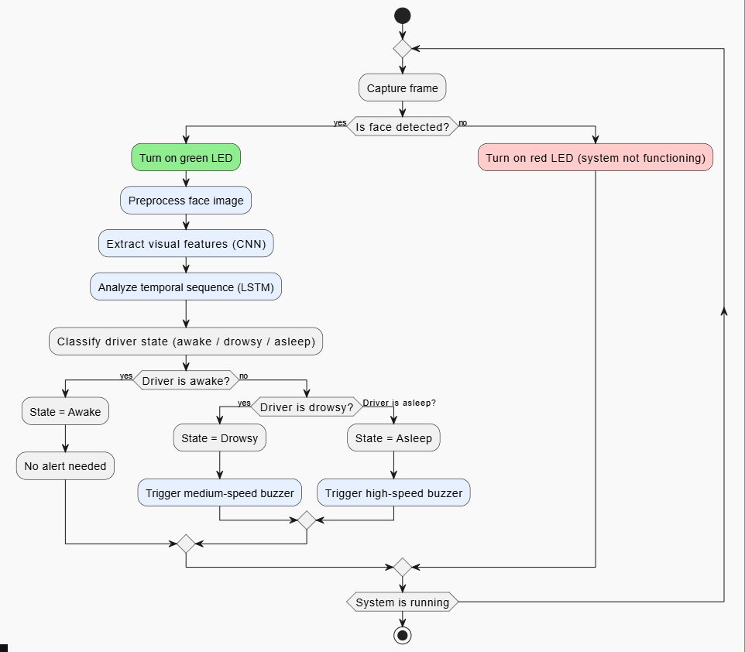

#### Reference list

1. M. Arefnezhad, M. K. Daneshvar, and R. Boostani, “PERCLOS estimation from EEG signals using dynamic regression models,” *Scientific Reports*, vol. 12, no. 1, 2022. [Online]. Available: <https://www.nature.com/articles/s41598-022-05810-x>
2. M. Awais, N. Badruddin, and M. Drieberg, “Driver drowsiness detection using physiological signals: A review,” *Sensors*, vol. 17, no. 3, p. 495, Mar. 2017. [Online]. Available: https://[www.mdpi.com/1424-](http://www.mdpi.com/1424-) 8220/17/9/1991
3. M. Arefnezhad, B. Sadeghi, and A. A. Pouyan, “Driver drowsiness detection based on steering behavior,” *Journal of Medical Signals and Sensors*, vol. 9, no. 1, pp. 45–52, 2019. [Online]. Available: <https://doi.org/10.3390/s17030495>
4. T. Soukupova and J. Cech, “Real-time eye blink detection using facial landmarks,” in *Proc. 21st Computer Vision Winter Workshop*, Rimske Toplice, Slovenia, 2016. [Online]. Available:

<https://vision.fe.uni-lj.si/cvww2016/proceedings/papers/05.pdf>

1. Ahmed, M. I. B., Alabdulkarem, H., Alomair, F., Aldossary, D., Alahmari, M., Alhumaidan, M., ... & Zaman, G. (2023). A deep-learning approach to driver drowsiness detection. *Safety*, *9*(3), 65. https://[www.mdpi.com/2313-576X/9/3/65](http://www.mdpi.com/2313-576X/9/3/65)
2. Madane, A., Singh, A., Fargade, S., & Dongare, A. (2025). *Real-time driver drowsiness detection using deep learning and computer vision techniques*. International Journal of Scientific Research in Science,

Engineering and Technology, 12(3), 222–229. https://doi.org/10.32628/IJSRSET2512335

1. Gomaa, M., Mahmoud, R., & Sarhan, A. (2022, August). A CNN-LSTM-based deep learning approach for driver drowsiness prediction. Journal of Engineering Research, 6. :

https://digitalcommons.aaru.edu.jo/cgi/viewcontent.cgi?article=1209&context=erjeng