CDI College
BDA400 – Data Science Tools and Techniques
Assignment 2: Technical Analysis Using R, Preliminary Stage
Student Name: Hanan Al Saka
GitHub Repository:
https://github.com/hananalsakka48-source/TechnicalAnalysis

BDA400 Assignment 2
Technical Analysis Using R
Student Name: Hanan Al Saka
Course: BDA400

1. Introduction
This report presents a technical analysis of five stocks using the R programming language and RStudio. The selected stocks are Apple (AAPL), Microsoft (MSFT), Alphabet (GOOGL), Amazon (AMZN), and NVIDIA (NVDA).
Historical stock price data was downloaded from Yahoo Finance using the quantmod package in R. Statistical measures, including the mean, median, mode, standard deviation, and 20-day simple moving average (SMA20), were calculated to examine stock price behavior.
The analysis also includes visualizations comparing daily closing prices with their 20-day moving averages. The R scripts and generated charts are stored in a GitHub repository.
2. Methodology
2.1 GitHub Repository Setup
I created a GitHub repository named TechnicalAnalysis to organize my BDA400 assignments. Inside the repository, I created a folder named Assignment2 to store the project files, including the R script, stock symbols, generated charts, and documentation.
Repository link: https://github.com/hananalsakka48-source/TechnicalAnalysis
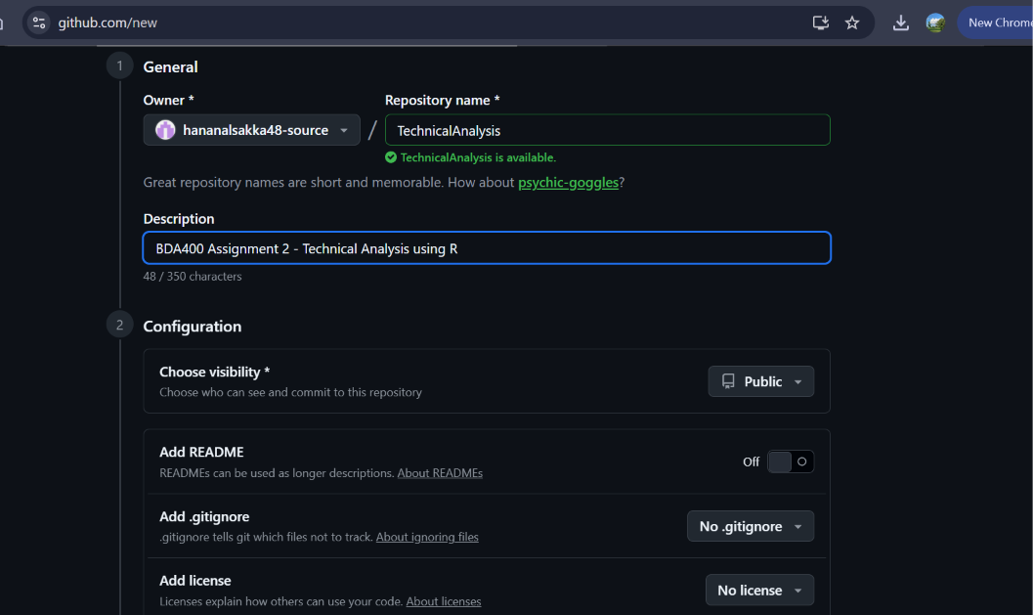

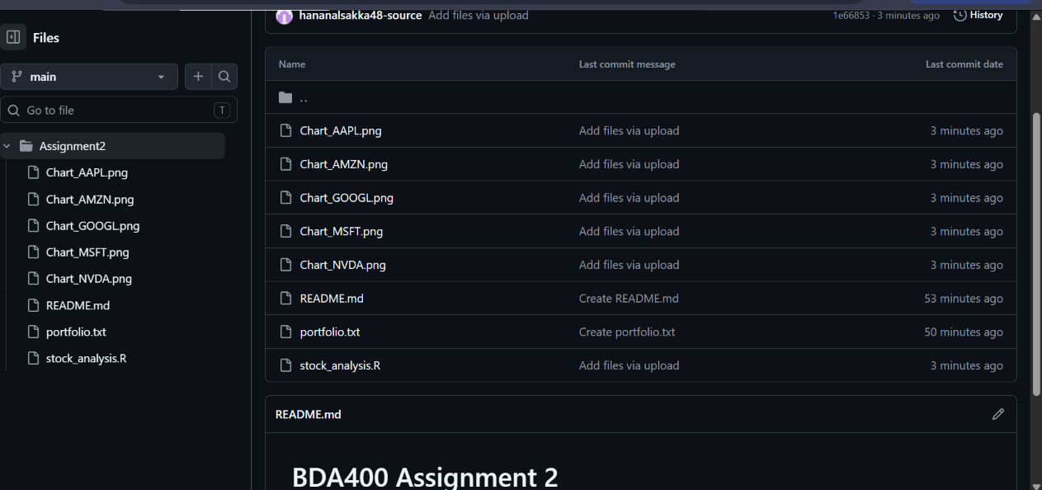

2.2 R Packages Installation
The R packages quantmod and TTR were installed and loaded in RStudio. The quantmod package was used to retrieve historical stock prices from Yahoo Finance, while TTR provided tools for technical analysis, including the 20-day Simple Moving Average (SMA20).
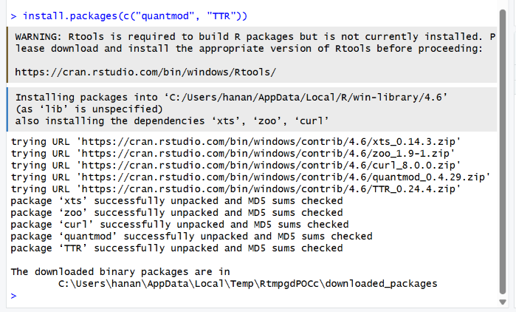
R and RStudio Installation
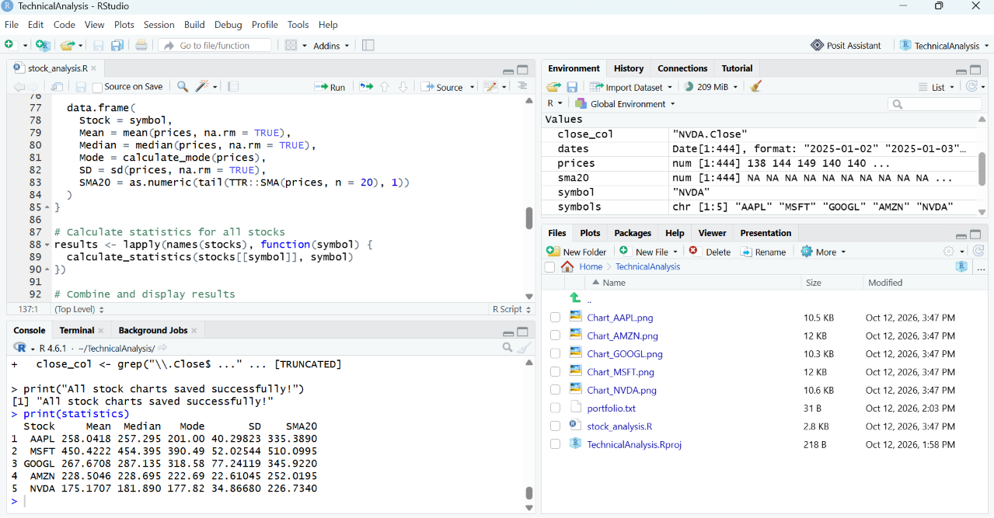

2.3 Stock Data Collection
Five stocks were selected for this analysis: Apple (AAPL), Microsoft (MSFT), Alphabet (GOOGL), Amazon (AMZN), and NVIDIA (NVDA).
The stock symbols were saved in a file named portfolio.txt. Historical stock prices starting from January 1, 2025, were retrieved from Yahoo Finance using the getSymbols() function from the quantmod package in R. The downloaded data was then organized for statistical analysis and visualization.
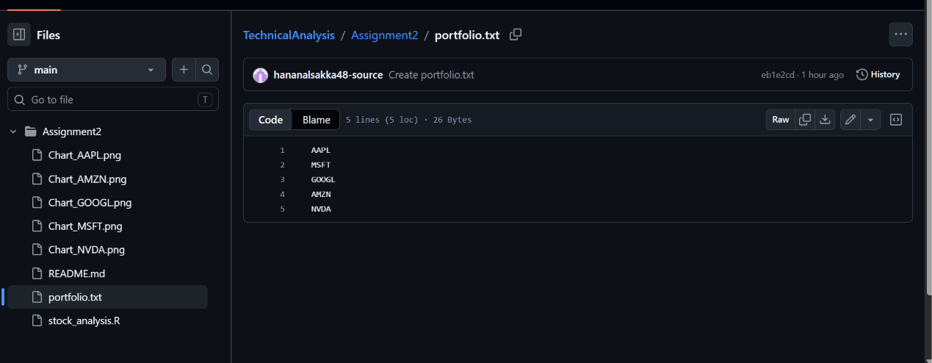
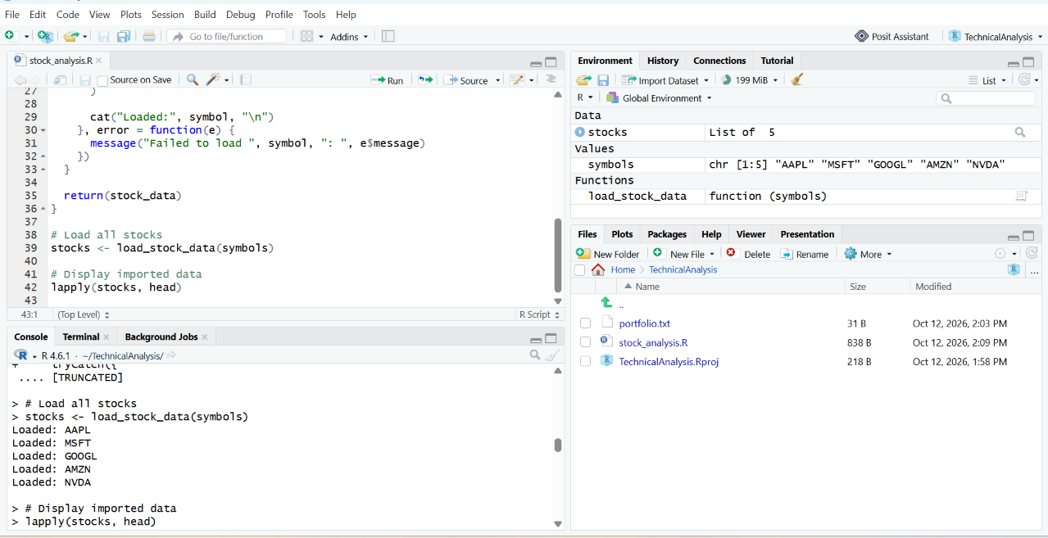

3. Statistical Analysis
The closing prices of the five selected stocks were analyzed using R. The following statistical measures were calculated:
- Mean: The average closing price.
- Median: The middle value of the closing prices.
- Mode: The most frequently occurring closing price.
- Standard Deviation (SD): A measure of price variability.
- 20-Day Simple Moving Average (SMA20): The average closing price over the most recent 20 trading days.
These measures provide a statistical summary of the stocks and help compare their price behavior.
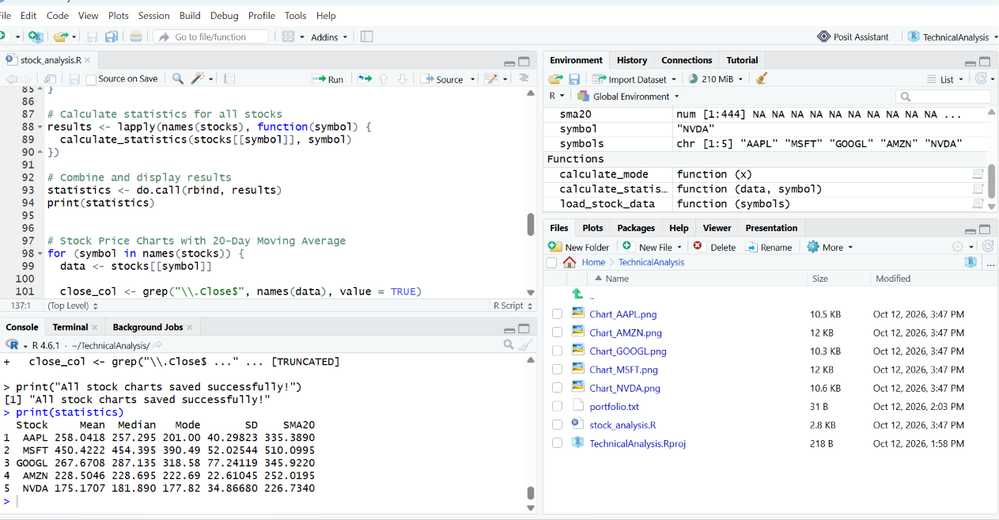
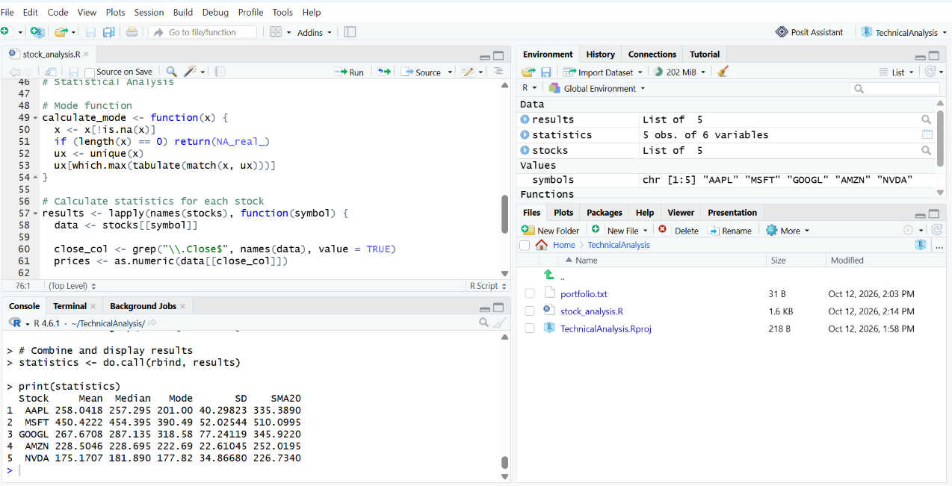

4. Technical Analysis and Stock Charts
The closing prices of the five selected stocks were plotted using R. Each chart includes a blue line representing the daily closing price and a red line representing the 20-day Simple Moving Average (SMA20).
The moving average helps identify general price trends by smoothing short-term price fluctuations. The charts allow a visual comparison of stock price movements and their moving averages.
4.1 Apple (AAPL)
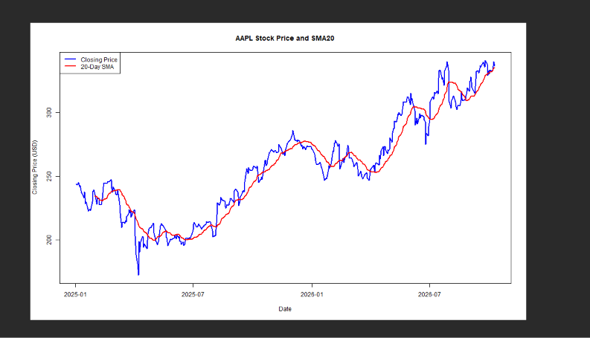

4.2 Microsoft (MSFT)
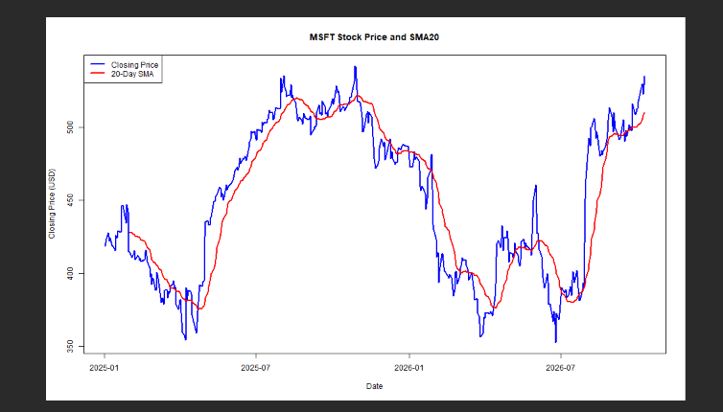

4.3 Alphabet (GOOGL) 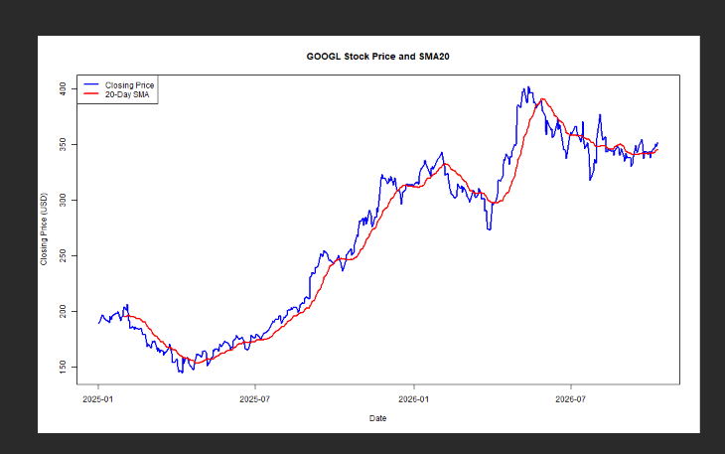

4.4 Amazon (AMZN)
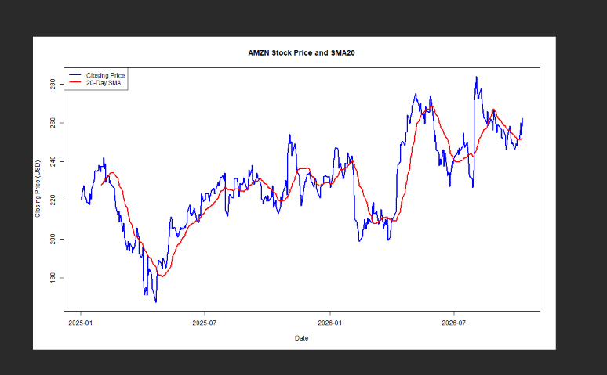

4.5 NVIDIA (NVDA)
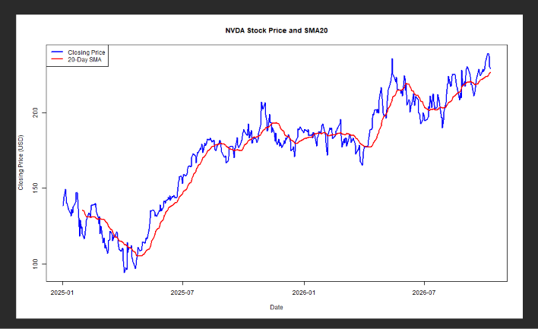

5. Conclusion
This assignment demonstrated how R can be used to perform technical analysis on five stocks: AAPL, MSFT, GOOGL, AMZN, and NVDA.
Historical stock data was retrieved from Yahoo Finance, and statistical measures were calculated to summarize closing price behavior. The 20-day Simple Moving Average (SMA20) was used alongside closing prices to visualize general price trends.
The analysis provided practical experience in using RStudio, the quantmod and TTR packages, and GitHub to organize and document a technical analysis project.

