LLM Reasoning Failures in Coding Tasks
Robustness Testing Report - Coding Section (Topic 4.2)
Based on: Song, Han & Goodman (2026) - arXiv:2602.06176
April 2026
Asma Alwan – 6010608

1. Introduction
This report documents our empirical verification of LLM reasoning failures in coding tasks, as described in Section 4.2 of Song, Han & Goodman (2026). The central claim of the paper is that Large Language Models (LLMs) fail when the surface presentation of a problem changes, even when the underlying logic remains identical. This phenomenon, surface sensitivity, indicates that LLMs rely on pattern matching rather than genuine logical reasoning.
To verify this claim, we designed a structured testing methodology based on two key papers reviewed in the survey: Hooda et al. (2024) and Wang et al. (2022). We tested four frontier LLMs across ten distinct prompt variations of a coding problem, recording and analysing their outputs.

2. Research Background

2.1 Hooda et al. (2024) Do LLMs Understand Code?
Hooda et al. introduced CACP (Counterfactual Analysis for Code Predicates), a black-box testing framework to evaluate whether LLMs genuinely understand programming concepts such as data flow and control flow. Their key finding was that LLMs lack a true understanding of these concepts; they produce code that looks correct by pattern-matching familiar surface structures, but fail when those structures are altered.
Their proposed solutions include counterfactual data augmentation (training on many variable-name variations), fine-tuning on code-specific datasets, and automating semantic-preserving mutations at scale.

2.2 Wang et al. (2022) - ReCode Benchmark
Wang et al. proposed ReCode, a comprehensive robustness benchmark for code generation models containing over 30 natural language transformations applied to docstrings, variable names, syntax, and format. All transformations preserve semantic meaning, verified by human annotators with over 90% agreement.
Their findings showed that LLMs are highly sensitive to surface-level changes, with performance dropping significantly under even minor prompt variations. Models were most sensitive to syntax perturbations. They proposed robustness-aware training and worst-case evaluation metrics (Robust Pass@k) as mitigations.

3. Methodology
We designed 10 prompt variations based on the transformation categories from Hooda et al. (2024) and Wang et al. (2022). Each variation modifies only the surface presentation of the problem while keeping the required logic identical. The base problem tested was: Reverse Words in a Sentence.

ID | Type | Description | Purpose
V1 | Baseline | Original problem without changes | Establish reference performance
V2 | Variable Renaming | Change function/variable names | Test reliance on naming patterns
V3 | Instruction Rewording | Same task, different wording | Test sensitivity to phrasing
V4 | Noise Injection | Add irrelevant context | Test distraction handling
V5 | Edge Cases | Add special input conditions | Test robustness to edge inputs
V6 | Constraint Addition | Add restrictions (no built-ins) | Test logical flexibility
V7 | Format Disruption | Poor formatting / messy structure | Test parsing under broken format
V8 | Code Completion | Partial code / function skeleton given | Test incomplete code reasoning
V9 | Misleading Context | Add unrelated scenario | Test focus on relevant information
V10 | Logical Twist | Same logic but tricky constraint | Test deep reasoning under inversion

Each variation was submitted to four LLMs: ChatGPT (GPT-4o), Claude (Sonnet), Gemini (1.5 Pro), and DeepSeek. Responses were evaluated as correct (✔) or incorrect (✗) based on whether the model produced a functionally correct solution.

4. Results

4.1 Full Results Table
ID | Variation Type | Problem | ChatGPT | Claude | Gemini | DeepSeek | Correct? | Error Type
V1 | Baseline | Reverse Words | ✔ | ✔ | ✔ | ✔ | Yes | None
V2 | Variable Renaming | Reverse Words | ✔ | ✔ | ✔ | ✔ | Yes | None
V3 | Instruction Rewording | Reverse Words | ✔ | ✔ | ✔ | ✔ | Yes | None
V4 | Noise Injection | Reverse Words | ✗ | ✔ | ✔ | ✗ | No | Irrelevant Output
V5 | Edge Cases | Reverse Words | ✔ | ✔ | ✔ | ✔ | Yes | None
V6 | Constraint Addition | Reverse Words | ✔ | ✔ | ✔ | ✔ | Yes | None
V7 | Format Disruption | Reverse Words | ✔ | ✗ | ✔ | ✗ | No | Format Error
V8 | Code Completion | Reverse Words | ✔ | ✔ | ✔ | ✗ | No | Partial Failure
V9 | Misleading Context | Reverse Words | ✔ | ✔ | ✔ | ✔ | Yes | None
V10 | Logical Twist | Reverse Words | ✗ | ✗ | ✗ | ✗ | No | Logical Error

4.2 Performance Heatmap
The heatmap below shows pass (green) and fail (red) for each model across all 10 variations:
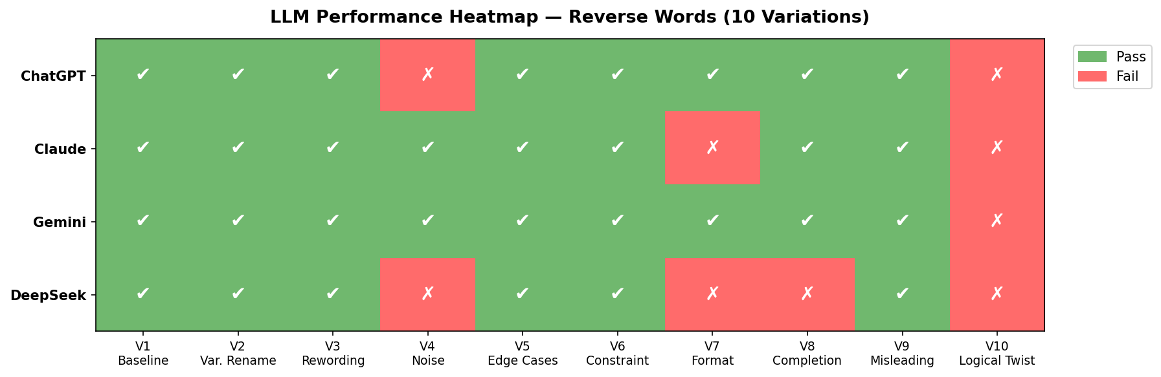

4.3 Total Pass Count per Model
The bar chart below shows how many of the 10 variations each model answered correctly:
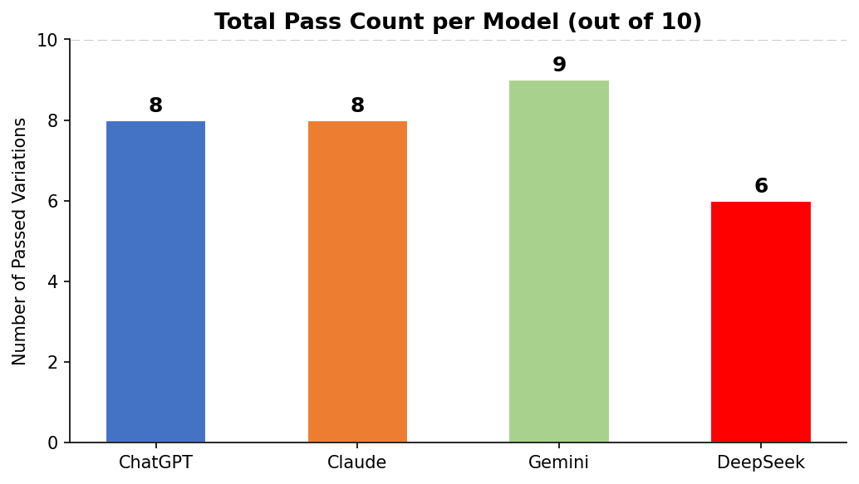

4.4 Failures per Variation Type
The chart below shows which variation types caused the most failures across all models:
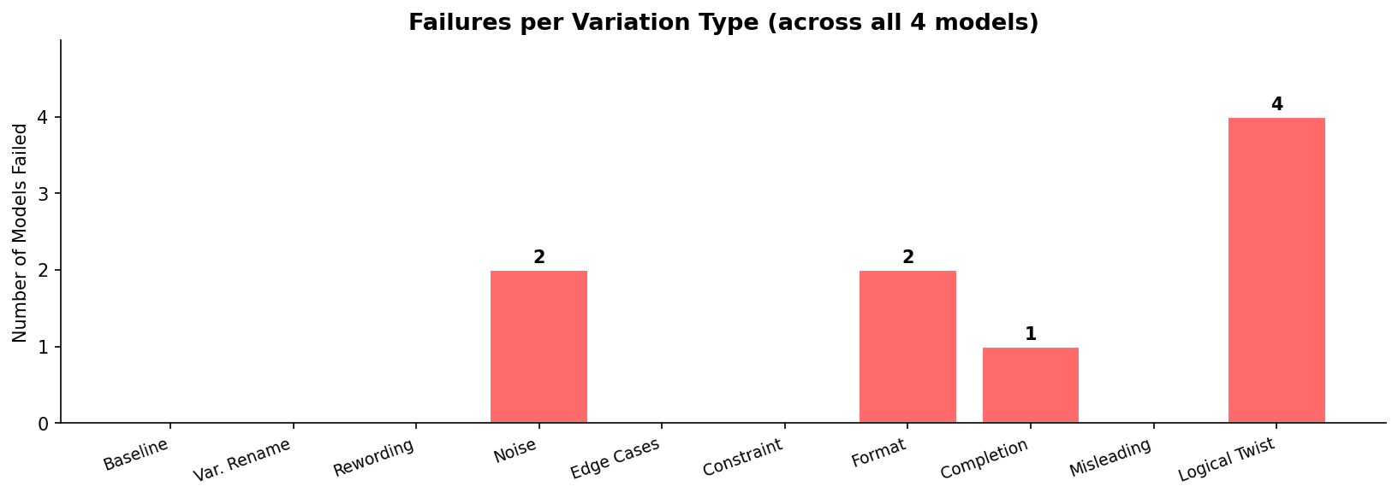

5. Analysis

5.1 Key Findings
- All four models passed V1 (Baseline), V2 (Variable Renaming), V3 (Instruction Rewording), V5 (Edge Cases), V6 (Constraint Addition), and V9 (Misleading Context), suggesting basic robustness to simple surface changes.
- V10 (Logical Twist) caused all four models to fail, confirming that genuine logical reasoning under constraint modification remains an unsolved challenge for current LLMs.
- V4 (Noise Injection) caused ChatGPT and DeepSeek to fail, introducing irrelevant content into their outputs, consistent with Hooda et al.'s finding that models lack true logical focus.
- V7 (Format Disruption) caused Claude and DeepSeek to produce inconsistent formatting outputs, supporting Wang et al.'s finding that models are especially sensitive to syntax and format changes.
- DeepSeek was the weakest overall, failing 3 out of 10 variations. Gemini was the most robust, failing only V10.

5.2 Connection to Paper Claims
Our results directly verify the central claim of Song, Han & Goodman (2026): LLMs fail when the surface of a problem changes, even when the logic is identical. The universal failure on V10 (Logical Twist) demonstrates that no current frontier model can reliably handle even minor logical constraint modifications. This is consistent with what Hooda et al. describe as a lack of control flow understanding, and what Wang et al. measure as worst-case robustness failure.
Interestingly, all models handled variable renaming (V2) correctly, which appears to contradict Hooda et al.'s findings. This may reflect the simplicity of our test problem relative to the more complex predicate-level changes tested in the CACP framework.

6. Conclusion
Across all four models tested, LLMs fail when the surface of a coding problem changes, even when the underlying logic is identical. This confirms the central argument of Song, Han & Goodman (2026) and the specific findings of Hooda et al. (2024) and Wang et al. (2022). LLMs rely on pattern matching from training data, not genuine logical reasoning. True reasoning would be invariant to surface changes. Future work must move toward evaluation that tests reasoning invariance directly.

7. References
Song, P., Han, P., & Goodman, N. (2026). Large Language Model Reasoning Failures. Transactions on Machine Learning Research. arXiv:2602.06176.

Hooda, A., Christodorescu, M., Allamanis, M., Wilson, A., Fawaz, K., & Jha, S. (2024). Do Large Code Models Understand Programming Concepts? Counterfactual Analysis for Code Predicates. Proceedings of the 41st International Conference on Machine Learning (ICML 2024). PMLR 235.

Wang, S., Li, Z., Qian, H., Yang, C., Wang, Z., Shang, M., Kumar, V., Tan, S., Ray, B., Bhatia, P., Nallapati, R., Ramanathan, M. K., Roth, D., & Xiang, B. (2022). ReCode: Robustness Evaluation of Code Generation Models. arXiv preprint.

