Reasoning Failures in Large Language Models
1. Introduction
Large Language Models (LLMs) are widely used to solve different types of problems. However, their reasoning abilities are not always reliable.
The goal of this project is to test whether LLMs truly understand problems or rely on patterns.
2. Methodology
We designed a set of 10 reasoning questions targeting different failure types, including:
- Arithmetic reasoning
- Logical reasoning
- Probability reasoning
- Language ambiguity
We tested four LLMs:
- ChatGPT
- Gemini
- DeepSeek
- Claude
Each model was evaluated based on whether it produced a correct answer.
3. Results
The results are summarized in the table below:
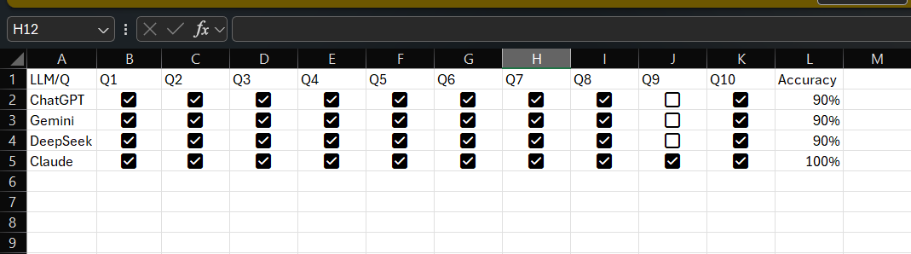

Overall accuracy:
- ChatGPT: 90%
- Gemini: 90%
- DeepSeek: 90%
- Claude: 100%
4. Analysis
The results show that most models perform well on standard reasoning tasks.
However, failures were observed in specific cases.
One key example is Question 9, which contains ambiguity in language.
Most models provided only one answer, while the correct solution has two possible interpretations.
This indicates that LLMs may struggle with understanding context and language ambiguity.
Additionally, the results suggest that LLMs rely on learned patterns rather than true reasoning in some cases.
5. Discussion
The experiment supports findings from previous research that LLMs are sensitive to problem formulation.
Small changes in wording or structure can affect performance.
Although models perform well on simple tasks, more complex reasoning and ambiguous scenarios still present challenges.
6. Conclusion
In conclusion, LLMs demonstrate strong performance in many reasoning tasks.
However, they are not fully reliable, especially in cases requiring deeper understanding.
LLMs can solve problems, but they do not always truly understand them.

