HOMEWORK 1 SCREENSHOTS

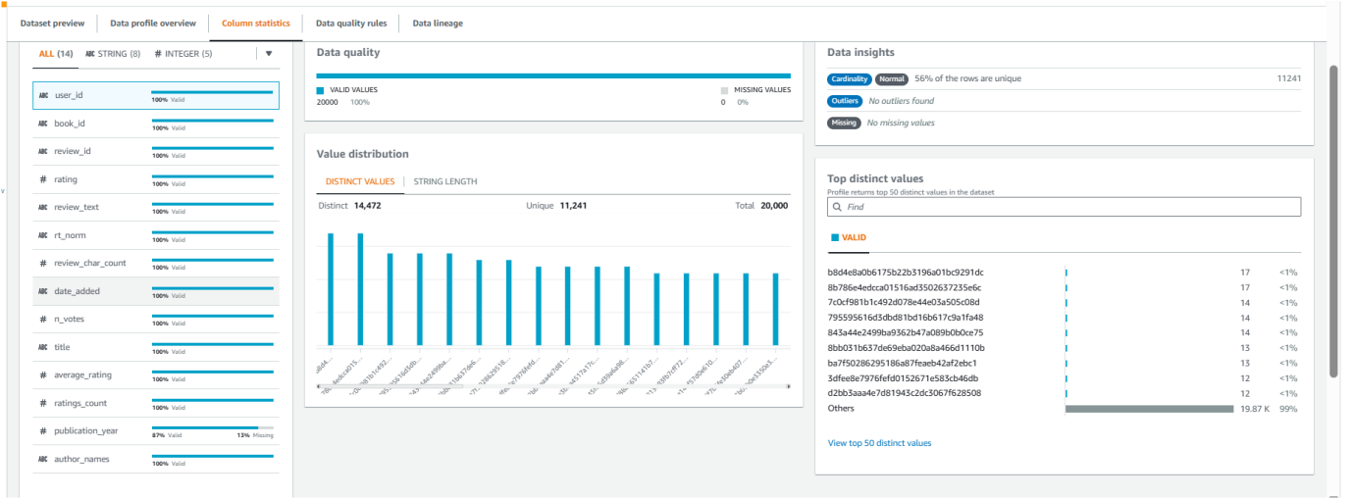
The column statistics shows that there are 14 columns 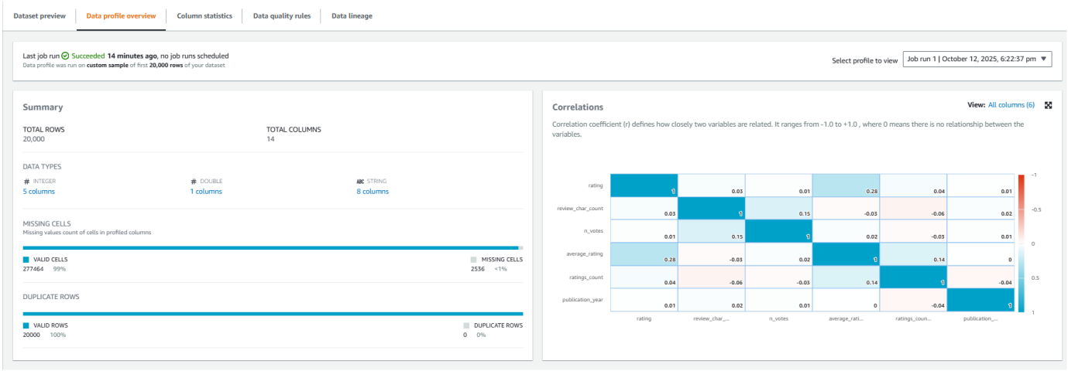
The data statistics shows us that there 20000 rows and integer,double and string data types and there are few missing cells
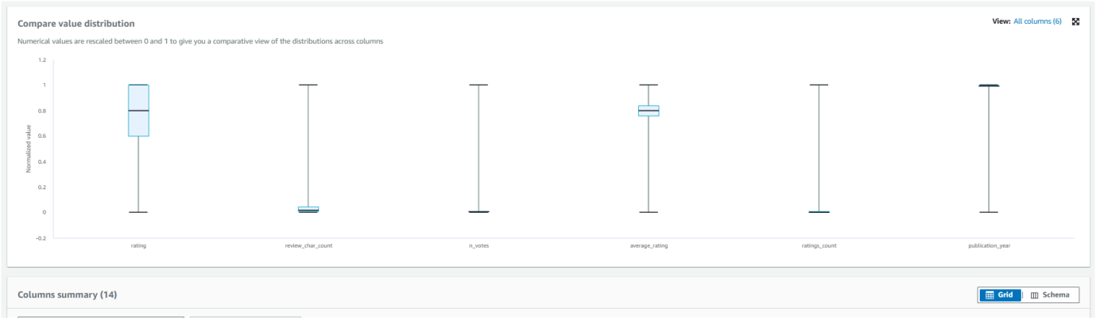

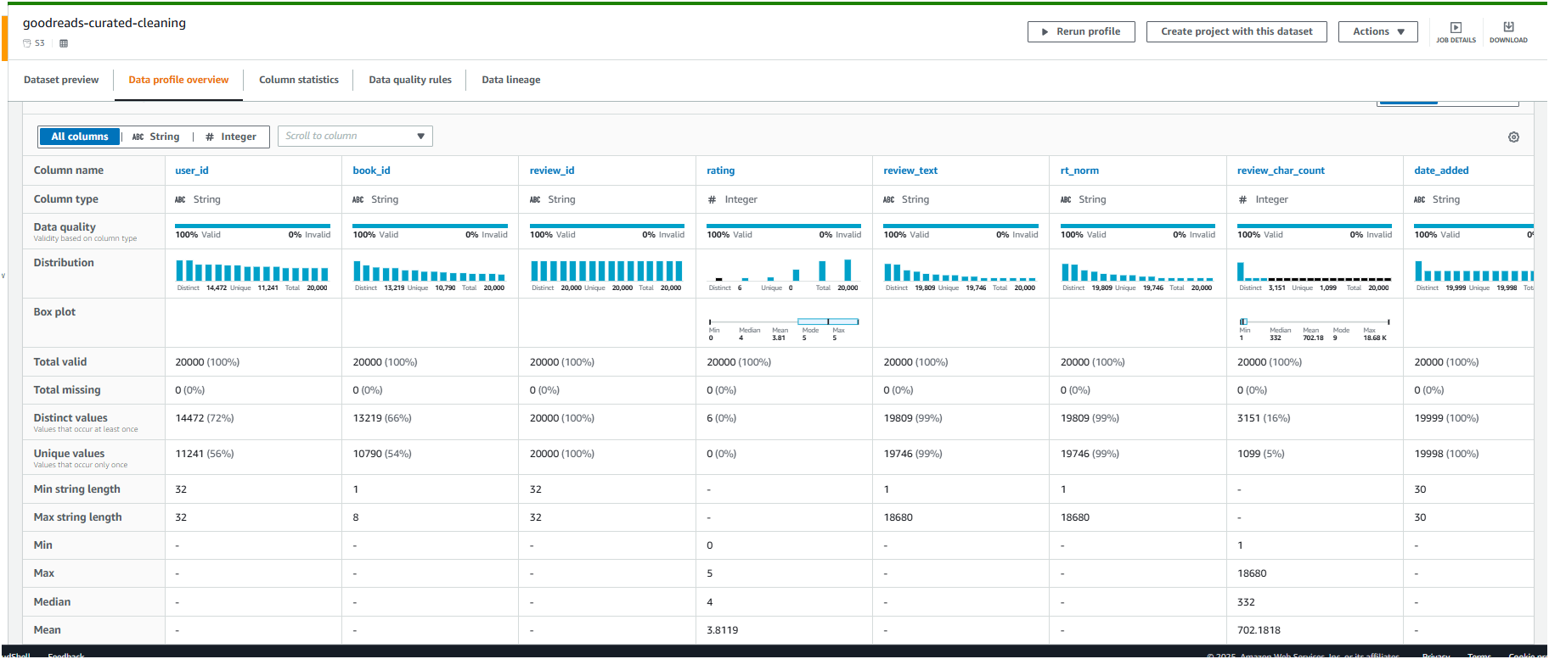

Data quality every Sunday within 12 hrs

HOMEWORK PART 2
QUESTION 1
Option 1
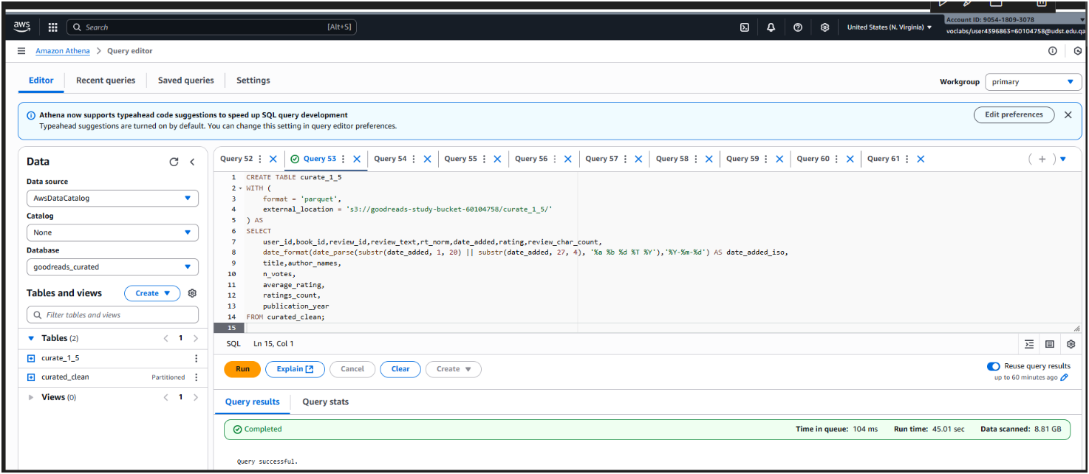
Imported the old recipies
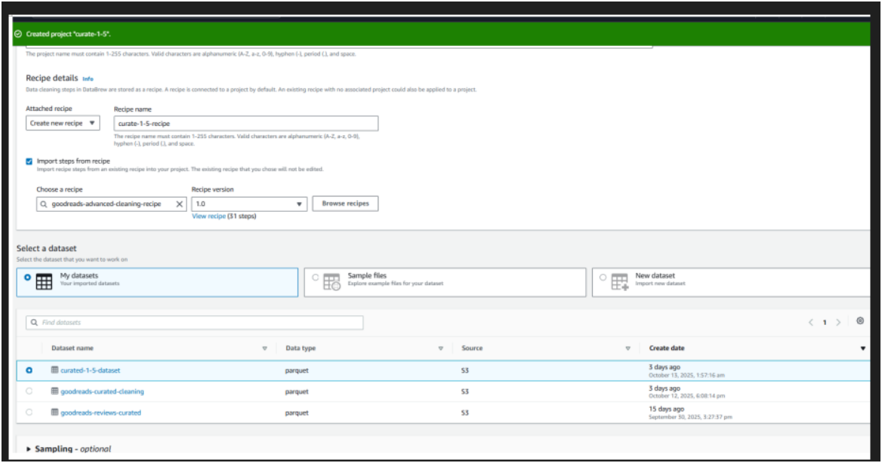
Created iso date column using athena query
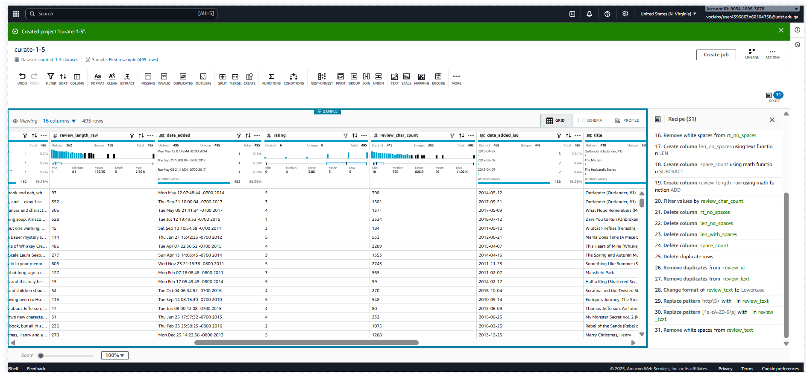
Final recipe with option 1
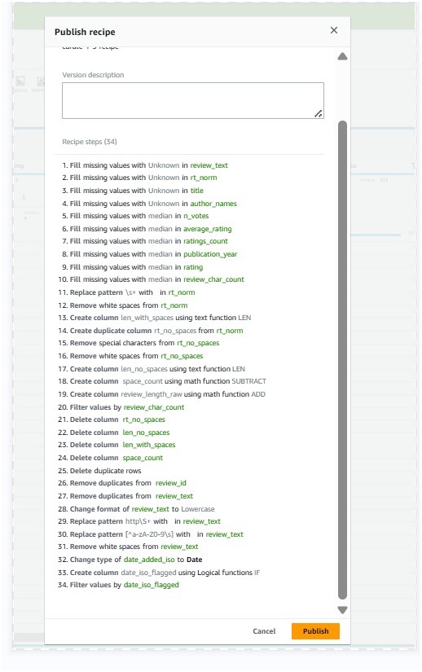

Using Option 1, done question 2 - the filtering part
Filtered using flagged method, everything before 2014 was flagged as 0
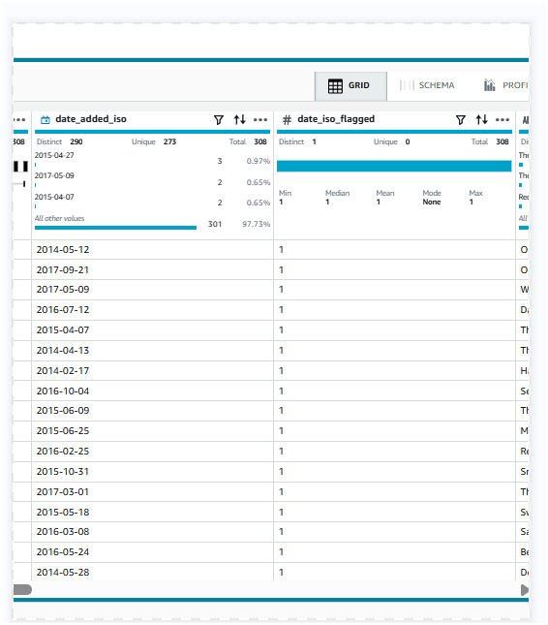

Deleted option1 to try option 2
After option 2 and question 2 of homwork part 2
- used option 2 here were year, date and day were extracted
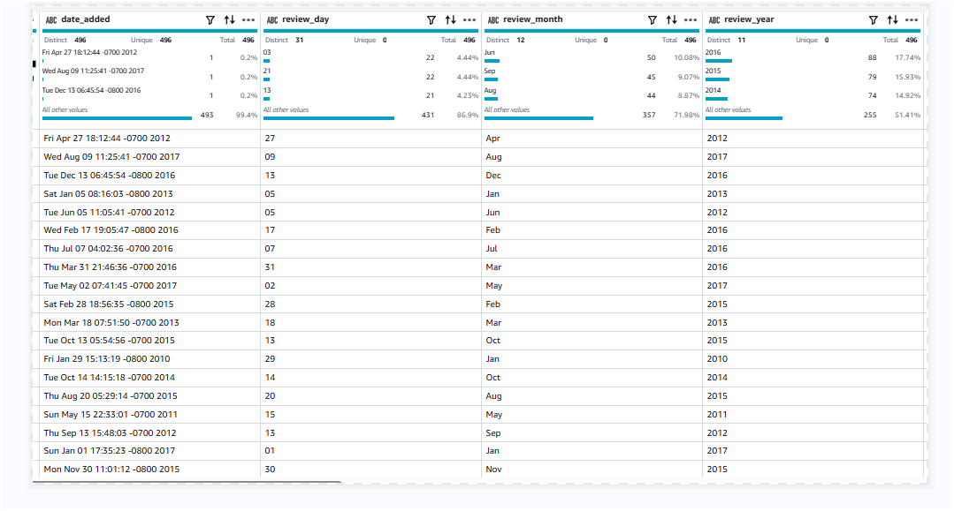
Merged into one columns
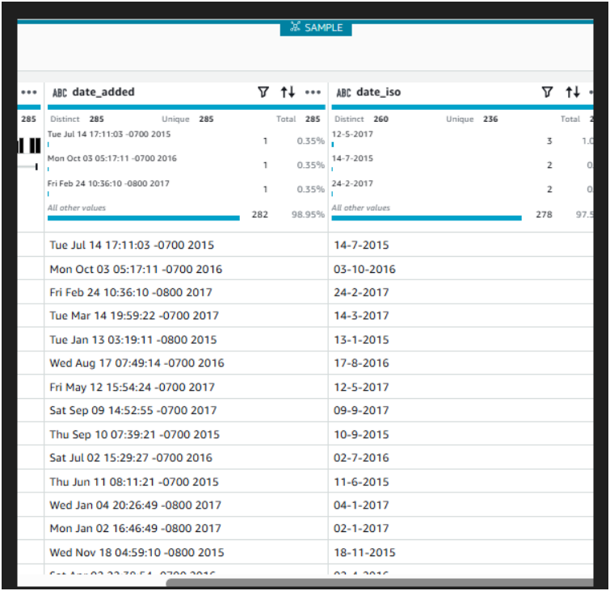
Filter the columns using the extracted year column
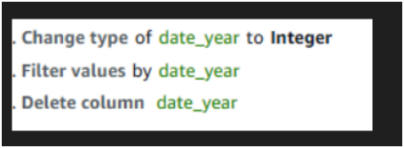

HOMEWROK 3

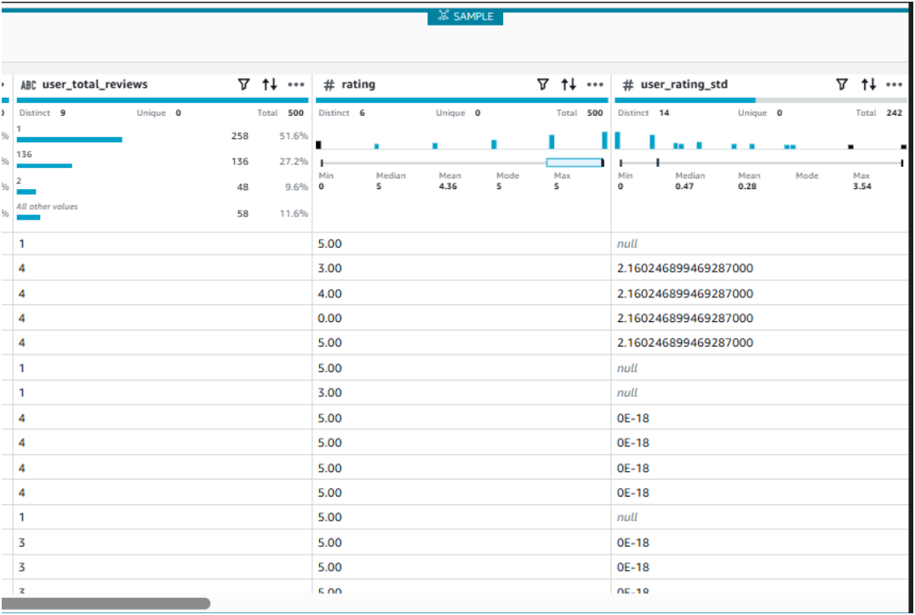
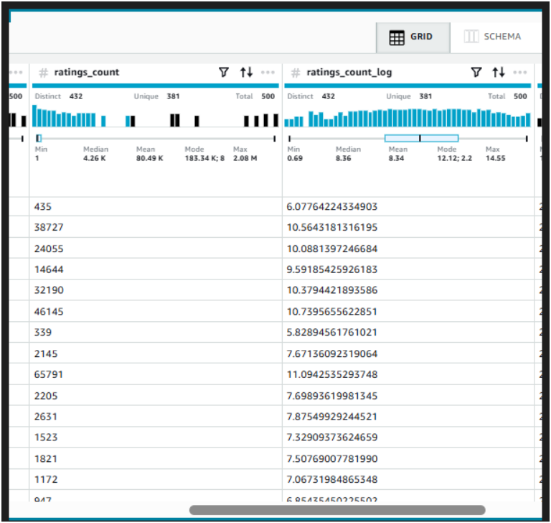
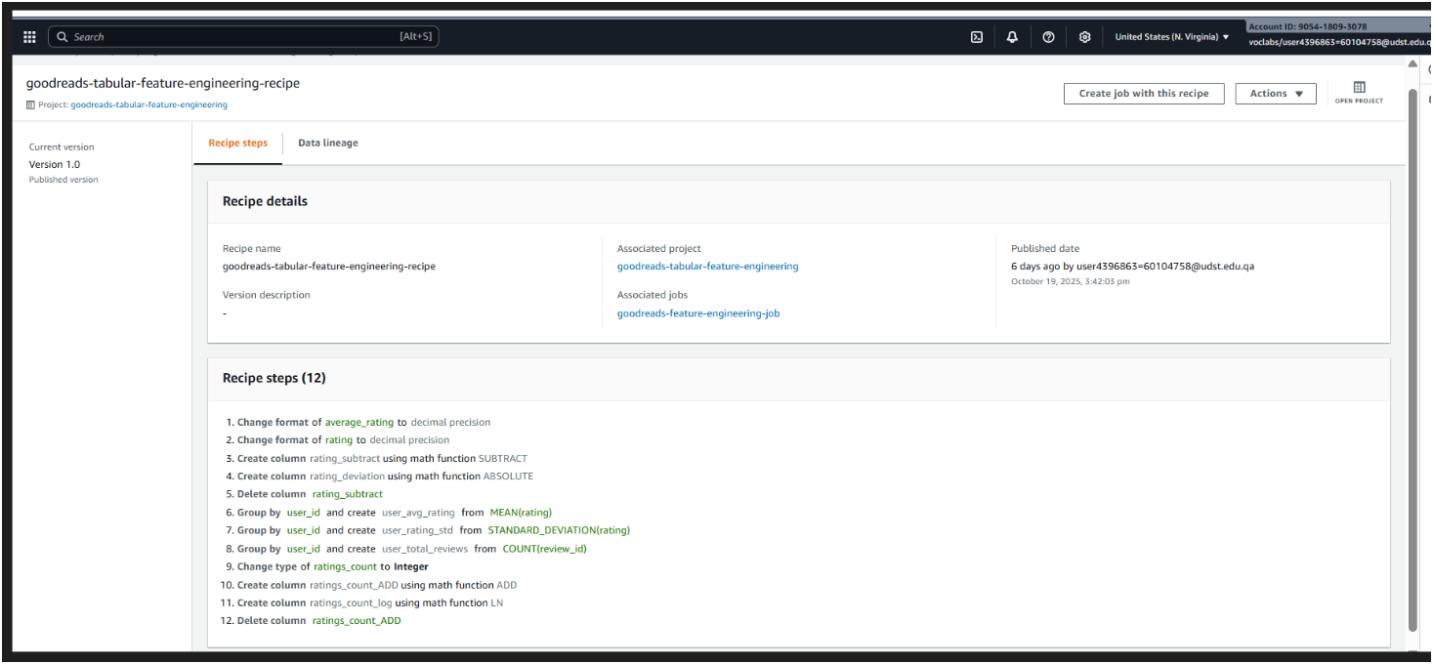
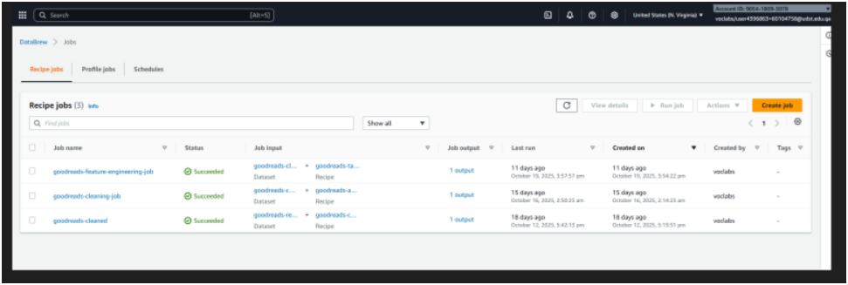
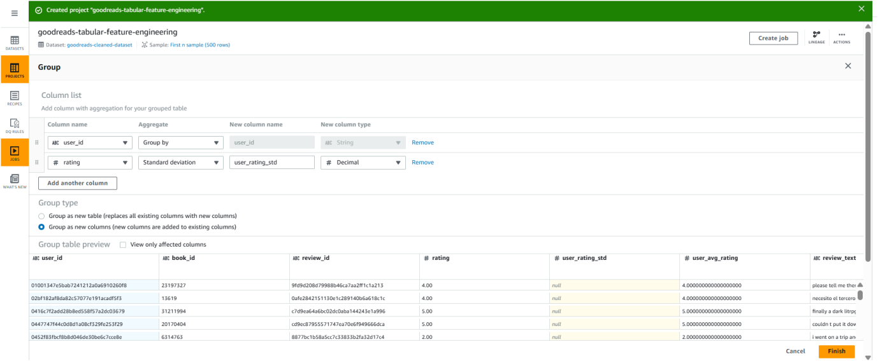
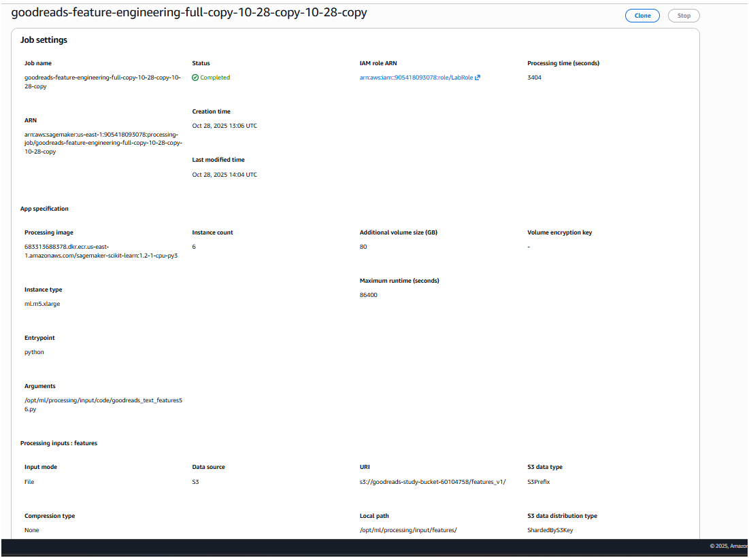

HOMEWORK 4
Trial output on 2000 rows
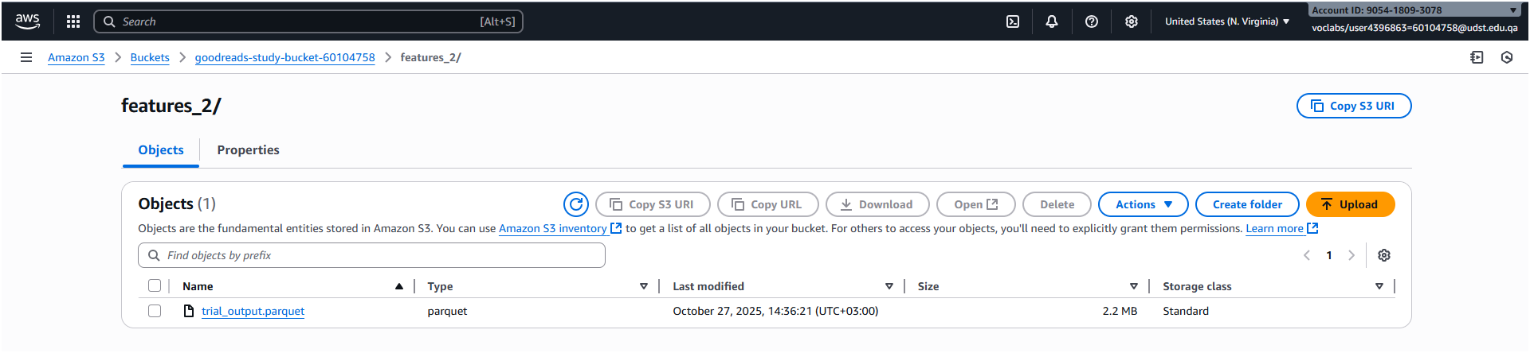

Trial output on 500
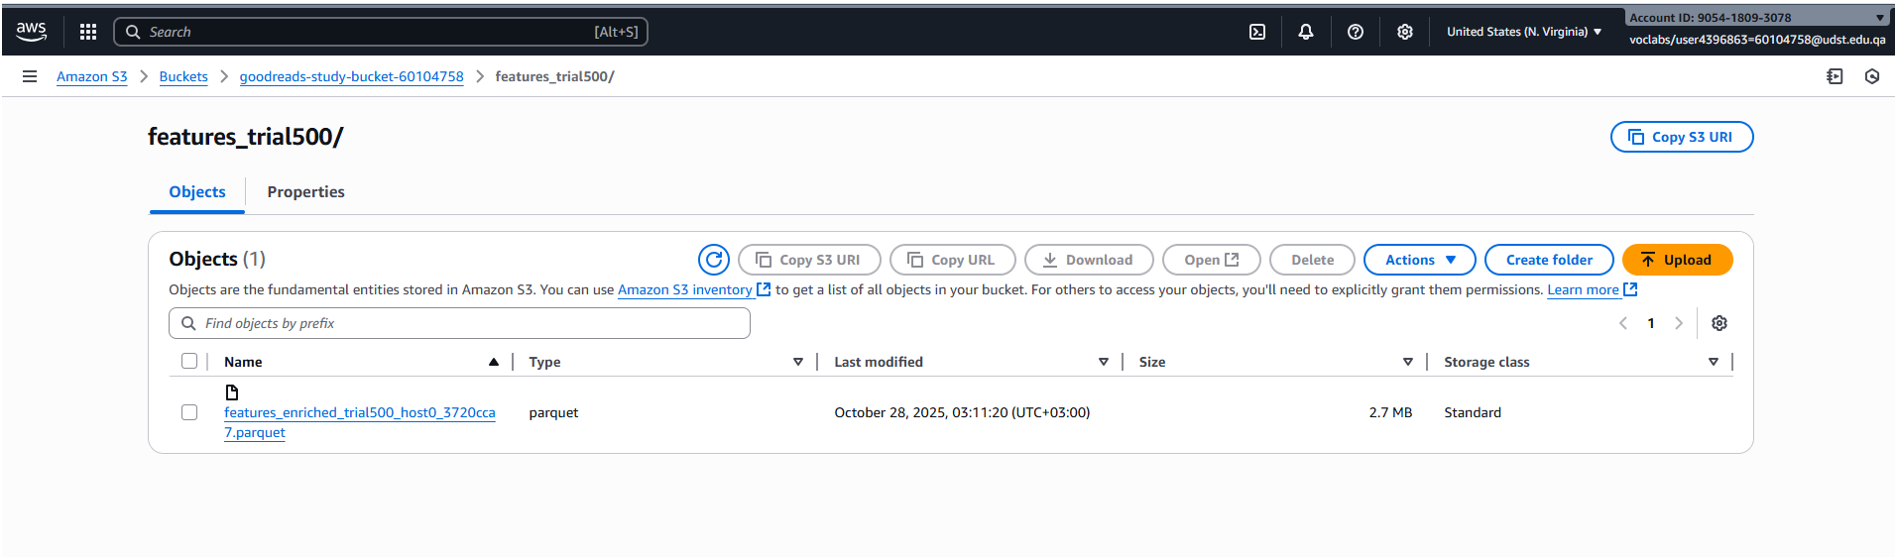
Full feature output with few options disabled
