StatioPoint
Point-of-Sale System for Retail Stationery

Foundation of Software Engineering
Deliverable # 2 — Iteration 1 / Sprint 1

FAST National University of Computer & Emerging Sciences

Submitted by:
Hanan Ishaq — 24L-2537
Mohid Israr — 24L-2510
Spring 2026

1. Project Introduction
StatioPoint is a web-based Point-of-Sale (POS) system designed specifically for small to medium-sized retail stationery shops in Pakistan. The platform enables shop owners and cashiers to manage day-to-day sales operations, track inventory, monitor business performance through analytics, and maintain employee records — all from a single, intuitive web interface.
The system is built using a modern 3-tier architecture: a responsive HTML/CSS/JS frontend for user interaction, a Node.js (Express) business logic layer for processing, and a Microsoft SQL Server relational database backend for data persistence. StatioPoint brings the efficiency of enterprise-grade retail software to local stationery businesses that traditionally rely on manual, paper-based operations.
Iteration 1 focuses on the core foundation of the platform: secure user authentication with role-based access control, enabling Admin and Cashier users to access their respective dashboards after login, and providing profile management. These four user stories — User Login, Admin Dashboard, User Profile Management, and Role-Based Access Control — form the minimum viable product (MVP) upon which all subsequent iterations will build.

2. Sprint 1 Backlog — User Stories
Module: User Authentication & Role-Based Access Control
Story ID: US-01 Story Title: User Login & Authentication | Priority: High
Estimated Hours: | 10 hrs
User Story:
As a shop employee (Admin or Cashier), I want to log into the StatioPoint system using my username and password so that I can securely access my role-specific dashboard and perform my duties.
Acceptance Criteria:
- The login form must accept a username and password field.
- The system must validate credentials against the Users table in the database.
- On successful login, the system must generate a JWT token valid for 8 hours.
- Admin users must be redirected to the Admin Dashboard after login.
- Cashier users must be redirected to the Cashier Checkout panel after login.
- If credentials are incorrect, a clear error message must be displayed.
- The role selector chips (Admin / Cashier) must match the actual role stored in the database.
- The login button must be disabled while the authentication request is pending.

Story ID: US-02 Story Title: Admin Dashboard Overview | Priority: High
Estimated Hours: | 14 hrs
User Story:
As an Admin, I want to view a comprehensive dashboard showing today's revenue, items sold, low stock alerts, a weekly sales chart, and recent transactions so that I can monitor the shop's daily performance at a glance.
Acceptance Criteria:
- The dashboard must display three KPI cards: Today's Revenue, Items Sold, and Low Stock Alerts.
- KPI values must be fetched dynamically from the database on every page load.
- A line chart must show revenue trends for the last 7 days.
- A Recent Transactions table must show the last 5 sales with product name, category, quantity, amount, and status.
- The dashboard must only be accessible to users with the Admin role.
- Cashiers must be redirected away from the admin panel if they attempt to access it.
- Quick Action buttons (Manage Users, View Reports) must be present on the dashboard.

Story ID: US-03 Story Title: User Profile Management | Priority: High
Estimated Hours: | 10 hrs
User Story:
As a logged-in user (Admin or Cashier), I want to view and edit my profile information including my full name, email, phone, and branch, and change my password so that my account details remain accurate and secure.
Acceptance Criteria:
- The profile page must display the user's full name, username, email, phone, role, and branch.
- The username and role fields must be read-only and cannot be edited by the user.
- The user must be able to update full name, email, phone, and branch.
- Updated values must be saved to the Users table in the database.
- A success message must be shown after a profile update is saved.
- The change password form must require the current password before allowing a new one.
- New password must be a minimum of 6 characters.
- Passwords must be stored using bcrypt hashing — never plain text.

Story ID: US-04 Story Title: Cashier Checkout & Sales Processing | Priority: High
Estimated Hours: | 16 hrs
User Story:
As a Cashier, I want to search for products, add them to a cart, and process a sale with cash or card payment so that I can serve customers quickly and accurately while updating stock levels automatically.
Acceptance Criteria:
- The checkout screen must display a searchable product grid loaded from the database.
- Products must be filterable by category using chip buttons.
- Clicking a product must add it to the cart with quantity control (+/-) buttons.
- Out-of-stock products must be visually disabled and cannot be added to the cart.
- Low-stock products must show a warning badge with remaining quantity.
- The cart must display a running total amount updated in real time.
- The cashier must be able to select Cash or Card payment method.
- On processing a sale, the system must insert records into Sales and SaleItems tables.
- Stock levels in the Products table must be decremented automatically after each sale.
- A success message must confirm the completed sale with the total amount.

Story ID: US-05 Story Title: Admin User Management | Priority: Medium
Estimated Hours: | 8 hrs
User Story:
As an Admin, I want to view all registered users, add new cashier accounts, and deactivate existing cashiers so that I can control who has access to the StatioPoint system.
Acceptance Criteria:
- The Users Management screen must display all active users in a table.
- Each user row must show full name, email, role, branch, and active status.
- The Admin must be able to add a new cashier by filling in a modal form.
- The new cashier form must include: full name, username, email, phone, password, and branch.
- New cashier passwords must be hashed with bcrypt before storing in the database.
- Duplicate usernames must be rejected with an appropriate error message.
- The Admin must be able to deactivate (soft delete) a cashier account.
- Deactivated users must not be able to log in.
- Admins cannot be removed from the users table through the UI.

3. Structured Specifications
Structured specifications are written for each sub-user story of all Sprint 1 user stories, covering Functional, Security, UX, and Performance types as required.

US-01: User Login & Authentication
US-01.1: Role chip validation before login
Type | Specification
Functional | The login form must present two role chips — Cashier and Admin — and exactly one must be selected before submission is allowed.
Functional | The backend must verify that the selected role matches the role stored in the database for the given username.
UX | If the role does not match, the system must display: "This account is not a [role] account. Please select the correct role."

US-01.2: JWT token generation and route protection
Type | Specification
Security | On successful login, the server must generate a signed JWT token containing the user's id, username, fullName, and role.
Security | The JWT token must have an expiry of 8 hours to limit the risk of token misuse.
Functional | All protected API routes (/api/admin/*, /api/cashier/*, /api/profile/*) must reject requests without a valid token with HTTP 401.

US-01.3: Login button state during request
Type | Specification
UX | The Sign In button must be disabled and show "Signing in..." text while the authentication request is in progress.
UX | On a failed request, the button must re-enable and display the original "Sign In →" text.
Functional | The form must prevent submission if either the username or password field is left empty.

US-02: Admin Dashboard Overview
US-02.1: KPI card data accuracy
Type | Specification
Functional | Today's Revenue must be calculated as the SUM of totalAmount from the Sales table where saleDate equals today's date and status is "paid".
Functional | Items Sold must reflect the SUM of quantity from SaleItems joined with today's Sales records.
UX | KPI cards must display a coloured accent line at the bottom: Gold for Revenue, Teal for Items Sold, Red for Low Stock Alerts.

US-02.2: Weekly sales line chart
Type | Specification
Functional | The chart must display revenue data for the last 7 days grouped by date, fetched from the Sales table.
UX | The chart line must be rendered in Teal colour with a gradient fill beneath it. The last data point must be highlighted in Gold to indicate today.
Functional | If no sales data exists for a day, that day must still appear on the chart with a zero value.

US-02.3: Recent transactions table
Type | Specification
Functional | The table must fetch the 5 most recent sales records joined with SaleItems, Products, and Users tables.
UX | Each row must display: product name, category, quantity, amount (in gold text), and a coloured status badge (green for Paid, red for Pending).
Functional | The table must update every time the dashboard screen is loaded or refreshed.

US-03: User Profile Management
US-03.1: Editable vs read-only fields
Type | Specification
Functional | The profile form must allow editing of: Full Name, Email, Phone, and Branch fields.
Security | The Username and Role fields must be rendered as read-only and cannot be modified by any user through the UI.
UX | Read-only fields must appear visually greyed-out so users understand they cannot be changed.

US-03.2: Password change validation
Type | Specification
Security | The system must verify the current password by comparing it with the bcrypt hash stored in the database before allowing a password change.
Functional | If the current password is incorrect, the system must return HTTP 401 with message: "Current password is incorrect."
Functional | The new password must be a minimum of 6 characters. Shorter passwords must be rejected with a validation message.

US-03.3: Profile update success feedback
Type | Specification
UX | A visible toast notification must appear at the bottom-right of the screen after a profile update is saved, confirming the action with a green success message.
Functional | On saving, the updated values must be written to the Users table in the database and the profile form must reflect the new values immediately.
UX | If the update fails (e.g. server error), a red error toast must appear with a readable error message.

US-04: Cashier Checkout & Sales Processing
US-04.1: Product search and filtering
Type | Specification
Functional | The search bar must filter the product grid in real time based on keywords matching the product name or SKU.
Functional | Category filter chips must filter products by their category field in the Products table.
UX | Out-of-stock products must be visually disabled (greyed-out cards) and clicking them must have no effect.

US-04.2: Cart management and total calculation
Type | Specification
Functional | Adding a product to the cart must increment its quantity if already present, rather than adding a duplicate entry.
Functional | The cart total must update instantly whenever items are added, removed, or quantity is changed.
UX | The cart must display a running item count badge on the cart icon updating in real time.

US-04.3: Sale processing and stock update
Type | Specification
Functional | On processing a sale, the system must insert one record in the Sales table and one record per item in the SaleItems table within a single transaction.
Functional | After a successful sale, the stock field in the Products table must be decremented by the sold quantity for each product.
UX | A green success toast must confirm the completed sale showing the total amount. The cart must be cleared automatically after a successful sale.

US-05: Admin User Management
US-05.1: Add new cashier validation
Type | Specification
Functional | The Add Cashier form must require: Full Name, Username, Email, Password, and Branch. All fields must be validated before submission.
Functional | If the submitted username already exists in the Users table, the system must return HTTP 409 with message: "Username already taken."
Security | The new cashier's password must be hashed using bcrypt with salt rounds of 10 before being stored in the database.

US-05.2: User deactivation (soft delete)
Type | Specification
Functional | Removing a cashier must set their isActive field to 0 in the Users table rather than permanently deleting the record.
Security | Deactivated users (isActive = 0) must be rejected at login with the message: "Invalid username or password."
UX | A confirmation prompt must appear before deactivating a user to prevent accidental removal.

US-05.3: Role-based access enforcement
Type | Specification
Security | All admin-only API routes must use the adminOnly middleware which checks req.user.role === "admin" and returns HTTP 403 if the check fails.
Functional | If a cashier attempts to access the admin panel URL directly, the frontend must detect the role mismatch and redirect to the cashier panel.
Security | JWT tokens must be verified on every protected API request using the verifyToken middleware before any business logic executes.

4. Scrum Board (Trello)
Three snapshots of the Trello board are provided below, representing the start, middle, and end of Sprint 1. The board was organized into four columns: To Do, In Progress, Done, and Leftover.
Snapshot 1 — Sprint Start
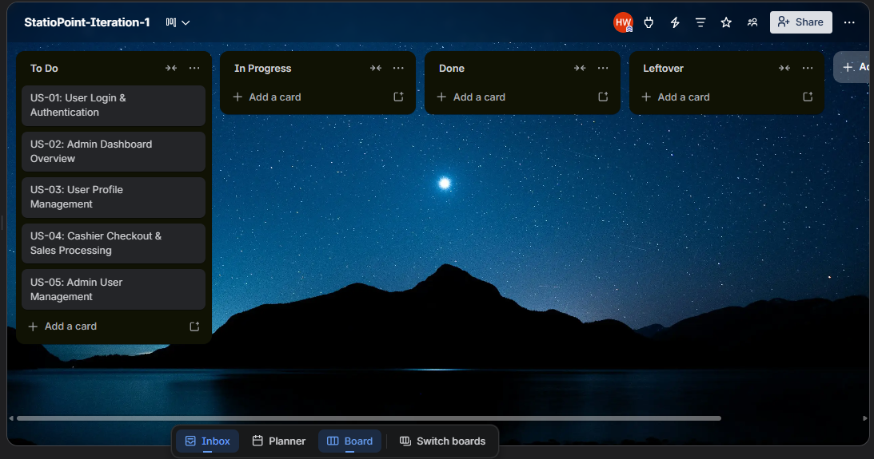
Snapshot 2 — Mid Sprint
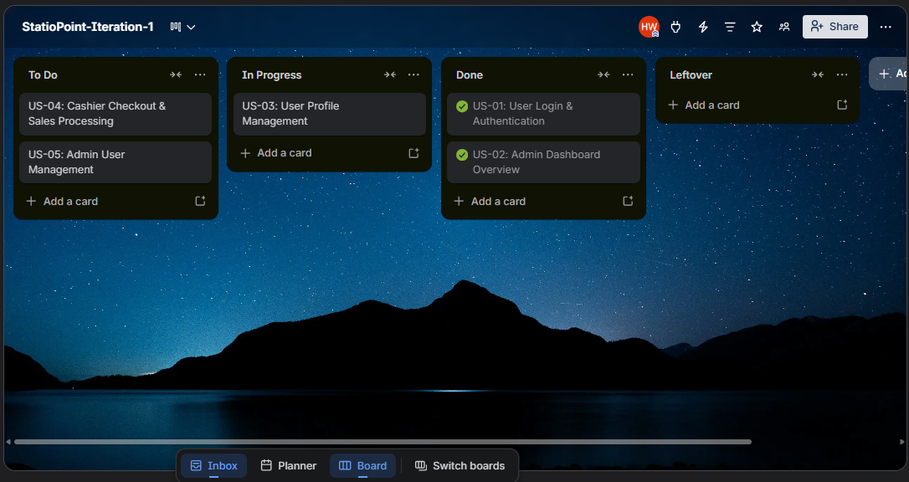
Snapshot 3 — Sprint End
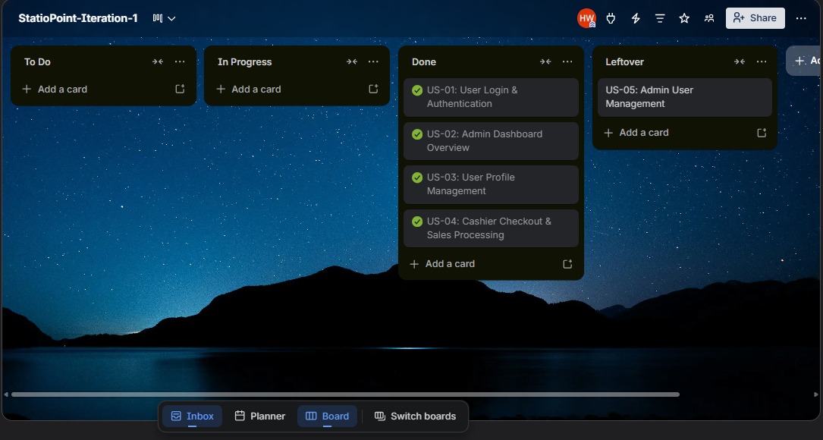

Burn-down Chart
The burn-down chart below shows the planned versus actual work remaining across Sprint 1 (14 days). Total estimated effort was 58 hours across all five user stories.
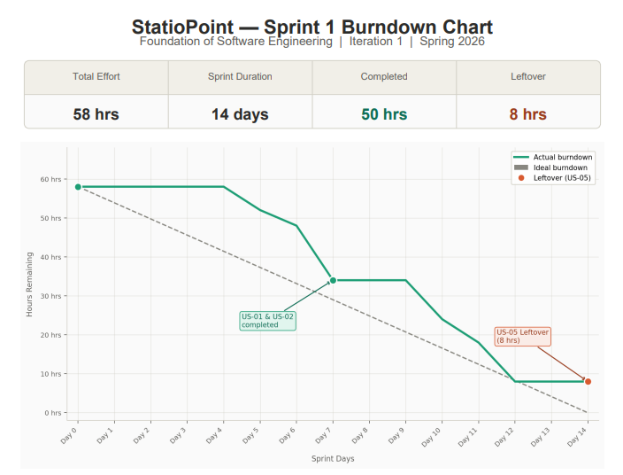
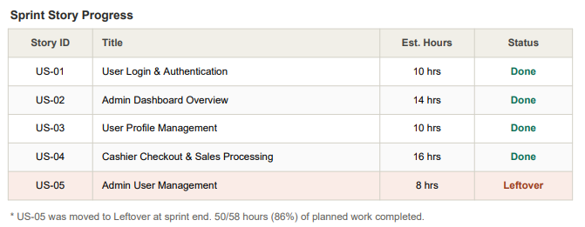

5. Non-Functional Requirements (NFR) Specification
The following non-functional requirements describe the quality expectations for the StatioPoint system beyond its core features. These requirements apply across all user stories in Iteration 1.
NFR Category | Metric / Target | Description
Usability | Responsive UI | The interface must be fully usable on both desktop and laptop screen sizes. All buttons, inputs, and tables must be clearly visible and accessible without horizontal scrolling.
Security | Password hashing | User passwords must never be stored in plain text. Bcrypt hashing with 10 salt rounds must be applied to all passwords before inserting into the database.
Security | Protected routes | Pages such as the Admin Dashboard, User Management, Reports, and Profile must not be accessible without a valid JWT token. Any unauthenticated request to a protected route must return HTTP 401.
Security | Role isolation | Admin-only routes must be protected by the adminOnly middleware. A cashier must never be able to access admin data or functionality through any API endpoint.
Reliability | Error handling | The application must handle failed API calls gracefully and display a readable toast notification to the user rather than crashing or showing raw error messages.
Maintainability | Code structure | The backend codebase must be organized into separate modules for routes, middleware, and configuration. Each route file must handle only one domain (auth, admin, cashier, profile).
Performance | Page load time | The dashboard KPI cards and recent transactions must load and render within 3 seconds on a standard local network connection.
Usability | Form validation | All input forms must validate required fields before submission and prevent empty submissions with appropriate inline error messages.

6. Iteration 1 — Implementation Screenshots
The following screenshots demonstrate the working implementation of all user stories developed in Sprint 1. The system is built with Node.js (Express) backend, MSSQL database, and HTML/CSS/JS frontend.
US-01 — Login Page (Role-Based)

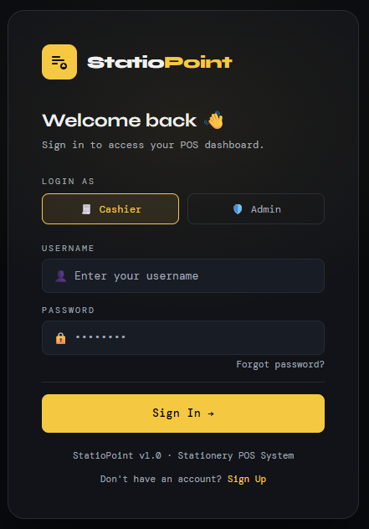
US-02 — Admin Dashboard
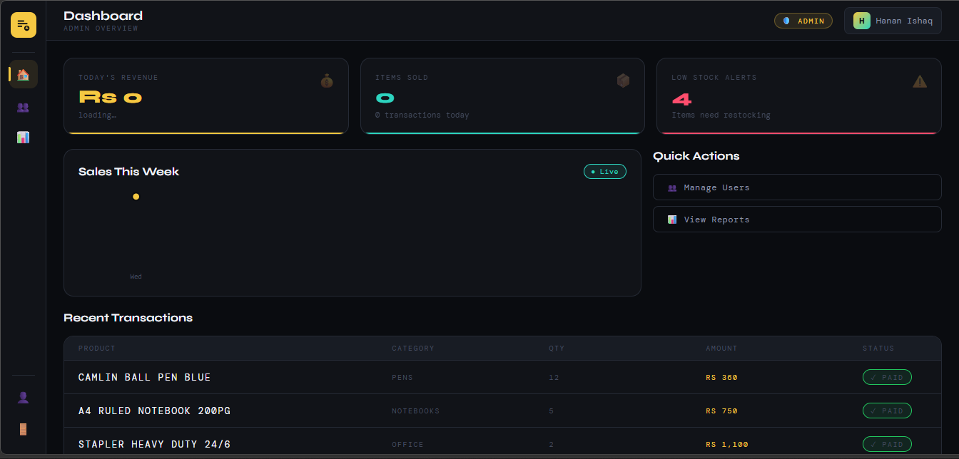
US-03 — User Profile Page
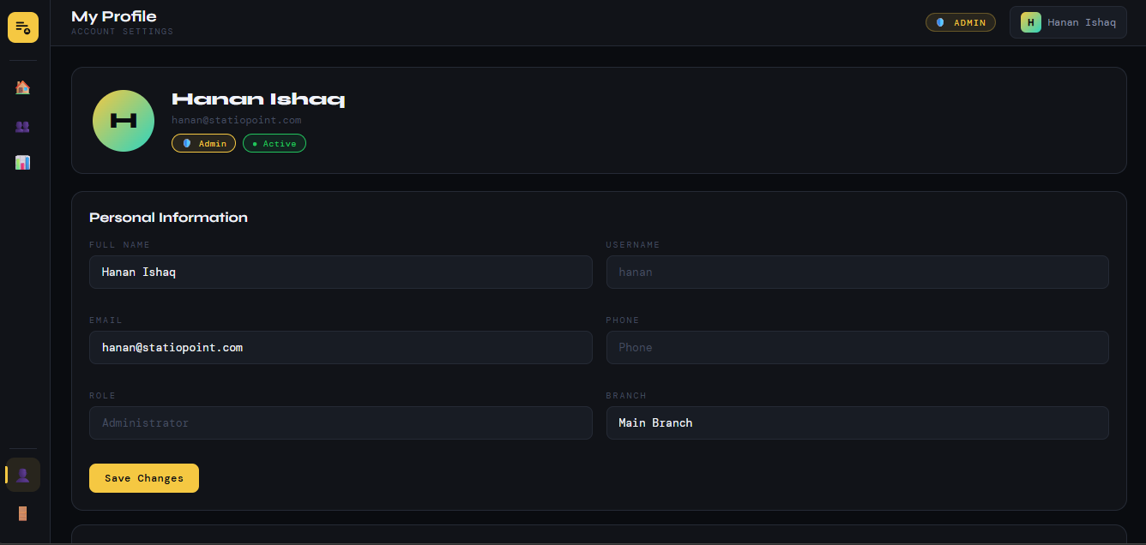
US-04 — Cashier Checkout Panel
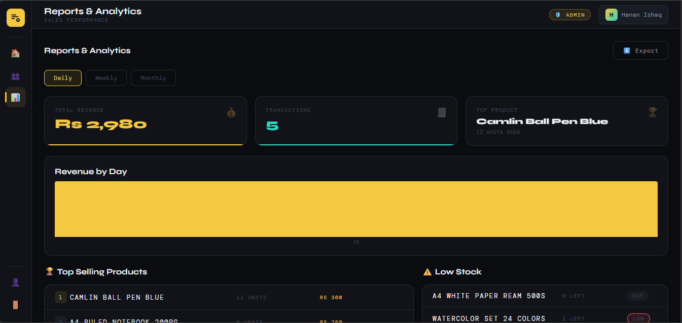
US-05 — Admin User Management
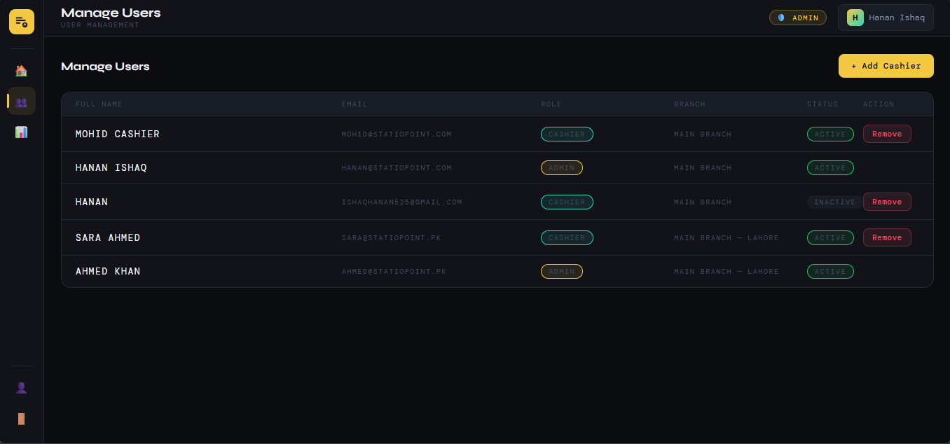

7. Work Division — Sprint 1
The following table outlines the tasks performed by each team member during Sprint 1:
Team Member | Role | Tasks Performed in Sprint 1
Mohid Israr (24L-2510) | Team Lead & Backend Lead | Database schema design (Users, Products, Sales, SaleItems tables). SQL script with sample data. Node.js server setup and Express configuration. JWT authentication implementation. Admin routes (dashboard KPIs, user management, reports). Middleware (verifyToken, adminOnly). DB connection with Windows Authentication.
Hanan Ishaq (24L-2537) | Frontend Developer & Cashier Module | Login page HTML/CSS/JS with role chip selector. Admin panel frontend (admin.html) — dashboard, users, reports screens. Cashier panel frontend (cashier.html) — checkout cart, product grid, my sales. Profile screen for both roles. Frontend API integration using Fetch API. Toast notifications and client-side routing.

