StatioPoint
Point-of-Sale System for Retail Stationery

Fundamentals of Software Engineering

Deliverable # 3 — Iteration 2 / Sprint 2

FAST National University of Computer & Emerging Sciences

Submitted by:

Hanan Ishaq — 24L-2537
Mohid Israr — 24L-2510

Spring 2026
Date of Submission: 13 April 2026

1. Project Introduction
StatioPoint is a web-based Point-of-Sale (POS) system designed specifically for small to medium-sized retail stationery shops in Pakistan. The platform enables shop owners and cashiers to manage day-to-day sales operations, track inventory, monitor business performance through analytics, and maintain employee records — all from a single, intuitive web interface.
The system is built using a modern 3-tier architecture: a responsive HTML/CSS/JS frontend for user interaction, a Node.js (Express) business logic layer for processing, and a Microsoft SQL Server relational database backend for data persistence.
Iteration 2 builds upon the authentication and dashboard foundation established in Sprint 1. This sprint focuses on two core operational modules: Inventory Management and Sales/Billing. These modules enable the Admin to manage the product catalogue and monitor sales, while the Cashier can process customer transactions in real time with automatic stock updates.

2. Sprint 2 Backlog — User Stories
Module: Inventory Management & Sales/Billing

Story ID: US-05 | Story Title: Product Management (Inventory) | Priority: High
Estimated Hours: | 14 hrs
User Story:
As an Admin, I want to add, edit, and delete products in the inventory so that the product catalogue is always accurate and up to date for cashiers to use during sales.
Acceptance Criteria:
- The inventory screen must display all products in a table showing name, SKU, category, price, stock, and minimum stock.
- An Add Product button must open a form with fields: name, SKU, category, price, stock, and minStock.
- All fields must be validated before submission — empty fields must show an error message.
- If a duplicate SKU is entered, the system must reject it with a clear error message.
- Each product row must have Edit and Delete buttons.
- Editing a product must pre-fill the form with existing values.
- Deleting a product must show a confirmation prompt before removing it from the database.
- Changes must be immediately reflected in the product table without a full page reload.

Story ID: US-06 | Story Title: Inventory Tracking & Low Stock Alerts | Priority: High
Estimated Hours: | 8 hrs
User Story:
As an Admin, I want to see real-time stock levels and receive visual alerts for low stock products so that I can restock items before they run out.
Acceptance Criteria:
- The inventory table must display the current stock quantity for each product.
- Products where stock is below minStock must be highlighted in red with a 'Low Stock' badge.
- Out-of-stock products (stock = 0) must be clearly marked.
- The admin dashboard must show a count of low stock items as a KPI card.
- Stock levels must automatically decrease after each successful sale.

Story ID: US-07 | Story Title: Create Sale / Cashier Checkout | Priority: High
Estimated Hours: | 16 hrs
User Story:
As a Cashier, I want to search for products, add them to a cart, and process a sale with cash or card payment so that I can serve customers quickly while stock updates automatically.
Acceptance Criteria:
- The checkout screen must display a searchable product list loaded from the database.
- Clicking a product must add it to the cart with a quantity defaulting to 1.
- The cashier must be able to increase or decrease quantity in the cart.
- Out-of-stock products must be disabled and cannot be added to the cart.
- The cart must display a running subtotal per item and a grand total.
- The cashier must be able to select Cash or Card as the payment method.
- Clicking Checkout must send the sale data to the backend and clear the cart on success.
- A success message must confirm the completed sale with the total amount.

Story ID: US-08 | Story Title: Payment Processing & Stock Update | Priority: High
Estimated Hours: | 10 hrs
User Story:
As a Cashier, I want the system to automatically save the sale and reduce product stock after checkout so that inventory records remain accurate without manual intervention.
Acceptance Criteria:
- On successful checkout, a record must be inserted into the Sales table with userId, totalAmount, paymentType, status, and saleDate.
- A record must be inserted into the SaleItems table for each item in the cart.
- The stock field in the Products table must be decremented by the sold quantity.
- If stock is insufficient at checkout time, the system must show an error and prevent the sale.
- The sale status must default to 'paid' upon successful checkout.

Story ID: US-09 | Story Title: Sales History (Admin) | Priority: Medium
Estimated Hours: | 8 hrs
User Story:
As an Admin, I want to view a complete history of all sales made by cashiers so that I can monitor revenue and track individual cashier performance.
Acceptance Criteria:
- The Sales History section must display all past sales in a table.
- Each row must show: Sale ID, Cashier Name, Total Amount, Payment Type, Status, and Date.
- The table must be sorted by most recent sale first.
- Sales data must be fetched from the backend using a protected GET /api/sales endpoint.
- Only Admin users can access the Sales History section.

3. Design

3.1 Use Case Diagram
The Use Case Diagram below illustrates all system actors and their interactions with StatioPoint. The two primary actors are the Admin and the Cashier. The Admin has access to product management, inventory tracking, sales history, and employee management. The Cashier can search products, create sales, process checkout, and manage their profile.
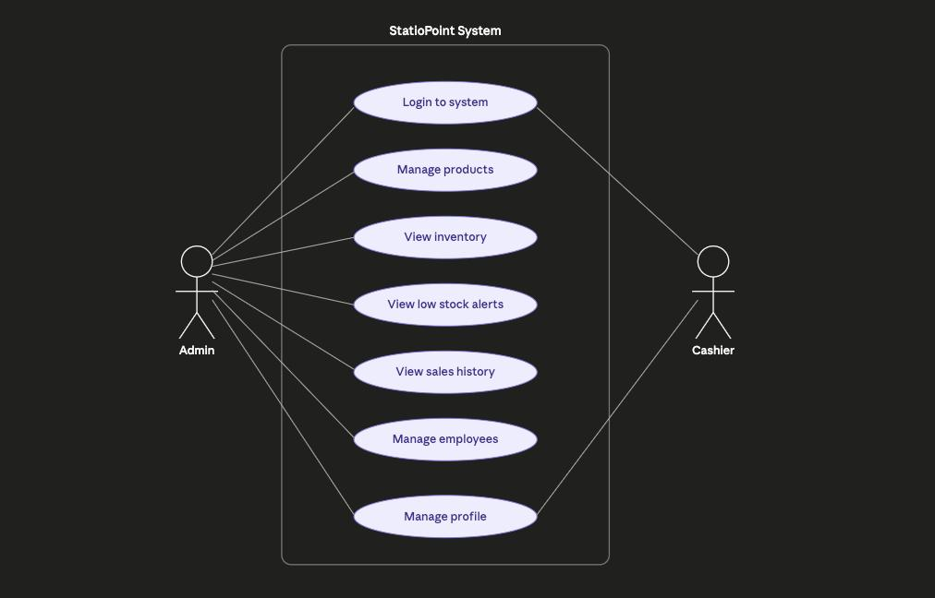

3.2 Activity Diagrams
Activity diagrams are drawn for the three main processes of StatioPoint in Sprint 2.

3.2.1 Activity Diagram — Add Product
This diagram shows the flow when an Admin adds a new product to the inventory, including validation and error handling.
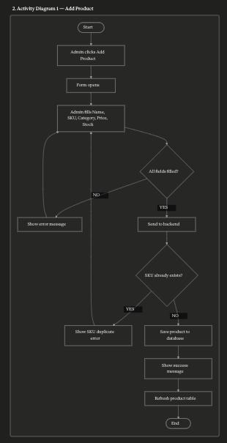

3.2.2 Activity Diagram — Create Sale (Cashier Checkout)
This diagram illustrates the complete checkout process: searching for products, building a cart, selecting payment, and completing the sale with automatic stock reduction.
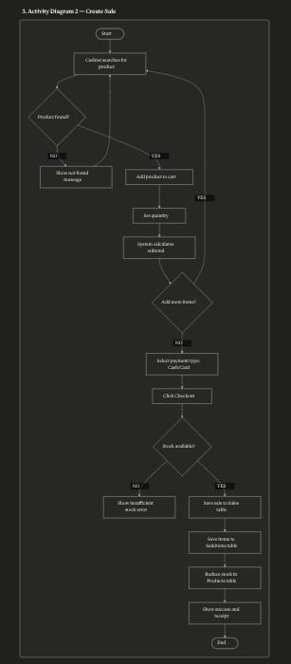

3.2.3 Activity Diagram — View Sales History
This diagram shows how the Admin accesses and views the complete sales history fetched from the database.

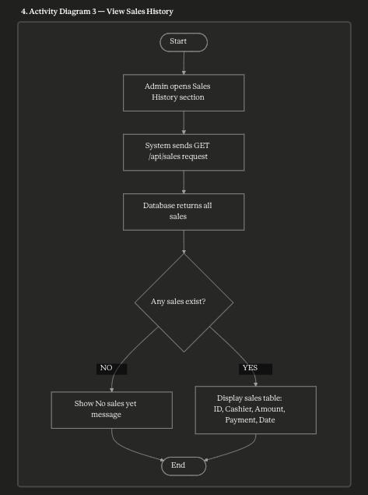

3.3 Sequence Diagrams
Sequence diagrams show the interaction between the user, frontend, backend (Node.js), and the SQL Server database for each main process.

3.3.1 Sequence Diagram — Add Product
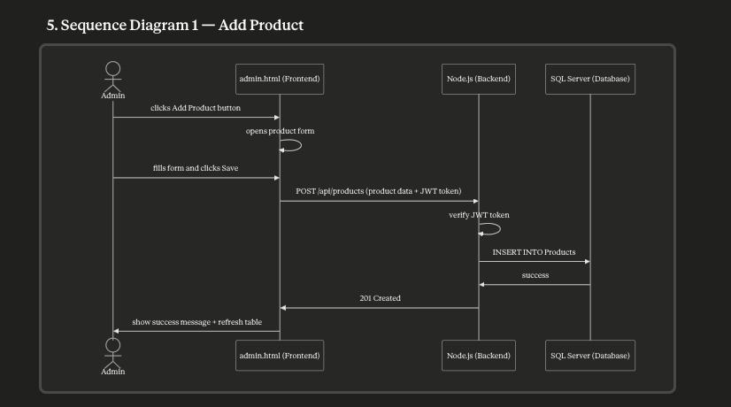

3.3.2 Sequence Diagram — Create Sale
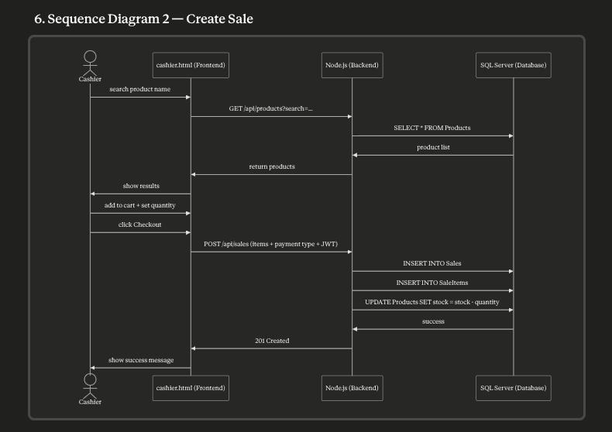

3.3.3 Sequence Diagram — View Sales History

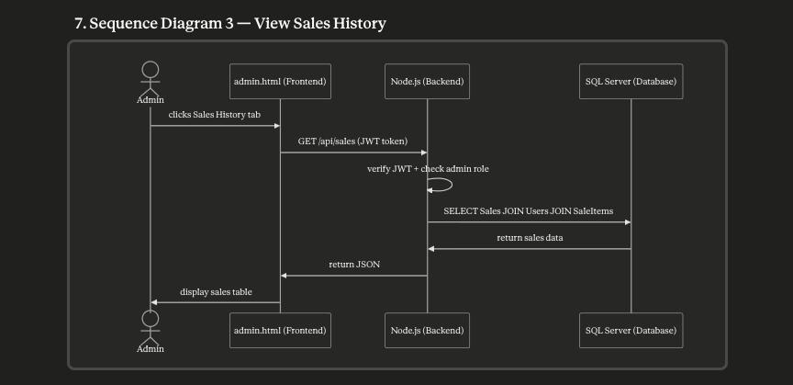

3.4 Class Diagram
The class diagram below shows the four main classes of StatioPoint — User, Product, Sale, and SaleItem — along with their attributes, methods, and relationships. A User processes many Sales. A Sale contains many SaleItems. A Product appears in many SaleItems.

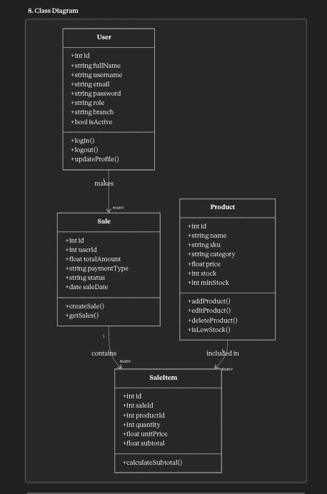

4. Scrum Board (Trello)
The Trello board was updated for Sprint 2 to reflect the new user stories. Tasks were moved from Backlog → In Progress → Done as development progressed.

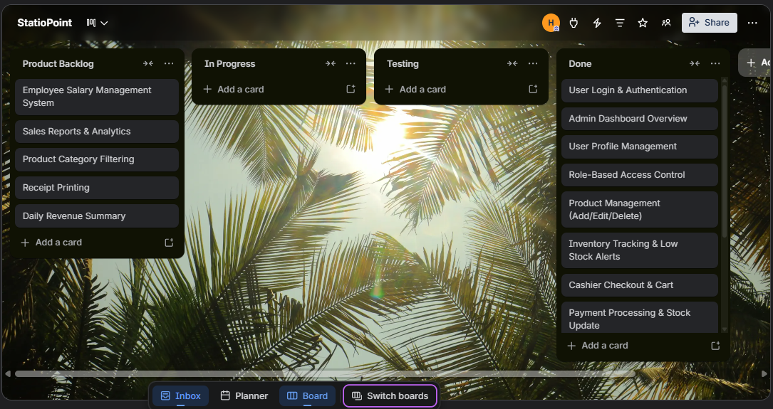

5. Implementation Screenshots
The following screenshots demonstrate the working implementation of Sprint 2 features.

5.1 Inventory Management — Admin Panel
The admin inventory screen shows all products in a table with low stock items highlighted in red. The Admin can add, edit, and delete products using the action buttons.

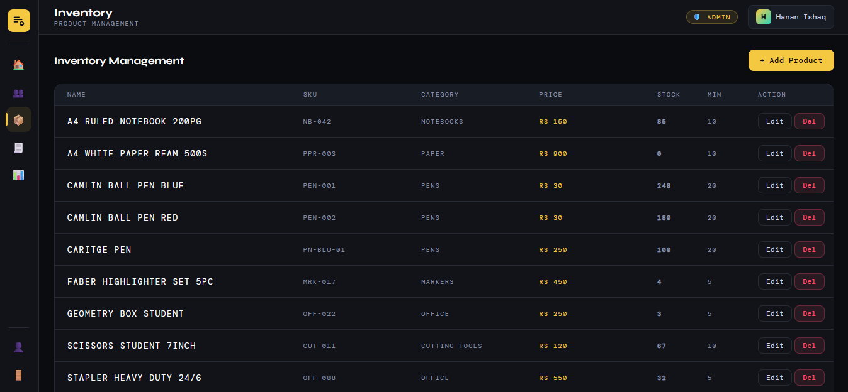

5.2 Add / Edit Product Form
The add product form allows the Admin to enter product details including name, SKU, category, price, stock quantity, and minimum stock threshold.

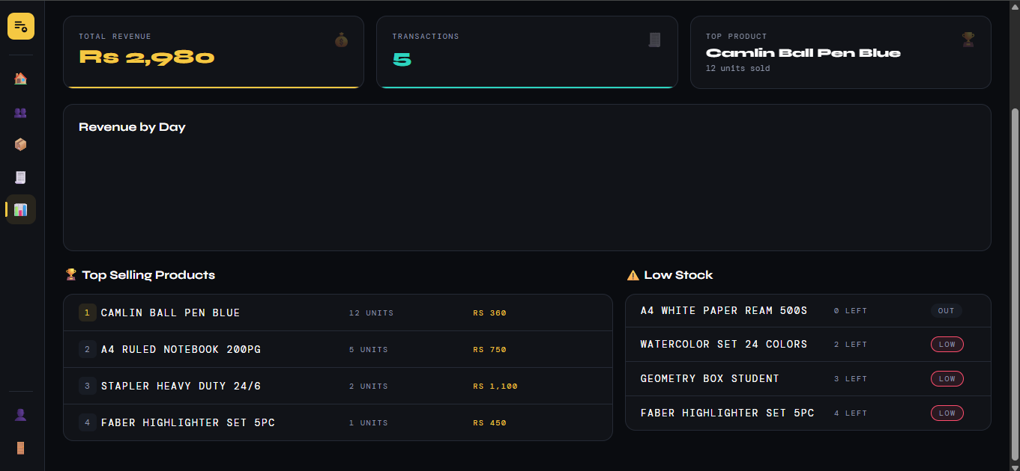

5.3 Cashier Checkout — Cart & Payment
The cashier checkout screen shows the product search, the cart with items and quantities, the running total, payment type selection, and the checkout button.

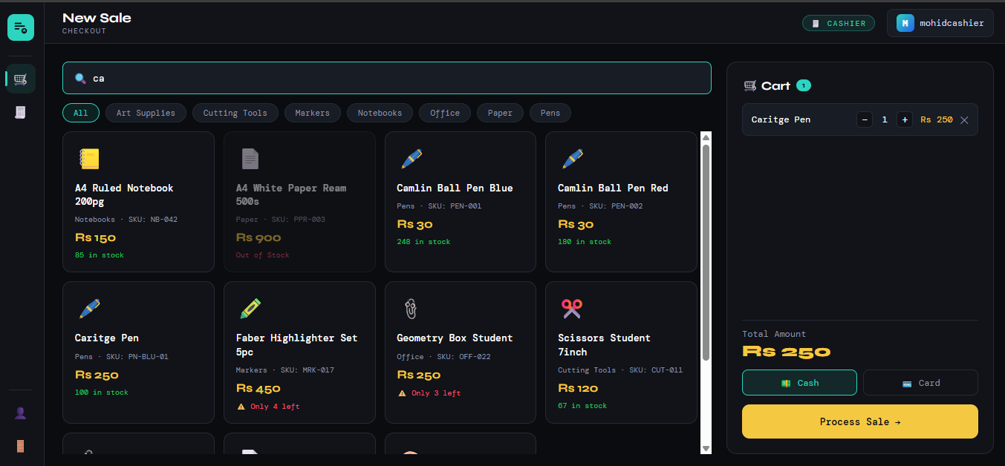

6. Work Division
The following table outlines the contribution of each team member during Sprint 2.

Team Member | Roll No. | Contribution
Hanan Ishaq | 24L-2537 | Backend API development (products & sales routes), Database integration, JWT middleware, Server configuration
Mohid Israr | 24L-2510 | Frontend development (admin inventory UI, cashier checkout UI), Testing & debugging, Report writing

