**Git Commands**

**1)git config**

**Usage: git config –global user.name “[User_name]”**

**Usage: git config –global user.email “[User _email_address]”**

**This command sets the author name and email address respectively to be used with your commits.**

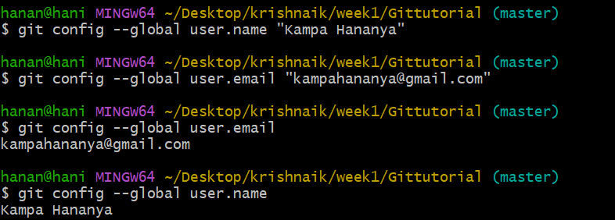

**2)git init**

**Usage: git init [repository name]**

**This command is used to start a new repository.**



**3)git clone**

**Usage: git clone [url]**

**This command is used to obtain a repository from an existing URL.**

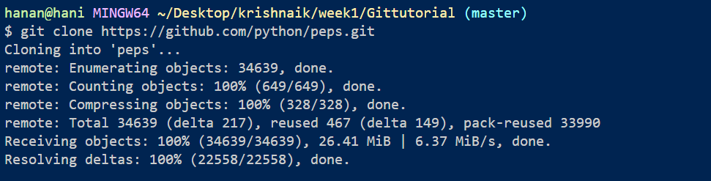

**4)git add**

**Usage: git add [file]**

**This command adds a file to the staging area.**

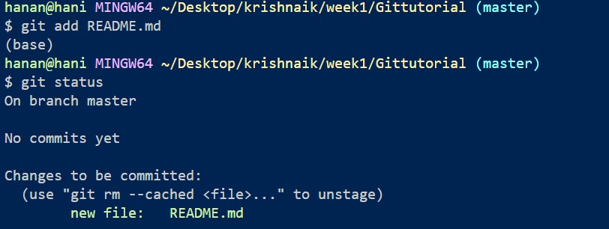

**Usage: git add \***

**This command adds one or more to the staging area.**

**5)git commit**

**Usage: git commit -m “[ Type in the commit message]”**

**This command records or snapshots the file permanently in the version history.**

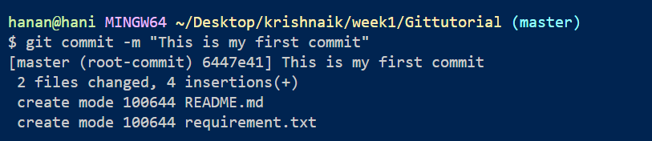

**Usage: git commit -a**

**This command commits any files you’ve added with the git add command and also commits any files you’ve changed since then.**

**6)git status**

**Usage: git status**

**This command lists all the files that have to be committed.**

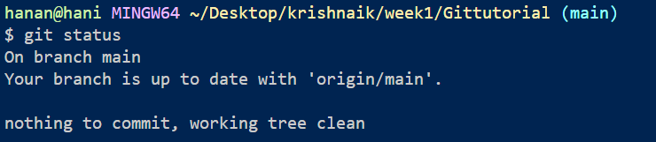

**7)git rm**

**Usage: git rm [file]**

**This command deletes the file from your working directory and stages the deletion.**

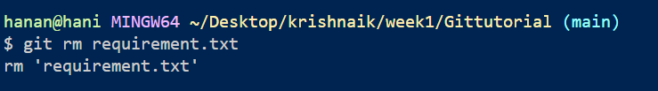

**8)git log**

**Usage: git log**

**This command is used to list the version history for the current branch.**

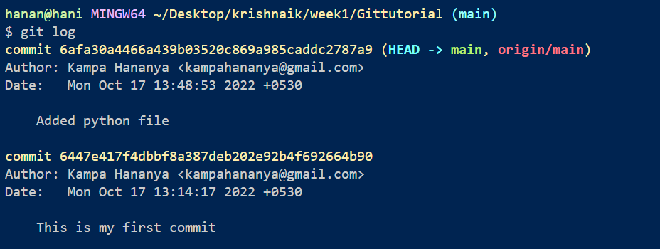

**Usage: git log –follow[file]**

**This command lists version history for a file, including the renaming of files also.**

**9)git show**

**Usage: git show [commit]**

**This command shows the metadata and content changes of the specified commit.**

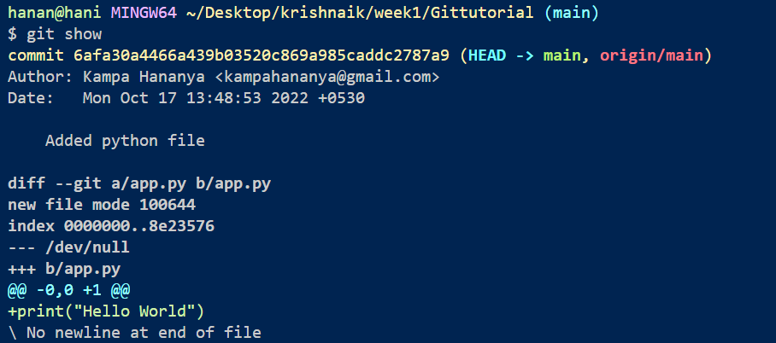

**10)git branch**

**Usage: git branch**

**This command lists all the local branches in the current repository.**

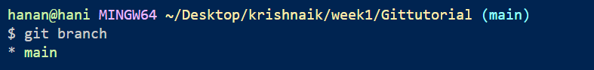

**11)Usage: git branch [branch name]**

**This command creates a new branch.**

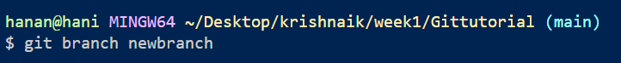

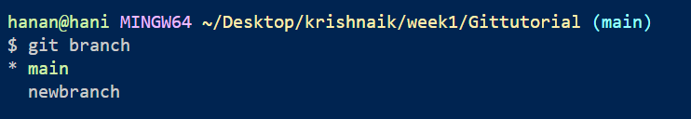

**12)Usage: git branch –-delete [branch name]**

**This command deletes whatever branch you want**

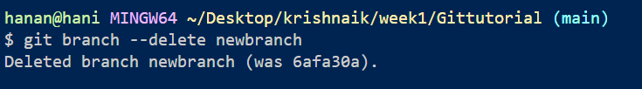

**13)git commit -m "first commit"**



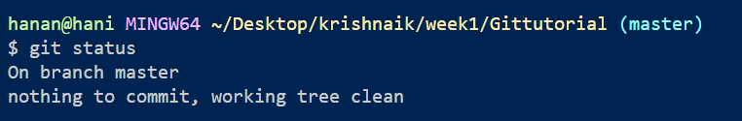

**14)git branch -M main**

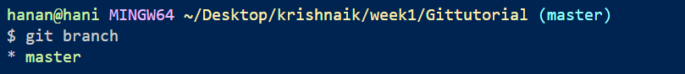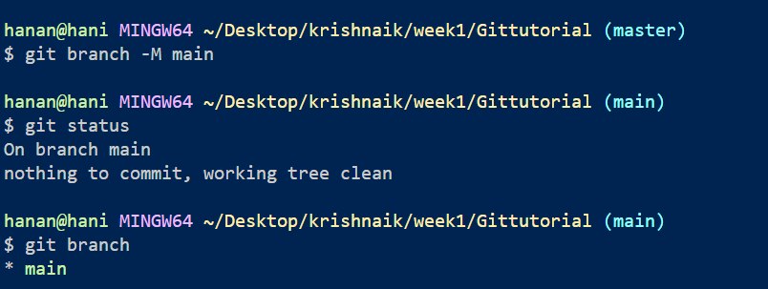

**15)git remote add origin** [**https://github.com/hananyakampa/Git_tutorials.git**](https://github.com/hananyakampa/Git_tutorials.git)

