Step1)Creating an open source project folder 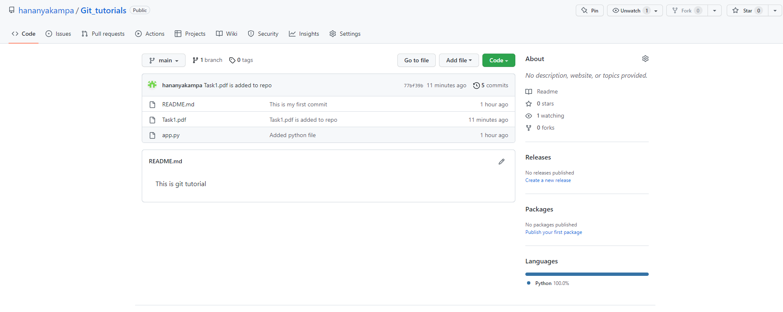

Step2)creating a Readme.md file and give details about the project repo

Step3)For adding collaborators

a)go to repo settings

b)settings->access

c)access->collaborators

e)enter account password

f)Manage access

g)Now we can add collaborators

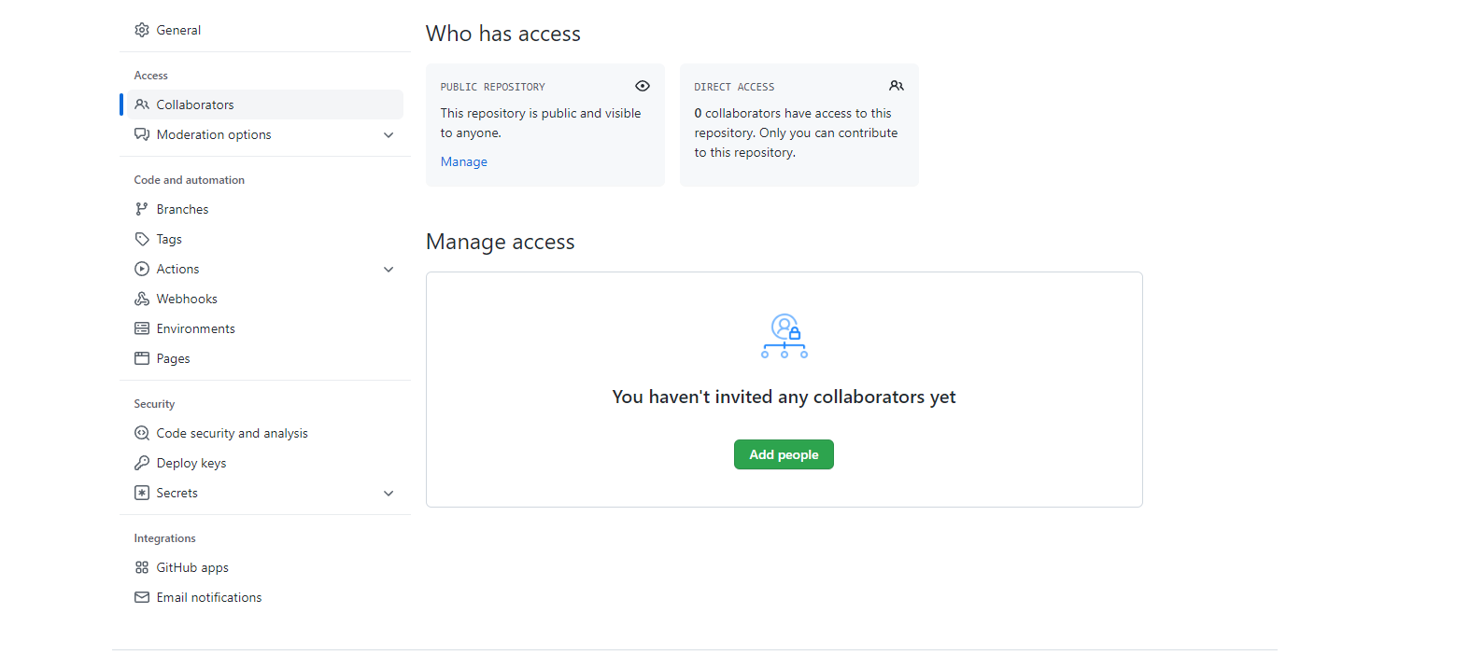

Step4)Host GitHub Pages using settings (Designed to host your personal, organization, or project pages from a GitHub repository)