dep_Windows8Logo.png

Windows Hardware Certification Step-by-Step Guide

Microsoft Corp.

Published: October 2012

Version 2.0

Applies To:

This information applies to Windows 8

Abstract

The Windows® Hardware Certification Kit (Windows HCK) enables developers, ISVs, IHVs, and OEMs to certify their hardware devices for Windows® 8.



Copyright Information

This document is provided “as-is”. Information and views expressed in this document, including URL and other Internet Web site references, may change without notice. You bear the risk of using it.

This document does not provide you with any legal rights to any intellectual property in any Microsoft product. You may copy and use this document for your internal, reference purposes.

© 2012 Microsoft. All rights reserved.

Microsoft, Windows, and Windows Media are trademarks of the Microsoft group of companies.

All other trademarks are property of their respective owners.

Contents

[Windows Hardware Certification Step-by-Step Guide 4](#_Toc337188406)

[Testing concepts 4](#_Toc337188407)

[Windows HCK test process 6](#_Toc337188408)

[Prerequisites 6](#_Toc337188409)

[Step 1: Install Controller and Studio on the test server 12](#_Toc337188410)

[Step 2: Install Client on the test computer(s) 13](#_Toc337188411)

[Step 3: Create a project 17](#_Toc337188412)

[Step 4: Create a machine pool 18](#_Toc337188413)

[Step 5: Select target to certify 20](#_Toc337188414)

[Step 6: Select and run tests 21](#_Toc337188415)

[Step 7: View test results and log files 22](#_Toc337188416)

[Step 8: Create a submission package 23](#_Toc337188417)

[Step 9: Submit a package for certification 25](#_Toc337188418)

[Appendix 25](#_Toc337188419)

# Windows Hardware Certification Step-by-Step Guide

The Windows® Hardware Certification Kit (Windows HCK) contains all of the tools and documentation that you need to certify hardware for these operating systems:

• Windows 8

• Windows Server® 2012

• Windows 7

• Windows Server 2008 R2

The Windows® Certification Program is the successor to the Windows® Logo Program. The Windows HCK is the successor to the Windows® Logo Kit (WLK).

## Testing concepts

Windows HCK testing is based on feature detection. Unlike previous kits, Windows HCK determines what parts of a device can be certified.

### Terminology

• Feature. A feature is a Windows capability exposed by a device. When you connect a device to a Windows HCK environment, the kit searches for features on the device using a mechanism called gatherers. Starting with Windows® 8, features are organized using a namespace style, for example, Device.Graphics.WDDM12, System.Client.BluetoothController.Base, and Filter.Driver.Network.LWF.

• Requirement. A requirement is the official specification that defines what a feature must do to qualify for Windows hardware certification. Starting with Windows® 8, requirements are organized using a namespace style. For exampleDevice.Imaging.Scanner.Base.RawFileFormat is a requirement for the Device.Imaging.Scanner.Basefeature.

• Tests. Tests validate that features are implemented on a device in accordance with requirements. Each test has a pointer to the requirement(s) it validates.

• Product type. A product that contains a predefined list of testable features. A Product type replaces the previous self-selection category system in Windows Logo Kit. To receive Windows Hardware Certification, a product must implement all of the features of at least one product type.

### How it works

In the following example, a multi-function printer device contains several features: It's a scanner, an Ethernet network port, a storage reader, and a printer. Windows HCK detects each feature, determines the associated requirements for it, and then runs a corresponding test to verify that the requirements are implemented correctly.

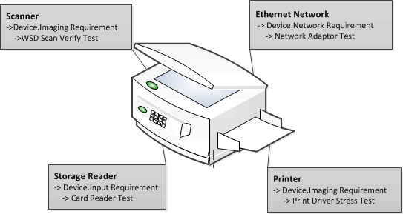

### Best practices

In addition to understanding the new terminology and logic, consider these best practices:

• Design your hardware using the Windows Hardware Requirements. If you fail to meet any of them, your device fails the testing process, which wastes valuable time.

• Review the Certification Test Reference for your device before testing. Any Windows HCK test may require a specific configuration. The more complex the device, the more complex the test configuration.

• Manual tests require more time and preparation. You should run manual steps separately from automated tests. When you connect a device to Windows HCK, you can sort detected test by automated and manual. To learn more about any test, select the test from Windows HCK Studio and press F1 for Help.

• Ensure that your test server contains the latest QFE and filters. We periodically release updated tests. For more info, see [Windows Hardware Certification](http://go.microsoft.com/fwlink/p/?LinkID=236110) in the Windows Dev Center.

### Testing strategy

The complexity of a device determines the complexity of a test. It can be as simple as connecting the device and running the test, or it can require additional hardware resources, extensive configuration, and/or active use. Considering your knowledge of the device and previous versions of this kit, you can approach testing two ways:

• Connect the device to a Windows HCK environment. Let the kit detect features and the corresponding tests to run against the device. Press F1 on each identified test to review any prerequisites for it.

• Review the Windows HCK Users Guide in advance. See the Test Reference section for the specific technologies implemented in the device, specifically the "Prerequisite" topic for each area.

## Windows HCK test process

Before you can start testing, you must set up the test environment needed for the hardware you want to certify. This includes the test server (controller), test computers, and any needed additional hardware or software. After the environment is set up, you can test hardware by using the new Windows HCK Studio tool. The process includes:

1. Review prerequisites

2. Install Controller and Studio software on the test server

3. Install Client software on test computer(s)

4. Create project

5. Create machine pool

6. Select feature to certify

7. Select and run tests

8. View results

9. Create a submission package

## Prerequisites

Before you begin testing, make sure that the test environment meets the necessary requirements. Windows HCK is comprised of two components: a test server and one or more test computers.

• Test server. Often referred to as the controller, a test server has two parts: Windows HCK Controller and Windows HCK Studio. The Controller software is the engine that manages tests that are run on test computers. The Studio software is the management tool that lets you select and schedule tests against any test computer connected to the test server. Controller and Studio are installed from the Windows HCK installation source. Once established, the test server contains separate installers to install a remote Windows HCK Studio and Windows HCK Client.

One controller governs a collection of client computers. Controllers can manage and access only the client computers that they govern.

• Test computer. Also referred to as a client computer, each one can have a different configuration that's appropriate for various testing scenarios, including different hardware, operating systems, service packs, and drivers. Each test computer can only be associated with one test server. You configure each test computer by running the Windows HCK Client software installer directly from a shared network location on the test server.

### Deployment scenarios

There are two deployment scenarios for Windows HCK:

• Domain-joined environment. In a domain-joined environment, a domain controller is present and all computers designated for Windows HCK features are joined to the domain controller. If you plan to deploy Windows HCK in a domain-joined environment, you need a minimum of three computers: a Windows domain controller, a Windows HCK test server, and one Windows HCK test computer. Make sure that Microsoft Active Directory® is configured and running on the domain controller.

• Workgroup environment. A workgroup environment has no domain controller. If you plan to deploy Windows HCK in a workgroup, you need at least two computers: a test server and a test computer. Don't use the Default Administrator account.

In addition, consider how you want to organize lab resources to best use the Windows HCK. You need to determine the number of test servers and the number of test computers connecting to them. These decisions are partly influenced by the type of devices or systems that you want to certify.

To test systems and filter drivers, you need at least 1 test server and 1 test computer.

To test external devices, you need at least 1 test server, 1 test computer, and the external device(s) to be tested.

You can choose to allocate fewer controllers, each with multiple clients connected to them, if you want less overhead administering the controllers and clients. A maximum of 150 clients can be connected to a single controller. Alternately, you can allocate more controllers and connect fewer clients to them. This allows any given controller to be more responsive because it has fewer clients communicating with it.

The following image shows an example test environment.

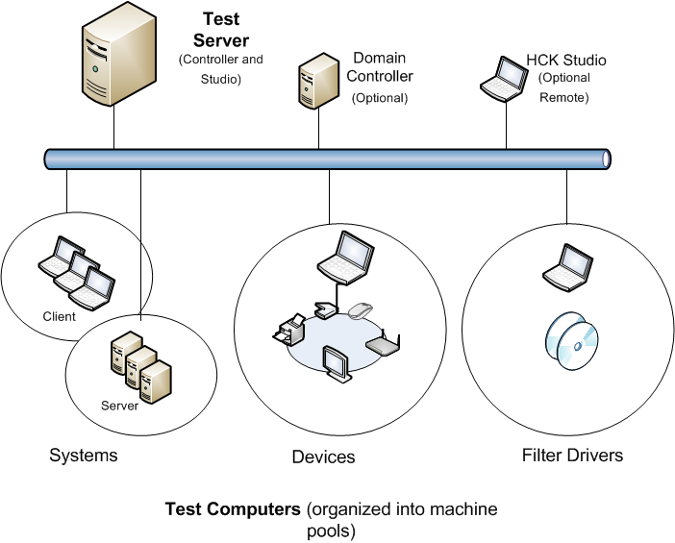

### System Requirements

#### Test server

|  |  |  |
| --- | --- | --- |
| Component | Minimum | Optimum |
| Processor | Single Intel or AMD-based x64 platform with a speed of 2.0 GHz | Multicore or multiple x64-based processors running in x64 mode with a speed of 2.0 GHz or faster |
| System memory | 2 GB main memory | 4 GB main memory |
| Hard disk capacity | 300 GB minimum to accommodate the volume of logs that can be generated. | RAID or JBOD array configuration |
| Network connection | 100 megabits per second (Mbps) |  |
| Operating system | English language and English local version of Windows Server 2008 R2 64-bit  Note  For information about installing Windows Server 2008 R2, see the [Windows Server](http://go.microsoft.com/fwlink/?LinkId=236055) website.  Note  Controller isn't supported on Windows Server 2003, Windows Server 2008, Windows Vista®, Windows XP, or Windows 2000.  Controller isn't supported on a Windows Server 2008 R2 installation that has already been set up as a domain controller.  Controller isn't supported in a virtual PC or any third-party Hypervisor environment.  If you plan to install the Windows® Assessment and Deployment Kit (Windows ADK) on the same system as Windows HCK, install Windows HCK first. Otherwise, Windows HCK installation will fail. |  |
| Additional requirements | Controller can't be installed on a domain controller computer.  The test server must have IPv6 addressing enabled. For Windows Server 2008 R2, it's enabled by default and shouldn't be disabled.  The system language needs to be set to US English. To do this, click Region and Language in Control Panel, click the Administrative tab, click Change system locale, and then select English (United States). |  |

#### Test computer

|  |  |
| --- | --- |
| Component | Minimum |
| Processor | The recommended processor for the operating system that you install. |
| System memory | Refer to the recommended processor for the operating system that you install. |
| Hard disk capacity | 300 GB minimum to accommodate the volume of logs that can be generated.  The client must be unique; you can't swap drives. |
| Network connection | 100 Mbps |
| Operating system | Install the Windows operating system that you are testing against.  Test computers are not supported in a virtual PC or any third-party Hypervisor environment.  If you are testing against a Windows “N” edition, you must also manually install Media Feature Pack. |
| Additional requirements | Many of the tests require a test system to restart—often more than once—to complete a test run. So, we recommend that you:  **•** Configure test computers to boot from the regular boot sector of a hard drive and not from external devices, CDs, or DVD boot discs.  **•** Enable automatic logon on test computers. For more information, see the HCK Lab Security topic.  Testing also requires:  **•** Filters.  **•** Test-sign drivers.  **•** Additional source code/Readme files that are requested at the end of package creation. |

#### Optional remote/standalone Windows HCK Studio

|  |  |
| --- | --- |
| Component | Minimum |
| Processor | The recommended processor for the operating system that you install. |
| System memory | Refer to the recommended processor for the operating system that you install. |
| Hard disk capacity | 300 GB minimum to accommodate the volume of logs that can be generated.  The client must be unique; you can't swap drives. |
| Network connection | 100 Mbps |
| Operating system | **•** Windows Vista  **•** Windows 7  **•** Windows 8  HCK Studio isn’t supported in a virtual PC or any third-party Hypervisor environment. |

### Additional requirements

You might need to configure additional hardware for the device or system that you're testing. For more info, see the Prerequisites section for each feature that you're testing:

Systems

• System.Client Testing

• System.Fundamentals Tests

• System.Server Testing

Devices

• Device.Audio Testing

• Device,Buscontroller Testing

• Device.Connectivity Tests

• Device.Fundamental Tests

• Device.Graphics Testing

• Device.Imaging Testing

• Device.Input Testing

• Device.Network Testing

• Device.Media Testing

• Device.Portable Testing

• Device.Storage Testing

• Device.Streaming Testing

Filter Drivers

• Filter.Driver Testing

## Step 1: Install Controller and Studio on the test server

In this step, you install Windows HCK software on the designated test server. The test server should be preinstalled with Windows Server 2008 R2. The setup program installs the Windows HCK Controller and Studio, in addition to other resources.



|  |
| --- |
| 1. Download the Windows HCK from the [Windows Hardware Dev Center](http://msdn.microsoft.com/en-us/windows/hardware/gg454513)  2. From the download location, click Download > Run.  Warning  Don't select the Save option. The Save option only downloads Windows HCK Setup and not the complete kit.  3. When the Specify Location screen appears, select appropriate option:  a. Install option – Select Install the Windows HCK to this computer, and then click Install .  b. Download option – Select Download Windows HCK for installation on a separate computer, and then click Next.  4. Select Controller + Studio option.  If you are installing directly, you must open a port on your server. Select Yes, to open port.  5. When the Join the Customer Experience Improvement Program (CEIP) screen appears, select Yes or No, and then click Next.  Note  If your network isn't connected to the Internet, select No.  6. Review the License Agreement, and then click Accept to proceed.  7. If you selected the install option, installation takes about 45 minutes. If Microsoft .NET Framework 4 isn't already installed on the computer, follow the prompts to install it. After the computer restarts, you must repeat the installation instructions from Step 1 for installing to this computer.  If you selected the download option, copy your download to your test server. Run HCKSetup.exe and repeat the installation instructions from Step 3 for installing to this computer. |

Important

If you are upgrading your HCK environment to a later version, you must first uninstall the previous version of the HCK software from both the test server and connected test client(s).

For Setup troubleshooting information, see [HCK Troubleshooting](http://go.microsoft.com/fwlink/?LinkId=251048) in the Windows Dev Center.

To learn more about other installation options, see the HCK Tools Technical Reference in the HCK Users Guide.

## Step 2: Install Client on the test computer(s)

After you install the Windows HCK on the test server, you're ready to add test computers to the environment. You install the Client software on each test computer. The Client software is stored on the test server.

Warning

If you're testing software, be sure to install the product on the test computer first, and then install the Client software.

1. On the test computer, browse to,

2. For x86 and X64, type \\<ControllerName>\HCKInstall\Client\Setup.exe.

For ARM devices, type \\<ControllerName>\HCKInstall\ARMClient\Setup.exe.

Note

Replace <ControllerName> with the name of the test server.

If this required software isn't already installed, it's installed in this step: .NET Framework 4 (Client Profile and Extended), Application Verifier, Windows Driver Test Framework (WDTF), and Windows Performance Test (WPT).

3. The Windows HCK Hardware Certification Kit Client Setup wizard appears. To start the wizard, click Next.

4. On the Internet Connection Firewall Agreement page, select Yes I will allow a port to be opened, and then click Next.

Note

If the Internet Connection Firewall Agreement page doesn't appear, Windows Software Firewall isn't installed, or another software firewall or hardware firewall is installed on the computer. If another firewall is installed, you must manually open TCP port 1771 to proceed with installation. Refer to the instructions that came with your firewall product to manually open a TCP port. Otherwise, the installation may fail or the Client software might not function properly.

5. When the Ready to Install page appears, select Install.

6. Click Finish to exit the wizard.

7. When installation completes, confirm its success by clicking Start > Control Panel> Uninstall a program. Confirm that Windows Hardware Certification Kit Client appears in the program list.

8. Repeat steps 1–5 for each test computer.

Important

In some cases, having Secure Boot enabled on a test computer can cause the HCK Client installation to fail. You should not see this failure on Windows RT devices but could see them on non-Windows RT devices. Follow these steps to ensure proper installation:

For system tests and non-class driver device tests

1. Disable Secure Boot protections.

• For x86/x64, enter your BIOS configuration and disable Secure Boot.

• For Windows RT, install the Windows Debug Policy; you don't need to disable Secure Boot.

Note

This can only be done by OEMs and Microsoft.

2. Install the HCK Client software.

3. Run the following tests (whichever is applicable from the list for your platform)

|  |
| --- |
| Test |
| System Must include SuperSpeed Port |
| USB 3.0 Hub Enumeration Stress |
| USB 3.0 Insertion Test |
| USB 3.0 Speed Switch Test |
| USB 3.0 Suspend Test |
| USB Controller Power State Test |
| USB Controller Power State Test for System |
| USB Descriptor Test |
| USB Device Connection S3+S4 |
| USB Device Control Request Test |
| USB Enumeration Stress |
| USB Exposed Port Controller Test |
| USB Exposed Port System Test |
| USB Host Controller Enable Disable Test |
| USB Hub Exposed Port Test |
| USB Hub Selective Suspend Test |
| USB Internal Device Idle |
| USB MS OS Descriptor Test (xHCI) |
| USB Selective Suspend Test (xHCI) |
| USB Serial Number |
| USB xHCI Compliance Suite (ARM) |
| USB xHCI Register System test |
| USB xHCI Register Test |
| USB xHCI Runtime Power Management System Test |
| USB xHCI Runtime Power Management Test |
| USB xHCI Transfer Speed Test |
| USB3 Termination |
| USB-IF Certification Validation Test (Device) |
| Debug Capability Test (Logo) |
| xHCI Debug Capability Compliance (Logo) |
| xHCI Debug Capability Device Compliance (Logo) |
| GFXIntegration Power Management Test |
| WDDM CCD Test for PersistentReset Monitor |
| DMA Extension Test - UART DMA |
| NPCTEST - Clock Interrupt Test |
| PCI Hardware Compliance Test For a Single Device (PCIHCT) |
| PCI Hardware Compliance Test For Systems |
| UEFI Firmware Certification Test |
| PPM Perf Logo Test |
| WHEAHCT Logo |
| Connected Standby IO Stress |
| BitLocker Drive Encryption USB BIOS Logo Test |
| TPM 2.0 Hardware Interface Test (Manual) |
| TPM 2.0 TCG Physical Presence Interface 1.2 Test |
| TPM 2.0 UEFI Preboot Interface Test |
| TPM Revoke Attestation |
| ACPI Logo Test |
| Crypto Capabilities – UEFI Hash Provider |

4. Enter your BIOS configuration, enable Secure Boot, and restore Secure Boot to the Default configuration. For Windows RT devices, remove the secure boot debug policy.

5. Run the rest of the HCK tests.

6. Enter the BIOS configuration and clear the Secure Boot configuration. This restores the system to Setup Mode by deleting PK and other keys.

Note

Support for clearing is required for x86/x64 and prohibited for production Windows RT devices.

7. Run the Secure Boot Manual Logo Test.

For devices that use drivers on Windows RT

1. Install the HCK Client software.

2. Run device tests for your devices only.

Note

System tests and tests that use drivers that aren't signed by Microsoft will fail.

For Client troubleshooting information, see [HCK Troubleshooting](http://go.microsoft.com/fwlink/?LinkId=251048) in the Windows Dev Center.

To learn more about client computers, see Manage Clients and Machine Pools in the HCK Users Guide.

## Step 3: Create a project

After you install all of the Windows HCK software (Controller, Studio, and Client), you're ready to begin testing by creating a project. You can create one project per submission or create several projects and merge the individual packages into one submission. For example, you can create a submission package for a device that supports Windows 7 and Windows 8 in one run by creating a project with the same hardware but different operating systems. Begin by opening Windows HCK Studio.

The following image shows the Studio Project tab.

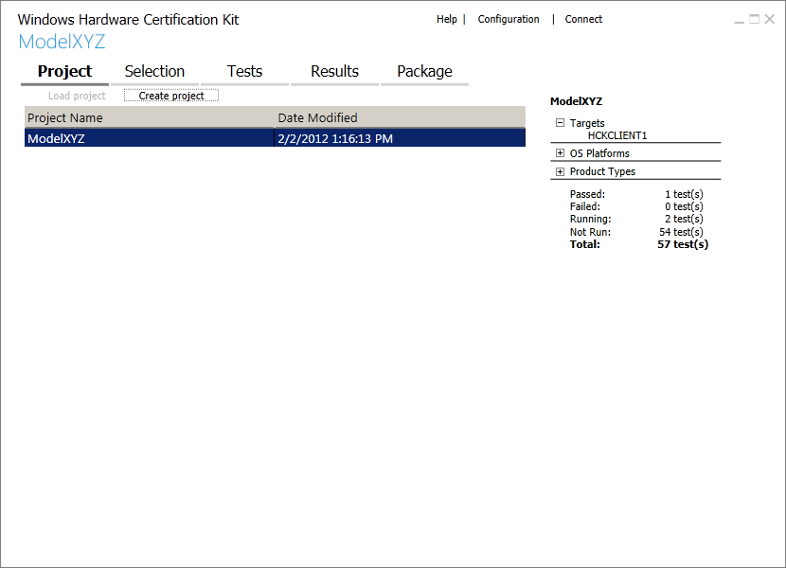

1. On the server computer, click Start > All Programs > Windows Kits > Hardware Certification Kit > HCK Studio.

2. On the Project tab, click Create project.

3. Replace the default project name with the name of your project, and then press Enter.

Note

A project should have a meaningful name that indicates its contents, for example, "Fabrikam Multi-function Device Model Z".

When the project name appears on the page, the project is loaded.

## Step 4: Create a machine pool

A machine pool is a logical grouping of one or more test computers. After you install Windows HCK Client on a test computer, that computer is automatically added to the default pool. Before you can work with a computer, you must move it to a working machine pool.

Every project needs a machine pool. A machine pool can be used for multiple projects, but each project can only be associated with one machine pool.

The following image shows the Studio Configuration page.

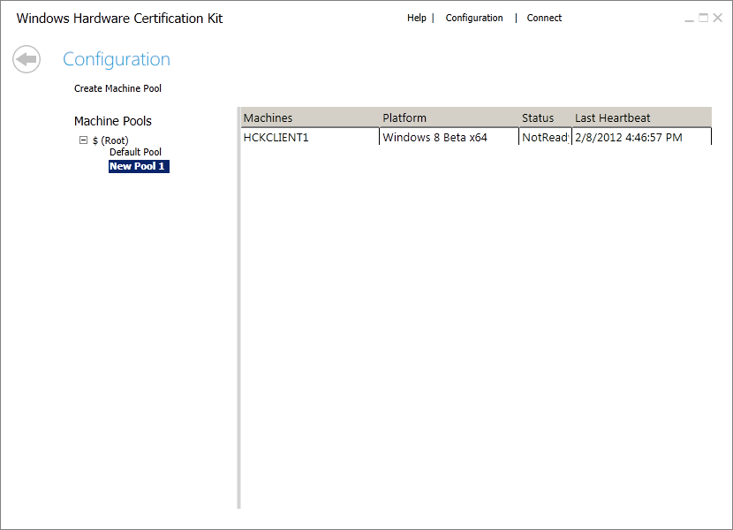

1. In Windows HCK Studio, click Configuration.

2. Under Machine Pools, right-click $ (Root), and then click Create Machine Pool.

The new pool is named "New Pool 1" by default. You can change that by typing a different name and then pressing Enter.

3. Click Default Pool, and then confirm that each test computer appears in the main pane. If you've installed the Client software on multiple test computers, you can add any of them to the pool.

Note

A computer can't be in more than one pool at a time.

4. Select the test computer, and then drag it to the newly created pool.

5. Under Machines, right-click the test computer, click Change Machine Status, and then click Ready.

The Status column changes to Ready.

Warning

Tests don't run if the computer status isn't Ready.

6. Repeat for each test computer that you want to include in the pool.

7. Click the Back arrow to return to the main area of Windows HCK Studio.

After all of the test computers are assigned to a pool, you're ready to conduct tests against those computers. If you're testing external devices like printers, they must be connected to the test computer.

To learn more about client computers, see Manage Clients and Machine Pools in the HCK Users Guide.

## Step 5: Select target to certify

Windows HCK Studio detects all features that a device implements. The specific testable device is called the target. A device may contain multiple targets, represented by one or more hardware IDs. Using the Selection tab, you can filter what you want to certify by using these views:

• Systems. To certify a client or server computer.

• Devices and printers. To certify an external device that's connected to a test computer. This device typically appears in Start > Devices and Printers on the test computer.

• Device manager. To certify a component of a test computer or external device, for example, a network card. This is the most detailed view.

• Software devices. To certify filter drivers, firewalls, and antivirus software that's installed on the test computer.

The following image shows the Studio Selection tab.

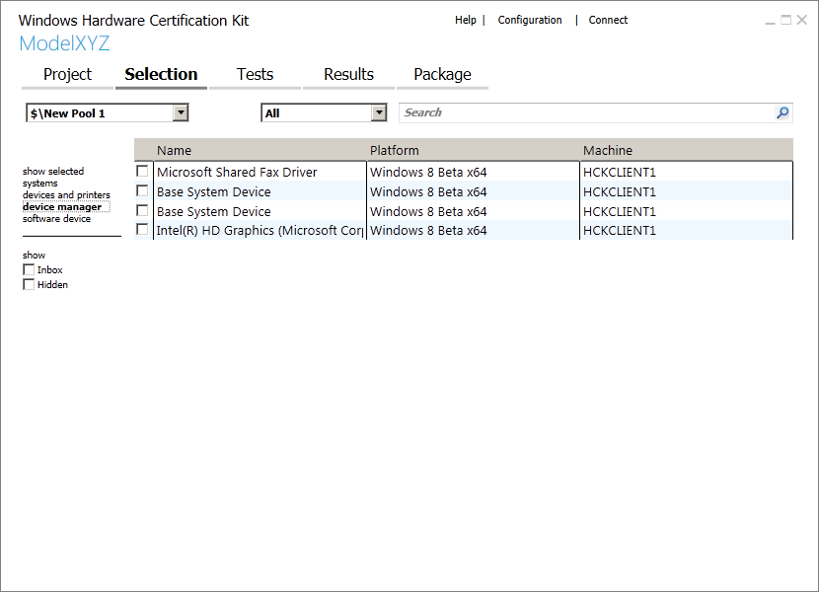

1. Click the Selection tab. From the machine pool list (upper-left drop-down list), select the pool that contains the devices that you want to certify.

2. From the left-pane, select the view based on the device you want to certify: systems, device and printers, device manager, or software device.

A list of available targets is displayed in the center detailed view. If you select device manager, you can choose to show inbox and hidden features.

3. From center detailed view, select the check box next to each item that you want to test.

Note

• You must select all of the features for a device to receive certification.

• If you're testing a Web Services on Devices (WSD) device, there may be a delay before required WSD features are automatically selected.

The show selected option displays the targets that you select in the other views. This view allows you to see just the areas you're testing. You also can filter a machine pool by category by using the category list. You can search for specific targets/features by using the search box.

To learn more about targets, see Work with Targets and Selection Tab in the HCK Users Guide.

## Step 6: Select and run tests

The Tests tab displays all of the tests required for certification for the target(s) you select. Testing a device can take a lot time. You can sort tests by type, length of time, and test computer.

The Type column specifies whether a test runs automatically (A) or requires manual input from a user (M). The Length column shows estimates for the time that each test takes.

Because manual tests interrupt the test process to await user input, we recommend that you run them separately from automated tests. Some automated tests require additional parameters before you can run them.

The following image shows the Studio Tests tab.

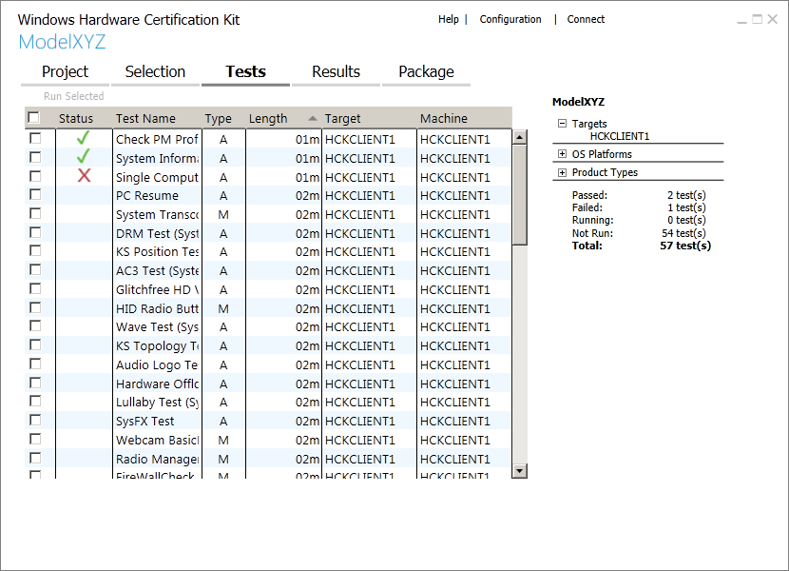

1. Select the check box next to each test that you want to run.

Important

A device must pass all of the tests displayed in the list to receive a certification.

2. To run the selected tests, click Run Selected.

A progress bar appears. A slight delay occurs when you run a test for the first time.

Some tests require additional input before they run. Windows HCK Studio prompts you accordingly for more information. To learn more about any test, right-click it in the list and select Help. To cancel any running test, right-click it and select Cancel.

As tests complete, the outcome of each one is displayed in the Status column. A green checkmark means that it passed; a red X means that it failed. The right pane displays project summary information, including target(s) selected, operating systems being tested, product types you qualify for, and status of all tests.

To learn more about managing tests, see Manage Tests using Test Tab in the HCK Users Guide.

## Step 7: View test results and log files

The Results tab displays detailed information about each test. As each test completes, the status column updates with the result—pass or fail.

The following image shows the Studio Results tab.

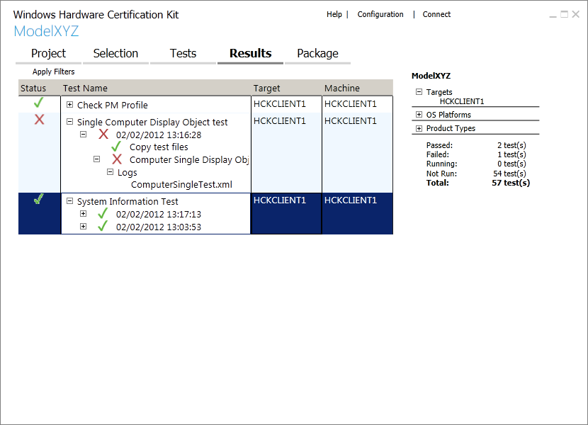

If a test fails, you can expand the test details to review the associated log file.

1. From the list, select a failed test, indicated by a red X.

2. Expand the Test Name node, expand the Logs node, and then double-click the log file.

You can review these log files:

• .log file. Text dump.

• .wtl file. Open to view error reports.

• .xml file. Change file name extension to .wtl to view error reports.

Right-click any test to see additional test details, including:

• Task logs.

• Additional files.

• Applied filters.

• Errors.

• Infrastructure (gather and execution logs).

To learn more about test results, see Manage Test Results using Result Tab in the HCK Users Guide.

## Step 8: Create a submission package

After the device passes all of the necessary tests, you can create a submission package (.hckx file) for certification.

Windows HCK Studio supports package creation, so you don't need to use a separate submission tool. It also supports adding resource files (drivers, symbols, errata) necessary to complete certification. You can also merge multiple packages (.hckx files) into one single package.

The following image shows the Studio Package tab.

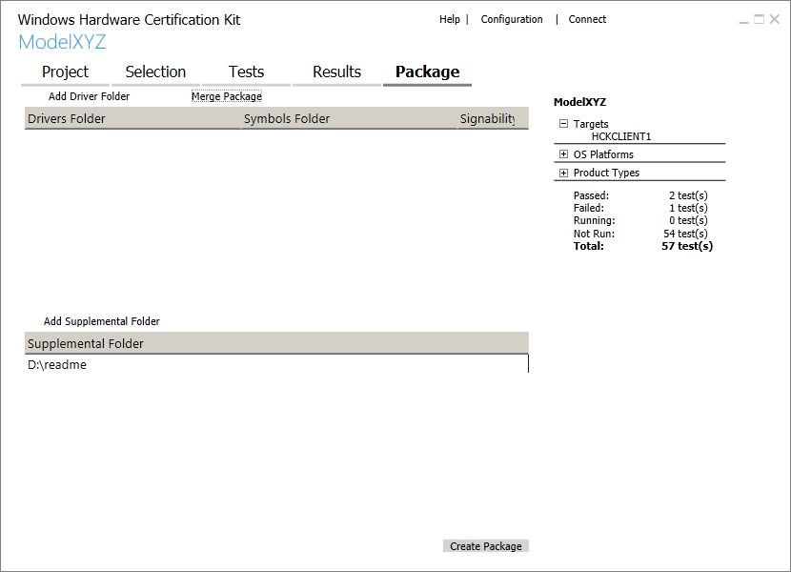

1. Select the Package tab.

2. If you used a special driver for a device (optional), submit it by doing this:

a. Click Add Driver Folder > Browse to select the folder, and then click OK.

b. In the Driver Properties dialog box, select the appropriate Products and Locales, and then click OK.

3. To add symbols (optional), right-click the driver folder, click Add Symbols > Browse to select the folder, and then click OK.

4. To add a supplemental folder (optional), such as a Readme file, contingency message, errata, or manual filter, click Add Supplemental Folder > Browse to select the folder, and then click OK.

5. Click Create Package.

6. From the Signing Options dialog box, select one of these options:

Important

All submissions must be digitally signed.

• Do not sign to create an unsigned package, for example, to send to Support for debugging or to later merge with other packages into a single submission package.

• Use the certificate store to create a digitally signed package—the most common scenario. This option requires an X509 certificate—for example a VeriSign certificate— to be installed on the computer running Windows HCK Studio. From the Windows Security dialog box, select the appropriate code signing certificate.

• Use a certificate file to create a digitally signed package by using a portable security file. This option asks you for an X509 certificate file (.cer file).

When the submission package is ready, the end-to-end testing of the device is complete.

To learn more about packages, see Work with HCK Packages (.hckx) in the HCK Users Guide.

## Step 9: Submit a package for certification

Submit the signed package (.hckx file) through the Hardware Dashboard on the Windows Hardware Dev Center. For more details, see [Dashboard Help](http://go.microsoft.com/fwlink/?LinkId=236060) in the Windows Dev Center.

## Appendix

For more information, how-to's, and troubleshooting, see the Windows HCK Users Guide, which is added to the test server during the kit installation.

On the test server, click Start > All Programs > Windows Kits > Hardware Certification Kit > HCK Users Guide.

For the latest Windows HCK information, see [Windows Hardware Certification](http://msdn.microsoft.com/en-us/windows/hardware/gg463010) in the Windows Dev Center.